**The Multifactorial Analysis (Environmental, Educational and Socioeconomic Factors) on Turkish Life Expectancy**

Ertan Kara1, Hasan Goksel Ozdilek2, Burcu Mestav 3

1 Cukurova University, Faculty of Medicine, Dept. of Public Health, Adana, Turkey

2 Canakkale Onsekiz Mart University, Faculty of Engineering, Dept. of Environmental Engineering Office: 118, Terzioglu Campus, 17020 Canakkale, Turkey

3 Canakkale Onsekiz Mart University, Faculty of Science, Dept. of Statistics, Terzioglu Campus, 17020 Canakkale, Turkey

**Abstract**

Although socioeconomic, environmental and medical factors have been improved over the past three decades in Turkey, countrywide average expected life is still under 80 years today despite the fact that the life expectancy of newborn in the EU was 81.0 years as of 2018 (EUROSTAT, 2019). In this paper, we analyzed factors determining life expectancy in Turkey. Education, population, forest area, traffic, water use, solid waste produced, economic growth, etc. are taken into account. The purpose of this study was to investigate the relationship between factors and life expectancy in provinces in Turkey. It was concluded that three significant factors (average year in education, air quality (SO2), and tractor number) are determined life of Turkish people.

Key words: Life expectancy, multifactor analysis, Türkiye provincials, health

**Introduction**

It is proved that environmental factors are important in life expectancy (Mariani et al., 2009). We also know that economic factors are also crucial at least to provide necessary health conditions to all citizens. It is rarely investigated economic, social, and environmental factors all together are taken into account to relate their roles in life expectancy, especially at a countrywide scale. Hollander and Staatsen (2003) noted that people lived in Catal Huyuk (in Anatolia) had a maximum life of 50 years and the median age was 20 years but today (1995 to 2000) maximum age is 100 years and mean age is 81 years in the Netherlands. In ancient times, the problems that cause decrease in life were different such as indoor air pollution, malnutrition, food contamination, drinking water quality, etc. Today, on the other hand, water pollution, urban air pollution, land degradation, hazardous waste, etc. are the factors shortening life expectancy in a modern society (Hollander and Staatsen, 2003).

Pope et al. (2009) reported that each 0.01 mg m3 increase in PM2.5 decreases life expectancy by 5 to 10 months in the USA. In the EU, the same parameter is 8.6 months (WHO, 2008). Mariani et al. (2010) investigated the effect of environmental quality on life span and found that the longer the life, there is a higher investment in environmental care. Abo et al. (1997) reported that environmental factors affect lifespan of males and females in Japan despite the fact that men and women are not equally affected by the parameters examined (atmospheric pressure, temperature, the duration time of sunshine, and relative moisture).

In addition to air people breathe, water and soil are also important in determination of health status of citizens. The population and population density, happiness, works related to soil excavation and land degradation, solid waste produced per capita, etc. all might affect expected life in a country. In this study, we investigated the factors important in expected life in Turkish provinces.

It is also important note that a heat wave caused 719 sudden deaths in a week of summer 2021 in Canada. Such climatic changes are responsible in increased infant deaths (Auger et al., 2015).

The life expectancy of some countries (including Turkey) is listed in Table 1 (https://www.worldlifeexpectancy.com/). It is clear that Turkish life expectancy is significantly lower than that in other Mediterranean countries. When one compares countries, females live significantly longer than males in Turkey and Portugal compared to that in other countries listed in Table 1. Note that these countries have not experienced a war or turmoil after the World War 2 and all of them are democratic countries. The top 20 countries in terms of their life expectancy are Monaco, Japan, Singapore, Macau, San Marino, Iceland, Hong Kong, Andorra, Guersney, Switzerland, Israel, South Korea, Luxembourg, Australia, Italy, Sweden, Liechtenstein, France, Canada, and Norway. The average life in these countries is 83.2 years (https://www.cbsnews.com/pictures/who-lives-longest-cias-top-20-nations-for-life-expectancy).

Table 1. Life expectancy in selected countries (2018)

|  |  |  |  |  |
| --- | --- | --- | --- | --- |
| Country | Males | Females | Mean | Difference |
| Cyprus | 78.4 | 83.1 | 80.7 | 4.7 |
| Greece | 78.7 | 83.7 | 81.2 | 5.0 |
| France | 80.1 | 85.7 | 82.9 | 5.6 |
| Italy | 80.5 | 84.9 | 82.8 | 4.4 |
| Malta | 79.6 | 83.3 | 81.5 | 3.7 |
| Spain | 80.3 | 85.7 | 83.1 | 5.4 |
| Portugal | 78.3 | 84.5 | 81.5 | 6.2 |
| Turkey | 73.3 | 79.4 | 76.4 | 6.1 |

**Materials and Methods**

There are 18 independent variables chosen. These are namely total forest area, percent forest area and forest cover change between 2000 and 2019 in provinces. This data set was obtained from a GIS system (www.globalforestwatch.org). Mean years of education and population data set were compiled from Turkish Statistical Institute (TUIK, 2021). Income per capita and real change in income was obtained from a reputable economic newspaper (Dunya, 2020). Traffic (car numbers, special purpose vehicles (such as bulldozers and excavators), and tractors)) data was compiled from Turkish Statistical Institute (TUIK, 2020). Air quality (in terms of SO2 and PM10 reflecting averages between 2005 and 2017) data was gathered from Turkish Ministry of Environment and Urbanization (TMEU, 2020). Mean capita per housing unit, solid waste produced per capita as well as wastewater produced per capita were gathered from Turkish Statistical Institute (TUIK, 2020). Finally, life satisfaction record was obtained from Turkish Statistical Institute (TUIK, 2015) note that this report is not updated after 2015.

R statistics were used to obtain results. Multifactorial analysis was performed. In addition, stepwise regression model was completed to see which factors best explain expected life of Turkish citizens.

**Results and Discussion**

It was found that there is a big gap between Kilis and Kastamonu in term of forest cover. It is not surprising that this gap caused a difference in life expectancy in these provinces. Table 2 provides descriptive statistics.

Table 2. Statistical results of parameters examined in this study

|  |  |  |  |  |  |
| --- | --- | --- | --- | --- | --- |
| Parameter | Minimum | Maximum | Mean | Median | Standard deviation |
| Forest area (ha) | 37.1 (Kilis-79) | 631000 (Kastamonu-37) | 111810 | 66000 | 127115 |
| Forest lost % (2000 to 2019) | 0.053 (Erzurum-25) | 66.11 (Agri-04) | 7.657 | 4.465 | 9.757 |
| Population | 81910 (Bayburt-69) | 15462452 (Istanbul-34) | 1032272 | 537762 | 1872577 |
| Population density | 11 (Tunceli-62) | 2976 (Istanbul-34) | 133 | 64 | 333 |
| Area (km2) | 798 (Yalova-77) | 40838 (Konya-42) | 9630 | 7659 | 6488 |
| GDP per capita (USD) | 3204 (Agri-04) | 16791 (Istanbul-34) | 7250 | 6745 | 2571 |
| Percent change in GDP | -2.81 (Giresun-28) | 11.95 (Hakkari-30) | 2.69 | 2.16 | 2.93 |
| Total vehicles (count) | 9096 (Hakkari-30) | 4306532 (Istanbul-34) | 294502 | 131664 | 561846 |
| Special purpose vehicles (count) | 89 (Bayburt-69) | 8789 (Istanbul-34) | 852 | 474 | 1352 |
| Tractor (count) | 140 (Rize-53) | 92699 (Manisa-45) | 23844 | 19951 | 20558 |
| Household population | 2.7 (Canakkale-17) | 7.3 (Sirnak-73) | 3.82 | 3.5 | 0.998 |
| Education (yrs) | 4.85 (Agri-04) | 8.51 (Ankara-06) | 6.65 | 6.75 | 0.688 |
| PM10 (µg/m3) | 27 (Artvin-08) | 120 (Igdir-76) | 65 | 63 | 18 |
| SO2 (µg/m3) | 4.2 (Eskisehir-26) | 153 (Yozgat-66) | 25 | 17 | 27 |
| Solid waste per capita (kg) | 0.598 (Hakkari-30) | 2.159 (Mugla-48) | 1.207 | 1.208 | 0.25 |
| Wastewater per capita (L) | 81.3 (Sirnak-73) | 392 (Mugla-48) | 163.3 | 154.1 | 48.21 |
| Happiness | 42.0 (Tunceli-62) | 77.7 (Sinop-57) | 61.2 | 60.4 | 7.53 |
| Lifespan in females | 73.5 (Gumushane-29) | 84.2 (Tunceli-62) | 81.0 | 81.0 | 1.34 |
| Lifespan in males | 72.9 (Kilis-79) | 77.6 (Mugla-48) | 75.3 | 75.4 | 1.36 |

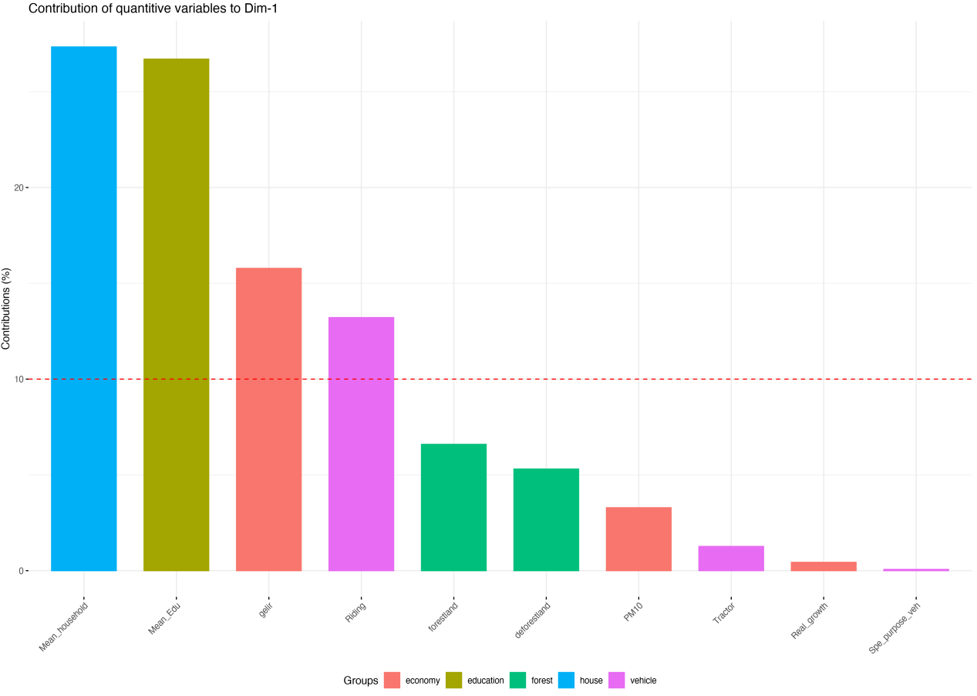

Figure 1. Factors and their contributions on Dimension 1.

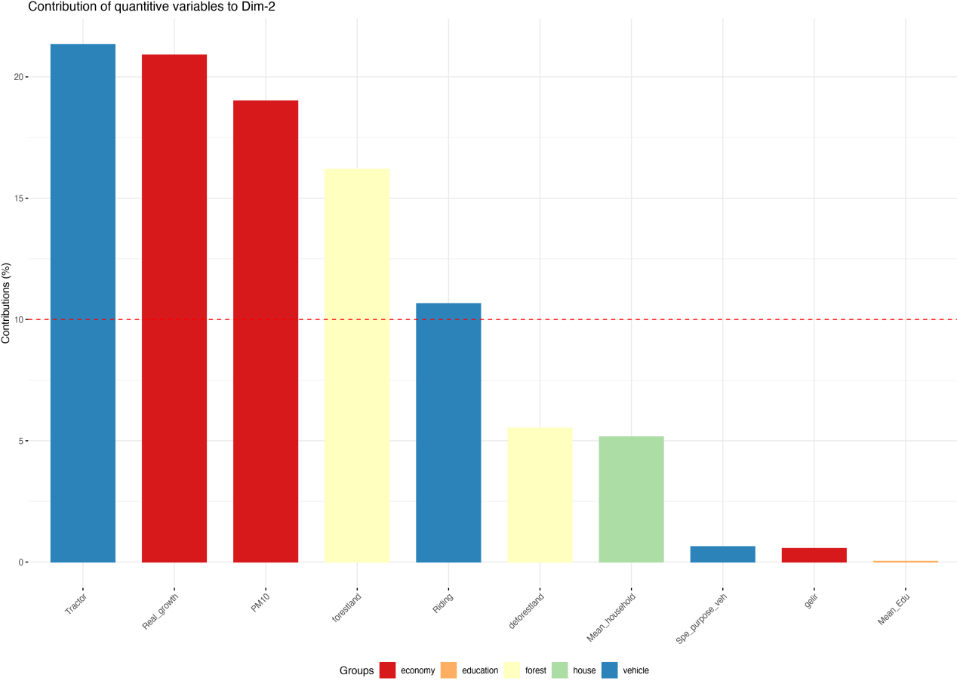

Figure 2. Factors and their contributions on Dimension 2.

Figures 1 and 2 provide factors on dimensions. Figure 3 provides two dimensional analysis.

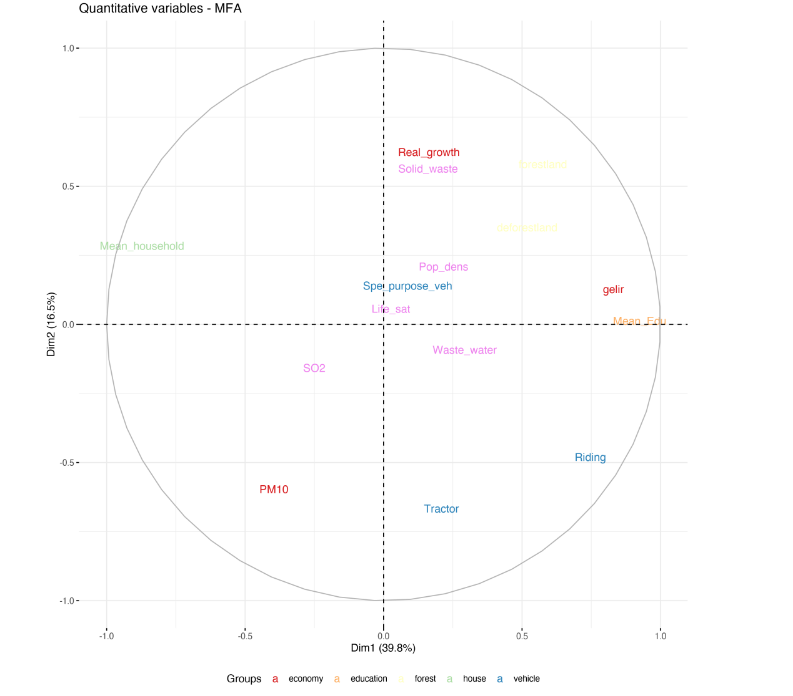

GDP

Figure 3. Two dimensional analysis of factors

When t-test was performed on the data presented in Table 1, the *t*-value is -4.69726. The *p*-value is .000171. The result is significant at *p* < 0.05. Two-way ANOVA also showed that both sexes and countries differ statistically differently in terms of life expectancy. The difference is really significant in Portugal and Turkey.

We concluded that life span of an average Turkish citizen could be explained by three determinants.

Life = 73.41 - 0.00878xSO2 + 0.03167xEducation - 8.30925xTractor (1)

In this formula SO2 is the ambient air sulfur dioxide concentration, education stands for total years in school, and tractor stands for number of tractors in agricultural sector in provinces. If the country can minimize air pollution, life expectancy will increase. If the country can increase education to over 12 years (instead of 6), there will be in increase (0.2 years) in life expectancy.

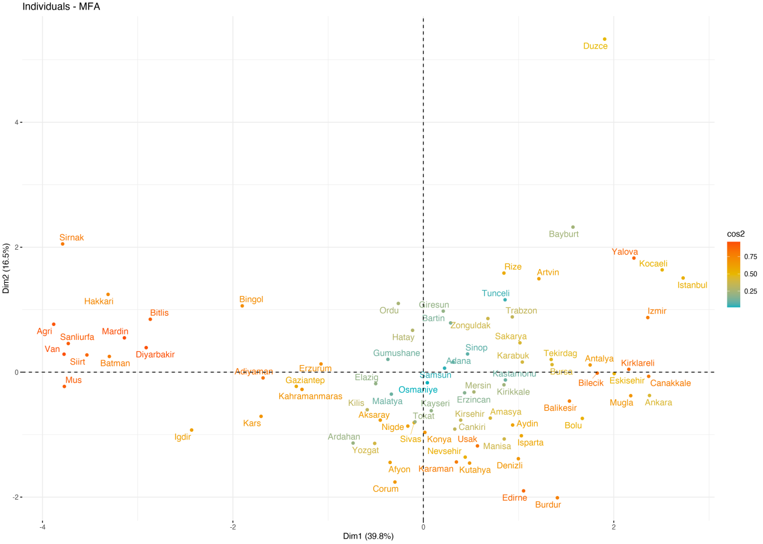

Figure 4. Separation of Turkish provinces according to dimensions

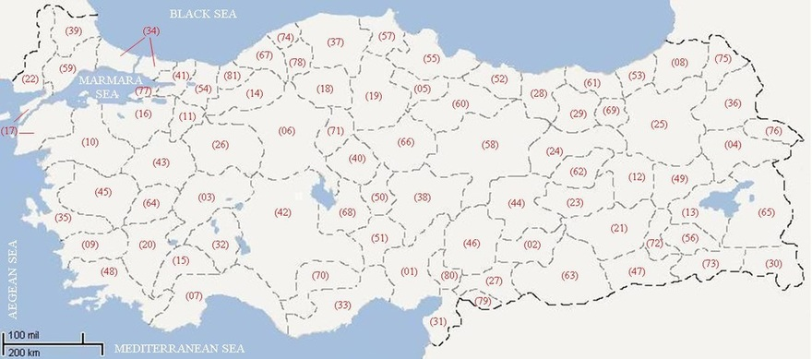

IRAQ

GEORGIA

ARMENIA

SALT LAKE

IRAN

LAKE VAN

SYRIA

GREECE

Figure 5. MFA on provincial map of Turkey (numbers are traffic plate codes) (see Figure 4 for further details).

It is reported that both COPD (5%) and pneumonia (3%) related deaths are higher in Turkey compared to that (3% and 2% respectively) in the European Union (Turkish Health Almanac, 2019). Furthermore, respiratory system related deaths are higher as 13% in Turkey compared to that (8%) in the European Union (Turkish Health Almanac, 2019). Both ambient air pollution and higher smoking rates in Turkey might have caused this result.

Figure 5 shows the difference between Eastern-Southeastern Turkey and Northern Turkey. Green colored provinces showed a higher lifespan. While average SO2 concentration in green colored provinces is 9.52 µg/m3, the average SO2 concentration in Eastern-Southeastern provinces is over 40 µg/m3.

**Conclusion**

One environmental (SO2 in ambient air), one educational (average school years) and one economic factor were found the main predictors on average Turkish lifespan.

**Contribution:**

Ertan Kara has reviewed data and helped writing the manuscript

Burcu Mestav has completed statistical analyses

Hasan Goksel Ozdilek collected data, wrote the manuscript.

**References**

Abo, T., Fukuda, M., Honda, S., Sato, Y., Toma, H., Suzuki, S. (1997). Environmental Factors Affecting the Life Span of Men and Women. Biomedical Research; 18 (4): 265-271.

Auger, N., Fraser W. D., Smargiassi, A., Kosatsky, T. (2015). Ambient Heat and Sudden Infant Death: A Case-Crossover Study Spanning 30 Years in Montreal, Canada. Children’s Health; 123 (7): 712-716.

EUROSTAT (2020). Life Expectancy across EU regions. [www.ec.europe.eu.](http://www.ec.europe.eu.)

Hollander, A. E. M. and Staatsen, B. A. M. (2003). Health, Environment, and Quality of Life: an epidemiological perspective on urban development. Landscape and Urban Planning; 65: 53-62.

Mariani, F., Perez-Barahona, A., Raffin, N. (2010). Life expectancy and the environment. Journal of Life Economic Dynamics and Control; 34: 798-815.

Pope, C.A. 3rd, Ezzati, M., Dockery, D.W. (2009). Fine-particulate air pollution and life expectancy in the United States. New England Journal of Medicine; 360: 376–386.

Turkish Health Almanac (2021). Turkish Health Statistics. Ankara, Turkey.