**Evaluation of the Carbon Sequestration Potential and Some Erodobility Characteristics under Tea Cultivated Soil**

**Orhan DENGİZ1 Sena PACCİ1* Pelin ALABOZ2**

1 Ondokuz Mayıs University, Agricultural Faculty, Plant Nutrition and Soil Science Department, Samsun, Turkey

2 Isparta University of Applied Sciences, Faculty of Agriculture, Department of Soil Science and Plant Nutrition, Isparta, Turkey

*Corresponding author: [pacciis@outlook.com](mailto:pacciis@outlook.com)

**Abstract**

Tea is an important cultural value in many different geographies of the world. As a result of global climate change affecting the world, carbon sequestration has become a remarkable issue. In recent years, the carbon sequestration potential of soils has also been investigated for quality. In this study, the relationships between the carbon sequestration potentials of soils and some erodobility factors were investigated under tea cultivation. The carbon sequestration potential (CSP) of the soils was determined as 27.45-215.05 tons C ha-1. The highest correlation with CSP was determined in the clay ratio. Clay ratio varies between1.760-19.740. Significant negative correlations were determined between CSP and clay rate (r:-0.6; p<0.001), erosion rate (r:-0.23;p<0.05), aggregate stability (r:-0.33; p<0.001) and organic carbon (r:-0.3; p<0.01). No significant relationship was found between C/N, dispersion ratios and CSP of soils. As a result of the study; it has been determined that the soils where tea is cultivated show great variability in organic carbon and carbon sequestration potentials. It has been determined that the carbon sequestration potential is higher in soils with low organic matter content. In addition, it has been determined that soils with high CSP values have high erosion susceptibility.

**Key words:** Soil structure,erosion, carbon sequestration, climate change

**Introduction**

Tea, which is the most consumed foodstuff after water in the world, is grown in about forty countries today and the Turkish tea market is the fifth largest tea market in the world by tonnage (Alikılıç, 2016). Tea cultivation in Turkey is carried out in the Eastern Black Sea Region starting from the border with Georgia to the Fatsa district of Ordu province (Ozyazici et al., 2013). The first province that comes to mind when it comes to tea in Turkey is Rize, which is rainy in all seasons. In regions where tea farming is done; the region receives rainfall in all seasons and the temperatures are not very high, it takes a long time for plant foliage and organic wastes to fall on the soil surface. For this reason, tea cultivated soils are rich in organic matter and organic carbon.

In recent years, rapid oxidation in soil carbon stocks has become a global problem in terms of disrupting the chemistry of the atmosphere. The increase in greenhouse gases, in particular the increase in the amount of CO2 gases; has a direct impact on many factors such as climate, plant physiology, the formation and breakdown of organic matter (Kocyigit, 2008). Soils, which are the largest carbon sinks, can store carbon in their bodies or be a source of carbon increase. In general, carbon stocks in soil consist of organic and inorganic carbon and the largest source of terrestrial carbon is found in soils (Yilmaz and Dengiz, 2021). According to the results obtained from some researches, the amount of organic carbon within a meter soil depth varies between approximately 1500 and 2000 Pg (Anonymous, 2000; Tolunay and Comez, 2008). Unconscious agricultural activities can accelerate the breakdown of carbon in the soil and encourage this situation. For this reason, if excessive tillage is prevented, carbon oxidation can be prevented and carbon can be stored in the soil.

Although carbon is seen as a global problem, it is an important resource that ensures the vitality and sustainability of the soil. The humic substances released when soil organic matter (SOM) is broken down and soil organic carbon (SOC) are food sources that ensure the continuation of microbial activity in the soil. For this reason, increasing the concentration of SOC; maintaining soil quality with increased microbial activity, ensuring food safety and regulating other physical and chemical soil properties (Comaklı, 2021). Maintaining SOC in agricultural fields is of great importance, especially for sustainable agriculture (Jiang et al., 2021). On the other hand, the resulting SOC is an important factor in preventing soil erosion and desertification, which is a global problem, by supporting soil aggregate.

With changes in land use and intensive agricultural practices, soil erosion is observed to increase. It is stated that approximately 25 million tons of soil is lost due to erosion on average every year in the world and that these soils contain about 4% organic carbon. In Turkey, it is emphasized in the same study that approximately 1 billion tons of carbon is removed by erosion (Vurarak and Bilgili, 2015). The effects of base material, slope, maintenance and land use on the loss of soils by erosion have been studied by many researchers (Bradford and Foster, 1996; Fox and Bryan, 2000; Zhao et al., 2015; Islam et al., 2021). In Turkey, tea farming lands with abundant rainfall and a lot of slope are among the areas prone to erosion if tea plants are shaved and the land is left empty and no protective measures are taken.

The aim of this study is to examine the carbon sequestration potential of tea cultivated soils and some erodibility factors. In the study, aggregate stability, dissolution rate, clay rate and erosion rate of soil properties taken from tea cultivated lands; erodibility factors. For this purpose, a small basin of Rize province has been selected as a working area.

**Material and Method**

The study was carried out in Rize, Turkey (longitudes 40o 21ı - 41o 25 ı E, latitudes 40o 33ı - 41o 20ı N). The area of ​​the province is 3920 km2 and the majority is mountainous. The study area covers an area of ​​approximately 1671.8 ha and an altitude of 0 to 862 m above sea level. The southwestern parts of the area have mild to moderate (6-12%) sloping lands. However, most of the southeast and north regions had steeper slopes. Tea cultivation is carried out in a large part of the basin and there are forest and pasture areas in a small number of lands. Black Sea climate prevails in the region. The summers are cool, the winters are mild and it is generally rainy in all seasons. The annual average temperature of Rize is 14.3°C and the annual precipitation is more than 2300 mm. Soil temperature and humidity regimes are Mesic and Perudic (Van Wambeke, 2000).

Disturbed and undisturbed soil samples were taken from 102 sampling points (0-40 cm) from tea cultivated soil. It was analyzed according to the methods outlined in Table 1.

Table 1. Soil analysis methods

|  |  |  |  |
| --- | --- | --- | --- |
| Parameters | Unit | Protocol | Reference |
| Aggregate stability (AS) | % | Wet sieving | Kemper and Rosenau (1986) |
| Dispersion ratio (DR) | % | DR= (a/b)* 100 | Lal and Elliot (1994) |
| Erodibility ratio (ER) | % | ER= (a/b)*(A/c)*100 | Lal and Elliot (1994) |
| Clay ratio (CR) | % | CR=(100-c)/c | Bouyoucos (1935) |
| Clay, Silt and Sand) | % | hydrometer method | Bouyoucos (1951) |
| Organic Carbon (OC) | % | Walkley-Black | Nelson and Sommers (1982) |
| Total N | % | Kjeldahl | Bremner and Mulvaney (1982) |
| Bulk Density | g cm-3 | undisturbed soil sample | Burt, 2014 |

a is the percentage of silt plus clay in suspension, b is the percentage of silt plus clay dispersed with chemical agent, A is the field capacity, c is the percentage of clay dispersed with chemical agent

The carbon sequestration potential of the soils (CSP, t C ha–1) was calculated by Equation 1 (Angers et al. 2011; Cao et al.., 2016).

CSP= Sdef × *γ* × *H* × (1-*d*2-mm/100) × 10–1 (Equation 1)

Sdef, g kg-1 : It is determined as a result of subtracting the organic carbon content from the soil carbon content in the saturation state. The potential saturation carbon content was determined according to Hassink, (1997). γ: bulk density (g cm–3) H: soil depth (cm), d2-mm (%) coarse fraction>2mm.

Descriptive statistics and correlation matrices of soil properties were performed using the R CORE program. The "Methane" package was used to generate the correlation matrices.

**Results and Discussion**

Descriptive statistics of soil properties are given in Table 2. The texture class distributions of the soils determined according to the sand, silt and clay contents are shown in Figure 1. When the distribution in the texture triangle was examined, it was determined that there were coarser textured soil groups. Clay variation coefficient was found to be the highest feature among the textural fractions.

Table 2. Descriptive statistics of soil properties

|  |  |  |  |  |  |  |  |
| --- | --- | --- | --- | --- | --- | --- | --- |
| Variable | Mean | StDev | CV | Min. | Max. | Skewness | Kurtosis |
| Sand % | 64.863 | 8.233 | 12.69 | 41.668 | 79.782 | -0.55 | 0.18 |
| Silt % | 20.413 | 3.434 | 16.82 | 13.22 | 29.167 | 0.37 | 0.03 |
| Clay % | 14.724 | 6.638 | 45.08 | 4.82 | 36.235 | 0.85 | 0.52 |
| Organic Carbon % | 2.871 | 1.369 | 47.67 | 0.266 | 6.532 | 0.54 | -0.2 |
| Bulk Density gr cm-3 | 1.3124 | 0.1395 | 10.63 | 1.02 | 1.58 | -0.17 | -0.92 |
| C/N | 14.31 | 10.82 | 75.61 | 2.58 | 54.3 | 1.6 | 2.18 |
| CSP-tC/ha | 95.53 | 42.73 | 44.73 | 27.45 | 215.05 | 0.46 | -0.13 |
| Clay rate | 7.337 | 3.955 | 53.9 | 1.76 | 19.748 | 0.98 | 0.28 |
| Erodobility rate % | 51.95 | 20.47 | 39.41 | 13.69 | 95.65 | 0.12 | -0.77 |
| Aggregate stability % | 57.52 | 13.64 | 23.71 | 11.08 | 86.06 | -0.68 | 0.76 |
| Dispersion rate % | 34.88 | 14.8 | 42.44 | 5.92 | 86.15 | 0.42 | 0.53 |

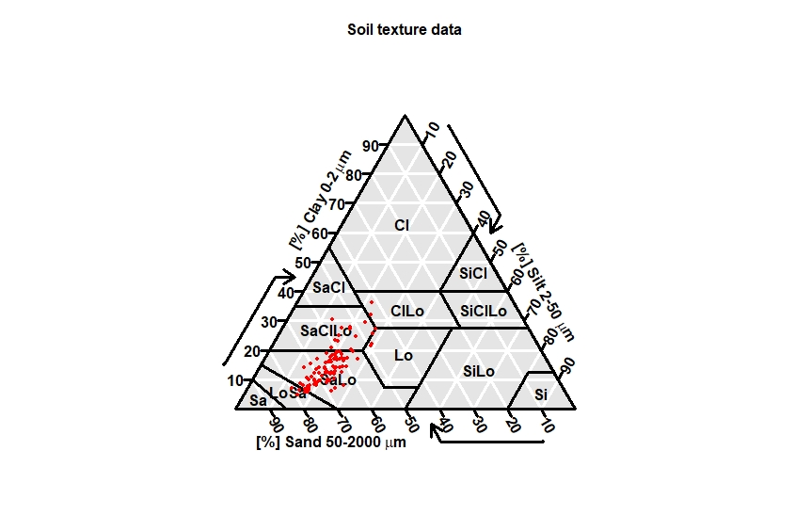

Sa:Sand, Lo:Loamy, Si:Silt, CI:Clay

Figure 1. Texture triangle

The organic carbon contents of the soils varied between 0.266% and 6.532%, and it has a data set that deviates from the average by 47.67%. That is, the variability from the mean was determined at high levels. According to Hazelton and Murphy (2016), the organic carbon contents of soils are classified between “very low and very high” levels.

The bulk density values of the soils were determined as 1.02-1.58 gr cm-3. This feature exhibits the furthest distribution from the normal. The fact that the skewness coefficient is positive in the data set is a result of a right-skewed distribution and the values are generally lower than the mean. The C/N ratio of soils has the highest coefficient of variation among the investigated properties. On average, it was determined as 14.31%. As the C/N ratios of the soils increase, that is, in soils with large C/N ratios, the decomposition and degradation of organic matter is slow. It is higher in soils with narrow C/N ratios. Therefore, knowing the C/N ratios of soils is important for the mineralization of organic matter (Sakin and Sakin, 2014). C:N 10-15 ratio from a soil is normal. Ratios between 15-25 indicate a slowdown in the decomposition process, while numbers above 25 indicate that rapid decomposition is not possible. When the C:N ratio is <20-30, soil organic matter is likely to decompose very quickly. In soils with a high C:N ratio (>20–30), organic matter leads to a decrease in the available nitrogen in the soil (Hoyle 2013). The carbon sequestration potentials of the soils were determined in the range of 27.45-215.05 tons C/ha. The coefficient of variation was found to be 44.75% in the data set, which exhibits a distribution close to normal. Clay rate, erosion rate, aggregate stability and dispersion rate properties, which are considered as erosion susceptibility parameters of soils, varied in the ranges of 1.76-19.748, 13.69-95.65%, 11.08-86.08%, 5.92-86.15%, respectively. The DR value is a parameter used in the evaluation of the change in the soil structure with the effect of precipitation, and they state that the soils are highly eroded as a result of the rate value being less than 15% and the erosion rate being more than 10%, the soils are considered to be resistant to erosion. It has been revealed in the literature that the clay ratio is less than 2 in erosion-resistant soils, and it approaches 10 in unstable soils (Bryan 1968; Lal, 1988). Organic matter in soils binds dispersed silt and clay particles through clay and cation bridges, and the dispersion rate is thus determined at lower levels (Igwe and Agbatah, 2008)

The correlation matrices between the investigated features are shown in Figure 2. DR negative (r:-0.5; p<0.001) AS positive (r:0.54; p<0.001) correlations were determined with the organic C content of the soils. As the organic carbon content increases, the organic carbon sequestration increases, while the organic carbon sequestration potential decreases. A negative statistically significant correlation was found between the carbon sequestration potential of the soils and the clay ratio, AS, ER.

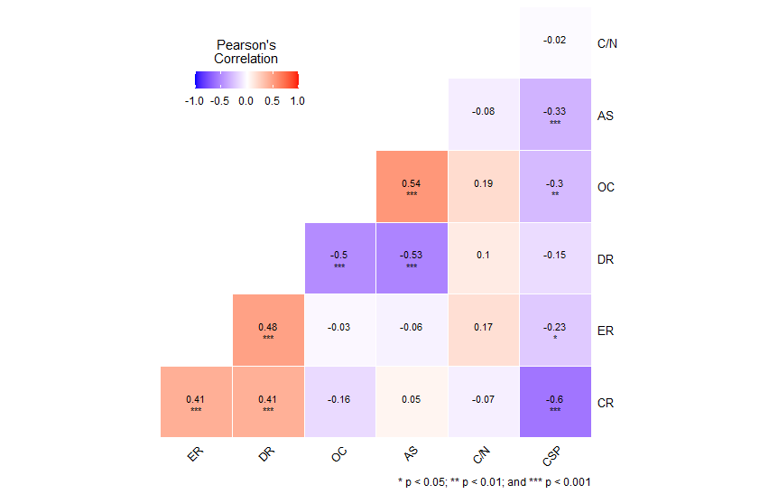

Figure 2. Correlation matrices of soil properties

Hassink (1994) stated that the organic carbon sequestration potential of soils showed a positive correlation with silt + clay content. Linear scatter plots showing the relationships of erosion parameters with CSP are shown in Figure 3. Due to the low aggregation in soils with high sand content and low organic matter content in the study area, organic C sequestration was considered low but with high potential. The increase in the erosion rate of the soils increases the erosiveness. In other words, the effect of aggregation (silt + clay), organic matter or other clumping agents is very low. In this case, it is expected that the organic carbon binding potential will be at low levels. The low clay rate is one of the reasons for the high clay content. Studies have shown that if the clay ratio is high, the carbon sequestration potential is also determined at high levels. It was reported by Islam et al., (2014) that carbon sequestration potentials and percentage of silt+clay were positively correlated with nitrogen and phosphorus. There was no significant relationship between soil dispersion rates and CSP.

|  |
| --- |
|  |
|  |
|  |
|  |

Figure 3. Distribution of erosion parameters with CSP

**Conclusion**

In this study, the relationships between the carbon sequestration potential of soils and some erosion parameters were investigated. As a result of the study, it was revealed that there are negative relationships between erosion susceptibility parameters and organic carbon sequestration potentials. The highest correlation among the investigated properties was obtained with the clay ratio of the soils. It has been evaluated that the organic carbon sequestration potentials will increase with the increase in the clay content of the soils and thus the resistance to erosion will increase. Organic C sequestration potentials showed variability in tea cultivated soils due to differences in organic matter and fine fraction.

While considering the necessity of considering organic matter applications in order to increase the carbon sequestration properties of soils, it is recommended that measures should be taken to reduce the tendency of erosion.

**References**

Abak, M.,Sakin, E. (2018). Ratio C: N of the soils and relationship with some soil properties; case study of Mazıdağı-Mardin. *Harran Journal of Agricultural and Food Science,* 22(2), 255-262.

Alikılıç, D. (2016). Importance of Tea for The Black Sea Region and Historical Duration *Journal of Black Sea Studies*., 11(21), 269-280.

Angers, D. A., Arrouays, D., Saby, N. P. A., Walter, C. (2011). Estimating and mapping the carbon saturation deficit of French agricultural topsoils. *Soil Use and Management*, 27(4), 448-452.

Anonymous, (2000). Landuse, landuse change and forestry. In: R.T. Watson, I.R. Noble, B. Bolin, N.H. Ravindranath, D.J. Verardo and D.J. Dokken, (Eds.). A Special Report of the Intergovernmental Panel on Climate Change, WHO/UNEP. Cambridge University Press, UK, pp. 25-51.

Bradford, J. M., Foster, G. R. (1996). Interrill soil erosion and slope steepness factors. *Soil Science Society of America Journal*, *60*(3), 909-915.

Bryan, R.B. (1968). The development, use and efficiency of indices of soil erodibility, *Geoderma,* 2: 5-26.

Burt R., (2014). Kellogg soil survey laboratory methods manual. Soil Survey Investigations Report No. 42, version 5.0. USDA.

Bremner, J.M., Mulvaney, C.S. (1982). Nitrogen total. In: Page AL, Miller RH, Keeney DR, editors. Methods of Soil Analysis, part II: Chemical and Microbiological Properties. Madison (WI): ASA; p. 595–625.

Bouyoucos, G.J. (1935). The Clay Ratio as a Criterion of Soils to Erosion. *Journal of the Am. Soc. Agron*., 27: 738-751.

Bouyoucos, G.J. (1951). A Recalibration of the Hydrometer Methods for Making Mechanical Analysis of Soils, *Agronomy Journal*, 43: 434-438.

Cao, X. H., Long, H. Y., Leı, Q. L., Jian, L. I. U., Zhang, J. Z., Zhang, W. J., Wu, S. X. (2016). Spatio-temporal variations in organic carbon density and carbon sequestration potential in the topsoil of Hebei Province, China. *Journal of Integrative Agriculture*, *15*(11), 2627-2638.

Comaklı, E. (2021). Bibliometric Analysis of Researches on Soil Organic Carbon and Soil Organic Carbon Stocks from 1970 to 2021. *European Journal of Science and Technology*, (25), 517-524.

Fox, D. M., Bryan, R. B. (2000). The relationship of soil loss by interrill erosion to slope gradient. *Catena*, *38*(3), 211-222.

Hassink, J. (1994). Effects of soil texture and grassland management on soil organic C and N and rates of C and N mineralization. *Soil Biology and Biochemistry*, *26*(9), 1221-1231.

Hazelton, P., Murphy, B., (2016). Interpreting soil test results: What do all the numbers mean. CSIRO publishing.

Hoyle, F. (2013) Managing Soil Organic Matter: A Practical Guide. Grains Research and Development Corporation, Canberra. <http://grdc.com.au/GRDC-Guide-ManagingSoilOrganicMatter>

Islam, K. K., Anusontpornperm, S., Kheoruenromne, I., Thanachit, S. (2014). Relationship between carbon sequestration and physico-chemical properties of soils in salt-affected areas, Northeast Thailand. *Agriculture and Natural Resources*, *48*(4), 560-576.

Islam, M. A., Islam, M. S., Chowdhury, M., Badhon, F. F. (2021). Influence of vetiver grass (Chrysopogon zizanioides) on infiltration and erosion control of hill slopes under simulated extreme rainfall condition in Bangladesh. *Arabian Journal of Geosciences*, 14(2), 1-14.

Igwe, C. A., Agbatah, C. (2008). Clay and silt dispersion in relation to some physicochemical properties of derived savanna soils under two tillage management practices in southeastern Nigeria. *Acta Agriculturae Scandinavica Section B-Soil and Plant Science*, *58*(1), 17-26.

Jiang, Z., Yang, S., Ding, J., Sun, X., Chen, X., Liu, X., Xu, J. (2021). Modeling Climate Change Effects on Rice Yield and Soil Carbon Under Variable Water and Nutrient Management. *Sustainability,* 13(2), 568.

Kemper, W. D., Rosenau, R.C., (1986). Aggregate stability and size distribution. In: Klute A, editor. Methods of soil analysis. Part 1. Physical and mineralogical methods. Madison, WI. p 425-42.

Koçyiğit, R. (2008). Carbon Management and Importance in Terrestrial Ecosystem. *Journal of Agricultural Faculty of Gaziosmanpasa University*, *2008*(1), 81-85.

Lal, R. (1988). Effects of slope length, slope gradient, tillage methods and cropping systems on runoff and soil erosion on a tropical Alfisol: preliminary results. IAHS Publ, 174, 79-88.

Lal, R., Elliot, W., (1994). Erodibility and Erosivity. In R. Lal (Ed.), Soil Erosion Research Methods (2nd ed., pp. 181– 210). Delray Beach: St. Lucie Press.

Nelson, D.W., Sommers, L.E. (1982). Total carbon, organic carbon and organic matter. In: Page, L.A., Miller, R.H., Keeney, D.R. (Eds.), Methods of Soil Analysis, Part 2. Chemical and Microbiological Methods, second ed. American Society of Agronomy, Madison, WI, pp. 539[–579. https://doi.org/10.2136/sssabookser5.3.c34](https://doi.org/10.2136/sssabookser5.3.c34).

Özyazıcı, M. A., Dengiz, O., Aydoğan, M. (2013). Reaction Changing and Distribution of Agricultural Land for Tea Cultivation. *Soil Water Journal*, 2, 1 (23-29).

Tolunay, D., Çömez, A., (2008). Amounts of Organic Carbon Stored in Forest Floor and Soil in Turkey. Air Pollution and Control National Symposium, 22-25 Ekim, Hatay, s. 750-765. (In Turkish).

Van Wambeke, A.R., (2000). The newhall simulation model for estimating soil moisture and temperature regimes. Department of Crop and Soil Sciences. Cornell University, Ithaca, NY. USA.

Vurarak, Y., Bilgili, M. (2015). Agricultural mechanization, erosion and carbon emission: A review. *Anadolu Journal of Agricultural Sciences*, *30*(3), 307-316.

Yılmaz, M., Dengiz, O. (2021). The Effect of Land Use and Land Cover on Soil Organic Carbon Stock in Relation to Some Soil Properties. *Turkish Journal of Agricultural Research, 8*(2), 154-167.

Zhao, Q., Li, D., Zhuo, M., Guo, T., Liao, Y., Xie, Z. (2015). Effects of rainfall intensity and slope gradient on erosion characteristics of the red soil slope. *Stochastic Environmental Research and Risk Assessment*, *29*(2), 609-621.