Antibiotic Removal from Wastewater by Adsorption
Mohammed Thabit Shihab SHİHAB ^{1,}∗ , Bengi ÖZKAHRAMAN ² , Zehra ÖZBAŞ¹
¹ Institute of Natural Sciences, Faculty of Engineering, Department of Chemical Engineering, Çankırı Karatekin University, Çankırı, Türkiye
² Institute of Graduate Education, Faculty of Engineering, Department of Polymer Materials Engineering, Hitit University, Çorum, Türkiye
Abstract
Antibiotics, are chemicals that reduce or inhibit the proliferation and growth of microorganisms, and are useful in the treatment of human infectious diseases, the livestock industry, and aquaculture. After administration, antibiotics are only partially metabolized in the body, while the remaining antibiotics are excreted. The sewage treatment plants of municipal systems and pharmaceutical businesses are not efficient enough to remove these antimicrobials [1, 2]. Among the existing processes for the treatment of antibiotic-containing wastewater, the adsorption process is accepted as an effective and efficient method [3]. In the present study, epichlorhydrin cross-linked chitosan particles were kept in carboxymethyl cellulose solution before cross-linked with citric acid. Ampicillin (AMP) adsorption studies were carried out with the obtained particles. The physical and morphological characterization of the prepared adsorbent before and after adsorption was revealed by FTIR (Fourier-transform infrared), BET (Brunner-Emmett-Teller surface area) and SEM/EDX (Scanning electron microscopy-energy dispersive X-ray) analyses. The recommended contact time under application conditions is determined as 28 hours. Kinetic studies have shown that the process is more compatible with the pseudo-second-order kinetic model. According to the experimental data obtained, it was determined that the equilibrium adsorption obeyed the Langmuir isotherm. These results demonstrate the feasibility of the process and the application potential of the chitosan- carboxymethyl cellulose adsorbent in the treatment of AMP-containing waters such as hospital wastewater and pharmaceutical industrial wastewater.
Keywords: Antibiotics, Adsorption, Ampicillin, Chitosan, Carboxymethyl cellulose

- Introduction
Antibiotics are chemotherapeutic agents that are widely used in the treatment of diseases in animals and humans, as well as in the field of food to increase the growth rates of animals [1]. Due to their chemical structure, antibiotics are resistant to many chemicals, oxidizing agents and heat, and they are not biodegradable. Therefore, once released into the aquatic environment, antibiotics are difficult to remove from wastewater [1, 2]. There are many methods for removing contaminants from water. The most important of these methods are reverse osmosis, ion exchange, precipitation and adsorption [1, 3].
In the study, crosslinked chitosan particles were kept in carboxymethyl cellulose solution and then re-crosslinked with citric acid to be used in ampicillin adsorption. Characterization of these prepared particles was carried out by FTIR, BET and SEM/EDX analyses, and ampicillin adsorption kinetics and isotherms were examined.

- Materials and Methods
Materials Used in Adsorbent Synthesis: CS (chitosan), CH₃COOH (acetic acid), NaOH (sodium hydroxide), EPC (epichlorohydrin), CMC (carboxymethyl cellulose), CA (citric acid), AMP (ampicillin), and HCl (hydrogen chloride) used in this study were Sigma-Aldrich products. Distilled water was used in the purification process while preparing the adsorbent.
Polymeric Adsorbent Preparation Method: After 1 g of CS was dissolved in 30 mL of 5% (v/v) CH₃COOH at 40°C, it was dropped into 0.5 M NaOH solution with a syringe and the formation of instant gelled particles was observed. The resulting CS particles were left in NaOH solution for 24 hours and then washed with distilled water. The obtained CS particles were kept in 0.01 M EPC solution at 60°C for 3 hours for cross-linking to occur. At the end of the period, the particles were washed with distilled water until the solution became neutral. Separately, 1 g of CMC was dissolved in 50 mL of water at 50°C. Then, the CS particles washed with water were kept in the prepared CMC solution for 24 hours for complex formation. At the end of the period, 0.2 g CA was added to the solution containing CS particles and mixed for 2 hours at 80°C for cross-linking. The final product obtained, the adsorbent, was named CS-CMC. Removal experiments of AMP with CS-CMC from solutions by adsorption were carried out in a batch system. The maximum absorbance wavelength of AMP (260 nm) was determined with a UV–vis spectrometer and all the absorbance measurements were made with a UV–vis spectrometer (Shimadzu UV-1800).

- Results and Discussion
  - Characterization Studies
Figure 1(a) shows the FTIR spectrum of the complex particle formed by crosslinked CS with crosslinked CMC. In the spectrum, except for the peaks belonging to the crosslinked CS, the peak at 1723 cm⁻¹ was attributed to the carbonyl band of the free carboxylic acid groups and the carbonyl groups of the ester structure formed during the crosslinking process. Figure 1(b) shows the FTIR spectrum of AMP adsorbed CS-CMC adsorbent. In the spectrum, apart from the characteristic peaks observed in the spectrum of the CS-CMC adsorbent, there were peaks belonging to AMP, but these peaks were not obvious because they interfered with each other.
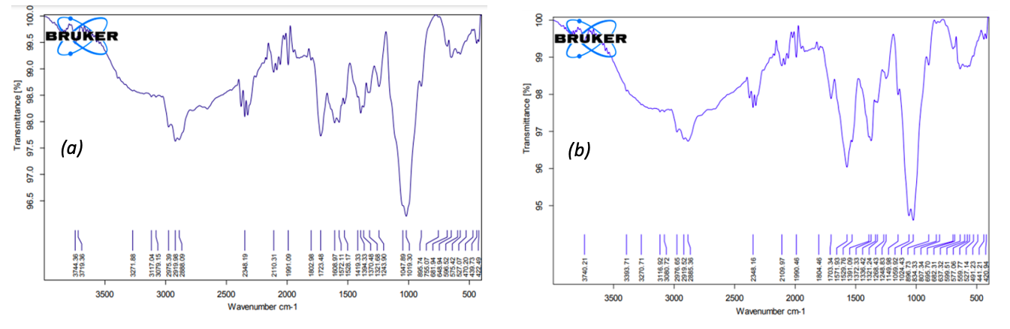
Figure 1. FTIR spectra of CS-CMC before (a) and after (b) adsorption.

According to the results of BET analysis, the specific surface area of the complex adsorbent CS-CMC was 7.30 m²/g before adsorption and 22.72 m²/g after adsorption. SEM images of the prepared CS-CMC adsorbent before and after adsorption were presented in Figure 2 (a) and (b) and Figure 3 (a) and (b). When the images were evaluated, it was determined that the CS-CMC sample before adsorption had a non-porous, slightly rough surface morphology, while the surface layer thickened after adsorption. EDX analysis results of the samples before and after adsorption were presented in Figure 2 (c) and Figure 3 (c). According to the analysis, % weight values before adsorption: 42.95 % carbon, 6.97 % nitrogen and 50.08 % oxygen, while the % weight values after adsorption changed to 47.70 % carbon, 6.41 % nitrogen, 41.76 % oxygen and 4.13 % sulfur due to the sulfur in the structure of adsorbed AMP.
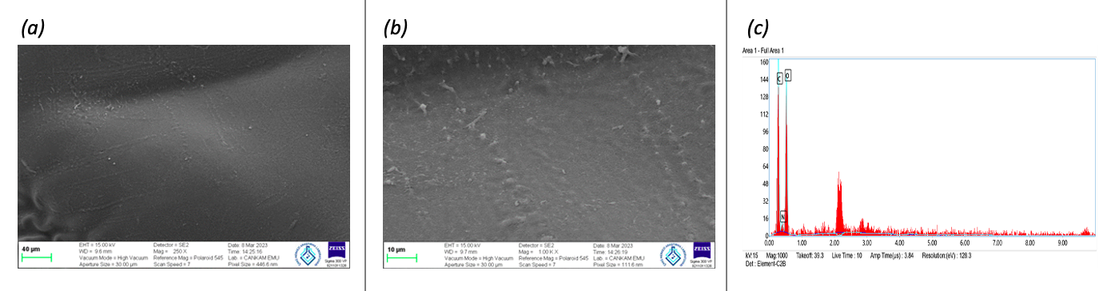
Figure 2. SEM/EDX analysis of CS-CMC before adsorption.

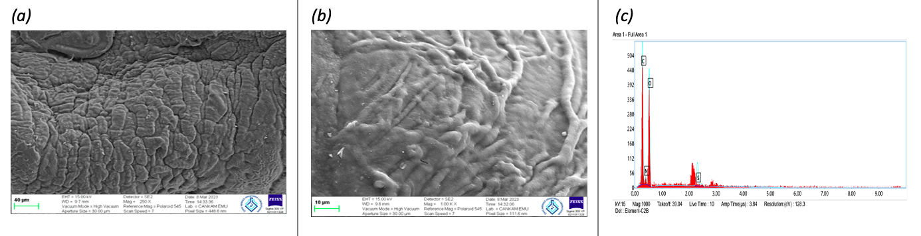
Figure 3. SEM/EDX analysis of CS-CMC after adsorption.

  - Adsorption Studies
To study the adsorption kinetics, approximately 10 mg of CS-CMC adsorbent was kept at 25°C in a 250 ppm solution with a pH of 7 until equilibrium was reached. According to the result obtained, the process did not show any capacity increase after the 28th hour and reached equilibrium, and the adsorption capacity at this hour was found to be 231.41 mg/g. The kinetic parameters were presented in Table 1.

Table 1. The linear equations, plots and the calculated values for pseudo-first-order and pseudo-second-order kinetic models.
Kinetic models | Linear equations* | Plots | Calculated parameters
Pseudo-first-order [4] | $\ln\left(q_{e}-q_{t}\right)=\ln{q_{e}}-k_{1}t$ | In(q_{e}-q_{t}) vs t | k₁= 0.1313 h⁻¹  q_{e}= 153.88 mg.g⁻¹  r²= 0.9514
Pseudo-second-order [4] | $t/{q_{t}}=1/{k_{2}q_{e}^{2}}+t/{q_{e}}$ | t/q_{t} vs t | k₂= 1.24×10⁻³ g.mg⁻¹.h⁻¹  q_{e}= 256.41 mg.g⁻¹  r²= 0.9966
*q_{t}: adsorbent capacity at time t, q_{e}: adsorbent capacity at equilibrium, k_{1,2}: rate constants

In order to study the adsorption isotherm, experimental studies were carried out for AMP adsorption at 25°C in solutions with initial solution concentrations of 50, 100, 150, 200 and 250 ppm, using pH 7 and approximately 10 mg CS-CMC adsorbent. According to the result, q_{e} values increased with increasing initial solution concentration. The calculated isotherm parameters were presented in Table 2.

Table 2. The linear equations, the plots and the calculated parameters for Langmuir and Freundlich isotherms.
Models | Equations and plots* | Calculated parameters
Langmuir [4] | ${C_{e}}/{q_{e}}=1/{b.q_{max}}+{C_{e}}/{q_{max}}$  Plot: C_{e}/q_{e} vs C_{e} | b (L.mg⁻¹)  q_{max} (mg.g⁻¹)  R_{L}  r² | 0.0063  416.67  0.387  0.9977
Freundlich [4] | $\ln{q_{e}}=\ln{K_{F}}+1/n\ln{C_{e}}$  Plot: In q_{e} vs In C_{e} | K_{F} ((mg.g⁻¹).(L.mg⁻¹)^{1/n})  1/n  r² | 9.83  0.5981  0.9769
*b: Langmuir constant, q_{max}: monolayer capacity of the adsorbent, K_{F}: Freundlich constant, n: Freundlich exponent

- Conclusion

In the study, AMP adsorption was carried out with complex adsorbent particles prepared with cross-linked CS and CMC from aqueous solutions. The physical and morphological characterization of the prepared adsorbent before and after adsorption was revealed by FTIR, BET and SEM/EDX analyses. The recommended contact time under application conditions was determined as 28 hours. According to the results, the process was more compatible with the pseudo-second-order kinetic model, and it was determined that the equilibrium adsorption obeyed the Langmuir isotherm. These results demonstrate the feasibility of the process and the application potential of the CS-CMC adsorbent in the treatment of AMP-containing waters such as hospital wastewater and pharmaceutical industrial wastewater.

References

- Balarak, D., Khatibi, A. D., & Chandrika, K. 2020. Antibiotics Removal from Aqueous Solution and Pharmaceutical Wastewater by Adsorption Process: A Review. International Journal of Pharmaceutical Investigation, 10(2), 106-111.
- Dutta, J., & Mala, A. A. 2020. Removal of antibiotic from the water environment by the adsorption technologies: A review. Water Science and Technology, 82(3), 401-426.
- Homem, V., & Santos, L. 2011. Degradation and removal methods of antibiotics from aqueous matrices–a review. Journal of Environmental Management, 92(10), 2304-2347.
- Özkahraman, B. & Özbaş, Z. 2020. Removal of Al(III) ions using gellan gum-acrylic acid double network hydrogel. Journal of Polymers and the Environment, 28, 689-698.

* Corresponding author. e-mail address:zehraozbas@karatekin.edu.tr

