Study of the load factor on the efficiency of an HV/MV transformer". Case of the UNILU substation.

**CHANSA WA CHANSA SEAN Serge**

**ABSTRACT**

The load factor is a ratio that exists between the electrical energy actually produced by a transformer over a given period and the energy it would have produced over a given period if it had operated at its nominal power during the same period. In principle, it is a time-dependent quantity, which follows the respective transformer power consumption depending on the transformer load. According to our analyzes on a UNILU post transformer, the load factor is average over the duration of the analysis, we calculated over a week (see the curve). And this average is calculated over the operating time (the moments of energy interruptions are not taken into account). Thus as a result obtained, depending on the load of each week,

KEY WORDS: Factor, Charge, Yield, Transformer

# INTRODUCTION

The transformer is a device in which the phenomena of electromagnetic induction are used without the intervention of a movement to transmit the power supplied to one of the windings, called the primary winding, to another winding called the secondary winding.

The transformation of a current system into several other alternating systems, of generally different voltage and intensities but of identical frequency.

The transformer being a capital element in the transport and distribution of electrical energy, we were interested in the load coefficient and its efficiency by entitling our subject: impact of the load factor on the efficiency of a HV / MV transformer case of the UNILU station.

To help operators better understand how efficiency varies with load factor, load factor is a function of load current and voltage.

At the end of our work, we will become an essential reference in the field of load factor on the efficiency of a transformer, because we have carried out our research on and abundant in the concerns of being able to achieve good results in order to achieve our pursued goals.

Our work is focused on the influence of load factor on the efficiency of a transformation which could be useful to the national electricity company and other sector using power transformations in order to know the load factor at each hour. load and to make a decision at any time whether to increase a load in order to operate the transformer at its maximum efficiency.

Having noted that the lack of load available in this station to better distribute power to subscribers according to their needs at the load is not stable, even also the performance of the transformer will experience a decline following this load instability ; while a transformer's mission is to lower or raise a voltage under the conditions of always having a good efficiency, while watching over the load factor. Given this observed difficulty, we are assigned the mission to ask ourselves a few questions in order to elucidate this nebulous situation:

* How to calculate the coefficient of loads per hour on a transformer?
* What is the variation of the load coefficient according to the yield?
* For how long the transformation reached its maximum yield during a day

For our work, we will use three methods, in this case the hermeneutic one which consists in analyzing, interpreting and giving the fruits of our research and this method will be useful to us in a first chapter, the second is the functionalist one consisting in observing the functioning of the transformer in the electrical energy transformer station and will be used in the second chapter and the third and last method is the experimental method which consists in observing and selecting the data necessary for our work, and the latter will be tested in the third chapter. And as a technique that we have taken is that of participant observation which consisted in transforming us into an agent of the SNEL during our internship period.

Our research was carried out in the commune of kampemba, precisely in an electrical energy transformation station called the UNILU station. Our investigation was spread over the period of this year 2022 from March to APRIL.

The specificity in this study is to plot the curves showing during different load hours of each day the variation of the load factor in relation to the efficiency of a power transformer. Our work is in the field of electrical energy transmission research.

**II: PRESENTATION FROM UNILU POST**

## Introduction

This chapter is devoted to the presentation of the environment which is the subject of our work and we will begin by presenting the SNEL of Lubumbashi, then the presentation of the substation, the HV/MV distribution of the city of Lubumbashi, the installed power, the diagram substation power supply, substation operation, busbar configuration, current peak, so we will drop by the conclusion of the chapter.

**II.2. Presentation de la SNEL/ Katanga**

### II .2.2. Objectifs de la FAST

Following the commissioning of this State establishment, the latter therefore had to ensure the production, transport and distribution of electrical energy at the lowest cost, like regideso and six other commercial companies. private companies existing and for following the same corporate purpose; then ensure direct control of strategic resources for the country's economic and social development.

#### II.2.3. Legal status

SNEL as predicted, is a public law establishment of an industrial and commercial nature, created by Ordinance No. 73/033 of May 16, 1970.

Indeed, anxious to meet the energy needs of the country, the public powers, by presidential ordinance n°67-391 of September 23, 1967, instituted the committee of technical and financial control for the works of Inga which committee will be replaced in 1970 by SNEL.

However, this public electricity service is entrusted to SNEL, set up in the form of a State company, and governed by the framework law on public companies and Ordinance No. 78/196 of May 5, 1978 approving its statutes, under the technical futility of the energy ministry and the administrative and financial futility being handled by the portfolio ministry.

### II.2.4. Location and geographical situation

The national electricity company "SNEL" in acronym is located west of the city of Kinshasa, capital of the DRC, in the commune of Gombe, on the avenue de la justice n ° 3281 at the crossroads of the avenues justices and Batetela, right in the administrative center. Indeed, it is one of the largest public companies in Central Africa where its services are located throughout the national territory, in order to better and better play its role as the backbone of the Congolese economy.

The UNILU substation was built in 1973 and put into service in 1974 with the aim of supplying the various cabins of the university halls of residence, the Kassapa prison, the Kassapa pumping station, the Gambela district and the pumping relay station of Kassapa. It is powered by the old Gécamines RS splitter through a 5OkV line.

(FAST ; 2021).

#### II.3.1. Geographical locations

The UNILU substation is located northeast of the city of Lubumbashi on the extension of boulevard M°siri going towards LUANO airport, 100m from the TEXACO bus stop.

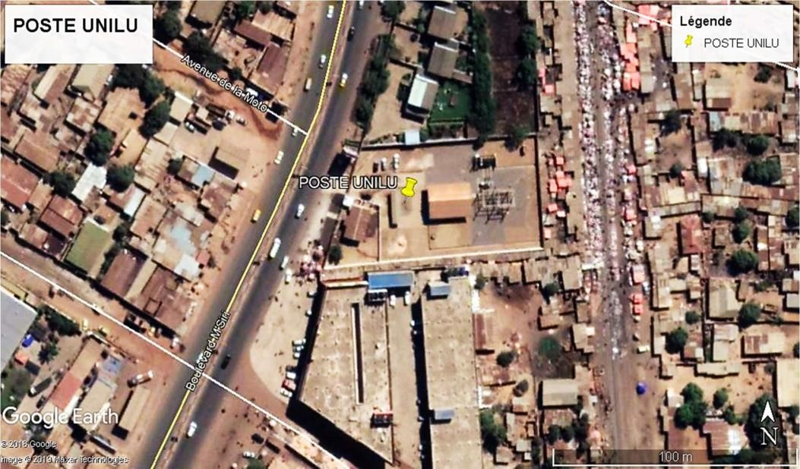

***Figure 1 Geographical location of the UNILU post (Google Earth, 2021)***

#### II.4. Post description

The UNILU substation is powered by the old Gécamines RS distributor at 50kV as shown in Figure 2.2 by a 20km overhead line. It supplies different cabins with 15kV HTB in the Gambela district, the university residences, the Kassapa relay station, the Kassapa pumping station, the Kassapa prison and the Moise district. (BCC SNEL, 2021) as shown in the following figure:

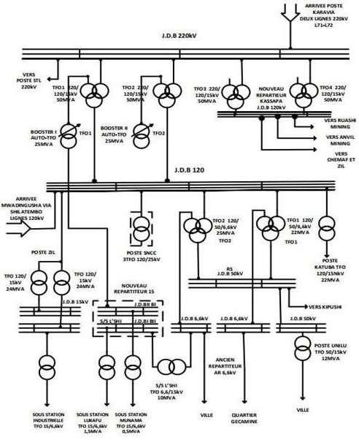

### Figure 2 Distribution HT/MT de la ville de Lubumbashi (FAST, 2021)

The city of Lubumbashi is supplied by 4 HV lines, 3 of which come from SCK at 220kV and one comes from Mwadingusha at 120kV. The 220kV voltage arrives on the 220kV busbars of the KARAVIA substation. This supplies 220kV to the NR15 Kasapa station, the RS station and the STL station. Then it lowers the voltage to 120kV and 15kV. In 120V it supplies the DCS station and the NR15 station and in 15kV it supplies some cabins.

* The NR15 Kasapa substation steps down to 120V and supplies the companies RUASHI MINING, CHEMAF, MMG and the ZIL substation.
* The ZIL substation transforms the voltage from 120kV to 15kV and supplies the industrial substation and some cabins.
* The DCS substation transforms the 120kV voltage into 25kV to supply the catenary line.
* The RS substation supplies 120 kV to the Katuba substation on the line that goes to Kipushi and lowers the voltage from 120kV to 50kV which goes to Kipushi and to the UNILU substation, and to 6.6kV which supplies the Lubumbashi substation and some cabins in the center -city and the Gécamines district.
* The KATUBA substation transforms the voltage from 120kV to 15kV to supply certain cabins.
* The NR15 substation transforms the 120kV voltage into 15kV to supply the LUKAFU and MUNAMA substations and supplies other cabins with 15kV.

The second voltage of 120kV from Mwadingusha supplies the RS substation busbars.

#### II.5. Installed power of the substation

It was started with a 12.5MVA transformer with characteristics indicated in table II.1.

Table II.1: Characteristics of the substation power transformer (SNEL, 2021).

|  |  |
| --- | --- |
| Nominal power | 10-12,5 MVA |
| Transformer cooling | ONAN-ONOFF |
| Year of manufacture | 1973 CEI |
| Winding coupling | Dy11 |
| Ucc | 8.6-8.13-7.72% |
| Insulation class | 72.5/24 |
| phase name | 3 |
| Primary and secondary voltage | 50 kV/15 Kv |

The transformer is protected on the primary and secondary side by circuit breakers using oil to extinguish the arc and is controlled by the Argus type relay and voltage and current reducers whose characteristics are described in table 3 Table 1 characteristics of the circuit breaker

|  |  |
| --- | --- |
| HV circuit breakers |  |
| Tensions nominal | 75.5 KV |
| Permissible overdensity | 15 KA |
| breaking capacity | 1500 MVA |
| Closing power | 37.5 KA max |
| Impulse voltages | 325 kV peak |
| Nominal current | 1250 A |

#### II.6. Operation of the UNILU HT / MT post

The transformer is supplied by a voltage of 50 kV said primary side is said secondary side by a voltage of 15 KV; as well as a current of 150 A called primary rating as well as 450 A at the secondary (so we can say that it is a lower voltage transformer with current booster) the power of the transformer is 10 to 12.5 MVA. They also have an auxiliary power transformer of 75 MW allowing to carry out the various works on the station as well as to overload the batteries, so that the battery injects direct current to the circuit breaker; it should be noted that each feeder is protected by its own circuit breaker powered by direct current 110 DC (SNEL 2021)

##### II.6.1. Supply Mode

The UNILU substation has a single transformer shown in Figure 0.4 and is powered by a single 50kV line from the RS substation. The disadvantage of having only one line as shown in the first chapter is that the network will not be much more reliable because on the line there can be a breakdown and this will put out of tension all the network of the station. As shown in the following figure:

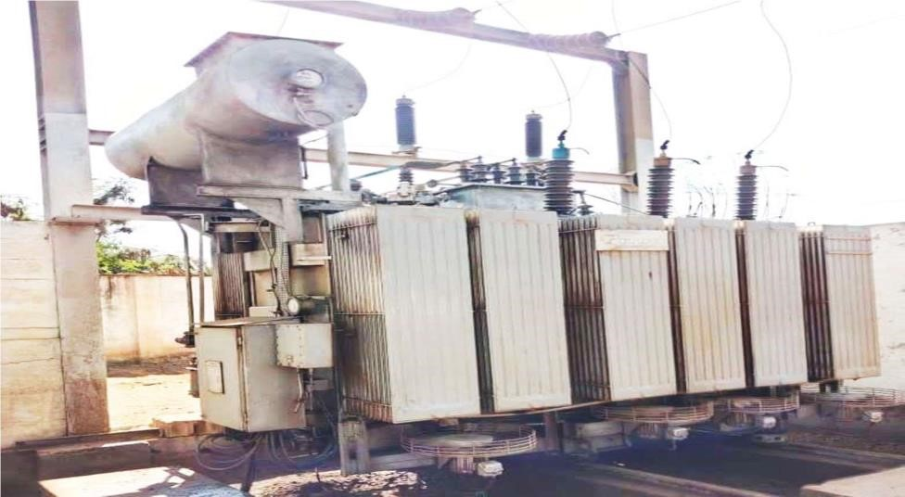

### Figure 3 Unilu substation power transformer

#### II.9.2. Protective equipment in the post

The equipment that allows us to protect UNILU substation electrical installations are:

* And TI
* And TP
* The disconnector
* The lightning arrester
* circuit breakers
* The protection relay

##### II.6.2.1. Lightning arresters and lightning conductors

The surge arrester protects the internal equipment of an electrical substation such as the

transformers, conductors and other HV equipment against overvoltages of internal origin (switching) or of external origin (lightning). Its principle is to level the shock wave by causing the overcurrent to flow to ground and to limit the overvoltage on the network. The location of surge arresters in the electrical network plays an important role in the coordination of insulation. They are preferably positioned at the terminals of the transformers, and at the arrival of the high voltage lines. The lightning conductor, on the other hand, protects the entire structure of the substation against lightning.

##### II.6.2.2. the disconnector

Disconnectors are devices intended to open or close an off-load electrical circuit, have no breaking capacity, they only allow a circuit to be opened in the absence of any current, The main function of a high voltage disconnector is to be able to separate an element of an electrical network (high voltage line, transformer, portion of electrical substation, etc.) in order to allow an operator to carry out a maintenance operation on this element without risk of electric shock.

##### II.6.2.3. circuit breakers

A circuit breaker is intended to make, carry and break currents under its rated voltage. It allows the opening and closing of circuits in normal operation and the interruption of the fault current that may occur in the network. It consists of an interrupting chamber and a mechanical spring or motorized control. The energy stored in the actuator spring is released on command to separate the contacts. The arc between the contacts is extinguished by spraying oil under pressure or by SF6 gas.

##### II.6.2.4. The protective relay

It is a device receiving information or electrical quantities from voltage or current converters and is intended to control cut-off, signaling or automation devices. The technologies used in relays have evolved from electromechanical technology to static technology (analog electronics) and then digital technology.

#### II.7. Current peak

It should be noted that since the establishment of the UNILU substation until today, the power has increased following the demand for electrical energy which is increasing each year.

##### II.7.1. Feeder UNILU et METALEC

The UNILU feeder has been reinforced by the METALEC feeder in order to reinforce the power of the cabins in the Gambela district, university residences and the Moise district. They are therefore coupled in parallel in the substation on the 15kV busbar. The table below shows the cabins they supply.

### Table 2. Cabin powered by UNILU AND METALEC feeders (SNEL 2021)

|  |  |  |  |
| --- | --- | --- | --- |
| Applied Science |  | Comedy | 500 kVA |
| Moulin d’or | 250 Kva | Unilu homes | 30 kVA |
| Mulilla | 500 Kva | Unilu household | 75 kVA |
| Unilu restaurant | 3400 Kva | Unilu is celibate | 50 kVA |
| Ecole Kassapa | 315 Kva | laundry room | 500 kVA |
| Prison Kassapa | 400 kVA | Bonne do you think | 500 kVA |
| Camp police | 250 kVA | Fraternity | 315 kVA |
| Kassapa pumping | 1000 kVA | Isthmus | 250 kVA |
| Mel's | 630 kVA | Chaplaincy 1 | 630 kVA |
| olive trees | 450 kVA | Chaplaincy 2 | 400 kVA |
| In the past | 500 kVA | Kasangulu | 400 kVA |
| Pluena | 500 kVA | Magistrate Alain | 100 KVA |

#### *(all its data comes from the SNEL of Lubumbashi according to their consumption per cabin. kVA: kilovolt ampere)*

#### *II.7.2. Feeder SECRET*

The MSIRI feeder feeds some cabins all around Boulevard Msiri to the vicinity of Carrefour. Table 5 shows the different cabins it supplies. Table 3 cabin powered by M'SIRI feeders (SNEL 2021)

|  |  |  |  |
| --- | --- | --- | --- |
| Prestige | 750 kVA | Inpp service | 250 KVA |
| Inpp | 250 kVA | Solar power | 160 Kva |
| Didier is a song | 160 kVA | Gambela | 1000 kVA |
| Luvlungi | 250 kVA | Manoah | 400 kVA |
| Redjaf | 250 Kva | Transmisions | 500 kVA |

#### II.7.3. Feeder GUEST HOUSE

The Guest House feeders feed some cabins all around the Guest House.

Table II.5. Cabin powered by Guest House feeders (SNEL 2021).

|  |  |  |  |
| --- | --- | --- | --- |
| G home | 630 ̷ 400 kVA | Try 2 | 630 kVA |
| Transmissions | 500 kVA | Regideso Relay | 630 kVA |
| Killed 1 | 500 kVA | Magistrate Jimmy | 100 kVA |

#### II.8. CONCLUSION

In this point we have given an idea of ​​the entire constitution of the UNILU substation without forgetting the history of SNEL, the observation made is that the power of the MV network that this substation supplies has practically doubled which leads to the load shedding of the cabins and very often to untimely cuts of the main circuit breaker of the power transformer and that the configuration of the busbars and mode of supply are not at all favourable, the solution of which will be provided in the following chapter.

#### III: STUDY OF THE VARIATIONS OF LOAD COEFFICIENTS ACCORDING TO YIELD

##### III.2. Calculation of maximum yield and load coefficient

We have a maximum load coefficient, when the iron losses are equal to the joule losses

Po = k 𝐶ℎ2max × Pcc (6)

k𝑐ℎ2max =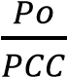(7)

kch max =(8)

√

𝑃𝑜

𝑃𝑐𝑐

To find the maximum yields we must first calculate the average yields of the week morning, noon and evening

###### III.2.1. The morning performance

Monday ɳ 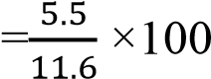= 41, 4%

Tuesday ɳ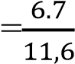× 100 = 57. 7%

Mecredi ɳ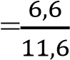× 100 = 56.8%

Thursday ɳ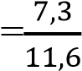× 100 = 62.9%

Friday ɳ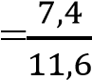 × 1OO = 63,7%

Saturday ɳ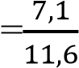× 100 = 61.2%

Sunday ɳ 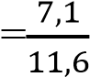1OO =61, 2%

###### III.2.2. The midday performance

Monday ɳ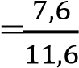 × 1OO = 65, 5%

Tuesday ɳ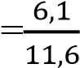 × 1OO = 52, 5%

Mecredi ɳ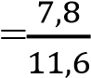 × 1OO = 68, 1%

Thursday ɳ 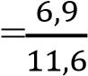1OO = 59, 4%

Friday ɳ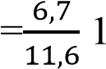OO = 57.7%

Saturday ɳ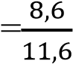 × 1OO = 74, 1%

Sunday ɳ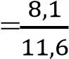× 1OO = 69, 8

###### III.2.3. evening performance

Monday ɳ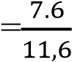× 1OO = 65, 5%

Tuesday ɳ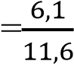× 1OO = 52, 5%

Mecredi ɳ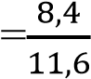 × 1OO = 72, 4%

Thursday ɳ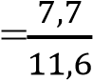 × 1OO = 66, 3%

Friday ɳ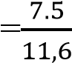 × 1OO = 64, 6%

Saturday ɳ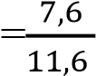 × 1OO =65,5%

Sunday ɳ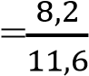 × 1OO =70,6%

##### III.3. The maximum yield

To determine the maximum efficiency of each peak hour (morning, noon and evening) we will take the maximum secondary power, that means we will take in each peak the high secondary power value divided by the primary power (see the UNILU cabin table and METALEC).

* morning

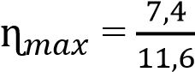 × 1OO = 63,79%

* midi

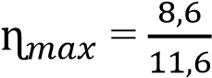× 100 = 74.13%

* evening

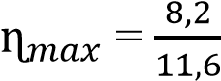 × 1OO = 70 ; 69%

##### III.3. The average maximum yield of the week

To find the oldest ɳ max for the week, we add the three yields morning, noon and evening, divide by 3.

ɳ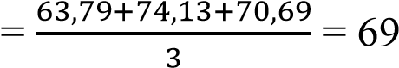,50%

**III.4. Variations in the weekly load factor as a function of performance**

## PictureIII. 1: Morning peak reading tables (08:00)

|  |  |  |  |  |  |  |  |  |  |
| --- | --- | --- | --- | --- | --- | --- | --- | --- | --- |
| Day | IN | I | S | Pnon | Kch | Pcc | P2 | P1 | ɳ |
| Monday | 15kV | 234A | 3,5kVA | 12.5MW | 3.1 | 8.92 | 5,5MW | 11,6MW | 47.4% |
| tuesday | 15kV | 290A | 4.3kVA | 12.5MW | 3.2 | 8.92 | 6,7MW | 11,6MW | 57.7% |
| mecred | 15kV | 285A | 4.2 kVA | 12.5MW | 2.9 | 8.92 | 6,6MW | 11,6MW | 56.8% |
| Thursday | 15kV | 315A | 4.7kVA | 12.5MW | 2.9 | 8.92 | 7, 3MW | 11,6MW | 62.9% |
| Friday | 15kV | 329A | 4.9kVA | 12.5MW | 3.2 | 8.92 | 7,4MW | 11,6MW | 63.7% |
| Saturday | 15kV | 302A | 4,5kVA | 12.5MW | 2.9 | 8.92 | 7.1MW | 11,6MW | 61.2% |
| sunday | 15kV | 306A | 4,5kVA | 12.5MW | 2.9 | 8.92 | 7.1MW | 11,6MW | 61.2% |

(all its values ​​were taken in the morning at 8:00 a.m. from SNEL in the UNILU station during the operation of the transformer)

0

234

290

285

315

329

302

306

0

50

one hundred

150

200

250

300

350

400

450

0

one

2

3

4

5

6

7

CURRENT IN (A)

DAYS FROM MONDAY TO SUNDAY

CURVE OF CURRENT VARIATION IN

FUNCTION OF DAYS (MORNING)

We see a strong current inrush on Friday (the number 5 represents Friday on this curve) and a weak current on Monday and this curve follows the shape of the variation of the current each day according to the load that the transformer supports.

### Table 4 Noon peak reading tables (12:00 p.m.)

|  |  |  |  |  |  |  |  |  |  |
| --- | --- | --- | --- | --- | --- | --- | --- | --- | --- |
| day | IN | I | S | Pnon | Kch | Pcc | P2 | P1 | ɳ |
| Monday | 15kV | 327A | 4.9kVA | 12.5MW | 3.1 | 8.92 | 7,6MW | 11,6MW | 65.5% |
| tuesday | 15kV | 262A | 3.9kVA | 12.5MW | 3.2 | 8.92 | 6.1MW | 11,6MW | 52.5% |
| Wednesday | 15kV | 335A | 5kVA | 12.5MW | 2.9 | 8.92 | 7,8MW | 11,6MW | 67.2% |
| Thursday | 15kV | 295A | 4.4kVA | 12.5MW | 2.9 | 8.92 | 6,9MW | 11,6MW | 59.4% |
| Friday | 15kV | 286A | 4.2 kVA | 12.5MW | 3.2 | 8.92 | 6,7MW | 11,6MW | 57.7% |
| Saturday | 15kV | 370A | 5,5kVA | 12.5MW | 2.9 | 8.92 | 8,6MW | 11,6MW | 74.1% |
| sunday | 15kV | 347A | 5.2 kVA | 12.5MW | 2.9 | 8.92 | 8.1MW | 11,6MW | 69.9% |

U : the voltage in volts

I: the current in ampere

S: the apparent power in kilovolt amperes

Pnom: rated power in megawatts

Kch: load factor

ɳ: yield in percentage

0

327

262

335

295

286

370

347

0

50

one hundred

150

200

250

300

350

400

450

0

one

2

3

4

5

6

7

CURRENT IN (A)

DAYS FROM MONDAY TO SUNDAY

CURVE OF CURRENT VARIATION IN

DAY FUNCTION (MIDI)

We see a strong current inrush on Saturday (6 represents Saturday on this curve) and a weak current inrush on Tuesday (2 represents Tuesday on this curve).

### Table 5 Evening peak reading tables (6:00 p.m.)

|  |  |  |  |  |  |  |  |  |  |
| --- | --- | --- | --- | --- | --- | --- | --- | --- | --- |
| day | IN | I | S | Pnon | Kch | Pcc | P2 | P1 | ɳ |
| Monday | 15kV | 325A | 4,8kVA | 12.5MW | 3.1 | 8.92 | 7,6MW | 11,6MW | 65.5% |
| tuesday | 15kV | 263A | 3.9kVA | 12.5MW | 3.2 | 8.92 | 6.1MW | 11,6MW | 52.5% |
| Wednesday | 15kV | 358A | 5.3kVA | 12.5MW | 2.9 | 8.92 | 8,4MW | 11,6MW | 72.4% |
| Thursday | 15kV | 330A | 4.9kVA | 12.5MW | 2.9 | 8.92 | 7,7MW | 11,6MW | 66.3% |
| Friday | 15kV | 320A | 4,8kVA | 12.5MW | 3.1 | 8.92 | 7.5MW | 11,6MW | 64.6% |
| Saturday | 15kV | 327A | 4.9kVA | 12.5MW | 2.9 | 8.92 | 7,6MW | 11,6MW | 65.5% |
| sunday | 15kV | 349A | 5.2 kVA | 12.5MW | 2.9 | 8.92 | 8,2MW | 11,6MW | 70.6% |

0

325

263

358

330

320

327

349

0

50

one hundred

150

200

250

300

350

400

450

0

one

2

3

4

5

6

7

CURRENT IN (A)

DAYS FROM MONDAY TO SUNDAY

CURVE OF CURRENT VARIATION IN

DAY FUNCTION (EVENING)

We see a strong inrush current on Wednesday (the number 3 represents Wednesday on this curve) and a weak current on Tuesday (the number 2 represents Tuesday on this curve)

#### III.5. The different calculations

##### III.5.1. max power of the week

Monday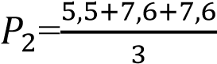 = 6, 9 MW

Tuesday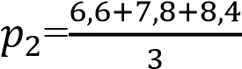 = 6, 3 MW

mecredi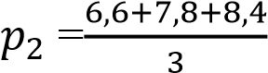 = 7, 6 MW

Thursday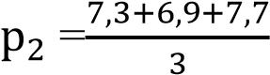 = 7, 3 MW

Friday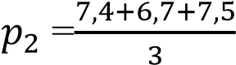 = 7,2 MW

Saturday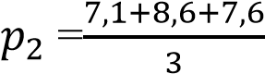 = 7,7 MW

Sunday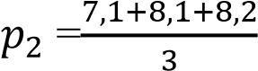 = 7,8 MW

##### III.5.2. The maximum yield of the week

Monday ɳ 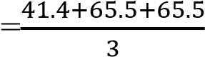= 57.4 %

Tuesday ɳ 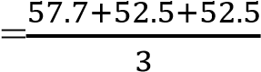= 54.2%

Mecredi ɳ 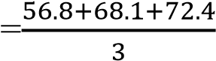= 65.7%

Thursday ɳ 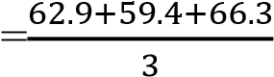= 62.8%

Friday ɳ 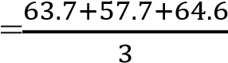= 62% Saturday ɳ 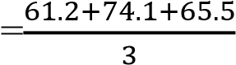= 66.9%

Sunday ɳ 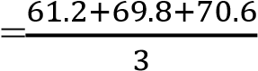= 67.2 %

#### III.5.3. The maximum current of the week

Monday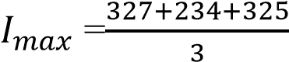 = 295A

Tuesday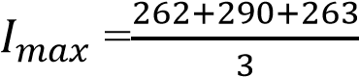 = 271A

mecredi 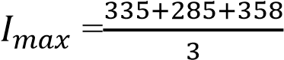= 326A

Thursday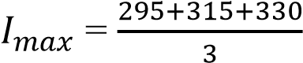 = 313A

Friday 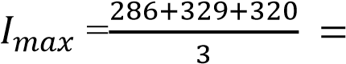307A Saturday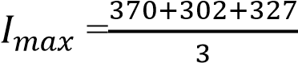 = 333A dimanche 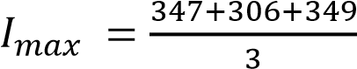= 334A

### Table 6 Table of peak survey sets (morning, noon and evening)

|  |  |  |  |  |  |  |  |  |  |
| --- | --- | --- | --- | --- | --- | --- | --- | --- | --- |
| Day | IN | I | S | Pnon | Kch | Pcc | P2 | P1 | ɳ |
| Monday | 15kV | 295A | 4.4kVA | 12.5MW | 3.1 | 8.92 | 6,9MW | 11,6MW | 59.4% |
| tuesday | 15kV | 271A | 4kVA | 12.5MW | 3.2 | 8.92 | 6,3MW | 11,6MW | 54.3% |
| Wednesday | 15kV | 326A | 4,8kVA | 12.5MW | 2.9 | 8.92 | 7,6MW | 11,6MW | 65.5% |
| Thursday | 15kV | 313A | 4.6kVA | 12.5MW | 2.9 | 8.92 | 7,3MW | 11,6MW | 62.9% |
| Friday | 15kV | 307A | 4.6kVA | 12.5MW | 3.1 | 8.92 | 7,2MW | 11,6MW | 62% |
| Saturday | 15kV | 333A | 4.9kVA | 12.5MW | 2.9 | 8.92 | 7,7MW | 11,6MW | 66.3% |
| sunday | 15kV | 334A | 5kVA | 12.5MW | 2.9 | 8.02 | 7,8MW | 11,6MW | 67.2% |

0

295

271

326

313

307

333

334

0

50

one hundred

150

200

250

300

350

400

450

0

one

2

3

4

5

6

7

CURRENT IN (A)

DAYS FROM MONDAY TO SUNDAY

CURVE OF CURRENT VARIATION IN

FUNCTION OF DAYS

We see a strong current draw on Sunday (the number 7 represents Sunday on this curve) and a weak current draw on Tuesday

#### III.6. determining the joule loss value

PJ = 𝑅2× I (9)

##### III.6.1. resistance value calculation

Monday R =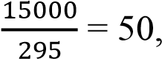 8O

Mardi R =15000= 55.3 Ω

Mecredi R =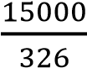 = 46O

Thursday R =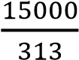 = 47.9 Ω

Friday R =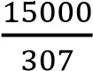 = 48.8 Ω

Saturday R =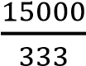 = 45 Ω

Sunday R =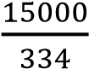 = 44.9 Ω

##### III.6.2. calculation of joule loss value Monday Pj =(58.8)2 × 295 = 761.2 W

Mardi PJ = (55,3)2 x 271 = 828,7W

Mecredi PJ = (46)2 × 326 =689,8W

Thursday PJ = (47.9)2 × 313 =704.3 W

Friday PJ = (48.8)2 × 307 = 731.1 W

Saturday PJ = (45)2 × 333 =674.3W

Sunday PJ = (44.9)2 × 334 =673.3W

III.6.3.calculation of load coefficient values

Monday Kch max =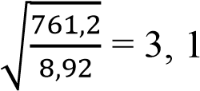

Mardi Kch max =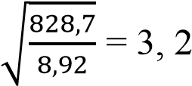

Wednesday Kch max =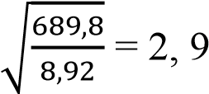

Thursday Kch max =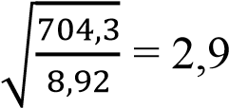

Friday Kch max =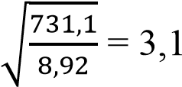

Samedi Kch max =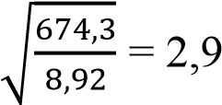

Sunday Kch max =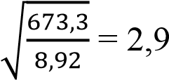

**III.7. Efficiency study taking into account the different load coefficients**

### Table 7 Calculation table of different load coefficient and efficiency

|  |  |  |  |  |  |  |  |
| --- | --- | --- | --- | --- | --- | --- | --- |
| S | Kch | so | pcc | Kch pcc | P2 | P1 | ɳ |
| 4.4kVA | 3.1 | 0.8 | 8.92 | 27.6 | 6,9MW | 11.6MW | 59.4% |
| 4,1kVA | 3.2 | 0.8 | 8.92 | 28.5 | 6,3MW | 11.6MW | 54.3% |
| 4,8kVA | 2.9 | 0.8 | 8.92 | 25.8 | 7,6MW | 11.6MW | 65.5% |
| 4.6kVA | 2.9 | 0.8 | 8 92 | 25.8 | 7,3MW | 11.6MW | 62.9% |
| 4.6kVA | 3.1 | 0.8 | 8.92 | 27.6 | 7,2MW | 11.6MW | 62% |
| 4.9kVA | 2.9 | 0.8 | 8.92 | 25.8 | 7,7MW | 11.6MW | 66.3% |
| 5kVA | 2.9 | 0.8 | 8.92 | 25.8 | 7,8MW | 11.6MW | 67.2% |

#### III.7.1. Curve of the Joule loss variation as a function of Load coefficient

We note that the load coefficients vary with the joule losses, this by the fact that the joule losses depend on the load current so the more the load coefficient increases the more the transformer heats up and becomes more and more dangerous.

**HISTOGRAM OF VARIATION OF COEFFICIENT OF**

**LOAD ACCORDING TO JOULE POWER**



0

,

5

one

one

5

,

2

5

,

2

3

3

,

5

**Kch**

Column 1

0

761.2 828.7 689.8 704.3 731.1 674.3 673.3

**Pj(w)**

#### III.7.2. Load coefficient curve as a function of efficiency

The maximum yields are reached on Monday, Tuesday, and Friday, this indicates a good exploitation of the transformer during these days compared to the others.

## HISTOGRAM OF LOAD COEFFICIENT VARIATIONS AS A FUNCTION OF PERFORMANCE



4

,

59

54.3

65.5

62

9

,

0

,

62

66

,

3

67.2

0

5

,

0

one

one

,

5

2

5

2

,

3

3

,

5

**ὴ(℅)**

**Kch**

Column 1

Monday

Merc

Thursday

Vendr

Saturday

Dim

Tuesday

We find that the more the load coefficient no longer increases and the efficiency decreases.

So when it increases to what point max after it decreases despite the increase in the load factor. So the efficiency of the transformer becomes zero when the maximum efficiency is exceeded.

**GENERAL CONCLUSION**

The transformers are entirely static electric machines, this absence of movement is elsewhere at the origin of their excellent efficiency as we have seen in this work or beyond 95%, their use is essential for the transport of electrical energy or it is preferred to carry volts rather than amps.

They raise the voltage between the source (alternators supplying 20,000V) and the transmission network (120 kV and 220 kV in the DRC), then they allow the lowering of the voltage from the network to the user.

Here we are at the end of our investigation, the subject of which was: impact of the load coefficient on the efficiency of a power transformer (case of the UNILU substation).

In the third point, we started with the voltage readings, currents for 6 days in the specifications of the station, the measurements were taken every hour at the (secondary) output of the 125/15Kv transformer. Knowing the nominal power, this allowed us to calculate the load coefficient per day (morning, noon and evening). The relation between the load coefficient and the tables showing per day the variation of the yield according to the load coefficient.

Finally, we found that:

1. the variation of the load coefficient as a function of time (per day): we have observed a fluctuation of the load coefficient, this is due to the fact that at each hour the values ​​of the currents and the voltage vary according to the load ( increase, or decrease in load);
2. it was also found that almost every day, one could reach the max coefficient 0.66 and the max efficiency 95.35 percent. This demonstrates good use of this transformer in operation.
3. There was also a report of the readings saying in no case of an overload was observed (a coefficient exceeding 1)
4. The joule losses vary with the load coefficient, in overload the transformer heats up and gives poor performance.

We must avoid overloading and underloading the transformer finally not to have a bad performance, it should be used at its maximum load coefficient and at its maximum performance to optimize operation.

**BIBLIOGRAPHIC REFERENCES**

[1]Claude chevasu, 2012, Machines electrical, pp3-35

1. Saoussi Youssef, 2014, transformer installations, pp 10-24.
2. Gean-clette, 1985, Electrical Machines 6th industrial technique pp52-63
3. Guy cheteigna , Michel boes Daniel Bnik , 2006, Manual of electrical engineering Dunod Paris pp557-559.
4. M. Kostenko and L. putrovskiv, 1979. Volume I. 3rd editions Ma moscou pp478-480

[6]Henry Ney, 1988, electrical engineering and standardization.

1. Preve C and Jeannot R, 1997, Guide to the installation of industrial electrical networks, Schneider Grenoble group pp522-909.
2. Jacob Henry, 2008, the different types of electrical conduits, electricity technology course, university of liège.
3. Schneider Electric, Determination of conductor sections Industrial electrical network design guide pp206-264.

[10]Turpain J. Noel D and Rochet M, 1998, electrical energy system reference guide, Schneider Electric group and Alstom, Grenoble.