A SUSTAINABLE INNOVATIVE CONGKAK BOARD

Agnes Pau*1, Ung Ean Na2 & Yap Tek Hong3

1 Department of Design and Visual Communication, Politeknik Tuanku Syed Sirajuddin,

Pauh Putra, 02600 Arau, Perlis, Malaysia.

2 Department of Hospitality and Tourism, Politeknik Tuanku Syed Sirajuddin,

Pauh Putra, 02600 Arau, Perlis, Malaysia.

3 Department of Mechanical Engineering, Politeknik Tuanku Syed Sirajuddin,

Pauh Putra, 02600 Arau, Perlis, Malaysia.

* Corresponding Author Email: agnes@ptss.edu.my

# ABSTRACT:

Congkak has been a popular pastime in Malaysia for many years. Sadly, it has lost its popularity among young people who spend a lot of time on gaming, especially mobile gaming. Mobile gaming addiction is becoming a public concern. As a result, there is a need to redesign traditional Congkak to attract the younger generation to appreciate and play Congkak before it goes extinct. The traditional Congkak board is heavy and relatively large, resulting in transportation inefficiency. Conversely, other widely available plastic Congkak boards are relatively light and small but lack collection value. This project presents a Congkak board that has ownership value, which not only preserves its traditional values but is also light, portable, and environmentally friendly for both domestic and foreign tourists. Bamboo is employed as an alternative raw material in this project since it is widely available in tropical countries. The advantages of using bamboo in today’s products have been ignored and bamboo is one of Malaysia’s abundant natural resources. Compared to wood, bamboo is a flexible and weather-resistant material. Bamboo also grows quicker than trees; thus, it can aid in sustaining the environment. The innovative design of Congkak is made up of 4 pieces: 2 bamboo halves that can be joined together by a fastening cap (“rumah”) on either end, which also functions as a chamber for storing tokens (“buah Congkak”). An added advantage of this Congkak board is the ease of manufacture, whereby small and medium-sized businesses (SMEs) can easily mass produce this design without the need for sophisticated and expensive technology.

**KEYWORDS:** *Congkak; Board game; Sustainability.*

# INTRODUCTION

Congkak, also known as Jongkak (Hellier, 1907) or Chongkak (Tan, 2010), is a traditional board game played by Malaysians, especially among Malays, Indians, and Baba-Nyonyas (Azlida Jamil, 2020). This two-player strategy game has many versions around the world; they are called Warri or Awari in the Caribbean, Congklak in Indonesia, Sungka in the Philippines (Azlida Jamil, 2020), and Mancala in most other parts of the world (Arjun & Shekher, 2014; Tan, 2010). However, Congkak has gradually lost its popularity in the current world, particularly among younger generations as a result of technological advancements (Noraziah ChePa et al., 2014; Siti Hajar Maizan, 2018).

In the current technological era, smartphone ownership has grown rapidly around the world, especially among younger generations (Pew Research Center, 2023); and at the same time, the functionalities of smartphones continue to improve and excel (Tecno Mobile, 2020). In addition, the latest mobile networks with high downloading and streaming speeds also provide online games a better and faster gaming experience (Li et al., 2022). All these factors have contributed to the rise of mobile gaming. As a result, digital games are now surpassing physical traditional games (Noraziah ChePa et al., 2014). Online gaming can be fun but there are a few negative effects on some gamers when they are addicted. Amongst them are poor academic performance (Li et al., 2022; Shiers, 2021); interpersonal relationship issues (Müezzin, 2015; Shiers, 2021); as well as mental and physical health problems (Shiers, 2021). Some studies also found that online games with antisocial content (violence) have led to aggressive emotions and destructive behaviour among gamers (Li et al., 2022; Shiers, 2021).

Besides the threat of digital games, the other reasons are the size and weight of traditional Congkak boards, which make them difficult to transport (as illustrated in Figure 1). Most of the traditional Congkak boards are too heavy to be carried around, especially for young children (Siti Hajar Maizan, 2018). Traditional Congkak boards are made from solid wood and many of them have rich and elegant carvings, especially during old times. These collectible boards are hardly available in shops nowadays.

**Figure 1**  
*A Circa 1960 Traditional Borneo Congkak Board*

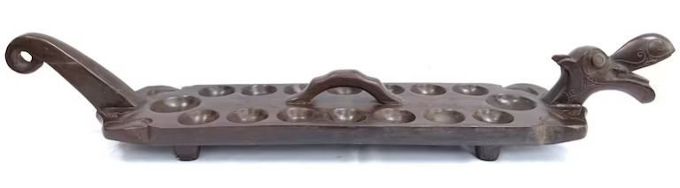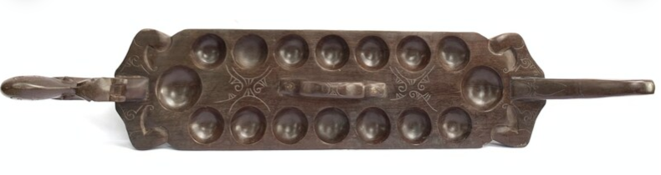

*Note.* This ancient, traditional Congkak board, which measures 124 cm in length and weighs 7.2 kg, was crafted from Borneo Ironwood and decorated with dragon features.

In order to address these issues, modern physical Congkak boards are designed to be lighter than the traditional ones, for ease of carrying and storage. These boards are commonly made from plastic and some boards are decorated or coloured with eye-catching, appealing hues (Siti Hajar Maizan, 2018). Although they are smaller and lighter, they serve no collectible value because the traditional aesthetic values are absent. Examples of these modern boards are shown in Figure 2 and Figure 3.

**Figure 2**  
*A Modern Plastic Congkak Board*

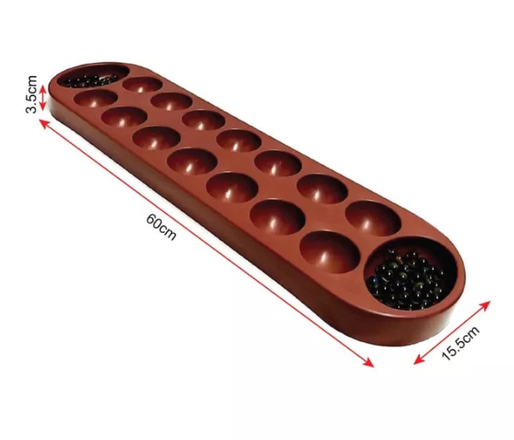

*Note.* This plastic Congkak board comes with a measurement of 15.5 cm x 60.7 cm x 3.5 cm.

**Figure 3**  
*A 16-hole Edition* *SPM* ® *Congkak (SMP-109)*

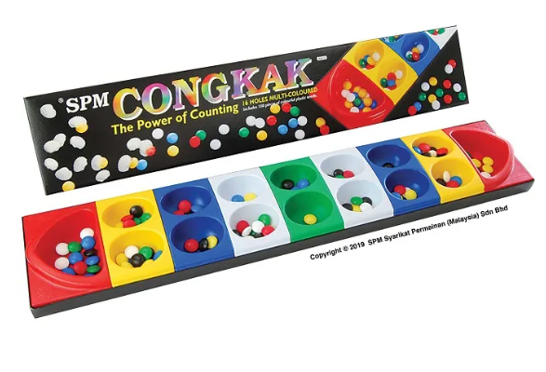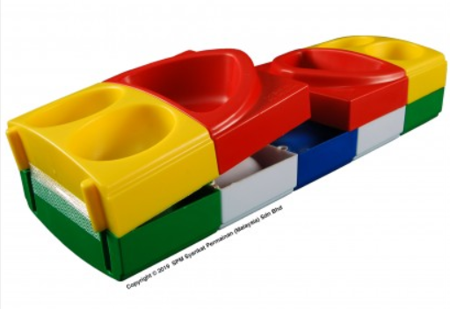

*Note.* With dimensions of 14 cm x 71.5 cm x 4.25 cm, this contemporary plastic Congkak board can be folded (with dimensions of 14 cm x 39.5 cm x 8.5 cm) for easier storage and portability. From *Congkak - 16 Holes Multi Colour (SPM-109)* [Photograph], by *SPM Games,* n.d., https://spmgames.com.my/spm109

In order to preserve and promote the Congkak game, a few researchers had digitised the game (Noraziah ChePa et al., 2014). However, the outcome was not impressive. The electronic Congkak is yet to be popular among online gamers. Nur Azzah Abu Bakar and Noraziah ChePa (2016) suggest that the usability of the electronic Congkak needs to be improved to encourage greater user game engagement. Meanwhile in Amir Faqihuddin Hafizan et al. (2018) studies, their version of electronic Congkak is an electronic based board game that looks nothing like the traditional Congkak. They also amended the rules of the traditional Congkak game. They claim that their version of Congkak was more preferred than the traditional ones by their participants, but no reasons were given. Besides, the number of their participants, which is 30 primary 2 students, is too small to conclude the findings.

Although there are many different versions of the modern Congkak board design, no product has yet been developed that can meet the proposed specifications, which are sustainability, lightweight, portability, and collectability. Therefore, the aim of this study is to develop a Congkak board that not only meets the specified specifications but is also easy to produce.

**BAMBOO AS AN ALTERNATIVE MATERIAL**

Based on desk research of current available contemporary Congkak boards, almost all are made from either wood or plastic. A more sustainable material, such as bamboo can be an alternative material for Congkak. At the time this paper was written, there were no commercial Congkak boards made from bamboo. Bamboo grows quickly even in areas where it is difficult for other crops to grow, making it a sustainable and environmentally friendly material (Chaowana, 2013; de Ruijter-Luken, n.d.; Poppens, van Dam, & Elbersen, 2013; Schröder, 2022).

**Figure 4**  
*Bamboo Culm and Cross-section of a Bamboo Culm*

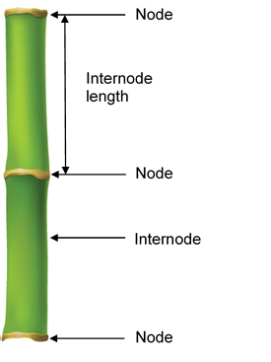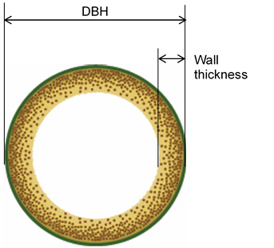

*Note.* The illustration on the left is a bamboo culm and the one on the right is a cross-section of the internode of a bamboo culm. The following bamboo terminologies are stated by Durai and Trinh, 2019, p.2: a bamboo culm or stem is an individual bamboo pole; a bamboo internode is the portion of bamboo

between two nodes; and a bamboo node is a join of two internodes.

As recommended by Guadua Bamboo (n.d.) and de Ruijter-Luken (n.d.), everything is possible with bamboo if it can be made from wood; therefore, it is highly likely that Congkak boards can be made from bamboo too. In comparison to wood, bamboo has several benefits. Amongst those advantages are:

1. bamboo continues to grow after its stem has been harvested; while a tree died after being harvested (de Ruijter-Luken, n.d.);
2. bamboo can grow rapidly and mature in a shorter amount of time (Azmy Hj. Mohamed & Appanah, 1999; de Ruijter-Luken, n.d.) and some species can grow faster than 1 meter per day (Poppens, van Dam, & Elbersen, 2013);
3. bamboo is hardy and it grows well even on less fertile lands (de Ruijter-Luken, n.d.; Poppens, van Dam, & Elbersen, 2013); and
4. bamboo stems are hollow, so they are lighter (Ruijter-Luken, n.d.).

Bamboo belongs to the grasses (*Poaceae*) family (Azmy Hj. Mohamed & Appanah, 1999; Chaowana, 2013; de Ruijter-Luken, n.d.; Poppens, van Dam, & Elbersen, 2013). The number of species of bamboo in the world is approximately 1600 (de Ruijter-Luken, n.d.). There were approximately 70 species in Malaysia in 1999 (Azmy Hj. Mohamed & Appanah, 1999); however, there is no current information on the number of species that exist today in Malaysia. Most bamboo species in Malaysia grow naturally in the forests and are also grown by locals in rural areas. Varied species of bamboo have different culm characteristics, including variations in height, internode length, diameter at breast height (DBH), and wall thickness (Azmy Hj. Mohamed & Appanah, 1999). Untreated bamboo has a lifespan of less than 2 years, but some species can last 4–7 years if they are stored under cover (Schröder, 2021). Schröder (2021) also states that there are a few factors that affect the durability of harvested bamboo; these include the species, the length of the culm, the thickness of the wall, as well as the time of harvesting. Consequently, it is important to research the characteristics of each bamboo species before making it a replacement material.

**Figure 5**  
*The Potential Usages of Bamboo in Sarawak*

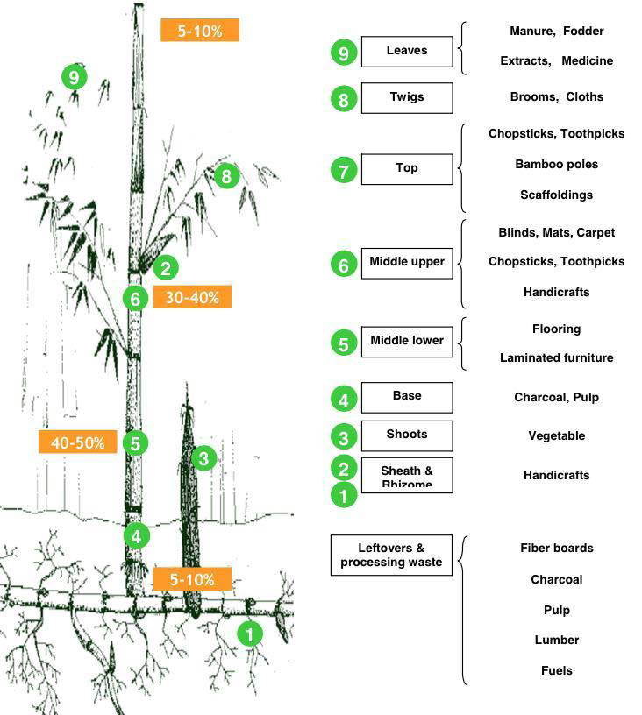

*Note.* The figure illustrates the potential products from bamboo. Reprinted from *Feasibility study on bamboo plantations and opportunities for its utilisation in Sarawak, Malaysia, 2016* (p. 31), by Subramony, T., Li, J., Muralidharan, E., & Parekh, B., 2016, International Bamboo and Rattan Organisation (INBAR) and Sarawak Timber Industry Development Corporation (STIDC). Retrieved from <https://www.inbar.int/wp-content/uploads/2020/05/1499156135.pdf>

Since this study is limited to the physical use of bamboo and does not encompass bamboo as food and fuel, the findings related to food and fuel as a product will not be discussed in this paper. Bamboo is widely used in Malaysia. There are many products in Malaysia that are made from bamboo, such as chopsticks, home utility items, rafts, bridges, handicrafts, musical instruments, vegetable baskets, toothpicks, joss papers, and a myriad of other items (Azmy Hj. Mohamed & Appanah, 1999; Wong, 1989). In Sarawak, bamboo is particularly important for the ethnic Iban, Bidayuh, and Melanau because bamboo not only fulfilling their needs but also symbolizes their identity, especially in handicraft items (Durin, 2004; Mohd Zaihidee Arshad, Izani Mat Il M.Hum, & Abd. Halim Ibrahim, 2014). However, lately, bamboo as a material in everyday life has been gradually replaced by other materials, especially plastic (Durin, 2004). As an effort to promote bamboo usage, the Sarawak Timber Industry Development Corporation (STIDC) has commissioned a study to identify the market opportunities for Sarawak bamboo (Subramony et al., 2016). The findings (referring to Figure 5) inform that the following products can be produced: furniture, building materials, craft items, musical instruments, flooring, etc. (Subramony et al., 2016). Since the Sarawak government intends to promote handicrafts made from bamboo, the proposed Congkak will use Sarawak motifs in line with their direction. Indirectly, the Congkak helps to promote the Malaysian tourism sector, especially Sarawak; as well as the economy of indigenous ethnic groups in Sarawak.

In Durin’s (2004) study, out of the 13 species of Bamboo in Sarawak, the following three species have the potential as the alternative material for the Congkak board based on their internode length, wall thickness, and diameter at breast height (DBH): *Gigantochloa levis*, *Bambusa vulgaris variety striata,* and *Schizostachyum brachycladum*; while based on Azmy Hj. Mohamed and Appanah’s (1999) research, besides those three species mentioned above, another three possible bamboo species are *Gigantochloa scortechinii, Gigantochloa wrayi,* and *Schizostachyum zollingeri*. Table 1 presents the summary of the findings of the culm characteristics of the selected bamboo species. The appropriate internode length of the culm is between 35 to 55 cm; the DBH should be around 7 to 10 cm; meanwhile, the wall thickness should be around 5 to 10mm. Any bamboo species with a wall thickness that are more than 10 mm is considered not suitable. It will be very bulky to carry around.

**Table 1**  
*The Culm Characteristics of the Selected Bamboo Species*

|  |  |  |  |  |
| --- | --- | --- | --- | --- |
| Species | Height (m) | Internode  Length (cm) | DBH (cm) | Wall  Thickness  (mm) |
| *Bambusa vulgaris* var. *striata* | 8-18 | 35 | 5-10  (10-13) | 8-16  (11-15) |
| *Gigantochloa levis* | 18-23 | 35 | 11-13  (10-13) | 11-15 |
| *Gigantochloa scortechinii* | 17-20 | 42 | 9-11 | 7-12 |
| *Gigantochloa wrayi* | 15-18 | 40 | 8.5-10 | 6-10 |
| *Schizostachyum brachycladum* | 12 | 58 | 6-7  (7-10) | 3-5 |
| *Schizostachyum zollingeri* | 12-15 | 55 | 5-7 | 4-7 |

*Note.* These are the potential bamboo species that could be used to make the Congkak board. The numbers in brackets are obtained from Durin (2004); the rest of the information comes from Azmy Hj. Mohamed and Appanah (1999). There are a few minor differences between these two sets of data.

Apart from the pros, it is equally important to understand the cons. The only drawback of bamboo compared to wood and plastics is that it decays rapidly after being harvested, especially in tropical environments, so it should be limited to short transportation distances and stored for the shortest amount of time possible (Poppens, van Dam, & Elbersen, 2013). However, with proper treatments such as chemical preservatives, the shelf-life as well as durability of bamboo can be prolonged to 50 years or more (Schröder, 2021).

**SARAWAK MOTIF AS A VALUE-ADDED ELEMENT**

In this section, all the discussion will only be closely related to the bamboo crafts as well as Sarawak motifs and patterns. Bamboo handicrafts have a long history in Sarawak. Most of the bamboo craft items, for example, baskets, flutes, and containers are decorated with art motifs. These motifs are unique and heavily influenced by the craft person’s surroundings, beliefs, character, and mind. The craft persons are mostly indigenous people from rural areas, namely Iban, Melanau, and Bidayuh tribes, who are known as Dayak. The term "Dayak" was first used by Europeans to refer to the non-Malay inhabitants of Borneo (WWF, n.d.) and this term will be used throughout the whole paper to refer to Sarawak indigenous people.

The Dayak motif is a representation of the Dayaks' distinctive identity in current society and each motif is displayed in a unique way that embodies the recognizable winding, curving, coiling tendrils, and striped of the Dayak people (Kanyan & Zainurul Aniza A Rahman, 2015). The primary subjects of Dayak motifs include mythical beings (e.g., dragons), anamorphic animals (e.g., hornbills, dogs, and reptiles), plants and flowers (e.g., wild ferns, flowers), celestial and cosmic objects (e.g., star and sun), spiritual beings (e.g., giants and ghosts), English alphabet letters (e.g., J, C, V, W, and S), and occasionally just abstract shapes (Durin, 2004; Kanyan and Zainurul Aniza A Rahman, 2015, Patrick Padri, Intan Khasumarlina Mohd Khalid, & Harozila Ramli, 2015). These motifs are frequently inspired by elements of nature, such as plants and animals as well as various faith symbols (Kanyan and Zainurul Aniza A Rahman, 2015). Some Dayak motifs are shown in Figure 6 and Figure 7.

**Figure 6**  
*The Dayak Motifs (Animal)*

 

*Note.* The motif on the left illustrates a dragon (nabau), a sacred creature for the Iban community in the past (Saging & Baco, 2022). Retrieved from <https://doi.org/10.51200/jba.v7i1.4137>. The motif on the right illustrates a dog (aso) with elaborated curls swirling towards pointy ends (Kanyan & Zainurul Aniza A Rahman, 2015).

**Figure 7**  
*The Dayak Motifs (Alphabet Letters)*



*Note.* The motif on the left was crafted based on the letter “V”; meanwhile, the motif on the right was crafted based on the letter “S” (Ganjing, 1991, as cited in Durin).

According to Mohd Zaihidee Arshad, Izani Mat Il M.Hum, and Abd. Halim Ibrahim (2014), bamboo craft items are the main source of income for many Dayaks. Besides, Kanyan and Zainurul Aniza A Rahman (2015) also highlight that Borneo Dayak-inspired handicrafts are a crucial part of the tourism-based industry, and these crafts are available in most souvenir shops, tourism information centres, airports as well as local craft fairs. Therefore, the Dayak motifs will be a value-added element for our Congkak that would further increase its collectible value. Some examples of Sarawak bamboo handicrafts are shown in Figure 8.

**Figure 8**  
*The Sarawak Bamboo Craft Items*

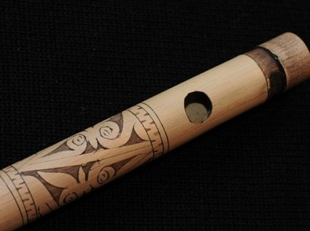­­­­­­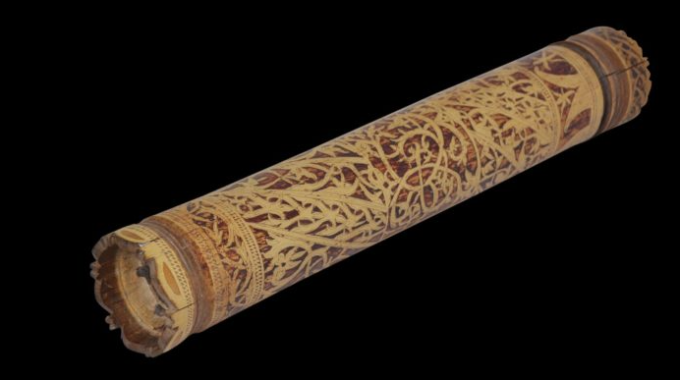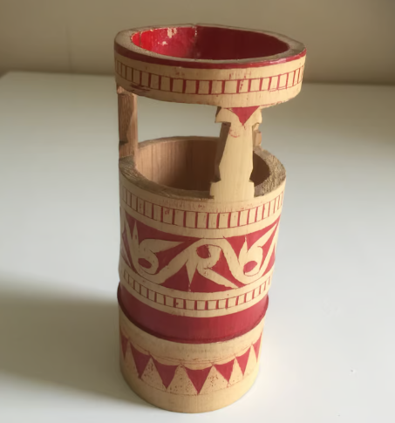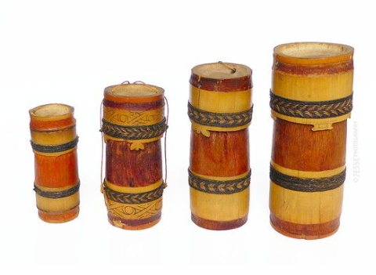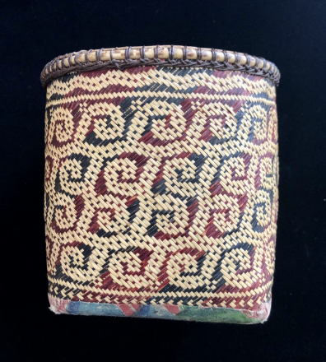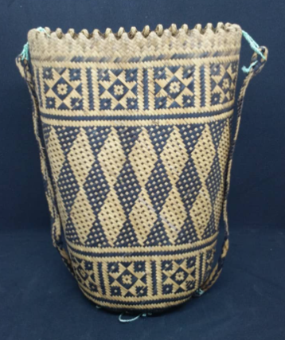

*Note.* From the left,

a bamboo flute (retrieved from https://www.malaysiadesignarchive.org/crafts-of-the-bidayuh/?print=print);

a bamboo container (retrieved from https://www.michaelbackmanltd.com/object/dayak-etched-bamboo-container/);

a pen holder (retrieved from https://www.gumtree.com/p/hobbies-collectibles/dayak-iban-sarawak-borneo-east-malaysia-bamboo-carving-pen-holder-1960/1456777333 );

a bamboo container (retrieved from https://www.pinterest.com/pin/500884789779740105/);

a seed planting basket (retrieved from https://rugrabbit.com/node/214030); and

an ‘Ajat’ Orang Ulu‘s Bag (retrieved from https://sarawakhandicraft.com.my/product/ajat-orang-ulu-s-bag/)

# METHODOLOGY

**Figure 9**  
*The Design and Development Process*

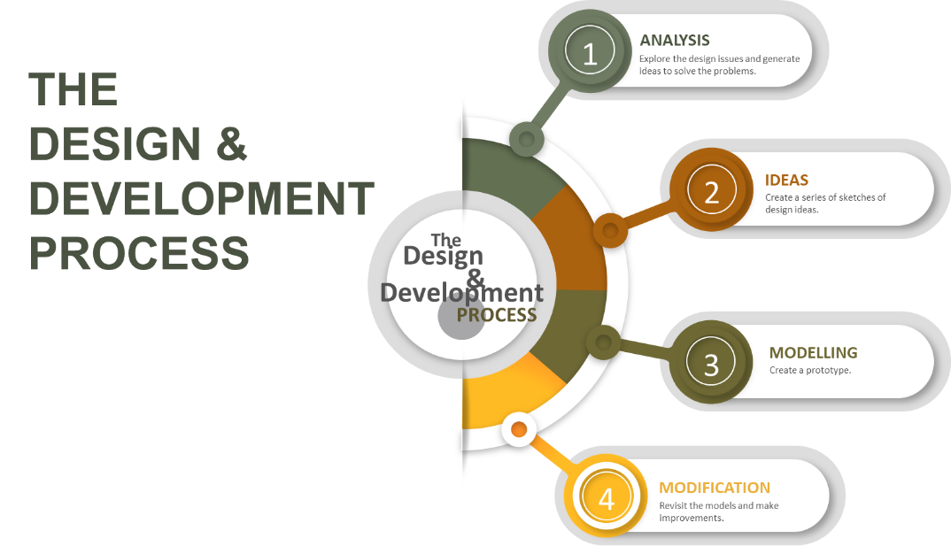

The design and development process for the Congkak is shown in Figure 9. The design and development process consists of four stages, and it is adapted from the design process that was introduced by Chicago Architecture Center (n.d.). The four stages are analysis, idea generation, modelling, and modification.

First, we defined the problem of the current Congkak. The first step was carried out by studying the available Congkak boards. We did both field and desk research. We studied the traditional Congkak board, as well as the contemporary ones. Photographs and sketches were collected. We learnt how to play Congkak so that we could figure out the issue on our own. Then, we identified our target audiences. A few scenarios were defined based on users’ experience, for example, how players travel with their Congkak board, how they keep the board, etc. We also collected information related to materials, such as wood, bamboo, and plastics. We visited bamboo plantations to observe and study a few bamboo species that are available in Malaysia. We also did research on Sarawak craft and motifs. We identified the potential motifs that could be used for our Congkak. Figure 10 illustrates our project analysis.

**Figure 10**  
*Project Analysis*

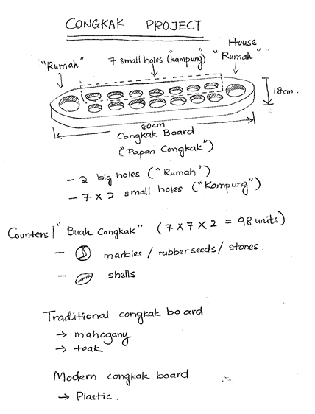

Next, we had a brainstorming session to gather more ideas. We came up with the concept of using bamboo as our Congkak material during this session, which is based on our sustainable concept. Several ideas were generated and five sketches were produced. Initial ideas are shown in Figure 11. We investigated and evaluated each idea to determine which one would best meet the needs of the players. Further analysis and refinement were made, and lastly, a concept was chosen. More sketches were drawn based on the chosen concept. After several iterations, the sketches in Figure 12 were proposed.

**Figure 11**  
*Idea Development (Initial sketch)*

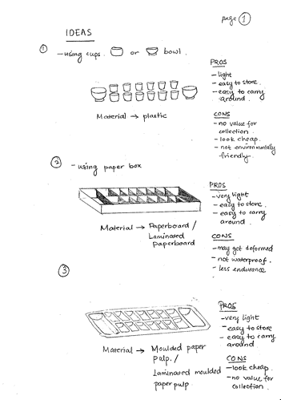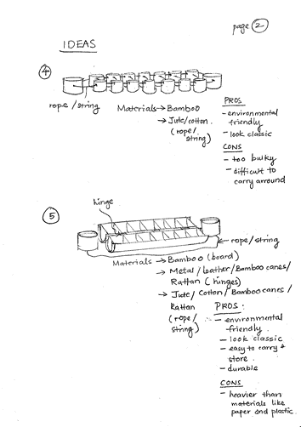

**Figure 12**  
*Idea Development (Refined Sketches)*

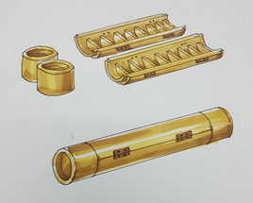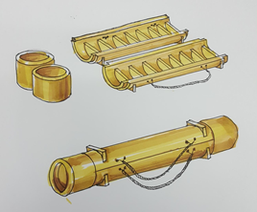

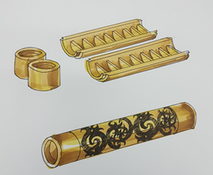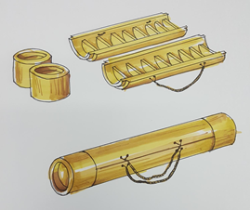

After further discussion and listing out the strengths and weakness of each concept in Figure 12, a choice was made based on group opinion. A computer-aided design (CAD) was drawn to visualise the actual product (as shown in Figure 13). Later, a prototype was made according to the proposed dimensions. The finalised prototype model is shown in Figure 14. Performance tests were done using the prototype model. Five players were invited to test the product and feedbacks were documented. Further refinement was identified.­­

**Figure 13**  
*A Finalised Congkak Board Drawn Using CAD*

**Figure 14**  
*A Completed Prototype Model*

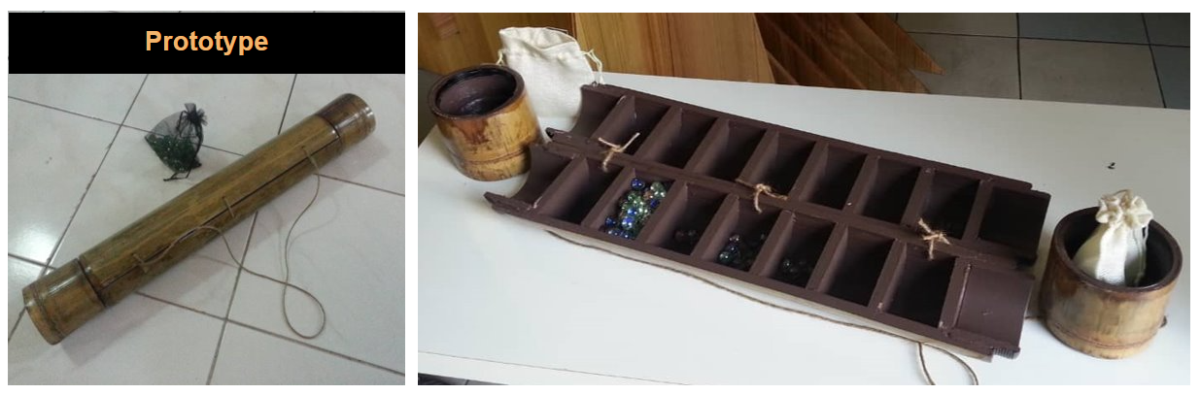

# RESULTS AND DISCUSSIONS

The prototype features and specifications are listed as follows:

1. The size of the product: 100 mm diameter, 660 mm length, and weight ±1.5 kg.
2. The congkak board is made from bamboo (80%), plywood (8%), jute rope (2%), and marble balls (10%).
3. The Congkak consists of 4 parts, 2 cylinder-shaped fastening caps as *Rumah* Congkak; and 2 bamboo halves as the *Kampung* Congkak (14 holes)
4. A pouch holds 140 tokens (“buah congkak”)

# Table 2 *Summary of the Prototype*

|  |  |  |  |
| --- | --- | --- | --- |
| a. | Specifications | Product Length | 660 mm |
|  |  | Product Diameter | ± 100 mm |
|  |  | Product Weight | ± 1500 gram |
| b. | Material | Species of Bamboo | Betung / Semeliang |
|  |  | Dimension of bamboo | Diameter (cm): 9-13  Segment Length (cm): 40-50  Thickness (mm): 10-14 |
|  |  | Plywood | Thickness: 10 mm (as a divider of *Rumah* Congkak) |
|  |  | Jute rope | Diameter: 8 mm (as a handle of Congkak) |
|  |  | Token of Congkak | 140 units of Marble balls  Diameter: 15 mm |
| c. | Manufacturing Techniques | Raw Bamboo | Cutting / Sawing of a bamboo segment  4 parts: 2 parts - *Kampung* Congkak and 2 part - *Rumah* Congkak |
|  |  | Bamboo Segment | Sanding of *Kampung* Congkak & *Rumah* Congkak |
|  |  | *Kampung* Congkak | Cutting the middle part of bamboo into two halves as *Kampung* Congkak  Threading at both end of bamboo (external: M90 x 6) with rotating thread. |
|  |  | *Rumah* Congkak | Threading inside of bamboo as Congkak covers (internal: M90 x 6) with rotating thread. |
|  |  | * Finishing | Shellac / Varnish |
|  |  | * Joining | Assemble of *Rumah* Congkak and *Kampung* Congkak |
|  |  | * Handle | Assemble the jute rope at both ends of *Rumah* Congkak as a handle of Congkak |

# After the performance tests, it was found that a few improvements needed to be done. The jute rope can be replaced by 3 small stainless-steel hinges to overcome the Congkak’s instability while playing. In addition, the Dayak’s motifs can be crafted on the Congkak to increase its collectible value.

# 4.0 CONCLUSIONS

This Congkak has a few promising benefits: low weight, sustainability, portability, and ease of manufacture. Bamboo grows relatively faster than trees so it can aid in protecting the environment. Additionally, this version of the Congkak board can be produced in bulk at a low cost by small and medium-sized businesses (SMEs) without the use of sophisticated technology. Bamboo as a material for local products may also strengthen local economies by boosting wages and employment possibilities and contributing to socio-economic benefits (Poppens, van Dam, & Elbersen, 2013).

This Congkak board has a higher economic value than the plastic Congkak board as it has a better collectible value. It can be a gift or memento. Souvenirs are known to be highly valued in the tourism industry. Therefore, it can be advertised and sold at tourist attractions like handicraft stores, art fairs, hotels, airports, etc., as well as online using social media or e-shops. Additionally, organisations like the International Bamboo & Rattan Organization or the Malaysian Ministry of Tourism, Arts, and Culture may be able to assist in promoting this Congkak. Malaysian handicrafts not only boost the economy but also promote the country to foreigners.

.

# BIBLIOGRAPHIES

Arjun, R., & Shekher, H. (2014). Game boards (Mancala) on the basalt exposures and the Khandoba temple of Deccan college campus. *Bulletin of the Deccan College Research Institute, 74*, 105-116. Retrieved from http://www.jstor.org/stable/26264689

Amir Faqihuddin Hafizan, Amar Faiz Zainal Abidin, Nik Zulfiqar Nik Suhaimi, Muhammad Muzamil Mustam, Kamaru Adzha Kadiran, Siti Aliyah Saleh, & Rozi Rifin. (2018, December). E-congkak: The development of an electronic congkak board game to promote traditional board game to younger Malaysian generation. *ARPN Journal of Engineering and Applied Sciences, 13*(24), 9624-9630.

Azlida Jamil. (2020, June 7). *Congkak, permainan tradisi Melayu*. Retrieved from Pusat Antarabangsa (i-PUTRA): https://intl.upm.edu.my/artikel/congkak_permainan_tradisi_melayu-43481

Azmy Hj. Mohamed, & Appanah, S. (1999). Bamboo resources conservation and utilization in Malaysia. In A. Rao, & V. R. Rao (Ed.), *Bamboo - conservation, diversity, ecogeography, germplasm, resource utilization and taxonomy.* Kunming and Xishuangbanna, Yunnan, China: IPGRI-APO, Serdang, Malaysia. Retrieved from https://www.bioversityinternational.org/fileadmin/bioversity/publications/Web_version/572/ch27.htm

Chaowana, P. (2013). Bamboo: An alternative raw material for wood and wood-based composites. *Journal of Materials Science Research, 2*(2), 90-102. doi:10.5539/jmsr.v2n2p90

Chicago Architecture Center. (n.d.). *Discover design handbook*. <https://discoverdesign.org/handbook>

de Ruijter-Luken, J. (n.d.). Bamboo wood: Why you should use bamboo as wood. *MOSO*. Retrieved from https://blog.moso-bamboo.com/bamboo-wood-why-you-should-use-bamboo-as-wood?

Durai, J., & Trinh, T. L. (2019). *Manual for sustainable management of clumping bamboo forest.* China: International Bamboo and Rattan Organisation (INBAR). Retrieved from https://www.inbar.int/wp-content/uploads/2020/05/1578457574.pdf

Durin, A. (2004). Tradisi buluh dalam budaya Iban di Sarawak. *Masters thesis*. University of Malaya.

Guadua Bamboo. (n.d.). *What products are made from bamboo?* Retrieved from Guadua Bamboo: https://www.guaduabamboo.com/products-from-bamboo

Hellier, M. (1907). Note on the Malay Game 'Jongkak'. *Journal of the Straits Branch of the Royal Asiatic Society, 49*, 93–94. Retrieved from https://www.biodiversitylibrary.org/partpdf/184990

Kanyan, R., & Zainurul Aniza A Rahman. (2015). Exploring the semiotics of the Dayak Motifs in Sarawak. *Social Sciences Postgraduate International Seminar (SSPIS).* Retrieved from http://eprints.usm.my/37582/1/sspis_2015_ms167_-_175.pdf

Mohd Zaihidee Arshad, Izani Mat Il M.Hum, & Abd. Halim Ibrahim. (2014). Sarawak bamboo craft: Symbolism and phenomenon. *SHS Web of Conferences, 5*(2). doi:10.1051/shsconf/20140500002

Müezzin, E. (2015, July). An investigation of high school students’ online game addiction with respect to gender. *The Turkish Online Journal of Educational Technology*(Special Issue 1), 55-60.

Noraziah ChePa, Asmidah Alwi, Aniza Mohamed Din, & Safwan Mohammad. (2014, August 12-15). Digitizing Malaysian traditional game: e-Congkak. *Knowledge Management International Conference (KMICe)*, (pp. 957-960). Malaysia. Retrieved from http://www.kmice.cms.net.my/

Nur Azzah Abu Bakar, & Noraziah ChePa. (2016). Towards game engagement: Usability evaluation of digital Malaysian traditional games. *Journal of Telecommunication, Electronic and Computer Engineering, 8*(8), 77-81.

Patrick Padri, L., Intan Khasumarlina Mohd Khalid, & Harozila Ramli. (2015). Motif ragam hias kalong, Sarawak. *Jurnal Seni dan Pendidikan Seni, 3*, 127-140.

Poppens, R., van Dam, J., & Elbersen, W. (2013). *Bamboo. Analysing the potential of bamboo feedstock for the biobased economy.* Food & Biobased Research, Wageningen UR. The Netherlands: NL Agency. Retrieved from https://edepot.wur.nl/381054

Saging, S., & Baco, Z. (2022). Simbolik motif-motif tatu tradisional masyarakat kaum Iban di Lubok Antu, Sri Aman, Sarawak: Symbolic of the traditional tattoo motifs of the Iban people in Lubok Antu, Sri Aman, Sarawak. *Jurnal Borneo Arkhailogia (Heritage, Archaeology and History)*, *7*(1), 130–144. <https://doi.org/10.51200/jba.v7i1.4137>

Schröder, S. (2021). How Durable is Bamboo? *Guadua Bamboo*. Retrieved from https://www.guaduabamboo.com/blog/durability-of-bamboo

Schröder, S. (2022). Mechanical properties of bamboo. *Guadua Bamboo*. Retrieved from Guadua Bamboo: https://www.guaduabamboo.com/blog/mechanical-properties-of-bamboo

Siti Hajar Maizan. (2018). Congkak variations through design transformation. *Idealogy, 3, 3*, 114-126.

Subramony, T., Li, J., Muralidharan, E., & Parekh, B. (2016). *Feasibility study on bamboo plantations and opportunities for its utilisation in Sarawak, Malaysia, 2016.* Sarawak: International Bamboo and Rattan Organisation (INBAR) and Sarawak Timber Industry Development Corporation (STIDC). Retrieved from https://www.inbar.int/wp-content/uploads/2020/05/1499156135.pdf

Tan, B. (2010, November 26). *Congkak*. Retrieved from Infopedia: https://eresources.nlb.gov.sg/infopedia/articles/SIP_1733_2010-11-26.html

Wong, K. (1989). Current and potential use of bamboo in Peninsular Malaysia. *Journal American Bamboo Society, 7*(1 & 2), 1-15.

WWF. (n.d.). *The human heart of Borneo*. Retrieved from <https://wwf.panda.org/discover/knowledge_hub/where_we_work/borneo_forests/about_borneo_forests/people/>