***Paenibacillus alvei* DZ/3 and *Bacillus subtillis* AA/11 as a Promising Probiotics in the Near Future**

Sofija Kostandinovska1*, Ana-Marija Bosilkovska1, Dzoko Kungulovski1, Natalija Atanasova-Pancevska1

*1Department of Microbiology and Microbial Biotechnology, Institute of Biology, Faculty of Natural Sciences and Mathematics, “Ss. Cyril and Methodius” University, Skopje, North Macedonia*

**Abstract**

The influence of microorganisms found in the intestinal microflora on human health leads to great interest in the study of microorganisms with a positive effect on the body, called probiotics. The probiotic microorganisms are now widely used in many countries by consumers and in clinical practice. Given the increasingly widespread use of probiotics, a thorough understanding of their risks and benefits is imperative.

This research highlights the probiotic candidature of spore forming *Paenibacillus alvei* DZ/3 and *Bacillus subtillis* AA/11 and presents an overview of the physiological tests such as determining the optimal conditions for growth and cultivation by monitoring the growth kinetics of these bacteria, the optimal temperature, time of incubation and pH, including the probiotic potential. Maximum growth of these bacteria was observed in Muller-Hinton broth. *P. alvei* DZ/3 showed maximum growth at pH 7 after 24 hours of incubation at 44 °C and *B. subtillis* AA/11 at pH 6 after 48 hours of incubation at 37 °C.

According to the probiotic potential determination protocol used in this research, *P. alvei* DZ/3 and *B. subtillis* AA/11, meet the criteria of potential probiotics, such as tolerance to low pH important for the survival of the bacteria in the stomach and food. The other criterion is sensitivity to bile salts, an important feature of a probiotic potential due to bacterial growth and survival in the gut. These research results will probably be essential for the positioning of probiotic preparations as either a food, a food supplements or as pharmaceutical preparation.

**Key words**: probiotic potential, microorganisms, optimal conditions, health benefits, determination protocol

1. **INTRODUCTION**

Probiotics are live microorganisms that, when ingested in sufficient amounts, offer health advantages to the host (Fontana *et al*., 2013). Probiotic bacteria have garnered worldwide attention in the past decade due to their safe, functional and technological properties (Kanmani *et al*., 2013). When selecting potential probiotics, several characteristics are crucial. Criteria for choosing probiotics include tolerance to gastrointestinal conditions (stomach acid and bile), the ability to attach the gastrointestinal mucosa, and the competitive exclusion of pathogens (Fontana *et al*., 2013).

Since the gastrointestinal tract (GIT) is known to have physical and chemical barriers against ingested microbes, a probiotic microorganism should meet multiple requirements to exist in such a harsh environment. Probiotics are expected to offer implications that are advantageous to the host’s health through a direct impact on the intestinal microbial communities, that is, they improve the intestinal microbial balance. They also create a range of metabolic end products with antagonistic properties against pathogens.

The constant quest for novel probiotics of significance in medical, industrial and agricultural settings is current around the world. Potential probiotics must be able to pass the test of basic probiotics properties, survive in gastrointestinal conditions, notoriously at low pH and high bile concentrations, generate antimicrobial compounds and be adhesive to the intestinal mucosa (Kesen and Olayinka, 2018). This study has been undertaken to ascertain the identification of selected strains isolated from rotten apple compost sample from Resen, North Macedonia applying the generally adopted cultural methods, biochemical and physiological tests. This study was further expanded to determine the probiotic potential of the isolated strains.

1. **MATERIALS AND METHODS**
   1. **Sample collection**

Compost samples of rotten apples were collected from the composting plant in Resen, North Macedonia. The collected compost sample was kept for screening and isolation of various microorganisms with antimicrobial properties. The selected antimicrobial strains, *Paenibacillus alvei* strain DZ/3 and *Bacillus subtillis* strain AA/11 were identified by sequencing the 16S rRNA gene (Atanasova-Pancevska *et. al*., 2016).

* 1. **Identification of microorganisms**

The isolated bacteria were first incubated in Muller-Hinton broth and Muller-Hinton agar medium and incubated at 37 °C for 24 hours. The phenotypic characterization of the selected strains was based on cell shape, Gram stain and Shaeffer & Fulton stain. The macroscopic properties of colonies of strains were examined by observing their growth on agar Petri dish, in order to describe their morphology, color, surface, appearance and opacity. Microscopic observation was performed using a microscope after Gram and Shaeffer & Fulton staining the isolated bacteria with objective 100.

* 1. **Optimal conditions for growth and growth kinetics**

The stains were identified further by observing the growth of the isolated strains at different temperatures, different pH values and growth kinetics. The growth test at different temperatures consists of inoculating the cultures of the isolates in tubes containing the broth, then incubated at 2 °C, 30°C, 37°C, 44°C for 24 and 48 hours. The growth of bacteria indicates the tolerance of the temperatures. Acidification and optimal incubation time were measured for selected bacteria that were examined at different pH values. Broths with different pH values including 3, 4, 5, 6, 7, 8 and 9 were made using HCl 1N and NaOH 1N and divided into universal bottles. The MHB together with the control bottles were autoclaved at 121°C for 15 minutes and inoculated with an overnight culture of the selected strain in broth followed by incubation. The optical density (OD) as a growth rate of bacteria was measured with a spectrophotometer at 600 nm after incubation at every 2 hours. The kinetics of growth of each strain was performed by inoculating 20 μL of each isolate into 100 ml MHB. The Formazin Attenuation Units (FAU) were determined at 0, 2, 4, 6, 8, 22, 24, 26, 28 and 30 hours using turbidimeter. The results were plotted to identify the phases, particularly the log phase.

* 1. **Physiological identification**

Further identification of the strains was made using the ability to grow on media with added Fe-Na-EDTA, catalase test, tolerance to 6,5% NaCl, gas production, arginine hydrolysis, haemolysis test and tolerance to ammonia nitrogen. The growth of the selected strains was determined in tubes with and without Fe-Na-EDTA, incubated for 24 hours. After the incubation, the strains were inoculated on MHA plates and the difference in bacterial growth with and without the addition of Fe-Na-EDTA was observed. The catalase activity was determined by adding of 3% hydrogen peroxide (H2O2) to the cultivated colonies on a glass slide. The isolates were tested for tolerance to 6,5% NaCl concentrations in broth media. The tubes were inoculated with young cultures and then incubated at optimal temperature for 24 hours. FAU as growth rate of bacteria was measured by turbidimeter after 24 hours of incubation. The homo- or hetero- fermentative character of the isolates was examined based on their ability to produce gas (CO2). The test was studied using inverted Durham tubes in Andrade Lactose Peptone broth.

For the haemolysis test, the isolates were cultured using broth at optimal °C for 15 hours and then transferred onto blood agar supplemented with 5% horse blood. The inoculated plates were incubated at optimal °C for 24 hours. The haemolytic response was assessed by observing both the partial hydrolysis of the red blood cells and the formation of a green zone (α-hemolysis), and the complete hydrolysis of the red blood cells, which produce a clear zone around the bacterial colony (β-hemolysis) or no reaction (γ-hemolysis).

For the arginine hydrolysis test, a basal MRS broth medium with 0.2% ammonium citrate, with and without 0.3% arginine, was prepared. The colonies which has grown in the basal medium were then inoculated into the prepared medium and incubated at optimal °C for 24 h. On the 2nd and 7th day of the incubation, a drop of the cultures was transferred from to a glass slide, with the addition of three drops of Nessler’s reagent (K2HgI4), and a color change from yellow to brown was observed.

Strains were tested for tolerance to ammonia nitrogen following the technique of Devaraj *et al*. (2012). Ammonia nitrogen concentrations tested were: 0.05, 0.1, 0.5, 1, 5, 10, 15, 20, 25, 30, 35, 40, 45, 50, 55 and 60 μg L-1. 20 μL of each strain culture were inoculated in tubes with 10 mL of medium and incubated at optimal °C for 24 and 48 hours. The medium was used as a control. The absorbance was determined at 600 nm using a spectrophotometer.

* 1. **Biochemical identification**

Carbohydrate fermentation was determined by the Jayne-Williams method, in which 0.1 molar sugar solutions are prepared in sterile distilled water and stored as stock solutions at a low temperature in the refrigerator. Medium consisting of peptone 1 g L-1 and NaCl 0.5 g L-1 and 0.5% bromthymol-blue dissolved in 50% ethanol were prepared and then autoclaved. 20 μL of bacterial suspension were inoculated in tubes containing the prepared medium and incubated at optimal °C in order to reach the log phase. The test was performed in microplate to which one drop of sterile sugar solution and four drops of suspension were added. The microplate was incubated at optimal °C for 1, 2, 5 and 7 days. Sterile distilled water was used as control. The color change of bromthymol-blue to yellow was observed.

* 1. **Testing for susceptibilities to antibiotics**

Bacterial antibiotic resistance was determined on solid agar using various antibiotic discs. The results (average of 3 readings) were expressed as sensitive (S) or resistant (R) by following the standard disc diffusion method. Standard antibiotics such as penicillin G, amoxicillin, rifampicin, chloramphenicol, clarithromycin, doxycycline, clindamycin, augmentin, gentamicin were used for this study.

* 1. **Antifungal test**

The disc diffusion method was used to test the antifungal properties of the isolated bacteria strains against selected fungal pathogen. Petri dishes containing equal volumes of MHA and SDA (7.5 + 7.5 mL) medium were inoculated with a standardized bacterial isolate. A disk containing 10 μL of a bacterial suspension was placed on a Petri plate pre-inoculated with the fungal pathogen. The plates were incubated at 25°C. The zones of inhibition were measured after 5 days of incubation.

* 1. **Tolerance to acidic pH values**

The acid tolerance of the strains tested was determined using the method of Nguyen *et al*. (2006). 1% inocula of the activated cultures in broth, acidified to pH 3 with 1N HCl were prepared. The strains that were able to grow to >107 CFU/mL after 24 hours of incubation were considered as acid resistant strains.

* 1. **Bile tolerance**

The bile resistance of the isolates was determined by the method of Gilliland *et al*., (1984). The strains were grown in broth overnight. 100 μL of the culture suspension was then inoculated into the tubes containing 20 mL of broth with or without 0.3% bile salts, the latter being used as a control. The inoculated tubes were incubated. The growth was monitored every hour by measuring the optical density at 620 nm using a spectrophotometer. The bile tolerance of each strain was defined as the difference in the time it took to increase the absorbance value to increase by 0.3 units between broth containing bile salts and the control (Liong and Shah, 2005; Patel *et al*., 2004; Prasad *et al*., 1998; Gilliland and Walker, 1990).

Bile tolerance was also assessed by another growth study (Succi *et al*., 2005). In this experiment, the ability of the strains studied to lower the pH in the presence of different percentages of bile salts was considered to be bile tolerance. One percent of the inocula of the activated culture medium of each strain was transferred to a broth containing 0, 0.3, 0.5, 1, 1.5 and 2% bile salts and the pH changes measured were monitored at time intervals of 3, 6, 24 and 48 hours.

1. **RESULTS**

The bacterial isolates obtained from compost samples of rotten apples collected from the composting plant in Resen, North Macedonia were isolated and screened using MHA medium. Morphological studies indicated that the isolates are Gram-positive, sporulating, rod-shaped bacteria. The effects of temperature and incubation time on the bacterial growth of *Paenibacillus alvei* DZ/3 and *Bacillus subtillis* AA/11 were investigated in MHB. The growth experiment at different temperatures was repeated twice with similar results. The results indicated that the optimal temperature for the growth of *P. alvei* DZ/3 is 44°C, after 24 hours of incubation (Table 1). The optimal temperature for the growth of *B. subtillis* AA/11 is 37°C, after 48 hours of incubation (Table 2).

**Table 1. Measured values for the turbidity of the bacterial culture *Paenibacillus alvei* DZ/3 when determining the optimal temperature**

|  |  |  |  |  |
| --- | --- | --- | --- | --- |
| *P. alvei* DZ/3 | 25 °C | 30 °C | 37 °C | 44 °C |
| DZ/3 | 214 FAU | 135 FAU | 343 FAU | 592 FAU |

**Table 2. Measured values for the turbidity of the bacterial culture *Bacillus subtillis* AA/11 when determining the optimal temperature**

|  |  |  |  |  |
| --- | --- | --- | --- | --- |
| *Bacillus subtillis* AA/11 | 25 ° C | 30 ° C | 37 ° C | 44 ° C |
| АА/11 | 135 FAU | 229 FAU | 350 FAU | 12 FAU |

With regard to the optimal pH value of the growth medium, maximum growth was observed for *P. alvei* DZ/3 at pH 7 and for *B. subtillis* AA/11 at pH 6, after 30 hours of incubation (Fig. 1).

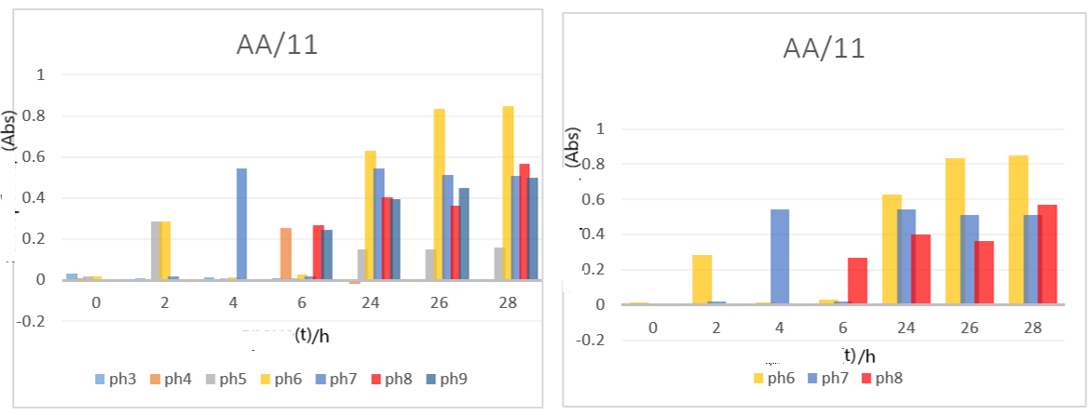

1. **B)**

**Fig. 1. Influence of different pH values on the growth of *P. alvei* DZ/3 and *B. subtillis* AA/11. A) pH 7 is the optimal pH for the growth of *P. alvei* DZ/3. B) pH 6 is the optimal pH for the growth of *B. subtillis* AA/11*.***

According to the obtained results from the growth kinetics, the log phase was identified at the 22nd hour of incubation, for both isolates (Fig. 2).

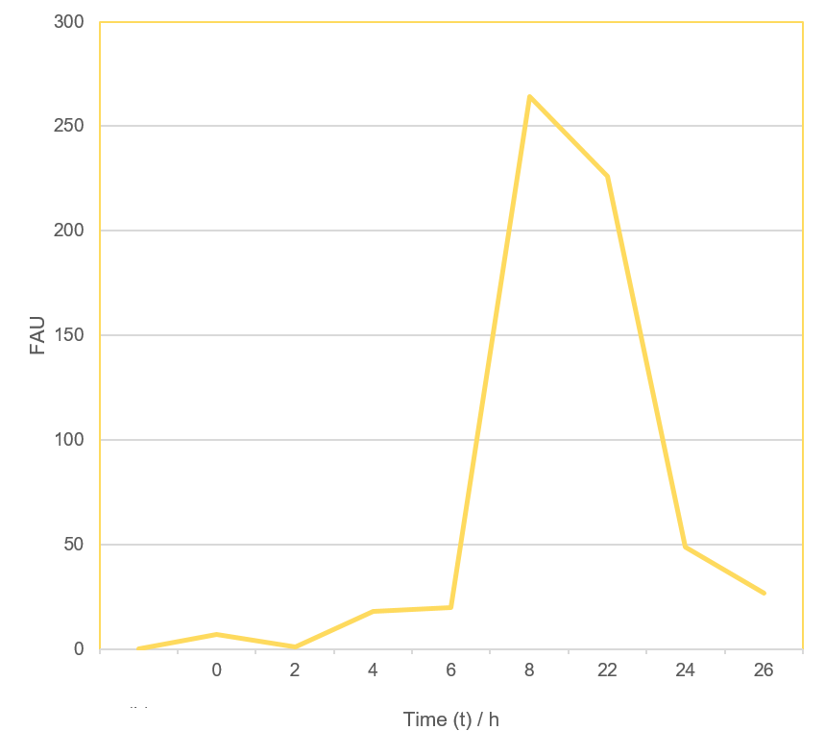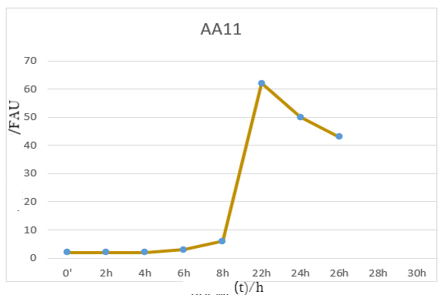

1. B)

**Fig. 2 Growth kinetics. A) Cell growth curve for *P. alvei* DZ/3. B) Cell growth curve for *B. subtillis* AA/11.**

Physiological identification showed that adding Fe-Na-EDTA in the medium, stimulates the growth of both bacteria. Further identification illustrated that both isolates are catalase positive, grow on 6,5% of NaCl added in the MHB, both bacteria also showed negative results regarding the gas production test. *P. alvei* DZ/3 showed α-hemolysis, while *B. subtillis* AA/11 showed γ-hemolysis (Fig. 3).

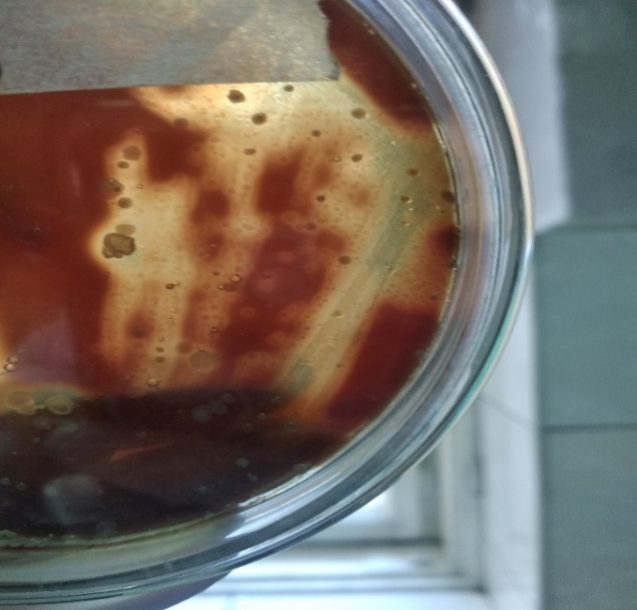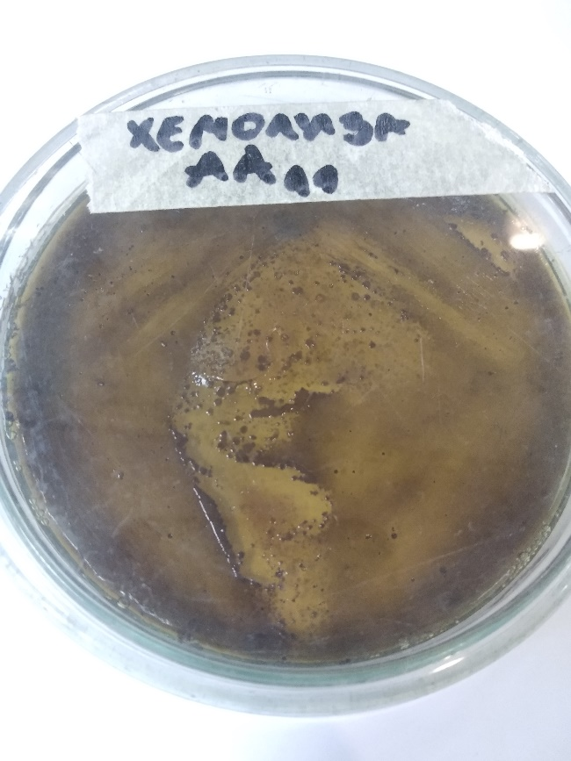

1. B)

**Fig.3. Haemolysis reaction. A) *P. alvei* DZ/3 shows α-haemolysis. B) *B. subtillis* AA/11 shows γ-haemolysis.**

For the arginine hydrolysis test, *P. alvei* DZ/3 demonstrated a positive reaction, while *B. subtillis* AA/11 showed a negative reaction after the 2nd and 7th day of incubation. The selected isolates showed growth at all TAN levels, *P. alvei* DZ/3 showed maximum growth at a concentration of 0.1 mg L-1, after 24 hours of incubation and at a concentration of 1 mg L-1, after 48 hours of incubation. *B. subtillis* AA/11 showed maximum growth at a concentration of 25 mg L-1, after 24 hours of incubation, and at a concentration of 30 mg L-1, after 48 hours of incubation (Fig. 4).

1. B)

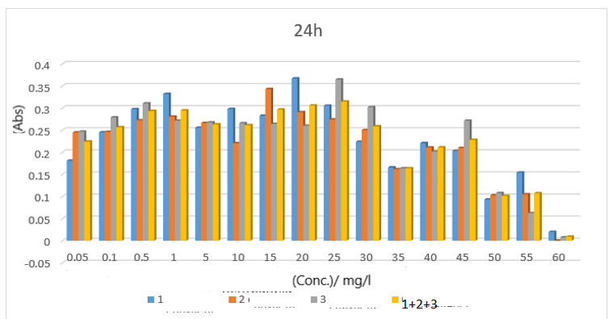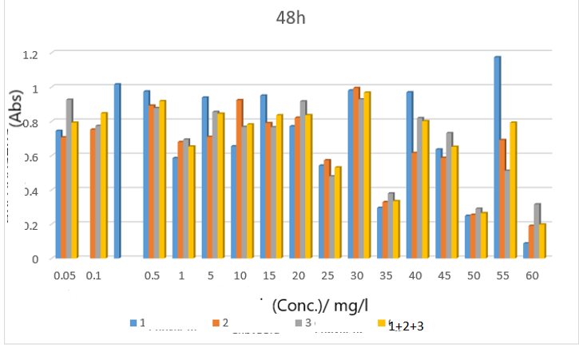

C) D)

**Fig. 4. Tolerance to different TAN levels. A) *P. alvei* DZ/3showed maximum growth at a concentration of 0.1 mg L-1, after 24 hours of incubation. B) *P. alvei* DZ/3 showed maximum growth at a concentration of 1 mg L-1, after 48 hours of incubation. C) *B. subtillis* AA/11 showed maximum growth at a concentration of 25 mg L-1, after 24 hours of incubation. D) *B. subtillis* AA/11 showed maximum growth at a concentration of 30 mg L-1, after 48 hours of incubation**

In terms of biochemical identification, both isolates tested positive for fermentation on various sugar substrates. The test results of the antibiogram showed that *P. alvei* DZ/3 is sensitive to the antibiotic augmentin and the measured zone of inhibition was 30 mm and also partially sensitive to the other test antibiotics used in this study. *B. subtillis* AA/11 is sensitive to the antibiotic rifampicin and the measured zone of inhibition was 53 mm, but was found resistant to the antibiotic amoxicillin (Fig.5).

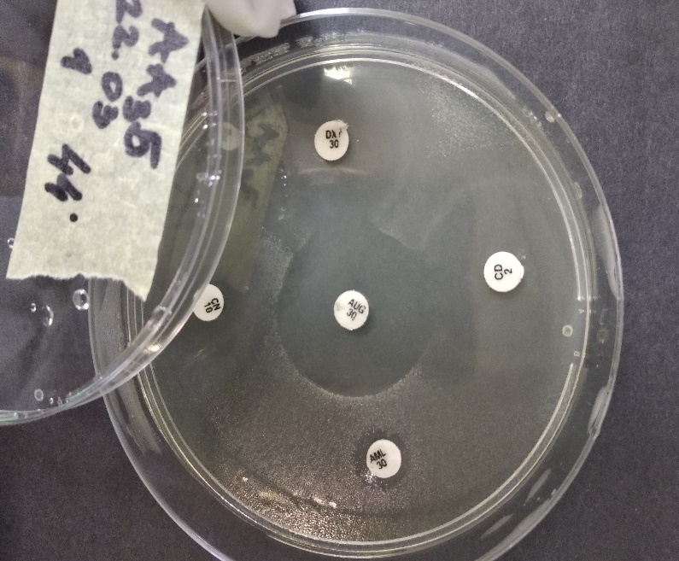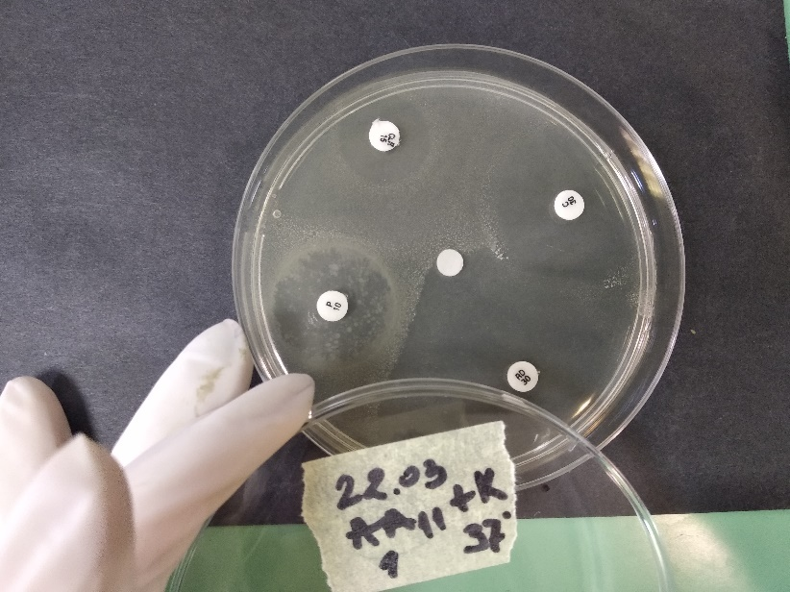

1. B)

**Fig. 5. Antibiogram. A*) P. alvei* DZ/3 is sensitive to the antibiotic augmentin. B) *B. subtillis* AA/11 is sensitive to the antibiotic amoxicillin.**

The isolated bacterial strains from compost samples of rotten apples were screened for secondary metabolites using the diffusion agar method, for antifungal activity. *P. alvei* DZ/3 showed potential antifungal activity against *Aspergillus niger* ATCC 16404, through the formation of an inhibition zone on the agar plate, while *B. subtillis* AA/11 showed a negative result with regard to the potential antifungal activity (Fig.6).

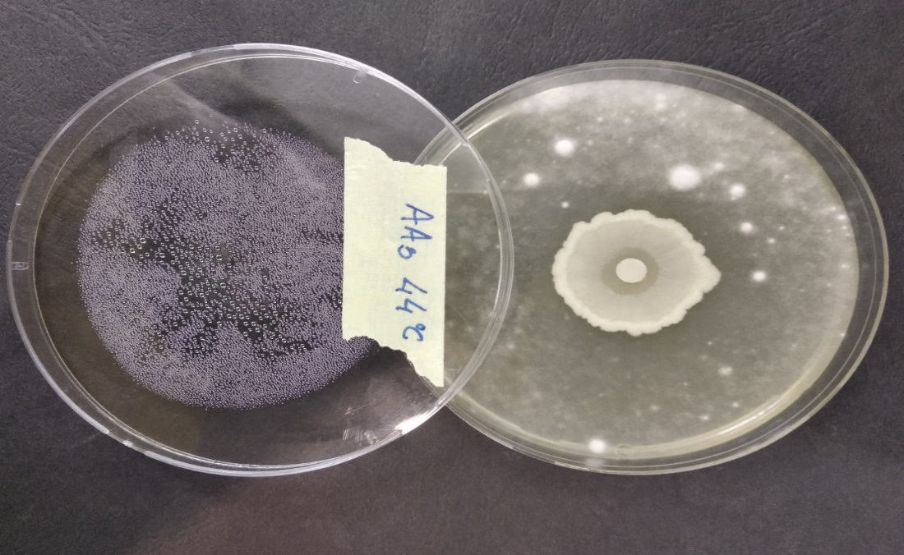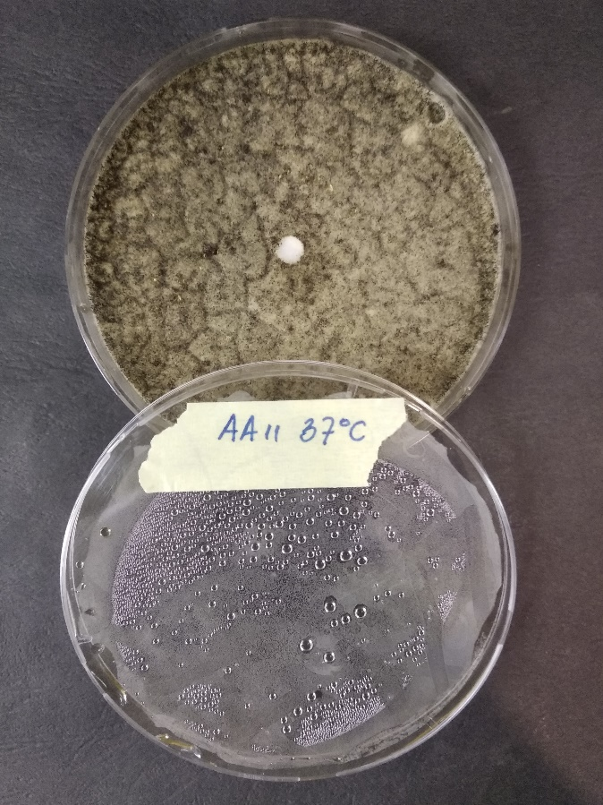

1. B)

**Fig. 6. Diffusion agar method for determining A) the antifungal activity of *P. alvei* DZ/3 against *A. niger* ATCC 16404 B) the antifungal activity of *B. subtillis* AA/11 against *A. niger* ATCC 16404**

The isolated strains tested positive for the acid tolerance test, as they were capable of growing to >107 CFU/mL after 24 hours of incubation. According to the tolerance of bile salts, both isolates were selected as tolerant to bile for both methods used in this study. The bile resistance of the isolates determined by the method of Gilliland *et al*., (1984), resulted with an increase by 0.3 units between broth with and without 0.3% bile salts (Fig. 7).

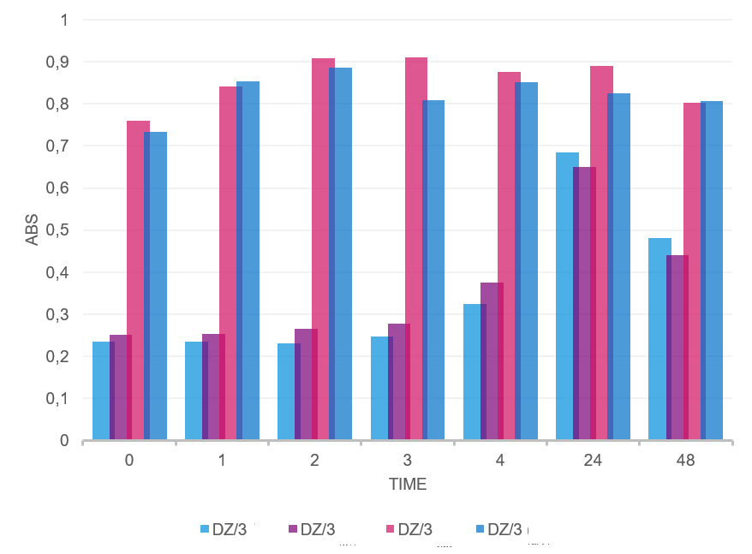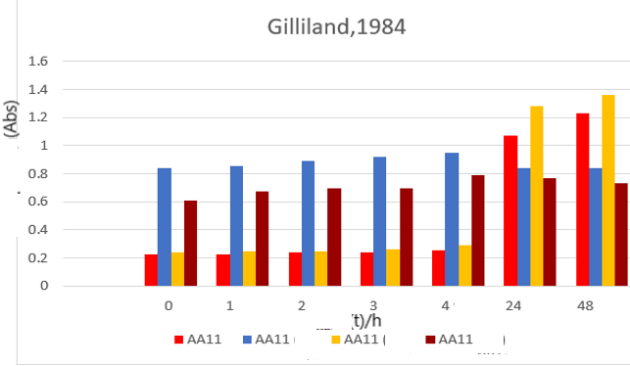

1. B)

**Fig. 7. Graphic with measured values of the absorbance in determining the bile salt tolerance. A) *P. alvei* DZ/3. B) *B. subtilis* AA/11.**

According to the method by Succi *et. al*., (2005), both isolates evidenced a good survival in the presence of 0.3%, 0.5%, 1%, 1,5% and 2% of bile salts (Fig. 8).

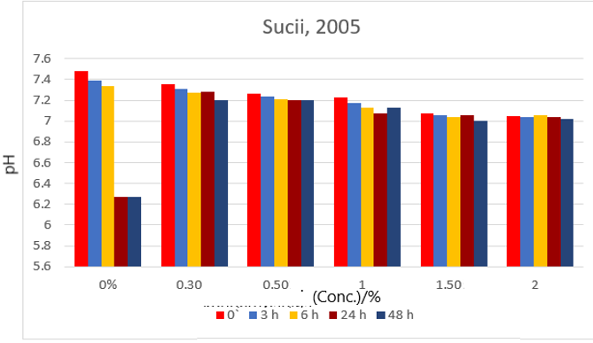

1. B)

**Fig. 8. Graphic with measured pH values when determining the bile salt tolerance. A) *P. alvei* DZ/3. B) *B. subtillis* AA/11.**

1. **DISCUSSION**

Any selected probiotic strain must be pure. Probiotics do not have to be pathogenic, must be non-toxic and also capable of supporting the healthy running of human body systems, therefore, strains selected as probiotics, should be completely characterized and identified. A Gram stain reaction is a normal laboratory technique used to detect the presence and morphology of bacteria in a sample. Gram stain is an extremely important first step in the characterization of probiotic bacteria. In general, *Bacillus* species are aerobic or facultative anaerobic, sporulating, rod-shaped, Gram-positive bacteria (Graumann, 2007). The identified strains, *P. alvei* DZ/3 and *B. subtillis* AA/11 are Gram-positive, rod-shaped, spore-forming and catalase positive bacteria (Najafi *et al*., 2011). In this study, various experiments were performed to ascertain the most favorable conditions for *P. alvei* DZ/3 and *B. subtillis* AA/11 to grow. The outcome of the results from this study, is that the optimal growth temperature for *P. alvei* DZ/3 is 44°C and for *B. subtillis* AA/11 is 37°C, after 24 and 48 hours of incubation, respectively. In the Bergey’s Manual of Determinative Bacteriology it is noted that the optimal temperature for growth of both strains ranges from 25 – 44°C (Vos *et al*., 2009), which means that the optimal temperature obtained in this study is within the optimal temperature presented in the Bergey’s Manual. The optimal pH for *P. alvei* DZ/3 and *B.* *subtilli*s AA/11 was determined to be pH 7 and pH 6, respectively, after 30 hours of incubation. The pH changes of the medium during the incubation period propose that bacteria have an ideal buffer system and they have the capability to adjust to the pH value that is optimal for them. According to the study from Alkotaini *et al*. (2013), *P. alvei* DZ/3 has a high stability towards pH ranges.

Haemolysin production is generally analyzed on blood agar plates. The existence of α- or β-hemolysis is demonstrated by the establishment of clear or greenish zones around the colonies. *P. alvei* DZ/3 shows α-hemolysis, while *B. subtillis* AA/11 shows γ-hemolysis. Haemolysin is a most popular virulence determinant among pathogens that commonly cause anemia and oedema in the host, and hence, haemolytic strains are not recommended for application as probiotics. Therefore, it would be desirable to select only the non-haemolytic strains as probiotic candidates. In the present study, the criteria for selecting a potential probiotic was also based on tolerance to TAN. The results of the present experiment, show that both isolates grow on different concentrations of TAN. High levels of TAN can be harmful resulting in high levels of toxic, unionized ammonia. *Bacillus* spp., comprising their spores, have been suggested as probiotics and biocontrol agents in fish and shellfish culture systems (Gatesoupe, 1999). Lalloo *et al*. (2007) showed that the application of *Bacillus* spp. was safe because in the ornamental fish aquaculture *in vitro* and *in vivo* a decrease in the pathogen load and the concentrations of waste ions occurred. In the present experiment, the application of *P. alvei* DZ/3 and *B. subtillis* AA/11 generated high survival at different concentrations of TAN, implying the effectiveness of *Bacillus* spp. Bacteria can use glucose and other carbohydrates through various metabolic pathways, some of which are fermentative and some of which are oxidative. Prepared sugar solutions inoculated with bacteria enable the classification of bacilli, with a simple method that demonstrates the ability of bacteria to ferment carbohydrates. The ratio of proteins to carbohydrates in the medium, prevents the neutralization of weak acids from alkaline products, when using proteins, which allows the detection of small amounts of acid. Acid production results in a change in pH that changes the color of the indicator bromthymol-blue to yellow. After the incubation of the microplate, in which a culture of *P. alvei* DZ/3 and *B. subtillis* AA/11 is inoculated in different sterile sugar solutions, on the 2nd day, the highest growth rate of the bacterium was observed, using the sugar solutions of mannose, sucrose, cellobiose and glucose as source of carbohydrates. There was a change in the color of bromthymol - blue to yellow, which is a positive reaction, i.e. it means that bacteria have the ability to ferment sugars. In the Bergey’s Manual, glucose is described as a source of carbohydrates that stimulates the growth of *P. alvei* (Vos *et al*., 2009). Glucose is recommended as a source of carbohydrates for bacterial growth in the production of certain antibiotics such as bacitracin (Haavik, 1974) and actinomycin (Gallo and Katz, 1972). Furthermore, glucose is the first source of carbohydrates used by bacterial cells to synthesize antibiotics, while in the absence of glucose, microorganisms can use other sources of carbohydrates to produce antibiotics (Gallo and Katz, 1972).

The characterization of *P. alvei* DZ/3 and *B. subtillis* AA/11 demonstrated that they were bile and acid tolerant. These properties are significant for potential probiotics because bile tolerance is expected for bacteria to grow and survive in the small intestine (Lee and Salminen, 1995) and acid tolerance is required for bacteria to survive gastric transit (Henriksson *et al*., 1999), as well as survival in food (Lee and Salminen, 1995). *P. alvei* DZ/3 and *B. subtillis* AA/11 isolated from compost samples of rotten apples and included in this study showed good survival in the presence of different concentration of bile salts and acid tolerance.

1. **CONCLUSION**

In the present study, the probiotic potential of two strains from compost samples of rotten apples was investigated. Both of the isolates showed preferable probiotic properties. *P. alvei* DZ/3 exhibited remarkable antifungal activity, while *B. subtillis* AA/11 showed no hemolytic reaction. Both bacteria demonstrated a good tolerance to low pH and bile salts. These strains present good candidates for application as novel probiotic strains. In addition, it will be necessary to test these strains on broader range of pathogenic microorganisms and also to test them on more animals, using different doses of both bacteria over extended periods of time to assess the long-term probiotic potential of *P. alvei* DZ/3 and *B. subtillis* AA/11.

**REFERENCES**

Alkotaini, B., N. Anuar, A. A. H. Kadhum, A. A. A. Sani (2013). Detection of secreted antimicrobial peptides isolated from cell-free culture supernatant of *Paenibacillus alvei* AN5. *J. Ind. Microbiol. Biotechnol.* 40: 571–579.

Atanasova-Pancevska, N., Popovska, I., Davalieva, K., Kungulovski, Dz. (2018). Screening for Antimicrobial Activity of *Bacillus subtilis* and *Paenibacillus alvei* Isolated From Rotten Apples Compost. *Acta Microbiologica Bulgarica*, 56-64, 2018

Fontana, L., Bermudez-Brito, M., Plaza-Diaz, J., Munoz-Quezada, S., Gil, A. (2013). Sources, isolation, characterisation and evaluation of probiotics. *British Journal of Nutrition*, 109, S35–S50.

[Gallo](https://www.ncbi.nlm.nih.gov/pubmed/?term=Gallo%20M%5BAuthor%5D&cauthor=true&cauthor_uid=4110143), M., [Katz](https://www.ncbi.nlm.nih.gov/pubmed/?term=Katz%20E%5BAuthor%5D&cauthor=true&cauthor_uid=4110143), E. (1972). Regulation of Secondary Metabolite Biosynthesis: Catabolite Repression of Phenoxazinone Synthase and Actinomycin Formation by Glucose.[*J Bacteriol.*](https://www.ncbi.nlm.nih.gov/pmc/articles/PMC285190/) 1972 Feb; 109(2): 659–667.

Gatesoupe, F.J. (1999) The use of probiotics in aquaculture. *Aquaculture* 180: 147–165.

Gilliland, S. E, Staley, T. E., Bush, L. J. (1984). Importance of the bile tolerance of *Lactobacillus acidophilus* used as dietary adjunct. *J. Dairy Sci.* 67, 3045-3051.

Gilliland, S. E. & Walker, K. (1990). Factors to consider selecting a culture of *Lactobacillus acidophilus* as a dietary adjunct to produce a hypocholesterolemic effect in humans. *J Dairy Sci*. 73, 905-911.

Graumann, P. (2007). *Bacillus*: Cellular and Molecular Biology. 1st ed. *Caister Academic Press*

[Haavik](https://pubmed.ncbi.nlm.nih.gov/?term=Haavik+HI&cauthor_id=4436646), H.I. (1974). Studies on the formation of bacitracin by *Bacillus licheniformis*: effect of inorganic phosphate. *J Gen Microbiol* 1974 Sep;84(1):226-30.

Henriksson, R., Bergstrom, P., Franzen, L., Lewin, F., Wagenius, G., (1999). Aspects of reducing gastrointestinal adverse effects associated with radiotherapy. *Acta Oncológica* 38 (2), 226–231.

Kanmani, P., Satish Kumar, R., Yuvaraj, N., Paari, K. A., Pattukumar, V., Arul, V. (2013). Probiotics and its functionally valuable products – A review. *Critical Reviews in Food Science and Nutrition*, 53, 641–658.

Kesen, M.A., Olayinka A., (2018). Beneficial Characteristics and Evaluation Criteria of Probiotics. *Int J Food Biosci*, Volume 1:1.

Lalloo, R., Ramchuran, S., Ramduth, D. (2007). Isolation and selection of *Bacillus* spp. as potential biological agents for enhancement of water quality in culture of ornamental fish. *J Appl Microbiol* 103: 1471–1479.

Lee, Y.K., Salminen, S., (1995). The coming age of probiotics. *Trends in Food and Science Technology* 6, 241–245.

Liong, M. T., Shah, N. P. (2005). Acid and bile tolerance and cholesterol removal ability of lactobacilli strain. *J Dairy Sci.* 88, 55-66.

Najafi, A., M. Rahimpour, A. Jahanmiri, R. Roostaazad, D. Arabian, M. Soleimani, Z. Jamshidnejad (2011). Interactive optimization of biosurfactant production by *Paenibacillus alvei* ARN63 isolated from an Iranian oil well. *Colloids Surf* B. 82: 33-39.

Nguyen, T. D. T., Kang, J. H., Lee, M. S. (2006). Characterization of *Lactobacillus plantarum* PH04, a potential probiotic bacterium with cholesterol-lowering effects. *Int J Food Microbiol.* 113, 358-361.

Patel, H. M., Pandiella, S. S., Wang, R. H., Webb, C. (2004). Influence of malt, wheat, and barley extracts on the bile tolerance of selected strains of lactobacilli. *Food Microbiol.* 21, 83-89.

Prasad, J., Gill, H., Smart, J., Gopal, P. K. (1998). Selection and characterization of *Lactobacillus* and *Bifidobacterium* strains for use as probiotics. *Int Dairy J.* 8, 993-1002.

Succi, M., Tremonte, P., Reale, A., Sorrentino, E., Grazia, L., Pacifico, S., Coppola, R. (2005). Bile salts and acid tolerance of *Lactobacillus rhamnosus* strains isolated from Parmigiano Reggiano cheese. *FEMS Microbiol Lett.* 244, 129-137.

Vos, P., Garrity, G., Jones, D., Krieg, N.R., Ludwig, W., Rainey, F.A., Schleifer, K.H., Whitman, W.B. (2009*). Bergey's Manual of Systematic Bacteriology*. Springer, New York