Coating of poly(aniline-co-o-toluidine) copolymer on FTO glasses in acetonitrile

Asuman ÜNAL^{1,}∗
¹Scienece Faculty, Chemistry, Cankiri Karatekin Universitiy, Cankiri, Turkiye

Abstract
Electrochemical and physical properties of conjugated polymers are strongly affected by the type of electrolyte, counterion, solvent and electrode and the pH of the environment as well as the voltage/current applied during electrochemical polymerization. However, the most important parameter to obtain an electroactive polymer film under good conditions is the monomer selection. Polyaniline is the most common electroactive polymer, showing high electroactivity in acidic environment, and its physical properties can vary over a wide range with changing counterions and solvent. For example, by changing the type of acid used, the growth rate of polyaniline is increased, and a more porous film is formed. On the other hand, the electroactivity of polyaniline is mostly affected by high pH because it loses its electroactivity as the pH increases. Copolymerization is a convenient way to enhance its electroactivity in higher pH environments. Additionally, it is possible to synthesize copolymer with new electrochemical and physical properties by adding other monomers to aniline monomer solution. According to a study previously reported in the literature, poly(aniline-co-o-toluidine) shows more electroactive properties than polyaniline and poly-o-toluidine in neutral environments. Also, this study emphasizes that the copolymer is more compact and uniform than its homopolymers. On the other hand, as mentioned before, the electrochemical and physical properties of a (co)polymer can be changed using different solvent and electrodes, and the coating of this copolymer on FTO glasses in acetonitrile has not been studied. In this study, the coating of this copolymer on FTO glasses in acetonitrile was carried out for the first time. Later, electroactivity and morphological properties of the copolymer films was investigated.
In this study, the relationship between transport performance of Cr(VI) through PVDF-co-HFP based ionic polymer inclusion
Keywords: Polyaniline, Poly-o-toluidine, Copolymer, Acetonitrile, FTO

- Introduction
Polymer conjugated modified electrodes have attracted great attention due to their promising properties such as high electroactivity, new electrochemical properties, chemical and thermal stability. Modification of electrodes with conjugated polymers can be achieved by chemical or electrochemical methods. Conjugated polymer modified electrodes can give a porous and larger electroactive surface area than single layer modified or bare electrodes [1–3]. Conjugated polymers are a special class of plastics that show electroactivity when doped. The most common conjugated polymers are polyaniline, polypyrrole, polythiophene and their derivatives, and their common features are high electroactivity and affordable costs [4].
When a polymer is doped, it is oxidized (or reduced), it is charged positively (or negatively). This process, called doping, is accompanied by the transport of some species (counterions and solvent molecules) at the electrode and film interface to maintain electroneutrality. On doping, the counter ions do not react chemically with the polymer but associate with simply redox sites along the polymer chain [5].
Polyaniline is the most widely used conjugated polymer due to its high electroactivity, chemical and thermal stability. It has various application in many fields such as energy storage devices, electrochromic devices, chemical and biosensor. However, it is pH dependent and loses its electroactivity at higher pH values. This significantly affect the use of polyaniline in neutral and basic environment. On the other hand, copolymerization of aniline in the presence of other monomers present some opportunity to use polyaniline above pH 4 [6]. According to the literature, copolymerization of aniline with other monomers can give it new electrochemical and better physical properties [7,8]. As a result, several studies on the copolymerization of aniline with other monomers, such as o-aminophenol and o-toluidine, have been reported in the literature. Among these studies, the electrochemical and physical properties of poly(aniline-co-o-toluidine) polymer have attracted much attention, and the use of this copolymer in some applications is more likely than the use of polyaniline. However, the synthesis of this copolymer was studied only in aqueous medium. On the other hand, it is reported in the literature that the nature of the electrolyte and solvent have a great impact on the properties of the resulting polymers and that organic solvents can provide better polymer film synthesis in electrochemical and physical [8]. In this study, the copolymerization of poly(aniline-co-o-toluidine) in acetonitrile was investigated to better understand the electrochemical dynamics and morphology of the resulting films. Fluorine tin oxide (FTO) glasses were used as working electrodes to see the electrode effect.

- Materials and Methods
Aniline (sigma-Aldrich 99%) and o-toluidine (Sigma-Aldrich 99%) were used as received and they are kept in the dark in a cold room. Sulphuric acid (Fisher-Scientific 99.9%, H₂SO₄) was used as received. Acetonitrile (sigma-Aldrich 99.5%) is used as solvent for polymerization experiments.
All electrochemical experiments were conducted in a standard three electrode cell. FTO glass, and Ag/AgCl were employed as a working electrode, a counter electrode and reference electrode, respectively. Cyclic voltammetry (Gamry 1010E potentiostat) is the main electrochemical technique used for the polymerization of polymer and copolymer films. FTO glasses was cleaned in ethanol and distilled water by ultrasonication, respectively. Then it was dried in oven at 50$℃$. Atomic Force Microscopy (AFM) technique used to analyze the image of copolymer film surface.

- Results and Discussion
  - Electrochemical deposition of copolymer films
Poly(aniline-co-o-toluidine) copolymer films were deposited a solution containing 0.1 M o-toluidine and 0.1 M H₂SO₄ in aqueous and acetonitrile media, 10 mV s⁻¹ and 5 mV s⁻¹. Figure 1 and Figure 2 show the growth of these copolymer films and the resultant films on FTO, respectively.

(a)
(b)
Figure 1. Electrochemical deposition of poly(aniline-co-o-toluidine) over 100 cycles a) in aqueous medium at10 mV s⁻¹ b) in acetonitrile at 5 mV s⁻¹

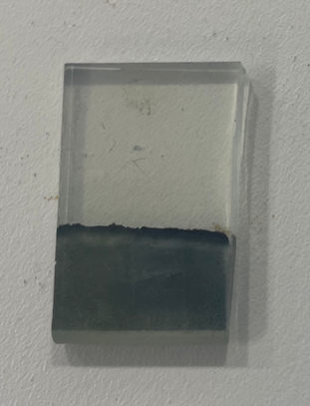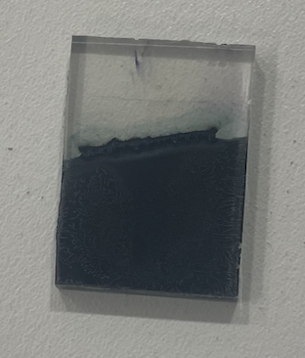
(b)
(a)
Figure 2. Poly(aniline-co-o-toluidine) copolymer film a) in aqueous medium b) in acetonitrile

The growth of the copolymer in aqueous medium gave one anodic at 0.4 V and two cathodic peaks at 0.1 V and 0.4 V, respectively, while its irreversible peak appeared at 0.9 V. With the number of cycles, the current of copolymer film reaches up 0.6 mA over 100 cycles with a function of applied voltage. These results show that the copolymer present electroactive property as mentioned in the literature [7]. However, the electrochemical deposition of this copolymer revealed a better difference and higher electroactivity in acetonitrile because it reached a value of approximately 4 mA at the end of 100 scans. Additionally, the appearance of the resulting copolymer is darker, thicker, and more compact compared to the Figure 2a. This supports our claim that the use of organic solvents like acetonitrile can improve the properties of electroactive polymers.

  - Surface analysis of copolymer films
The surface morphology of the doped polyaniline films is shown in Figure 3 and Figure 4. AFM analysis showed that the films have a thick and porous surface with nanospheres. The fact that the copolymer film obtained in aqueous medium is thinner than the other copolymer film shows the polymerization happens more efficiently in acetonitrile.

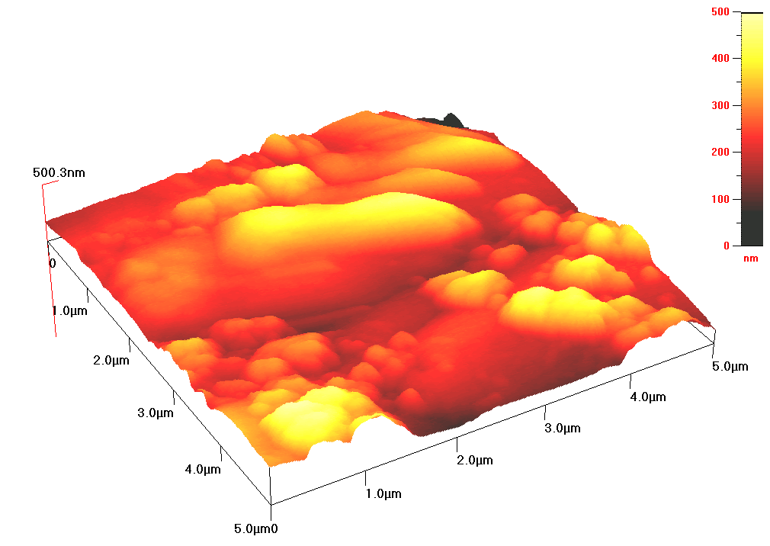
Figure 3. Three-dimensional (3D) AFM images for poly(aniline-co-o-toluidine) copolymer generated in aqueous medium.
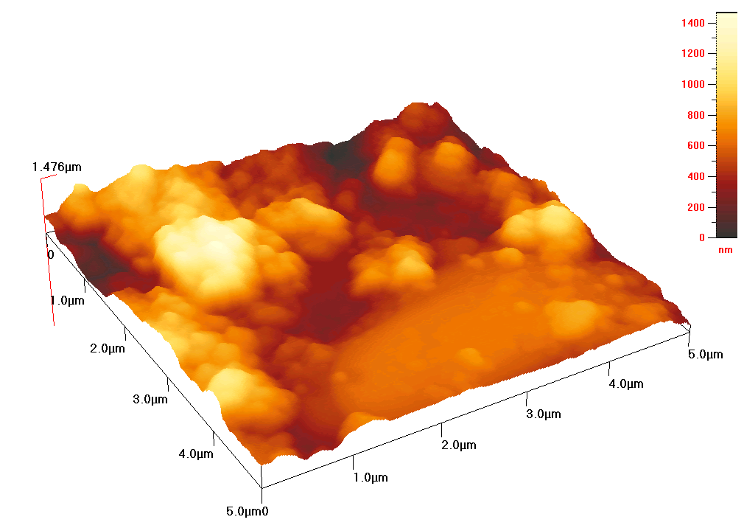
Figure 4. Three-dimensional (3D) AFM images for poly(aniline-co-o-toluidine) copolymer generated in acetonitrile.

- Conclusion

This study covers the analysis of the electrocoating of poly(aniline-co-o-toluidine) on the conductive surface of FTO glasses in aqueous medium and acetonitrile. The results show that the choice of acetonitrile as solvent provided the synthesis of more electroactive copolymer film compared to the copolymer film obtained in aqueous medium. Also, its morphology analysis showed that the copolymer film is more compact and homogenous film. Also, its chemical stability is much better than homopolymers because it did not overoxidized with continuing cycle like polyaniline. This is a sign that this copolymer can be used in practical applications such as chemical sensors.

Acknowledgement

All experimental works were conducted in Çankırı Karatekin University Research Laboratory. The author would like to thanks to all supporters due to their precious contributions.

References

[1] R.C. Alkire, D.M. Kolb, J. Lipkowski, P.N. Ross, Chemically Modified Electrodes, 2011. https://doi.org/10.1002/9783527627059.
[2] K.D. Snell, A.G. Keenan, Surface modified electrodes, Chem Soc Rev. (1979). https://doi.org/10.1039/CS9790800259.
[3] M.W. Espenscheid, A.R. Ghatak-Roy, R.B. Moore, R.M. Penner, M.N. Szentirmay, C.R. Martin, Sensors from polymer modified electrodes, Journal of the Chemical Society, Faraday Transactions 1: Physical Chemistry in Condensed Phases. (1986). https://doi.org/10.1039/F19868201051.
[4] G. Inzelt, Conducting polymers: past, present, future, Journal of Electrochemical Science and Engineering. (2017). https://doi.org/10.5599/jese.448.
[5] G. Inzelt, M. Pineri, J.W. Schultze, M.A. Vorotyntsev, Electron and proton conducting polymers: Recent developments and prospects, Electrochim Acta. (2000). https://doi.org/10.1016/S0013-4686(00)00329-7.
[6] A.A. Syed, M.K. Dinesan, Review: Polyaniline-A novel polymeric material, Talanta. (1991). https://doi.org/10.1016/0039-9140(91)80261-W.
[7] A. Unal, A. Robert Hillman, K.S. Ryder, S. Cihangir, Electrogravimetric analysis of poly(aniline-co-o-toluidine) copolymer films in the presence of fluoride ions, Journal of Electroanalytical Chemistry. 895 (2021). https://doi.org/10.1016/j.jelechem.2021.115519.
[8] A. Unal, A.R. Hillman, K.S. Ryder, S. Cihangir, Highly Efficient Defluoridation of Water through Reusable poly(aniline-co-o-aminophenol) Copolymer Modified Electrode Using Electrochemical Quartz Crystal Microbalance, J Electrochem Soc. 168 (2021). https://doi.org/10.1149/1945-7111/abd926.

* Corresponding author. e-mail address: asumanunal@karatekin.edu.tr

