Optically Transparent FSS-Based Absorber for Electromagnetic Shielding in 5G Applications
Ömer Faruk GÜNAYDIN^{1,}∗ , Sultan CAN²
¹ Institute of Science, Engineering, Electrical and Electronics, Ankara University, Ankara, Turkey
² Institute of Science, Engineering, Electrical and Electronics, Ankara University, Ankara, Turkey

Abstract
In this study, a frequency selective surface (FSS)-based absorber that can be used in 5G applications is proposed. The FSS-based absorber is designed to shield 3.5 GHz, the most used frequency in 5G applications. The purpose of the application is to create an electromagnetic shield for the 3.5GHz frequency and to protect devices that can be used at this frequency from electromagnetic interference. Parametric analysis is conducted employing three-dimensional full-wave electromagnetic simulation software (CST Studio Suite®). This analysis aims to verify the suitability of the chosen ground thickness and FSS pattern in meeting the specified frequency requirements. Simulation results indicate that both the ground line thickness and the diameter of the circular ring play pivotal roles in shaping the frequency characteristics of the frequency selective surface. In the design of the FSS-based absorber, transparent PVC with a dielectric constant of 2.77 was used as the dielectric material and copper as the conductor. The measurements taken from the fabricated sample were aligned with the simulation outcomes, showcasing a consistent agreement between the two sets of data.
Keywords: Frequency selective surface, Absorber, Electromagnetic shielding, Electromagnetic interference, 5G applications

- Introduction
Metamaterials are a new class of functional materials designed around macro- and nanoscale patterns or structures that cause them to interact with light and other forms of energy in ways not found in nature[1]. They are artificial materials that can achieve electromagnetic properties that do not occur naturally, such as a negative refractive index or electromagnetic cloaking. These artificially engineered composite materials derive their properties from internal micro- and nanostructures rather than the chemical composition found in natural materials[2]. Their shape, geometry, size, orientation and arrangement give them properties that can manipulate electromagnetic waves. They can be used more efficiently than traditional materials by blocking, absorbing, enhancing or bending electromagnetic waves. The two-dimensional or surface counterpart of metamaterial are called metasurface[3]. It is also called metafilm in the literature [4]. Metasurface is defined as periodic structures in which the thickness and periodicity of unit cells are smaller than the wavelength[3-5]. Frequency selective surface(FSS) is a periodic surface with identical two-dimensional arrays of elements arranged on a dielectric substrate[6]. They are frequently used in communication systems for spectral filtering. FSS are designed to reflect, transmit and absorb electromagnetic fields depending on the frequency of the field[7].
Manipulation of electromagnetic waves(EM) is one of the important topics in modern optics and photonics[8]. Conventional materials generally use properties of light such as propagation and refraction to manipulate EM waves, meaning their ability to manipulate the waves is limited[9]. Metasurfaces which have unique abilities to block, absorb, concentrate, scatter, or direct the waves have emerged as an alternative application for controlling EM waves[10-11]. The amplitude, phase or polarization of EM waves can be easily controlled by changing the structural parameters of the metasurface or the constituent materials of the meta-atoms that make up the metasurface[12]. Electromagnetic emissions have the potential to impact the operation of electronic devices, electrical systems, and radio frequency (RF) systems. Due to the inherent nature of circuit electricity, virtually all electronic devices emit a certain degree of electromagnetic radiation.
Absorbers are materials that are used to attenuate/absorb signals up to a specific frequency when passed through an absorbing material and they are designed and shaped to absorb incoming electromagnetic radiation. Metamaterial absorbers have found a lot of use in the stealth technology due to their features such as ease of production, easy design and good, broadband absorption. Also there are many studies in the literature where metamaterials are used as radio frequency absorbers[13-14]. Parameters such as frequency range, surface resistance, operating temperature, form factor and thickness play an active role in determining the design of a metamaterial-based radio freaquency(RF) absorber. RF absorbers are critical in a variety of applications across multiple industries. For example, in aerospace and defense, RF absorbers are used in the design and testing of radar systems and stealth technologies. In the telecommunications sector, RF absorbers help prevent interference in signal transmission, improving the quality and reliability of communication networks[8-15]. Metamaterial absorbers are used to improve the isolation of antennas. Radiated power from nearby antennas, coupled through radiation and passing through the common ground plane, can be absorbed by absorber structures. And so the unwanted power between the antennas is isolated, which improves the quality of the communication[15].
In this study, FSS-based absorber is presented to provide electromagnetic shielding in 5G applications. Electromagnetic (EM) shielding offers a reliable method for safeguarding delicate electronic devices against electromagnetic interference (EMI), serving as a spatial filter to block specific frequency ranges. While many FSS-based EM shielding structures are devised to reflect incoming waves, this reflective approach can potentially create EMI issues for nearby devices and equipment, especially in densely populated electronic environments. On the contrary, absorptive FSS shielding presents a viable solution in such settings, offering an effective alternative that mitigates these concer. The study focused on 3.5GHz (n77), which is the most used 5G band. Transmission of other frequency bands is allowed. The aim of the study is to minimize the effect of electromagnetic interference on devices operating with the 5G frequency band 3.5GHz, which is widely used today.

- Materials and Methods
In the unit cell structure proposed in this study, transparent PVC, a dielectric material, is used as the substrate material and copper is used as the conductor material. The transparent PVC was cut according to the dimensions of the WR229 waveguide used in the measurements. Copper tape was used in the production of the conductive material. The 2D drawing of the proposed design was drawn in Autocad with actual dimensions. This 2D drawing and the copper tape were sent to the printer at the same time and the drawing was made on the copper tape. Thus, the required conductive parts were cut according to the reference drawing on the copper tape. The cut conductive copper patches were glued to the actual position on the transparent PVC. After production was completed, the dimensions of the design were tested with the WR229 waveguide. Minor problems caused by production were resolved using waveguide. Simulation studies and parameter analyzes for the designed model were carried out using the CST Microwave Studio program.
- Results and Discussion
  - Unit Cell Design
The geometry of the top and bottom surface of the proposed unit cell design is given in Figure 2. The optically transparent PVC used as substrate has width W, length L and thickness h_{s}. In the conductor part, the diameter of the circle seen on the top surface is d, the width of the ground line on the buttom surface is W and the length is k. The thickness of the transparent PVC is 1.48 mm and the dielectric constant is 2.77. In the conductor part, copper is used as the material and its thickness is 35 microns.

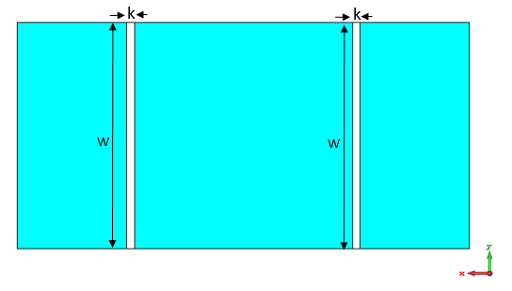 | 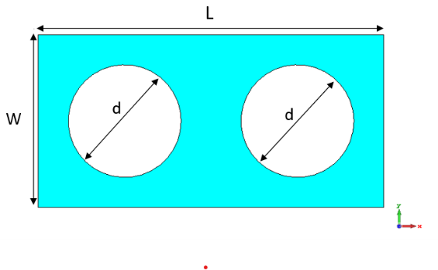
a) | b)

Figure 1. a) Unit cell geometry bottom view of proposed design, b) Unit cell geometry top view of proposed design

The design parameters of the proposed design was given in Table1. As can be seen in the figure, the diameters of the circles used on the top surface are equal to each other and are d. In addition, the thickness of all the conductive shapes used is the same, 35microns. Single-layer absorbers using FSS incorporate sheets that offer both resistive and reactive elements. The resistive aspect connects to the material's lossy properties, while the reactive component corresponds to the lengths and gaps between the elements.
Table1. Design parameters of the proposed unit cell
Design Parameters
W | L | k | d | hs | hc
29.083 mm | 58.166 mm | 1 mm | 19 mm | 1.48 mm | 0.035mm

  - Boundary Conditions
The surface current distributions of the structure are presented in Figure 2a and Figure 2b for the FSS and conducting plate. As can be seen in the figure, the current density on the bottom side of the design, called the conducting plate, is much higher than the circles on the front surface. To simplify, the illustration shows the current path of each element at its specific resonant frequency, offering an explanation for the resonance mechanism behind the proposed design of the FSS unit cell. The E and H field directions for TE polarization are presented in Figure 4.

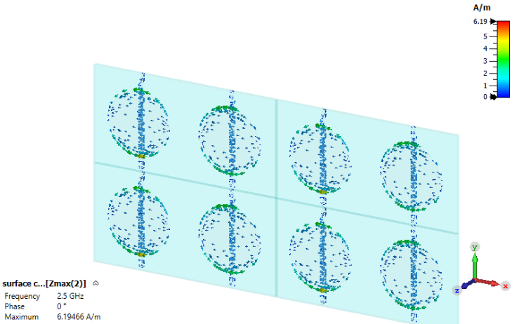 | 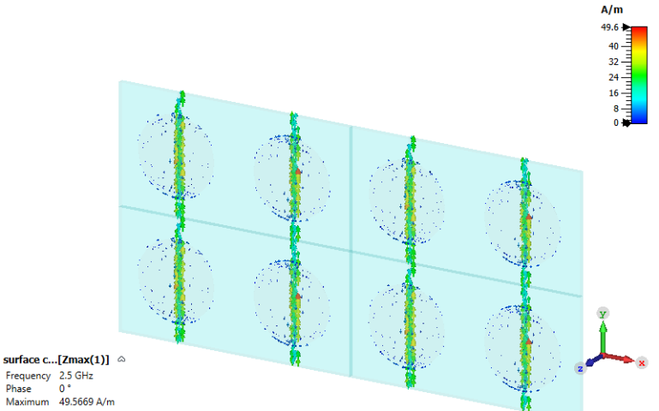
a) | b)

Figure 2. Surface current distrubition a) FSS, b) Conducting plate

  - Absorption S11 and S21
Electromagnetic waves directed at the absorber undergo reflection, transmission, or absorption. The absorption coefficient (A) signifies the proportion of incident power absorbed by the frequency selective surface. It's represented by equation (1). As a copper layer exists at the absorber's base, minimal power is transmitted through, resulting in S21=0.
$A=1- {\left|S_{11}\right|}^{2}-{\left|S_{21}\right|}^{2}$ (1)
This equation indicates that a decrease in return loss corresponds to increased absorption. In the proposed design, a return loss below -10 dB is consistently observed within the 3.4 -3.7 GHz. range. The design parameters in the design were varied and their effects on the frequency characteristics were observed by simulation.

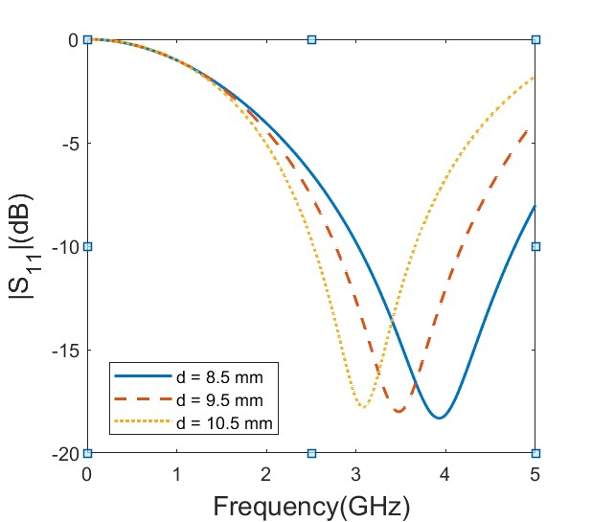 | 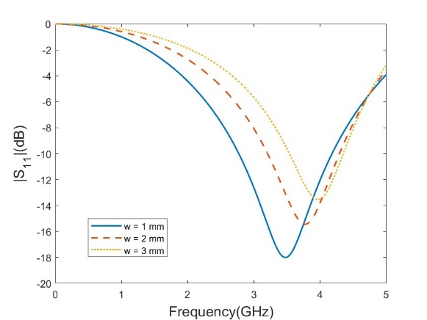
a) | b)
Figure 3. a) The effect of diameter to frequency, b) The effect of copper patch width of ground plate

Figure 3a explored the impact on resonance frequency by altering the diameter of the circle on the front surface. As the diameter decreases, the resonance frequency rises, and conversely, as it increases, the resonance frequency declines. A change of about 1mm in diameter led to an approximate shift of 0.5GHz in the resonance frequency. In Figure 3b, the influence of copper patch thickness on the ground plane's rear surface on resonance frequency was investigated. It was noted that as the copper patch thickness increases, the resonance frequency also increases.

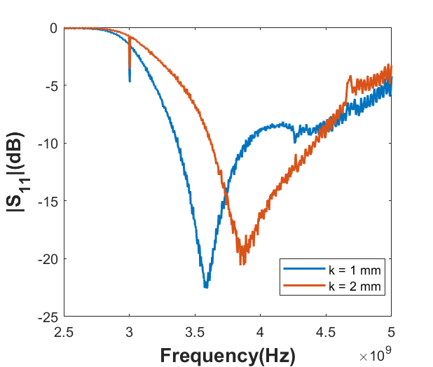 | 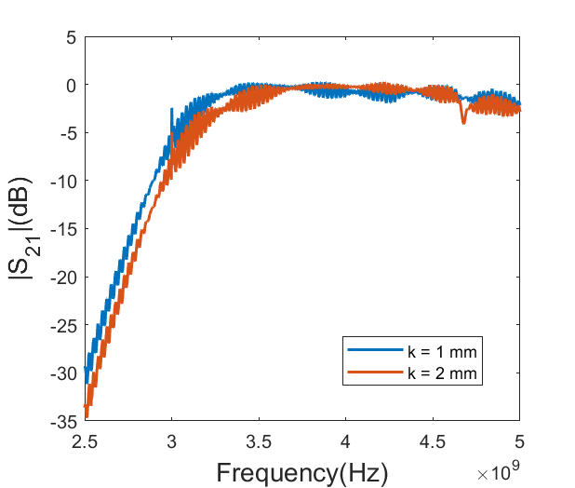
a) | b)

Figure 4. a) S11 comparasion of the different copper patches, b) S21 comparison of the copper patches

Figure 4a presents a comparison of resonance frequencies between two unit cells differing in copper patch thickness. Consistent with simulation outcomes, experimental findings confirm that resonance frequency escalates with an increase in copper patch thickness. Measurements conducted with copper patch thicknesses of 1 mm and 2 mm revealed a resonance frequency difference of 0.25GHz. Figure 4b juxtaposes the transmission characteristics of these two distinct designs using the S21 parameter. The figure illustrates that both designs showcase S21 parameters hovering around 0 at the resonance frequency. This signifies the effective absorption capability of the proposed design within the specified frequency band. Referring to Formula 1, the proximity of the S21 parameter to 0 further substantiates the heightened absorptive nature of the design.

  - Prototype and the experimental results
The proposed design was fabricated in the laboratory using transparent PVC and copper tapes. After fabrication, measurements were performed. Rohde Schwarz network analyzer, which can measure up to 14GHz, was used to measure dispersion characteristics such as reflection and transmission. WR229 waveguide was used to measure the frequency characteristics. The image of the fabricated prototype in the waveguide is shown in figure a.

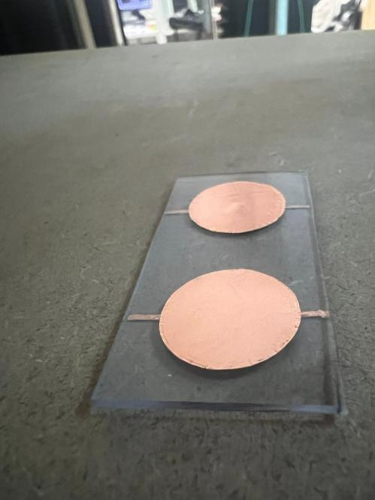 | 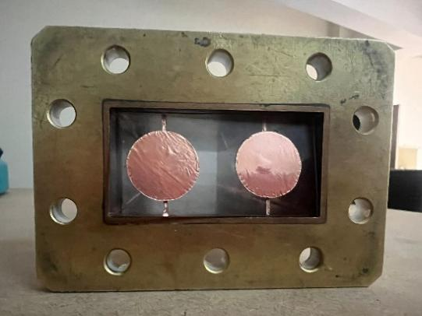 | 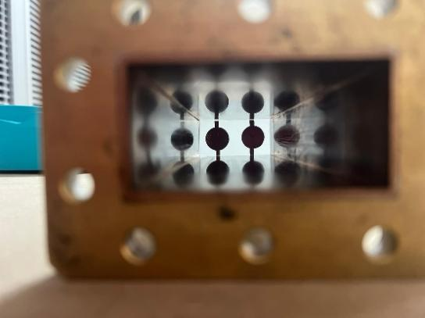
a) | b) | c)

Figure 5. a) Unit cell prototype b) Prototype in waveguide, c) Prototype in waveguide.
In the unit cell design given above, the thickness of the conductor on the bottom surface, k, is 1mm. In the simulations, this thickness was varied and its effect on the frequency characteristics was examined. At the same time, two more unit cells were produced for k values of 2 and 3 mm and measurements were performed. Simulation results and measurement results are compared.

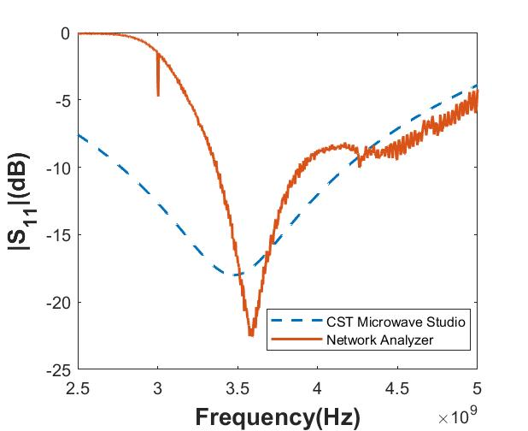

Figure 6. S₁₁ comparison of the simulation and experimental result

Simulation studies and experimental measurements for different copper patch thicknesses were compared, and it was determined that the copper patch thickness of the most suitable design for the 3.5GHz band, which is one of the 5G applications to be used in practice, was 1 mm. As seen in Figure 6, the simulation results and measurement results are very close to each other. The difference in resonance frequency between the two results is approximately 0.1GHz, and it is thought that this difference is due to possible errors in production. As a result, looking at the measurement results and S parameters, an FSS-based absorber with a bandwidth of 0.2GHz for the 3.5GHz frequency band was produced.

- Conclusion

In this study, an FSS-based absorber was specifically crafted to serve as electromagnetic shielding for the 3.5GHz frequency band, widely utilized in 5G applications. Through experimental studies, a noteworthy correlation between the experimental and simulation data was observed. A unique aspect of this research lies in the utilization of transparent PVC as a dielectric material, diverging from the conventional use of FR-4. This work revealed an easily fabricated structure that is not only low-cost but also capable of distinguishing transparency in the visible spectrum. Due to the flexibility of this structure used in the design, it is very suitable for use in many different shapes or different coating technologies. It is also possible to design a double band absorber by choosing different diameters of the circles used in the FSS part of the proposed design.

References

[1] Chaturvedi, P., Hsu, K., Zhang, S., & Fang, N. (2008), New frontiers of metamaterials: design and fabrication, MRS BULLETIN,Volume 33, pp. 915-920.
[2] Gangwar, K., Paras Dr., & Gangwar, Dr. R.P.S. (2014), Metamaterials: characteristics, process and application, SSN 2231-1297, Volume 4, pp. 97-10.
[3] Bukhari, S. S., Vardaxoglou, J., & Whittow, W. (2019), A metasurfaces Review : Definitions and Applications, Appl. Sciences.
[4] Kuester, E., Mohamed, M., Piket-May, M., & Holloway, C. (2003), Averaged transition conditions for electromagnetic fields at a metafilm, IEEE Trans. Antennas Propag., Volume 51, pp. 2641–2651.
[5] Yu, N., & Capasso, F. (2014), Flat optics with designer metasurfaces, Nat. Mater., Volume 13, pp. 139–150.
[6] Hussein, M., Hung, Y., & Zhou, J., Frequency selective surface with miniaturize different elements: a different approach.
[7] Kohlgraf, D.C. (2005), Design and testing of a frequency selective surface (FSS) based wide-band multiple antenna system, pp. 6-8.
[8] Zheludev, N.I. (2015), Obtaining optical properties on demand, Science 348, pp. 973-974.
[9] Yu, S., Cheng, J., Li, Z., Liu, W., Cheng, H., Tian, J., & Chen, S.(2022), Electromagnetic wave manipulation based on few-layer metasurfaces and polyatomic metasurfaces, ChemPhysMater, Volume 1, pp. 6-16.
[10] Luo, K.(2015), Principles of electromagnetic waves in metasurfaces, Sci. China Phys. Mech. Astron., Volume 58.
[11] Chen, S., Li, Z., Liu, W., Cheng, H., & Tian, J.(2019), From single-dimensional to multidimensional manipulation of optical waves with metasurfaces, Adv. Mater., Volume 31, 1802458.
[12] Ozden, K., Yucedag, M.O., & Kocer, H.(2016), Metamaterials based broadband RF absorber at X-band, AEU-International Journal of Electronics and Communications, Volume 70, pg. 1062-1070.
[13] Jorwal, S., Dubey, A., Gupta, R., & Agarwal, S.(2023), A review:Advancement in metamaterial based RF and microwave absorbers, Sensor and Actuators, Volume 354.
[14] Costa, F., Genovesi, S., Monorchio, A., & Manara, G.(2019), A circuit-based model for the interpretation of perfect metamaterial absorbers, IEEE Trans. Antennas Propag., Volume 61, pp. 1201–1209.
[15] Agarwal, M., & Meshram, K.M. (2016), Isolation improvement of 5GHz WLAN Antenna Array using Metamaterial Absorber”, URSI Asia-Pasific Radio Science Conference.

* Corresponding author. e-mail address: ofgunaydin.@ankara.edu.tr

