**Improved Speed and Torque Efficiency for DTC Controlled Asynchronous Machine Using Fuzzy Switching Algorithm**

***Goksu GOREL1,\*[C:\Users\Abdullah\AppData\Local\Microsoft\Windows\INetCache\Content.Word\ORCID-iD_icon-16x16.gif](https://orcid.org/0000-xxxx-xxxx-xxxx), Wahib HILOUAN MOHAMED2[C:\Users\Abdullah\AppData\Local\Microsoft\Windows\INetCache\Content.Word\ORCID-iD_icon-16x16.gif](https://orcid.org/0000-xxxx-xxxx-xxxx)***

*1 Institute of science, Faculty of engineering, Department of electrical and electronic, Çankırı Karatekin University, Çankırı, Turkey*

*2 Institute of science, Faculty of engineering, Department of electrical and electronic, Çankırı Karatekin University, Çankırı, Turkey*

|  |
| --- |
| **Abstract**  A vector form of control called direct torque control is based on stator flux and torque. Takashi invented it in the middle of the 1980s. Control of the primary components of an asynchronous machine, particularly the stator flux and electromagnetic torque, is possible by direct selection of the inverter's output voltage vectors. These choices are done in a manner that keeps both values inside a hysteresis band. Through the use of two regulators, the PI controller and fuzzy logic, this study aims to reduce torque ripple while also accomplishing motor speed control. To determine which performs better, comparisons will be made [1] [2] [3] [4] [5]. The results will be shown by using Matlab/Simulink at the end of the article, and a discussion will be made by comparing those two regulator. |
| Keywords: Asynchronous machine, direct torque control, fuzzy logic, pi regulator |

1. **Introduction**

The asynchronous machine is the most widely used machine for achieving speed variations. It has a default unlike the DC machine, in which the power supply causes the same current to create the flux and the torque, by causing a flux variations obtained by the torque variations.

The DTC is the most efficient, straightforward, and accurate method of torque control for IM drives. With the exception of stator resistance, it is widely known for being tolerant to changes in motor parameters. The drive performance may suffer if the parameters speed, or loads are changed because the majority do not provide the quickest torque response [6]. Speed management is one of the most crucial components of an IM drive and must be handled skillfully. Researchers have been working on kind solutions to help DTC perform well for decades. Our study is focusing on applied direct torque control on the induction machine while using fuzzy logic controller, and PI regulator. Then seing the difference between them and the performance they can afford.

1. **Materials and Methods**

**2.1. Direct torque control method**

Direct Torque Control (DTC) has replaced previous methods, particularly Field Oriented Control, more and more in the industry. The DTC estimates the stator flux and torque of the motor using stator current measurements without the use of electromechanical sensors.

Direct torque control has gained popularity due to its quick dynamic torque feedback and easy control structures. In contrast to other control systems, the direct torque control approach still has a number of drawbacks. The most prominent of these is excessive torque ripple, which can lead to problems with motor performance [7].

In order to control the electro-magnetic torque and stator flux, a voltage inverter is switched using a control sequence that must be determined. Hysteresis controllers are in charge of regulating the system's state while taking electromagnetic torque and the amplitude of the stator fluctuation into account.

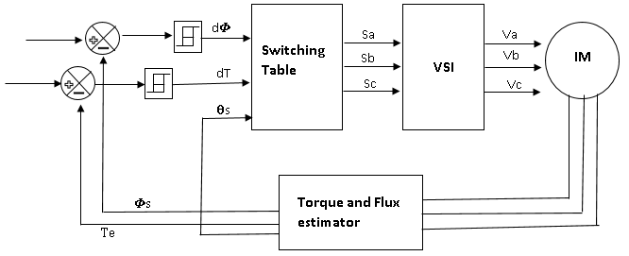

**Figure 1**: The conventional structure of direct torque control.

Seven possible points in the phase plane, or eight sequences of the voltage vector at the inverter output, are reachable by the inverter (a two-level inverter). The following figure 2 can be used to demonstrate direct control of the conventional torque of a three-phase asynchronous machine:

The inverter's purpose is to convert a DC voltage E (provided by a rectifier or another DC supply) into three simple AC voltages noted Van, Vbn, and Vcn that are given to the motor as a three-phase system with variable frequency and amplitude. The logical Sa, Sb, Sc operate the converter. The voltage vector Vs can have two null vectors (V0 and V7) and six non-null vectors, as shown in Figure 2, when the converter's various states are combined.

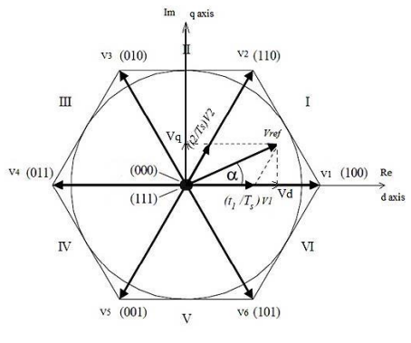

**Figure 2**: Voltage vector Vs based on switching states

The following equation is a representation of the voltage vector:

$Vs=\sqrt{\frac{2}{3}}*E\left(Sa+a*Sb+a^{2}*Sc\right)$ (1)

The following equation is a representation of the voltage vector:

There are six zones within the (\_s)) movement area, with i=[1;6].

One of the eight voltage vectors given below can be utilized to control the flux and torque while it is inside a zone i [8].

When $V (i+1)$ is selected, $\left(Φ_{s}\right)$ and $\left(Γ_{em}\right)$ rise.

If $V (i-1)$ is selected, $\left(Φ_{s}\right)$ rises and $\left(Γ_{em}\right)$ decreases.

If $V \left(i+2\right)$ is selected, both $\left(Φ_{s}\right)$ and $\left(Γ_{em}\right)$ increase.

If V (i-2) is selected, $\left(Φ_{s}\right)$ and $\left(Γ_{em}\right)$ decrease as well.

If V 0 and V 7 are selected, the rotation of the stator flux is halted and a sharp reduction in $\left(Γ_{em}\right)$ is demonstrated while still taking into consideration the fact that the stator value is unaltered.

At the beginning of the region, the. vectors V\_i and V\_(i+3) are not used because the flux component is very strong with a zero torque in the middle of the. zone. At the end of the zone, the direction of the torque or flux evolution is the opposite.

The voltage vector at the inverter's output is calculated from the torque and flux differences, as well as the position of the vector Fs, in relation to their reference. A flux estimator in modulus and position is needed along with a torque estimator.

**2.1.1 Stator Flux and Torque Estimation**

The flux is shown as follows using the equation from the stator reference:

$Φ_{s}=\int_{0}^{t}{\left(V_{s}-R_{s}*I_{s}\right)ⅆt}$ (2)

The stator current is measured while the stator voltage depends on the state of the switches (Sa, Sb, Sc), and the DC link voltage E. Projecting on the two axes α and β, we will obtain the two components of the estimated stator flux vector:

$Φ_{s_{α}}=\int_{0}^{t}{\left(V_{s_{α}}-R_{s}*I_{s_{α}}\right)ⅆt}$ (3)

$Φ_{s_{β}}=\int_{0}^{t}{\left(V_{s_{β}}-R_{s}*I_{s_{β}}\right)ⅆt}$ (4)

When we use Concordia's transformation, we get:

$V_{s_{α}}=\sqrt{\frac{2}{3}}*E*(s_{a}-\frac{1}{2}\left(s_{b}+s_{c}\right)$ (5)

$V_{s_{β}}=\sqrt{\frac{1}{2}}*E*\left(s_{b}-s_{c}\right)$ (6)

$V_{s}=V_{sα}+jV_{sβ}$ (7)

Similar to how the currents Is and Is are produced from the measurement of the machine's true currents Isa, Isb, and Isc (Isa+Isb+Isc= 0), we also get the following results after performing the CONCORDIA transformation:

$I_{s_{α}}=\sqrt{\frac{2}{3}}*I_{sa}$ (8)

$I_{s_{β}}=\sqrt{\frac{1}{2}}*\left(Is_{b}-{Is}_{c}\right)$ (9)

$I_{s}=I_{sα}+jI_{sβ}$ (10)

From the two flux components in frame -, the estimated stator flux's angle and amplitude are calculated as follows:

$Φ_{s}=\sqrt{Φ_{s_α}^{2}+Φ_{s_β}^{2}}$ (11)

$θ_{s}=atan\left(\frac{Φ_{sα}}{Φ_{sβ}}\right)$ (12)

The measured currents and estimated fluxes can be used to estimate the electromagnetic torque, which can be represented as follows:

$Te=\frac{3}{2}p*(Φ_{s_{α}}I_{s_{β}}-Φ_{s_{β}}I_{s_{α}})$ (13)

**2.1.2 Stator Flux and Torque Hysteresis Comparator**

This corrector is used to maintain the end of the stator flux vector in a circular band. The error between the reference flux and the estimated flux is injected into the two-level hysteresis controller. It generates at its output the variable  Φflux which indicates whether the amplitude should be increased or decreased.

The electromagnetic torque can be positive or negative depending on the direction of rotation of the machine. It is possible to propose two solutions (two-level or three-level corrector) The two-stage corrector allows controlling in one sense of rotation only [9].

**2.1.4 Switching Table**

The state of the Boolean variables at the output of the two flux correctors, the electromagnetic torque, and the sector providing the information on the position of the flux vector are taken into account when creating the switching table.

**Table 1** Switching table.

|  |  |  |  |  |  |  |  |
| --- | --- | --- | --- | --- | --- | --- | --- |
| **Flux** | **Torque** | **S1** | **S2** | **S3** | **S4** | **S5** | **S6** |
|  | dT=-1 | V3 | V4 | 5 | V6 | V1 | V2 |
| d𝜱=1 | dT=0 | V0 | V7 | V0 | V7 | V0 | V7 |
|  | dT=1 | V5 | V6 | V1 | V2 | V3 | V4 |
|  | dT=-1 | V2 | V3 | V4 | V5 | V6 | V1 |
| d𝜱=0 | dT=0 | V7 | V0 | V7 | V0 | V7 | V0 |
|  | dT=1 | V6 | V1 | V2 | V3 | V4 | V5 |

**2.2 Speed Controllers**

Pid controller is widely used in industries to regulate pressure, temperature, speed, flow, e.g. Subordinate mode improves the model system's soundness and allows for an increase in gain Kp. In the actual world, the PID controller seems to be a very effective approach to a variety of control problems [10] [11].

The mathematical form of this controller can be described as follows:

$U\left(t\right)=Kpe\left(t\right)+Ki\int_{0}^{t}{e\left(τ\right)dτ}+Kd\frac{de\left(t\right)}{dt}$ (14)

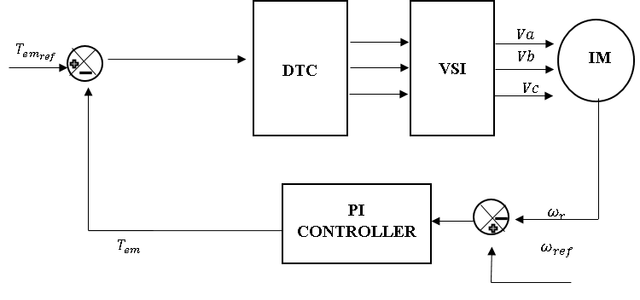

**Figure 3**: The design of PI speed controller.

The fuzzy logic controller (FLC) does not deal with a well-defined mathematical relationship. Instead, it uses inferences with several rules, based on linguistic variables. In this section, we will present the general procedure of designing a fuzzily-controlled computer system [9].

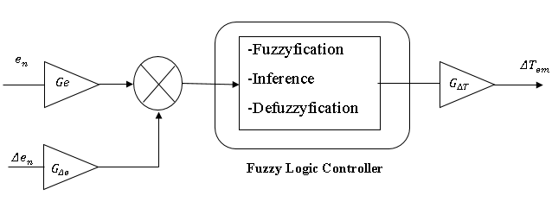

**Figure 4**: The design of Fuzzy logic speed controller.

The variables that reflect the error, its speed change, and the change in output can be normalised in the manner shown below:

$e_{n}=\frac{e}{G_{e}}$ (15)

${Δe}_{n}=\frac{Δe}{G_{de}}$ (16)

${ΔT}_{em}=\frac{ΔT_{em}}{G_{ΔT}}$ (17)

**3. Results and Discussion**

**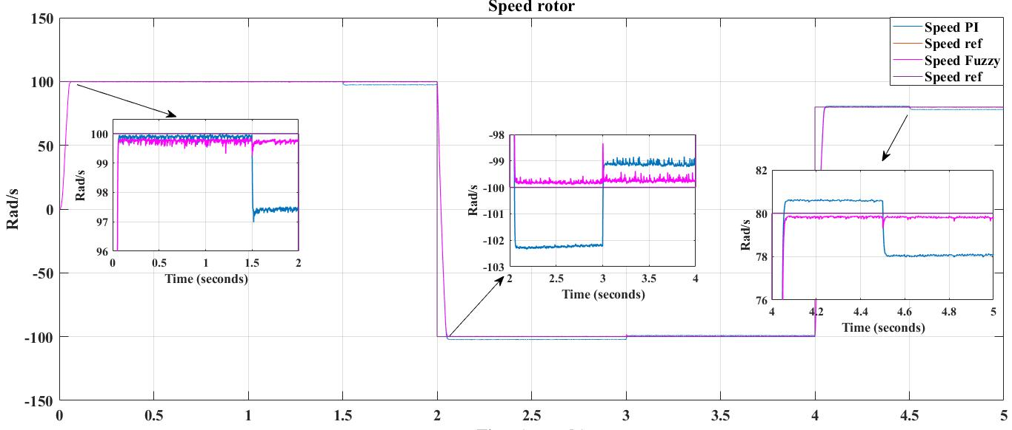**

**Figure 5** Rotor speed’s response.

Both methods showed excellent response at start-up, but when the speed reference was changed, the fuzzy logic showed excellent performance not only in tracking the reference point but also when a change in torque reference was modified, it also showed excellent response, as you can see in the figure. In terms of efficiency and responsiveness, the fuzzy logic clearly outperforms the PI regulator.

**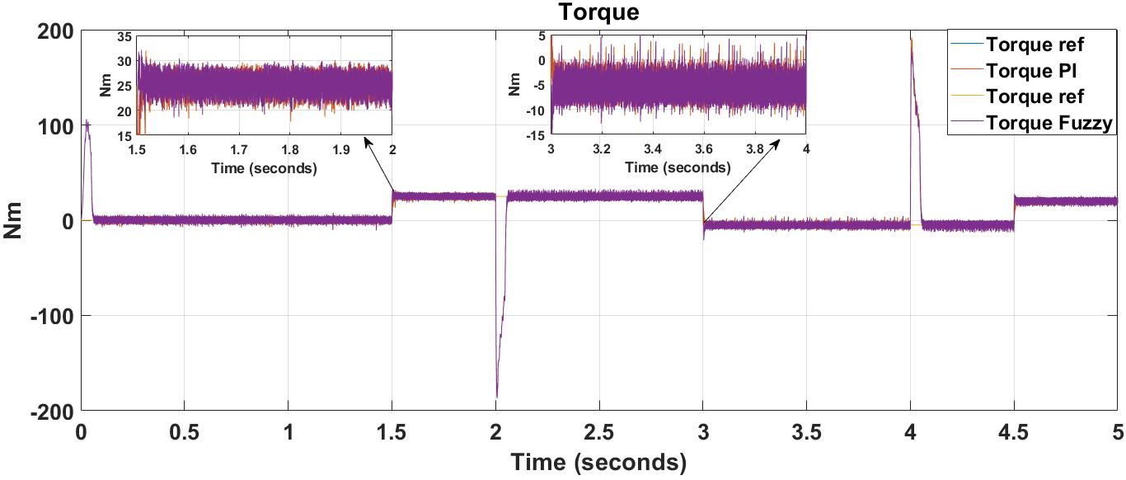**

**Figure 6** Torque’s result.

At t= 1.5 s to t=2 s, The fuzzy logic method has slightly reduced the torque ripple in contrast to the PI regulator, as shown in the figure. However, both of them shows a slight ripple when the torque becomes negative.

**3.1 Conclusion**

In conclusion, by directly choosing the output voltage vectors of the inverter from a switching table, the primary asynchronous machine characteristics, notably the stator flux and the electromagnetic torque, are controlled. These decisions are taken in order to keep both quantities within a hysteresis band that is within the bounds of their reference values.

İn addition, After comparing these two controllers, it is found that fuzzy logic provides better efficiency and reference point tracking than the Pi controller when the speed reference is changed.

**References**

1. Korkmaz, F., Cakir, M. F.and Topaloglu, I. (2012). Fuzzy based stator flux optimizer design for direct torque control. arXiv preprint arXiv:1212.0160.
2. Farah, N., Talib, H. N. and Isa, Z. (2021). Fuzzy membership functions tuning for speed controller of induction motor drive: Performance improvement. *Indonesian Journal of Electrical Engineering and Computer Science*, 23(3), 1258-1270.
3. Patel, C., Rajeevan, P. P. and Kazmierkowski, M. P. (2011). Fast direct torque control of an open-end induction motor drive using 12-sided polygonal voltage space vectors. *IEEE Transactions on Power Electronics*, 27(1), 400-410.
4. Korkmaz, F., Topaloğlu, İ., and Mamur, H. (2015). Fuzzy logic based direct torque control of induction motor with space vector modulation. arXiv preprint arXiv:1508.01345.

[5] El-Shimy, M. E., and Zaid, S. A. (2016). Fuzzy PID controller for fast direct torque control of induction motor drives. *Journal of Electrical Systems*, 12(4), 687-700.

[6] Yordanova, S. (2015). Intelligent approaches to real time level control. International Journal of Intelligent Systems and Applications, 7(10), 19.

[7] Farah, N., Talib, H. N. and Isa, Z. (2021). Fuzzy membership functions tuning for speed controller of induction motor drive: Performance improvement. *Indonesian Journal of Electrical Engineering and Computer Science*, 23(3), 1258-1270.

[8] Cheok, A. D., and Fukuda, Y. (2002). A new torque and flux control method for switched reluctance motor drives. *IEEE Transactions on Power Electronics*, 17(4), 543-557.

[9] Chikhi, A., Chikhi, K., and Belkacem, S. (2010). Induction Motor Direct Torque Control–Fuzzy Logic Contribution. *IU-Journal of Electrical & Electronics Engineering*, 10(2), 1207-1212.

[10] Aggarwal, A., Rai, J. N., and Kandpal, M. (2015). Comparative Study of Speed Control of Induction Motor Using PI and Fuzzy Logic Controller. *IOSR Journal of Electrical and Electronics Engineering (IOSR-JEEE)*, *10*(2), 43-52.

[11] Abdullah, A. N., and Ali, M. H. (2020). Direct torque control of IM using PID controller. *International Journal of Electrical and Computer Engineering*, 10(1), 617.