# A DENSITY FUNCTIONAL THEORY ANALYSIS OF THE PRESSURE-INDUCED MECHANICAL STABILITY OF KNiF3 PEROVSKITE COMPOUND

***Belgin KOÇAK1,[[1]](#footnote-1)\*[C:\Users\Abdullah\AppData\Local\Microsoft\Windows\INetCache\Content.Word\ORCID-iD_icon-16x16.gif](https://orcid.org/0000-0002-4395-4467) and Yasemin Öztekin ÇİFTCİ2[C:\Users\Abdullah\AppData\Local\Microsoft\Windows\INetCache\Content.Word\ORCID-iD_icon-16x16.gif](https://orcid.org/0000-0003-1796-0270)***

*1Vocational School of Higher Education, Department of Electronics and Automation, Ostim Technical University, Ankara, Turkey*

*2Faculty of Science, Department of Physics, Gazi University, Ankara, Turkey*

|  |
| --- |
| **Abstract**  In this study, we employed density functional theory to evaluate the structural, electronic, and mechanical properties of the KNiF3 cubic perovskite compound, which belongs to the *Pm3m* space group, under high-pressure conditions ranging from 0 to 100 GPa. The results were calculated employing the GGA-PBE approximation in the Vienna Ab initio Simulation Package (VASP) code. Our findings were compared with existing research, and consistent results were obtained. The mechanical properties that our calculations determine are the following: Cauchy pressure, bulk modulus, Young's modulus, shear modulus, Pugh's ratio, Poisson's ratio, hardness, machinability index, Zener anisotropy factor, sound velocities, and Debye temperature. KNiF3 compound was found to meet the criteria for mechanical stability and exhibited consistent mechanical stability across the entire 0 to 100 GPa pressure range. The computed mechanical properties suggest that KNiF3 is a ductile material, and its ductility increases with pressure. The elastic anisotropic mechanical properties were visually represented. The estimation of electronic properties has been performed through spin-polarized calculations. |
| Keywords: KNiF3, density functional theory, structural properties, mechanical stability |

1. **Introduction**

KNiF3 compound has a member of fluoride perovskite family, which has drawn a lot of interest in technological applications [1-11]. Despite the interest in fluoride perovskite alloys, the physical properties of the KNiF3 compound have been researched poorly under pressure, to the best of our knowledge. A few experimentally measured reports on this compound's band structure [2-5]. Experimentally, Onuki et al. [2] have studied absorption sprectra of KMF3 (M=Mn, Fe, Co, Ni, Cu, and Zn) compounds. Shulman et al. [3] measured x-ray-absorption spectra of KMF3 (M=Mn, Fe, Co, Ni, and Zn) compounds via synchrotron radiation. Using X-ray diffraction data, the topological analysis of the electron density of KNiF3 were reported by Tsirelson et al. [4]. They noticed that the K-F interaction is ionic and the Ni-F bond shows polar covalent type in KNiF3. Rousseau et al. [5] were reported on the elastic constants of perovskite AMF3 (A =K, Rb; M=Mg, Ni, Co, Zn, Mn) compounds by long waves method. Kitamura et al. [6] studied electronic properties of KMF3 (M = Mn, Fe, Co, Ni, Cu, and Zn) compounds.

The electronic properties, magnetic properties and elastic properties of KNiF3 has been obtained by Ref [7] using the ab initio method within Hartree-Fock approach as implemented in the CRYSTAL code. They found that KNiF3 is a large gap insulator in ferromagnetic and antiferromagnetic phase [7]. Pari et al. [8] is theoretically investigated antiferromagnetic electronic structure of title compound. Moreira et al. [9] studied the magnetic coupling of KNiF3 via an ab initio method within cluster model approach. Erum and Iqbal [10] calculated the elastic, optic and magneto-electronic features of KNiF3 via an ab initio method. They point out that KNiF3 compound shows ductile and anisotropic characteristic. The first principle calculation of electronic and magnetic properties for title compound is also reported in Ref [11] using WIEN2K package. They reported KNiF3 compound is elastically stable in Pm3m space group.

1. **Materials and Methods**

In this study, the properties being investigated include structural, electronic, elastic, and related properties of the KNiF3 compound were obtained using first-principles calculations within Vienna Ab-initio Simulation Package (VASP) [12]. The study covers a pressure range from 0 to 100 GPa.The interaction between valence electrons and ionic cores is modeled using the projector-augmented-wave (PAW) [13, 14] approach. The generalized gradient approximation (GGA) is employed for the exchange-correlation energy. Specifically, the Perdew-Burke-Ernzerhof (PBE) functional is used [15]. The number of k-points was set to Monkhorst-Pack [16] scheme 16 x 16 x 16 after the convergence test, and the cut off energy was 700 eV. These numbers were sufficient to satisfy convergence criterion for KNiF3 compound.

1. **Results and Discussion**

**3.1. Geometric optimization**

By employing fully geometrical relaxation, the predicted KNiF3 lattice parameters are obtained. [Table 1](https://www.sciencedirect.com/science/article/pii/S0921452621007808#tbl1) present the computed values of lattice constant (a0) with experimental and theoretical value. The experimental lattice constants coincide quite well our prediction. The pressure effect of lattice constant for this compound is depicted in Figure 1. It is shown clearly that lattice constant of KNiF3 is decreased by increasing the pressure. This can be expressed that there exist stronger atomic interactions. Unfortunately, unavailability of theoretical or experimental results, the ambient pressure values of calculated lattice constants cannot be compared.

**Table 1.** Calculated structural equilibrium lattice constant a0 (in Å) of KNiF3.

|  |  |
| --- | --- |
| KNiF3 | ***a0* (Å)** |
| Present-PBE | 4.039 |
| Experimental [5] | 4.010 |
| Experimental [17] | 4.034 |
| Theory [7] | 4.10 |
| Theory [8] | 4.12 |
| Theory [10] | 4.013LDA  4.018 GGA |
| Theory [11] | 4.012 |

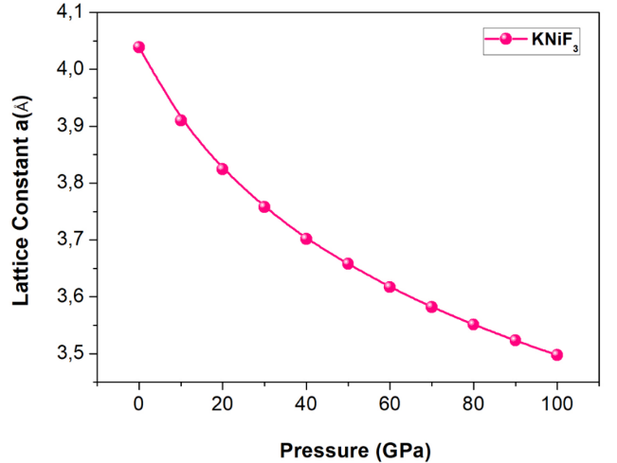

**Figure 1.** Pressure dependence of lattice constant of KNiF3.

**3.2. Mechanical stability**

Through application of the “stress-strain” method [18], the mechanical properties of cubic perovskite KNiF3 under high pressure are characterized by three independent elastic constants: C11, C12, and C44. Table 2 shows the computed Cij of KNiF3 at P = 0 GPa. According Table 2, our predicted elastic constant values at 0 GPa correspond well with the published experimental values [5]. Thus, our calculation approach is plausible and accurate. The results obtained at 0 GPa also agree with prior theoretical studies in general [7, 10, 11]. The elastic constants of the title compound rise with increasing pressure, as shown in Figure 2. It's also worth noting that under 100 GPa, the obtained C11, C12, and C44 are all positive and fullfill the requirements [19] for the cubic structure. It's also found that C11 is more susceptible to pressure than C44 which has the least effect.

**Table 2.** Elastic properties of KNiF3 at 0 GPa.

|  |  |  |  |  |  |
| --- | --- | --- | --- | --- | --- |
| **KNiF3** | **Present- PBE** | **Exp. [5]** | **Theory [7]** | **Theory [10]** | **Theory [11]** |
| C11 (GPa) | 140.96 | 158.2 | 168 | 121.231 | 115.73 |
| C12 (GPa) | 54.771 | 48.5 | 60 | 58.989 | 53.85 |
| C44 (GPa) | 36.278 | 40.3 | 46 | 46.639 | 41.63 |
| Cauchy Pressure (GPa) | 18.49 |  |  | 12.06 |  |
| B (GPa) | 83.50 |  | 79 | 80.217 | 89.26 |
| G (GPa) | 38.87 |  |  | 39.971 | 36.96 |
| Y (GPa) | 100.94 |  |  | 102.824 | 95.14 |
| B/G | 2.15 |  |  | 2.006 | 2.01 |
| ν | 0.299 |  |  | 0.29 | 0.2 |
| μM | 2.30 |  |  |  |  |
| A | 0.84 |  |  | 1.55 | 1.35 |
| Hv (GPa) | 5.15 |  |  |  |  |
| νl (m/s): | 5890.22 |  |  | 5440 |  |
| νt (m/s): | 3156.71 |  |  | 2980 |  |
| νm (m/s): | 3525.32 |  |  | 4210 |  |
| θ (K) | 444.3 |  |  | 320 |  |

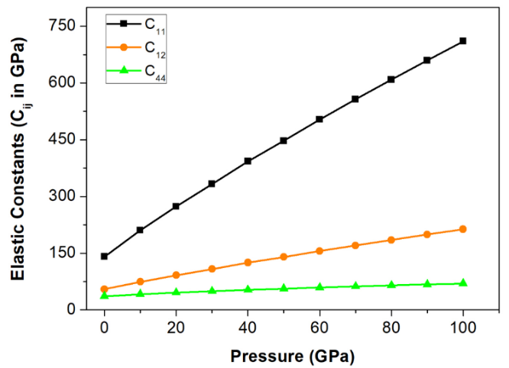 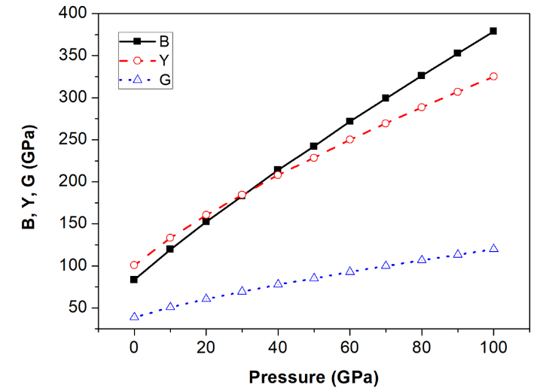

**Figure 2.** Pressure dependence of elastic properties of KNiF3 compound.

Furthermore, various additional mechanical properties, such as Cauchy pressure, bulk modulus (B), shear modulus (G), Young's modulus (Y), machinability index (μM), Zener anisotropy factor (A), Poisson's ratio (ν), Pugh's ratio (B/G), hardness (Hv), longitudinal wave velocity (νl), transverse wave velocity (νt), average wave velocity (νm), and Debye temperature (θ) were systematically calculated [20-27]. The corresponding values of these mechanical properties at 0 GPa are provided in Table 2, and their pressure dependence is illustrated in Figure 2. The bulk modulus (B), shear modulus (G), and Young's modulus (Y) exhibit an upward trend with increasing pressure within the specified pressure range.

Table 2 shows that the B/G ratios of KNiF3 are more than 1.75, indicating that it is ductile [24, 25]. At 0 GPa, the B/G value of the title compound changes from 2.15 to 3.16 at 100 GPa. This suggests that as the pressure is increased, the KNiF3 becomes more ductile. Cauchy pressure is found 18.49 GPa at zero pressure and 143.3 GPa at 100 GPa pressure. These values exhibit ductile nature and ductility of this compound increase also with pressure. The ductility of this compound is also confirmed since the obtained value of v is bigger than 0.26 [10, 25]. The elastic ansitropy properties [28] is also depicted in Figure 3 and 4.

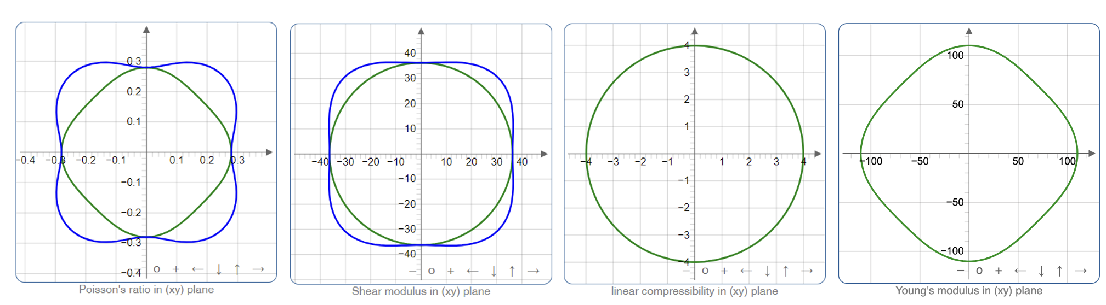

**Figure 3.** 2D elastic anisotropy properties of KNiF3 compound at 0 GPa.

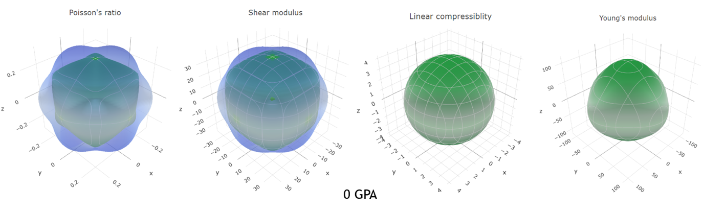

**Figure 4.** 3D elastic anisotropy properties of KNiF3 compound at 0 GPa.

**3.3. Electronic properties**

The electronic properties were determined using spin-polarized calculations. The spin-up and spin-down electronic band structure presentation for KNiF3 compound is given in Figure 5 and and total density of states (TDOS) is displayed in Figure 6. The computed electronic band structure aligns with the existing theoretical findings [10, 11] at 0 GPa.

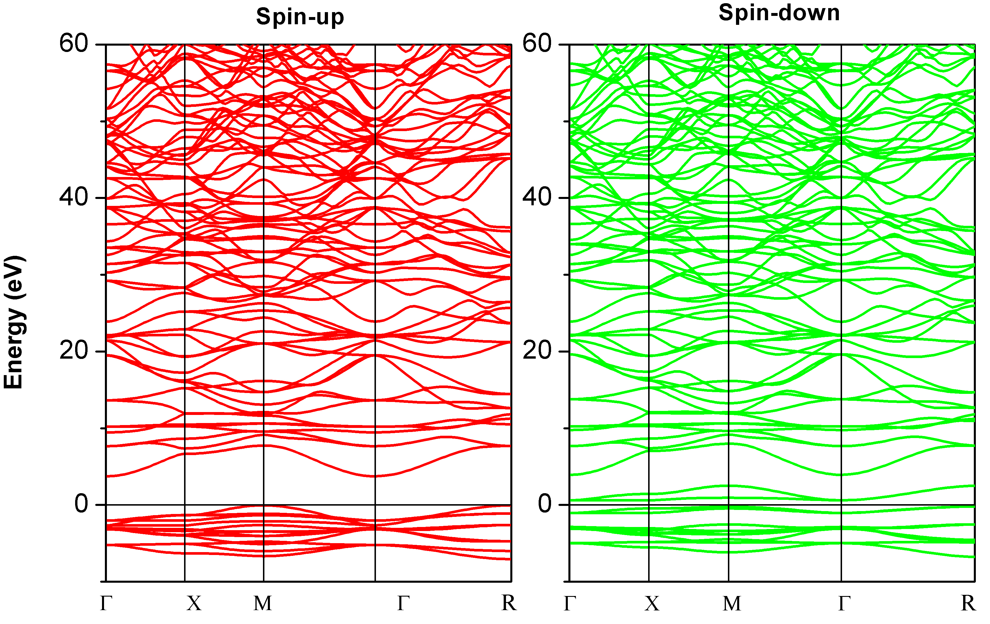

**Figure 5.** Electronic band structure of KNiF3 compound at 0 GPa.

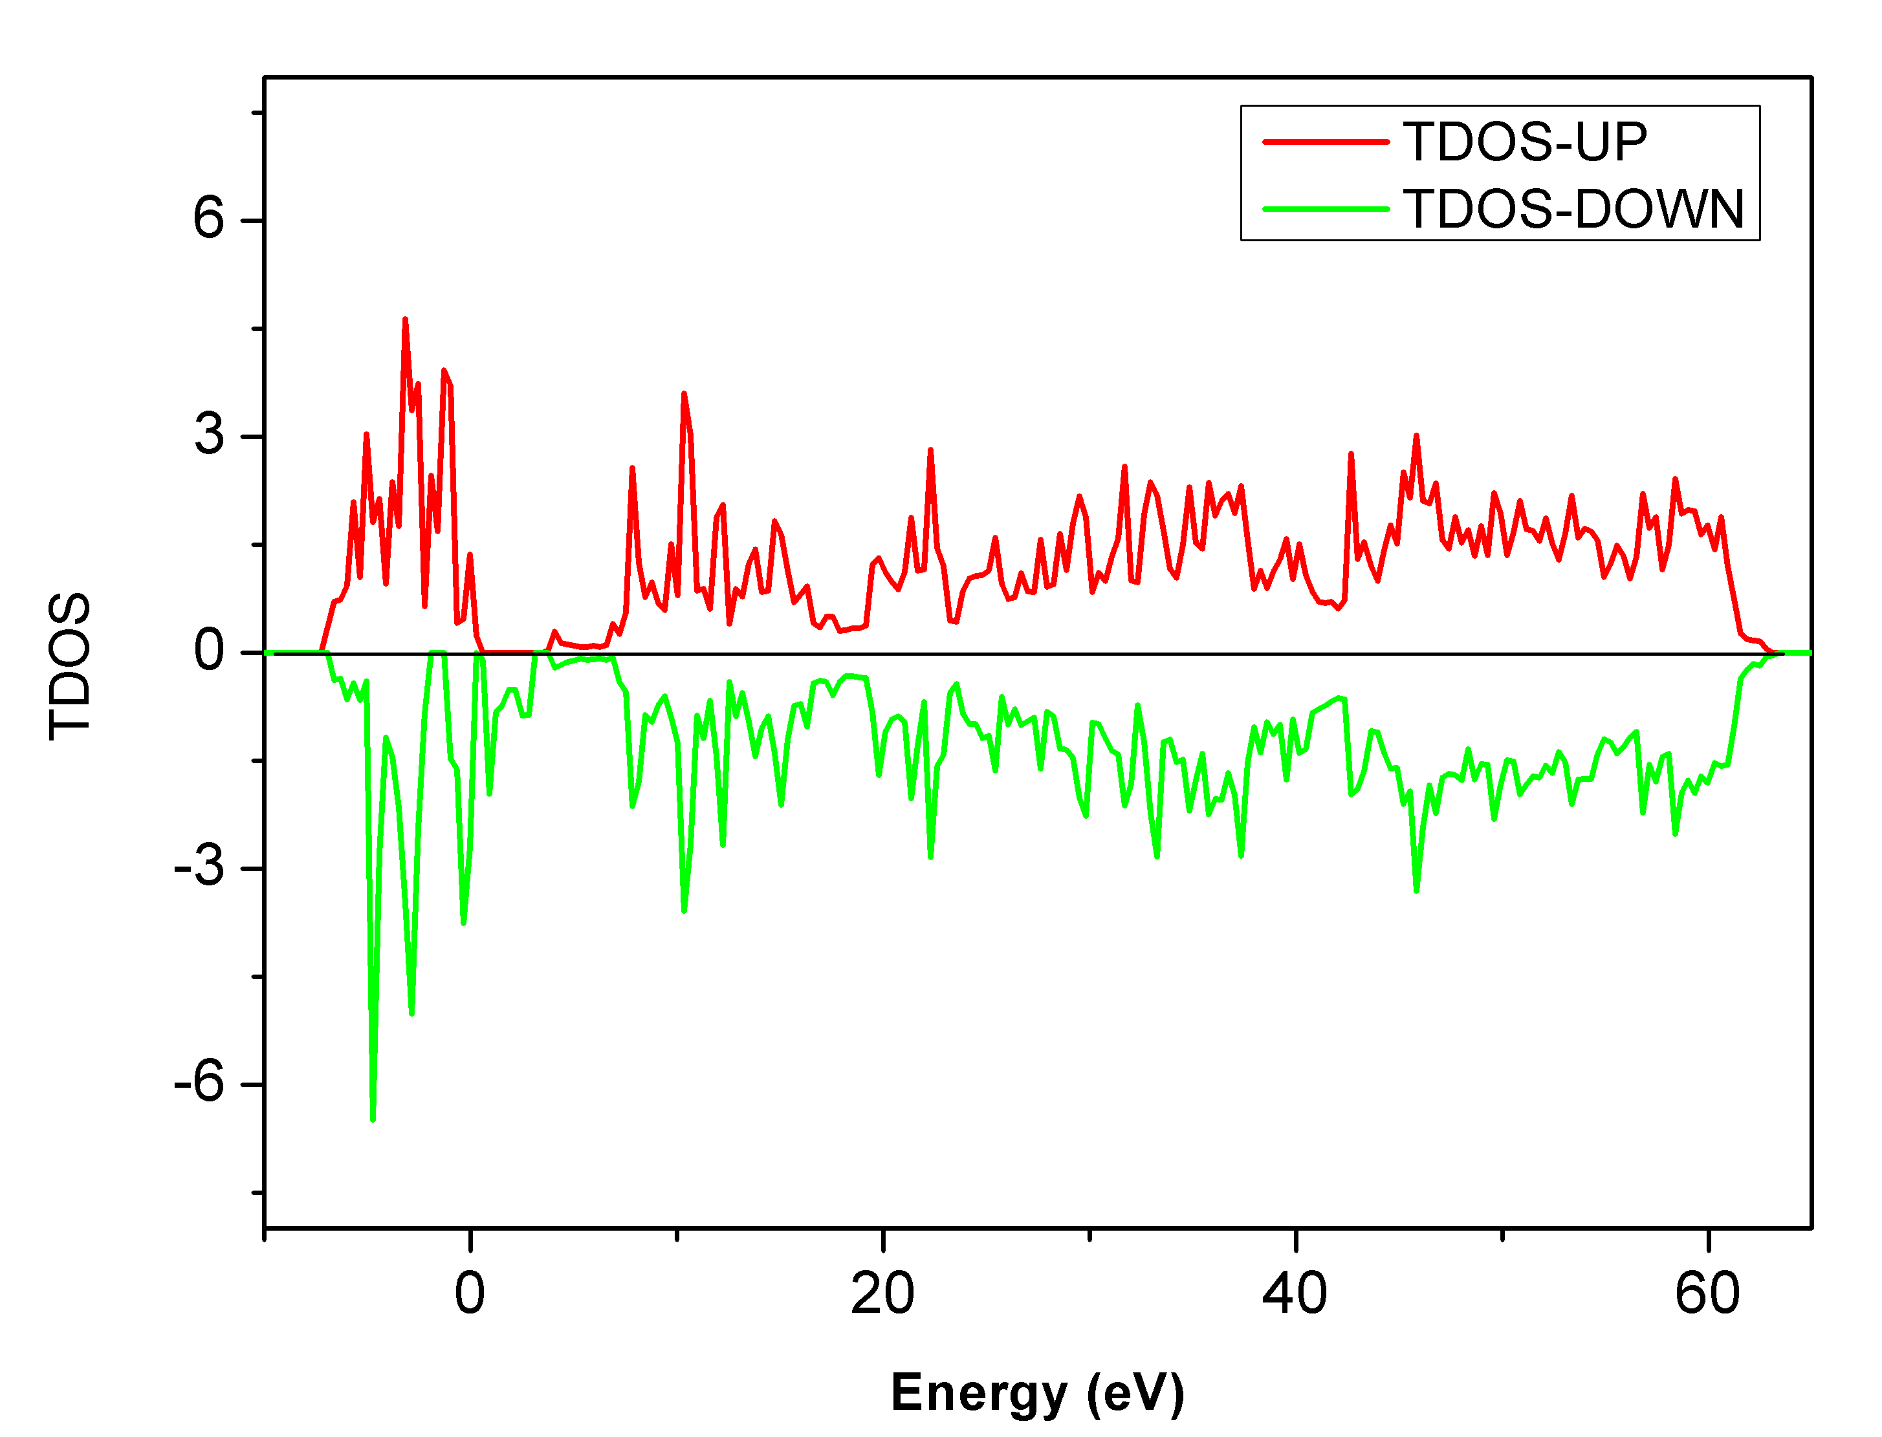

**Figure 6.** Total density of states of KNiF3 compound at 0 GPa.

1. **Conclusion**

This study employed first principles calculations to investigate the impact of pressure (in the range of 0–100 GPa) on the physical properties of fluoroperovskite KNiF3 compounds. The lattice constant, spin polarized electronic band structure, and elastic constants presented in this research consistent with both experimental structures and theoretical studies. The findings reveal a reduction in lattice constants under pressure, accompanied by an increase in elastic constants as the pressure rises. Importantly, at the assessed pressure levels, all elastic constants adhere to the conditions for mechanical stability.

# Acknowledgement

# The numerical calculations reported in this paper were performed at TUBITAK ULAKBIM, High Performance and Grid Computing Center (TRUBA resources).

**References**

1. Rehman, J. U., Usman, M., Tahir, M. B., Hussain, A., Rehman, M. A., Sagir, M., Alrobei, H., Ullah, S., Assiri, M. A. (2022). First-principles calculations to investigate ultra-wide bandgap semiconductor behavior of NaMgF3 fluoro-perovskite with external static isotropic pressure and its impact on optical properties. *Optik*, *252*, 168532.
2. Onuki, H., Sugawara, F., Nishihara, Y., Hirano, M., Yamaguchi, Y., Ejiri, A., Takahashi, H., Abe, H. (1976). Absorption spectra of KMF3 (M= Mn, Fe, Co, Ni, Cu, Zn) in the extreme ultraviolet region. *Solid State Communications*, *20*(1), 35-37.
3. Shulman, G. R., Yafet, Y., Eisenberger, P., & Blumberg, W. E. (1976). Observations and interpretation of x-ray absorption edges in iron compounds and proteins. *Proceedings of the National Academy of Sciences*, *73*(5), 1384-1388.
4. Tsirelson, V., Ivanov, Y., Zhurova, E., Zhurov, V., & Tanaka, K. (2000). Electron density of KNiF3: analysis of the atomic interactions. Acta Crystallographica Section B: Structural Science, *56*(2), 197-203.
5. Rousseau, M., Nouet, J., & Zarembowitch, A. (1974). Interatomic force constants studies of AMF3 perovskite-type crystals (A= K, Rb; M= Mg, Ni, Co, Zn, Mn). *Journal of Physics and Chemistry of Solids*, *35*(8), 921-926.
6. Kitamura, M., & Muramatsu, S. (1990). Electronic structure of perovskite-type compounds. *Physical Review B*, *41*(2), 1158.Ricart, J. M., Dovesi, R., Roetti, C., & Saunders, V. R. (1995). Electronic and magnetic structure of KNiF 3 perovskite. *Physical Review B*, *52*(4), 2381.
7. Ricart, J. M., Dovesi, R., Roetti, C., & Saunders, V. R. (1995). Electronic and magnetic structure of KNiF3 perovskite. *Physical Review B*, *52*(4), 2381.
8. Pari, G., Jaya, S. M., & Asokamani, R. (1994). Electronic structure and magnetism of KMF3 (M= Mn, Fe, Co, Ni). *Physical Review B*, *50*(12), 8166.
9. Moreira, I. D. P. R., Illas i Riera, F. (1997). Ab initio theoretical comparative study of magnetic coupling in KNiF3 and K2NiF4. *Physical Review B, 55 (7), 4129-4137.*
10. Erum, N., Iqbal, M. A. (2017). Mechanical and magneto-opto-electronic investigation of transition metal based fluoro-perovskites: An ab-initio DFT study. *Solid State Communications*, *264*, 39-48.
11. Murtaza, G., Khenata, R., Muhammad, S., Reshak, A. H., Wong, K. M., Omran, S. B., & Alahmed, Z. A. (2014). Structural, chemical bonding, electronic and magnetic properties of KMF3 (M= Mn, Fe, Co, Ni) compounds. *Computational materials science*, *85*, 402-408.
12. Hafner, J. (2008). Ab‐initio simulations of materials using VASP: Density‐functional theory and beyond. *Journal of computational chemistry*, *29*(13), 2044-2078.
13. Kresse, G., Furthmüller, J. (1996). Efficient iterative schemes for ab initio total-energy calculations using a plane-wave basis set. *Physical review B*, *54*(16), 11169.
14. Blöchl, P.E., “Projector augmented-wave method”, *Physical Review B*, 50: 17953, (1994).
15. Perdew, J. P., Burke, K., & Ernzerhof, M. (1996). Generalized gradient approximation made simple. *Physical review letters*, *77*(18), 3865.
16. Monkhorst, H. J., & Pack, J. D. (1976). Special points for Brillouin-zone integrations. *Physical Review B*, *13*(12), 5188.
17. Lee, J., Shin, H., Lee, J., Chung, H., Zhang, Q., & Saito, F. (2003). Mechanochemical Syntheses of Perovskite KMIIF3 with Cubic Structure (MII= Mg, Ca, Mn, Fe, Co, Ni, and Zn). *Materials transactions*, *44*(7), 1457-1460.
18. Le Page, Y., & Saxe, P. (2002). Symmetry-general least-squares extraction of elastic data for strained materials from ab initio calculations of stress. *Physical Review B*, *65*(10), 104104.
19. Mouhat, F., & Coudert, F. X. (2014). Necessary and sufficient elastic stability conditions in various crystal systems. *Physical review B*, *90*(22), 224104.
20. Reuss, A. (1929). Berechnung der fließgrenze von mischkristallen auf grund derplastizitätsbedingung für einkristalle. *ZAMM‐Journal of Applied Mathematics and**Mechanics/Zeitschrift für Angewandte Mathematik und Mechanik*, *9*(1), 49-58.
21. Voigt, W., “Lehrbuch der Kristallphysik (mit Ausschluss der Kristalloptik)”, Teubner, Leipzig, (1928).
22. Hill, R. (1952). The elastic behaviour of a crystalline aggregate. *Proceedings of the Physical Society. Section A*, *65*(5), 349.
23. Pettifor, D. G. (1992). Theoretical predictions of structure and related properties of intermetallics. *Materials science and technology*, *8*(4), 345-349.
24. Pugh, S. F. (1954). XCII. Relations between the elastic moduli and the plastic properties of polycrystalline pure metals. *The London, Edinburgh, and Dublin Philosophical Magazine and Journal of Science*, *45*(367), 823-843.
25. Bannikov, V. V., Shein, I. R., & Ivanovskii, A. L. (2010). Elastic properties of antiperovskite-type Ni-rich nitrides MNNi3 (M= Zn, Cd, Mg, Al, Ga, In, Sn, Sb, Pd, Cu, Ag and Pt) as predicted from first-principles calculations. *Physica B: Condensed Matter*, *405*(22), 4615-4619.
26. Ahmed, R., Mahamudujjaman, M., Afzal, M. A., Islam, M. S., Islam, R. S., & Naqib, S. H. (2023). DFT based comparative analysis of the physical properties of some binary transition metal carbides XC (X= Nb, Ta, Ti). *Journal of Materials Research and Technology*, *24*, 4808-4832.
27. Tian, Y., Xu, B., & Zhao, Z. (2012). Microscopic theory of hardness and design of novel superhard crystals. *International Journal of Refractory Metals and Hard Materials*, *33*, 93-106.
28. Gaillac, R., Pullumbi, P., & Coudert, F. X. (2016). ELATE: an open-source online application for analysis and visualization of elastic tensors. *Journal of Physics: Condensed Matter*, *28*(27), 275201.

1. \* Corresponding author. *e-mail address: belgin.kocak@ostimteknik.edu.tr* [↑](#footnote-ref-1)