THE ROLE OF EGO RESILIENCE IN THE NEWLY CHANGING SOCIAL ORDER: ERCIYES UNIVERSITY EXAMPLE

Ali Kasta MUKENDİ
İsmira JULFAYEVA
Ahmed ABDULATİF
Degani BANZULU BOMBA ⁴
Abstract

Our research examined the relationship between immeasurable (uninhibited) behavior, planned conscientious behavior and socially restricted behavior with a practice in which the ego resilience scale was used by international students for the first time in Turkey. In the study conducted between 04.01.2020-07.30.2020 during the covid-19 pandemic period, the ego resilience scale was used to measure the ability to adapt the level of ego control to different conditions. As a result of the study, on the ego resilience scale, women score more moderate and high than men, in general, the ego resilience score gradually decreases as age progresses, and there is an inverse correlation between immeasurable (uninhibited) behavior and planned conscientious behavior and it has been found that immeasurable (uninhibited) behavior, socially restrained behavior, and education affect planned conscientious behavior.

Key Words: Ego resilience, Under control, Uninhibited behaviors, Planned conscientious behaviors, Socially restrained behaviors

Introduction
The reason why the concept of “personality”, which originated from the Latin word “persona” and is used in Western languages as “personality”, “personalität”, “personnalité” and “personality”, has many definitions in the literature is still not a single definition that psychologists and researchers agree on (Cüceloğlu, 2011: 403-405).
Personality is the distinctive and persistent patterns of thoughts, emotions and behaviors that enable each individual to adapt to life's situations (Jani, 2011: 90). Personality also refers to qualities that distinguish a person from others, or reveal its similarity to them (McShane and Von Glinow, 2017: 28-31). The ego, used in conjunction with the personality, is the whole of what the individual sees, learns, knows and thinks in this process, covering all the material and spiritual elements that make up society (Özen and Gülaçtı, 2010: 22).

In recent years, the person-centered perspective has been claimed to be an important complement to the more common feature-centered perspective in current personality research. In this context, new types such as flexible, over-controlled and controllable personality have been added to existing personality types (Alessandri vd., 2013). Therefore, personality types have begun to be combined with concepts such as control, resilience and flexibility.

According to the American Psychological Association (APA) definition, ego resilience is a personality trait consisting of the ability to adaptively change the degree to which a person blocks or expresses emotional impulses, depending on social demands, and a capacity that allows individuals to adapt to constantly changing environmental demands (Farkas and Orosz, 2015).

The study of personality by combining ego resilience with ego control as an effect processing system (Block, 2002) allows the internalization of the interaction between them. The ego resilience /flexibility capacity that a person has is the result of interactions between personal and environmental factors (Ungar et al., 2007). Resilient or flexible individuals with the ability to change adaptively; it can more easily adapt to acute stress, uncertainty or conflicts. It benefits individuals with low resilience levels to provide better psychological adaptation (Fredrickson, Tugade, Waugh and Larkin, 2003); Alessandri vd, 2013).

Individuals ego resilience/resilience levels; their internalization and externalization problems (Hofer, Eisenberg, and Reiser, 2010), social competence (Block and Block, 2006), mental and related functions into account (Martel et al., 2007) is associated with academic achievement levels (Prince-Embury, 2015).

METHODOLOGY
Working Group

Erciyes University staff and students were the participants of the study. Since the application part of the research began before the pandemic, some survey applications were conducted face-to-face. However, during the period of the covid-19 pandemic-era restrictions, surveys were conducted via online interviews or Google docs. Because the researchers were students in the field of health, some of the researchers ' teachers and friends actually served in hospitals during the pandemic period. July – April 2020 the number of samples was limited to 100 people due to the fact that the practice coincided with the pandemic process (April-July 2020). Of the 100 people who participated in the study, 54% were women and 46% were men. Information on the demographics of the Working Group is as follows.

Table 1. Frequency and percentage distribution of survey participants according to various variables.

Variable |  | Frequency | Percantage (%)
Gender | Man | 46 | 46
 | Woman | 54 | 54
Age | 17-19 between the ages | 2 | 2
 | 20-25 between the ages | 38 | 38
 | 26-29 between the ages | 20 | 20
 | 30-35 between the ages | 11 | 11
 | 36-39 between the ages | 4 | 4
 | 40-49 between the ages | 19 | 19
 | 50-59 between the ages | 6 | 6
Education level | Vocational High School students | 20 | 20
 | Undergraduate students | 55 | 55
 | Graduate students | 15 | 15
 | Academic | 10 | 10
 | Total | 100 | 100

Data Collection Tool

The research aimed to measure the ability to adapt the level of ego control to different conditions (Letzring et al., 2005), used the ego resilience scale developed by Block and Block (1980). The Cronbach alpha value and compliance indices for the scale are given in the table below.

Table 2. Fit indices (Fit indices of scales)

Indices | Cronbach Alpha | Perfect Fit | Acceptable Fit | Ego resilience scale
RMSEA | ,738 | ,000≤RMSEA≤,050 | ,050≤RMSEA≤,080 | ,033
χ2/df |  | ,000 ≤ χ2/df ≤ 2,000 | 2,000 ≤ χ2/df ≤ 3,000 | 1,109
PCLOSE |  | ≥,050 |  | ,723
RFI |  | ,900<RFI≤1,000 | ,850<RFI≤,900 | ,873
IFI |  | ,950≤IFI≤ 1,000 | ,900≤IFI≤,950 | ,972
NFI |  | ,950≤NFI≤1,000 | ,900≤ NFI≤,950 | ,908
TLI |  | ,950≤TLI≤1,000 | ,900≤TLI≤,950 | ,962
CFI |  | ,970≤CFI≤1,000 | ,950≤CFI≤,970 | ,970
Source: (Seker et al., 2020)

Hypotheses
Hypotheses developed for the research are as follows:
Hypothesis 1: women have lower ego resilience than men.
Hypothesis 2: as age increases, the ego resilience score decreases.
Hypothesis 3: there is an inverse correlation between immeasurable (uninhibited) behavior and planned conscientious behavior.
Hypothesis 4: immeasurable (uninhibited) behavior, socially restricted behavior, age, gender, and education affect planned conscientious behavior.

FINDINGS
The findings of the research are presented below.

Table 3. Distribution of sizes by gender
immeasurable (uninhibited) behavior
 | Low | Medium | High | Total
Woman | 12 | 28 | 14 | 54
Man | 13 | 18 | 15 | 46
Total | 25 | 46 | 29 | 100
planned conscientious behavior
 | Low | Medium | High | Total
Woman | 11 | 15 | 21 | 47
Man | 11 | 18 | 24 | 53
Total | 22 | 33 | 45 | 100
socially restrained behavior
 | Low | Medium | High | Total
Woman | 15 | 26 | 13 | 54
Man | 14 | 25 | 7 | 46
Total | 29 | 51 | 20 | 100
Ego resilience
 | Low | Medium | High | Total
Woman | 0 | 41 | 13 | 54
Man | 2 | 34 | 10 | 46
Total | 2 | 75 | 23 | 100

In the above table, we can say that women score more moderately than men (1.5 times as many as men), men score more moderately and highly than women in the planned conscientious behavior size, while women score higher in the socially restricted behavior size than men, and in particular, they feel more socially restricted than men (1.85 times as many as men). Considering the average Ego resilience scale, it will be seen that women score more medium and high than men. Women have an average ego resilience score of 1.2 times that of men. These results also mean that women are less egotistical than men. Therefore, " women have lower ego resilience than men." the hypothesis found in Proposition 1 is accepted.

Table 4. Distribution of sizes by age
immeasurable (uninhibited) behavior
Age Group | Low | Medium | High | Total
17-19 age | 1 | 1 | 0 | 2
20-25 age | 10 | 15 | 13 | 38
26-29 age | 4 | 8 | 8 | 20
30-35 age | 2 | 8 | 1 | 11
36-39 age | 1 | 0 | 3 | 4
40-49 age | 5 | 11 | 3 | 19
50-59 age | 2 | 3 | 1 | 6
total | 25 | 46 | 29 | 100
planned conscientious behavior
Age Group | Low | Medium | High
20-25 age | 4 | 8 | 15 | 14
26-29 age | 4 | 4 | 4 | 12
30-35 age | 4 | 5 | 4 | 13
36-39 age | 4 | 5 | 5 | 14
40-49 age | 6 | 7 | 11 | 24
50-59 age | 4 | 9 | 10 | 23
total | 26 | 38 | 49 | 100
socially restrained behavior
Age Group | Low | Medium | High
17-19 age | 1 | 1 | 0 | 2
20-25 age | 11 | 17 | 10 | 38
26-29 age | 5 | 12 | 3 | 20
30-35 age | 1 | 7 | 3 | 11
36-39 age | 1 | 2 | 1 | 4
40-49 age | 9 | 8 | 2 | 19
50-59 age | 1 | 4 | 1 | 6
total | 29 | 51 | 20 | 100
Ego resilience
Age Group | Low | Medium | High | Total
17-19 age | 0 | 2 | 0 | 2
20-25 age | 1 | 27 | 10 | 38
26-29 age | 0 | 17 | 3 | 20
30-35 age | 0 | 8 | 3 | 11
36-39 age | 0 | 2 | 2 | 4
40-49 age | 1 | 14 | 4 | 19
50-59 age | 0 | 5 | 1 | 6
total | 2 | 75 | 23 | 100

When the above table is examined, immeasurable (uninhibited) behaviors are not more than 25 years and under (40%), but at least between 36-39 years (4%) and 50-59 years (5%).; it can be said that planned conscientious behavior increases as age progresses; socially restricted behavior increases at most at the age of under 30 (60%), and in general, the score of ego resilience gradually decreases as age progresses. Therefore, hypothesis 2, which offers the proposition that “as age increases, the ego resilience score decreases”, is accepted.
Table 5. Interdimensional correlation table

 | socially restricted behaviors | planned conscientiousness  behaviour
planned conscientiousness  behaviour | ,297**
immeasurable (uninhibited) behavior | ,099* | -0,188**
Looking at the above correlation table: a two-way and positive relationship between Planned conscientious behavior and Socially restricted behavior at 297**; a one-way and positive relationship between immeasurable (uninhibited) behavior and socially restricted behavior at 099* ; it will be seen that there is a bidirectional and negative -0.188* relationship between immeasurable (uninhibited) behavior and planned conscientious behavior. Therefore, hypothesis 3, which suggests that” there is an inverse correlation between immeasurable (uninhibited) behavior and planned conscientious behavior", is accepted.
Histogram  Dependent variable: Planned conscientiousness behavior  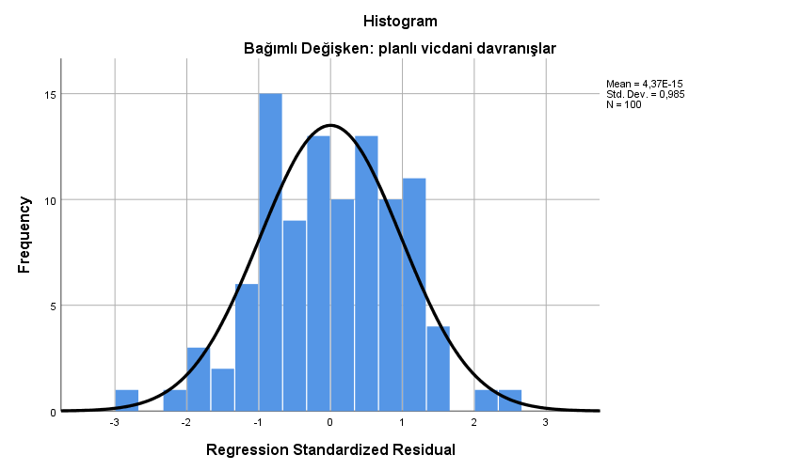 | Normal P-P Plot of Regression Standardized Residual  Dependent variable: Planned conscientious behavior  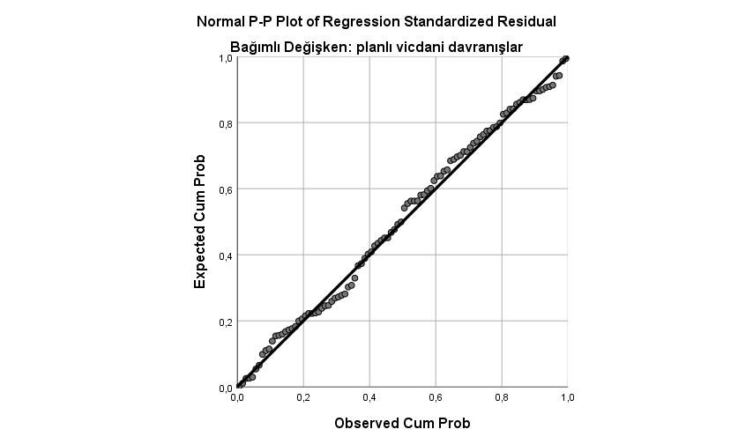
Figure 1. Immeasurable (uninhibited) behavior, socially restricted behavior, age, gender, and education levels that affect planned conscientious behavior histogram and normal distribution graph of stepwise regression analysis.

One of the main assumptions in regression is that there is no relationship between error terms. The relationship between error terms reveals the existence of autocorrelation (Alkaya et al., 2016:10). The fact that the Durbin-Watson value is close to 2.0 indicates that there is no autocorrelation between variables ((Draper and Smith, 1981). In our research, the Durbin-Watson value was calculated as 1,985.

Table 6. Immeasurable (uninhibited) behavior, socially restricted behavior, age, gender, and education levels that affect planned conscientious behavior stepwise regression table.
Durbin-Watson | R | R² | F
1,985 | 0,421 | 0,177 | 6,886
Independent variable | B | t | Sig
constant | 3,422 | 8,784 | 0,000
socially restricted behaviors | 0,307 | 3,385 | 0,001
immeasurable (uninhibited) behavior | -0,177 | -2,337 | 0,022
Age | 0,044 | 0,408 | 0,684
Gender | -0,141 | -1,522 | 0,131
Education | -0,122 | -2,190 | 0,031
Sig<0,05
Table 6, a regression form that shows the effect of immeasurable (uninhibited) behavior, socially restricted behavior, age, gender, and educational level on planned conscientious behavior can be written as follows when examined in detail:

Y=3,422+ 0,307_{(socially restricted behavior)}- 0,177(immeasurable/uninhibited behavior)- 00,122 _{(education)}

Therefore, hypothesis 4, which includes the proposition that” immeasurable (uninhibited) behavior, socially restricted behavior, age, gender and education affect planned conscientious behavior", is partially accepted.

According to the analyses detailed above, the acceptance/rejection status of hypotheses is shown in table7.

Table 7. Acceptance/rejection of hypotheses
No | Hypothesis | Acceptance/rejection
1 | Women have lower ego resilience than men. | Accepted
2 | As age increases, the ego resilience score decreases. | Accepted
3 | There is an inverse correlation between immeasurable (uninhibited) behavior and planned conscientious behavior | Accepted
4 | Immeasurable (uninhibited) behavior, socially restricted behavior, age, gender and education affect planned conscientious behavior | Partially Accepted

DISCUSSION, CONCLUSIONS AND RECOMMENDATIONS

April 2020 July 2020 research data is limited to Erciyes University staff and students (100 people) during the covid-19 pandemic period. It is estimated that there will be great benefits in conducting research in different sample groups at normal times without a pandemic. Research data was collected by international students within the scope of Presidency for Turks Abroad and Related Communities (YTB) Academy Kayseri activities. According to the data obtained, it examined the relationships between immeasurable (uninhibited) behaviors, planned conscientious behaviors, and socially restricted behaviors. Our research is also the first in Turkey in this sense. In addition, Erciyes University's leadership in domestic and National First covid-19 vaccine studies has increased the importance of the research once again.

Considering the effect of Ego resilience levels on social competence (Block and Block, 2006) and academic achievement (Prince-Embury, 2015), it becomes clear how important it is to support this trait. When the research results were examined, the correlation values between the lower dimensions were consistent with the results obtained by Roger and Najarian (1989) and Selby et al (2016). The presence of small correlations between the lower dimensions has been found. The direction and intensity of interdimensional correlations gives us the consideration of what aspects we should pay attention to the management and behavioral characteristics of the institution or unit. If unit and institutional analyses can be carried out separately, it is possible to create more health for the department and inter-unit interaction

REFERENCES

Alkaya, A., Çoban, S., Tehci, A. &. Ersoy, Y. (2016). Çevresel duyarlılığın yeşil ürün satın alma davranışına etkisi: Ordu Üniversitesi örneği. Erciyes Üniversitesi İktisadi and İdari Bilimler Fakültesi Dergisi, (47), 121-134.

Alessandri, G., Vecchione, M., Caprara, G., & Letzring, T. D. (2012). The Ego Resiliency Scale Revised. European Journal of Psychological Assessment, 28(2), 139–146.

Alessandri, G., Vecchione,M., Donnellan, B.M., Eisenberg, N., Caprara, G.V.,&Cieciuch, J. (2013). On the cross-cultural replicability of the resilient, Undercontrolled, and Overcontrolled personality types. Journal of Personality, 82(4), 340–353.

Ayten, MA. (2016). Strategic sustainable site management in higher education institutions. Journal of Higher Education, 6(3), 142–154.

Block, J. H., & Block, J. (1980). The role of ego-control and egoresiliency in the organization of behavior. In W. A. Collins (Ed.), Development of cognition, affect, and social relations: The Minnesota symposia on child psychology Hillsdale: NJ: Erlbaum, 13, 39–101.

Block, J. (2002). Personality as an affect-processing system. Mahwah, NJ: Erlbaum.

Block, J. & Block, J. H. (2006). Venturing A 30-Year Longitudinal Study. American Psychologist, 61 (4): 315–327.

Cüceloğlu, D. (2011). İnsan and davranışı. 22. Basım. İstanbul: Remzi Kitabevi.

Draper,N.R. & Smith, H. (1981). Applied Regression Analysis. 2.ed., New York: John Wiley &Sons.

Farkas D, Orosz G (2015) Ego-Resiliency Reloaded: A Three-Component Model of General
Resiliency. PLoS ONE, 10(3): e0120883.

Hofer, C., Eisenberg, N. & Reiser, M. (2010). The Role of Socialization, Effortful Control, and Ego-Resiliency in French Adolescents’ Social Functioning. Journal of Research on Adolescence, 20 (3): 555-582.

Fredrickson, B. L., Tugade, M.M.,Waugh, C. E., & Larkin, G. R. (2003). What good are positive emotions in crisis? A prospective study of resilience and emotions following the terrorist attacks on the U.S. on September 11th, 2001. Journal of Personality and Social Psychology, 84, 365–376.

Jani, D. (2011). The influence of personality on tourist information behavior. e-Review of Tourism Research [Online], 9(3), 88-95.

Letzring, T. D., Block, J., & Funder, D. C. (2005). Ego-control and egoresiliency: Generalization of self-report scales based on personality descriptions from acquaintances, clinicians, and the self. Journal of Research in Personality, 39(4), 395–422.

Martel, M. M., Nigg, J. T., Wong, M. M., Fitzgerald, H. E., Jester, J. M. & Puttler, L. I. (2007). Childhood and Adolescent Resiliency, Regulation, and Executive Functioning İn Relation to Adolescent Problems and Competence in A High-Risk Sample. Development and Psychopathology, 19 (2): 541–563.

McShane, S. L. and Von Glinow, M. A. (2017). Organizational Behavior. McGraw-Hill Education

Özen, Y. & Gülaçtı, F. (2010). Benlik-Kavramı and Benliğin Gelişimi Bilen Benliğe Gereksinim Var Mı?, Erzincan Eğitim Fakültesi Dergisi, 2, 20-38.

Prince-Embury, S. (2015). Assessing Personal Resiliency in School Settings: The Resiliency Scales for Children and Adolescents. Journal of Psychologists and Counsellors in Schools, 25 (1): 55-65.

Roger, D., & Najarian, B. (1989). The construction and validation of a new scale for measuring emotion control. Personality and Individual Differences, 10(8), 845–853.

Seker, M., Bayram, A., Buyuksivaslioglu, N., Reyhancan, M., Vyacheslav, T., & Botakarayev, B. (2020). The mediating role of stress on the relationship between organizational culture and dysfunctional attitudes: A field study. Elementary Education Online, 19(1), 147-156.

Selby, E. A., Fehling, K. B., Panza, E. A., & Kranzler, A. (2016). Rumination,mindfulness, and borderline personality disorder symptoms. Mindfulness, 7(1), 228–235.

Ungar, M., Brown, M., Liebenberg, L., Othman, R., Kwong, W.M., Armstrong, M. & Gilgun, J. (2007). Unique Pathways to Resilience Across Cultures. Adolescence, 42 (166): 287-310.

A national of the Democratic Republic of Congo,Assistant of research in Mental Health and Disease Kinshasa University and a graduate student in Mental Health and Disease Nursing at the Institute of Health Sciences of Erciyes University, alikasta01@gmail.com
Kazakhstan national, Erciyes University Faculty of Health Sciences Department of Nursing 4. class student, dj.ismira@mail.ru
Ethiopian national, Erciyes University Faculty of Medicine 3. class student, ahmedabdulatif48@gmail.com ⁴ A national of the Democratic Republic of Congo, Associated Prof. Dr. Kınshasa University Faculty of Medecine. Department of Psychiatry. Drbanzulu2008@gmail.com

