**Removal of Zn(II) Ion from Aqueous Solutions by Gellan Gam-Chitosan Complex Adsorbent**

***Nazife DOĞAN1 [C:\Users\Abdullah\AppData\Local\Microsoft\Windows\INetCache\Content.Word\ORCID-iD_icon-16x16.gif](https://orcid.org/0000-xxxx-xxxx-xxxx), Bengi ÖZKAHRAMAN2 [C:\Users\Abdullah\AppData\Local\Microsoft\Windows\INetCache\Content.Word\ORCID-iD_icon-16x16.gif](https://orcid.org/0000-xxxx-xxxx-xxxx), Zehra ÖZBAŞ1,\* [C:\Users\Abdullah\AppData\Local\Microsoft\Windows\INetCache\Content.Word\ORCID-iD_icon-16x16.gif](https://orcid.org/0000-xxxx-xxxx-xxxx)***

*1Institute of Natural Sciences, Faculty of Engineering, Department of Chemical Engineering, Çankırı Karatekin University, Çankırı, Turkey*

*2Institute of Graduate Education, Faculty of Engineering, Department of Polymer Materials Engineering, Hitit University, Çorum, Turkey*

|  |
| --- |
| **Abstract**  In this study, the cross-linked gellan gum (GG) beads were kept in the chitosan (CS) solution for the formation of the polyelectrolyte complex, later the beads were purified and removed from the solution before the second crosslinking [1]. The potential of these complex beads to remove Zn(II) ions from wastewater was investigated. The analysis of FT-IR and SEM/EDX was performed to characterize the obtained polyelectrolyte complex. In the adsorption studies performed with the polyelectrolyte complex, the most appropriate pH value was 6. When the experimental conditions were applied at temperature: 25°C, pH: 6, the initial concentration of the solution: 200 ppm, and the adsorption time: 10 hours, the adsorption capacity was found to be approximately 42.05 mg/g. Kinetic studies demonstrated that the experimental results were consistent with the pseudo-second-order kinetic model. The Langmuir isotherm model was also found to be compatible with the equilibrium adsorption results. It has also been determined that the complex adsorbent can be used at least five times without a serious reduction in the adsorption capacity. As a result, the prepared polyelectrolyte complex may be a proper adsorbent for the adsorption of Zn(II) ions to treat wastewater containing a low metal concentration. |
| Keywords: Chitosan, Gellan gum, Polyelectrolyte complex, Zn(II) |

1. **Introduction**

Zinc is widely used in many industrial applications such as dry cell, electroplating industry, pesticides, foundry, metallurgy, pigments, and explosives manufacturing. Zinc is often present in high levels in the wastewater from many sources, including galvanizing plants, mine drainage, pharmaceutical production, and pigment production [1]. Known as an inorganic pollutant, zinc is not biodegradable and can bioaccumulate through the food chain. Zinc is considered an essential trace element for life, but it is harmful to health in high concentrations. The WHO recommends that the maximum acceptable concentration of zinc in drinking water be 5 mg/L [2]. The conventional technologies use to remove Zn(II) from wastewater include ion exchange, chemical precipitation, electrolysis, membrane separation, and adsorption. The adsorption is the preferred method under being a cheap, effective, and easy-to-apply process [1, 2].

In the present study, we aimed to prepare a polyelectrolyte complex consisting of GG and CS for Zn(II) adsorption. The complex was characterized by FTIR and SEM/EDX analysis before and after adsorption process. pH, adsorption time, temperature, and initial Zn(II) concentration were examined for the adsorption process. In addition, the desorption process was performed with HCl.

1. **Materials and Methods**

**2.1. Materials**

Gellan gum (GG), CaCl2, chitosan (CS), glutaraldehyde (GA), CH3COOH, zinc acetate dihydrate (Zn(CH3COO)2.2H2O), NaOH and HCl used in the study were Sigma-Aldrich products and used without purification.

**2.2. Methods**

The adsorbent particles in spherical form were prepared in three steps: bead formation-combination-crosslinking [3].

**Bead formation:** 1.5 g of GG was dissolved in 100 mL of distilled water to prepare a 1.5% GG solution. Then, GG solution was dropped dropwise into 7% CaCl2 solution using a syringe pump (New Era Pump System, Inc.) and cross-linked GG gel beads were obtained. After these beads were kept in the crosslinker solution for 3 hours, they were washed in distilled water for 1 hour to remove the chloride ions on the surface.

**Combination:** 1 g of CS was dissolved in 100 mL of 1% CH3COOH solution to prepare a 1% CS solution. The GG beads washed in the previous step were transferred to this CS solution and kept for 24 hours.

**Crosslinking:** The combined beads were kept in 1% GA solution for 2 hours at room temperature to ensure crosslinking. The GA remaining on the surface of the complex beads was removed by washing with distilled water. The obtained complex beads (CS-GG) were used in adsorption studies after drying in an oven.

**Adsorption studies:** The batch system was applied in the adsorption studies of Zn(II) ions by the complex beads. First of all, in the presence of 100 ppm initial concentration and 0.15 g adsorbent, the initial pH value of the solution was changed in the range of 2-8, and the appropriate pH value for adsorption was determined. The solutions of HCl and NaOH were used for pH adjustment of the solution. The suitable conditions for Zn(II) adsorption were determined by changing the experimental conditions such as the contact time (0-28 h), the initial concentration of the solution (100-500 ppm), and the temperature (25-45°C). The experiments were conducted in a shaking water bath at 100 rpm and at specific temperatures. At the end of the time, the adsorbent was filtered off and the Zn(II) concentration in the solution was determined using AAS (atomic absorption spectrophotometer). Equation (1) was used to estimate qe (mg/g, the sorption capacity at equilibrium). For desorption studies, 1 g Zn(II) adsorbed complex adsorbent was mixed with 1 M HCl solution at 25°C at 100 rpm for 4 hours. After desorption, the same adsorbent sample was dried and the reusability of the complex adsorbent was evaluated through the adsorption-desorption cycle repeated 5 times. The desorption percentage was determined with Equation (2):

$q_{e}=\frac{\left(C_{i}-C_{e}\right).V}{m}$ (1)

$Desorption \%=\frac{metal ions desorbed to the solution}{metal ions adsorbed onto adsorbent}.100$ (2)

**3. Results and Discussion**

**3.1. The characterization of the complex beads**

The structural characterization of the beads obtained in the study was carried out by FT-IR analysis. The FT-IR spectrum of cross-linked GG and the complex beads CS-GG were given in Figure 1. The FT-IR spectrum of the complex adsorbent after Zn(II) adsorption was also presented in Figure 1.

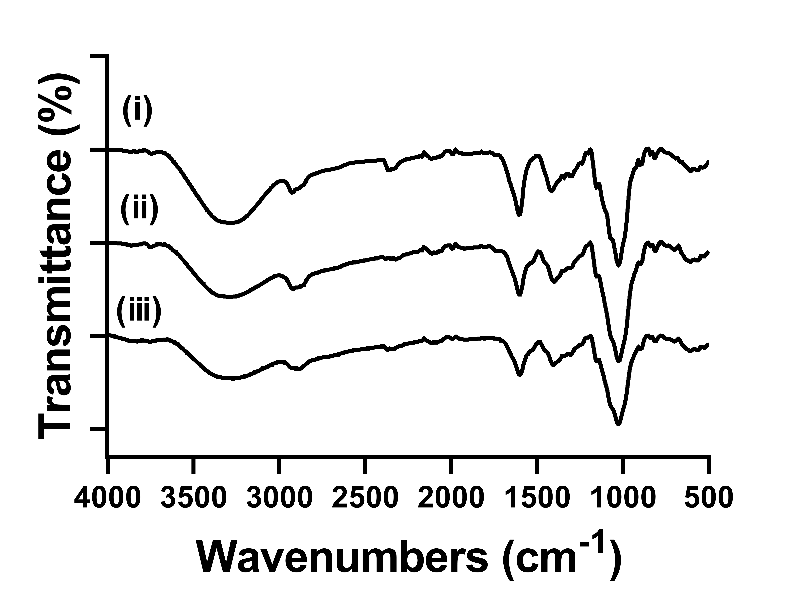

**Figure 1**. FTIR spectrum of crosslinked (i) GG, (ii) CS-GG (before adsorption), and (iii) CS-GG (after adsorption).

The SEM images obtained before and after adsorption to elucidate the morphological structure of CS-GG complex adsorbent were given in Figure 2 (a) and (b). EDX analysis after adsorption confirmed the existence of Zn(II) (Figure 2 (c)).

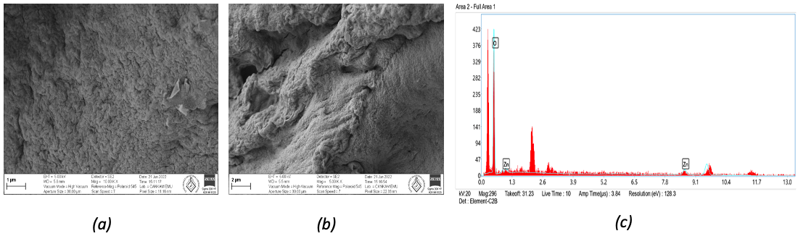

**Figure 2**. SEM images: a) CS-GG (before adsorption), b) CS-GG (after adsorption), and EDX analysis: c) CS-GG (after adsorption).

**3.2. Adsorption studies**

The pH of the initial solution is one of the most important parameters governing the adsorption of metal ions to adsorbents [3]. The effect of pH on Zn(II) adsorption with the complex adsorbent was investigated at different pH values ranging from 2 to 8 (initial concentration: 200 ppm, adsorption time: 24 h, and adsorbent dose: 0.15 g), and the results obtained was shown in Figure 3 (a). pH 6 was determined as the appropriate pH value for the adsorption of Zn(II) ions.

The adsorption of Zn(II) with CS-GG was investigated as a function of time at initial concentration: 200 ppm, adsorbent dose: 0.15 g, and pH: 6, and the results were shown in Figure 3 (b). As observed in the figure, qe increased with the increase of contact time and reached the highest value at 10 h. After this period, no increase in adsorption capacity was observed. The experimental kinetic data was tested using pseudo-first-order and pseudo-second-order kinetic models. The kinetic model parameters were presented in Table 1. The experimental results were consistent with the pseudo-second-order kinetic model.

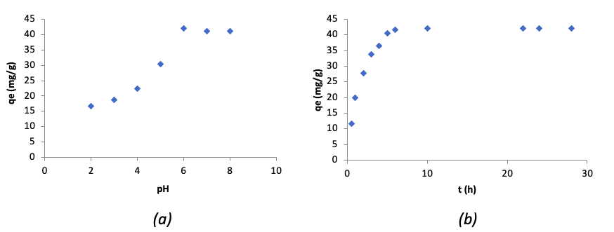

**Figure 3.** The effect of pH (a) and contact time (b).

**Table 1.** Kinetic parameters.

|  |  |  |
| --- | --- | --- |
| Kinetic models | Pseudo-first-order [4] | Pseudo-second-order [4] |
| Equations\* | $$\ln\left(q_{e}-q_{t}\right)=ln q_{e}-k_{1}t$$ | $$\frac{t}{q_{t}}= \frac{1}{k_{2}q_{e}^{2}}+ \frac{1}{q_{e}}t$$ |
| Plots | ln(qe-qt) vs. t | t/qt vs. t |
| Parameters | k1= 0.7341 1/h | k2= 0.014g/mg.h |
| qe= 53.18 mg/g | qe= 49.50 mg/g |
| R2= 0.9308 | R2= 0.9945 |
|  |  |

\**k*1, *k*2: rate constants, qt: adsorbent capacity at time t

Adsorption isotherms express the specific relation between the concentration of adsorbate and the quantity adsorbed on the adsorbent surface at a constant temperature. Figure 4 showed the amount of adsorbed Zn(II) (qe) as a function of the equilibrium Zn(II) ion concentrations (Ce) in the solutions (at 25°C, pH: 6, contact time: 10 h). Obviously, qe values tend to increase with increasing initial Zn(II) ion concentration. The isotherm data had analyzed for Langmuir and Freundlich isotherms (Table 2), and Langmuir isotherm model was also found to be compatible with the equilibrium adsorption results.

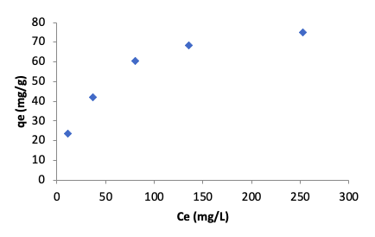

**Figure 4.** The equilibrium adsorption of CS-GG (qe vs. Ce).

**Table 2.** Parameters for the isotherm.

|  |  |  |
| --- | --- | --- |
| Models | Langmuir [5] | Freundlich [5] |
| Equations\* | $$1/q_{e}=\frac{1}{{b.q}_{max}.C_{e}}+\frac{1}{q_{max}}$$ | $$\ln{q_{e} }=\ln{K_{F}}+\frac{1}{n}\ln{C_{e}}$$ |
| Plots | Ce/qe vs. Ce | ln qe vs. ln Ce |
| Parameters | b= 0.037 L/mg | KF ((mg/g).(L/mg)1/n)= 10.09 |
| qmax= 79.36 mg/g | 1/n= 0.3833 |
| RL= 0.051 | R2= 0.9622 |
| R2= 0.9918 |  |
|  |  |

\*b: Langmuir constant, qmax: monolayer capacity, RL: seperation factor, KF: Freundlich constant, n: Freundlich exponent

For an adsorption process, the evaluation of thermodynamics parameters provides useful information to identify processes that may occur spontaneously. These parameters were calculated by the following equations 3-5 [4].

$K_{d}= \frac{q_{e}}{C_{e}}$ (3)

$\ln{K_{d}}= \frac{{-∆H}^{0}}{RT}+ \frac{{∆S}^{0}}{R}$ (4)

${∆G}^{0 }= {∆H}^{0 }-{T.∆S}^{0 }$ (5)

**Table 3.** Thermodynamic parameters.

|  |  |  |  |
| --- | --- | --- | --- |
| Temperature | ΔH0 (kJ/mol)\* | ΔS0 (kJ/mol.K)\* | ΔG0 (kJ/mol)\* |
| 293.15 | 9.62 | 0.057 | -7.37 |
| 303.15  313.15 | -7.94  -8.51 |

\*ΔH0: change in enthalpy, ΔS0: change in entropy, ΔG0: change in free energy

The positive value of ΔH° was an indication that the adsorption process has an endothermic character. The positive ΔS° value indicated a randomness in the solid-solution interface during the Zn(II) ion removal process. Negative ΔG° values meant that the ion removal process was spontaneous and feasible.

Good desorption performance and regeneration of an adsorbent is an essential parameter for practical applications. As seen in Figure 5, a loss of approximately 11% was observed in the capacity of the adsorbent after the first and fifth adsorption. Therefore, it is predicted that the complex adsorbent can be reused without a serious reduction in adsorption capacity.

**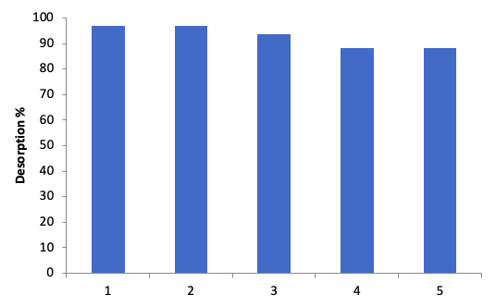**

**Figure 5.** The desorption rates of the adsorbent CS-GG.

**Acknowledgment.**

The financial support from the Scientific Research Projects Unit of Çankırı Karatekin University under the project number MF210621L11 is gratefully acknowledged.

**References**

1. Zhang, H., Tong, Z., Wei, T. & Tang, Y. (2011). Removal characteristics of Zn(II) from aqueous solution by alkaline Ca-bentonite. *Desalination*, *276*, 103-108.
2. Wang, H., Yuan, X., Wu, Y., Huang, H., Zeng, G., Liu, Y., Wang, X., Lin, N. & Qi, Y. (2013). Adsorption characteristics and behaviours of graphene oxide for Zn(II) removal from aqueous solution. *Applied Surface Science, 279*, 432-440.
3. Zhang, W., Yun, M., Yu, Z., Chen, D. & Li, X. (2019). A novel Cu(II) ion-imprinted alginate-chitosan complex adsorbent for selective separation of Cu(II) from aqueous solution. *Polymer Bulletin, 76*, 1861-1876.
4. Özkahraman, B. & Özbaş, Z. (2020). Removal of Al(III) ions using gellan gum-acrylic acid double network hydrogel. *Journal of Polymers and the Environment, 28*, 689-698.
5. Emik, S. (2014). Preparation and characterization of an IPN type chelating resin containing amino and carboxyl groups for removal of Cu(II) from aqueous solutions. *Reactive and Functional Polymers, 75*, 63-74.