CHALLENGES IN ARTIFICIAL INTELLIGENCE-BASED EXPERIENTIAL MARKETING

Kadir Demir1, 0000-0001-9568-9450, kadir.demir@idu.edu.tr  
Gökhan Akel2, 0000-0003-4353-7855, gokhan.akel@akev.edu.tr

Mesut Türk3, 0000-0001-5988-5075, mesut.turk@amasya.edu.tr

Abdullah Kuzu2, 0000-0002-1030-0424, abdullah.kuzu@akev.edu.tr

1İzmir Demokrasi University, 2Antalya AKEV University, 3Amasya University

Abstract

Customers desire brands that will provide them with challenging experiences. Artificial intelligence is the most astounding technology that can be employed now to attain this goal. The majority of organizations and brands now use artificial intelligence in their services. When you visit Amazon.com, for example, it recommends new things based on your previous orders; similarly, the Instagram algorithm predicts what you like to watch or discover based on your interactions with content types and individuals. High levels of engagement and trust-based digital experiences improve customer satisfaction, which is critical for both customers and brands. The forms of contact that can occur with experiential marketing will be highlighted by stressing current digital technology and the digital transformation in our lives. Virtual reality, augmented reality, mixed reality, wearable devices, and other similar technologies are altering our way of life dramatically. As holoportation becomes more common, it has the potential to have a significant impact on our lives as an exceedingly rare example. Holoportation is a futuristic system that combines display and real-time 3D capturing technologies. The 3D material of people or things is recorded quickly and concurrently sent to remote participants through the internet. Remote participants can see 3D content on augmented reality (AR), virtual reality (VR), or holographic display bases. This technology will also be beneficial in the field of experiential marketing. Through his/her customer journey and contacts with brands, companies, and other players, the consumer experience has been affected by numerous dimensions such as behavioral, emotional, intellectual, cognitive, physical, and social. With artificial intelligence, these dimensions and interactions become more predictable and interpretable. Consumer-artificial intelligence interactions can be managed sociologically, psychologically, and technologically. Consumer interactions with artificial intelligence are divided into four categories: data capture, classification, delegation, and social. Additionally, the AI canvas can assist in understanding how AI is used in marketing. The AI canvas is made up of seven different elements: prediction, judgment, action, outcome, input, training, and feedback. Companies and brands might fill the canvas with identifying answers while designing, managing, and selling AI-based experiential tools. The large picture will aid in the development of their strategy and action plan. IBM created the Acoustic platform to plan and automate marketing campaigns using artificial intelligence technology, tailor campaigns specifically for the customer, and monitor customer-brand interaction at every stage of the marketing process using analytical tools. Acoustic, for example, gives insights into creating data-driven experiences. AI-enabled technologies such as humanoid robots, chatbots, digital assistants, voice-enabled smart devices, and avatars change the customer experience. Most customer support services (such as banking and e-commerce) rely on these technologies rather than hiring real people. The sensory, emotional, cognitive, behavioral, and relational values of customer encounters are the focus of experiential marketing. Artificial intelligence, like a circle, will be increasingly used in our lives soon, shaping our values via our experiences. In addition to the potential that artificial intelligence technologies provide now, they also promise future developments. At this moment, potential ethical issues emerged, as did opportunity potential tied to experiential marketing. Capturing consumer data, for example, could enable improved technical improvements and provide personalized experiences. However, using and processing consumers’ data without their permission or active participation is prohibited and demands a criminal inquiry.

**Keywords:** Experiential marketing, artificial intelligence, digitalization

# Introduction

In the future, it is predicted that artificial intelligence will have a closer relationship with marketing in the context of business models, sales processes, customer service, and consumer behavior (Davenport et al., 2020). In this relationship, "experience" for artificial intelligence will perhaps appear as a research topic rather than goods and services. Thanks to artificial intelligence, online retailers can predict what customers will want in terms of goods and services (Davenport et al., 2020). Businesses like Birchbox, Stitch Fix, and Trendy Butler are already using AI to varying degrees of success to try to predict what their customers want (Davenport et al., 2020). When the possibilities offered by artificial intelligence are combined with the experience economy and experiential marketing opportunities, some opportunities and challenges may arise.

Customers prefer brands that offer the experience. Artificial intelligence is the most useful and surprising technology in the technology orientation of enterprises when evaluated from an experiential point of view. The use of artificial intelligence technology in different sectors offers radical innovations in terms of both e-commerce and marketing. High levels of engagement and trust-based digital experiences increase customer satisfaction, which is critical for both customers and brands. Virtual reality, augmented reality, mixed reality, wearables, and other similar technologies are dramatically changing the way businesses and individuals live. A futuristic system, Holoportation combines imaging and real-time 3D capture technologies. The 3D material of people or objects is quickly recorded and simultaneously sent over the Internet to remote participants. Remote participants can view 3D content in augmented reality (AR), virtual reality (VR), or holographic viewing bases. This technology will also be useful in the field of experiential marketing.

Consumers and businesses are affected by experiential marketing elements. With artificial intelligence, the interactions between these elements and the business-consumer are becoming more predictable and interpretable. Consumer-AI interactions can be managed sociologically, psychologically, and technologically. Consumer interactions with AI fall into four categories: data capture, classification, delegation, and social. Also, the AI ​​canvas can help understand how AI is used in marketing. The AI ​​canvas consists of seven different elements: prediction, judgment, action, outcome, input, training, and feedback. Companies and brands can fill the canvas with descriptive responses as they design, manage, and sell AI-based experiential tools.

In addition, IBM created the Acoustic platform to plan and automate marketing campaigns using artificial intelligence technology, tailor campaigns specifically for the customer, and monitor customer-brand interaction at every stage of the marketing process using analytical tools. Acoustic, for example, gives insights into creating data-driven experiences. AI-enabled technologies such as humanoid robots, chatbots, digital assistants, voice-enabled smart devices, and avatars change the customer experience. Most customer support services (such as banking and e-commerce) rely on these technologies rather than hiring real people. The sensory, emotional, cognitive, behavioral, and relational values of customer encounters are the focus of experiential marketing.

Artificial intelligence, like a circle, will be increasingly used in our lives soon, shaping our values via our experiences. In addition to the potential that artificial intelligence technologies provide now, they also promise future developments. At this moment, potential ethical issues emerged, as did opportunity potential tied to experiential marketing.

**Experiences in Digital Transformation and Consumer AI Experience**

Schmitt (1999) proposes key characteristics of experiential marketing which you can see in Figure 1.

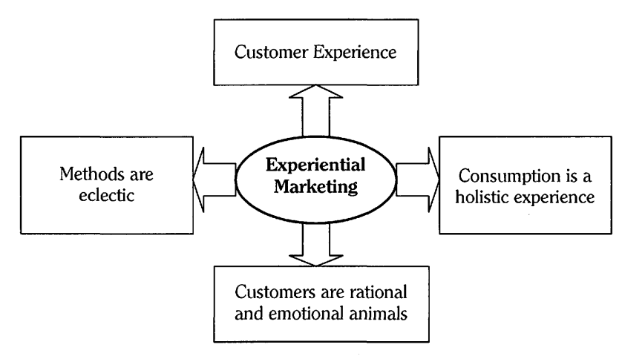

Figure 1. Key characteristics of experiential marketing (Schmitt, 1999)

In the following part of this subtitle, artificial intelligence technologies that exist in our lives and artificial intelligence technologies that are likely to enter our lives soon will be discussed in two different groups.

Artificial intelligence that exists in our lives can be seen in the semantic web also known as Web 3.0. Nowadays, most companies and brands have already used artificial intelligence in their services. For example, when you visit Amazon.com, it recommends new items according to your prior orders, similarly Instagram algorithm predicts what you want to watch or like to discover based on your interactions with content type and users.

In this paper, the importance of digitalization in marketing is discussed with examples from the literature. High levels of interactivity and trust-based digital experience provide enhanced customer satisfaction which is important for both customers and brands (Urdea et al., 2021). Virtual reality, augmented reality, mixed reality, wearable devices, and many similar technologies are radically changing our way of life. Holoportation is a futuristic system that combines display technologies with real-time 3D capture. The 3D content belonging to people or objects is recorded instantly and transferred to the remote participants simultaneously over the internet (Orts-Escolano et al., 2016). Remote participants can see 3D content on holographic displays such as augmented reality (AR), virtual reality (VR), or holographic display base. PORTL is the company that produces Holoportation cabinets. PORTL users can teleport themselves to anywhere in the world at the same time. PORTL system has the potential to provide users with a brand experience that they have never experienced before. PORTL system can provide higher customer satisfaction which perfectly mediated the influence of experiential marketing on customer loyalty (Soliha, 2021). In this way, customers will have one-to-one experiences with the representatives or ambassadors of the brands. Customers have the opportunity to try unlimited products with the integration of PORTAL-like systems and computer vision technologies.

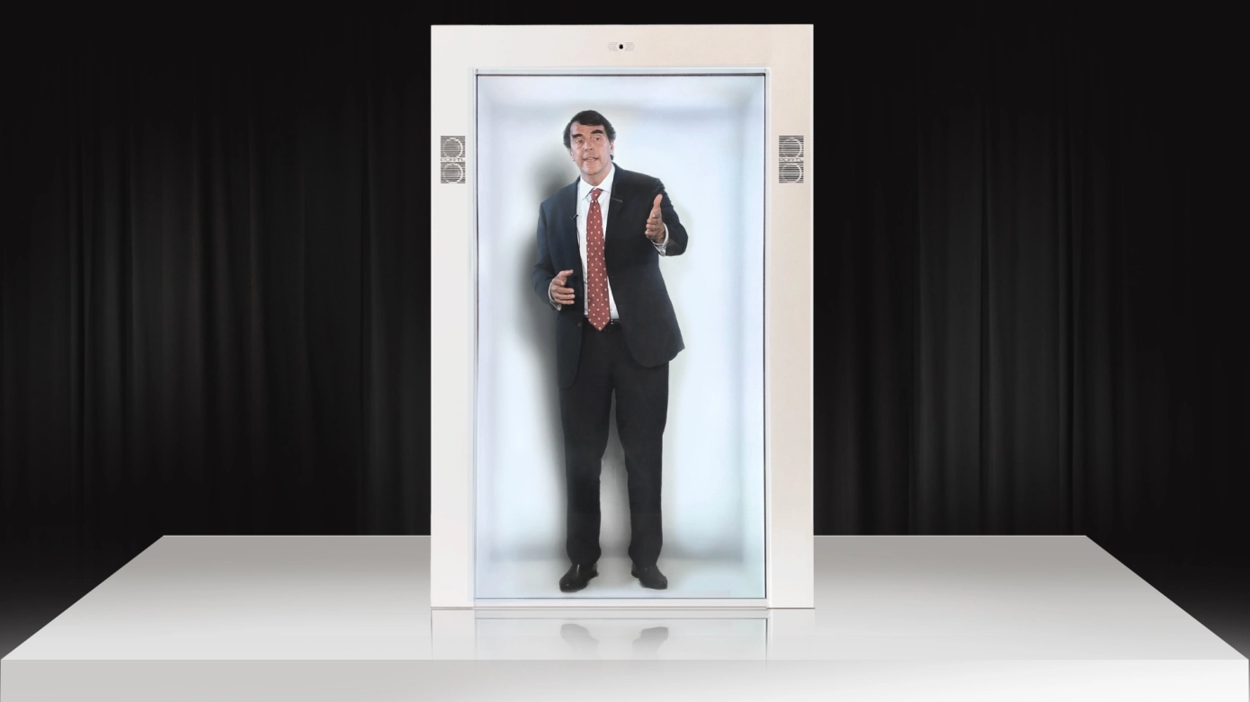

Picture 1. PORTL system (Portlhologram, 2021)

Consumer experience has been shaped by multiple dimensions such as behavioral, emotional, intellectual, cognitive, physical, and social via his/her customer journey and interactions with brands, companies, and other actors (Brakus et al., 2009; Verhoef et al., 2009; Lemon & Verhoef, 2016). With artificial intelligence, these dimensions and interactions become more predictable and interpretable. The relationship between consumers and artificial intelligence can be handled sociologically, psychologically, and technologically. Under this title, first of all, the artificial intelligence consumer relationship is discussed depending on the literature. Afterward, inferences will be presented depending on the findings obtained from the research carried out on the relationship between artificial intelligence and technology as below.

The experiences of consumers interacting with artificial intelligence are discussed in four types: data capture, classification, delegation, and social (Puntoni et al., 2020). Data capture is expressed as the experience of individually providing data to artificial intelligence. Artificial intelligence systems collect data about consumers' experiences and transfer this data to artificial intelligence. These data can be obtained with facial recognition technology or a residential area map (iRobot Roomba). Classification is the experience of receiving personalized predictions from artificial intelligence. Businesses are leveraging the predictive ability of artificial intelligence to create customized offers and increase engagement and satisfaction (Kumar et al., 2019). Classification experience is expressed as an experience in which consumers perceive artificial intelligence-assisted personalized predictions after classifying them into types. Delegation is the experience of participating in production processes where AI performs certain tasks in the consumer role. The empowerment experience is the experience where consumers incorporate an AI solution into a production process to perform their tasks. The task can be accomplished by the consumer making a call and obtaining information with the support of Google Assistant. Social is an interactive communication experience with an AI partner. Social AI experiences are useful in the absence of human interaction as they can communicate more efficiently with businesses with AI. , Agrawal et al. (2018)’s AI canvas can help to understand how AI is utilized in marketing.

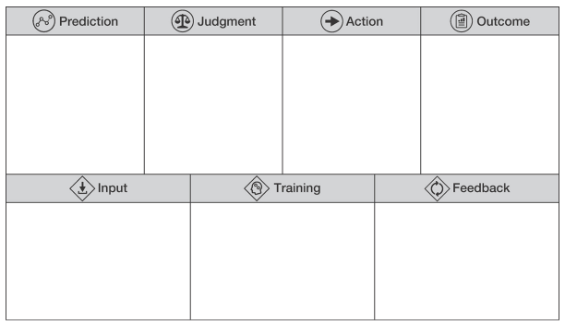

Figure 2. AI Canvas (Agrawal et al., 2018)

Agrawal et al. (2018)’s AI canvas (Fig. 2) consists of seven elements: prediction, judgment, action, outcome, input, training, and feedback. While developing, managing, and marketing AI-based experiences tools, companies and brands could fill the canvas with identifying answers. The big picture will help to create their strategy and action plan.

**AI-Based Experiential Marketing Examples**

Recently released artificial intelligence technologies have quickly extended to the realm of marketing. Although the conceptual relationships between artificial intelligence and marketing have not yet been established, many examples can be found when evaluating application domains. In recent years, there have been significant developments in marketing in terms of artificial intelligence capabilities such as natural language processing, image and speech recognition, and machine learning (Davenport et al., 2020; Kietzmann et al., 2018). The Internet of Things (IoT) has also come to the fore as an important development element in marketing in recent years (Fan et al., 2020). It is a technology that drives data-driven analytics and decision-making by working in the field of artificial intelligence, automation, and continuous learning (Kumar et al., 2019).

Artificial intelligence collects, stores, and manages information that can help create business proposals (Kumar et al., 2019). A very rich toolbox of predictive models and machine learning approaches is utilized for use in AI solutions in marketing (Wirth, 2018). Using technologies such as artificial intelligence, deep learning, and algorithms, it trains machines to recognize patterns in large amounts of data (Kumar et al., 2019). Artificial intelligence also acts as an assistant such as Alexa, Siri, and Cortana for personal uses (Kumar et al., 2019). Artificial intelligence also offers new technologies such as Sentient in terms of e-commerce and digital marketing (Kumar et al., 2019). Artificial intelligence also offers facial recognition support like Haystack (Kumar et al., 2019).

There are platforms, tools, and software that can be used in AI-Based experiential marketing. The Acoustic platform was developed by IBM to design and automate marketing campaigns by employing artificial intelligence technologies, personalize the campaigns specifically for the customer, and monitor the customer-brand relationship at every step of the marketing process with analytical tools (Acoustic, 2021). The acoustic platform provides insights to build data-driven experiences.

Customer experience is shaped by AI-supported technologies such as humanoid robots, chatbots, digital assistants, voice-enabled smart devices, and avatars (Hasan, 2021). Most customer care services (e.g. banking, e-commerce, etc.) use these technologies instead of recruiting a real human.

Service robots are robots that help employees who do not find the product easily in online shopping or in-store (Bogue, 2019). In addition to the store, service robots are also used in cafes and restaurants, hospitals, libraries, hotels, and museums (Davenport et al., 2020; Fan et al., 2020; Lin et al., 2014; Pee et al., 2019; Wirtz et al., 2018). Robots that assist customers can interact with customers (Belanche et al., 2020; Wirtz et al., 2018). LoweBot, a service robot developed by a retailer specializing in home improvement, helps customers find products.

**Future Directions and Challenges in AI-Based Experiential Marketing**

Experiential marketing focuses on the sensory, emotional, cognitive, behavioral, and relational values of customer experiences (Schmitt, 1999). In the near future, artificial intelligence will be increasingly used in our lives and shape our values through our experiences, like a circle. In addition to the opportunities that artificial intelligence technologies offer today, there are also developments that they will offer in the future. At this point, possible ethical problems have arisen and the opportunity potentials related to experiential marketing were appealed. For example, capturing consumers’ data, could enable better technological developments and offer personalized experiences. But on the other hand, without permission or voluntary participation, using and processing consumers’ data is illegal and requires criminal investigation.

References

Acoustic (2021, December 7). *Acoustic Platform.* <https://www.acoustic.com/about-acoustic>

Agrawal, A., Gans, J. & Goldfarb, A. (2018). *Prediction Machines: The Simple Economics of Artificial Intelligence*. Boston: Harvard Business Review Press.

Belanche, D., Casaló, L. V., Flavián, C., & Schepers, J. (2020). Service robot implementation: a theoretical framework and research agenda. *The Service Industries Journal*, *40*(3-4), 203-225.

Bogue, R. (2017). Domestic robots: Has their time finally come? *Industrial Robot: An International Journal*, *44*(2), 129-136.

Brakus, J. J., Schmitt, B. H., & Zarantonello, L. (2009). Brand experience: what is it? How is it measured? Does it affect loyalty? *Journal of Marketing*, *73*(3), 52-68.

Davenport, T., Guha, A., Grewal, D., & Bressgott, T. (2020). How artificial intelligence will change the future of marketing. *Journal of the Academy of Marketing Science*, *48*(1), 24-42.

Fan, X., Ning, N., & Deng, N. (2020). The impact of the quality of intelligent experience on smart retail engagement. *Marketing Intelligence & Planning, 38*(7), 877-891.

Hasan, R., Thaichon, P., & Weaven, S. (2021). Are We Already Living with Skynet? Anthropomorphic Artificial Intelligence to Enhance Customer Experience. In *Developing Digital Marketing*. Emerald Publishing Limited.

Kietzmann, J., Paschen, J., & Treen, E. (2018). Artificial intelligence in advertising: How marketers can leverage artificial intelligence along the consumer journey. *Journal of Advertising Research*, *58*(3), 263-267.Kumar, V., Rajan, B., Venkatesan, R., & Lecinski, J. (2019). Understanding the role of artificial intelligence in personalized engagement marketing. *California Management Review*, *61*(4), 135-155.

Lemon, K. N., & Verhoef, P. C. (2016). Understanding customer experience throughout the customer journey. *Journal of Marketing*, *80*(6), 69-96.

Lin, W., Yueh, H. P., Wu, H. Y., & Fu, L. C. (2014). Developing a service robot for a children's library: A design‐based research approach. *Journal of the Association for Information Science and Technology*, *65*(2), 290-301.

Orts-Escolano, S., Rhemann, C., Fanello, S., Chang, W., Kowdle, A., Degtyarev, Y., ... & Izadi, S. (2016, October). Holoportation: Virtual 3d teleportation in real-time. In *Proceedings of the 29th annual symposium on user interface software and technology* (pp. 741-754).

Pee, L. G., Pan, S. L., & Cui, L. (2019). Artificial intelligence in healthcare robots: A social informatics study of knowledge embodiment. *Journal of the Association for Information Science and Technology*, *70*(4), 351-369.

Portlhologram (2021, December 7). *Portlhologram*. https://www.portlhologram.com/about

Puntoni, S., Reczek, R. W., Giesler, M., & Botti, S. (2021). Consumers and artificial intelligence: An experiential perspective. *Journal of Marketing*, *85*(1), 131-151.

Schmitt, B. (1999). Experiential marketing. *Journal of Marketing Management*, *15*(1-3), 53-67.

Soliha, E., Aquinia, A., Hayuningtias, K. A., & Ramadhan, K. R. (2021). The Influence of Experiential Marketing and Location on Customer Loyalty. *The Journal of Asian Finance, Economics and Business*, *8*(3), 1327-1338.

Urdea, A. M., Constantin, C. P., & Purcaru, I. M. (2021). Implementing Experiential Marketing in the Digital Age for a More Sustainable Customer Relationship. *Sustainability*, *13*(4), 1865.

Verhoef, P. C., Lemon, K. N., Parasuraman, A., Roggeveen, A., Tsiros, M., & Schlesinger, L. A. (2009). Customer experience creation: Determinants, dynamics and management strategies. *Journal of Retailing*, *85*(1), 31-41

Wirth, N. (2018). Hello marketing, what can artificial intelligence help you with? *International Journal of Market Research*, *60*(5), 435-438.

Wirtz, J., Patterson, P. G., Kunz, W. H., Gruber, T., Lu, V. N., Paluch, S., & Martins, A. (2018). Brave new world: service robots in the frontline. *Journal of Service Management*, *29*(5), 907-931.