**Flow and Heat Transfer in an Asymmetric Trapezoidal Duct with Turbulators**

***Nasser Abdoul Halim ISMAEL1, [C:\Users\Abdullah\AppData\Local\Microsoft\Windows\INetCache\Content.Word\ORCID-iD_icon-16x16.gif](https://orcid.org/xxxx-xxxx-xxxx-xxxx), SelmaAKÇAY2[[1]](#footnote-1)\*[C:\Users\Abdullah\AppData\Local\Microsoft\Windows\INetCache\Content.Word\ORCID-iD_icon-16x16.gif](https://orcid.org/0000-0003-2654-0702), Maher Abdulhameed Sadeq SADEQ3[C:\Users\Abdullah\AppData\Local\Microsoft\Windows\INetCache\Content.Word\ORCID-iD_icon-16x16.gif](https://orcid.org/xxxx-xxxx-xxxx-xxxx)***

*1* **0009-0003-4779-0847**, *Undergraduate Student of Mechanical Engineering, Çankırı Karatekin University, Çankırı, Türkiye2*

*2\** **0000-0003-2654-0702**, *Çankırı Karatekin University, Engineering Faculty, Department of Mechanical Engineering, Çankırı, Türkiye*

*3* **xxxx-xxxx-xxxx-xxxx**, *Undergraduate Student of Mechanical Engineering, Çankırı Karatekin University, Çankırı, Türkiye*

|  |
| --- |
| **Abstract**  Channels with wavy/corrugated surfaces, which are passive heat transfer improvement methods, have attracted great attention for a long time [1,2]. Corrugated channels provide significant improvement in heat transfer because they increase surface area [3]. Another passive method is the turbulators/obstacles added to channel [4]. The purpose of these turbulators is to direct the flow in a certain direction, improve flow mixing and increase heat transfer [5]. To date, heat transfer in wavy channels with different geometries with or without turbulators has been investigated by many numerical and experimental studies and as a result, it has been reported that significant improvements in heat transfer are obtained in these channels compared to straight channels [6-8]. In this study, a trapezoidal duct with asymmetric geometry was used and circular turbulators were placed inside the wavy channel. The heat transfer behavior of circular turbulators in three different diameters was investigated. The analyses were performed with the finite volume method and the standard k-ε turbulence model was used as the viscous model. The wavy surfaces of the channel were kept constant at Tw=340 K and the channel outlet temperature (Tout), convection heat transfer coefficient (h), Nusselt number (Nu) and heat transfer improvement rate (ER) were found at different Reynolds numbers (3000≤Re≤6000). The results were presented as graphs. The velocity and temperature images were obtained for different parameters in the channel and the results were discussed. In addition, the results were compared with the wavy channel without turbulators. As a result of the study, it was observed that heat transfer improved by increasing inlet velocity. It was seen that the circular turbulators added to the channel significantly affected the heat transfer and the heat transfer increased with the increase in the circular turbulator diameters. |

|  |
| --- |
| Keywords: Asymmetric trapezoidal duct, Heat transfer, Turbulator |

1. **Introduction**

Channels with wavy/corrugated surfaces, which are passive heat transfer improvement methods, have attracted great attention for a long time [1, 2]. Corrugated channels provide significant improvements in heat transfer because they increase surface area [3]. Another passive method is the obstacles/turbulators added to the channel [4]. The purpose of these turbulators is to direct the flow in a certain direction, improve flow mixing and increase heat transfer [5]. To date, heat transfer in wavy channels with different geometries with or without turbulators has been investigated by many numerical and experimental studies and as a result, it has been reported that significant improvements in heat transfer are obtained in these channels compared to straight channels [6-8]. Uysal and Akcay [6] investigated the flow and heat transfer in hybrid wavy channels and showed that the hybrid wave profile improved the heat transfer compared to the uniform wave profile. Zheng et al. [7] numerically investigated the effects of vortex generators with different shapes on heat transfer and nanofluid flow and reported that the flow and heat transfer behavior were significantly affected by the vortex shapes. Brodniansk´a, & Kotˇsmíd [8] investigated the heat transfer enhancement in a new type of corrugated channel heat exchanger with circular cylinders. They reported that the circular vortex generator provided improved heat transfer, and the heat transfer in corrugated channels was improved by 1.98 times compared to the flat channel.

The geometry of the wave profile, the geometry of the vortex generators added into the channel, their locations, their sizes, flow and fluid conditions affect the flow and heat transfer. Studies on this subject have increased due to the large number of parameters to be examined. Therefore, in this study, the effects of circular turbulators on the flow and heat transfer in an asymmetric wavy channel were investigated numerically under turbulent flow conditions.

1. **Materials and Methods** 
   1. **Numerical geometry**

Figure 1 indicates the geometry of the asymmetric trapezoidal duct with turbulators used in this work. There are adiabatic straight parts with a length of L1 = 100 mm at the inlet and outlet of the channel. The asymmetric trapezoidal duct part (L2) is heated. This part is kept at a constant temperature of 340 K. Circular cylinders are placed inside the wavy channel. Analyses were performed for three different diameters values of circular turbulators ​​(d: 2 mm, 4 mm, 6 mm). The geometric parameters of the numerical model are given in Figure 1.

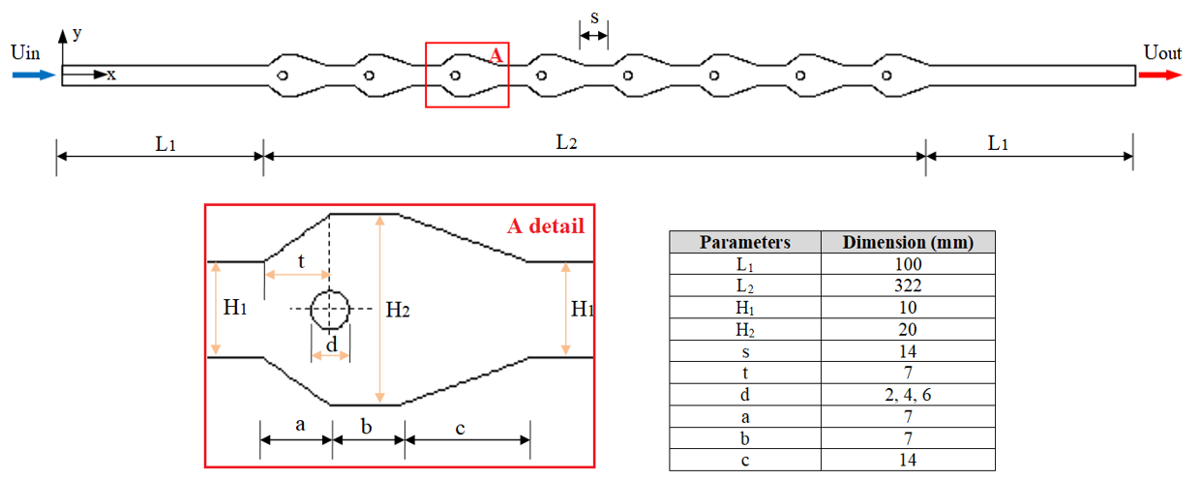

**Figure 1.** Geometry of the numerical model (with details)

* 1. **Governing equations**

In the numerical study, the solution field is 2d. The fluid is considered single-phase, incompressible and Newtonian. The flow is turbulent and steady case. Viscous terms are ignored. Fluid properties are constant. The effects of gravity and radiation are neglected. According to these assumptions, the governing equations are given below:

$\frac{∂}{∂x_{i}}\left(ρ{\overline{u}}_{i}\right)=0$ (1)

$\frac{∂}{∂t}\left(ρ{\overline{u}}_{i}\right)+\frac{∂}{∂x_{j}}\left(ρ{\overline{u}}_{i}{\overline{u}}_{j}\right)=-\frac{∂\overline{p}}{∂x_{i}}+\frac{∂}{∂x_{j}}\left[\left(μ+μ_{t}\right)\left(\frac{∂{\overline{u}}_{i}}{∂x_{j}}+\frac{∂{\overline{u}}_{j}}{∂x_{i}}\right)\right]-ρ\overline{u_{i}^{'}u_{j}^{'}}$ (2)

$\frac{∂}{∂t}\left(ρc\overline{T}\right)+\frac{∂}{∂x_{j}}\left(ρ{\overline{u}}_{i}\overline{T}\right)=\frac{∂}{∂x_{j}}\left[\left(Γ+Γ_{t}\right)\left(\frac{∂\overline{T}}{∂x_{j}}\right)\right]$ (3)

$-ρ\overline{u_{i}^{'}u_{j}^{'}}=(μ_{t})\left(\frac{∂u_{i}}{∂x_{j}}+\frac{∂u_{j}}{∂x_{i}}\right)$ (4)

$\frac{∂}{∂t}\left(ρk\right)+\frac{∂}{∂x_{i}}\left(ρk{\overline{u}}_{i}\right)=\frac{∂}{∂x_{j}}\left[\left(μ+\frac{μ_{t}}{σ_{k}}\right)\frac{∂k}{∂x_{j}}\right]+G_{k}-ρε$ (5)

$\frac{∂}{∂t}\left(ρε\right)+\frac{∂}{∂x_{i}}\left(ρε{\overline{u}}_{i}\right)=\frac{∂}{∂x_{j}}\left[\left(μ+\frac{μ_{t}}{σ_{ε}}\right)\frac{∂ε}{∂x_{j}}\right]+C_{1ε}\frac{ε}{k}G_{k}-C_{2ε}ρ\frac{ε^{2}}{k}$ (6)

In this study, the heat transfer in the asymmetric trapezoidal duct with different diameters of circular turbulators were studied at different Reynolds numbers (3000 ≤ Re ≤ 6000).

* 1. **Numerical method and boundary conditions**

The numerical study was conducted by the ANSYS Fluent solver. The standard k- ε turbulence model was used as the flow model. Governing equations were discretized with the finite volume approach and the velocity-pressure relationship was used with the SIMPLE algorithm. The convergence criterion was set as 107 for the energy equations and 10-4 for the other equations. For the mesh independence testing, the Nusselt numbers were calculated for different element numbers. As a result of this calculations, it was decided that 164122 element numbers are sufficient for the numerical solutions.

The working fluid is air. The air enters the channel at a constant velocity (Uin) and temperature (Tin=293 K). In the study, Reynolds number varied in the range of 3000≤Re≤6000. The surfaces of the wavy duct (L2) were kept constant at Ts=340 K. The non-slip wall condition was defined for the all surfaces. Straight parts at the inlet and outlet of the channel are adiabatic. The circular turbulators were assumed to be adiabatic and non-slip conditions.

* 1. **Mathematical Model**

The Reynolds number (Re) is calculated by Equation (7):

$Re=\frac{ρU_{in}D_{h}}{μ}$ (7)

where, Dh is the hydraulic diameter, ρ is the density, μ is the dynamic viscosity, and Uin is the inlet velocity.

The average Nusselt number (Nu) is obtained by Equation (8):

$Nu=\frac{hD_{h}}{k_{f}}$ (8)

where, kf and h are thermal conductivity and convective heat transfer coefficient, respectively.

$$h=\frac{q"}{{ΔT}_{log}}$$

where, q” and ΔTlog are heat flux and logaritmic temprerature difference, respectively.

Logaritmic temprerature difference is calculated by Equation (9):

${∆T}_{log}=\frac{\left[({T_{w}-T}_{out}{)-(T_{w}-T}_{in})\right]}{ln\left[\frac{\left(T_{w}{-T}_{out}\right)}{\left(T_{w}{-T}_{in}\right)}\right]}$ (9)

where, *Tin*, *Tout*, and *Tw* represent the inlet and outlet temperatures of the fluid and the temperature of the wavy surface, respectively.

The improvement ratio (ER) is described with Equation (10).

$ER=\frac{{Nu}_{w}}{{Nu}_{o}}$ (10)

where, Nuw shows the Nusselt number obtained in the asymmetric trapezoidal wavy duct with circular turbulators, and Nuo shows the Nusselt number obtained in the asymmetric trapezoidal wavy duct without turbulators.

**Results and Discussion**

* 1. **Validation of the numerical results**

The numerical results obtained in this work were validated with the results of previous studies. Wang et al. [9] experimentally examined heat transfer for the turbulent flow of air in a flat channel. Fig. 2 indicates the comparison of the results of this study with Wang et al. [9].

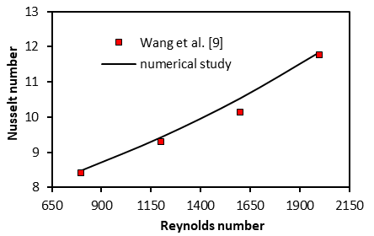

**Figure 2.** Validation of the numerical study

In this study, the velocity and temperature contours were presented to indicate the effects of the asymmetric trapezoidal wavy duct, circular turbulators and Reynolds number on heat transfer.

In Figure 3, the velocity contours are indicated in the asymmetric trapezoidal wavy duct with different diameters of circular turbulators for Re=6000. The circular turbulators in the wavy channel were considerably changed the flow fields. The presence of stagnant liquid regions in trapezoidal wavy gaps in the channel without circular turbulators is remarkable. It was observed that as the diameter of the circular turbulators increased, the fluid penetrated better into the wavy channel surfaces. However, the increase in the turbulator diameters caused the low pressure regions formed behind the turbulators to increase.

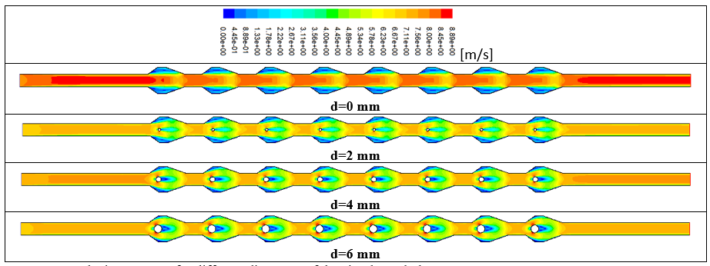

**Figure 3.** Velocity contours for different diameters of the circular turbulators at Re=6000

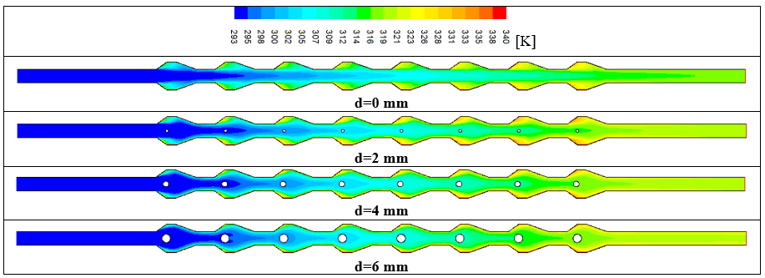

**Figure 4.** Temperature contours for different diameters of the circular turbulators at Re=6000

Figure 4 shows the temperature contours in the asymmetric trapezoidal wavy duct with different diameters of circular turbulators for Re=6000. The circular turbulators significantly affected the thermal fields. It was observed that the temperature gradient within the channel decreased by increasing the size of the circular turbulators. A decrease in the temperature of the wavy surfaces was observed with increasing turbulator diameters. In the channel with the turbulator diameter of d=6 mm, the temperature of the wavy surfaces decreased significantly compared to the turbulator diameter of d=2 mm. It was also observed that the channel temperature increased in the flow direction for all the channels with and without turbulators.

Figure 5 indicates the outlet temperature of the fluid (a), heat transfer coefficient (W/m2K) (b), Nusselt number (c), and heat transfer enhancement ratio (d) with Reynolds number for the asymmetric trapezoidal wavy duct with/without turbulators. It was observed that the outlet temperature decreased with increasing Reynolds number for all channel flows. The highest outlet temperature was obtained in the channel with d=6 mm turbulator diameter (Fig. 5a). Increasing Reynolds number increased the heat transfer coefficient in all channel cases. The highest heat transfer coefficient was obtained in the turbulator diameter of d=6 mm (Fig. 5b). Increasing Reynolds number also increased the Nusselt number in all channels. It is seen that higher heat transfer is provided in the highest turbulator diameter studied (d=6 mm) (Fig. 5c). In Figure 5d, the channel without turbulators is considered as reference and the effects of different turbulator diameters on heat transfer improvement are calculated. The heat transfer improvement rate also increased with increasing turbulator diameters. At Re=6000, heat transfer in the turbulator diameter of d=6 mm increased by 1.27 times compared to the channel without turbulator (Fig. 5d).

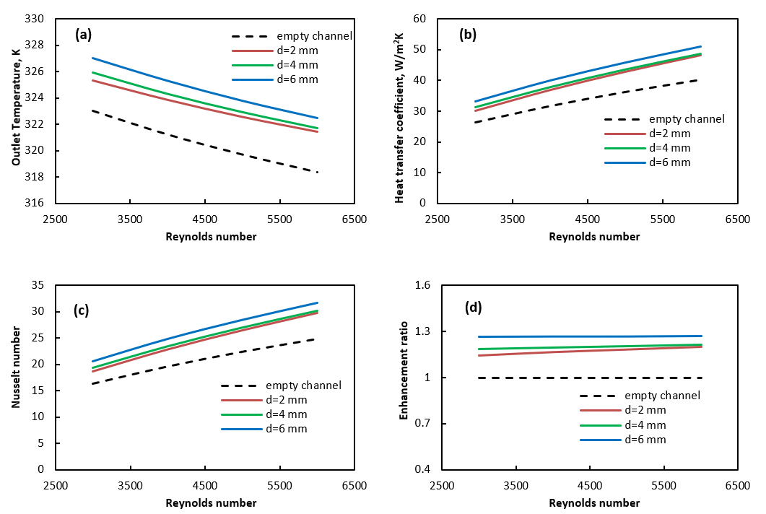

**Figure 5.** a- Outlet temperature, b- Heat transfer coefficient, c- Nusselt number, d- Enhancement ratiowith Re

1. **Conclusion**

In this study, the effects of circular turbulators on the flow and heat transfer in an asymmetric trapezoidal wavy channel were numerically investigated under turbulent flow conditions. The analyses were carried out for different diameters of turbulators and Reynolds numbers in the range of 3000≤Re≤6000. In the study, the channel outlet temperature (Tout), convection heat transfer coefficient (h), Nusselt number (Nu) and heat transfer improvement ratio (ER) obtained for different parameters were presented as graphs. The velocity and temperature images were obtained in the channel. The main findings are listed below:

* It was seen that the circular turbulators added to the channel significantly affected the flow and heat transfer.
* The outlet temperature of the channel decreased with increasing Reynolds number for all channel flows. The highest outlet temperature was obtained in the channel with d=6 mm turbulator diameter.
* Increasing Reynolds number increased the heat transfer coefficient in all channel cases. The highest heat transfer coefficient was obtained in the turbulator diameter of d=6 mm.
* Increasing Reynolds number increased the Nusselt number in all channel flows. It is seen that higher heat transfer is provided in the highest turbulator diameter studied (d=6 mm).
* Heat transfer enhancement ratio increased with increasing turbulator diameters. At Re=6000, heat transfer in the turbulator diameter of d=6 mm increased by 1.27 times compared to the channel without turbulators.

**Acknowledgement**

In this study, the financial support was provided by The Scientific and Technological Research Council of Turkey (TUBITAK), Project No: 1919B012319076 (2209A, University Students Research Projects Support Program, 2023-2). All numerical work was conducted in Çankırı Karatekin University Computer Laboratory. The authors would like to thanks to all supporters due to their precious contributions.

**References**

1. Zhang, J., Zhu, X., Mondejar, M. E., & Haglind, F. (2019). A review of heat transfer enhancement techniques in plate heat exchangers. *Renewable and Sustainable Energy Reviews*, 101, 305-328.
2. Nitturi, L. K., Kapu, V. K. S., Gugulothu, R., Kaleru, A., Vuyyuri, V., & Farid, A. (2023). Augmentation of heat transfer through passive techniques. *Heat Transfer*, https://doi.org/10.1002/htj.22877
3. Alfellag, M.A., Ahmed, H.E., Jehad, M.G., & Farhan, A.A. (2022). The hydrothermal performance enhancement techniques of corrugated channels: A review. *Journal of Thermal Analysis and Calorimetry*, 147, 10177-10206.
4. Alam, T., & Kim, M. H. (2018). A comprehensive review on single phase heat transfer enhancement techniques in heat exchanger applications. Renewable and Sustainable Energy Reviews, 81, 813-839.
5. Akcay, S. (2023). Numerical study of turbulent heat transfer process in different wavy channels with solid and perforated baffles, *Heat Transfer Research*, 54(18), 53-82.
6. Uysal, D., & Akçay, S. (2024). Numerical study of thermal and hydrodynamic characteristics of turbulent flow in hybrid corrugated channels with different wave profiles. *Journal of Mechanical Engineering and Sciences,* 18(2), 10026–10045
7. Zheng, Y., Yang, H., Mazaheri, H., Aghaei, A., Mokhtari, N., & Afrand, M. (2021). An investigation on the influence of the shape of the vortex generator on fluid flow and turbulent heat transfer of hybrid nanofluid in a channel. *Journal Thermal Analysis and Calorimetry*, 143,1425–1438.
8. Brodniansk´a, Z., & Kotˇsmíd, S. (2023). Heat transfer enhancement in the novel wavy shaped heat exchanger channel with cylindrical vortex generators. *Applied Thermal Engineering*, 220, 119720
9. Wang, G., Qia, C., Liu, M., Li, C., Yan, Y., & Liang, L. (2019). Effect of corrugation pitch on thermo-hydraulic performance of nanofluids in corrugated tubes of heat exchanger system based on exergy efficiency. *Energy Conversion and Management*, [186](https://doi.org/10.1016/j.enconman.2019.02.046), 51–65.

1. \* Corresponding author. *e-mail address: selmaakcay@karatekin.edu.tr* [↑](#footnote-ref-1)