**Different Methods Used for Increasing Gingival Tissue**

***Semra ESER 1,[[1]](#footnote-1)\*[C:\Users\Abdullah\AppData\Local\Microsoft\Windows\INetCache\Content.Word\ORCID-iD_icon-16x16.gif](https://orcid.org/0000-0002-4546-1017), Başak KARASU 1 [C:\Users\Abdullah\AppData\Local\Microsoft\Windows\INetCache\Content.Word\ORCID-iD_icon-16x16.gif](https://orcid.org/0000-0001-6537-9902)***

*1 Faculty of Dentistry, Department of Periodontology, Çankırı Karatekin University, Çankırı, Turkey*

|  |
| --- |
| **Abstract**  In the treatment of gingival recession, the goal is to cover the exposed root surface for aesthetic or sensitivity issues in some cases, while in other cases, the aim is to increase the amount of keratinized gingival tissue around the tooth or implant to enhance the survival rate of the respective tooth or implant. The purpose of our study is to present different soft tissue grafting methods used in various cases. |
| Keywords: Free gingival graft, Keratinized gingival tissue, Subepithelial connective tissue graft, Soft tissue graft |

1. **Introduction**

Gingival recessions can lead to dentin hypersensitivity, root caries, and aesthetic issues [1,2]. When gingival recession occurs, maintaining hygiene in the affected area becomes challenging due to factors like sensitivity to mechanical and thermal stimuli or difficulty in reaching the area during brushing, leading to inflammation. Therefore, it is necessary to cover exposed root surfaces with gingival grafts.

The insufficiency of the attached keratinized gingiva around the tooth or implant causes the non-keratinized marginal gingiva around the tooth to move in the apical direction with lip and cheek muscle movements. This movement triggers plaque accumulation, complicating plaque elimination with difficulty in brushing the alveolar mucosa. The result is increased inflammation and gingival recession. According to the American Academy of Periodontology Regeneration Workshop Report, if plaque control cannot be achieved ideally, a minimum of 2mm keratinized gingiva is required to prevent attachment loss [3].

Free gingival grafts are commonly used to create keratinized gingiva, and pedicle grafts can be applied when adjacent gingival tissues are sufficient. Connective tissue grafts are applied to cover open root surfaces and thicken the gingival tissue [4]. Various methods, such as tunnel technique and advancement flaps, can be used to apply connective tissue grafts [5].

1. **Materials and Methods**

A 29-year-old female presented to our clinic with complaints of hot/cold sensitivity and pain while brushing her lower front teeth. Clinical examination revealed Miller Class 1 gingival recession on tooth 31 with 1mm of keratinized tissue. Due to inadequate keratinized gingiva around the tooth, the patient struggled to brush the area, leading to plaque accumulation and inflammation. Following Phase I periodontal treatment and oral hygiene education, inflammation was resolved at the follow-up session. Free gingival graft was planned. The free gingival graft obtained from the patient's palate was sutured to the recipient site and postoperative recommendations were made. The presence of keratinized gingiva was observed in the follow-up session 3 months later (Figure 1). The patient's pain complaint disappeared.

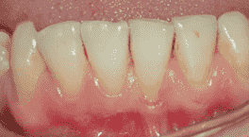 (a)

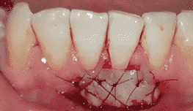 (b) 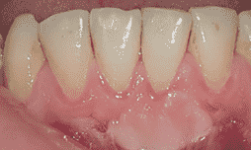 (c)

**Figure 1.** Gingival recession before surgery (a), post operation (b), 3 months post operation (c)

A 51-year-old female, who had dental implants and prosthetics placed one year ago, complained of pain while brushing and discomfort from lip movements during eating. Intraoral examination revealed no keratinized gingiva mesial to the implant, and lip movement caused mobility of the mucosa around the implant. Radiographic examination confirmed bone loss around the implant. Stemmed gingival graft around the implant was decided. After removing the prosthetics and attaching a healing abutment, a 4mm thick gingival tissue stemmed from the palate was buccally adapted and sutured. At three-week follow-up, healthy keratinized tissue had formed around the implant and lip movement did not mobilize the tissue (Figure 2).

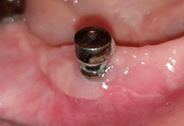 (a) 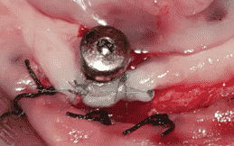 (b)

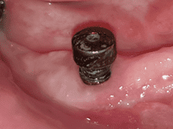 (c)

**Figure 2.** Around the implant before surgery (a), post operation (b), 3 weeks post operation (c)

In the intraoral examination of a 64-year-old male patient who applied to our clinic with the complaint of tooth sensitivity, it was observed that he had Miller Class 1 gingival recession in teeth number 13 and 14. It was planned to perform a coronally advanced connective tissue graft on the patient in order to cover the exposed root surface. For this purpose, a subepithelial connective tissue graft was taken from the patient's palate and sutured to the recipient area. The half-thickness flap was closed by sliding it coronally. In the follow-up session 6 weeks later, it was observed that the open root surface was successfully closed (Figure 3).

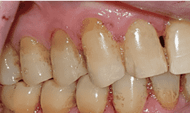 (a) 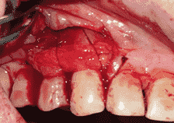 (b) 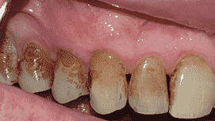 (c)

**Figure 3.** Gingival recession before surgery (a), post operation (b), 6 weeks post operation (c)

A 32-year-old female with complaints of tooth sensitivity and esthetic concerns presented with Miller Class 1 gingival recession around teeth 43, 44, 45, and 46. The recipient site was prepared with the tunnel technique and the subepithelial connective tissue graft obtained from the patient's palate was sutured to the relevant site. In the follow-up session 4 weeks later, it was observed that the open root surface was successfully closed (Figure 4).

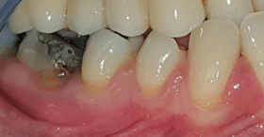 (a) 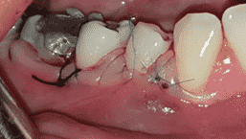 (b)

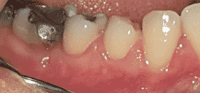 (c)

**Figure 4.** Gingival recession before surgery (a), post operation (b), 4 weeks post operation (c)

1. **Conclusion**

There are various soft tissue grafting methods available. The success of the treatment depends on the selection of the most appropriate method. Factors such as the amount and quality of keratinized gingival tissue, depth and width of gingival recession, and patient complaints should be evaluated together, guiding the selection of the method [6].

**References**

1. Cortellini P, Bissada NF. (2018). Mucogingival conditions in the natural dentition: Narrative review, case definitions, and diagnostic considerations. J Clin Periodontol. Jun;45 Suppl 20:S190-S198.
2. Jepsen, S, Caton, JG, et al. (2018). Periodontal manifestations of systemic diseases and developmental and acquired conditions: Consensus report of workgroup 3 of the 2017 World Workshop on the Classification of Periodontal and Peri-Implant Diseases and Conditions. *J Periodontol*. 89(Suppl 1): S237–S248.
3. Scheyer ET, Sanz M, Dibart S, et al.(2015) Periodontal soft tissue non–root coverage procedures: a consensus report from the aap regeneration workshop.J Periodontol 86 : 73-76.
4. Zucchelli G, Tavelli L, McGuire MK, Rasperini G, Feinberg SE, Wang HL, Giannobile WV. (2020). Autogenous soft tissue grafting for periodontal and peri-implant plastic surgical reconstruction. J Periodontol. Jan;91(1):9-16.
5. Zadeh HH. (2011). Minimally invasive treatment of maxillary anterior gingival recession defects by vestibular incision subperiosteal tunnel access and platelet-derived growth factor BB. Int J Periodontics Restorative Dent. 31:653-660.
6. Blanc A, Pare-Dargent C, Giovannoli JL.(1991). Traitement des recessions gingivales par lambeau positionne coronairement. J Parodontol. Sep;10(3):329-34.

1. \* Corresponding author. *e-mail address: semraeser@karatekin.edu.tr* [↑](#footnote-ref-1)