**The use of phase change materials with waste materials for sustainable thermal energy storage in buildings**

***Ali KARAİPEKLİ1,[[1]](#footnote-1)\*[C:\Users\Abdullah\AppData\Local\Microsoft\Windows\INetCache\Content.Word\ORCID-iD_icon-16x16.gif](https://orcid.org/0000-0001-8851-5284), Fatma Burcu UZUNOĞLU2[C:\Users\Abdullah\AppData\Local\Microsoft\Windows\INetCache\Content.Word\ORCID-iD_icon-16x16.gif](https://orcid.org/0000-0002-4197-785X)***

*1Faculty of Science, Department of Chemistry, Karatekin University, Çankırı, Türkiye*

*2Graduate School of Natural and Applied Sciences, Department of Chemistry, Karatekin University, Çankırı, Türkiye*

|  |
| --- |
| **Abstract**  This study provides an overview of the utilization of phase change materials (PCMs) with waste materials in buildings for thermal energy storage. PCMs, with their unique ability to absorb and release latent heat during phase transitions, present a revolutionary solution for mitigating temperature fluctuations in diverse climates. However, some issues including leakage and stability need to be considered when integrating them into building materials. To prevent or minimize these issues, PCMs could be used with some carrier mediums such as capsules, shells, pouches, pipes or porous materials. The use of waste materials, particularly those with porous structures, has become the subject of research as they have a great potential to be used as carrier mediums of PCMs. Apart from these, repurposing industrial by-products, biomass, wood-derived materials and other kind of wastes offer economic feasibility and environmental benefits aligned with circular economy principles.  While the benefits of PCM application in buildings have been recognized, there is still a paucity of studies specifically addressing their combination with waste materials. This study aims to inspire further research, innovation, and mainstream adoption of the use of PCMs with waste materials, driving progress toward energy-efficient and environmentally conscious buildings. |
| Keywords: Phase change material, Thermal energy storage, Latent heat, Waste materials, Thermal energy efficiency in buildings |

1. **Introduction**

The use of waste materials, such as recycled-plastic waste, wood sawdust waste, and industrial and agricultural solid waste, has been explored for their potential to be integrated with phase change materials (PCMs) to create building materials that offer improved thermal performance and reduced environmental impact. This approach presents an opportunity to repurpose and recycle waste, contributing to the circular economy principles in the construction industry.

PCM is a type of material that is able to store and release thermal energy during phase change processes [1]. There are different types of PCMs available, including organic PCMs and inorganic PCMs. Organic PCMs, such as paraffin and fatty acids, are characterized by high latent heat and chemical stability; however, they often have low thermal conductivity and high fluidity, which can limit their heat transfer efficiency [2]. On the other hand, inorganic PCMs, such as salt hydrates and metal alloys, have higher thermal conductivity but lower latent heat compared to organic PCMs [3]. The selection of PCMs for building integration is crucial to ensure effective thermal energy storage and regulation within the desired temperature range for energy savings and comfort. Organic PCMs have been found to have a melting temperature and heat of fusion ranging from 19°C to 29°C and from 120 kJ/kg to 280 kJ/kg, respectively, making them suitable for building applications within this temperature range [4].

Incorporating PCMs into traditional building structures is an effective approach to reduce the mismatch between energy supply and demand, thereby minimizing energy consumption for cooling and heating purposes. The application of PCMs in buildings extends to various building elements, including structural materials, plaster, mortar, insulation, and concrete structures. Previous studies successfully integrated micro-encapsulated PCMs into these building materials, highlighting the versatility and potential applications of PCMs in the construction industry [5]. However, selection of the integration method of PCM as well as the waste materials to be used has to meet some criteria in order for them to be utilized efficiently together. To prevent the leakage issue of PCM in liquid state and its interference with cement hydration and adverse effects on concrete's mechanical properties, many researchers have employed multiple materials such as porous materials, metallic materials and polymer materials as a carrier for PCM. Nevertheless, porous materials have been considered to be more advantageous owing to their low cost, high specific surface area, easy availability and light weight.

This study serves as a resource for researchers interested in the intersection of waste materials, PCMs, and sustainable building technologies. The insights provided aim to stimulate further exploration, innovation, and the widespread implementation of waste material encapsulated PCMs, contributing to the realization of energy-efficient and environmentally-friendly buildings in the future.

1. **Application of PCMs into Buildings**

PCMs absorb or release a significant amount of energy while maintaining a constant temperature during the phase change, which makes them valuable for achieving energy efficiency, thermal comfort, and sustainability in the built environment. Figure 1 shows the working principle of PCMs.

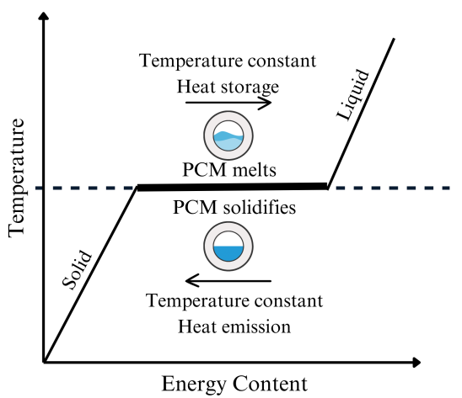

**Figure 1.** Working principle of PCMs

PCMs can be used in walls, wallboards, floors, ceilings, roofs, trombe walls, solar façades, insulation materials and plastering mortar. Figure 2 show an example for the use of PCMs in floors.

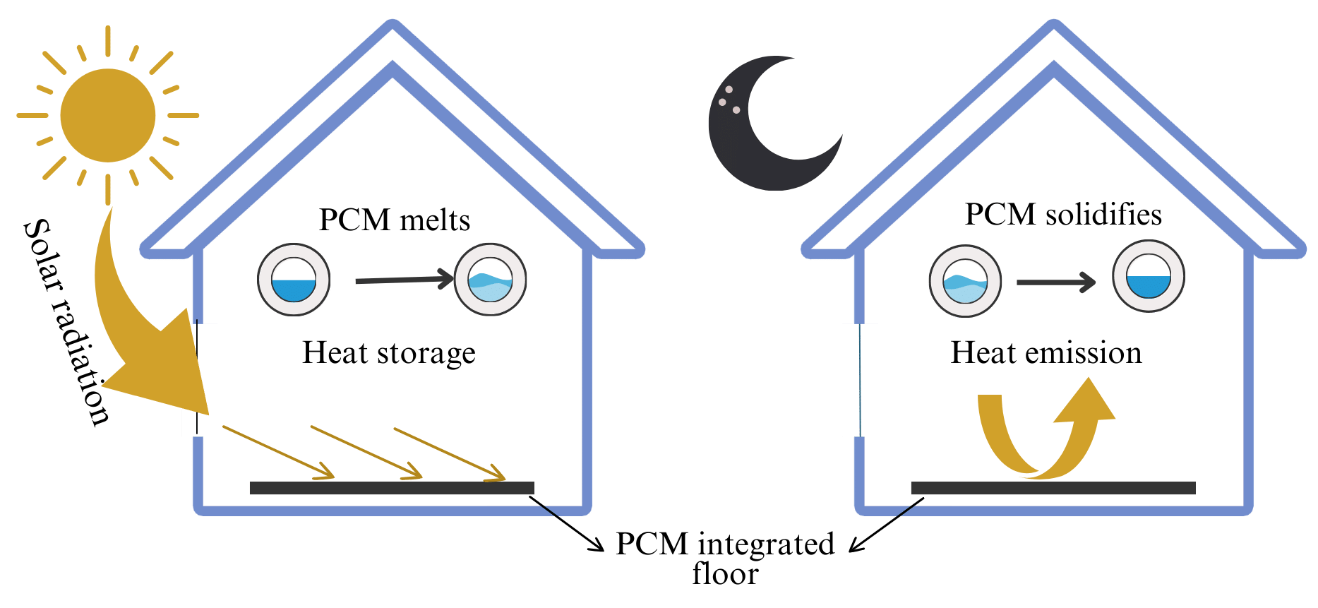

**Figure 2.** The use of PCMs in floors

Practically, PCMs are incorporated into building components by four main methods: i) Direct incorporation, ii) immersion, iii) Encapsulation, micro or macro encapsulation, iv)stabilization, shape stabilization or form stabilization [6].

The direct incorporation method involves adding PCMs in powder or liquid state directly to construction materials like gypsum mortar, cement mortar, and concrete mixture. This method is the easiest and most economical, as it does not require specialized expertise. Nonetheless, a major drawback is the potential leakage of PCM during the melting phase, leading to material incompatibility and an increased risk of fire, especially for flammable PCMs. On the other hand, the immersion method entails immersing a porous material into liquid PCM, which is then absorbed through capillarity. Drawbacks of this method include potential leakage, construction incompatibility, and corrosion of reinforced steel when incorporated with concrete elements, affecting their service life [7]. In contrast, encapsulation is a suitable method to address leakage issues of PCM and enhance its compatibility with building structures. This involves covering the PCM with a protective shell to prevent leakage and protect it from the external environment. PCM can be macroencapsulated using shells, spheres, tubes, channels, and thin plates, as shown in Figure 3, or microencapsulated when the microsized PCM is covered by a unique polymeric material.

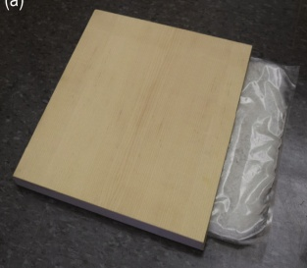 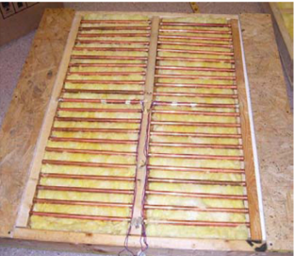 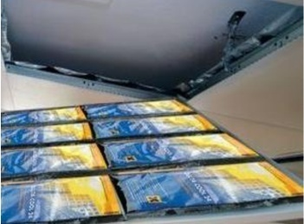 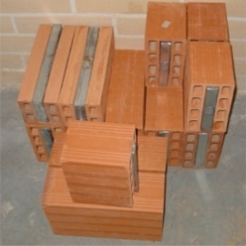

d

c

b

a

**Figure 3.** Some macro-encapsulation forms used in buildings a) PCM brick [8], b) wooden panel with PCM pouch [9], c) PCM in pipes [10], d) PCM pouch in the ceiling [11]

Microencapsulation, on the other hand, involves enclosing micron-sized particles of solids or droplets of liquids or gases in an inert shell, as shown in Figure 4, providing protection and isolation from the external environment. This method is widely used in building applications in order to increase heat transfer areas, reduce reactivity of PCMs towards the outside environment, and prevent unwanted volume changes.

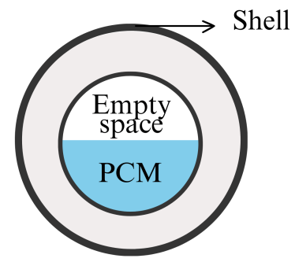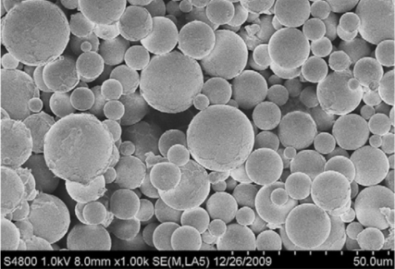

b

a

**Figure 4.** The scheme of PCM microcapsules a), silvernanoparticles PCM microcapsules b) [12].

The concept of shape-stabilized PCMs (ss-PCMs), or form-stable PCMs (FSPCMs), involves incorporating the PCM into a supporting matrix or structure, which can be organic, inorganic, or a combination of both, to prevent the PCM from leaking or changing shape during the phase transition. This is achieved through various methods such as encapsulation, composite formation, or impregnation, where the PCM is immobilized within the matrix, thereby maintaining its form stability. The supporting matrix provides mechanical strength and containment for the PCM, allowing it to retain its shape and structural integrity. Figure 5 represents an example for ss-PCMs.

a

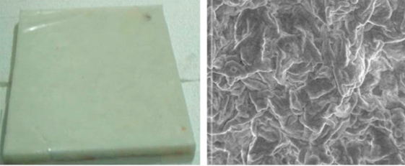

b

**Figure 5.** Shape-stabilized PCM plate, a) image of the plate, b) SEM image of the PCM plate [13]

1. **The Use of Waste Materials with PCMs**

The integration of waste materials with PCMs has been explored in various applications, including building materials, concrete, and energy-efficient room cooling systems [14]. These applications demonstrate the versatility and potential of waste materials in enhancing the performance of PCMs for thermal energy storage. Economically, the utilization of waste materials for PCM encapsulation offers opportunities for cost-effective and sustainable solutions in thermal energy storage applications. Additionally, the environmental advantages of utilizing waste materials for PCM encapsulation are significant. This approach is in line with the principles of circular economy, waste reduction, and sustainable resource management, thereby contributing to environmental sustainability and mitigating the environmental impact of waste materials.

The usage of waste materials derived from particularly biomass and wood-based products have been the subject of a number of studies due to their porous structure, which has the potential to prevent leakage and thermal conductivity issues providing a shape-stable matrix for the PCM.

Biochar, the residual product of biomass pyrolysis, is a carbon-rich material with a fine-grained black appearance. It is formed through a thermochemical decomposition process at moderate temperatures under oxygen-limiting conditions, resulting in a porous structure with a large specific surface area and strong adsorption capacity. Due to its mesoporous framework, biochar has been utilized to design ss-PCMs. By encapsulating the liquid phases of PCMs within its pores, biochar overcomes the leakage problem associated with PCMs [15].

A number of studies have focused on the use of carbonized biomass materials such as wood, cotton, fungi, potato and corn cob and so on [16]. For instance, Zheng et al. [17] studied the effect of paraffin wax incorporated carbonized rice husks (CRHs) in wood plastic composites (WPCs) and reported that the thermal conductivity of paraffin improved by the addition of CRHs. Abdulmunem et al. [18] reported that incorporating 75% of recycled waste paper with PCM into PVC panels resulted in reductions of 19% in the required cooling load and 16.3% in electricity cost, as compared to panels filled solely with PCM. Chen et al. [19] investigated the thermal efficiency of carbonized wood and graphite coated n-octadecane. The authors reported that carbonized wood's porous structure physically absorbs the organic PCM n-octadecane, and a thin graphite coating encases the exterior of the wood structure to prevent n-octadecane leakage and that it not only stabilizes the form of n-octadecane during phase change but also boosts its thermal conductivity by 143% while retaining 87% of its latent heat. Zheng et al. [17] prepared ss-PCMs incorporating polyethylene glycol (PEG) into porous carbonized bamboo parenchyma cells (CPC) with carbon nanotubes(CNTs). They reported that the thermal conductivity of PEG/CPC-CNTs increases by 128% comparing to pure PEG.

Liu et al. [20] prepared a hybrid PCM with palmitic acid (PA) and hybrid multivariate typical solid wastes (MTSW) composed of biomass solid wastes (BSW), iron tailings (IT) and diatomite (DT), shown in Figure 6. The authors stated that MTSW can adsorb 30 wt% PA without any PA leakage and the composites can keep form-stable.

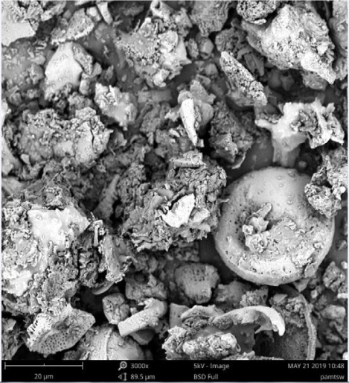

BSW

DTT

IT

PA

**Figure 6.** SEM photographs of PA/MTSW [20]

Anagnostopoulos et al. [21] prepared a composite PCM with red mud, an industrial waste of the aluminum industry, and nitrate salt. The authors reported that the PCM was thermally stable with a maximum latent heat of 58 J/g and a maximum energy storage density of 1396 MJ/m3.

Moreover, the study of Jeo et al. [22] showed that composite PCMs made of rice husk biochar and soy wax can be used in buildings. The results obtained by the authors revealed that reduction in the building energy consumption is 531.31 kWh/year after the incorporation of rice husk biochar/soy wax into the interior of the building’s outer wall. Moreover, the monitored SEM images of the composite PCMs, Figure 7, showed that soy wax was succusfully penetrated into the porous structure of rice husk biochar, as desired.

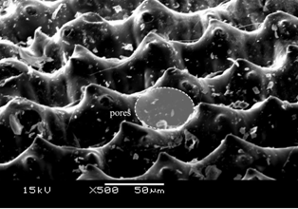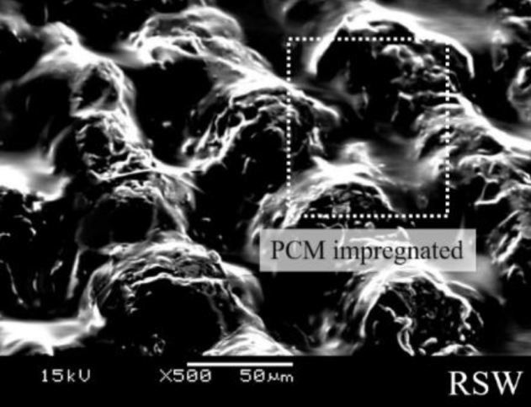

**PCM impregnated**

**Pores**

b

a

**Figure 7.** SEM images of a) rice husk biochar, b) rice husk biochar/soy wax [22]

1. **Conclusion**

The use of waste materials as carriers for PCM introduces economic and environmental benefits. The versatility of waste materials, particularly those derived from biomass and wood-based products, has been harnessed to prevent PCM leakage and improve thermal efficiency. Biochar, the by-product of biomass pyrolysis, stands out for its porous structure, making it an effective carrier for PCM. Despite the promising results presented in the existing studies in literature, it is noteworthy that there is still a limited body of research specifically addressing the integration of waste materials with PCMs. The information presented here intends to encourage additional research, creativity, and the extensive use of PCMs together with waste materials, making a contribution to the achievement of energy-efficient and environmentally friendly buildings in the coming years.

**References**

[1] Wang, R., Kang, Y., Lei, T., Li, S., Zhou, Z., and Xiao, Y. (2021) Microcapsules Composed of Stearic Acid Core and Polyethylene Glycol-based Shell as a Microcapsule Phase Change Material, *International Journal of Energy Research*.

[2] Zhao, J., Zhang, W., Gao, C., and Yin, D. (2020) Shape Stabilization of Phase Change Material by Polymerized High Internal Phase Emulsion for Thermal Energy Storage, *International Journal of Energy Research*.

[3] Galazutdinova, Y., Al-Hallaj, S., Grágeda, M., and Ushak, S. (2019) Development of the Inorganic Composite Phase Change Materials for Passive Thermal Management of Li‐ion Batteries: Material Characterization, *International Journal of Energy Research*.

[4] Cui, Y., Xie, J., Liu, J., Wang, J., and Chen, S. (2017) A Review on Phase Change Material Application in Building, *Advances in Mechanical Engineering*.

[5] Kumar, D., Alam, M., and Sanjayan, J. (2021) Retrofitting Building Envelope Using Phase Change Materials and Aerogel Render for Adaptation to Extreme Heatwave: A Multi-Objective Analysis Considering Heat Stress, Energy, Environment, and Cost, *Sustainability*.

[6] Al-Yasiri, Q., and Szabó, M. (2021) Incorporation of phase change materials into building envelope for thermal comfort and energy saving: A comprehensive analysis, *Journal of Building Engineering* *36*, 102122.

[7] Frigione, M., Lettieri, M., and Sarcinella, A. (2019) Phase Change Materials for Energy Efficiency in Buildings and Their Use in Mortars, *Materials* *12*, 1260.

[8] Silva, T., Vicente, R., Soares, N., and Ferreira, V. (2012) Experimental testing and numerical modelling of masonry wall solution with PCM incorporation: A passive construction solution, *Energy and Buildings* *49*, 235-245.

[9] Mahis, D., Blanchet, P., Landry, V., and Lagière, P. (2018) Thermal characterization of bio-based phase changing materials in decorative wood-based panels for thermal energy storage, *Green Energy & Environment* *4*.

[10] Sun, X., Medina, M. A., and Zhang, Y. (2019) Potential Thermal Enhancement of Lightweight Building Walls Derived From Using Phase Change Materials (PCMs), *Frontiers in Energy Research* *7*.

[11] Yordanova, R. (2012) Low-energy buildings. Why and How? Bachelor of Architectural Technology and Construction Management, November 2012.

[12] Li, W., Song, G., Tang, G., Chu, X., Ma, S., and Liu, C. (2011) Morphology, structure and thermal stability of microencapsulated phase change material with copolymer shell, *Energy* *36*, 785-791.

[13] Mavrigiannaki, A., and Ampatzi, E. (2016) Latent heat storage in building elements: A systematic review on properties and contextual performance factors, *Renewable and Sustainable Energy Reviews* *60*, 852-866.

[14] Ghani, S. A. A., Jamari, S. S., and Abidin, S. Z. (2021) Waste materials as the potential phase change material substitute in thermal energy storage system: a review, *Chemical Engineering Communications* *208*, 687-707.

[15] Sparavigna, A. C. (2021) Phase-Change Materials and Biochar: Some New Composite Materials in Recent Literature, *SSRN Electronic Journal*.

[16] Chen, X., Cheng, P., Tang, Z., Xu, X., Gao, H., and Wang, G. (2021) Carbon-Based Composite Phase Change Materials for Thermal Energy Storage, Transfer, and Conversion, *Adv Sci (Weinh)* *8*, 2001274.

[17] Zheng, C., Zhang, H., Xu, L., and Xu, F. (2022) Carbonized bamboo parenchyma cells loaded with functional carbon nanotubes for preparation composite phase change materials with superior thermal conductivity and photo-thermal conversion efficiency, *Journal of Building Engineering* *56*, 104749.

[18] Abdulmunem, A. R., Hussein, N. F., Samin, P. M., Sopian, K., Hussien, H. A., and Ghazali, H. (2023) Integration of recycled waste paper with phase change material in building enclosure, *Journal of Energy Storage* *64*, 107140.

[19] Chen, B., Han, M., Zhang, B., Ouyang, G., Shafei, B., Wang, X., and Hu, S. (2019) Efficient Solar-to-Thermal Energy Conversion and Storage with High-Thermal-Conductivity and Form-Stabilized Phase Change Composite Based on Wood-Derived Scaffolds, In *Energies*.

[20] Liu, P., Zhang, Z., Gu, X., Rao, J., Shi, J., and Bian, L. (2020) Fabrication of a novel shape-stabilized composite phase change material based on multivariate supporting materials by using typical solid wastes, *Construction and Building Materials* *240*.

[21] Anagnostopoulos, A., Navarro, M. E., Stefanidou, M., Ding, Y., and Gaidajis, G. (2021) Red mud-molten salt composites for medium-high temperature thermal energy storage and waste heat recovery applications, *Journal of Hazardous Materials* *413*, 125407.

[22] Jeon, J., Park, J. H., Wi, S., Yang, S., Ok, Y. S., and Kim, S. (2019) Latent heat storage biocomposites of phase change material-biochar as feasible eco-friendly building materials, *Environmental Research* *172*, 637-648.

1. \* Corresponding author. *e-mail address: akaraipekli@karatekin.edu.tr* [↑](#footnote-ref-1)