**Analysis of one-dimensional photonic crystal biosensor for detection of SARS-CoV-2**

***Nurettin Bilgili 1[[1]](#footnote-1)\*[C:\Users\Abdullah\AppData\Local\Microsoft\Windows\INetCache\Content.Word\ORCID-iD_icon-16x16.gif](https://orcid.org/xxxx-xxxx-xxxx-xxxx), Ali Çetin 2[C:\Users\Abdullah\AppData\Local\Microsoft\Windows\INetCache\Content.Word\ORCID-iD_icon-16x16.gif](https://orcid.org/xxxx-xxxx-xxxx-xxxx)***

*1 Graduate School of Natural and Applied Sciences, Eskişehir Osmangazi University, Eskişehir, Turkey*

*2Faculty of Science, Department of Physics, Eskişehir Osmangazi University, Eskişehir, Turkey*

|  |
| --- |
| **Abstract**  We theoretically investigate one-dimensional photonic crystal (1D PC) with a defect layer as a biosensor for the detection of COVID-19 (SARS-CoV-2). The composed 1D photonic crystal was chosen as Silicon dioxide $(SiO_{2})$ and Titanium dioxide $(TiO_{2})$, with a central defective layer. The defect layer is taken as a healthy and an infected blood sample. The different refractive indices of samples cause a shift in the transmission peak which can be used for the detection of COVID-19 (SARS-CoV-2). We optimized our structure and designed it in OptiFDTD software which uses the Finite-difference time-domain method (FDTD) to calculate the transmission spectrum of the biosensor. We show that the sensitivity of the biosensor is $152.27 nm/RIU$, quality factor is $1,864 ×{10}^{5}$ and detection limit is $1.97×{10}^{-4} RIU$. Presented biosensor could be preferred than the other alternatives such as chemical and bronchoscopic methods when the detection time, simplicity and efficient are taken into consideration. |
| Keywords: Photonic crystal, Transmittance, Defect modes, Biosensors, SARS-CoV-2 |

1. **Introduction**

Coronavirus (SARS-CoV-2) has spread rapidly and has become a pandemic since first confirmed in December 2019 $\left[1\right]$. According to a 2020 report by the World Health Organization (WHO), the SARS-CoV-2 virus, which causes COVID-19, is estimated to have killed more than 3.3 million people worldwide $\left[2\right]$. A lot of research is being done all over the world to control the spread. Biosensors are key technologies for the quick detection of viruses $\left[3\right]$. Photonic crystals (PCs) have recently been used as a biochemical sensor $\left[4\right]$.

Photonic crystals (PCs) are multilayer structures whose refractive indexes change periodically $\left[5\right]$. There are three types of PCs depending on refractive index change directions: one-dimensional (1D), two-dimensional (2D), and three-dimensional (3D) $\left[6\right]$. PCs can control the propagation of electromagnetic waves of different frequencies. Because of the multiple Bragg scattering of light at the interface of different media photonic band gaps (PBGs) $\left[7\right]$ occur which forbids the propagation of light at some frequencies. Today PC based devices used in technological applications such as high-efficiency semiconductor lasers, high-reflection mirrors, solar cells, light-emitting diodes, waveguides, optical filters, high-Q resonators, nanoantennas, frequency-selective surfaces, amplifiers and antireflection coatings, biosensors, etc. $\left[8-10\right]$.

Biosensors are devices with mechanisms that can measure changes in biological systems. PC-based Biosensor technology is recognized as a simple and cost-effective method for the detection of various diseases compared to conventional methods $\left[11\right]$.

When we break the periodicity of the PCs by adding a different layer between the PCs structures, which is called the defect layer, a single transmission peak occurred, called the resonant mode inside PBG $\left[12\right]$. Any change in the refractive index of the defect layer causes a shift in the position of the transmission peak in the PBG which is the basic principle of the PC biosensors $\left[13\right]$. Because of the low cost and easy fabrication, 1D PC biosensors attract the interest of scientists worldwide $\left[14\right]$.

In this study, we design a 1D PC biosensor for the detection of transmission peak shift in the PBG upon the change in the refractive index of blood samples containing healthy and infected by SARS-CoV-2 virus under different concentrations based on the FDTD Method approach. We optimized the relevant parameters to improve the sensitivity of this photonic biosensor.

1. **Structural design of the sensor**

We proposed a 1D defective PC whose layout is shown in Fig.1 where the vertical red line is the input wave, and the green point is the observation point to detect transmission waves. Since 700-780 nm wavelength laser diodes are widely used for biomedical measurement $\left[15\right]$, we use $715 nm$ as an input Gaussian modulated continuous wave. Our optimized PC is designed as ${(AB)}^{m}/C/{(AB)}^{m}$ where layer $A$ is taken as $SiO_{2}$, layer B is taken as $TiO_{2}$ and layer $C$ is defect layer which taken as healthy blood sample and effected blood sample with SARS-CoV-2 virus. $m$ is the number of periods taken as 5. The thickness and refractive indexes of $SiO_{2}$ and $TiO_{2}$ layers are ${ d}_{1}=120 nm$, $d_{2}=70 nm$ and $n_{1}=1.4550$, $n_{2}=2.5455 \left[16\right],$ respectively. The defect layer thickens taken as $150 nm$ according to the maximum diameter of SARS-CoV-2 virus $\left[17\right]$. The healthy blood sample refractive index was taken as $1.35$ $\left[18\right]$ and infected blood sample refractive indexes according to their concentrations (Nano Mole-nM) taken as shown in Table 1 $\left[19, 20\right]$.

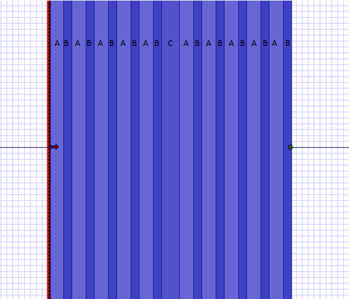

Figure 1. Schematic design of the proposed 1D PC biosensor with a defect layer

**Table 1**. Refractive index of blood cells in different SARS-CoV-2 concentrations

|  |  |
| --- | --- |
| SARS-CoV-2 concentration (nM) | Refractive index |
| 0 | 1.35 |
| 0.0001 | 1.372 |
| 0.001 | 1.416 |
| 0.01 | 1.526 |
| 0.1 | 1.658 |

1. **Theoretical formulation**

Finite-difference time-domain method (FDTD) divides the space and time in a regular grid for solving the Maxwell equations depending on time. Maxwell equations in isotropic and linear media are

$$∇×H=ε\frac{∂E}{∂t}+σE$$

**(1)**

$$∇×E=-μ\frac{∂H}{∂t}+σ_{m}H$$

where $ε, σ, μ and σ_{m}$ are, the dielectric permittivity, the medium electrical conductivity, permeability of medium and magnetic loss of the medium, respectively. If we assume TEM wave propagates along z-direction we can write

$$\frac{∂}{∂x}=\frac{∂}{∂y}=0$$

and Eq. 1 can be written as

$$-\frac{∂H_{y}}{∂z}=ε+\frac{∂E_{x}}{∂t}+σE_{x}$$

$$\frac{∂E}{∂z}=μ+\frac{∂H_{y}}{∂t}+σ_{m}H_{y}$$

A time step is determined for iterations and TE and TM fields can be calculated by using these iterations according to FDTD method

$$E_{x}^{n+1}\left(k\right)=\frac{1-\frac{σ(m)∆t}{2ε(m)}}{1+\frac{σ(m)∆t}{2ε(m)}}×E_{x}^{n}\left(k\right)-\frac{\frac{∆t}{ε(m)}}{1+\frac{σ(m)∆t}{2ε(m)}}×\frac{H_{y}^{n+1/2}\left(k+\frac{1}{2}\right)-H_{y}^{n+1/2}\left(k-\frac{1}{2}\right)}{∆z}$$

$$H_{y}^{n+1/2}\left(k+1/2\right)=\frac{1-\frac{σ(m)∆t}{2μ(m)}}{1+\frac{σ(m)∆t}{2μ(m)}}×H_{y}^{n-1/2}\left(k+\frac{1}{2}\right)-\frac{\frac{∆t}{μ(m)}}{1+\frac{σ(m)∆t}{2μ(m)}}×\frac{E_{x}^{n}\left(k+1\right)-E_{x}^{n}\left(k\right)}{∆z}$$

where $k$ and $n$ are space step integer and time step integer respectively. Also transmission expressions of electric and magnetic fields can be written as $\left[21\right]$

$$R={\left|\frac{E_{t}(t)}{E_{i}(t)}\right|}^{2} R={\left|\frac{H_{t}(t)}{H_{i}(t)}\right|}^{2}$$

1. **Result and discussion**

We theoretically investigated transmittance spectra of 1D PC with a defect layer for detecting SARS-CoV-2 in human blood. We studied the refractive index for the normal and infected blood samples at $715 nm$.

We obtain defect mode in PBG at $715,62 nm$ which is shown in Fig. 2 when we take the defect layer as a healthy blood sample.

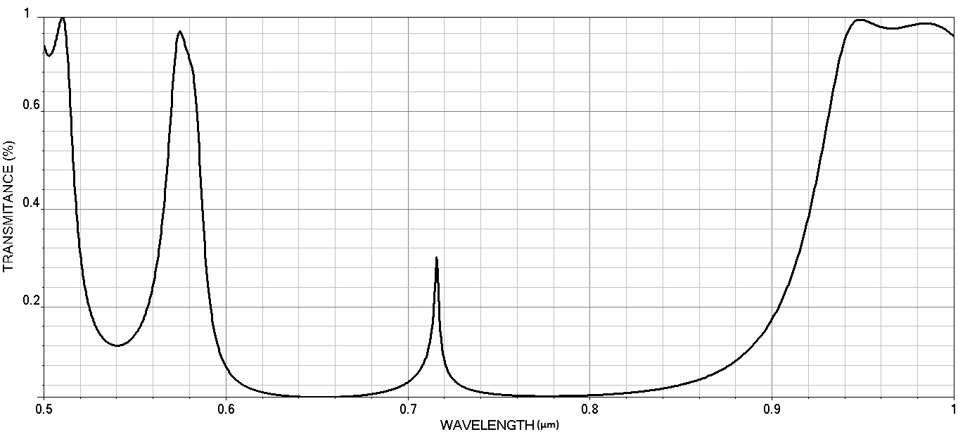

**Figure 2**. The transmittance spectrum (Y) of a defective photonic crystal as a function of wavelength (X) at healthy blood sample

Table 1 shows the refractive index of blood cells at different SARS-CoV-2 concentrations. From Table 1, we can see that as SARS-CoV-2 concentrations in the blood increase, the refractive index of the samples increases accordingly.

Fig. 3 shows the transmittance spectrum of defective 1D PCs with different values of SARS-CoV-2 concentration in the blood which is shown in Table 1. By increasing the blood SARS-CoV-2 concentration, the defect mode shifted towards longer wavelengths and defect modes amplitudes increased. The defect state is sharp as the quality factor is large $\left[22\right]$.

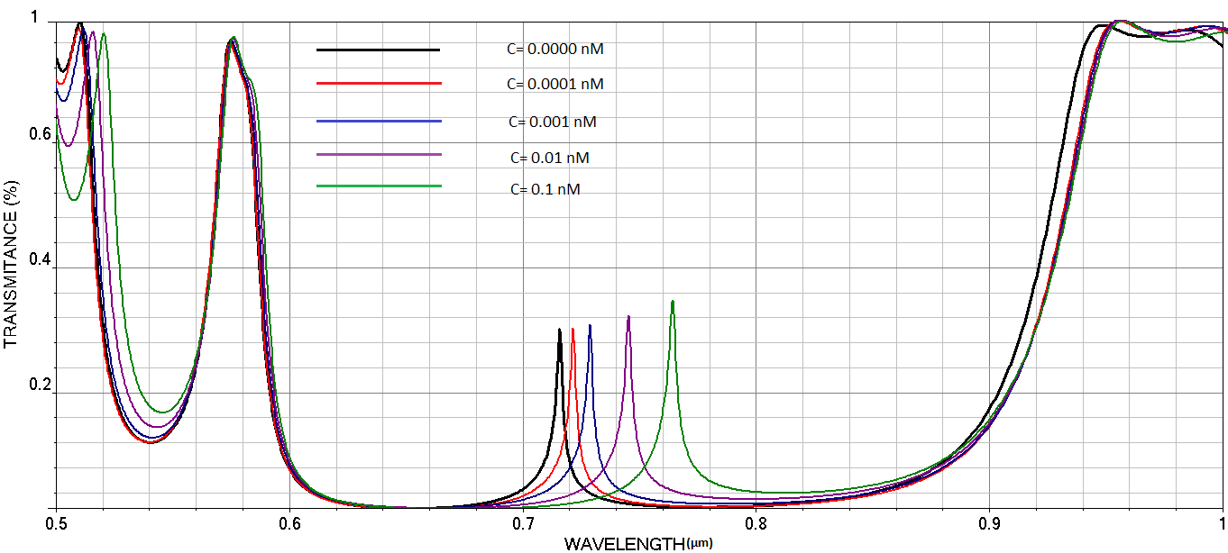

**Figure 3**. The transmittance spectrum of defective 1D PCs as a function of wavelength with different value of SARS-CoV-2 concentration (nM) in blood.

Sensitivity (S) is an important parameter for a sensor. The sensitivity is defined as the change in defect state wavelength per unit refractive index $\left[23\right]$. We obtain the sensitivity of the proposed biosensor from the graph shown in Fig. 4. Wavelength peaks shift towards longer wavelengths linearly by increasing the refractive index of the defect layer. We obtain the sensitivity of the proposed biosensor as $152,27 nm/RIU$, which is well comparative to the modern sensors.

**Figure 4**. Sensitivity of the proposed biosensor due to transmission peak wavelength with refractive index of defect

Quality factor $(Q)$ shows the performance of the biosensors and calculated from $Q=\frac{λ_{d}}{λ_{FWHM}}$ formula where $λ_{d}$ and $λ_{FWHM}$ are the resonant wavelength and the full width at half maximum of defect mode. Table 2 shows the quality factor of our proposed biosensor as $1,864 ×{10}^{5}$.

**Table 2**. The values of Quality factor at different SARS-CoV-2 virus concentrations

|  |  |  |  |
| --- | --- | --- | --- |
| SARS-CoV-2 concentration | Refractive index | Wavelength (nm) | Quality factor $$(×{10}^{3})$$ |
| 0 | 1.35 | 715.62 | 0.150 |
| 0.0001 | 1.372 | 719.22 | 0.153 |
| 0.001 | 1.416 | 726.02 | 0.136 |
| 0.01 | 1.526 | 742.75 | 0.132 |
| 0.1 | 1.658 | 762.01 | 0.116 |
|  |  |  |  |

Finally, we calculated the detection limit from $LOD=λ(20×S×Q)$ formula $\left[24\right]$ and obtain $1.97×{10}^{-4} RIU$. According to the value of $LOD$ is very low, the proposed sensor is efficient as it can resolve very small changes in the refractive index.

1. **Conclusion**

In the present paper, the 1D defective PC was studied as a biosensor for SARS-CoV-2. We theoretically investigated the performance of the PC using FDTD Method. We optimized the characteristics of the biosensor by keeping the layer type, layer thicknesses, incidence angles of the input wave, and the number of periods constant except for the SARS-CoV-2 concentration in blood. The simulations showed that the positions and the amplitudes of defect mode increase linearly with the increase of SARS-CoV-2 concentration in blood. Also, the sensitivity, quality factor, and detection limit of the biosensor obtained as $152,27 nm/RIU$, $1,864 ×{10}^{5}$ and $1.97×{10}^{-4} RIU$. This structure is conducive to the industrial design by using low-cost materials and high sensitivity. Therefore, this sensor may be desirable for bio/chemical sensing applications.

**References**

1. WU, Fan, et al. A new coronavirus associated with human respiratory disease in China. Nature, 579.7798: 265-269 (2020).
2. MACHHI, Jatin, et al. The natural history, pathobiology, and clinical manifestations of SARS-CoV-2 infections. Journal of Neuroimmune Pharmacology, 15.3: 359-386 (2020).
3. VALERA, Enrique, et al. COVID-19 point-of-care diagnostics: present and future. ACS nano,15.5: 7899-7906 (2021).
4. TONG, Allison, et al. Research priorities for COVID-19 sensor technology. Nature Biotechnology, 39.2: 144-147 (2021).
5. KORKMAZ, Veysel; CETIN, Ali. Optical visible wavelength region selective reflector design for photovoltaic cells using photonic crystal. Turkish Journal of Physics, 41.6: 491-497 (2017).
6. ZHANG, Yuping, et al. Optical properties of one-dimensional Fibonacci quasi-periodic graphene photonic crystal. Optics Communications, 338: 168-173 (2015).
7. YABLONOVITCH, Eli. Inhibited spontaneous emission in solid-state physics and electronics. Physical review letters, 58.20: 2059 (1987).
8. HUNG, Hui-Chuan; WU, Chien-Jang; CHANG, Shoou-Jinn. Terahertz temperature-dependent defect mode in a semiconductor-dielectric photonic crystal. Journal of Applied Physics, 110.9: 093110 (2011).
9. BUSCH, Kurt, et al. (ed.). Photonic crystals: advances in design, fabrication, and characterization. John Wiley & Sons (2006).
10. BERGER, V. Photonic crystals and photonic structures. Current Opinion in Solid State and Materials Science, 4.2: 209-216 (1999).
11. KATS, Mikhail A., et al. Nanometre optical coatings based on strong interference effects in highly absorbing media. Nature materials, 12.1: 20-24 (2013).
12. ALY, Arafa H., et al. Biophotonic sensor for the detection of creatinine concentration in blood serum based on 1D photonic crystal. RSC advances, 10.53: 31765-31772 (2020).
13. ALY, Arafa H.; ELSAYED, Hussien A. Defect mode properties in a one-dimensional photonic crystal. Physica B: Condensed Matter, 407.1: 120-125 (2012).
14. MUKUNDAN, Harshini, et al. Waveguide-based biosensors for pathogen detection. Sensors, 9.7: 5783-5809 (2009).
15. SINGH, R., et al. High-power, reliable operation of 730 nm AlGaAs laser diodes. Applied physics letters, 75.14: 2002-2004 (1999).
16. PALIK, Edward D. (ed.). Handbook of optical constants of solids. Academic press, (1998).
17. PANDEY, Amritanshu, et al. Analysis of ternary layer photonic band gap tunable filters for wavelength division multiplexing applications. Journal of Nanoelectronics and Optoelectronics, 12.4: 331-336 (2017).
18. MALIK, Yasmin A. Properties of coronavirus and SARS-CoV-2. The Malaysian journal of pathology, 42.1: 3-11 (2020).
19. LONDON, R. X-Ray Microimaging for the Life Sclences.
20. TAGHIPOUR, Ata; HEIDARZADEH, Hamid. Design and Analysis of Highly Sensitive LSPR-Based Metal–Insulator–Metal Nano-Discs as a Biosensor for Fast Detection of SARS-CoV-2. In: Photonics. Multidisciplinary Digital Publishing Institute, p. 542 (2022).
21. ÇETIN, Ali; BILGILI, Nurettin. TRANSMISSION PROPERTIES OF 1D DEFECT METALLIC-DIELECTRIC PHOTONIC CRYSTALS. Anadolu University Journal of Science and Technology A-Applied Sciences and Engineering, 17.4: 633-640 (2016).
22. ARUNKUMAR, Rajendran; SUAGANYA, Thinakaran; ROBINSON, Savarimuthu. Design and analysis of 2D photonic crystal based biosensor to detect different blood components. Photonic Sensors, 9.1: 69-77 (2019).
23. SUTHAR, Bhuvneshwer, et al. Biosensor application of one-dimensional photonic crystal for malaria diagnosis. Plasmonics, 16.1: 59-63 (2021).
24. WHITE, Ian M.; FAN, Xudong. On the performance quantification of resonant refractive index sensors. Optics express, 16.2: 1020-1028 (2008).

1. \**nurettinbilgili@gmail.com* [↑](#footnote-ref-1)