**ÇANKIRI KARATEKİN UNIVERSITY**

**SCIENCE INSTITUTE**

**MASTER'S THESIS**



**STUDY OF RELATIONSHIP BETWEEN LEVELS OF HEPCIDINE HORMONE AND GDF15 FOR PATIENTS WITH PROSTATIC CANCER AND THEIR CLINICAL IMPORTANCE**

**Omer Zedan Khalaf KHALAF**

**Supervisors**

**Prof. Dr. Ayşe Şahin YAĞLIOĞLU**

**CO- Supervisors**

**Prof. Dr. Maysaa JALAL MAJEED**

**BIOCHEMISTRY /CHEMISTRY DEPARTMENT**

**ÇANKIRI**

**2021**

**Her hakkı saklıdı**

**TEZ ONAYI**

**Omer Zedan Khalaf** tarafından hazırlanan “**Prostatik Kanseri Olan Hastalar İçin Hepsidin Hormonu İle Gdf15 Düzeyleri Arasındaki İlişki Ve Klinik Önemiçalışması”** adlı tez çalışması aşağıdaki jüri tarafından oy birliği ile Çankırı Karatekin Üniversitesi Fen Bilimleri Enstitüsü Biyoloji Anabilim Dalı’nda **YÜKSEK LİSANS TEZİ** olarak kabul edilmiştir.

**Danışman** : Prof. Dr. Ayşe Şahin YSAĞLIOĞLU

**Eş-danışman**: Prof. Dr. Maysaa Jalal Majeed

**Yukarıdaki sonucu onaylarım**

**Pro. Dr. Ibrahim ÇİFTÇİ**

**Enstitü Müdürü**

# Director of the Institute

**Kontrol edilmiştir**

**I hereby declare that all information in this document has been obtained and presented in accordance with academic rules and ethical conduct. I also declare that, as required by these rules and conduct, I have fully cited and referenced all material and results that are not original to this work.**

**Omer Zedan KHALAF**

# 

# ÖZET

**Yüksek Lisans Tezi**

**Prostatik Kanseri Olan Hastalar İçin Hepsidin Hormonu İle Gdf15 Düzeyleri Arasındaki İlişki Ve Klinik Önemiçalışması**

**Omer Zedan Khalaf KHALAF**

**Çankırı Karatekin Üniversitesi**

**Fen Bilimleri Enstitüsü**

**Biyokimya /Kimya Anabilim Dali**

**Danışman: Yrd. Doç. Dr. Ayşe Şahin YSAĞLIOĞLU**

**Eş-danışman: Prof. Dr. Maysaa Jalal Majeed**

Prostat Kanseri (PCa), özellikle yaşlanan popülasyonlarda dünya çapında önde gelen bir malignitedir. Avrupa'da, 2012'de yaklaşık 417.000 erkeğe PCa tanısı konmuştur. PCa'nın çeşitliliği nedeniyle, prognozu, kanserin ciddiyetini, tedavinin etkililiğini ve hastaların sonuçlarını gösteren yeni biyobelirteçlere önemli ve artan bir ihtiyaç vardır. Ayrıca, potansiyel olarak yaşamı uzatan çeşitli tedavilerle ilgili olarak tümör ilerlemesini ve saldırganlığı tahmin etmek için birincil tedaviyi takiben CRPC'ye ilerleyen gelişmiş PCa'da biyobelirteçlere ihtiyaç vardır. Hepsidin ve Büyüme Farklılaşma Faktörü 15'in (GDF-15) çeşitli kanserlerde yüksek oranda eksprese edildiği bildirilmiştir. Serum hepsidin ve GDF-15 düzeylerinin kanserlerde potansiyel prognostik belirteçler olduğu gösterilmiştir. Bu çalışma, prostat kanseri hastalarının yeni bir prognostiği için hepsidin, GDF15, PSA ve diğer bazı ilgili hormonlar arasındaki ilişki hakkında yeni veriler sağlamayı amaçlamaktadır. Dolayısıyla, bu çalışma Iraklı hastalar için önem arz etmektedir. Çalışmamızda Hepsidin Hormonu (H.H.), C-Reaktif Proteini (C-RP), Büyüme Farklılaşma Faktörü 15 (Gdf15) ve Folikül Uyarıcı Hormonu (FSH) ile anlamlı farklılıklar (P ≤ 0.05) tespit edildi. Bu yüksek korelasyon nedeniyle hasta grubu ve kontrol grubu arasında, prostat hastalıklarının kesin tahmininde bu değişkenlerin (H.H, C-RP, GDF15 ve PSA) kullanılabilineceği görüldü. Ayrıca, Hepsidin Hormonu ile Yaş, C -Reaktif Protein (C-RP), Prostata Özgü Antijen (PSA) ve Büyüme Farklılaşma Faktörü 15 (Gdf15) gibi bazı biyokimyasal değişkenler arasında kuvvet ilişki olduğu belirlendi.

**2021, 74 sayfa**

**ANAHTAR KELİMELER**: Prostate Cancer, Hepcidine , GDF15, PSA

# ABSTRACT

**Master Thesis**

**Study of relationship between levels of hepcidine hormone and GDF15 for patients with prostatic cancer and their clinical importance**

**Omer Zedan Khalaf KHALAF**

**Çankırı Karatekin University**

**Graduate School of Natural andAppliedSciences**

**Biochemistry /Chemistry department**

**Supervisors: Prof. Dr. Ayşe Şahin YAĞLIOĞLU**

**Co-Supervisor: Prof. Dr. Maysaa Jalal Majeed**

Prostate cancer (PCa) is a considered of malignancy worldwide, particularly among the elderly. In Europe, about 417.000 men were diagnosed with PCa for the first time in 2012. Since PCa is so diverse, there is a growing The development of novel biomarkers capable of predicting prognosis, cancer incidence, therapy effectiveness,& patient outcomes is critical. Additionally, biomarkers are required in advanced PCa that has progressed to CRPC following first therapy, it is possible to anticipate tumor growth and aggressiveness in connection to a range of potentially life-extending drugs. Hepcidin and Growth Differentiation Factor 15 have been shown to be present in significant concentrations in a variety of cancers (GDF-15). The levels of serum hepcidin and GDF-15 have been proven to be prognostic markers in cancer patients in the past. To determine the significance of hepcidin, Growth Differentiation Factor 15, Prostate-Specific Antigen,& several other associated Harmons in the prediction or early detection of prostate cancer, the investigators conducted a research. As a result, this research will be regarded as significant in the area of Iraqi patients. There were substantial disparities in our research. (P ≤ 0.05) with Hepcidin Hormone (H. H.), C-Reactive Protein (C-RP), Growth Differentiation Factor 15 (GDF-15),& Follicle-Stimulating Hormone (FSH), Because of the high importance (correlation) shown by our study (H.H, C-RP, GDF15,& PSA) between the Patient Group and Control Group, it can be used these variables to precise prediction of prostate diseases. Several biochemical factors, including age, C-reactive protein, prostate-specific antigen, and growth differentiation factor 15, have been found to have significant correlations with Hepcidin Hormone variables (GDF-15).

**2021, 74 Pages**

**KEY WORD:** Prostate Cancer, Hepcidine, GDF15, PSA

**PREFACE AND ACKNOWLEDGEMENTS**

I would like to thank my thesis advisor, Prof. Dr. Ayşe Şahin YAĞLIOĞLU, for his patience, guidance and understanding.

**Omer Zedan Khalaf KHALAF**

# Çankırı-2021

# SIMGELER DIZINI

- Eksi

% Percent

% Yüzde

/ Taksim

+ Artı

° Derece

µg mili gram

I- Iodide

Kg Kilo Gram

m² Metrekare

ml milli litter

mm milimetre

ng Nano gram

ºC Santigrat Derece

OH Fenolik Hidroksil

WHO World Health Organization

# TABLE OF CONTENTS Page

ÖZET i

ABSTRACT ii

PREFACE AND ACKNOWLEDGEMENTS iii

SIMGELER DIZINI iv

TABLE OF CONTENTS v

LIST OF FIGURES vii

LIST OF TABLE viii

1. INTRODUCTION 1

2. LITRATURE REVIEW 3

2.1. Prostate Cancer 3

2.1.1. Introduction to Prostate Cancer Gland 4

2.1.2. Prostate Anatomy ………………………………………………………..4

2.1.3. Prostate Cancer Rates 5

2.1.4. Grading Prostate cancer Aggression 7

2.1.5. Prostate Cancer Diagnosis 8

2.1.6. Prostate Cancer Treatment and Overtreatment 9

2.2. Hepcidin ………………………………………………………………..….10

2.2.1. Discover and Role ………………………………………………………10

2.2.2. Hepcidin Function ………………………………………………………11

2.2.3. Synthesis and Structure of Hepcidin …………………………………….12

2.2.4. Hepcidin Kinetics ………………………………………………………14

2.2.5. Hapcidin, Iron and inflammation 15

2.2.6. Hepcidin and peripheral blood leukocytes 19

2.2.7. Regulation of Hepcidin 19

2.2.8. Therapeutic aspects of Hepcidin 23

2.2.9. Growth differentiation factor-15 (GDF15) 24

2.3. Hormone……………………………………………………………………..36

2.3.1. FSH……………………………………………………………………….36

3. MATERIAL AND METHOD ….38

3.1. Material 38

3.1.1. BioTek Elisa ELx800 (S.N 257381) 38

3.1.1.1. Overview……………………………………………………………....38

3.1.1.2. Calibration work and Result reading……………………..……………39

3.1.2. Roche Cobas c 311 Automated Chemistry Analyzer (REF 04826876001) 39

3.1.2.1. Overview…………...…………………………………………………..39

3.1.2.2. Specifications………………………………………..…………………40

3.1.2.3. Calibration work and Result reading…………………………………..41

3.1.3. Automatic Micropipette (Diamond) 41

3.1.4. Centrifuge C- 12000 (6M 1810968) 42

3.1.5. Memmert water bath (WNE 22) (L513.0977) 43

3.1.6. Additional material ………………………………………………………44

3.2. Kits 44

3.2.1. Prostate Specific Antigen – PSA (REF 52030) 44

3.2.1.1. Principle of PSA……………………………………………………..45

3.2.2. Human GDF15 (Growth Differentiation Factor 15) H0150F038 45

3.2.2.1. Principle………………………………………………………………..45

3.2.2.2. Regarding Calculation…………………………………………………47

3.2.3. CRP (0004956842190c501V11.0) 47

3.2.4. Hepcidin (MBS2881688) 48

3.2.4.1.Principle of Assay…………………………………………….………..48

3.2.4.2.Reagent preparation…………………………………………………….48

3.2.5. FSH (425-300)……………………………………………………………49

3.2.5.1.Principle ……………………………………………………………….49

3.2.5.2.Reagent preparation……………………………………………………50

4. RESULTS AND DISCUSSION 51

4.1. Prostate cancer Analysis 51

4.2. Hormons Results ……………………………………………………………..55

4.2.1. FSH……………………………………………………………………….55

4.2.2. PSA……………………………………………………………………….56

4.2.3. Hepcidin Hormone ………………………………………………………57

4.2.4. GDF15……………………………………………………………………58

5. CONCLUSIONS 59

References 60

# LIST OF FIGURES Page

Figure 1.1. The normal prostate area in young males contains only 5% -10% of the glandular tissue. The central region of the prostate base and passes through the ejaculation ducts. The prostate is made up of the peripheral region, especially away from veromontanum 2

# Figure 2.1. An immunohistochemical examination of paraffin-embedded tissue parts of benign prostatic glandular tissue (A) and prostatic adenocarcinoma (B) (Karan, D. *et at.,* 2003) 3

Figure 2.2. The prostate gland anatomy of the male body relative to the rectum and bladder (Broeke, N. C., 2018) 5

Figure 2.3. Gleason grades characteristics System for tissue and Cellular of 1-5 from left to right (1 is the lowest classification and 5 is the highest grade) (Epstein J. I., *et al.,* 2005) 7

Figure 2.4. Physiology of hepcidin-ferroportin interaction (Badawy, A. E. A., 2010) 12

Figure 2.5. The human molecular structure of synthetichepcidin-25 (Ganz, T., 2006) 133

Figure 2.6. Modulation of hepcidin transcription by iron (Zhang, A. S. et al., 2011) 16

Figure 2.7. Normal distribution and storage of body iron (Andrews, N. C., 2008) 17

Figure 2.8. The role that (GDF15) plays in the tissue microenvironment and the progression of cancer (Vaňhara, P., et al., 2012) 31

Figure 2.9. The suggestion role of GDF15 in the development of prostate cancer (PCa) (Vaňhara, P., et al., 2012) 34

Figure 2.10. Structure of the follicle stimulating hormone receptor (FSHR) with the related FSH alpha and beta 36

Figure 3.1. BioTek Elisa ELx800 (S.N 257381)…………………………………….38

Figure 3.2. Roche Cobas c 311 Automated Chemistry Analyzer……………….…..39

Figure 3.3. Automatic micropipette type diamonds…………………………………41

Figure 3.4. Centrifuge C- 12000 (6M 1810968)……………………………..………42

Figure 3.5. Memmert water bath (WNE 22) (L513.0977)………………….……….43

# Figure 4.1.The relation between Control group and patient group with Mean of age 566

Figure 4.2.The relation between Control group and patient group with Mean of weıght (Kg) 57

Figure 4.3.The relation between Control group and patient group with Mean of CRP 58

Figure 4.4.The relation between Control group and patient group with Mean of FSH 59

Figure 4.5.The relation between Control group and patient group with Mean of PSA 60

Figure 4.6. The relation between Control group and patient group with Mean of HH 61

Figure 4.7. The relation between Control group and patient group with Mean of GDF15 62

# LIST OF TABLE Page

Tablo 3.1. Specifications of the system and other details 39

Tablo 3.3. Kit Components 45

Tablo 4.1. Age in Patients and Control………………………………………………...55

Tablo 4.2. Correlation between Hepcidin Hormone and Some Variables in all Case of Prostate cancer 56

# INTRODUCTION

Cancer affects more than just a single cell or a community of homogeneous tumor cells. As a result, research into the mechanisms that modulate the tumour cells, particularly the relationship with tumor and stromal cells, as well as the immune response, is essential. Humans are adamant that cancer are being healed as soon as practicable; indeed, this isn't always the case. Humans, on the other hand, hold this belief. This prevalent ideas that have negative implications for certain types of cancer, such as prostate cancer (Jemal, A., *et al.,* 2002).

Prostate cancer is the most common form of cancer among men in many countries. A man's lifetime risk of developing prostate cancer is about 30%, with a 10% to 11% chance of dying from it. Prostate cancer starts out small and then develops into an invasive, migratory,& metastatic disease. A localized prostate cancer is usually androgen-dependent and can be treated with surgery or other treatments such as radiation therapy (Davison, B. J., *et al.,* 2003).

A tubuloalveolar gland of the reproductive area makes up the male prostate gland. The genitourinary system of a male's body is situated inside the pelvic cavity. It is situated down part of the bladder and in front of the rectum. It is considered both muscular and glandular. The prostate gland in a young male weighs about 20 grams and has a volume similar to that of a golf ball (4×2×3cm). Because of benign conditions like prostate cancer (BPH) or cancerous conditions like adenocarcinoma, men are more likely to develop prostate cancer, the prostate volume rises with increasing the ménage. It is composed of 70 percent of overall glandular tissue and 30 percent of overall fibromuscular stroma, according to Figure 1.1 (Ward, A. D., Crukley, *et al.,* 2012; Balk, S. P., *et al.,* 2003).



**Figure 1.1.** The normal prostate area in young males contains only 5% -10% of the glandular tissue. The central region of the prostate base and passes through the ejaculation ducts. The prostate is made up of the peripheral region, especially away from veromontanum

# LITRATURE REVIEW

## Prostate Cancer

Malessuffered from PCa disease have to select either continuous monitoring or more radical treatment, see Figure 2.1. Males who fail to make this decision when suffering from untreated cancer are met with suspicion. Furthermore, because of the widespread belief that cancer is always fatal, males with a low cancer risk will receive treating even it's not needed. Overtreatment is the term for this occurrence (Broeke, N. C. 2018; Stephan, C., 2014).

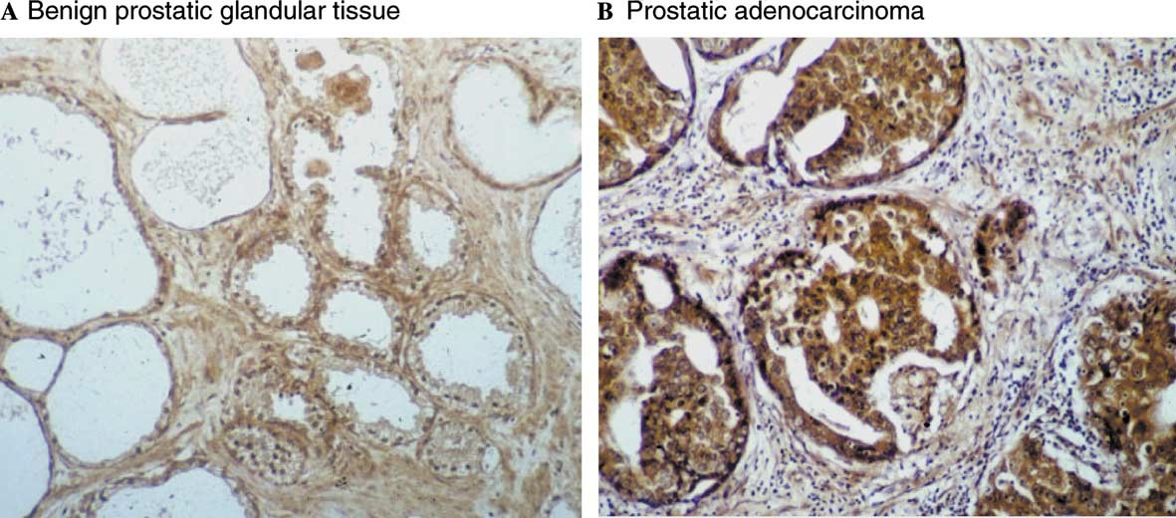

Figure 2.. An immunohistochemical examination of paraffin-embedded tissue parts of benign prostatic glandular tissue (A) and prostatic adenocarcinoma (B) (Karan, D. *et al* 2003)

### Introduction to Prostate Cancer Gland

The prostate gland of the male body is situated in the genitourinary region. These sections below illustrate the relative fundamental information about Prostate gland of the human and its cancer such as the anatomy, physiology prostate gland,& other sufficient details.

### Prostate Anatomy

The base of the prostate gland is situated just below the bladder,& the urethra runs across the center of the prostate gland (Figure 1.3). There are 2 ejaculatory ducts that pass during the prostate transport the seminal makeup of semen of the seminal vesicle in the urethra (Hayes, V. M., *et al.,* 2006; Thulborn, K. R., *et al.,* 1999). The main structure of the gland is included four unlike zones (Figure 2.2); central zone (CZ), peripheral zone (PZ), transitional zone (TZ) indeed anterior-fibro muscular stroma (Sadar, M. D, *et al.,* 1999; Qi, H., Labrie, 2001).

The mustache-shaped that surrounded the prostate is the biggest zone, as can be seen from Figure 2.2. Prostate inflammation often occurs mostly in the surrounded-shaped prostate tissue, which accounts for approximately three-quarters of glandular prostate tissue (chronic prostatitis). In the PZ, approximately 70-80 percent of prostatic cancers occur (McNeal, J. E., *et al.,* 1988; Hammerich, K. H., 2009). The superior-posterior part of the gland contains the central zone (CZ), it makes up 25% of the glandular tissue and its known to enlarge as men age, the final region of the prostate is the anterior-fibro-muscular stroma in the apex and its comprises muscle fibers and connective tissue(McNeal, J. E., 1981; Uhlén, M., *et al.,* 2015).

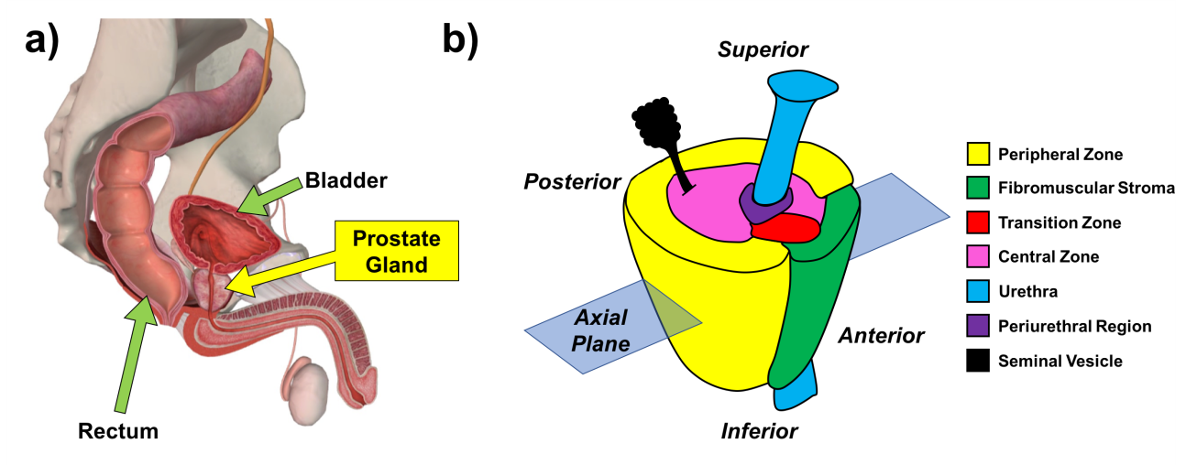

Figure 2.. The prostate gland anatomy of the male body relative to the rectum and bladder (Broeke, N. C., 2018)

### Prostate Cancer Rates

Prostate cancer (PCa) affects one out of every seven men at some stage in their lives, It is also the most common cancer in men (Kolata, G., 2016). Prostate cancer cases in dead men were approximately proportional to their age, according to post-mortem reports (Sakr, W. A., 1996). Non-aggressive PCa can be found in approximately 65 percent of men 65 years old in a random sample. Men in Canada were diagnosed with 103,100 new cancer cases in 2017. Prostate cancer was the most common form, accounting for 20.4 percent of all cases. Prostate cancer affects one out of every seven men, but only one out of every 28 men will die from it in their lifetime,& it is the most common cancer among men in the United States (Karan, D., *et al.,* 2003).

This is far lower than the overall cancer death rate, 1 in every 3.5 people is thought to be affected. Because of improved therapeutic options for both early and late-stage disease, the overall mortality rate for PCa has decreased by 3.3 percent per year since 2001. Prostate cancer is more likely to kill men who have diabetes and have a higher body mass index (BMI) (Cao, Y., & Ma, J., 2011).

A man age is a good indicator of new prostate cancer diagnoses. Prostate cancer was diagnosed in 21,300 Canadian men in 2017. The 30-39 age group was the smallest in terms of new diagnoses, accounting for just 0.02 percent of all new diagnoses. Up until the age of 60 to 69, the number of new cases increases monotonically with age group: 1.7% for males aged 40 to 49, 16.9% for men aged 50 to 59, and 38.5% for men aged 60 to 69. Men aged 60 to 69 were the age group most frequently diagnosed. Men aged 70 to 79 accounted for 29% of all new PCa diagnoses, whereas men aged 80 and older accounted for 14% of all new PCa diagnoses. Prostate cancer has very high 5-, 10-,& 15-year survival rates after diagnosis: 99 percent, 98 percent,& 96 percent, respectively(Kolata, G., 2016).

The adenocarcinoma subtype of prostate cancer accounts for around 98 percent of all occurrences. Adenocarcinoma starts in the cells of the epithelial glands, which responsible to form the mucus and the prostatic fluid of the sperm. The most common location for adenocarcinomas is the peripheral region, which can be palpated during a digital rectal test. The low-risk cancer group is assigned to half of men newly diagnosed with prostate cancer. Low-risk cancer, also known as indolent cancer, has a low associated mortality rate and a low risk of a spread of cancer (metastasis). Active surveillance (AS) is becoming more common among low-risk men who prefer it to care, with more than half opting for AS rather than therapy; nevertheless, this number is remain small compared to the numeral of male who may benefit from AS treatment (Fendler, W. P., *et al.,* 2019; Kolata, G., 2016).

The range of what is considered healthy can be affected by age and racial demographics. PSA levels of 0 – 2 ng/mL , 0 - 2 ng/mL and 0 - 2.5 ng/mL, respectively, were found to be appropriate for Asian Americans, African Americans,& Caucasians under the age of 50. These figures are expected to rise as people get older,& this is believed to begin with due to a natural, age-associated raise in prostate size (Ellsworth, P. I., 2018).

### Grading Prostate cancer Aggression

The Gleason Scoring System was the main aggression of the prostate cancer, this clinical became the standard until 2015 for characterizing of prostate cancer aggression(Gleason, D. F., 1992).

The aggression of the PCa of men according the grade grouping standard, this standard grouping combines a Gleason score to isolate male to one of five groups according to the microscopic observation in the samples' tissue of the prostatic (see Figure 2.3) these samples are taken from needle biopsies or entire prostate gland sections, depending on which process is used (Gordetsky, J., & Epstein, J., 2016).

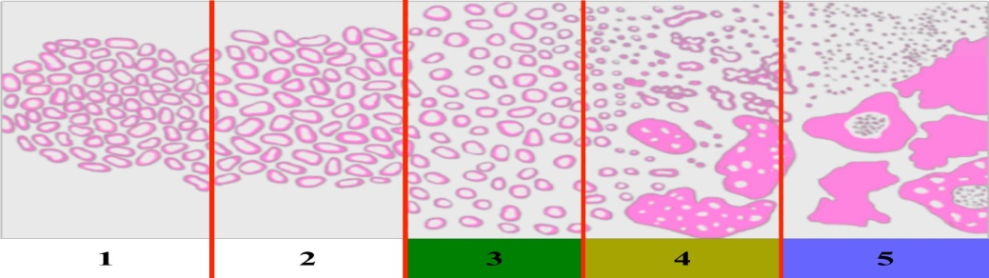

Figure 2.. Gleason grades characteristics System for tissue and Cellular of 1-5 from left to right (1 is the lowest classification and 5 is the highest grade) (Epstein J. I., *et al.,* 2005)

Grades 1 and 2 on the Gleason scale are the lowest levels of cancer. Gleason scores of 2–4 frequently indicate a misclassification of more aggressive lesions (Epstein, J. I., 2000). Previous research found that after radical prostatectomy, 55 percent of needle biopsies with Gleason scores of 2-4 revealed extra-prostatic extensions (Steinberg, D. M., *et al.,* 1997). Other studies have linked a Gleason score 2-4 diagnosis with a so low hazard of patient mortality through fifteen years (Albertsen, P. C., *et al.,* 1998; Allsbrook Jr, *et al.,* 2001).

According to the literature, patients with a Gleason score of 5 or 6 pose little risk (Epstein, J. I., 2000). The most prevalent Gleason type found on biopsy substance is Gleason grade 3, which is a reliable determination. (Category 3 in Figure 2.3), Grade 3 gland cells, for example, still have a distinct boundary. Poorly shaped or fused gland cells are known as Gleason grade 4 (Gordetsky, J., & Epstein, J., 2016).

The edges of prostate cells are irregular and the lumen is unrecognizable (Figure 1.5. Cat. 4). Gleason grade 4 cells are commonly integrate jointly, without stroma to distinguish them. The highest (most aggressive) grade of cancer that the Gleason system can grant is Gleason grade 5. Gleason grade 5 tissue has minimal gland development but does not look like common prostate tissue. Individual cells, planar sheets of tumor,& long cords of cells are all common GG5 patterns (Kweldam, C. F., *et al.,* 2015; Epstein, J. I., 2010).

Grade 5 Gleason cells are often under-graded. This aspect of Figure 1.5 is not shown the BPH and atypical small acinar proliferation (ASAP) are two "precancerous" diseases of the prostate, as are prostatic intraepithelial neoplasia (PIN) and proliferative inflammatory atrophy (PIA) (Gasparrini, S., *et al.,* 2017; Bechis, S. K., *et al.,* 2014).

### Prostate Cancer Diagnosis

Asymptomatic male can be classified according to The National Comprehensive Cancer Network’s (NCCN) as having suspected cancer in the prostate after an unusual digital rectal exam (DRE). A digital rectal examination involves palpating the prostate's peripheral zone to determine its expansion. DRE screening was first used to monitor the progression of PCa patient staging in the early 1900s,& it was later prescribed as an annual male test for men over the age of 50 (Kash, D. P., *et al.,* 2014).

However, the normal test is inconvenient to the male and rely on an experience, skill-based on evaluation via the doctor around the gland properties such as the stiffness and volume. Presently, DRE issued to detect with other tools such as PSA blood test in conjunction for prostate cancer diagnostic, approximately, the PSA levels about 4 ng/ml were found in the 33% of male to have biopsy detected malignancy(Catalona, W. J., *et al.* 1991).

A 2D transrectal ultra-sound (TRUS) guided biopsy is another diagnostic method utilized in the clinic for patients with a suspected DRE and elevated blood PSA levels. The clinical standard for diagnosing prostate cancer is a TRUS-guided biopsy. This procedure involves inserting 12 needles into the prostate gland along pathways led by an ultra-sound probe. Tissue piths are extracted using these needles, which are then pathologically tested for Gleason grade(Gleason, D. F., 1966).

According to the American Joint Committee on Cancer (AJCC), prostate cancer may be staged using the TNM classification system. The T-category refers to the tumor inside the prostate gland, the N-category to the status of any surrounding lymph nodes,& the M-category to any metastases to other regions of the body. Metastases are most often seen in the bone, lymph nodes, lungs,& liver. The para aortic, predominant iliac, inguinal area, supraclavicular fossa, scalene muscles,& cervical lymph nodes are the most often metastasized locations (Fendler, W. P., *et al.,* 2019).

### Prostate Cancer Treatment and Overtreatment

Many treatment selections are offered for males suffered with prostate cancer, as male patients must choose between aggressive monitoring (AS) and more invasive medical procedures right away. Active monitoring is a form of observation that helps patients to postpone or even stop treatment entirely. This is accomplished without jeopardizing the patient's cancer-specific long-term survival. (Thomsen, F. B., 2014; Parker, C., 2003).For PSA blood tests and an annual DRE, men can see their doctor twice a year (every six months). Additionally, a biopsy is performed on these illnesses males once a year to aid in determining the stage of the lesions (Parker, C., 2003; Sanyal, C., *et al.,* 2016).

Because of the society idea that all kinds of cancer are lethal and must process, there is a big psychological load on the patients whom selecting active observation through radical therapy, this gives rise to a muddled decision-making process for both physicians and patients over the final treatment choice for each patient's cancer, such as radical prostatectomy or brachytherapy (Yao, S. L., & Lu-Yao, G., 2002; Li, Y., Yao, D., & Chen, W., 2005, July)

## Hepcidin

### Discover and Role

Hepcidin investigated and isolated at first from the plasma of human ultra-filtrate by an antimicrobial peptides group's, they used the term liver-expressed antimicrobial peptide (LEAP-1)(Krause A., *et al.,* 2000). Another investigated researcher isolated this peptide from the urine of the human and used the term the peptide hepcidin, as a sequence of its effect in vitro such as bacterial and hepatic origin (Park C. H., *et al.,* 2001).

The first common information on hepcidin such as structure, regulation, expression, and properties were came from vitro approaches and investigations applying on mouse models. Hepcidin was discovered to be important liable to regulation in Iron loaded mice (Pigeonetal. 2001), while the gene of mouse targeted confusing of its hepcidin because of Iron overload (Choulika, A., & Nicolas *et al .,* 2001; Viatte *et al.,* 2005).

### Hepcidin Function

It was discovered that mice with high hepcidin levels developed serious Iron Deficiency Anemia (IDA) also that most endear during childbirth (Nicolas, G. *et a l.,* 2002a). Extreme Iron overload evolution in HAMP gene knock-out mice (Choulika , A., & Nicolas, et al., 2001) indicated that hepcidin is involved in Iron metabolism,& that the phenol form of hepcidin mutations in sick people highlight the system's common control. Inflammation, iron storage, hypoxia, and anemia are all known to influence the activity of a recently discovered peptide. Hepcidin is responsible for its function, which is to regulate the production of new Fpn on the plasma membrane. Fpn is the primary or only source of iron in the cell (Nemeth *et al.,* 2004).

Hepcidin causes Fpn degradation and internalization, that prevents Iron from entering the plasma (commonly from macrophages, enterocytes, placenta,& hepatocytes), thereby saving the cell's Iron and of the importance of Iron distribution. The irregular duodenal iron uptake that distinguish most hereditary hemochromatosis disorders is caused by insufficient hepcidin expression in relation to body iron stores (Roetto, A., *et al.,* 2003).

Hepcidin because of scale down of the iron decrease in serum. Injections of the hepcidin agonist in mice result in hypo ferremia already within one hour,& a same impact was seen after tetracycline-induced acute stimulation of hepcidin expression in genetically engineered animals. Hypoferremia occurs as a consequence of hepcidin blocking the availability of iron from plasma, while the comparatively tiny plasma iron group is quickly consumed by erythrocyte precursors. Hepcidin prevents iron from being recycled by macrophages, from being stored in the liver,& from being absorbed by intestinal cells., Figure 2.4 (Viatte, L. *et al.,* 2005).

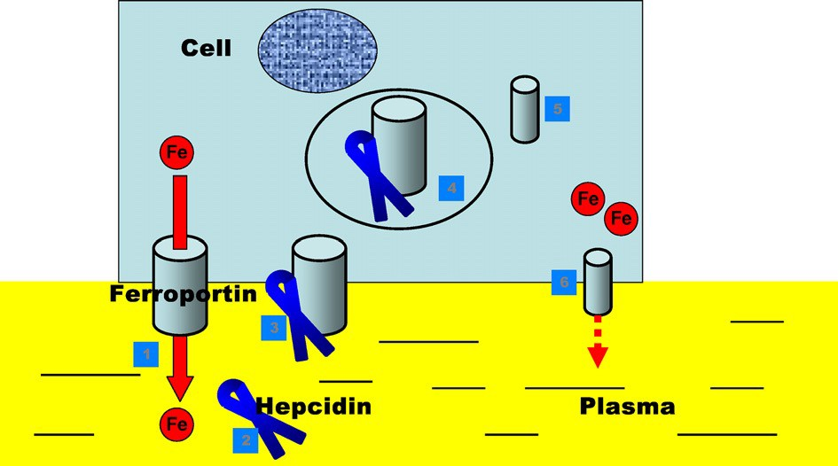

**Figure 2.4.** Physiology of hepcidin-ferroportin interaction (Badawy, A. E. A., 2010)

* + 1. **Synthesis and Structure of Hepcidin**

The human hepcidin gene structure has 3 exons, the data is unclear about the origin of the mini shape of hepcidin, although, the tissue activity of calcium-independent at pancreas extracts probably refers to hepcidin's systemic N-terminal decomposition into hepcidin-22,& in order to dipeptide peptidase is share in the conversion of hepcidin-22 to hepcidin-20 (Schmeichel, K. L., & Bissell, M. J., 2003).

Examples of chronic sickness anemia include acute myocardial infarction (also known as AMI), blood poisoning, chronic disease anemia (also known as ACD), and metabolic syndrome. All generate the smaller hepcidin isoform, which is exclusively detected in the serum of individuals with illnesses associated with elevated hepcidin levels (CKD) (Ganz, T., 2002; Suzuki, h., *et al.,* 2009).

When full-length mature hepcidin is injected intraperitoneally, According to some studies, only full-length mature hepcidin causes severe hyperemia. Recent investigations demonstrate that Other than hepatocytes, other cells express hepcidin, although in much smaller amounts. The renal tubule, the heart, and the retina are all examples of these structures, as are monocytes, neutrophils, fat cells, alveolar cells, pancreatic cells, and cardio myocardial cells. While the synthesis of hepcidin by these cells is unlikely to have a substantial impact on systemic circulating levels, it may have an effect on specific organs **(**Kulaksiz, H. *et al.,* 2008; Merle, U. *et al.,* 2007).

The composition of human hepcidin is revealed by nuclear magnetic resonance (NMR). Hepcidin has four preserved disulfide connections, three of which function as anchors for its fundamental beta sheet hairpin structure's antiparallel strands.. (Figure 2.5). The 4th disulphide forms an unusual vicinal disulfide bridge between two adjacent cysteine residues at the hairpin's turn, which is likely functional. Hepcidin has an amphiphilic structure, similar to other antimicrobial peptides, On the convex side, there are hydrophobic residues,& on the concave side, there are more positively charged residues (Peyssonnaux, C. *et al.,* 2006 ; Crichton, R. 2016).

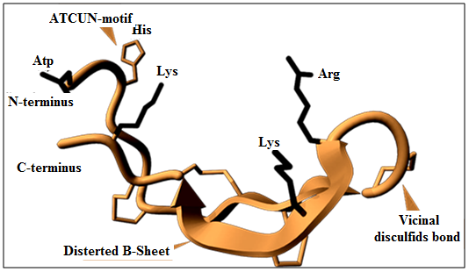

**Figure 2.5.** The human molecular structure of synthetichepcidin-25 (Ganz, T., 2006)

Distorted β leaves appear as gray arrows, gray peptide backbone. Colorful yellow disulfide bonds, emphasizing the unique relationship between neighboring cystines. In this diagram, positively charged arginine (Arg) and lysine (Lys) residues are depicted in blue, negatively charged aspartic acid (Asp) residues are depicted in red, and a binding motif including histidine Cu2 + -Ni2 + (ATCUN) is depicted in green (Ganz 2006).

### Hepcidin Kinetics

The first stage of the hepcidin kinetic during secreted by the hepatocytes into the circulation, after the secretion of the Hepcidin, iron absorption and excretion from the human cellular in the urine is the main hepcidin kinetic while the performing its regulation role. The excreted by the kidneys is supposed to happen through co-degradation of Fpn at its action sites in cells. In a recent theoretical computation of circulating hepcidin, it was determined that with relatively high agreement between 2-macroglobulin and albumin and with relatively poor agreement between albumin and hepcidin, it was determined that approximately 11% of hepcidin is indicated to be freely circulating. This was determined with relatively high agreement between 2-macroglobulin and albumin and with relatively poor agreement between albumin and hepcidin (Peslova, G. *et al.,* 2009; Isoda, M., *et al.,* 2010).

The behavior of the free hepcidin passing into the glomerular filtrate is similar freely via of its low molecular weight. In some previous investigations of hepcidin in humans, the computing of the fractional excretion concentrations value tobeaslowas0%–5%, this low rang may be via of its absorption or freely filtered (Ganz *et al.,* 2008; Swinkels and Wetzels 2008).

Recent research suggests that patients with glomerular dysfunction had modest increases in hepcidin concentrations (1–6-fold) compared to the 20–30-fold increases in blood -2-microglobulin (2M). Glomerular filtration is considered to regulate almost entirely the excretion of β2M. Binding to 2-macroglobulin or other carrier proteins may obstruct the free flow of circulatory hepcidin, Alternatively. Binding to 2-macroglobulin or other carrier proteins may obstruct the free flow of circulatory hepcidin. Alternatively, in patients with reduced renal filtration, the otherwise predicted increased circulating concentrations could be compensated as a result of a compensatory decrease in hepatic hepcidin production (Peters *et al.,* 2010; Gnana-Prakasam *et al.,* 2008).

### Hepcidin, Iron and inflammation

Initial investigations with mouse models illustrated that the indication of the hepcidin mRNA is result of parenteral and dietary iron loading. The physiological significance of hepcidin organization through iron is supported by the phenotypes of many hereditary diseases iron balance disorders defined by deregulation of hepcidin. (Pietrangelo, A., 2011; Bekri, S., *et al.* 2006).

Hepcidin reduction is a distinguishing trait of inherited hemochromatosis's recessive forms (HH). IRIDA is a hereditary disorder that is caused by mutations in the TMPRSS6 gene. This gene encodes a type II transmembrane protease serine-6, which is also known as matripase-2. It has been discovered that IRIDA patients have a failure in their ability to down-regulate the release of hepcidin (Ramsay, A., *et al.,* 2009).

Since genetic disorders are necessary to maintain systemic iron balance in these disorders, coded gene products tend to play a role in the hepidine response to systemic iron. BMPs signals have emerged as a major pathway that the liver promotes hepcidin expression. The BMPR-I and BMPR-II are the two kinds of trans-membrane BMP Involved receivers in the signal mediation of BMP **(**Nohe, A. *et al.,* 2003; Nguyen, N. B. *et al.,* 2006).

BMPs are restricted by receptors related (the type II receptor), which are essentially energetic protein kinases, as are all cytokines in the TGF superfamily. This evidence leads to the combination. BMP6 regulates In the body, hepcidin expression and iron metabolism. Nature genetics, 41(4), 482-487.‏n for both of phosphorylate BMPR-I and BMPR-II receptor (Figure 2.6 & Figure 2.7). SMAD4 phosphorylation at the C terminus of a subset of activated receptors (SMADs 1, 5,& 8) that link to the co-SMAD protein SMAD4 in the cytoplasm, activates the activity of kinase(Andriopoulos *et al.,* 2009; Wallace *et al.,* 2004).

After that, the molecule makes its way to the nucleus, where it binds to a wide variety of distinct types of DNA and stimulates the transcription of a huge number of genes, one of which is the hepcidin gene (HAMP). In addition, freelancing routes, most notably the mitogen-activated protein kinase (MAP) route, have the potential to be utilized in the process of identifying BMPs. This may have been accomplished in the case of mitogen-activated protein kinase (p38) rout by a TGF- activated kinase 1 complex (Nohe *et al.,* 2003; Valore and Ganz 2008). SMAD4 inhibition of the liver leads to fail to make the hepcidin and a phenotype of iron overload similar to that which has been observed in mice emerging with hepcidin. Processing with BMPs causes an increase in the production of hepcidin. The expression of a dominant negative BMP receptor or a positively regulated SMAD protein is required for hepcidin production to be controlled (Babitt *et al.,* 2006; Badawy 2010).

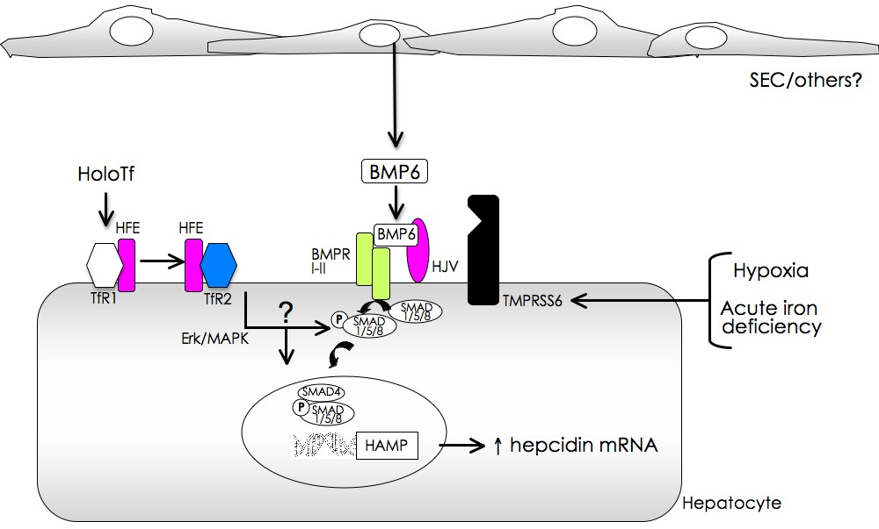

Figure 2.. Modulation of hepcidin transcription by iron (Zhang, A. S. et al., 2011)

Numerous transport connections (Holo) are used to convey a single receptor (TfR1). TfR1 facilitates the interaction of the human hemochromatosis (HFE) protein with TfR2, which is found on the cell surface. The mechanism by which HFE and TfR2 work together synergistically to change hepcidin transcription upon contact was just recently elucidated. A rise in intracellular iron levels triggers the transcriptional expression of BMP6 in sinusoid endothelial cells (SEC) and other non-parenchymal cells. Hepatocyte-specific BMP co-receptor hemojuvelin (HJV) interacts to both the TI and T2 BMP receptors in the BMP receptor complex when BMP6 is present. Maternal offspring phosphorylation and interaction with decapentaplegic are facilitated by the formation of the multiprotein complex on the surface of hepatocytes (SMAD). Complications of SMAD are carried to the nucleus and activate hepcidin. Hypoxia / acute iron shortage is required to increase the activity of the transmembrane protease serine TMPRSS6, which inhibits the degradation of hepsidin mRNA by HJV. ERK; extracellular signal-regulating kinases MAPK; mitogen-activated protein kinases ERK; extracellular signal-regulating kinases ERK; extracellular signal-regulating kinases (Camaschella, C., & Poggiali, E., 2011; Nemeth, E., & Ganz, T., 2006).

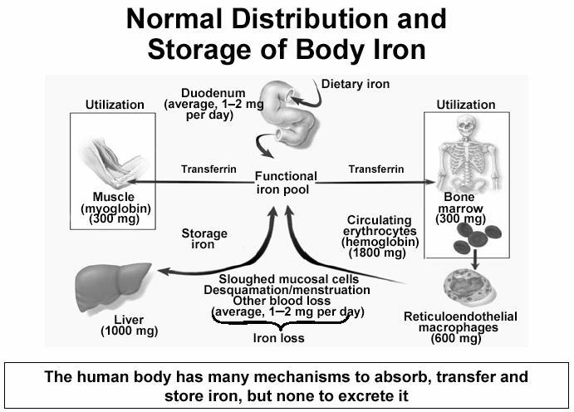

**Figure 2.7.** Normal distribution and storage of body iron (Andrews 2008)

The relative ability of chosen individuals BMPs in promoting hepcidin transcription by rat primary hepatocytes is BMP9 > BMP4 > BMP2. BMPs have been found to function independently of the human pigment repository protein (HFE), transferrin-2 receptor (TfR2) and interleukin-6 (IL-6)(Truksa *et al.,* 2006).

Co-receptors are the main regulatory mechanism that facilitates or inhibits the binding of BMR ligands to their respective receptors. Members of the RGM (protein believed to be important for neurodevelopment) family, RGMb, and RGMa, have been found to act as co-receptors to enhance BMP signaling. HJV, Protein gets infected, HH begins early, 50-60% of amino acid identity is implicated, and essential building elements for both RGMa and RGMb are involved. The HJV mission has been identified as a coreceptor that increases BMP signaling through the traditional BMP pathway in the hepatocyte (Babitt, J. L., *et al.,* 2006).

### Hepcidin and peripheral blood leukocytes

Many investigation proved the expression of hexidine by cells other than liver cells (hepatocytes), despite significantly lower levels compared with. These cells' hepcidin may have more local than systemic effects in these tissues. Hepatocytes excrete the majority of hepsidine in the circulatory system, with macrophages, T-lymphocytes,& adipocytes excreting a smaller volume (Maliken *et al.,* 2011).

Within three hours of LPS or IL-6 stimulation, human monocyteshepcidin mRNA expression is induced. As a result of the interaction between hepcidin and its receptor ferroportin, the amount of iron that was initially present in the body was reduced. This, in turn, caused hypovolemia, a decreased ability of serum iron to bind iron, and an increase in ferritin levels above the normal range, which inhibited the expansion of microbes(Theurl *et al.,* 2008).

Another investigator proved the role of hepcidin in the biology of lymphocytes. The term hepcidin in peripheral blood lymphocyte (PBLs) was described s and proved that it A positive following laboratory T-lymphocyte activation (Pinto et al., 2010). The expression and signal mechanism that control the expression of hexidine mRNA in peripheral white blood cells has recently been found (leukocytes). Previous in vivo investigations found that NF-kB is a critical mediator for the production of hexidine in LPS-induced peripheral blood cells (leukocytes) (Wu *et al.,* 2012).

### Regulation of Hepcidin

Because of the fundamental function of Hepatic hepcidin has been researched extensively since it was identified in maintaining systemic iron homeostasis, ways to orgnize hepcidin. Mechanisms have been identified that positive and negative regulation of peptide hormone based on the needs for hepcidin and hepatic iron levels.

#### Positive Regulation

With a view to decrease the outflow of iron for both of the macrophages and intestinal enterocytes, the production of hepcidin must be raised to decrease iron values in the circulation of the blood. to obtain that aim, the iron regulates hepcidin in a constructive way through a rout that includes the rout of bone morphogenic protein (BMP) and components of the downstream signaling, SMA and mothers against decapentaplegic vertebrate homologs (SMADs)(Miyazono, K. *et al.,* 2010).

The transforming growth factor beta (TGF-) superfamily includes the BMPs as a subfamily, that response of controlling a variation range of growth factor functions, for example the bone formation. When hepatocyte-specific SMAD4 knockout mice with a serious iron overload phenotype were discovered, the correlation between iron homeostasis and BMP rout was discovered. It was found in the livers of these animals about a 100-fold lessening in hepatic hepcidin mRNA, that leads the role of SMAD4 as an hepcidin regulator for the fundamental transcriptional (Wang, R. H., *et al.,* 2005).

After that, many investigations seen that BMPs and the TGF-β family ligands are able of motivating hepcidin illustration in hepatocytes and else cell kinds. However, that investigations determined the BMP6 as the main positive regulation ligand *in vivo* of the hepcidin transcription by iron. The exact mechanism by which iron is stimulated BMPs and the cell type provenance of BMPs remains unknown for hepcidin positive regulation (Xia, Y. *et al.,* 2008).

More recently, other members have been shown to be a pathway for BMP signals to regulate hepidin. These were determined by parasitological analysis for hereditary hemochromatosis patients. Specifically, illness persons suffered from transition in BMP co-receptor hemojuvelin (HJV), Inappropriately low hexidine levels were observed and the HJV played an important role in hepcidin control. Mutations in other membrane iron sensors such as transfer receptor 2 (TFR2) or hemochromatosis protein (HFE) lead to small deficits in hexidine production, which in turn leads to a less severe form of hereditary hemochromatosis. (Lee, P. L., *et al.,* 2004).

It is considered that TF-bonded iron increases in quantity and refers to displaced HFE from TFR1, which is the principal iron import protein, of the cell membrane. This allows it to subscribe to TFR2, which in turn allows it to expand. This belief stems from the fact that concentrations of TF-bonded iron have been shown to increase. This leads to the TFR2 balance to stimulate the source of the BMP route but the direct relationship between TFR2 and the BMP-SMAD path is not established. In addition, hepsidine is strongly regulated by activation, with hepsidine initially administered as a peptide with antibacterial characteristics. (Goswami, T., & Andrews, N. C., 2006).

It is think that the organization of hepcidin by inflammation improved as a family's preventative technique against microbes by minimization the amount of iron in the body that are required by microbes to thrive. A clear association between inflammation and iron appeared firstly when treating liver cells (hepatocytes) with lipid polysaccharide(LPS) activated the transcription of the hepcidin(Ganz, T., 2002).

Further relevant studies that pattern II acute cytokines, not pattern I cytokines, is responsible for the hepcidin induction. Specially, The major and most powerful cytokine for copying hepsin*invivo*seentobeIL-6. IL-6stimulate Janus kinase 2(JAK2)and the appropriate downstream signal transformers and transcription stimulants 3 (STAT3). STAT3 transmits the bands and nucleus to the STAT3 according to the stimulation during phosphorylation A chemical that induces copies of hepidine on the catalyst for hepidine. This cross-discussion between the BMPs and IL-6 is important to note. It was found that induction was controlled more of hepecidin(Mayeur, C. *et al.,* 2014).

#### Negative Regulation

Hepcidin is the primary regulator of systemic iron homeostasis; hence, it is important to inhibit its expression when elevated iron levels in the body are required. Whenever elevated iron levels in the body are called for, measures should be taken to suppress the expression of hepcidin, the primary control unit for systemic iron homeostasis. Hepcidin must be suppressed because of the increased demand during the formation of red blood cells. Other studies have indicated that the erythroferrone factor or growth differentiation 15 (GDF-15) is an erythroid factor that negatively regulates hepcidin, though a few of these studies were performed in pathological conditions like –thalassemia (Kautz, L., *et al.,* 2014).

A complete understanding of negative regulation by erythroid is still unaccomplished. In parallel to the control of erythropoietic in the inhibition of hexidine, hypoxia seen to minimize values of hepecidin. Low levels of oxygen stimulate the production of red blood cells, this triggers a rise in iron demand and, as a result, hepcidin suppression. (Huh, S. *et al.,* 2010).

The primary molecular relation between the levels of oxygen and hepidin was a investigate in which the deletion of the hypoxia inducible facto 1 (HIF1α) showed that there was no hepcidin during iron deficiency or hypoxia, indicating that the regulation of hypoxia in hepsidine was mediated by HIF1α. Research continued to assure that HIF1α was associated with the hypoxia response component of the hepidin stimulator to inhibit gene transcription. Nonetheless, other investigations supposed a negative regulation of hepidin by hypoxia to include HIF2α or an indirect techniques via hypoxia, like hypoxia which leads to more HJV splitting, which isolates BMPs and prevents their activation of the final signal a route. The negative organization of hepcidin by hypoxia, including erythropoietin regulation, is totally unfathomable (Mastrogiannaki, M., *et al.,* 2009).

Finally, there is another molecular strategy to suppress hepcidin by inhibiting the positive hepcidin regulators such as activations in the TMPRSS6 gene, that encodes a transmembrane serine protease via a type II membrane under the name of matriptase-2, lead to increased levels of hepcidin and severe anemia that does not respond to conventional treatment (Finberg, K. E., *et al.,* 2008).

It was found that the matriptase-2 cleave the common BMP co-receptorHJV which would decrease BMP signals to minimize the level of the hepcidin. Likewise, the single-protein Scelerostin range (SOSTDC1) contains BMP ligand antagonists which leads to diminished BMP signals and has seenin prostate cancer cells to be a negative regulator of hepcidin (Silvestri, L., *et al.,* 2008).

* + - 1. Addition Regulators

Additional regulators have emerged as complementary mechanisms to regulate Hepcidin recently although they do not include all of the properties. These regulatory bodies include growth factors, hormones, in addition to other signaling molecules. For instance, the hormonal regulator of hepsin was assumed to increase iron during the period (menstruation).

Further investigations discovered an estrogen responsive component in the provider of the hepidin, which performed in the suppression of Hepcidin to minimize the iron level in the circulation. Nevertheless other investigations of studied the Hepcidin referred appositive regulation through the estrogen (Ikeda, Y., *et al.,* 2012). In addition, it was hypothesized that a Wnt transcription factor sensitive component in the Hepcidin supplier worked in tandem with Wnt signaling to increase Hepcidin production in prostate cancer cells. Hepcidin is organized in both positive (BMP7, IL-6) and negative (SOSTDC1) ways, as was recently discovered by studying prostate cells (Tesfay *et al.* 2015).

### Therapeutic aspects of Hepcidin

Although our understanding of The regulation of iron metabolism and homeostasis strengthened over the last ten years, the effect on the treatment of iron excess and deficiency disorders has remained minor. Several studies have added to our knowledge of hepcidin control and functional properties (Gardenghi, S., *et al.,* 2010; Fatih, N. *et al.,* 2010; Sasu, B. J. *et al.,* 2010).

The advancement of research in the information that is obtainable to measure the amount of hepcidin and its similar forms in biological fluids has aided the determination of the function of hepcidin in the regulation of iron in a variety of clinical circumstances. Nonetheless, it is not clear that a routine measurement of hepcidin would be useful in diagnosing these cases remaining in a clinical situation. Hepcidin with an aggressive or agonizing activity against Fpn intrusion Its degradation may change the treatment of genetic and secondary iron disorders, ACD, and AI syndrome, a possibility that remains intriguing. (Kroot, J. J., *et al.,* 2011; Paul, B. Y. *et al.,* 2008; Braliou, G. G. *et al.,* 2008).

#### Hepcidin agonists

Preclinical clinical investigations provided conceptual validation of synthetic hepcidin, hepecidin small peptides, HIFs stabilizers,& BMP agonists, to demonstrate iron overload attributable to hepcidin deficiency (Kroot *et al.,* 2011). It has been shown that small hepaticin peptides act as agonists in vivo of mice depended on the amino terminal domain. It was shown that increasing the amount of transgenic hepcidin in mice with intermediate beta-thalassemia can reduce iron overload, however this treatment is unsuccessful even when combined with better erythrocytes (Gardenghi *et al.,* 2010; Babitt*et al.,* 2006).

### Growth differentiation factor-15 (GDF15)

Deregulation of the growth factor-b (TGF-b) family's expression and cytokine functions is frequently linked to cancer. Many TGF-b family members' detailed cancer-related functions, however, are unknown. The Growth / Differentiation Factor-15 (GDF15), for example, is a heterogeneous of the TGF-b family of proteins. This cytokine is believed to possess immunomodulatory characteristics, as shown by its increased expression has been linked to cancer progression. However, no investigations have been done to explain its role in tissue growth, hematopoiesis,& cancer development. Clarifying the physiological function of GDF15 in more detail may lead to new innovative treatment strategies for treating future illnesses person suffering from cancer (Kempf, T., *et al.,* 2006).

#### Growth differentiation factor -15 sequence and structure

The determinant of growth differentiation GDF15 was discovered in the late 1990s by a number of researcher groups at the same time,& it is found on chromosome 19 in the p13.11 region. It has a 2746-bp DNA chain with two exons separated by a single intron as its main structure (Bootcov, M. R., *et al.,* 1997; Baek, S. J., *et al.,* 2001).

One of the two GDF15 alleles is distinguished from the other by a single C-G transversal ion in exon II at chr2:2423 kb, resulting in a change in amino acid composition at codon 202 from histidine to aspartic acid (Brown, D. A., *et al.,* 2002).

This swapping leads to changing the biochemical features of the ripe protein and may cause mutations GDF15 exchanging. The H6D kinds of GDF15 has a prospect fundamental clinical, as many investigations referred broad prognosis in PCa volunteers and patients suffering from the G allele (H6D protein) compared to those with wild-type GDF15, the genotype recurrence in the healthy people. It was anticipated that human beings will have 54% of their homozygotes composed entirely of histidine (alleles CC), 7% of their homozygotes composed wholly of aspartic acid (alleles GG), and 39% heterozygotes (CG) (Hayes, V. M. *et al.,* 2006).

#### Growth differentiation factor (GDF15) in Tissue Homeostasis and Repair

The GDF15 expression is closely related to stressful situation or tissue damage, which indicates its significance in tissue regeneration and healing, as certified in many investigation, for instance the heart muscle (myocardium). Via GDF15 is not usually expressed in the heart of the healthy person, it is quickly regulated by stress or with signs of heart bad changing, for instance blood pressure, inﬂammation, oxidative ischemia or depression, which indicates an anti-apoptotic or safeguarding function through failure of the heart, hypertension of the arteries or some cardiovascular conditions brutal. GDF15 can also provide clinical prognostic characterizing (Daniels, L. B., *et al.,* 2011).

The scale up of GDF15 in plasma refers deteriorating results for certain cardiac failure. The GDF15 biological function for tissue renovation in the myocardium haven't been resolved satisfactorily demonstrated to date; Accordingly, polymer phonuclear leukocytes or macrophage white leukocytes has been suggested in filtering the affected site as target groups for GDF15. The pathological accumulation of polymorphonuc learleukocytes white blood cells in the congested heart muscle can be prevented by secretion of GDF15, as it scale down the adherence of leukocyte adhesion polymorphonuclear by inhibiting the integrin **b2** and In vitro GTP as a small signal. Besides external signals, GDF15 mediated signal transmission in myocardial cells includes the canonical SMAD rout (SMAD2 / 3). Not only both procedures preventing pathological changes in the **a**rchitecture of tissues, for instance ventricular dilationand cardiachypertrophy, but can also prevent an inappropriate immune response (Wiklund, F. E., *et al.,* 2010).

In vitro, human umbilical vein endothelial cells were exposed to hypoxia, progressing with GDF15 important supports expression by HIF1a-mediated by Additionally VEGF stabilizes the p53-MDM2 complex, which results in solar ubiquitination and subsequent p53 breakdown. Along with cardiovascular tissues, elevated GDF15 expression is seen in Rheumatoid arthritis patients, congenital anemia patients, and individuals with metabolicpdisordersosuch as obesity, diabetes, or preeclampsia (Wallace, E. M. *et al.,* 2004).

Tissue regeneration and repair, GDF15 participates In human embryonic development, where it is largely concentrated throughout pregnancy in placenta, &a low GDF15 level is connected to the increased chance of miscarriage during the first quarter of pregnancy. Nevertheless, infected mice without GDF15 fetal development abnormalities seem to be completely alive and productive. Seminal GDF15 seems not to affect sperm cell uptake or impair vaginal or cervical cells, but may restrict peripheral blood development in a single-core cell in a way that TGF-b-1 can only be more efficient. Additionally, in CD4+CD25+ peripheral mononuclear blood cells from healthy donors, GDF15 promoted FOXP3 expression. Implantation and the first stages of fetal development(Tong, S., *et al.,* 2004).

Investigations appearing that the GDF15 is associated with light weight body, dietary problems, cachexia due to cancer and a metabolic response in person suffering from cancer perhaps critical to clinical examination. Similar impacts have also been noticed in examination animals. Therefore, if GDF15 contributes in complex motivational or inhibitory circuits to regulate fixation of adipose tissue, novel therapeutic methods may be introduced to manage the consequences of unfavorable diseases or curative side effects (Vila, G. *et al.,* 2011).

Previous study (Johnen, H. et al., 2007) demonstrated that GDF15 can alter hypothalamic mediators which are both orexigenic and anorexigenic arising from unprecedented and unprecedented sources and indirectly suppress food uptake. GDF15, which is present in a variety of fatty tissue repositories and is regulated by leptin and IL1-b, has recently been discovered to play a direct role. expression of GDF15 is high in individuals with co-morbid obesity, indicating a reaction to cellular exhaustion or tissue damage harm (Vila *et al.,* 2011; Dinh *et al.,* 2011).

#### Regulation of Growth Differentiation Factor (GDF15) Expression

The transcriptional regulation of GDF15 expression is complicated, with several different pathways depending on the cellular tissue and the signals it receives. GDF15 is expressed differently mature tissues, particularly reproductive and brain tissues. Additionally, GDF15 is extra embryonal in tissues other than the fetus, suggesting that it has a beneficial impact on development of the embryo. This degree of tissue heterogeneity is mirrored molecularly, via the utilization of tissue-specific transcription machinery or upstream signals. (Bock, A. J. *et al.,* 2010).

The GDF15 In murine, human,& mouse tissues, the promoter sequence is maintained and includes a TATA-like motif in addition to the consensus sites SP1 and AP1/2. Promoter of GDF15 consists two distinctive P53 binding sites have various linking function for p53 in vitro. It is interesting that identified a new p53 transcription component near the p53 linking sites, indicating a complex orginization of GDF15 activation in a method according to cell (Wong, J., & Klamut, H. J., 2002).

GDF15 is a typical gene that contribution on cellular stress, as its represents a normally low in cells that known as a quiescent, but it is fastly improving with various stimuli that cause stress use various signaling routs. Upon energizing, GDF15 is a protein that is highly expressed in response to NSAIDs and is caused by the anti-proliferative phenotype in most cases. NSAIDs, basically used to heal inﬂammation and pain, Inhibit cyclooxygenase-1 and -2 and activate transcription factors Egr-1 and p53 for cell cycle arrest (Baek, S. J. *et al.,* 2005).

It proved that GDF15 was activated by Nonsteroidal Anti-Inflammatory Drugs (NSAIDs) during p53 rout and it is assumed One of the main mediators for stopping the cell cycle with NSAIDs. Nonetheless, inhibition of cyclooxygenase is not necessary for NSAIDs to affect GDF15 expression,& other methods were suggested. Stunted cell growth was induced by expression GDF15 or programmed cell death by many chemicals, especially NSAIDs and often required activation of p53 / p21Cip1 / Waf1 (Baek *et al.,* 2002).

According to the construction and pharmacokinetic information of NSAIDs or their metabolites, GDF15 involvement in anti-tumorigenic activities appears to be very complex. In APC feeding / min mice NSAID SOLENDAK was either an prodrug (DM-SOLINDAC) or Sulindac sulfide, not a prodrug, was used to induce GDF15 in the liver parenchyma because it is Pharmacologically active anti-tumor chemicals (Zimmers *et al.,* 2010).

Likewise, the expression GDF15 follows programmed cell death (apoptosis) caused by NSAIDs in the oral cavity by cancer cells SCC1483,& the conditional barrier including GDF15 effectively inhibits the proliferation of these cells. The rapid effects of suppressing GDF15 cancer cells in ovarian cancer cell lines SKOV3 and OVCAR3 that were already undergoing treatment with a variety of NSAIDs were also detailed. These cell lines were already in the process of undergoing treatment (Kim *et al.,* 2005).

#### Growth differentiation factor (GDF15) in Cancer progression, System and Immune response

In fact, there is a generally consideration that the GDF15 is to be part of cell antitumorigenic actions, due in large part to its expression being critical to the chemopreventive protective effects of different compounds. However, a scale up expression of GDF15 always reported through the development of the cancer, Including, ovarian, gastric, prostate cancer or breast cancer with a different effect on tumors(Baek *et al.,* 2009).

Although the description of the expression GDF15 has been listed in detail in different types of cancers, its specified function in the evolution of tumors still unclear (Figure 2.8). For instance, in stomach or breast cancer, it was established that GDF15 was upregulated when MAPK-ERK1 / 2 or PKB / Akt pathways were activated to recruit the SP-1 family of transcription factors. GDF15 also promotes the phosphorylation and activation of the ErbB receptors, in addition to the mTOR/Akt and ERK1/2 signaling routes (Wollmann *et al.,* 2005).

HIF-1 and VEGF activation may occur as a result of these signal integrations. Additionally, inhibiting or specifically downregulating ErbB2 reduces the scale down-stream signaling mediated by GDF15. These findings suggest that GDF15 is clinically important, particularly in ErbB2 (HER2) malignancies that are susceptible to small molecule inhibitors such as lapatinib (Burris III 2004).

GDF15 is strongly upregulated in liver cancer (Hepato cellular carcinoma) and other illness happen in the liver, For instance, hepatitis C virus-induced fibrosis or cirrhosis. GDF15 autocrine signals caused an increase in AKT, GSK-3/b catinine, and Raf phosphorylation, in addition to a range of additional downstream targets, such as cell cycle regulators (cyclones A2, E1, and D2) and adhesion molecules (E-cadherin). It is fascinating to think that a low level of GDF15 might prevent the proliferation of viruses. In cancers GDF-15 is overexpressed in malignant melanomas and has the ability to imitate VEGF in the formation of new blood vessels. (neovascularization) at the site of the tumor. Likewise, in malignant glioblastomas, GDF15 is regulated as an interaction to anoxia , which indicates a more wide participation in the evolution of blood vessels (vascularization) (Si *et al.,* 2011; Huh *et al.,* 2010).

In addition, the study found that a reduction in GDF15 expression led to an increase in natural killer T-cell-mediated cytotoxicity, which led to an increase in the immunogenicity of glioma cells in a manner that was comparable to the effects of TGF-b regulation being reduced. Mice in vivo. GDF15 is likely to act as a potent inhibitor of immune cells while promoting the growth of cancer cells simultaneously through autocratic signals. These findings highlight the significance of examining the function of reactions inside the tumor microenvironment in determining the context-dependent role of GDF15 (Roth, P. *et al.,* 2010).

Recently interestingly, two antagonistic investigations were published in vivo. First one demonstrated that ectopic over expression of GDF15 endoscopy increased the PCa cell proliferation ability. However, Second one proved that absence of GDF15 expression canceled the chemo preventive Effects of NSAIDs in hereditary colon models (Zimmers, T. A., *et al.,* 2010; Senapati, S., *et al.,* 2010).

As a result, GDF15's main impact on cancer growth may be can attributed to the control of immune responses during tissue regeneration. GDF15 was detailed as a negative the focal point on interactions with regulatory T-lymphocytes in contexts, it is previously identified for TGF-b in different types of tumors. With each other, elevated cancer-related expression of GDF15 may have strong forecasting potentials that could justification the clinical preface of GDF15 as a vital sign of specific cancers. Moreover, concerning on its immunosuppressive properties, Restore immune-mediated tumor response, GDF15 can be precisely targeted (Souček, K. *et al.,* 2010; Ostroukhova, M., Qi, Z., *et al.,* 2006).

The (GDF15) action in tissue microenvironment and cancer advancement is illustrated as below functions (Vaňhara, P., *et al.,* 2012). See Figure **(**2.8):-

1. The growth differentiation factor, also known as GDF15, is either produced or released by an essential tumor or the extracellular matrix accordingly, and this has an effect not only on the tumor itself but also on neighboring stromal cells or immune cells that have a response to GDF15.
2. The growth differentiation factor (GDF15) is released into the bloodstream and it is a part responsible of tumor distribution, immunosuppression and vascularization.
3. The growth differentiation factor (GDF15) helps to remodel boneIarchitecture by acting on osteoblasts and osteoclasts, which in turn affects the delicate environment of bone marrow and stem cell characteristics.
4. The expression of the growth differentiation factor (GDF15) is catalyzed by different catalysts, for instance, by p53 and / or versions based on Sp1-Egr-1. GDF15 stimulates the signal path consisting of the SMAD, MAPK and Akt specified so far and activates copies of the supported promoters SMAD, AP-1 and Sp-1.

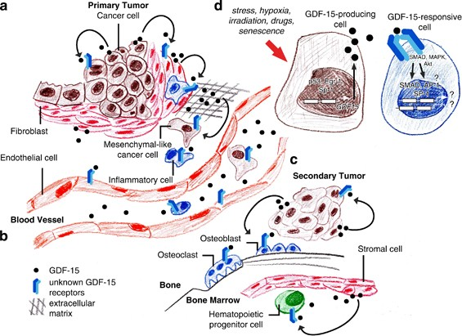

Figure 2.. The role that (GDF15) plays in the tissue microenvironment and the progression of cancer (Vaňhara, P., et al., 2012)

#### Growth differentiation factor (GDF15) in Prostate Cancer

There is a big requirements that are needed for both specified and biomarker that permit accurate prediction and assessment of illness consequence for PCa and other types of cancer. Nowadays, just PSA was inserted to clinical examination. Nonetheless, overall serum PSA levels aren’t cancer properties, as they can be present in even the benign of diseases, referring to a possible PCa diagnosis made on the basis of a false-positive test. The improvement was accomplished via the examination of PSA's alternate molecular forms., that resulted in a decrease in the number of negative cancer biopsies in the cases indicated(Catalona, W. J. *et al.,* 1998).

Of particularly significant, GDF15 concentration value in Serum has been shown scale up the accuracy of potential PSA information and its forms. When compared to normal prostate tissues, the expression of serum GDF15 decreased significantly in topical BPH or PCA, but increased in metastatic disease (Welsh, J. B. *et al.,* 2003).

Inflammatory processes in the prostate tissue are believed to be responsible for the shift from normal to benign enlargement and may influence an individual's vulnerability to autoimmune diseases. Inflammatory processes in the prostate tissue are believed to be responsible for the shift from normal to benign enlargement and may influence an individual's vulnerability to autoimmune diseases.. Expression the inflammatory alterations of glandular architecture followed by increased fleshy tissue in benign prostatic hypertrophy are negatively associated with the expression GDF15(Taniguchi, S., *et al.,* 2009).

Investigations of total serum levels of GDF15 have demonstrated a clear estimated ability to PCA mortality and disease outcomes, which justifies the possibility of more potential future studies of GDF15's introduction as a clinically significant biomarker for prostate cancer. Despite the fact that GDF15 can exist in a number of different molecular forms, these studies have shown that total serum levels of GDF15 can predict PCA mortality and disease outcomes. For example, GDF15 analysis has the potential to generally give a reliable sorting strategy (Brown, D. A., *et al.,* 2009).

#### Role of GDF-15 in PCa development

GDF15 is dynamically expressed in the division of epithelium caused by urogenital sinuses and buds, its expression decreases as soon as the phase of advanced prostate lobes is arrived. GDF15 is then re-stimulated through prostate maturation,& its expression is associated for signs of differentiation (for instance, K19). Consequently, data from the development of The embryonic, fetal,& early postnatal mouse models indicate that GDF15 has a unique dual function in regulating urogenital sinus epithelial proliferation and differentiation the development of a prostate with an articulating (lobular) structure. (Noorali, S., *et al.,* 2007).

Although the GDF15 coding sequence has a modest genetic diversity and numerous polymorphisms, present in individual nucleotides were not associated with the possibility of PCa infection, the wild type function GDF15 variant can be distinguished in the advanced PCa (Wang, X. *et al.,* 2012; Zhao, L., *et al.,* 2009).

To determine the regulation of GDF15 in PCa bone metastasis, the x-ray and the histomorphological consequence proved an At the sites of bone metastases, osteoblast differentiation and bone remodeling activity are accelerated. This study revealed an increase in the number of osteoblasts at metastatic locations.(Cheng, J. C. *et al.,* 2011). Another investigation referred agreement inhibitory impact of GDF15 on osteoclast formation regulator of differentiation and activity of osteoblasts(Wakchoure, S. *et al.,* 2009).

Increased technical information of GDF15 signaling pathways in cells produced or received contributes to an comprehension of the occurrences that make up the intricate Within the tumor microenvironment, a network exists. The GDF15 protein family has both tumor-promoting and tumor-inhibiting characteristics. As cellular, histological,& systemic manifestations impacts of GDF15 signals have been demonstrated in well-defined experimental conditions, GDF15, rather than bystander-induced stress, is most likely an involved and critical player in the development of PCa, see Figure 2.9. Therefore, introducing GDF15 in clinical discussions maybe provide new possibilities to better comprehend the development of cancer and may enhance diagnostic or treatment strategies (Brown, D. A. *et al.,* 2003; Costa, V. L. *et al.,* 2010; Massagué, J., 2008; Cheng J. C. *et al.,* 2011).



Figure 2.. The suggestion role of GDF15 in the development of prostate cancer (PCa) (Vaňhara, P., et al., 2012)

GDF15 is triggered in response to tissue damage or inflammation by cellular pressure and shields the lesion site from an insufficient immune response. When pathological circumstances, such as established prostate cancer, exist, GDF15 is triggered as a consequence of cellular stress induced by changes in and/or loss of the prostate tissue structure, thus triggering the immune response to the malignant region. (Vaňhara, P., *et al.,* 2012).

#### The relation between GDF15 and Hepcidin for prostate cancer patients

Prostate cancer (PCA) and some other kinds of cancers such as Breast cancer are tumors that are hormone-dependent. Tano et al. (2011) suggested that GDF15 and hepcidin could be used as prognostic indicators in prostate cancer. Compared to patients with non-metallic PCa, those with metastatic disease were shown to have a higher incidence of hepsidin and a trend toward higher GDF15 levels (Tanno, T., *et al.,* 2011; Grönberg, H. 2003).

Currently, the PSA conjugate is most often utilized in conjunction with GDF15 and serum hepcidin. GDF15 serum levels are inversely proportional to hepcidin serum levels. Surprisingly, higher GDF15 and serum hepcidin levels were associated with increased risk of mortality with each unit: induction of GDF15 at 1,000 pg / mL raised the risk of death by 20.6 percent. The induction of hepesidin at a concentration of 25 ng/mL increased the risk of death by 10%. In conclusion, a researcher determined the predictive value of GDF15 and serum hepcidin levels in prostate cancer. Another researcher determined that serum GDF15 and serum hepsidin may serve as prognostic indicators for PCa that progresses slowly or swiftly compared to the progression of cancer in limited organs(Winand *et al.,* 2014; Smith *et al.,* 2009).

Due to the variety of PCa, there is an urgent need for novel biomarkers that may be used to predict prognosis, disease severity, therapy effectiveness,& patient outcomes. Additionally, biomarkers are required in advanced PCa that formed after first therapy with antihormones to predict tumor development and aggressiveness in response to different therapies that may extend life. (Gelmann, E. P., & Henshall, S. M., 2009).

## Hormone

### FSH

FSH is a glycoprotein hormone that has structural similarities with other members of his family, including LH., it consisting of two polypeptides (alpha and beta). Thyroid-stimulating hormone and chorionic gonadotropin (Robboy, S. J., 2009).

These hormones have a common alpha subunit with a length of 96 amino acids but vary in their beta subunits. The heterodimer has biological action. SFH includes a beta subunit of 111 amino acids (FSH-), which is important for the hormone's biological activity and interaction with follicle-stimulating hormone receptors. FSH is produced in the same pituitary cells that produce gonadotrophins. All mammalian species need increased pituitary gland production of SFH to promote follicular development. (Atwell, J. W. *et al.,* 2012). See Figure 1.10.

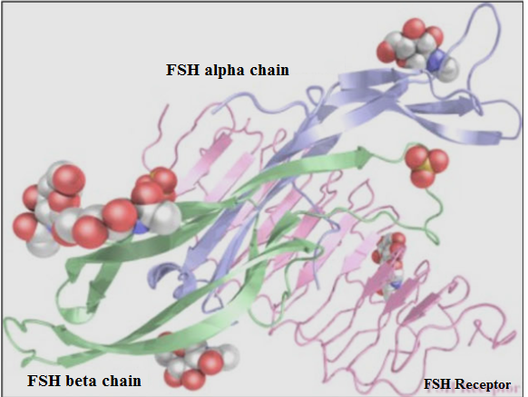

Figure 2.. The follicle stimulating hormone receptor (FSHR) structure in relation to the associated FSH alpha and beta

# **MATERIAL** AND METHOD

# **Material**

### BioTek Elisa ELx800 (S.N0 257381)

#### Overview

The ELx800 is intended for use in clinical, biotechnology,& pharmaceutical laboratories. Its small footprint and proven sturdy construction make it an excellent choice for a wide variety of microplate-based biological experiments. When used independently, the ELx800's on-board software supports a wide range of qualitative and quantitative applications.

The reader's optical characteristics are better, with an increased dynamic range of up to 3.000 absorbance units in certain read modes. The wavelength range is 400 to 750 nanometers. Instruments classified as "UV" have a wavelength range of 340 nm to 750 nm. The onboard data reduction capability surpasses many computer software packages with its complete curve fitting, cutoff calculation, data translation, and validation capabilities. The DAR800 interfaces with Diagnostic Automation Data Processing Software, enhancing data analysis and reporting versatility.



**Figure 3.1.** BioTek Elisa ELx800 (S.N 257381)

#### Calibration work and Result reading

biotek Elisa xl 800 fully automated therefore we insert calibration for kits in maps of instrument , some kits contient four or five or more calibrations depending on each kits, Then insert standard in maps then choose numbers of samplw then press on start for reading the results

### Roche Cobas c 311 Automated Chemistry Analyzer (REF 04826876001)

* + - 1. Overview

Roche Diagnostics' cobas C311 analyzer is a fully automated, software-controlled clinical chemistry analyzer. It is designed to be utilized for a wide variety of in vitro quantitative and qualitative evaluations utilizing various types of analytical tests. The cobas C311 analyzer utilizes serum/plasma to conduct photometric tests and ion-selective electrode measurements.

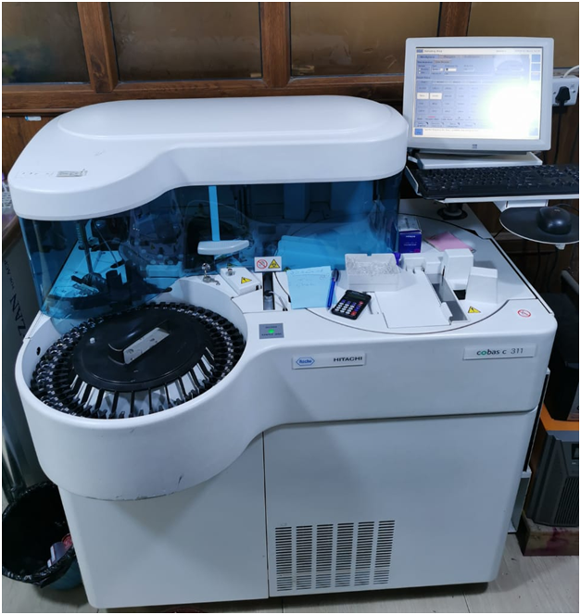

**Figure 3.2.** Roche Cobas c 311 Automated Chemistry Analyzer

Cobas c 311, a stand-alone Clinical Chemistry analyzer. Consolidation of regular and exceptional chemical tasks using a flexible methodology. 45 tests may be performed on-board, with a maximum throughput of 480 tests per hour. The following samples are acceptable serum, plasma, urine, cerebrospinal fluid (CSF), hemolysis, and whole blood are used for analysis. Eliminating the need for reagent preparation and manual sample handling saves time, increases the availability of results, and decreases turnaround time.

* + - 1. Specifications

Table 3.. Specifications of the system and other details

|  |  |
| --- | --- |
| **System** | **Clinical Chemistry and Homogeneous Immunology fully automated, random access analyzer (HIA).** |
| Sample throughput | Up to 300 samples each hour (theoretical max) |
| Test throughput  (Theoretical max) | 300 tests/hr for photometry tests only  480 tests/hr for only ISE tests |
| Number of channels Reagent  slots) | 42 cassette slots  3 channels on ISE module |
| Sample types | Serum, Plasma, Urine, CSF, Whole Blood  (HbA1c only)slots) |
| Sample volume | 1.0 – 35 μl in 0.1 μl steps |
| Sample dilution | 3 – 121 times, diluent 100 μl |
| Sample clot detection | Available |
| Minimum sample volume | Primary tubes : 700 μl  Sample cup: 100 μl  Micro cup: 50 μl |
| Calibrator/QC Input | On the sample disk, bar coded |
| Sample data base | 10.000 routine / STAT samples |

* + - 1. Calibration work and Result reading

The calibration procedure and read samples in cobas C 311 very easily because cobas c 311 full automatic, we only pass the serial number for solution through the red right light that read the bar code for this kit, then put the calibration and QC in patient positions on the outer row with the barcodes facing out. we put the sample that want read the values for it in suitable position then from moniter for instrument choose the tests for this sample then put start for reading.

### Automatic Micropipette (Diamond)

Diamond micropipettes are an economical alternative to name-brand pipettors. Diamond pipettors are manufactured to the highest standards of accuracy and precision and include a calibration certificate, a calibration tool,& a complete one-year guarantee.

High accuracy and precision are assured; the streamlined tip ejector is ideal for use with narrow necked containers and tubes; the two-step plunger action enables the use of the reverse pipetting method; and the tip ejector is color marked for easy identification.

In this study, it has been used automatic micropipette type diamonds with 50µl & 1 ml volumes.



**Figure 3.3.** Automatic micropipette type diamonds

### Centrifuge C- 12000 (6M 1810968)

In this study, ıt used centrifuge with 5000 Rpm/min of Chinese origin. After collecting the blood, ıt separated it in the device with a speed of 3000 spins for five minutes.

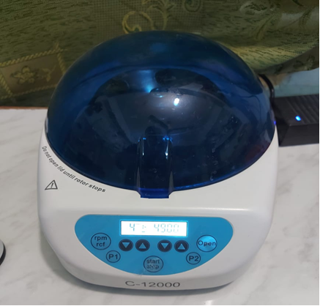

Figure 3.. Centrifuge C- 12000 (6M 1810968)

### Memmert water bath (WNE 22) (L513.0977)

Memmert water baths are suggested for routine laboratory heating activities involving water. They are made of corrosion-resistant stainless steel and include dual protection against possible dangers associated with overheating. A perfect temperature management is ensured by an electronic PID controller that features an integrated self-diagnosis system as well as a platinum temperature sensor of the highest quality (Pt100). Mummer WNB water baths include cutting-edge control technology, precise temperature control and monitoring, as well as sophisticated safety features.

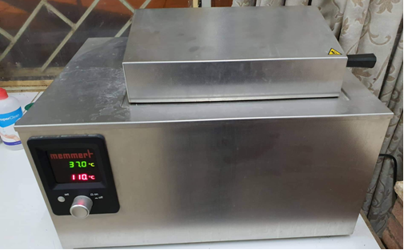

Figure 3.. Memmert water bath (WNE 22) (L513.0977)

### Additional material

Laboratory freezer, Centrifugation Tube, Pipette Tip, Distilled waste.

## Kits

### Prostate Specific Antigen – PSA (REF 52030)

PSA, or prostate-specific antigen, is a protein generated by both normal and cancerous cells of the prostate gland in males. The PSA test determines the PSA level in a man's blood. PSA levels in the blood are often high in individuals with prostate cancer. A blood sample (which must be serum-separated) is submitted to a laboratory for examination in this test. Typically, the findings are expressed as nanograms of PSA per milliliter. (ng/mL) of blood (Ilic, D., et al., 2018).

#### Principle of PSA (REF 52030)

The principle according to the data is giving in this kit The human PSA ELISA is designed for use in the laboratory. In the ELISA used for direct antigen detection, matching monoclonal anti-PSA antibodies that are both highly specific and monoclonal are coated on the surface of microtiter wells and are covalently attached to the enzyme. The initial incubation stage involves mixing the specimens, calibrators or controls,& antibody-enzyme conjugate to create the sandwich complex on the well surfaces. Excess conjugate and unbound antigen are rinsed away at the conclusion of the incubation. When TMB/Substrate is introduced (step 2), a blue color emerges that changes to yellow at reaction termination. The color's intensity is related to the PSA content in the material.

### Human GDF15 (Growth Differentiation Factor 15) H0150F038

It is a member of the transforming growth factor beta superfamily of proteins. GDF-15 is expressed at modest levels in the majority of organs under normal conditions and becomes uncontrolled as a consequence of injury to organs such as the liver, kidney, heart, and lung.

Among the many mammalian tissues on which its expression may be found, mRNA levels of this distantly related member of the TGF-superfamily are surprisingly high. Its expression is strictly controlled, and it is frequently triggered in response to cellular stress. Research indicates that GDF-15 is a powerful predictive factor in patients with a wide range of diseases, including cardiovascular disease and cancer.

#### Principle

During the process of developing this product, the sandwich enzyme linked immune sorbent assay approach was applied. Pre-coated capture antibody was applied to 96-well plates before they were used. In addition to this, biotin-conjugated antibodies were utilized for the role of detection antibodies. After adding the standards, test samples, and biotin-labeled detection antibody, the wells were rinsed with wash buffer. We then employed a wash buffer to get rid of any unattached conjugates after adding HRP-Streptavidin. The enzymatic activity of HRP was studied using TMB as a substrate. TMB was catalyzed by HRP, yielding a blue product that became yellow when an acidic stop solution was added. The yellow density is proportional to the amount of sample captured in the plate. Using a microplate reader, determine the concentration of the target by reading the absorbance of the optical density measured at 450 nm.

Table 3.. Kit Components

|  |  |  |
| --- | --- | --- |
| Item | Specifications (48T/96T) | Storage |
| ELISA Microplate (Dismountable) | 8×6/8×12 | 4°C/-20°C |
| Lyophilized Standard | 1 Vial/ 2vial | 4°C/-20°C |
| Sample/Standard dilution buffer | 10mi/20ml | 4°C |
| Biotin-labeled Antibody (concentration) | 60ul/120ul | 4°C(Protect from light) |
| Antibody Dilution Buffer | 5ml/10ml | 4°C |
| HRP-Streptavidin Conjugate (SABC) | 60ul/120ul | 4°C(Protect from light) |
| SABC Dilution Buffer | 5ml/10ml | 4°C |
| TMB Substrate | 5ml/10ml | 4°C(Protect from light) |
| Stop Solution | 5ml/10ml | 4°C |
| Wash Buffer (25×) | 15ml/30ml | 4°C |
| Plate sealer | 3/5pieces |  |
| Product Description | 1 copy |  |

#### Regarding Calculation

(The optical density relative to 450) = (the optical density relative to 450 of each well) – (the O.D.450nm blank well). The standard curve may be shown by plotting the relative O.D.450 value of each standard (Y) versus the concentration of the standard solution. (X). Interpolation of the Samples' target concentration from the standard curve is possible. It is suggested that you do this computation using any expert program, such as.

### CRP (0004956842190c501V11.0)

The C-reactive protein (CRP) test is used to determine the blood level of C-reactive protein (CRP). C-reactive protein is a liver-produced protein. It enters the circulation as a result of inflammation. Inflammation is the body's defense mechanism against damage or illness. A high level of CRP in the blood indicates inflammation. It is caused by a variety of illnesses, ranging from infection to cancer. Increased CRP levels may also indicate inflammation in the coronary arteries, implying an increased risk of coronary artery disease. heart attack.

#### Principle

Immunoturbidimetric test with particle enhancement. With latex particles coated with monoclonal antiCRP antibodies, human CRP agglutinates. Turbidimetric analysis is used to determine the aggregates.

#### Reagents - Working Solutions

R1 contains a buffer made of bovine serum albumin as well as preservatives. R2 contains immunoglobulins derived from mice, latex particles that have been coated with anti-CRP antibodies derived from mice, and a preservative.

#### Procedure

By Cobas C111 systems automatically calculate the results and the analytic concentration of each sample.

### Hepcidin (MBS2881688)

Hepcidin is a protein that is encoded by the HAMP gene in humans. Hepcidin is a critical regulator of the iron element's entrance into the mammalian circulatory system.. Hepcidin is decreased in iron element deficiency anemia, hemolytic anemia,& anemia’swith ineffective erythropoiesis. The mechanisms may be mediating hepcidin suppression in these conditions, however, may not be the same.

#### Principle of Assay

This kit includes a microtiter plate that has been pre-coated with an antibody specific to the target antigen (Hipsidin hormone). After incubating standards or samples with a biotin-conjugated antibody preparation specific for the target antigen in the relevant microtiter plate wells, each microplate well is treated with avidin linked to Horseradish Peroxidase (HRP). Then, a substrate solution containing TMB is applied to each well. There will be variation in the color of the wells containing the target antigen, biotin-conjugated antibody, and enzyme-conjugated Avidin. To terminate the enzyme-substrate interaction, a sulphuric acid solution is introduced, and the spectrophotometric color shift at 450 nm 2 nm is detected. The concentration of target antigen in the samples is then determined by comparing them to the reference curve's optical density (OD).

#### Reagent preparation

Standard - Please refer to the Data Sheet inserting in the kit.Detection Reagents A and B - Using the Assay, dilute to the working concentration. Diluents A and B (1:100) are used. If crystals have developed in the concentrate, bring it to room temperature and gently stir until all crystals have dissolved. 30mL Wash Buffer diluted Prepare 750 mL of Wash Buffer by diluting the concentrate with deionized or distilled water.

### FSH (425-300)

In our study, one of the important tests that we were researched that is FSH, or follicle-stimulating hormone, is a hormone that is required for pubertal growth and normal ovarian and testicular function in women and men. This hormone stimulates ovarian follicle growth in women prior to the release of an egg from a single follicle during ovulation. Additionally, it increases oestradiol production. FSH is produced by the pituitary gland, a small organ located under the brain. FSH is needed for the proper development and function of the sexual organs. FSH has a role in women's menstrual cycle control and stimulates egg growth in the ovaries.

#### Principle

Immunoenzymometric tests need a large quantity of high affinity and specificity antibodies (enzyme and immobilized), as well as natural antigen. Immobilization occurs at the surface of the microplate well during the test as a consequence of the interaction between streptavidin-coated wells and biotinylated monoclonal anti-FSH antibody that is supplied exogenously. This interaction is caused by the biotinylation of the monoclonal anti-FSH antibody. When a monoclonal antibody is biotinylated, an enzyme-labelled antibody,& a serum containing the native antigen are combined, no competition or steric hindrance exists between the native antigen and the antibodies, leading in the formation of a soluble sandwich equation.:

K a

ENZAb (P) + AgFSH+ Btn Ab (m)  ENZAb (P) -AgFSH - Btn Ab (m)

K -a

Btn Ab (m) = Biotinylated Monoclonal Antibody (Excess Quantity)

AgFSH =Native Antigen (Variable Quantity)

ENZAb (P) = Enzyme labelled Antibody (Excess Quantity)

ENZAb (P) -AgFSH - Btn Ab (m) = Antigen-Antibodies Sandwich Complex

Ka = Rate Constant of Association

K-a = Rate Constant of Dissociation

Simultaneously, the complex is deposited in the well through a highly specific reaction between streptavidin and biotinylated antibody. The following diagram illustrates this relationship.:

ENZAb (P) -AgFSH - Btn Ab (m) + Streptavidin C.W. Immobilized complex

C.W. Streptavidin = Streptavidin On well, immobilized.

Sandwich complexes that are immobilized on a solid surface are called immobilized complexes. After reaching equilibrium, the antibody-bound fraction and the unbound antigen are separated from one another via decantation or suction, respectively. The amount of natural antigen present has a direct bearing on the enzyme's level of activity in the section of the sample that contains antibodies. When serum references are combined with antigen concentrations that are already known, a dosage response curve may be produced. Using this curve, it is possible to determine the antigen concentration of a serum sample that is unknown.

#### Reagent preparation

1. **Wash buffer:** In an appropriate container for storage, bring the total volume of the wash to 1000 milliliters by diluting it with distilled or deionized water. Keep at a temperature between 2 and 30 degrees Celsius for up to 60 days.
2. Working Substrate solution - Oneyear stability
3. After transferring the contents of the clear vial labeled "B" to the amber vial labeled "A," step 3. Replace the yellow cap on the clear vial for easy recognition. Put together and properly label. Keep between 2 and 8 degrees Celsius.

# RESULTS AND DİSCUSSİON

# **Prostate cancer Analysis**

This study included two groups, first group included 60 person as control Group (Group A), while Second Group 70 person (patients group or Group B), in our study the total of cases 130 people, their ages between 26 - 66 year for analysis.

As can be seen in Table 4.1 and Figure 4.1, there were no statistically significant variations in mean age between Group A (Controls) and Group B (Patients), with Group A having a mean age of 61.3 9.26 years and Group B having a mean age of 64.7 10.8 years. While there are correlation between Hepcidin Hormone and age (r = 0.257**, P-Value 0.003).

Table 4.. Age in Patients and Control

|  |  |  |  |  |  |  |  |
| --- | --- | --- | --- | --- | --- | --- | --- |
| Variable | Groups A  Mean ± SD |  | Group B  Mean ± SD | |  | Sig. | |
|  |  |  |  | |  |  | |
| Age | 64.7 ± 10.8 |  | 38.3±7.62 | |  | 0.031 | |
| Weight | 80.5 ± 12.9 |  | 78.9 ± 12.5 | |  | 0.287 | |
| C.R.P | 12.9 ± 30.6 |  | 92.5 ± 79.3 | |  | 0.001 | |
| FSH | 2.89 ± 3.37 |  | 4.88 ± 5.45 | |  | 0.016 | |
| PSA | 2.19 ± 0.57 |  | 36.4 ± 13.3 | |  | 0.001 | |
| H.H | 2.44 ± 1.91 |  | 5.47 ± 3.24 | |  | 0.001 | |
| GDF15 | 33.3 ± 19.2 |  | 53.8 ± 50.8 |  | | 0.004 |  |

Tablo 4.. Correlation between Hepcidin Hormone and Some Variables in all Case of Prostate cancer

|  |  |  |
| --- | --- | --- |
|  | Hepcidin Hormone | |
| Variables | *R* | *P*-Value |
| Hepcidin Hormone - Age (years) | 0.257** | 0.003 |
| Hepcidin Hormone - Weight (kg) | 0.082 | 0.354 |
| Hepcidin Hormone –C-RP (mg/dl) | 0.376** | 0.001 |
| Hepcidin Hormone – FSH ( MU/ML) | 0.163 | 0.063 |
| Hepcidin Hormone – PSA (mg/dl) | 0.454** | 0.001 |
| Hepcidin Hormone – Gdf15 (mg/dl) | 0.220* | 0.012 |
| no risk: P > 0.05; ⃰ ⃰ highly significant at (P < 0.01); ⃰ Statistically significant at (P < 0.05); N.S. : non-significant. | | |

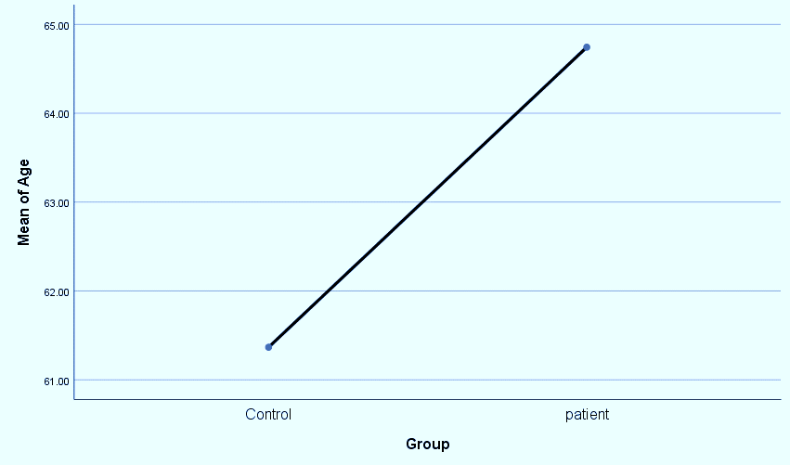

**Figure 4.1**.The relation between Control group and patient group with Mean of age

As a result shown in Table 4.1 the mean of weight (kg) was has a no significant difference between control group (group A, 80.5 ± 12.9) as compare to the patients group (B group, 78.9 ± 12.5) (Figure 4.2).

There are link between rheumatoid arthritis (RA) weights (Pødenphant, J., *et al.,* 1996), this study agreed with our study. While don't there are correlation between Hepcidin Hormone and weight (r = 0.082, P-Value 0.354) (Figure 4.2). The association between BMI and risk of prostate cancer differed by stage and grade at diagnosis (Rodriguez, C., *et al.*, 2007). There are not was adiposity related positively to prostate cancer incidence (Wright, M. E., *et al.,* 2007).

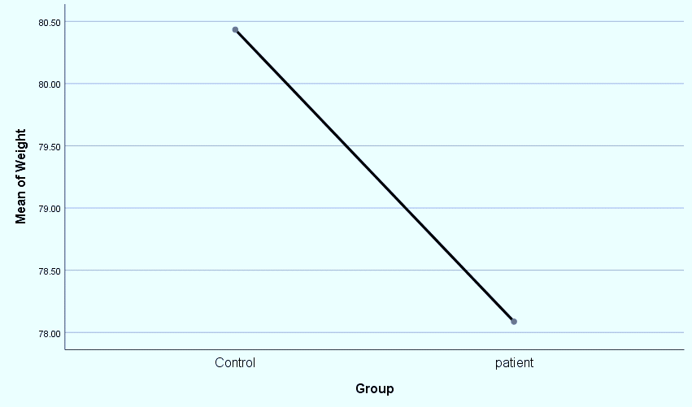

**Figure 4.2.** The relation between Control group and patient group with Mean of weıght (Kg)

As indicated in Table 4.1 and Figure 4.3, there is a substantial difference in the mean C-reactive protein concentration (mg/dl) between the control group (group A) (12.9 ± 30.6) and the patient group (group B) (92.5 ± 79.3). As well as the mean of BMI (kg/m2) in group A was (28.32± 3.60), addition, the Correlation between Hepcidin Hormone and C-RP was strong (r=0.376**, P-Value=0.001) showing in Table 4.2. In a study Steven Lehrer and other friends in 2005, there was also a significant correlation of CRP level with prostate‐specific antigen (PSA) in those with cancer,& this agreement with our study. The level of C‐reactive protein in another study is elevated in prostate cancer patients (Stark, J. R., et al., 2009),& this agree with our study.

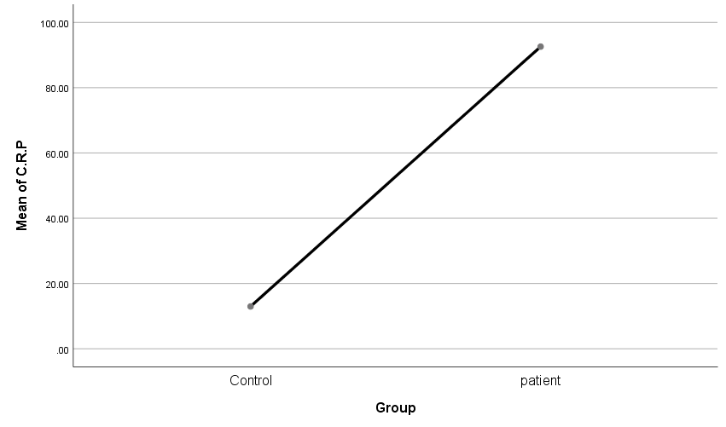

Figure 4..The relation between Control group and patient group with Mean of CRP

## Hormons Results

### FSH

As shown in Table 4.1 the mean of FSH concentration was has a significant difference between the control group (group A, 2.89 ± 3.37) as compared to the patients' group (B groups, 4.88± 5.45) at P > 0.05, also the correlations with Hepcidin Hormone was no significant difference positively (r= 0.163, P-0.063 ) as shown in Table 4.2. Immunohistochemistry revealed the found of FSH in PC3 and Du145 cells, as well as in human adenocarcinoma of the prostate (Ben-Josef, E., *et al.,* 1999). In the study of Mariani, S., *et al.*, 2006, It has become clear recently recent interest focusing on gonadotropin, follicle-stimulating hormone (FSH).

FSH is generated in and FSH receptors are expressed in the prostate, according to research conducted over the past decade. Additionally, researchers discovered that prostate cancer alters FSH production: FSH levels are increased and receptor synthesis is enhanced in the malignant prostate. These findings corroborate previous research..

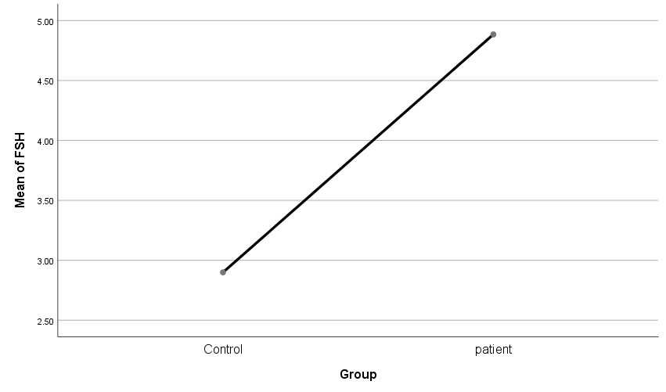

Figure 4..The relation between Control group and patient group with Mean of FSH

* + 1. PSA

As shown in Table 4.1, The mean of PSA (mg/dl) in the Control group (Group A) there was (2.19± 0.57), a significant difference with patient's group (Group B), also, the correlation between Hepcidin Hormone and PSA was positive as shown in Table 4.2. These results agreed with a previous study (Catalona, W. J., *et al.,* 1991), Serum PSA levels ranged from 4.0 to 9.9 μ9 per liter, which means an elevation of PSA in men with prostate cancer. Prostate-specific antigen (PSA) may be elevated in men with prostate disease.(Catalona, W. J., *et al.*, 2000 ). See Figure 4.5.

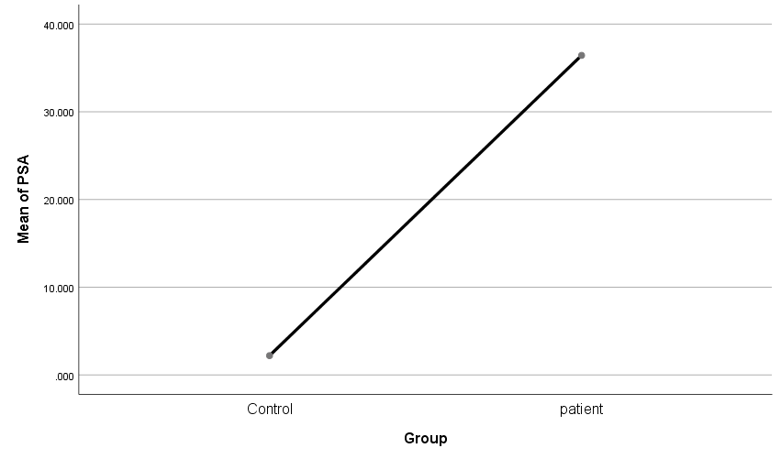

Figure 4..The relation between Control group and patient group with Mean of PSA

* + 1. Hepcidin Hormone

Hepcidin hormon Hepcidin hormone is a circulating peptide hormone produced by the human liver. It is a critical regulator of systemic iron absorption and recycling. (Tesfay, L., *et al.,* 2015). The data of this study showed that there were significant differences in level of Hepcidin Hormone (mg/dL) in Control group (group A) with patient (Group B) (2.44 ± 1.91; 5.47 ± 3.24) respectively, as shown in Table 4.1 (Figure 4.6). Hepcidin hormon in patients with Prostate cancer increasing than in controls (p < 0.01) (Tesfay, L., *et al.,* 2015). High concentration of urea and creatinine in RA (Pattrick, M., et al., 1989), there was a trend to higher serum hepcidin (Winand, F. J., *et al.,* 2014), this result shows agreed with our study.

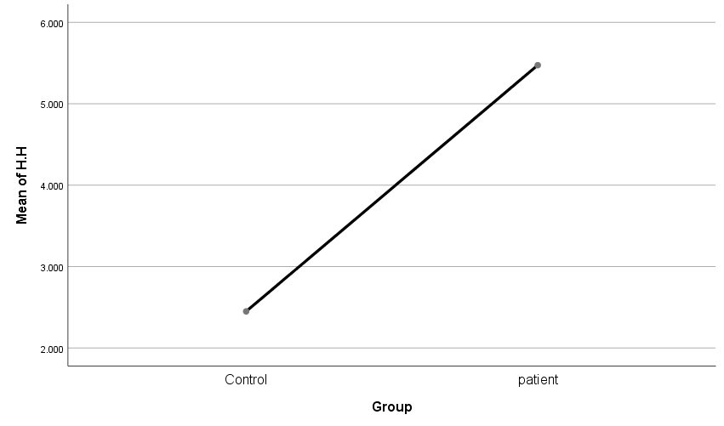

Figure 4.. The relation between Control group and patient group with Mean of HH

### GDF15

The mean of GDF15 (mg/dl) in control group (Group A) was (5.25± 0.91), while patient group (Group B) Non a significant difference between group A with B, groups. Also, the correlation between Hepcidin Hormone and Gdf15 was therebare correlated (r=0.220*, P=0.012) as showed in Table 4.2 (Figure 4.7). There was a correlation between prostate-specific antigen (PSA) and serum levels of hepcidin and GDF15. There was a correlation between serum GDF15 levels and serum hepcidin levels (Winand, F. J., *et al.,* 2014). This result shows agree compared this study with our study.

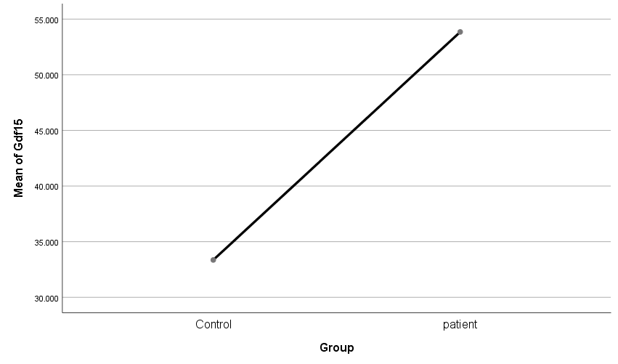

Figure 4.. The relation between Control group and patient group with Mean of GDF15

# CONCLUSIONS

After performing pathological analyzes for prostate cancer patients and hormonal laboratory analyzes, depending on the results and statistical analyzes and comparison the obtained results with previous investigation in the same topics. It has been concluded:-

1. This study has significant differences with H.H, C-RP, Gdf15 and FSH, that means we can use these biochemical parameters as marker for risk prostate diseases.
2. Because both age and weight have a role in prostate illness, these characteristics are frequently utilized as biomarkers to identify men who are at risk for developing prostate disease.
3. The study's findings of high significance (correlation) between the sick group (Group B) and the control group (Group A) for H. H, C0RP, GDF15, and PSA allow for the reliable prediction of prostate diseases.
4. There are significant connections between H.H factors and various physiological variables such as age, C-reactive protein, prostate specific antigen (PSA), and Gdf15.

**References**

‏ Albertsen, P. C., Hanley, J. A., Gleason, D. F., & Barry, M. J. (1998). Competing risk analysis of men aged 55 to 74 years at diagnosis managed conservatively for clinically localized prostate cancer. *Jama*, *280*(11), 975-980.‏

Allsbrook Jr, W. C., Mangold, K. A., Johnson, M. H., Lane, R. B., Lane, C. G., Amin, M. B., ... & Sakr, W. (2001). Interobserver reproducibility of Gleason grading of prostatic carcinoma: urologic pathologists. *Human pathology*, *32*(1), 74-80.‏

Andrews, N. C. (2008). Forging a field: the golden age of iron biology. *Blood, The Journal of the American Society of Hematology*, *112*(2), 219-230.

Andriopoulos Jr, B., Corradini, E., Xia, Y., Faasse, S. A., Chen, S., Grgurevic, L., ... & Babitt, J. L. (2009). BMP6 is a key endogenous regulator of hepcidin expression and iron metabolism. *Nature genetics*, *41*(4), 482-487.‏

Atwell, J. W., Cardoso, G. C., Whittaker, D. J., Campbell-Nelson, S., Robertson, K. W., & Ketterson, E. D. (2012). Boldness behavior and stress physiology in a novel urban environment suggest rapid correlated evolutionary adaptation. *Behavioral Ecology*, *23*(5), 960-969.‏

Babitt, J. L., Huang, F. W., Wrighting, D. M., Xia, Y., Sidis, Y., Samad, T. A., ... & Andrews, N. C. (2006). Bone morphogenetic protein signaling by hemojuvelin regulates hepcidin expression. *Nature genetics*, *38*(5), 531-539.‏ ‏

Badawy, A. E. A. (2010). *ROLE OF HEPCIDIN HORMONE IN PATIENTS OF β-THALASSEMIA MAJOR* (Doctoral dissertation, Zagazig University).‏ ‏

Baek, K. E., Yoon, S. R., Kim, J. T., Kim, K. S., Kang, S. H., Yang, Y., ... & Lee, H. G. (2009). Upregulation and secretion of macrophage inhibitory cytokine-1 (MIC-1) in gastric cancers. *Clinica Chimica Acta*, *401*(1-2), 128-133.

Baek, S. J., Kim, J. S., Moore, S. M., Lee, S. H., Martinez, J., & Eling, T. E. (2005). Cyclooxygenase inhibitors induce the expression of the tumor suppressor gene EGR-1, which results in the up-regulation of NAG-1, an antitumorigenic protein. *Molecular pharmacology*, *67*(2), 356-364.‏

Baek, S. J., Kim, K. S., Nixon, J. B., Wilson, L. C., & Eling, T. E. (2001). Cyclooxygenase inhibitors regulate the expression of a TGF-β superfamily member that has proapoptotic and antitumorigenic activities. *Molecular pharmacology*, *59*(4), 901-908.‏

Baek, S. J., Wilson, L. C., Lee, C. H., & Eling, T. E. (2002). Dual function of nonsteroidal anti-inflammatory drugs (NSAIDs): inhibition of cyclooxygenase and induction of NSAID-activated gene. *Journal of Pharmacology and Experimental Therapeutics*, *301*(3), 1126-1131.

Balk, S. P., Ko, Y. J., & Bubley, G. J. (2003). Biology of prostate-specific antigen. *Journal of clinical oncology*, *21*(2), 383-391.‏

Bechis, S. K., Otsetov, A. G., Ge, R., & Olumi, A. F. (2014). Personalized medicine for the management of benign prostatic hyperplasia. *The Journal of urology*, *192*(1), 16-23.‏ ‏

Bekri, S., Gual, P., Anty, R., Luciani, N., Dahman, M., Ramesh, B., ... & Saint–Paul, M. C. (2006). Increased adipose tissue expression of hepcidin in severe obesity is independent from diabetes and NASH. *Gastroenterology*, *131*(3), 788-796

Ben-Josef, E., YANG, S. Y., Ji, T. H., BIDART, J. M., Garde, S. V., Chopra, D. P., ... & Tang, D. G. (1999). Hormone-refractory prostate cancer cells express functional follicle-stimulating hormone receptor (FSHR). The Journal of urology, 161(3), 970-976.

Bissell, M. J., & Hines, W. C. (2011). Why don't we get more cancer? A proposed role of the microenvironment in restraining cancer progression. Nature medicine, 17(3), 320-329.‏

Bock, A. J., Stavnes, H. T., Kempf, T., Tropè, C. G., Berner, A., Davidson, B., & Staff, A. C. (2010). Expression and clinical role of growth differentiation factor-15 in ovarian carcinoma effusions. *International Journal of Gynecologic Cancer*, *20*(9).‏

Bootcov, M. R., Bauskin, A. R., Valenzuela, S. M., Moore, A. G., Bansal, M., He, X. Y., ... & Walsh, B. J. (1997). MIC-1, a novel macrophage inhibitory cytokine, is a divergent member of the TGF-β superfamily. *Proceedings of the National Academy of Sciences*, *94*(21), 11514-11519.‏

Braliou, G. G., Falzacappa, M. V. V., Chachami, G., Casanovas, G., Muckenthaler, M. U., & Simos, G. (2008). 2-Oxoglutarate-dependent oxygenases control hepcidin gene expression. *Journal of hepatology*, *48*(5), 801-810

Broeke, N. C. (2018). Characterization of Human Prostate Cancer Using Sodium Magnetic Resonance Imaging.‏ Available at:-<https://ir.lib.uwo.ca/cgi/viewcontent.cgi?article=7467&context=etd>

Brown, D. A., Bauskin, A. R., Fairlie, W. D., Smith, M. D., Liu, T., Xu, N., & Breit, S. N. (2002). Antibody-based approach to high-volume genotyping for MIC-1 polymorphism. *Biotechniques*, *33*(1), 118-126

Brown, D. A., Lindmark, F., Stattin, P., Bälter, K., Adami, H. O., Zheng, S. L., ... & Wiklund, F. E. (2009). Macrophage inhibitory cytokine 1: a new prognostic marker in prostate cancer. *Clinical cancer research*, *15*(21), 6658-6664.‏

Brown, D. A., Ward, R. L., Buckhaults, P., Liu, T., Romans, K. E., Hawkins, N. J., ... & Breit, S. N. (2003). MIC-1 serum level and genotype: associations with progress and prognosis of colorectal carcinoma. *Clinical Cancer Research*, *9*(7), 2642-2650.‏ ‏

BURRIS III, Howard A. Dual kinase inhibition in the treatment of breast cancer: initial experience with the EGFR/ErbB‐2 inhibitor lapatinib. *The oncologist*, 2004, 9: 10-15.‏ Available at:- [https://scholar.google.com/scholar?hl=ar&as_sdt=0%2C5&q=Burris+III%2C+H.+A.+%282004%29.+Dual+Kinase+Inhibition+in+the+Treatment+of+Breast+Cancer%3A+Initial+Experience+with+the+EGFR%2FErbB%E2%80%902+Inhibitor+Lapatinib.+The+Oncologist%2C+9%2C+10-15.%E2%80%8F&btnG=#](https://scholar.google.com/scholar?hl=ar&as_sdt=0%2C5&q=Burris+III%2C+H.+A.+%282004%29.+Dual+Kinase+Inhibition+in+the+Treatment+of+Breast+Cancer%3A+Initial+Experience+with+the+EGFR%2FErbB%E2%80%902+Inhibitor+Lapatinib.+The+Oncologist%2C+9%2C+10-15.%E2%80%8F&btnG=)

Camaschella, C. & Poggiali, E. 2011. Inherited disorders of iron metabolism 25.

Cao, Y., & Ma, J. (2011). Body mass index, prostate cancer–specific mortality, and biochemical recurrence: a systematic review and meta-analysis. *Cancer prevention research*, *4*(4), 486-501.‏

Catalona, W. J., Partin, A. W., Slawin, K. M., Brawer, M. K., Flanigan, R. C., Patel, A., ... & Lange, P. H. (1998). Use of the percentage of free prostate-specific antigen to enhance differentiation of prostate cancer from benign prostatic disease: a prospective multicenter clinical trial. *Jama*, *279*(19), 1542-1547

Catalona, W. J., Smith, D. S., Ratliff, T. L., Dodds, K. M., Coplen, D. E., Yuan, J. J., ... & Andriole, G. L. (1991). Measurement of prostate-specific antigen in serum as a screening test for prostate cancer. New England Journal of Medicine, 324(17), 1156-1161.

Catalona, W. J., Southwick, P. C., Slawin, K. M., Partin, A. W., Brawer, M. K., Flanigan, R. C., ... & Lange, P. H. (2000). Comparison of percent free PSA, PSA density, and age-specific PSA cutoffs for prostate cancer detection and staging. Urology, 56(2), 255-260.

Cheng, J. C., Chang, H. M., & Leung, P. C. (2011). Wild-type p53 attenuates cancer cell motility by inducing growth differentiation factor-15 expression. *Endocrinology*, *152*(8), 2987-2995.‏

Choulika, A., & Nicolas, J. F. (2001). *U.S. Patent No. 6,200,800*. Washington, DC: U.S. Patent and Trademark Office.‏

Costa, V. L., Henrique, R., Danielsen, S. A., Duarte-Pereira, S., Eknaes, M., Skotheim, R. I., ... & Teixeira, M. R. (2010). Three epigenetic biomarkers, GDF15, TMEFF2, and VIM, accurately predict bladder cancer from DNA-based analyses of urine samples. *Clinical Cancer Research*, *16*(23), 5842-5851.‏

Crichton, R. (2016). *Iron metabolism: from molecular mechanisms to clinical consequences*. John Wiley & Sons.‏

‏Curr.Opin.Pediatr., 23, (1) 14-20.

Daniels, L. B., Clopton, P., Laughlin, G. A., Maisel, A. S., & Barrett-Connor, E. (2011). Growth-differentiation factor-15 is a robust, independent predictor of 11-year mortality risk in community-dwelling older adults: the Rancho Bernardo Study. *Circulation*, *123*(19), 2101-2110.

Davison, B. J., Goldenberg, S. L., Gleave, M. E., & Degner, L. F. (2003, January). Provision of individualized information to men and their partners to facilitate treatment decision making in prostate cancer. In *Oncology nursing forum* (Vol. 30, No. 1).‏

Dinh, W., Füth, R., Lankisch, M., Hess, G., Zdunek, D., Scheffold, T., ... & Nickl, W. (2011). Growth-differentiation factor-15: a novel biomarker in patients with diastolic dysfunction?. *Arquivos Brasileiros de Cardiologia*, *97*(1), 65-75.

Epstein, J. I. (2000). Gleason score 2–4 adenocarcinoma of the prostate on needle biopsy: a diagnosis that should not be made (Available on Google Scholar).

Epstein, J. I. (2010). An update of the Gleason grading system. *The Journal of urology*, *183*(2), 433-440.‏ Available on:- <https://scholar.google.com/scholar?hl=ar&as_sdt=0%2C5&q=Epstein%2C+J.+I.+%282010%29.+An+update+of+the+Gleason+grading+system.+The+Journal+of+urology%2C+183%282%29%2C+433-440.%E2%80%8F&btnG=>

Epstein,J.I.,etal.,*The2005InternationalSocietyofUrologicalPathology(ISUP)ConsensusConferenceonGleasonGradingofProstaticCarcinoma.*AmJSurgPathol,2005.**29**(9):p.1228-42.

Farnaud, S., Patel, A., & Evans, R. W. (2006). Modelling of a metal-containing hepcidin. *Biometals*, *19*(5), 527-533.‏

Fatih, N., Camberlein, E., Island, M. L., Corlu, A., Abgueguen, E., Détivaud, L., ... & Loréal, O. (2010). Natural and synthetic STAT3 inhibitors reduce hepcidin expression in differentiated mouse hepatocytes expressing the active phosphorylated STAT3 form. *Journal of molecular medicine*, *88*(5), 477-486.‏

Fendler, W. P., Calais, J., Eiber, M., Flavell, R. R., Mishoe, A., Feng, F. Y., ... & Emmett, L. (2019). Assessment of 68Ga-PSMA-11 PET accuracy in localizing recurrent prostate cancer: a prospective single-arm clinical trial. *JAMA oncology*, *5*(6), 856-863.‏

Finberg, K. E., Heeney, M. M., Campagna, D. R., Aydınok, Y., Pearson, H. A., Hartman, K. R., ... & Andrews, N. C. (2008). Mutations in TMPRSS6 cause iron-refractory iron deficiency anemia (IRIDA). *Nature genetics*, *40*(5), 569.‏

Ganz, T. (2002). The role of hepcidin in iron sequestration during infections and in the pathogenesis of anemia of chronic disease. *Sat*, *30*, 20.‏

Ganz, T. (2006). Hepcidin—a peptide hormone at the interface of innate immunity and ir.on metabolism. In *Antimicrobial Peptides and Human Disease* (pp. 183-198). Springer, Berlin, Heidelberg.‏

Ganz, T., Olbina, G., Girelli, D., Nemeth, E., & Westerman, M. (2008). Immunoassay for human serum hepcidin. *Blood, The Journal of the American Society of Hematology*, *112*(10), 4292-4297.‏

Gardenghi, S., Ramos, P., Marongiu, M. F., Melchiori, L., Breda, L., Guy, E., ... & Nemeth, E. (2010). Hepcidin as a therapeutic tool to limit iron overload and improve anemia in β-thalassemic mice. *The Journal of clinical investigation*, *120*(12), 4466-4477.‏

Gasparrini, S., Cimadamore, A., Scarpelli, M., Massari, F., Doria, A., Mazzucchelli, R., ... & Montironi, R. (2019). Contemporary grading of prostate cancer: 2017 update for pathologists and clinicians. *Asian journal of andrology*, *21*(1), 19.‏

Gelmann, E. P., & Henshall, S. M. (2009). Clinically relevant prognostic markers for prostate cancer: the search goes on. Annals of internal medicine, 150(9), 647-649.‏

Gleason, D. F. (1966). Classification of prostatic carcinomas. *Cancer Chemother. Rep.*, *50*, 125-128.‏

Gleason, D. F. (1992). Histologic grading of prostate cancer: a perspective. *Human pathology*, *23*(3), 273-279.‏

Gnana-Prakasam, J. P., Martin, P. M., Mysona, B. A., Roon, P., Smith, S. B., & Ganapathy, V. (2008). Hepcidin expression in mouse retina and its regulation via lipopolysaccharide/Toll-like receptor-4 pathway independent of Hfe. *Biochemical Journal*, *411*(1), 79-88.‏

Gordetsky, J., & Epstein, J. (2016). Grading of prostatic adenocarcinoma: current state and prognostic implications. *Diagnostic pathology*, *11*(1), 25.‏

Goswami, T., & Andrews, N. C. (2006). Hereditary hemochromatosis protein, HFE, interaction with transferrin receptor 2 suggests a molecular mechanism for mammalian iron sensing. *Journal of Biological Chemistry*, *281*(39), 28494-28498.‏

Grönberg, H. (2003). Prostate cancer epidemiology. The Lancet, 361(9360), 859-864.

Haase, V. H. (2010). Hypoxic regulation of erythropoiesis and iron metabolism. *American Journal of Physiology-Renal Physiology*, *299*(1), F1-F13.‏‏

Hammerich, K. H., Ayala, G. E., & Wheeler, T. M. (2009). Anatomy of the prostate gland and surgical pathology of prostate cancer. *Cambridge University, Cambridge*, 1-10.‏

Hayes, V. M., Severi, G., Southey, M. C., Padilla, E. J., English, D. R., Hopper, J. L., ... & Sutherland, R. L. (2006). Macrophage inhibitory cytokine-1 H6D polymorphism, prostate cancer risk, and survival. *Cancer Epidemiology and Prevention Biomarkers*, *15*(6), 1223-1225.‏

Huh, S. J., Chung, C. Y., Sharma, A., & Robertson, G. P. (2010). Macrophage inhibitory cytokine-1 regulates melanoma vascular development. *The American journal of pathology*, *176*(6), 2948-2957.

Ikeda, Y., Tajima, S., Izawa-Ishizawa, Y., Kihira, Y., Ishizawa, K., Tomita, S., ... & Tamaki, T. (2012). Estrogen regulates hepcidin expression via GPR30-BMP6-dependent signaling in hepatocytes. *PloS one*, *7*(7), e40465.‏

Ilic, D., Djulbegovic, M., Jung, J. H., Hwang, E. C., Zhou, Q., Cleves, A., ... & Dahm, P. (2018). Prostate cancer screening with prostate-specific antigen (PSA) test: a systematic review and meta-analysis. bmj, 362, k3519.

Isoda, M., Hanawa, H., Watanabe, R., Yoshida, T., Toba, K., Yoshida, K., ... & Tanaka, K. (2010). Expression of the peptide hormone hepcidin increases in cardiomyocytes under myocarditis and myocardial infarction. *The Journal of nutritional biochemistry*, *21*(8), 749-756.‏

Jemal, A., Thomas, A., Murray, T., & Thun, M. (2002). Cancer statistics, 2002. *Ca-A Cancer Journal for Clinicians*, *52*(1), 23-47.‏

Johnen, H., Lin, S., Kuffner, T., Brown, D. A., Tsai, V. W. W., Bauskin, A. R., ... & Hunter, M. (2007). Tumor-induced anorexia and weight loss are mediated by the TGF-β superfamily cytokine MIC-1. *Nature medicine*, *13*(11), 1333-1340.‏

Karan, D., Chen, S. J., Johansson, S. L., Singh, A. P., Paralkar, V. M., Lin, M. F., & Batra, S. K. (2003). Dysregulated expression of MIC-1/PDF in human prostate tumor cells. *Biochemical and biophysical research communications*, *305*(3), 598-604.‏

Kash, D. P., Lal, M., Hashmi, A. H., & Mubarak, M. (2014). Utility of digital rectal examination, serum prostate specific antigen, and transrectal ultrasound in the detection of prostate cancer: a developing country perspective. *Asian Pac J Cancer Prev*, *15*(7), 3087-91.

Kautz, L., Jung, G., Valore, E. V., Rivella, S., Nemeth, E., & Ganz, T. (2014). Identification of erythroferrone as an erythroid regulator of iron metabolism. *Nature genetics*, *46*(7), 678-684.‏

Kempf, T., Eden, M., Strelau, J., Naguib, M., Willenbockel, C., Tongers, J., ... & Niessen, H. W. (2006). The transforming growth factor-β superfamily member growth-differentiation factor-15 protects the heart from ischemia/reperfusion injury. *Circulation research*, *98*(3), 351-360.‏

Kim, J. S., Baek, S. J., Sali, T., & Eling, T. E. (2005). The conventional nonsteroidal anti-inflammatory drug sulindac sulfide arrests ovarian cancer cell growth via the expression of NAG-1/MIC-1/GDF-15. *Molecular cancer therapeutics*, *4*(3), 487-493.‏

Kolata, G. (2016). Patients of early prostate cancer avoid treatment.‏

Krause, A., Neitz, S., Magert, H. J. ,Schulz, A., Forssmann, W. G., Schulz-Knappe, P., & Adermann, K. 2000. LEAP-1, ano ve lhighly disulfide-bonded human peptide, exhibitsantimicrobial activity.*FEBSLett.*, 480, (2-3) 147-150.

Kulaksiz, H., Fein, E., Redecker, P., Stremmel, W., Adler, G., & Cetin, Y. (2008). Pancreatic b-cells express hepcidin, an iron-uptake regulatory peptide. *Journal of Endocrinology*, *197*(2), 241-250.‏

Kweldam, C. F., Wildhagen, M. F., Steyerberg, E. W., Bangma, C. H., Van Der Kwast, T. H., & Van Leenders, G. J. (2015). Cribriform growth is highly predictive for postoperative metastasis and disease-specific death in Gleason score 7 prostate cancer. *Modern pathology*, *28*(3), 457-464.‏

Lee, P. L., Beutler, E., Rao, S. V., & Barton, J. C. (2004). Genetic abnormalities and juvenile hemochromatosis: mutations of the HJV gene encoding hemojuvelin. *Blood*, *103*(12), 4669-4671.‏

Lehrer, S., Diamond, E. J., Mamkine, B., Droller, M. J., Stone, N. N., & Stock, R. G. (2005). C‐reactive protein is significantly associated with prostate‐specific antigen and metastatic disease in prostate cancer. BJU international, 95(7), 961-962.

Li, Y., Yao, D., & Chen, W. (2005, July). Adaptive particle swarm optimizer for beam angle selection in radiotherapy planning. In *IEEE International Conference Mechatronics and Automation, 2005* (Vol. 1, pp. 421-425). IEEE

Maliken, B. D., Nelson, J. E., & Kowdley, K. V. (2011). The hepcidin circuits act: balancing iron and inflammation. *Hepatology*, *53*(5), 1764-1766.‏

Mariani, S., Salvatori, L., Basciani, S., Arizzi, M., Franco, G., Petrangeli, E.,& Gnessi, L. (2006). Expression and cellular localization of follicle-stimulating hormone receptor in normal human prostate, benign prostatic hyperplasia and prostate cancer. The Journal of urology, 175(6), 2072-2077.

Massagué, J. (2008). TGFβ in cancer. *Cell*, *134*(2), 215-230.‏

Mastrogiannaki, M., Matak, P., Keith, B., Simon, M. C., Vaulont, S., & Peyssonnaux, C. (2009). HIF-2α, but not HIF-1α, promotes iron absorption in mice. *The Journal of clinical investigation*, *119*(5), 1159-1166.‏ ‏

Mayeur, C., Lohmeyer, L. K., Leyton, P., Kao, S. M., Pappas, A. E., Kolodziej, S. A., ... & Peterson, R. T. (2014). The type I BMP receptor Alk3 is required for the induction of hepatic hepcidin gene expression by interleukin-6. *Blood, The Journal of the American Society of Hematology*, *123*(14), 2261-2268.‏ ‏

McNeal, J. E. (1981). The zonal anatomy of the prostate. *The prostate*, *2*(1), 35-49.

McNeal, J. E., Redwine, E. A., Freiha, F. S., & Stamey, T. A. (1988). Zonal distribution of prostatic adenocarcinoma: correlation with histologic pattern and direction of spread. *The American journal of surgical pathology*, *12*(12), 897-906.

Melino, S., Garlando, L., Patamia, M., Paci, M., & Petruzzelli, R. (2005). A metal‐binding site is present in the amino terminal region of the bioactive iron regulator hepcidin‐25. *The journal of peptide research*, *66*, 65-71.‏

Merle, U., Fein, E., Gehrke, S. G., Stremmel, W., & Kulaksiz, H. (2007). The iron regulatory peptide hepcidin is expressed in the heart and regulated by hypoxia and inflammation. *Endocrinology*, *148*(6), 2663-2668.‏

Miyazono, K., Kamiya, Y., & Morikawa, M. (2010). Bone morphogenetic protein receptors and signal transduction. *The Journal of Biochemistry*, *147*(1), 35-51.‏

Nemeth, E., & Ganz, T. (2006). Regulation of iron metabolism by hepcidin. *Annu. Rev. Nutr.*, *26*, 323-342.‏

Nemeth, E., Rivera, S., Gabayan, V., Keller, C., Taudorf, S., Pedersen, B. K., & Ganz, T. (2004). IL-6 mediates hypoferremia of inflammation by inducing the synthesis of the iron regulatory hormone hepcidin. *The Journal of clinical investigation*, *113*(9), 1271-1276.‏

Nguyen, N. B., Callaghan, K. D., Ghio, A. J., Haile, D. J., & Yang, F. (2006). Hepcidin expression and iron transport in alveolar macrophages. *American Journal of Physiology-Lung Cellular and Molecular Physiology*, *291*(3), L417-L425.‏

Nicolas, G., Chauvet, C., Viatte, L., Danan, J. L., Bigard, X., Devaux, I., ... & Vaulont, S. (2002). The gene encoding the iron regulatory peptide hepcidin is regulated by anemia, hypoxia, and inflammation. *The Journal of clinical investigation*, *110*(7), 1037-1044.‏

Nohe, A., Keating, E., Underhill, T. M., Knaus, P., & Petersen, N. O. (2003). Effect of the distribution and clustering of the type IA BMP receptor (ALK3) with the type II BMP receptor on the activation of signalling pathways. *Journal of cell science*, *116*(16), 3277-3284.‏

Noorali, S., Kurita, T., Woolcock, B., De Algara, T. R., Lo, M., Paralkar, V., ... & Vielkind, J. (2007). Dynamics of expression of growth differentiation factor 15 in normal and PIN development in the mouse. *Differentiation*, *75*(4), 325-336.‏

Ostroukhova, M., Qi, Z., Oriss, T. B., Dixon-McCarthy, B., & Ray, A. (2006). Treg-mediated immunosuppression involves activation of the Notch-HES1 axis by membrane-bound TGF-β. *The Journal of clinical investigation*, *116*(4), 996-1004.‏

Park,C.H.,Valore,E.V.,Waring,A.J.,&Ganz,T.2001.Hepcidin,aurinaryantimicrobialpeptidesynthesizedintheliver.*J.Biol.Chem.*, 276, (11) 7806-7810.

Parker, C. (2003). Active surveillance: an individualized approach to early prostate cancer. *BJU international*, *92*(1), 2-3.

Paul, B. Y., Hong, C. C., Sachidanandan, C., Babitt, J. L., Deng, D. Y., Hoyng, S. A., ... & Peterson, R. T. (2008). Dorsomorphin inhibits BMP signals required for embryogenesis and iron metabolism. *Nature chemical biology*, *4*(1), 33-41.‏

Peslova, G., Petrak, J., Kuzelova, K., Hrdy, I., Halada, P., Kuchel, P. W., ... & Huang, M. L. H. (2009). Hepcidin, the hormone of iron metabolism, is bound specifically to α-2-macroglobulin in blood. *Blood*, *113*(24), 6225-6236.‏

Peters, H. P., Laarakkers, C. M., Swinkels, D. W., & Wetzels, J. F. (2010). Serum hepcidin-25 levels in patients with chronic kidney disease are independent of glomerular filtration rate. *Nephrology Dialysis Transplantation*, *25*(3), 848-853. ‏

Peyssonnaux, C., Zinkernagel, A. S., Datta, V., Lauth, X., Johnson, R. S., & Nizet, V. (2006). TLR4-dependent hepcidin expression by myeloid cells in response to bacterial pathogens. *Blood*, *107*(9), 3727-3732.‏

Pietrangelo, A. (2011). Hepcidin in human iron disorders: therapeutic implications. *Journal of hepatology*, *54*(1), 173-181.‏‏

Pigeon, C., Ilyin, G., Courselaud, B., Leroyer, P., Turlin, B., Brissot, P., & Loréal, O. (2001). A new mouse liver-specific gene, encoding a protein homologous to human antimicrobial peptide hepcidin, is overexpressed during iron overload. *Journal of biological chemistry*, *276*(11), 7811-7819.

Qi, H., Labrie, Y., Grenier, J., Fournier, A., Fillion, C., & Labrie, C. (2001). Androgens induce expression of SPAK, a STE20/SPS1-related kinase, in LNCaP human prostate cancer cells. *Molecular and cellular endocrinology*, *182*(2), 181-192.‏

Ramsay, A. J., Quesada, V., Sanchez, M., Garabaya, C., Sardà, M. P., Baiget, M., ... & López-Otín, C. (2009). Matriptase-2 mutations in iron-refractory iron deficiency anemia patients provide new insights into protease activation mechanisms. *Human molecular genetics*, *18*(19), 3673-3683.‏

Robboy, S. J. (2009). *Robboy's pathology of the female reproductive tract*. Elsevier Health Sciences.

Rodriguez, C., Freedland, S. J., Deka, A., Jacobs, E. J., McCullough, M. L., Patel, A. V., ... & Calle, E. E. (2007). Body mass index, weight change, and risk of prostate cancer in the Cancer Prevention Study II Nutrition Cohort. Cancer Epidemiology and Prevention Biomarkers, 16(1), 63-69.

Roetto, A., Papanikolaou, G., Politou, M., Alberti, F., Girelli, D., Christakis, J., ... & Camaschella, C. (2003). Mutant antimicrobial peptide hepcidin is associated with severe juvenile hemochromatosis. *Nature genetics*, *33*(1), 21-22.‏

Roth, P., Junker, M., Tritschler, I., Mittelbronn, M., Dombrowski, Y., Breit, S. N., ... & Wischhusen, J. (2010). GDF-15 contributes to proliferation and immune escape of malignant gliomas. *Clinical Cancer Research*, *16*(15), 3851-3859.

Sadar, M. D., Hussain, M., & Bruchovsky, N. (1999). Prostate cancer: molecular biology of early progression to androgen independence. *Endocrine-Related Cancer*, *6*(4), 487-502.‏

Sakr, W. A., Grignon, D. J., Haas, G. P., Heilbrun, L. K., Pontes, J. E., & Crissmana, J. D. (1996). Age and racial distribution of prostatic intraepithelial neoplasia. *European urology*, *30*, 138-144.‏

Sanyal, C., Aprikian, A. G., Cury, F. L., Chevalier, S., & Dragomir, A. (2016). Management of localized and advanced prostate cancer in Canada: A lifetime cost and quality‐adjusted life‐year analysis. *Cancer*, *122*(7), 1085-1096.‏

Sasu, B. J., Cooke, K. S., Arvedson, T. L., Plewa, C., Ellison, A. R., Sheng, J., ... & Molineux, G. (2010). Antihepcidin antibody treatment modulates iron metabolism and is effective in a mouse model of inflammation-induced anemia. *Blood*, *115*(17), 3616-3624.‏

Schmeichel, K. L., & Bissell, M. J. (2003). Modeling tissue-specific signaling and organ function in three dimensions. *Journal of cell science*, *116*(12), 2377-2388.‏

Senapati, S., Rachagani, S., Chaudhary, K., Johansson, S. L., Singh, R. K., & Batra, S. K. (2010). Overexpression of macrophage inhibitory cytokine-1 induces metastasis of human prostate cancer cells through the FAK–RhoA signaling pathway. *Oncogene*, *29*(9), 1293-1302.‏

Si, Y., Liu, X., Cheng, M., Wang, M., Gong, Q., Yang, Y., ... & Yang, W. (2011). Growth differentiation factor 15 is induced by hepatitis C virus infection and regulates hepatocellular carcinoma-related genes. *PLoS One*, *6*(5), e19967.‏

Silvestri, L., Pagani, A., Nai, A., De Domenico, I., Kaplan, J., & Camaschella, C. (2008). The serine protease matriptase-2 (TMPRSS6) inhibits hepcidin activation by cleaving membrane hemojuvelin. *Cell metabolism*, *8*(6), 502-511.‏

Smith, M. R., Egerdie, B., Toriz, N. H., Feldman, R., Tammela, T. L., Saad, F.,& Leder, B. Z. (2009). Denosumab in men receiving androgen-deprivation therapy for prostate cancer. New England Journal of Medicine, 361(8), 745-755.

Souček, K., Slabáková, E., Ovesná, P., Malenovská, A., Kozubík, A., & Hampl, A. (2010). Growth/differentiation factor-15 is an abundant cytokine in human seminal plasma. *Human reproduction*, *25*(12), 2962-2971.‏

Stark, J. R., Li, H., Kraft, P., Kurth, T., Giovannucci, E. L., Stampfer, M. J.,& Mucci, L. A. (2009). Circulating prediagnostic interleukin‐6 and C‐reactive protein and prostate cancer incidence and mortality. International journal of cancer, 124(11), 2683-2689.

Steinberg, D. M., Sauvageot, J., Piantadosi, S., & Epstein, J. I. (1997). Correlation of prostate needle biopsy and radical prostatectomy Gleason grade in academic and community settings. *The American journal of surgical pathology*, *21*(5), 566-576.‏

Stephan, C., Ralla, B., & Jung, K. (2014). Prostate-specific antigen and other serum and urine markers in prostate cancer. *Biochimica et Biophysica Acta (BBA)-Reviews on Cancer*, *1846*(1), 99-112.‏

Stephan, C., Ralla, B., & Jung, K. (2014). Prostate-specific antigen and other serum and urine markers in prostate cancer. *Biochimica et Biophysica Acta (BBA)-Reviews on Cancer*, *1846*(1), 99-112.‏

Suzuki, H., Toba, K., Kato, K., Ozawa, T., Tomosugi, N., Higuchi, M., ... & Fukuda, N. (2009). Serum hepcidin-20 is elevated during the acute phase of myocardial infarction. *The Tohoku journal of experimental medicine*, *218*(2), 93-98.‏

Swinkels, D. W., & Wetzels, J. F. (2008). Hepcidin: a new tool in the management of anaemia in patients with chronic kidney disease?.‏

Taniguchi, S., Taoka, R., Inui, M., Sugimoto, M., & Kakehi, Y. (2009). Influence of inflammation and aging on macrophage inhibitory cytokine-1 gene expression in rat ventral prostate. *Urology*, *73*(2), 410-414.

Tanno, T., Rabel, A., Alleyne, M., Lee, Y. T., Dahut, W. L., Gulley, J. L., & Miller, J. L. (2011). Hepcidin, anaemia, and prostate cancer. BJU international, 107(4), 678.‏

Tesfay, L., Clausen, K. A., Kim, J. W., Hegde, P., Wang, X., Miller, L. D., ... & Babitt, J. L. (2015). Hepcidin regulation in prostate and its disruption in prostate cancer. Cancer research, 75(11), 2254-2263.

Tesfay, L., Clausen, K. A., Kim, J. W., Hegde, P., Wang, X., Miller, L. D., ... & Babitt, J. L. (2015). Hepcidin regulation in prostate and its disruption in prostate cancer. *Cancer research*, *75*(11), 2254-2263.‏

Theurl, I., Theurl, M., Seifert, M., Mair, S., Nairz, M., Rumpold, H., ... & Weiss, G. (2008). Autocrine formation of hepcidin induces iron retention in human monocytes. *Blood*, *111*(4), 2392-2399.‏ ‏

Thomsen, F. B. (2014). Active surveillance strategy for patients with local-ised prostate cancer.‏

Thulborn, K. R., Gindin, T. S., Davis, D., & Erb, P. (1999). Comprehensive MR imaging protocol for stroke management: tissue sodium concentration as a measure of tissue viability in nonhuman primate studies and in clinical studies. *Radiology*, *213*(1), 156-166.‏

Tong, S., Marjono, B., Brown, D. A., Mulvey, S., Breit, S. N., Manuelpillai, U., & Wallace, E. M. (2004). Serum concentrations of macrophage inhibitory cytokine 1 (MIC 1) as a predictor of miscarriage. *The Lancet*, *363*(9403), 129-130.‏

Truksa, J., Peng, H., Lee, P., & Beutler, E. (2006). Bone morphogenetic proteins 2, 4, and 9 stimulate murine hepcidin 1 expression independently of Hfe, transferrin receptor 2 (Tfr2), and IL-6. *Proceedings of the National Academy of Sciences*, *103*(27), 10289-10293.‏

Uhlén, M., Fagerberg, L., Hallström, B. M., Lindskog, C., Oksvold, P., Mardinoglu, A., ... & Olsson, I. (2015). Tissue-based map of the human proteome. *Science*, *347*(6220). ‏

Valore, E. V., & Ganz, T. (2008). Posttranslational processing of hepcidin in human hepatocytes is mediated by the prohormone convertase furin. *Blood Cells, Molecules, and Diseases*, *40*(1), 132-138.‏

Valore, E. V., & Ganz, T. (2008). Posttranslational processing of hepcidin in human hepatocytes is mediated by the prohormone convertase furin. *Blood Cells, Molecules, and Diseases*, *40*(1), 132-138.‏

Vaňhara, P., Hampl, A., Kozubík, A., & Souček, K. (2012). Growth/differentiation factor-15: prostate cancer suppressor or promoter?. *Prostate cancer and prostatic diseases*, *15*(4), 320-328.‏

Viatte, L., Lesbordes-Brion, J. C., Lou, D. Q., Bennoun, M., Nicolas, G., Kahn, A., ... & Vaulont, S. (2005). Deregulation of proteins involved in iron metabolism in hepcidin-deficient mice. *Blood*, *105*(12), 4861-4864.‏

Vila, G., Riedl, M., Anderwald, C., Resl, M., Handisurya, A., Clodi, M., ... & Luger, A. (2011). The relationship between insulin resistance and the cardiovascular biomarker growth differentiation factor-15 in obese patients. *Clinical Chemistry*, *57*(2), 309-316.‏ ‏

Wakchoure, S., Swain, T. M., Hentunen, T. A., Bauskin, A. R., Brown, D. A., Breit, S. N., ... & Selander, K. S. (2009). Expression of macrophage inhibitory cytokine‐1 in prostate cancer bone metastases induces osteoclast activation and weight loss. *The Prostate*, *69*(6), 652-661.‏

Wallace, E. M., Marjono, B., Brown, D. A., Crossley, J., Tong, S., Aitken, D., & Breit, S. (2004). Maternal serum and amniotic fluid levels of macrophage inhibitory cytokine 1 in Down syndrome and chromosomally normal pregnancies. *Prenatal Diagnosis: Published in Affiliation With the International Society for Prenatal Diagnosis*, *24*(3), 224-226.‏‏

Wang, R. H., Li, C., Xu, X., Zheng, Y., Xiao, C., Zerfas, P., ... & Deng, C. X. (2005). A role of SMAD4 in iron metabolism through the positive regulation of hepcidin expression. *Cell metabolism*, *2*(6), 399-409.‏

Wang, X., Chrysovergis, K., Bienstock, R. J., Shim, M., & Eling, T. E. (2012). The H6D variant of NAG‐1/GDF15 inhibits prostate xenograft growth in vivo. *The Prostate*, *72*(6), 677-689.‏ .‏

Ward, A. D., Crukley, C., McKenzie, C. A., Montreuil, J., Gibson, E., Romagnoli, C., ... & Fenster, A. (2012). Prostate: registration of digital histopathologic images to in vivo MR images acquired by using endorectal receive coil. *Radiology*, *263*(3), 856-864.‏

Welsh, J. B., Sapinoso, L. M., Kern, S. G., Brown, D. A., Liu, T., Bauskin, A. R., ... & Sutherland, R. L. (2003). Large-scale delineation of secreted protein biomarkers overexpressed in cancer tissue and serum. *Proceedings of the National Academy of Sciences*, *100*(6), 3410-3415.‏

Wiklund, F. E., Bennet, A. M., Magnusson, P. K., Eriksson, U. K., Lindmark, F., Wu, L., ... & Adami, H. O. (2010). Macrophage inhibitory cytokine‐1 (MIC‐1/GDF15): a new marker of all‐cause mortality. *Aging cell*, *9*(6), 1057-1064.‏

Winand, F. J., Boegemann, M., Gallitz, I., Hertle, L., Semjonow, A., Eveslage, M., & Steinbicker, A. U. (2014). GDF15 and Hepcidin as prognostic factors in patients with prostate Cancer. Journal of Molecular Biomarkers & Diagnosis, 5(6), 1.

Wollmann, W., Goodman, M. L., Bhat-Nakshatri, P., Kishimoto, H., Goulet Jr, R. J., Mehrotra, S., ... & Nakshatri, H. (2005). The macrophage inhibitory cytokine integrates AKT/PKB and MAP kinase signaling pathways in breast cancer cells. *Carcinogenesis*, *26*(5), 900-907.‏

Wong, J., Li, P. X., & Klamut, H. J. (2002). A novel p53 transcriptional repressor element (p53TRE) and the asymmetrical contribution of two p53 binding sites modulate the response of the placental transforming growth factor-β promoter to p53. *Journal of Biological Chemistry*, *277*(29), 26699-26707.‏

Wright, M. E., Chang, S. C., Schatzkin, A., Albanes, D., Kipnis, V., Mouw, T.,& Leitzmann, M. F. (2007). Prospective study of adiposity and weight change in relation to prostate cancer incidence and mortality. Cancer: Interdisciplinary International Journal of the American Cancer Society, 109(4), 675-684.

Wu, S., Zhang, K., Lv, C., Wang, H., Cheng, B., Jin, Y., ... & Fang, X. (2012). Nuclear factor-κB mediated lipopolysaccharide-induced mRNA expression of hepcidin in human peripheral blood leukocytes. *Innate immunity*, *18*(2), 318-324.‏

Xia, Y., Babitt, J. L., Sidis, Y., Chung, R. T., & Lin, H. Y. (2008). Hemojuvelin regulates hepcidin expression via a selective subset of BMP ligands and receptors independently of neogenin. *Blood*, *111*(10), 5195-5204.‏

Yao, S. L., & Lu-Yao, G. (2002). Understanding and appreciating overdiagnosis in the PSA era.‏

Zhang, A. S., Anderson, S. A., Wang, J., Yang, F., DeMaster, K., Ahmed, R., ... & Enns, C. A. (2011). Suppression of hepatic hepcidin expression in response to acute iron deprivation is associated with an increase of matriptase-2 protein. *Blood*, *117*(5), 1687-1699.‏ ‏

Zhao, L., Lee, B. Y., Brown, D. A., Molloy, M. P., Marx, G. M., Pavlakis, N., ... & Sutherland, R. L. (2009). Identification of candidate biomarkers of therapeutic response to docetaxel by proteomic profiling. *Cancer research*, *69*(19), 7696-7703.‏

Zimmers, T. A., Gutierrez, J. C., & Koniaris, L. G. (2010). Loss of GDF-15 abolishes Sulindac chemoprevention in the Apc Min/+ mouse model of

Zimmers, T. A., Gutierrez, J. C., & Koniaris, L. G. (2010). Loss of GDF-15 abolishes Sulindac chemoprevention in the Apc Min/+ mouse model of intestinal cancer. *Journal of cancer research and clinical oncology*, *136*(4), 571-576.‏