**Modelling and Simulation of Lorentz-Drude Dispersive Material as Nano waveguides by using FDTD Method**

***Nurettin Bilgili 1[[1]](#footnote-1)\*[C:\Users\Abdullah\AppData\Local\Microsoft\Windows\INetCache\Content.Word\ORCID-iD_icon-16x16.gif](https://orcid.org/xxxx-xxxx-xxxx-xxxx), Ali Çetin 2[C:\Users\Abdullah\AppData\Local\Microsoft\Windows\INetCache\Content.Word\ORCID-iD_icon-16x16.gif](https://orcid.org/xxxx-xxxx-xxxx-xxxx)***

*1 Graduate School of Natural and Applied Sciences, Eskişehir Osmangazi University, Eskişehir, Turkey*

*2Faculty of Science, Department of Physics, Eskişehir Osmangazi University, Eskişehir, Turkey*

|  |
| --- |
| **Abstract**  In this work, we theoretically investigate the electric (TE) and magnetic (TM) field behaviours in linear nanowaveguides with different Lorentz-Drude dispersive materials using the finite difference time domain method (FDTD). We simulate the propagation of light in different materials to obtain the maximum efficient media. We investigate the amplitude, extinction and dissipation characteristics of the fields in the nanowaveguides and make comparisons to select the appropriate material for our needs. For electric field we obtain Titanium media for maximum amplitude, Silver media for minimum amplitude, Gold media for maximum extinction, and Titanium media for minimum extinction and Gold media for maximum dissipation, Silver media for minimum dissipation. For magnetic field we obtain Gold media for maximum amplitude, Silver media for minimum amplitude, Gold media for maximum extinction, and Chromium media for minimum extinction and Silver media for maximum dissipation, Chromium media for minimum dissipation. |
| Keywords: Lorentz-Drude Materials, Nano waveguide, FDTD Method |

1. **Introduction**

In dispersive medium permittivity or permeability of medium depends on the wave frequency [1]. At optical frequencies, metals defined as dispersive [2]. At optical and near-infrared frequencies, the permittivity of metals can be describe by Lorentz-Drude (LD) model [3]. The refractive indexes of Lorentz-Drude dispersive materials continuously change under plasma frequency [4]. LD model studies free electrons (intra-band effects) and bounded electrons (inter-band effects). To investigate the metallic part of the plasmonic structure, LD model insert in the Maxwell equations.

To investigate the electromagnetic waves propagation in dispersive media, many various approaches developed [5] such as Finite Element Method (FEM) [6], Perturbation Method (PM) [7] , Beam Propagation Method (BPM) [8] and Finite-Difference Time-Domain Method [9, 10]. Losses of propagation fields in the other approximation methods are bigger than estimated value in FDTD method and can be apply many materials. Therefore, we prefer FDTD method to others [11]. FDTD method can be analyses metallic media at optical and infrared frequencies by solving Maxwell equations for complex geometries [12].

Because of wave propagation maintain in plasmonics at the interface of metal and dielectric boundaries, miniaturization of photonic devices can be made bellow the diffraction limits. From this characteristic properties of plasmonics, there have been many theoretical studies and fabricated works done on dispersive media in literature such as nanoantennas [13, 14], lenses [15, 16], resonators [17, 18], sensors [19] and waveguides [20-22].

In this paper, we design linear nanowaveguides which made of Lorentz-Drude dispersive materials such as Chromium, Titanium, Gold and Silver. We used OptiFDTD software [23] which based on FDTD method for simulation of TE and TM components in nanowaveguides. From obtained graphs, we compared amplitude, strength and dispersion properties of TE and TM through nanowaveguides according to time. We determined more suitable LD materials for nano-photonic devices.

1. **Materials and Methods**

The frequency dependence of the dielectric permittivity can be described as sum of multiple resonances Lorentzian functions in Lorentz dispersion materials,

$ε_{r}\left(ω\right)=ε_{∞}+\sum_{m=1}^{N}{\frac{{χ_{0}G_{m}ω}_{0m}^{2}}{ω_{0m}^{2}+jΓ_{m}ω}}$ (1)

here $ω_{0m}$ are the resonant frequencies, $G_{m}$ are the oscillator strength coefficients, $Γ_{m}$ are the damping coefficients, $ε_{∞}$ is the permittivity at infinite frequency and $χ_{0}$ is the permittivity at $ω=0$.

In the lossless case, Eq. (1) is directly related to Sellmeier equation. In lossy case, the Sellmeier equation can be written in a generalized form shown in Eq. (2).

$n^{2}\left(ω\right)=ε_{∞}+\frac{χ_{0}G_{1}λ^{2}}{λ^{2}+jΓ_{1}λ-λ_{1}^{2}}+\frac{χ_{0}G_{2}λ^{2}}{λ^{2}+jΓ_{2}λ-λ_{2}^{2}}+\frac{χ_{0}G_{3}λ^{2}}{λ^{2}+jΓ_{3}λ-λ_{3}^{2}}$ (2)

Drude dispersive materials are characterized by dielectric function in Eq. (3),

$ε_{r}\left(ω\right)=ε_{r∞}+\frac{ω_{p}^{2}}{jΓ_{ω}-ω^{2}}$ (3)

where, $ε_{r∞}$ is permittivity for infinite frequency, $ω_{p}$ is the plasma frequency and $Γ$ collision frequency or damping factor.

Some metals complex can be expressed by dielectric function [24]

$ε_{r}=ε_{r}^{f}(ω)+ε_{r}^{b}(ω)$

Intraband effects and interband effects are separated from each other by above dielectric function. The intraband part of the dielectric function $(ε_{r}^{f}(ω))$ is described by Drude model [25]

$ε_{r}^{f}\left(ω\right)=1+\frac{Ω_{p}^{2}}{jΓ_{0}ω-ω^{2}}$

However, the interband part of the dielectric function is described by semi-quantum model which similar to Lorentz results for dielectrics [4]

$ε_{r}^{b}\left(ω\right)=\sum_{m=1}^{M}{\frac{Ω_{p}^{2}}{ω_{m}^{2}--ω^{2}+jΓ_{m}ω}}$

where $Ω_{p}$ is the plasma frequency, $M$ is the number of oscillators, $ω_{m}$ is the m-th oscillator frequency and $Γ_{m}$ is the m-th oscillator damping coefficient.

The plasma frequency associated with intraband transistions can be written as,

$Ω_{p}=\sqrt{G_{0}ω_{P}}$

where $G_{0}$ is the oscillator strength.

Eq. (4) is more general expression for metals which named as Lorentz-Drude model [26]

$ε_{r}\left(ω\right)=ε_{r∞}+\sum_{m=0}^{M-1}{\frac{G_{m}Ω_{m}^{2}}{ω_{m}^{2}-ω^{2}+jΓ_{m}ω}}$ (4)

where $Ω_{m}$ is the plasma frequency and $G_{m}$ is the m-th oscillator strength coefficient. If only the term $m=0$ exists and $ω_{0}=0$ then the general equation describes the Drude model. If $m=1…M$ terms exist and $Ω_{1}=Ω_{2}=…=Ω_{M}$, then the general model becomes the Lorentz model.

Above we described Lorentz-Drude model in frequency domain. For fullwave analysis of Lorentz-Drude materials we need to transpose from the frequency domain Lorentz-Drude model to time domain. This transformation can be made by using the polarization field within Maxwell’s equations. Lorentz-Drude model in time domain can be expressed as,

$-∇×H=ε_{0}ε_{r∞}\left(ω\right)\frac{∂E}{∂t}+\sum_{m=0}^{M-1}{\frac{∂P}{∂t}}$ (5)

$∇×E=μ_{0}\frac{∂H}{∂t}$ (6)

We can write relations between polarization-electric field and polarization-magnetic field such as,

$P_{m}=ε_{0}G_{m}ω_{m}^{2}E$

$H=ε_{0}E+P_{m}$

If we use relation between polarization and electric-magnetic fields then by taking the Fourier transform of the Maxwell’s equations we obtained Eq. (7)

$\frac{∂^{2}P_{m}}{∂t^{2}}+Γ_{m}\frac{∂P_{m}}{∂t}+ω_{m}^{2}P=ε_{0}G_{m}ω_{m}^{2}E$ (7)

which FDTD algorithm can be derived from it.

1. **Results and Discussion**

In this work we have performed simulations in OptiFDTD tool. We take wafer dimension $10 μm×10μm$ and wafer material has taken air. The input plane has taken to be Gaussian modulated continuous wave.

We design linear nanowaveguides which materials are chosen dispersive Chromium, Titanium, Gold, Copper and Silver. The dimension of linear nanowaveguide has taken $1μm×1μm×8μm$. Fig. 1 shows the layout of the linear nanowaveguides.

We simulate the electric and magnetic field propagation throughout nanowaveguides. For all nanowaveguides the mesh delta along the x-axis and z-axis has taken $0.0135 μm$. The number of mesh cells along x-axis and z-axis has taken 740 and the simulation selected to be run for 1582 steps.

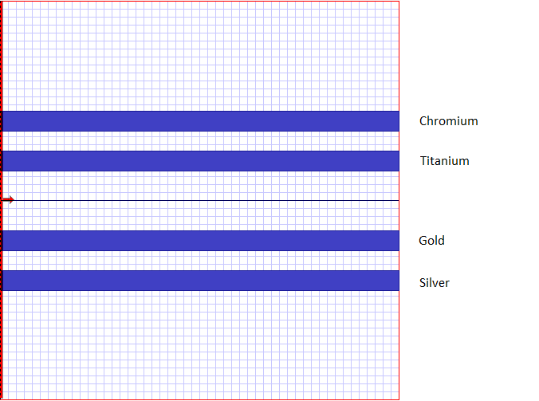

**Figure 1:** Layout of Nanowaveguides

Fig. 2 shows the propagation of electric field components $E_{y}$ in Lorentz-Drude dispersive materials nanowaveguides.

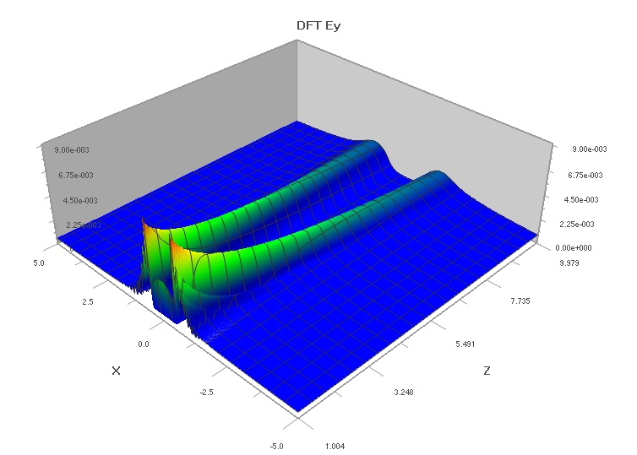

(a)

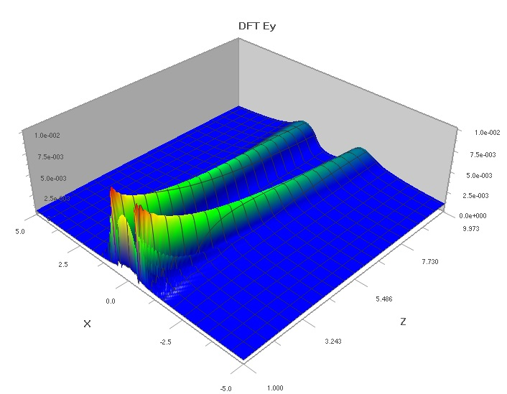

(b)

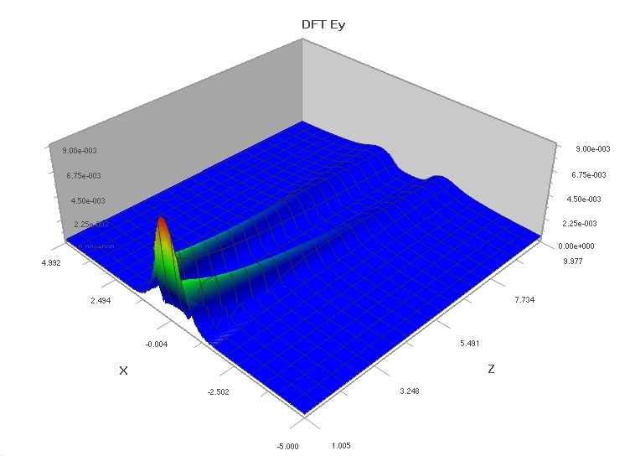

(c)

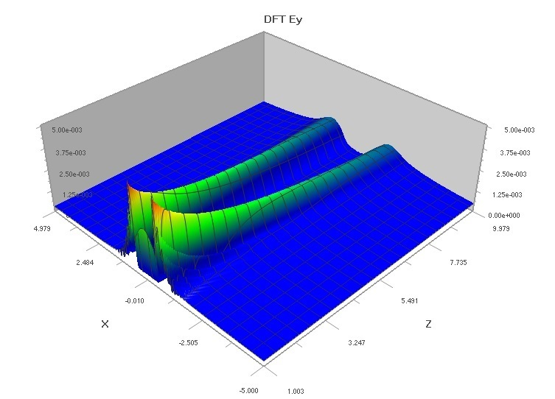

(d)

**Figure 2:** The propagation of $E_{y}$ in (a) Chromium, (b) Titanium, (c) Gold and (d) Silver nanowaveguides.

From Fig. 2 we can see that maximum amplitude of $E_{y}$ occurred in Titanium nanowaveguide and minimum amplitude of $E_{y}$ occurred in Silver nanowaveguide. $E_{y}$ amplitude quickly damped in Gold nanowaveguide as slowly damped in Titanium nanowaveguide.

Fig.3 shows the propagation of magnetic field components $H_{x}$ in Lorentz-Drude dispersive materials nanowaveguides.

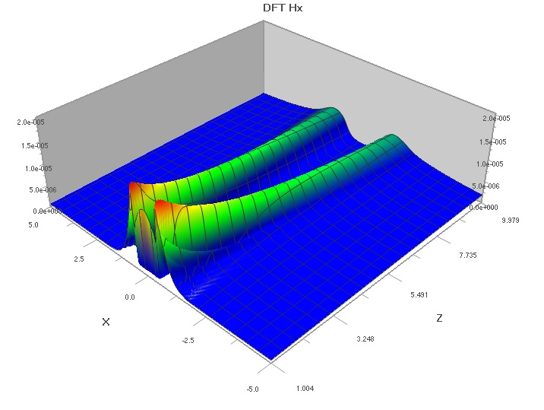

(a)

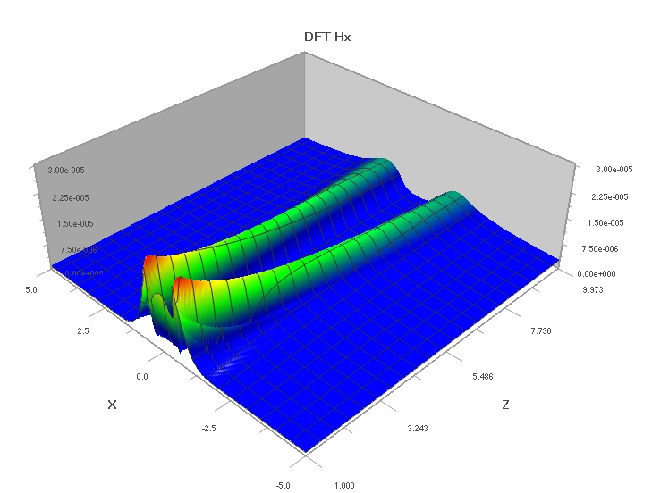

(b)

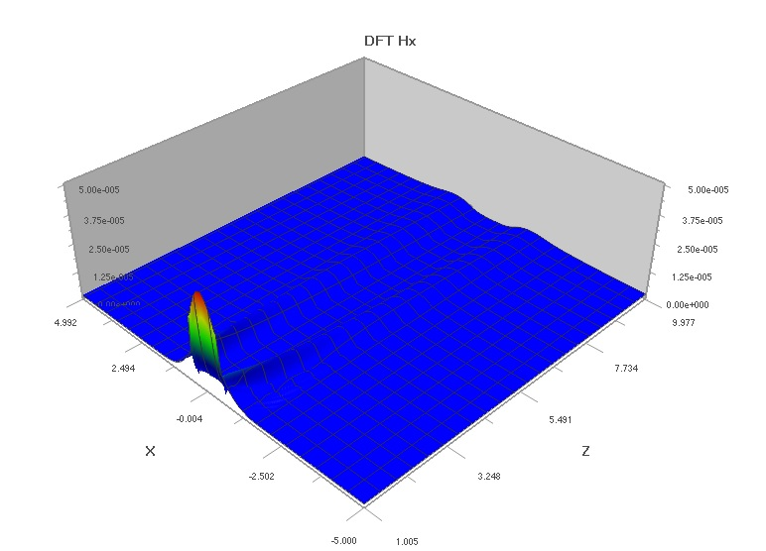

(c)

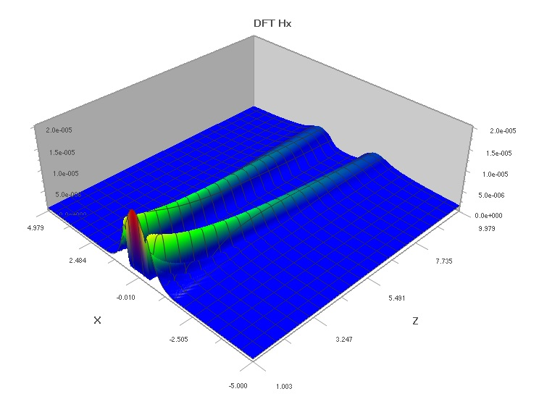

(d)

**Figure 3:** The propagation of $H_{x}$ in (a) Chromium, (b) Titanium, (c) Gold and (d) Silver nanowaveguides.

From Fig. 3 we can see that maximum amplitude of $H_{x}$ occurred in Gold nanowaveguide and minimum amplitude of $H_{x}$ occurred in Silver nanowaveguide. $H_{x}$ amplitude quickly damped in Gold nanowaveguide as slowly damped in Chromium nanowaveguide.

Electric fields dispersions can be seen clearly in Fig. 4 for Chromium, Titanium, Gold and Silver nanowaveguides.

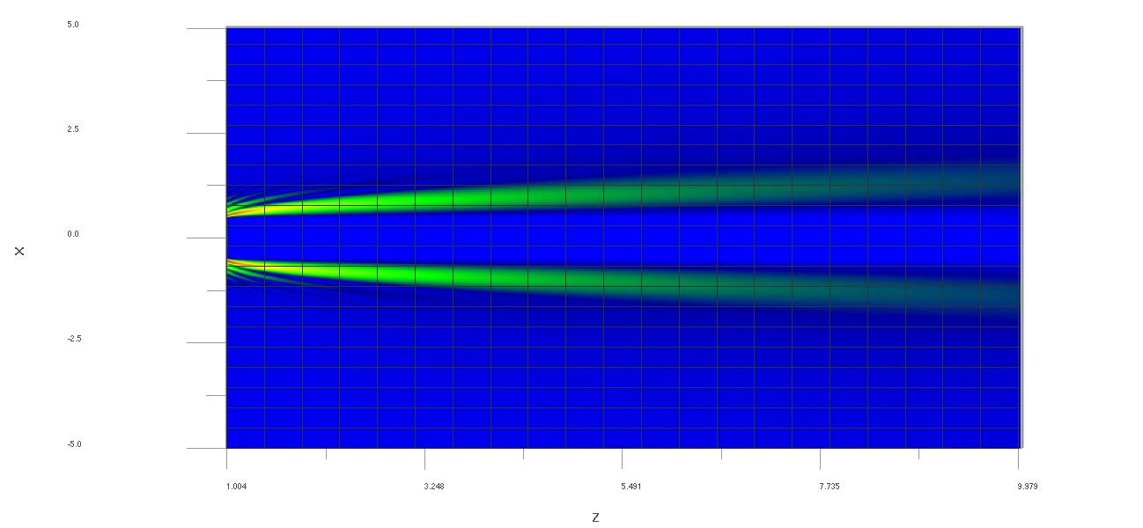

(a)

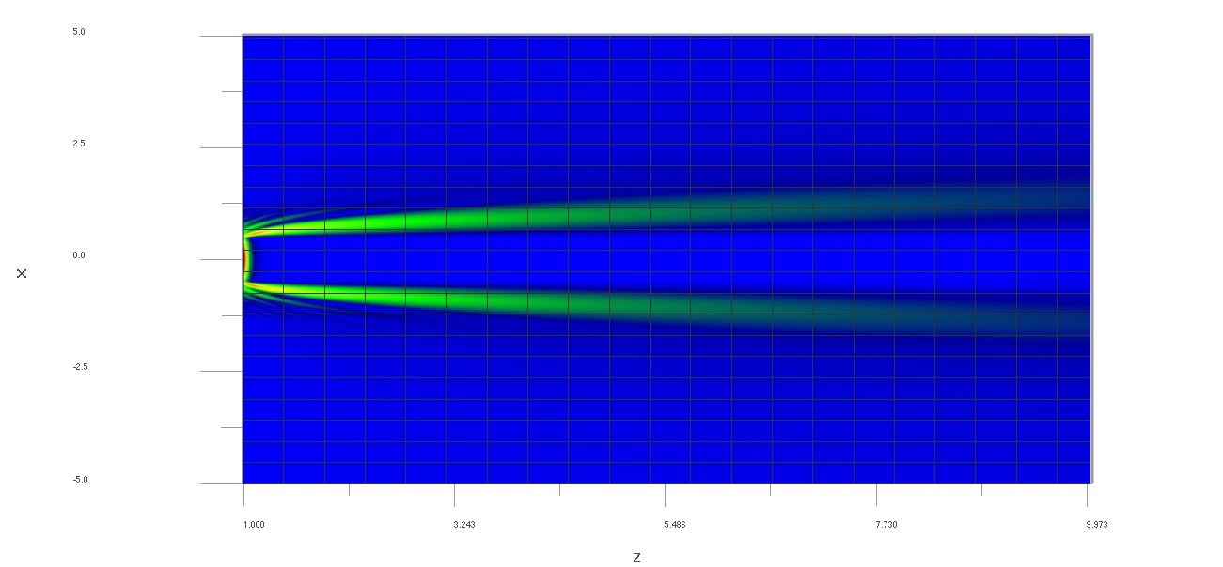

(b)

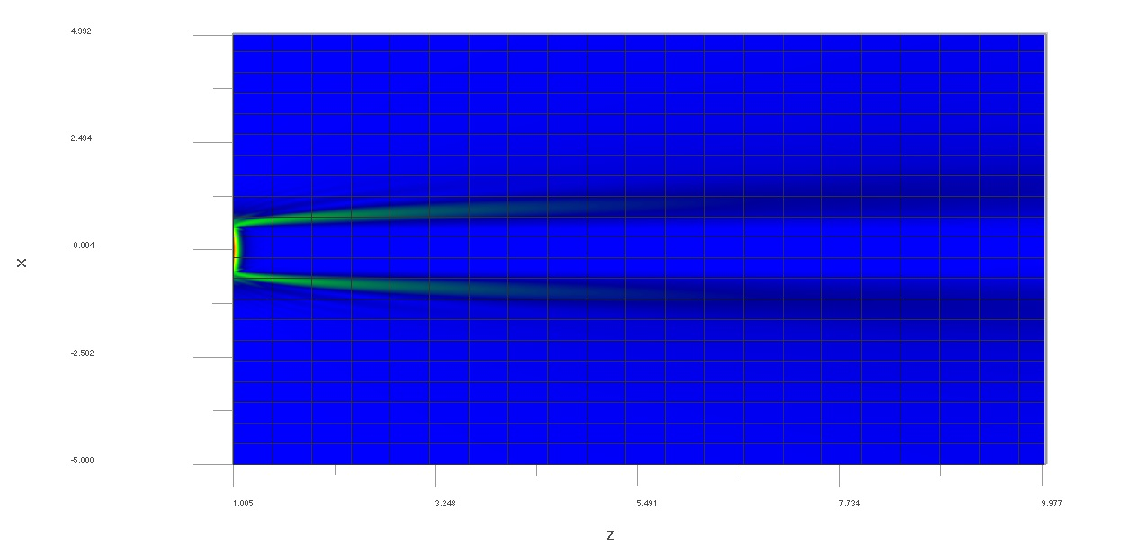

(c)

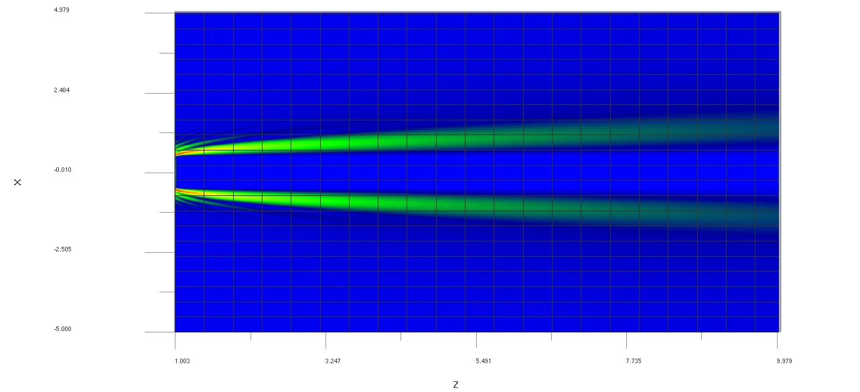

(d)

**Figure 4:** The dispersion of $E_{y}$ in (a) Chromium, (b) Titanium, (c) Gold and (d) Silver nanowaveguides.

Maximum dispersion of $E_{y}$ has seen in Silver nanowaveguide and minimum dispersion of $E_{y}$ has seen in Gold nanowaveguide.

Also, magnetic fields dispersions can be seen clearly in Fig. 5 for Chromium, Titanium, Gold and Silver nanowaveguides.

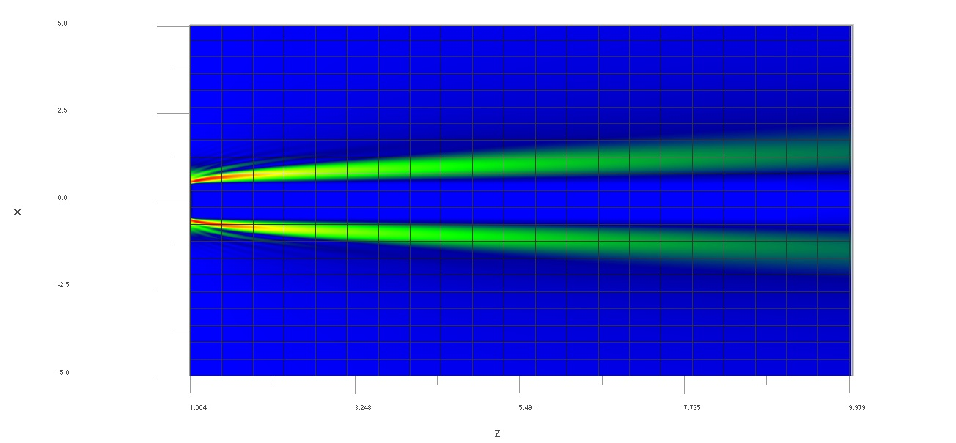

(a)

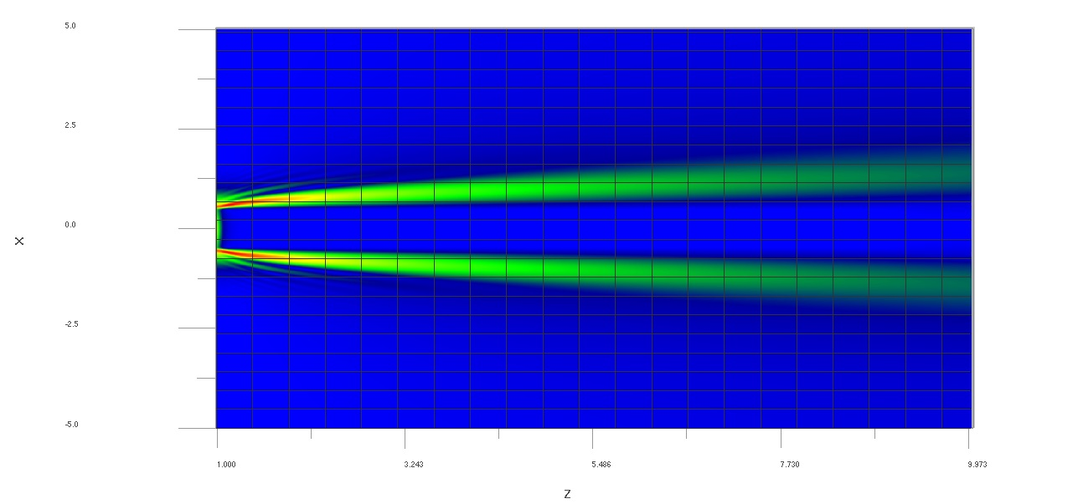

(b)

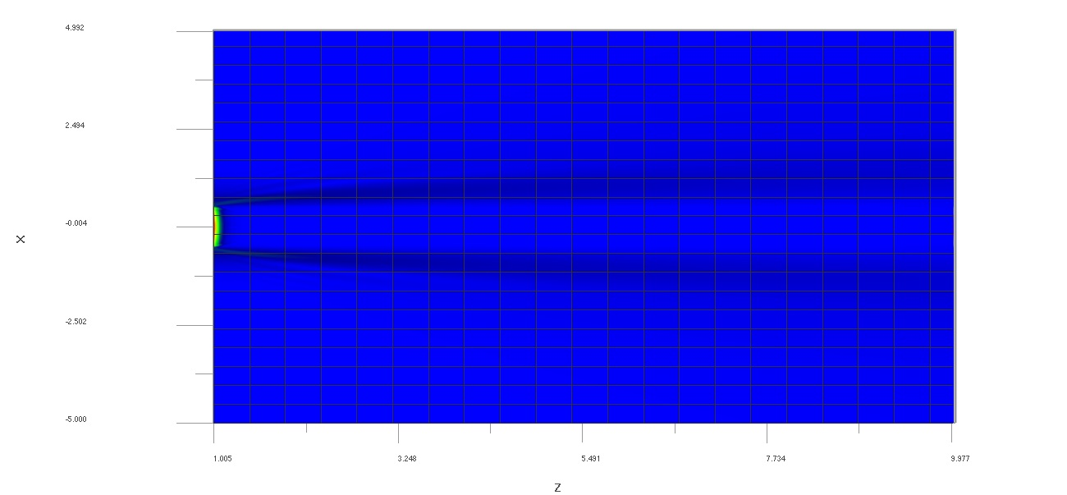

(c)

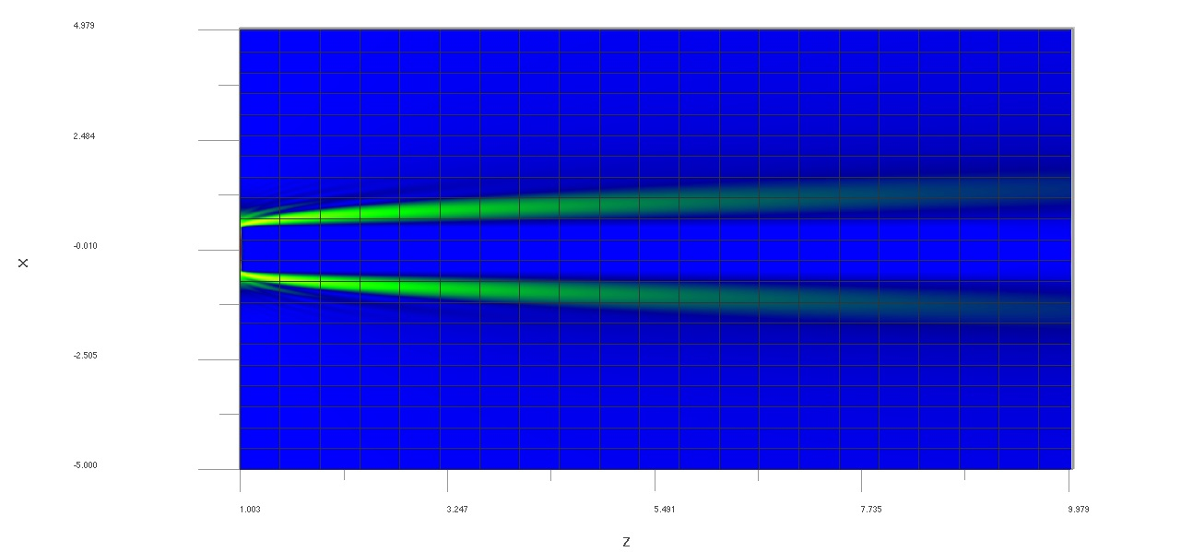

(d)

**Figure 5:** The dispersion of $H_{x}$ in (a) Chromium, (b) Titanium, (c) Gold and (d) Silver nanowaveguides.

Maximum dispersion of $H_{x}$ has seen in Silver nanowaveguide and minimum dispersion of $H_{x}$ has seen in Chromium nanowaveguide.

1. **Conclusion**

We have theoretically studied maximum amplitude, damp and dispersion of $E_{y}$ and $H_{x}$ in Chromium, Titanium, Gold and Silver nanowaveguides. From our simulation results we compared these properties of Lorentz-Drude dispersive materials. We have determined maximum electric and magnetic field amplitudes at different materials. Also, we obtained damping and dispersions in different materials. Our results demonstrate that the maximum amplitude of $E_{y}$ is observed in Titanium nanowaveguide and minimum amplitude of $E_{y}$ is observed in Silver nanowaveguide. $E_{y}$ amplitude quickly damped in Gold nanowaveguide as slowly damped in Titanium nanowaveguide. The maximum amplitude of $H_{x}$ is observed in Gold nanowaveguide and minimum amplitude of $H_{x}$ is observed in Silver nanowaveguide. $H_{x}$ amplitude quickly damped in Gold nanowaveguide as slowly damped in Chromium nanowaveguide. The maximum dispersion of $E_{y}$ has seen in Silver nanowaveguide and minimum dispersion of $E_{y}$ has seen in Gold nanowaveguide. The maximum dispersion of $H_{x}$ has seen in Silver nanowaveguide and minimum dispersion of $H_{x}$ has seen in Chromium nanowaveguide. As a consequence, these results paved the way for us to choose more suitable materials for our purpose in nano optical devices.

**References**

[1]Rivzi S.: Handbook of Photomask Manufacturing Technology. CRC Press, Boca Raton (2005)

[2]Kolwas K., Derkachova A., Shopa M.: Size characteristics of surface plasmons and their manifestation in scattering properties of metal particles. J. Quant. Spectrosc. Radiat. Transfer. 110, 1490–1501 (2009)

[3]Taflove A.:Computational Electrodynamics. Artech House, Vol. 160, London (2000)

[4]Lee, K. H., Ahmed, I., Goh, R. S. M., Khoo, E. H., Li, E. P., and Hung, T. G. G.: Implementation of the FDTD method based on Lorentz-Drude dispersive model on GPU for plasmonics applications. Progress in Electromagnetic Research. 116, 441-456 (2011)

[5]Carcione, José M.: Wave fields in real media: Wave propagation in anisotropic, anelastic, porous and electromagnetic media. Elsevier, Vol. 38, (2007)

[6]Melenk, Jens M., and Ivo Babuška.: The partition of unity finite element method: basic theory and applications. Computer methods in applied mechanics and engineering. 139.1: 289-314 (1996)

[7]He, Ji-Huan.: A coupling method of a homotopy technique and a perturbation technique for non-linear problems. International journal of non-linear mechanics. 35.1: 37-43 (2000)

[8]Saitoh, Kunimasa, and Masanori Koshiba.: Full-vectorial imaginary-distance beam propagation method based on a finite element scheme: application to photonic crystal fibers. IEEE Journal of Quantum Electronics. 38.7: 927-933 (2002)

[9]Garcia, S. Gonzalez, Tae-Woo Lee, and Susan C. Hagness.: On the accuracy of the ADI-FDTD method. IEEE Antennas and Wireless Propagation Letters. 1.1: 31-34 (2002)

[10]Cetin, Ali, Ercan Ucgun, and M. Selami Kilickaya.: Determining the effective refractive Index of AlGaAs-GaAs slab waveguide based on analytical and finite difference method. Journal of Physical Science and Application. 2.9: 381 (2012)

[11]Oskooi, A. F., Roundy, D., Ibanescu, M., Bermel, P., Joannopoulos, J. D., and Johnson, S. G.: MEEP: A flexible free-software package for electromagnetic simulations by the FDTD method. Computer Physics Communications. 181(3), 687-702 (2010)

[12]Namiki, Takefumi.: 3-D ADI-FDTD method-unconditionally stable time-domain algorithm for solving full vector Maxwell's equations. IEEE Transactions on Microwave Theory and Techniques. 48.10: 1743-1748 (2000)

[13]Kinkhabwala, A., Yu, Z., Fan, S., Avlasevich, Y., Müllen, K., & Moerner, W. E.: Large single-molecule fluorescence enhancements produced by a bowtie nanoantenna. Nature Photonics. 3(11), 654-657 (2009)

[14]Li, Jingjing, Alessandro Salandrino, and Nader Engheta.: Shaping light beams in the nanometer scale: A Yagi-Uda nanoantenna in the optical domain. Physical Review B. 76.24: 245403 (2007)

[15]Smit, Meint K.: New focusing and dispersive planar component based on an optical phased array. Electronics letters. 24.7: 385-386 (1988)

[16]Neto, Andrea.: UWB, non dispersive radiation from the plenary fed leaky lens antenna—Part 1: Theory and design. IEEE Transactions on Antennas and Propagation. 58.7: 2238-2247 (2010)

[17]Drever, R. W. P., Hall, J. L., Kowalski, F. V., Hough, J., Ford, G. M., Munley, A. J., and Ward, H.: Laser phase and frequency stabilization using an optical resonator. Applied Physics B. 31(2), 97-105 (1983)

[18]Hakki, B. W., and P. D. Coleman.: A dielectric resonator method of measuring inductive capacities in the millimeter range. IRE Transactions on Microwave Theory and Techniques. 8.4: 402-410 (1960)

[19]Lu, X., Qi, H., Zhang, X., Xue, Z., Jin, J., Zhou, X., and Liu, X.: Highly dispersive Ag nanoparticles on functionalized graphene for an excellent electrochemical sensor of nitroaromatic compounds. Chemical Communications. 47(46), 12494-12496 (2011)

[20]Testa, Italo, Gianpaolo Evangelista, and Sergio Cavaliere.: Physically inspired models for the synthesis of stiff strings with dispersive waveguides. EURASIP Journal on Advances in Signal Processing. 2004.7: 1-14 (2004)

[21]Bernekorn, Peter, Anders Karlsson, and Gerhard Kristensson.: Propagation of transient electromagnetic waves in inhomogeneous and dispersive waveguides. Journal of electromagnetic waves and applications. 10.9: 1263-1286 (1996)

[22]Bartoli, I., Marzani, A., di Scalea, F. L., and Viola, E.: Modeling wave propagation in damped waveguides of arbitrary cross-section. Journal of Sound and Vibration. 295(3), 685-707 (2006)

[23]htpp://www.optiwave.com (2016)

[24]Kelly, K. L., Coronado, E., Zhao, L. L., & Schatz, G. C.: The optical properties of metal nanoparticles: the influence of size, shape, and dielectric environment. Journal of Physical Chemistry B-Condensed Phase. 107(3), 668-677 (2003)

[25]Bade, W. L.: Drude‐Model Calculation of Dispersion Forces. I. General Theory. The Journal of Chemical Physics. 27.6: 1280-1284 (1957)

[26]Van Beijeren, Henk.: Transport properties of stochastic Lorentz models. Reviews of Modern Physics. 54.1: 195 (1982)

1. \**nurettinbilgili@gmail.com* [↑](#footnote-ref-1)