**Dynamic resynchronization units in Microgrids transitions**

***Nour Aboubakr Hasan Fadheel 1,[[1]](#footnote-1)\*[C:\Users\Abdullah\AppData\Local\Microsoft\Windows\INetCache\Content.Word\ORCID-iD_icon-16x16.gif](https://orcid.org/0009-0001-6771-9306), Fatih KORKMEZ 2[C:\Users\Abdullah\AppData\Local\Microsoft\Windows\INetCache\Content.Word\ORCID-iD_icon-16x16.gif](https://orcid.org/0000-0001-8524-2831)***

*1 Graduate Education Institute, Engineering Faculty, Electrical and Electronic Department, Çankırı Karatekin University, Çankırı, Türkyie*

*2* *Graduate Education Institute, Engineering Faculty, Electrical and Electronic Department, Çankırı Karatekin University, Çankırı, Türkyie*

|  |
| --- |
| **Abstract**  Microgrids, as decentralized energy systems, play a pivotal role in the modern energy landscape, offering flexibility, resilience, and sustainability. At the heart of this system lies the resynchronization unit, a critical component ensuring the seamless transition of microgrids between grid-connected and islanded operational modes. This paper offers a comprehensive examination of the intricacies and nuances of the resynchronization unit within microgrids. The transition between grid-connected and islanded modes is not just a switch but a complex process that requires precision and reliability. The seamless nature of this transition is vital to prevent disruptions, power quality issues, and potential equipment damage. It is here that the resynchronization unit proves its mettle, ensuring that the transition occurs without hitches. Factors such as synchronization speed, voltage and frequency matching, and phase alignment are of paramount importance. However, designing such a unit is not without its challenges. Issues related to transient stability, harmonics introduction, and potential feedback loops can complicate the resynchronization process. To address these challenges, this paper presents several proposed solutions aimed at enhancing the reliability and efficiency of island microgrids during resynchronization. These include advanced control algorithms, integration of fast-response energy storage systems, and utilization of state-of-the-art power electronics. |
| Keywords: Microgrids, Resynchronization Unit, Grid-connected, Islanded Modes |

1. **Introduction**

Microgrids are a new approach to localized energy generation, distribution, and consumption, particularly in remote or isolated regions (López-García et al., 2018). These standalone electricity systems operate independently from the main grid, reducing dependency on fossil fuels and ensuring resilience against grid disturbances. They integrate diverse energy sources, such as solar, wind, and hydro, reducing dependency on fossil fuels and promoting a sustainable, eco-friendly energy mix. Advanced control mechanisms and state-of-the-art technologies optimize energy production, storage, and consumption, catering to varying demand profiles and resource availability (Mahmood et al., 2021). The decentralized nature of island microgrids minimizes energy losses, enhances resilience against external shocks, and can be more cost-effective in regions where extending the main grid is impractical. Given the growing global focus on sustainability, energy security, and electrifying remote areas, island microgrids are a crucial solution in the modern energy landscape. Island microgrids require a seamless transition between operational modes, from grid-connected to islanded mode, to maintain system stability, prevent equipment damage, and ensure uninterrupted power supply to consumers (D’silva et al., 2020). Resynchronization is a crucial process that facilitates these transitions smoothly and efficiently. System stability and reliability are essential for resynchronization, as it ensures that the generated electricity matches the voltage, phase, and amplitude of the connected system or grid. Without proper resynchronization, significant mismatches can lead to system instability, such as voltage sags, frequency deviations, and complete system blackouts (Shi et al., 2014). Unsynchronized transitions can also pose safety risks to electrical equipment, reducing their lifespan and potentially leading to catastrophic failures. Consumer experience and trust are crucial for a reliable electricity provider, and sudden power outages or fluctuations can disrupt daily activities, lead to financial losses, and erode trust in the utility provider (Aleem et al., 2019). Efficient resynchronization can prevent unforeseen expenses, contributing to the economic viability of the microgrid. Island microgrids often incorporate renewable energy sources like solar and wind, which can introduce fluctuations in the grid's voltage and frequency. Effective resynchronization is even more crucial in such scenarios to ensure the stability of the microgrid (Zacharia et al., 2018). This paper analyzes the resynchronization unit in microgrids, highlighting its importance in maintaining system stability during operational mode transitions. It examines current challenges and evaluates emerging solutions, contributing to the ongoing discourse on improving the reliability and efficiency of microgrids.

1. **Design of Microgrid**

In this study, Simulink model for analyzing the performance of a photovoltaic (PV) system and a battery energy storage system (BESS) in a hybrid microgrid. The system comprises a 1-megawatt solar energy generation system that links to the grid. Additionally, there is a 1-megawatt battery energy storage system (BESS). The Point of Common Coupling (PCC) serves as the juncture where the microgrid integrates with the primary utility grid, facilitating the amalgamation of distributed energy resources. This utility grid stands as the central electrical network to which the microgrid connects, supplying power as required and assimilating surplus power generated by the microgrid. Within the microgrid, the loads represent the electricity consumers. They source power from the solar system, the BESS, or the utility grid, contingent on power availability and consumption demand. Figure 1 shows the simple design of microgrid.

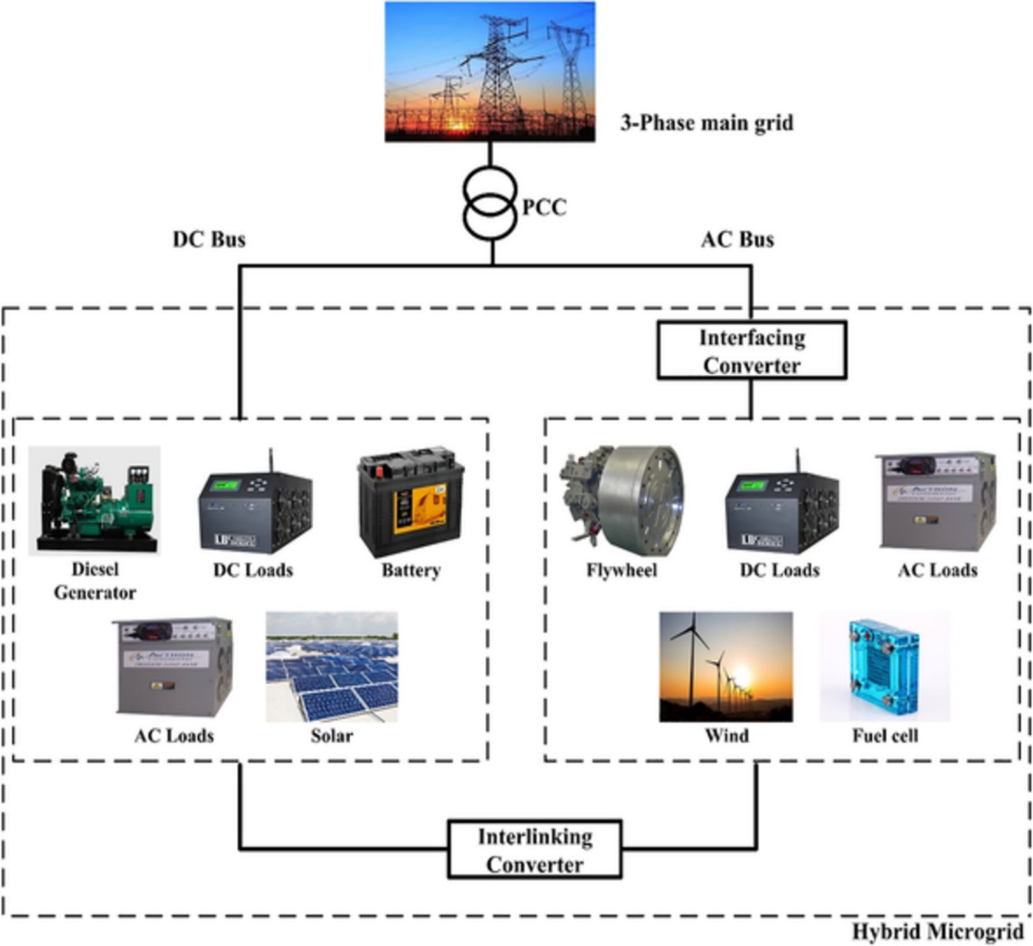

Figure 1. Design of Microgrid (Sarangi et al., 2020)

1. **Principle of a Resynchronization Unit**

A resynchronization unit is a specialized system designed to ensure that the electrical parameters of a localized energy system match those of a larger interconnected grid or another microgrid (Kroposki et al., 2008). This matching involves aligning parameters such as frequency, voltage magnitude, and phase angle to ensure a seamless and safe connection or transition between different operational modes. The fundamental operation of a resynchronization unit revolves around monitoring, comparing, and adjusting electrical parameters (Nishikawa & Motter, 2015). The unit continuously monitors the electrical parameters of both the microgrid and the main grid, tracking their frequency, voltage magnitude, and phase angle. If discrepancies are identified, the unit initiates corrective actions, such as frequency adjustment, voltage magnitude correction, and phase angle alignment. Once the electrical parameters are closely aligned, the microgrid can safely connect to the main grid or transition to another operational mode. Modern resynchronization units often incorporate feedback mechanisms to continuously adjust and optimize the synchronization process, ensuring real-time response to maintain synchronization even in dynamic grid conditions (Cho et al., 2011). Safety protocols are equipped with resynchronization units to prevent potential damages or instabilities. If the unit detects that synchronization is not achievable within a specified timeframe or if discrepancies exceed safe limits, it will inhibit the connection to protect both the microgrid and the main grid. In essence, the resynchronization unit acts as a guardian, ensuring that the microgrid's electrical parameters are in harmony with those of the connecting system before any connection or transition occurs (Taul et al., 2019).

This unit brings the microgrid voltage in phase with the distribution system voltage before reclosing the grid breaker, ensuring a seamless reconnection without the risk of an out-of-phase reclosing. The resynchronization unit is crucial for ensuring a safe and reliable reconnection to the distribution system, ensuring all connected systems are in phase and operating correctly. It controls the frequency and voltages of the BESS, synchronizing it with the grid and providing the necessary power and voltage. It also regulates the current and voltage to prevent overloading. The synchronization process is an important step when connecting a microgrid to the main grid. During this process, PI regulators are used to slowly make the microgrid voltage and frequency equal to the main grid. This process is typically done over a period of 3 seconds, during which the PI regulators will adjust the microgrid voltage and frequency to match the main grid. The synchronization process helps ensure that the microgrid stays connected to the main grid and that power is being transferred properly. Once the synchronization process is complete, the microgrid is connected to the main grid and power can be exchanged. This process ensures that the microgrid is operating safely and efficiently, and that the main grid is not affected by the microgrid. In the BESS's Grid-forming mode, the voltage and frequency of a microgrid can be managed. Due to the mode's droop P/F setting of 0.5%, the microgrid frequency can vary between 60.3 and 59.7 hertz. With the droop Q/V setting at 3%, the microgrid voltage at the PCC bus can fluctuate between 609 Vrms and 582 Vrms. Given these parameters, the BESS can act as a reliable energy storage and power management system for the microgrid.

1. **Results and Discussion**

The synchronization unit closely monitors the microgrid's vital signs, continuously tracking its frequency and voltage. This real-time data is then compared with its counterparts on the master data grid. Regular monitoring is crucial when the microgrid is intentionally disconnected or when it operates in grid-forming mode. In such cases, the synchronization unit proactively adjusts the microgrid's frequency and voltage to align them with the main grid's parameters. Once the microgrid is reconnected to the grid, precise calibration is essential. The MEMS facilitates a smooth transition back to grid-following mode by ensuring a tight alignment between the microgrid's characteristics and those of the main grid. This not only ensures a consistent electricity supply but also safeguards the system against voltage and frequency variations. Figure **2** shows the performance of synchronization control unit.

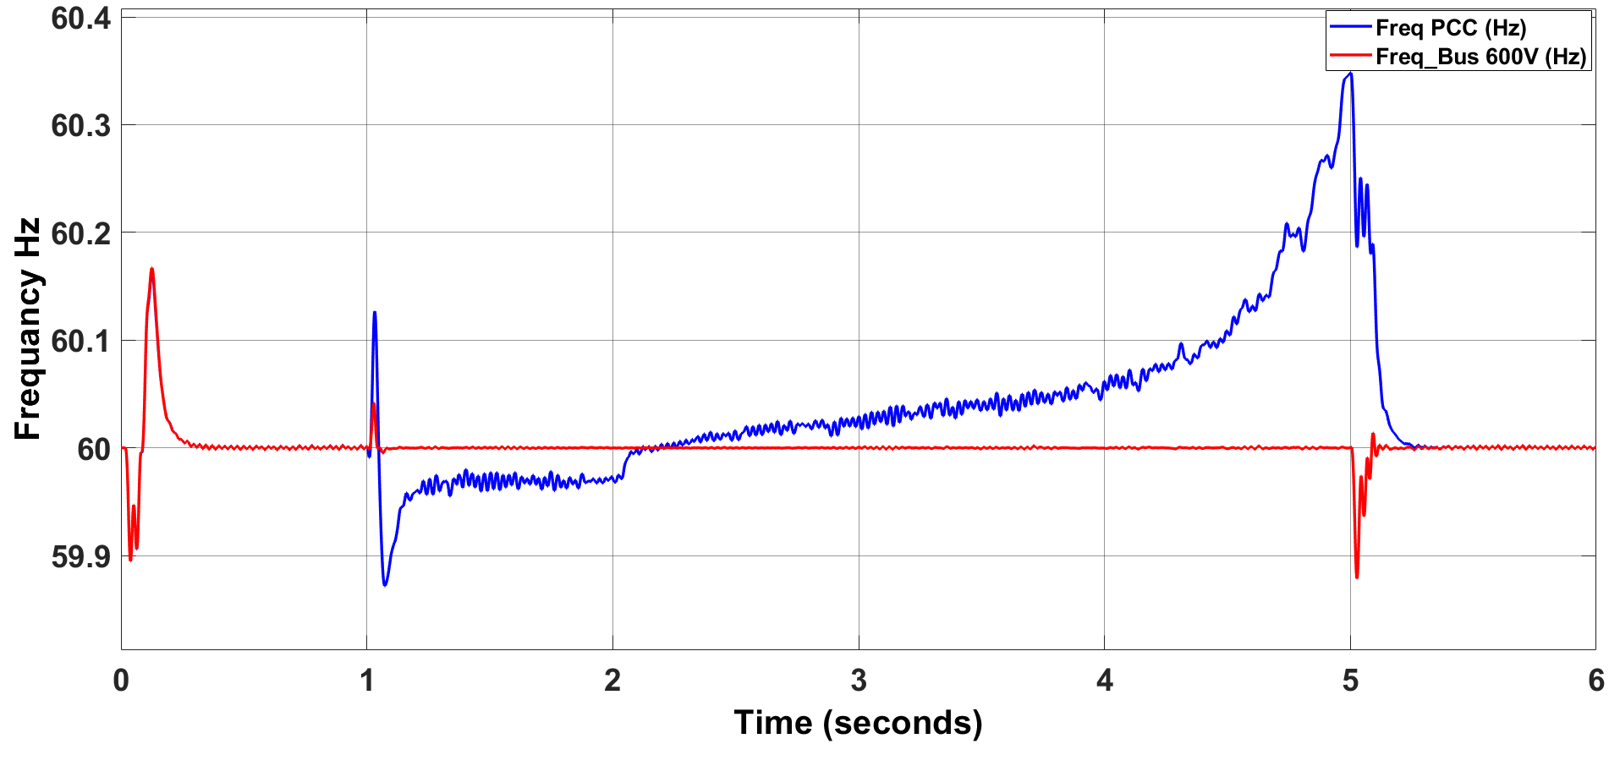

**Microgrid Islanded**

**Resynchronize to grid**

**Microgrid reconnected to grid**

**Frequency**

**60.15 Hz < 60 Hz < 59.9 Hz**

**Microgrid**

**Grid**

Figure 2. Frequency variations of PCC and 600V Bus

The scenario described is a critical moment in the operation of a microgrid, showcasing its dynamic response to a sudden change in its operational status and subsequent recovery.

*• Initial Islanding (0-1 second):*

At the outset, the microgrid is suddenly islanded. This means it's disconnected from the main grid, which could be due to various reasons such as a fault in the main grid, maintenance activities, or a deliberate transition to off-grid mode. Upon islanding, the immediate effect observed is a change in frequency. The microgrid's frequency rises to 60.15 Hz, slightly above the standard nominal value of 60 Hz. This frequency deviation could be attributed to an imbalance between load and generation within the microgrid. When disconnected, the excess power generated, which was initially accommodated by the main grid, causes the frequency to rise.

*• Response and Resynchronization Preparation (1-2 seconds):*

In this brief but crucial window, control systems within the microgrid respond to the frequency deviation. Advanced control strategies, possibly based on fast-acting power electronics and sophisticated software, are employed. These systems might adjust the output of generators, manage demand through load shedding or shifting, or leverage energy storage systems to absorb excess power. Concurrently, preparations to resynchronize with the main grid are initiated. This involves communicating with the main grid's operators, ensuring safety protocols are in place, and adjusting the microgrid's parameters to match those of the main grid (like frequency, voltage, and phase angle).

*• Stabilization and Resynchronization (2-5 seconds):*

Over these critical seconds, the control measures take effect, and the microgrid's frequency begins to stabilize. Sophisticated algorithms and high-speed communication systems play a crucial role in this rapid stabilization. By the 5-second mark, the frequency has been corrected back to the reference value of 60 Hz. This swift return to normal operating conditions highlights the resilience and advanced design of the microgrid, ensuring reliability and continuous power supply to the connected loads.

*• Post-Stabilization (5 seconds onwards):*

After frequency stabilization, the microgrid continues to operate in a stable state, with its operational parameters aligned with those of the main grid. The seamless transition back to the reference frequency, without any observable issues between the main grid and the microgrid, underscores the effectiveness of the microgrid's control systems and its capability to operate in both grid-connected and islanded modes. This flexibility is vital for modern power systems, contributing to enhanced energy security, better integration of renewable resources, and improved resilience against disturbances. In Figure 3 appears to represent the behavior of the phase angle during a microgrid transitioning through three distinct stages: islanding from the main grid, resynchronization preparations, and finally, reconnection to the main grid. The phase angle is a crucial parameter when considering the synchronization of two power systems, as it reflects the difference in the position of the voltage waveforms in the power system.

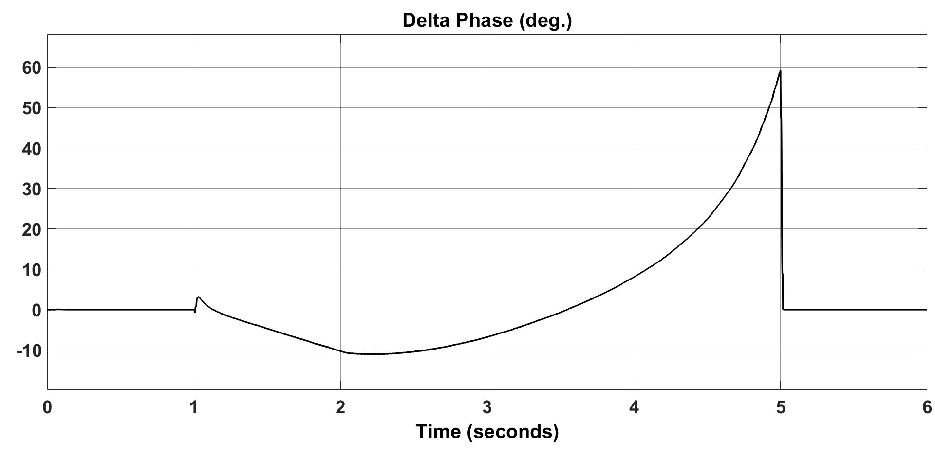

**Microgrid Islanded**

**Resynchronize to grid**

**Microgrid reconnected to grid**

Figure 3. Phase difference between Microgrid and grid

1. **Conclusion**

This study underscores the significant advancements in microgrid technology facilitated by the integration of Resynchronization Unit Control. The observed enhancements in dependability during the pivotal transitions between grid-connected and islanded operations herald a new era in energy system operations. The seamless execution of resynchronization processes, evidenced by minimal disturbances and the assurance of uninterrupted energy provision, speaks volumes about the strides taken in this domain. The journey from an unexpected islanding event to a well-coordinated reconnection to the main grid illustrates the intricate ballet of real-time controls and automation that underpin modern microgrids. The ability to not only monitor and adjust but masterfully control the phase angle during these transitions is emblematic of the technological sophistication inherent in today's energy systems. This capability ensures fluidity between operational modes, safeguarding both the stability of the microgrid and the continuity of the power supply.

**References**

1. Aleem, S. K. A., Aftab, M. A., Hussain, S. M. S., Ali, I., Ganesh, V., & Ustun, T. S. (2019). Real-Time Microgrid Synchronization using Phasor Measurement Units. 2019 IEEE International Conference on

Intelligent Systems and Green Technology (ICISGT). https://doi.org/10.1109/icisgt44072.2019.00019

1. Cho, C.-H., Jeon, J.-H., Kim, J.-Y., Kwon, S., Park, K.-Y., & Kim, S. (2011). Active Synchronizing Control of a Microgrid. IEEE Transactions on Power Electronics, 26(12), 3707–3719. https://doi.org/10.1109/tpel.2011.2162532
2. D’silva, S., Shadmand, M., Bayhan, S., & Abu-Rub, H. (2020). Towards grid of microgrids: Seamless transition between grid-connected and islanded modes of operation. IEEE Open Journal of the Industrial Electronics Society, 1, 66–81. https://doi.org/10.1109/ojies.2020.2988618
3. Kroposki, B., Basso, T., & DeBlasio, R. (2008, July 1). Microgrid standards and technologies. IEEE Xplore. https://doi.org/10.1109/PES.2008.4596703
4. López-García, D., Arango-Manrique, A., & Carvajal-Quintero, S. X. (2018). Integration of distributed energy resources in isolated microgrids: The colombian paradigm. TecnoLógicas, 21(42), 13–30. https://doi.org/10.22430/22565337.774
5. Mahmood, D., Javaid, N., Ahmed, G., Khan, S., & Monteiro, V. (2021). A review on optimization strategies integrating renewable energy sources focusing uncertainty factor – Paving path to eco-friendly smart cities. Sustainable Computing: Informatics and Systems, 30, 100559. https://doi.org/10.1016/j.suscom.2021.100559
6. Nishikawa, T., & Motter, A. E. (2015). Comparative analysis of existing models for power-grid synchronization. 17(1), 015012–015012. https://doi.org/10.1088/1367-2630/17/1/015012
7. Sarangi, S., Sahu, B. K., & Rout, P. K. (2020). Distributed generation hybrid AC/DC microgrid protection: A critical review on issues, strategies, and future directions. International Journal of Energy Research, 44(5), 3347–3364. https://doi.org/10.1002/er.5128
8. Shi, D., Luo, Y., & Sharma, R. K. (2014, October 1). Active synchronization control for microgrid reconnection after islanding. IEEE Xplore. https://doi.org/10.1109/ISGTEurope.2014.7028802
9. Taul, M. G., Wang, X., Davari, P., & Blaabjerg, F. (2019). An overview of assessment methods for synchronization stability of grid-connected converters under severe symmetrical grid faults. IEEE Transactions on Power Electronics, 34(10), 9655–9670. https://doi.org/10.1109/tpel.2019.2892142
10. Zacharia, L., Avgoustina Kyriakou, Lenos Hadjidemetriou, Kyriakides, E., Panayiotou, C., Martensen, N., & van. (2018). Islanding and Resynchronization Procedure of a University Campus Microgrid. 2018 International Conference on Smart Energy Systems and Technologies (SEST). https://doi.org/10.1109/sest.2018.8495828

1. \* Nour Fadheel. *nour.fadheel@gmail.com* [↑](#footnote-ref-1)