**Inhibitory potential of endemic *Centaurea paphlagonica* and *Centaurea cankiriense* plant extracts obtained by using different branches against alpha glucosidase enzyme**

***Zeyad Adil HAMEED*\**1[C:\Users\Abdullah\AppData\Local\Microsoft\Windows\INetCache\Content.Word\ORCID-iD_icon-16x16.gif](https://orcid.org/0000-xxxx-xxxx-xxxx)****,* ***Ali Rıza TÜFEKÇİ2[C:\Users\Abdullah\AppData\Local\Microsoft\Windows\INetCache\Content.Word\ORCID-iD_icon-16x16.gif](https://orcid.org/0000-xxxx-xxxx-xxxx), Şevki ADEM3[C:\Users\Abdullah\AppData\Local\Microsoft\Windows\INetCache\Content.Word\ORCID-iD_icon-16x16.gif](https://orcid.org/0000-xxxx-xxxx-xxxx)***

**1*Faculty of Science, Department of Chemistry, Cankiri Karatekin University, Cankiri, Turkey***

**2*Faculty of Science, Department of Chemistry, Cankiri Karatekin University, Cankiri, Turkey***

**3*Faculty of Science, Department of Chemistry, Cankiri Karatekin University, Cankiri, Turkey***

|  |
| --- |
| **Abstract**  Synthetic drugs are viewed with a negative eye, in the scientific field and in the community, because of their excessive side effects or for some reasons, such as drug resistance. Some diseases caused by synthetic drugs arise as a result of drug resistance, unconscious consumption, or a change in the genetic form of the disease. To solve this problem, especially in the process that has been going on since the 21 st century, herbal-based natural compounds can help to mitigate the effects as a drug potential. Nowadays, type 2 diabetes can be prevented by the presence of natural inhibitors of α-glucosidase and α-amylase enzymes. This makes it possible to treat diabetes [1, 2]. In this study, the potential for aglycosidase enzyme inhibition of methanol/chloroform extracts obtained from different branches of *C. cankiriense* and *C. paphlagonica* plant was studied. The highest activity of the *C. cankiriense* plant was found to be IC50 of 474.76 μg/ml with the extrain of the flower part. On the other hand, the activity of the *C. paphlagonica* plant, with an IC50 range of 181.93-787.67 μg/ml, was shown to vary depending on the extraction method and to have the highest activity. The results are remarkably positive for the availability of flower extract from the *C. paphlagonica* plant as α-glucosidase enzyme inhibitor. |
| ***Keywords:*** *Centaurea paphlagonica, Centaurea cankiriense*, Alpha-glucosidase, Enzyme activity |

1. **Introduction**

Diabetes, also known as diabetes mellitus, is a disease commonly known as diabetes. This disease occurs when the pancreas in the body fails to produce enough insulin or when the insulin produced is not used effectively by the body. When this happens, blood sugar levels rise and can lead to many health problems. It is a chronic metabolic disorder characterized by hyperglycemia and disorders of carbohydrate, protein and fat metabolism. This leads to failure of insulin production or failure of insulin action, or both. According to data from the International Diabetes Federation (IDF) in 2019, approximately 463 million adults worldwide have diabetes. They explained in their report that this number is expected to be 700 million by 2045. The reasons for the increase in the number of diabetic patients in the world are the aging population, increasing urbanization, changes in lifestyle and, most importantly, wrong eating habits. In the ranking of the countries with the highest incidence of diabetes worldwide, countries in Central Asia-India-Africa as well as European countries contribute to this rate at a very high rate [3, 4]. Turkey is the third country in Europe in terms of diabetes and its prevalence. As of 2045, Turkey will be among the top 10 countries with the highest population with diabetes in the world. Diabetes is divided into four groups: type 1, type 2, gestational diabetes and diabetes due to other causes. More than 90% of people with diabetes have type 2 diabetes, while the remaining 10% have type 1 diabetes.

Type 1 diabetes develops as a result of insulin-secreting cells in the pancreas not functioning. It is thought that genetic predisposition and environmental factors play a role in type 1 diabetes, although it is not clearly stated. It usually starts in childhood and adolescence. Rarely, it can also be seen that it starts in adulthood. Since type 1 diabetes is insulin deficiency, treatment is necessarily done with insulin.Type 2 diabetes diseases generally occur more frequently in middle age and later with aging. Recently, type 2 diabetes is common even in childhood due to changes in lifestyle and daily activities and the increasing prevalence of obesity. Type 2 diabetes (T2D) is a disease caused by an imbalance between the absorption of blood sugar and insulin secretion. Regulating blood glucose levels is vital to delay or prevent T2D. The ability of a drug or diet to delay glucose production or absorption is one of the therapeutic approaches to reduce hyperglycemia by inhibiting carbohydrate hydrolysis enzymes such as α-amylase and α-glucosidase. Currently, the use of carbohydrate digesting enzyme inhibitors plays an important role in controlling hyperglycemia by reducing intestinal absorption of glucose. Acarbose is one of the leading inhibitors of carbohydrate metabolism enzymes in the gastrointestinal tract [5]. The World Health Organization (WHO) has stated that nearly four-thirds of people in secondary countries such as Africa, Asia and Latin America with type 2 diabetes rely on traditional plant-based products [6]. Therefore, starting from this region in particular, studies on the discovery of new and effective plant-derived compounds, including commercialization status, have increased significantly all over the world. Traditionally, herbal medicines have been widely used globally for the treatment of diabetes for thousands of years, as they are favored for their traditional acceptability and fewer side effects. Therefore, screening for α-amylase and α-glucosidase inhibitors in herbal medicines has attracted great interest.

1. **Materials and Methods**

**2.1. Plant materials**

*Centaurea paphlago*nica and *Centaurea cankiriense* plants, which occur side by side in the same region, were collected from the Kalfat region in the Orta district of Çankırı province in July-August 2017*.* The species identifications were made by Dr. Selçuk Tuğrul Koruklu, a faculty member of Ankara University, Faculty of Science, Department of Biology, and the plant specimens are preserved in the herbarium of Ankara University.

**2.2. Preparation of extracts**

Plant species collected during the flowering period were divided into root, stem-leaf and flower parts. The separated parts were dried within themselves. After drying, a certain amount of the plant branches were taken and extracts were obtained by two different extraction methods. According to the 1st extraction method, hexane solvent was added to the plants and extracted 3 times with 2 days intervals by mesaration technique [7]. The extracts were filtered through filter paper. The extracts obtained were combined and the solvent was removed in a rotary evaporator. Then the remaining pulp was extracted with methanol/chloroform (1:1) solvent. These procedures were performed in 3 replicates [8, 9]. Similar extracts were again combined and the solvents were removed and the extracts were obtained as a result (**Fig. 1**).

According to the 2nd extraction method, sufficient amounts (plants coded AT-4 and AT-5) were boiled with water and the aqueous part was separated from the pulp. Extracts were obtained by first liquid extraction with ethyl acetate (EA) and n-butanol (nBu) respectively (**Fig. 2**). The solvents of the extracts were removed in a rotary evaporator and stored at +4 °C until activity studies [10].

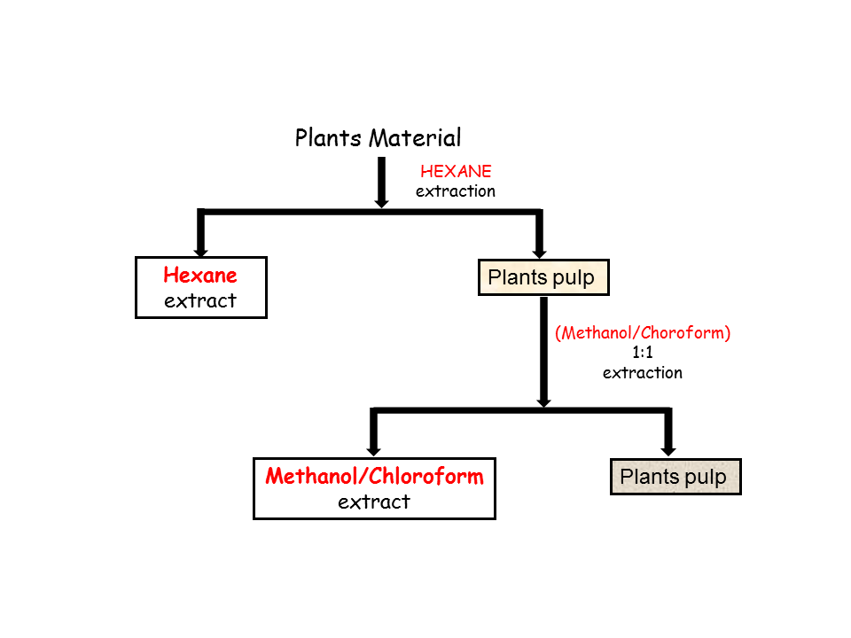

**Fig. 1** Methods-1 of obtaining extracts from plants

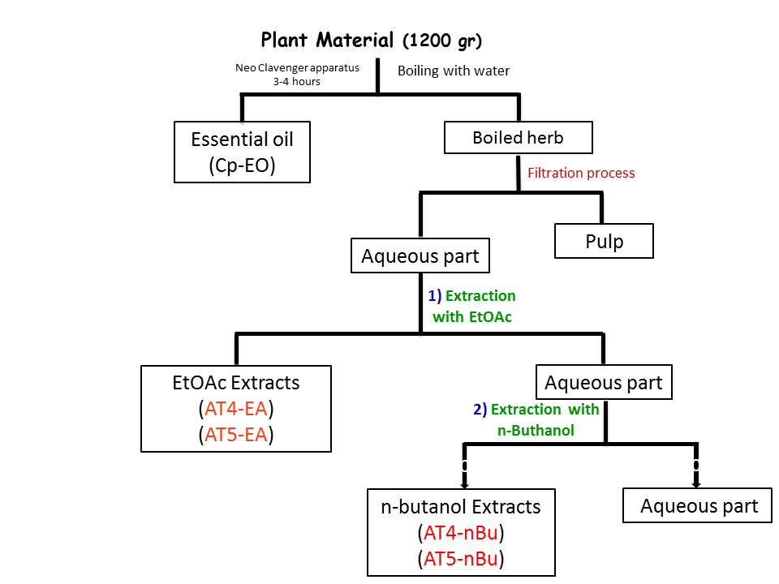

**Fig. 2** Methods-2 of obtaining extracts from plants

**2.3. Alpha glucosidase (α-glucosidase) enzymes activities**

In vitro activity assays were prepared as stock solutions by dissolving the extracts 1:1 with DMSO. The in vitro inhibitory activity of the extracts against α-glucosidase enzyme was re-optimized by making some modifications in the method used by Uysal et al. According to the method, *in vitro* α-glucosidase inhibitory activity of the extracts was determined using para-nitrophenyl-α-D-glucopyranoside (pNPG) as substrate[11]. The extract (50 μl) was mixed with 50 μl glutathione, 50 μl α-glucosidase solution prepared in buffer (sodium phosphate, pH 6.8) and 50 μl pNPG. The mixture was incubated at 37°C for 15 min and the reaction was stopped by adding 50 μl sodium carbonate. Absorbance for α-glucosidase activity was measured at 400 nm.

**3. Results and Discussion**

*C. paphlagonica* and *C. cankiriense* plants were extracted by two different extraction methods using different tissues. Accordingly, the first one involved the mesheration technique with methanol/chloroform (1:1) solvent and the second one involved the extraction of the aqueous fraction after boiling with water using ethyl acetate and n-butanol solvents. The inhibitory activity of the extracts obtained by the two techniques against α-glucosidase enzyme was determined (Table 1).

**Table 1**. IC50 values of *C. cankiriense* and *C. paphlagonica* extracts α-glucosidase on enzyme

|  |  |
| --- | --- |
| Extracts Code | α-glucosidase  IC50 (µg/ml) |
| AT-1 (*Centaurea cankiriense*-Flower) | 474.76 |
| AT-2 (*Centaurea cankiriense*-Steam/Leaf) | 717.74 |
| AT-3 (*Centaurea cankiriense*-Root) | 902.59 |
| AT-4 (*Centaurea paphlagonica*-Flower) | 693.15 |
| AT-4 EA (*Centaurea paphlagonica*-Flower-Boiling then with EtOAc extraction) | 309.44 |
| AT-4 n-Bu (*Centaurea paphlagonica*-Flower-Boiling then with n-Butanol extraction) | 181.93 |
| AT-5 (*Centaurea paphlagonica-*Steam/Leaf) | 202.15 |
| AT-5 EA (*Centaurea paphlagonica*-Steam/Leaf-Boiling then with EtOAc extraction) | 88.64 |
| AT-5 n-Bu (*Centaurea paphlagonica*-Steam/Leaf-Boiling then with n-Butanol extraction) | 195.01 |
| AT-6 (*Centaurea paphlagonica-*Root) | 787.67 |

Table 1 shows that only the inhibitory effect of methanol:chloroform extracts of *C. cankiriense* against this enzyme was examined. From the results, it was determined that the activity of the extract of the flower part coded AT-1 was approximately 2-3 times higher inhibition effect than the extracts obtained from other branches of the same plant. Extracts from the branches exceeding the normal amount of *Centaurea* *paphlagonica* plant were obtained by two different methods. The extract with the code AT-5 showed the highest inhibition effect with an IC50 value of 202.15 μg/ml among the methanol/chloroform extracts, as observed in Table 1. On the other hand, it can be seen from the IC50 values that the applied and modified extraction method to plant parts with codes AT-4 and AT-5 significantly differentiated the activity. Accordingly, it has been observed that the IC50 value of the extracts obtained by boiling the AT-4 plant part with water and then extracting with ethyl acetate and n-butanol solvents decreased by approximately 4-5 times, indicating a proportional increase in the inhibition effect. According to Table 1, when AT-5 extracts were evaluated internally, it was observed that, especially with a 88.64 μg7ml IC50 value, the AT-5 EA extract exhibited a very good inhibitory effect among these extracts as the method deviated from the methanol/chloroform extract.

Based on this, it is assumed that the method difference creates diversity in terms of secondary compound content and, at least in this study, the inclusion of specific secondary compounds is a factor that enhances the inhibitory effect. In this case, it is thought that the abundance of sesquiterpene lactone groups, especially in these extracts, contributes to this effect. To date, there hasn't been any scientific study determining the effects of these two plant species on this enzyme. Therefore, this study is valuable as the first scientific research in this regard.

**Acknowledgment**

In this study, the financial support was provided by University of Çankırı Karatekin.

**Conflict of Interest**

The article authors declare that there is no conflict of interest between them

**Author’s Contributions**

The authors declare that they have contributed equally to the article

**References**

[1] Abebe, S.M., & Balcha, S.A. (2012). The effect of supervised progressive resistance training (PRT) on glycemic control and cardio vascular disease (CVD) risk markers in Type 2 diabetes patients, North West Ethiopian. *Journal of Diabetes & Metabolism*, *3*(1): 2-5.

**[2]** Telagari, M., & Hullatti, K. (2015). In-vitro α-amylase and α-glucosidase inhibitory activity of *Adiantum caudatum* Linn. and *Celosia argentea* Linn. extracts and fractions. *Indian Journal of Pharmacology*, *47*(4), 425-429.

**[3]** Mbanya, J.C, Ramiaya, K. (2006). Disease and Mortality in Sub-Saharan Africa. 2nd edition. Washington (DC): World Bank; 2006.

**[4]** Mbanya, J.C., Motala, A.A., Sobngwi, E., Assah, F.K., Enoru, S.T. (2010) Diabetes in sub-Saharan Africa. Lancet 375: 2254-2266.

**[5]** <https://www.temd.org.tr/hastaliklar/diyabet-seker-hastaligi>

**[6]** Yoon, K.H., Lee, J.H., Kim, J.W., Cho, J.H., Choi, Y.H., Ko, S.H., & Son, H.Y. (2006). Epidemic obesity and type 2 diabetes in Asia. *The Lancet,* 368(9548): 1681-1688.

**[7]** Demirtas, I., Tufekci, A.R., Yaglioglu, S., Elmastas, M. (2017). Studies on the antioxidant and antiproliferative potentials of *Cirsium arvense* subsp. *vestitum*. *Journal of Food Biochemistry*, *41*(1): e12299.

**[8]** Gecibesler, I.H., Demirtas, I., Behcet, L., & Tufekci, A.R. (2017). Two new flavonoids and other phytochemicals from endemic *Phryna ortegioides* (Fish. & CA mey.) pax & k. hoffm and their antioxidant potentials. *Records of Natural Products*, *11*(3): 290-298.

**[9]** Tüfekçi, A.R., Akşit, H., Gül, F., & Demirtaş, İ. (2018). Determination of phenolic profile of *Cirsium arvense* (L.) Scop. subsp. *vestitum* (Wimmer et Grab.) Petrak Plant. *Eurasian Journal of Biological and Chemical Sciences*, *1*(2): 33-36.

**[10]** Tüfekçi, A.R., Demirtaş, İ., Akşit, H., Arslan, Ş., Kocabıyık, K., Zeybek, S., Ozen, T., & Köksal, E. (2023). Two new compounds from endemic *Centaurea paphlagonica* (Bornm.) Wagenitz and their cytotoxic activities. *Chemical Biology & Drug Design*, *103*(1): e14409.

**[11]** Uysal, A., Zengin, G., Mahomoodally, M.F., Picot-Allain, C., Jeko, J., Cziaky, Z., Rodrigues, M.J., Ak, G., Polat, R., Urusan, Z., Sinan, K.I., & Custodio, L. (2021). A comparative study on biological properties and chemical profiles of different solvent extracts from *Centaurea bingoelensis*, an endemic plant of Turkey. *Process Biochemistry*, *102*, 315-324.