**A Bibliometric Study of Destination Competitiveness Literature**

Azamat Maksüdünov[1] Kyialbek Dyikanov[2]

**Abstract**

Destination competitiveness is an important area of research in tourism and hospitality management. The literature suggests that destination competitiveness is a complex and multifaceted concept that involves a range of factors and stakeholders. Successful destination competitiveness requires the cooperation of all stakeholders, including governments, the private sector, local communities, and tourists. Furthermore, the literature highlights the need for sustainable tourism development and the use of innovative approaches and technologies to enhance destination competitiveness. This study aims to provide an overview of the existing research on destination competitiveness. The most relevant source, authors, affiliations, countries were identified to understand the current state of studies on the destination competitiveness concept using R programming tools. Results of the review provides a comprehensive understanding of the current state of research on destination competitiveness and valuable insights for researchers, policymakers, and practitioners in the tourism and hospitality industry.

**Keywords:** Tourism, destination competitiveness, bibliometric study.

**1. Introduction**

The rapid global transformation of the 21st century has intensified competition in the tourism industry, as well as in all other sectors. Therefore, countries, regions, and tourist destinations classified in the tourism industry must prioritize quality human resources, appropriate strategies, prompt decision-making, and efficient organization. These endeavors are the culmination of both theoretical and practical research aimed at identifying destinations, assessing and quantifying factors, and enhancing competitiveness.

Before addressing the significance of destination competitiveness, it is crucial to examine the ongoing discourse surrounding the definition of a destination. Despite the numerous attempts by researchers, including Crouch and Ritchie (1999), Heath (2002), Dwyer and Kim (2003), Enright and Newton (2004), Bahar and Kozak (2007), Goffi (2013), Armeniski (2018), and Happ (2021), to define destination competitiveness, a definitive response remains elusive in the literature. The intricate nature of its structure, the wide-ranging scope it covers, and its dynamic and multidimensional characteristics make it challenging to establish a universal agreement on the definition of competitiveness (Dwyer and Kim, 2004; Crouch and Ritchie, 1999). However, a comprehensive analysis of the literature on destination competitiveness indicates that this concept aims to improve the quality of life and actual income of the local residents foster and sustain economic growth and welfare and boost tourism performance in terms of visitor numbers, revenue, market share, economic contribution, and employment opportunities (Buhalis, 2000; Ritchie and Crouch, 2003; Dwyer and Kim, 2003; Bahar and Kozak, 2007). On the contrary, scholars have undertaken extensive research on the competitiveness of tourist destinations, with a focus on sustainability (Hassan, 2000; Heath, 2003; Goffi, 2013; Mihalic, 2000, 2016; Cuculleli and Goffi, 2016). The authors agree that a destination can be deemed competitive if it successfully preserves its natural and cultural resources, promotes the sustainable well-being of its residents, and offers a more satisfying experience than other comparable destinations.

In order to sustain the competitiveness of tourist destinations, stakeholders must consistently enhance tourism offerings by creating novel services and products. This presents a significant challenge for tourism destinations to fortify and sustain their positions in the progressively competitive global marketplace (World Economic Forum, 2019). Moreover, evaluating the competitiveness of tourist destinations is closely linked to the regulations implemented, particularly in terms of resource management. For this reason, the matter of competitiveness of tourist destinations has gained importance for strategic planning and researchers in the field of tourism destinations (Mendola and Volo, 2017).

Given the variations in the literature and the abundance of research on this subject, a comprehensive analysis of the competitiveness of tourism destinations is necessary to offer deeper insights and greater advantages for forthcoming studies. It is important for both the tourism industry and government to understand the evolving nature of competitiveness and the reasons behind its emergence in various destinations (Dwyer et al., 2000). However, Cronje and Plessis (2020) pointed that in order to gain a comprehensive understanding of the current research on tourism destination competitiveness and identify gaps in the literature, it is necessary to review the diverse perspectives and various definitions presented, as well as to consider universal factors and patterns.

Bibliometric studies have been of significant importance in literature reviews for many years. Their contributions have revealed and enhanced the profile of specific scientific fields of interest (Teixeira and Ferreira, 2018). According to Cronje and Plessis’s (2020) study findings, tourism destination competitiveness is a widely researched topic within the tourism industry, with a majority of the studies conducted in Europe. The research conducted in this field predominantly adopts a supply-side perspective. Specifically, out of the articles reviewed, 48 of them concentrated on identifying the factors, indicators, and aspects that contribute to destination competitiveness. Another study of Seguí-Amortegui et al (2019) reveals that a total of 808 scholarly articles have been published on various aspects pertaining to tourism, sustainability, and competitiveness, while 409 articles have been published on tourism destination. The findings indicate that there is a higher level of scientific productivity concerning sustainability-related factors compared to competitiveness-related factors. The significance of bibliometric research has also been demonstrated by other scholars. The study conducted by Estevao et al. (2019) aimed to map the intellectual structure of research on tourism and competitiveness as it is represented in the academic literature. The present study has identified the principal contributions of research in this particular field, ascertained the intellectual framework of the research lines, and pinpointed the scientific journals that exert the most significant influence.

The aim of this study is to conduct a comprehensive review of previous research on tourism destination competitiveness. This review considers various criteria, including annual scientific publications, related resources, authors' affiliations and countries, and citations. This contribution addresses the gaps resulting from the limited number of scientific studies by conducting a comprehensive analysis of the literature on destination competitiveness. The results of the bibliometric analysis can contribute to the development of destination competitiveness literature.

**2. Methodology**

This paper is based on data retrieved from the Web of Science. As a keyword, "destination competitiveness" was used and the topic section was chosen. As seen in Table 1 as of April 14th, 2023, 1934 related documents were found for the period of 1991-2023. The field exhibits an annual growth rate of scientific publications of approximately 12%, and the average age of documents is approximately 6 years. The production of this literature involved 4221 authors and 828 distinct sources. The majority of the documents, accounting for 67%, were articles, while the remaining 33% comprised other types of academic papers.

**Table 1.** Main Information about Data

|  |  |
| --- | --- |
| **Description** | **Results** |
| Timespan | 1991:2023 |
| Documents | 1934 |
| Annual Growth Rate % | 12.22 |
| Document Average Age | 5.91 |
| Average citations per doc | 17.39 |
| Sources (Journals, Books, etc) | 828 |
| Authors | 4221 |
| Co-Authors per Doc | 2.76 |
| Article | 1301 |
| Other types | 633 |

Source: Web of Science, 14.04.2023

The visualizations presented in this study were generated using Biblioshiny, a tool available in the R programming language (Aria & Cuccurullo, 2017). In the final stage of the analysis, the results are interpreted and discussed in detail. Bibliometric analysis is a research methodology utilized to investigate and scrutinize vast quantities of scientific data. It is advantageous to have a comprehensive understanding of the evolution of a specific field of study and to identify emerging areas within that field (Donthu et al., 2021; Mirhashemi et al., 2022).

**3. Findings**

The graphical representation in Figure 1 illustrates the annual worldwide scientific production on destination competitiveness and average citation per year, demonstrating a steady growth in the quantity of scholarly publications and citations throughout the years. The first paper was published in 1991 and the year 2021 saw the highest number of publications with 241 papers. The analysis of citation data indicates that the mean total citation per article reached its peak during the period of 2000-2001. Specifically, in the year 2000, the highest citation rate of 13 citations per year was observed.

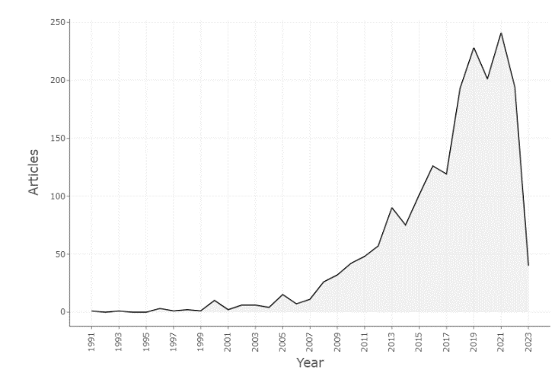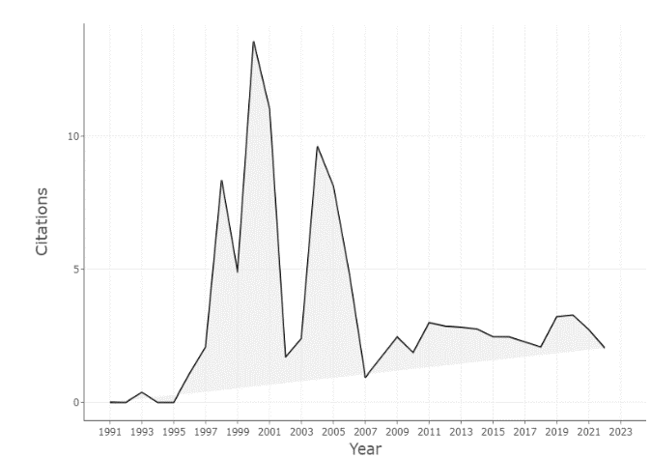

**Figure1:** Annual Scientific Production and Average Citation Per Year

The following figure (Figure 2) displays the top 20 most relevant sources, which published 32% of total publications. All journals in the field, except for Sustainability, are directly related as shown in the figure. Tourism Management (79 papers), Tourism Economics (56 papers), and Current Issues in Tourism (45 papers) are top academic journals in the field.

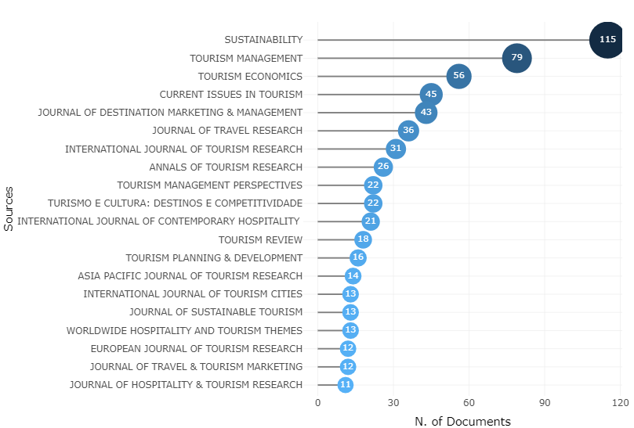

**Figure 2:** Most Relevant Sources

In Figure 3, the top three most cited journals in the field are identified as Tourism Management (8174 citations), Annals of Tourism Research (3832 citations), and Journal of Travel Research (1992 citations).

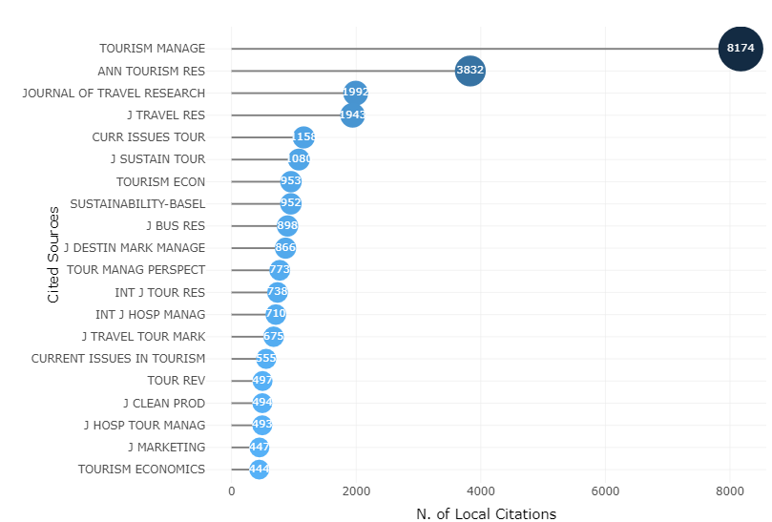

**Figure 3:** Most Local Cited Sources

Figure 4 displays the top 20 authors who contributed to academic papers on destination competitiveness.

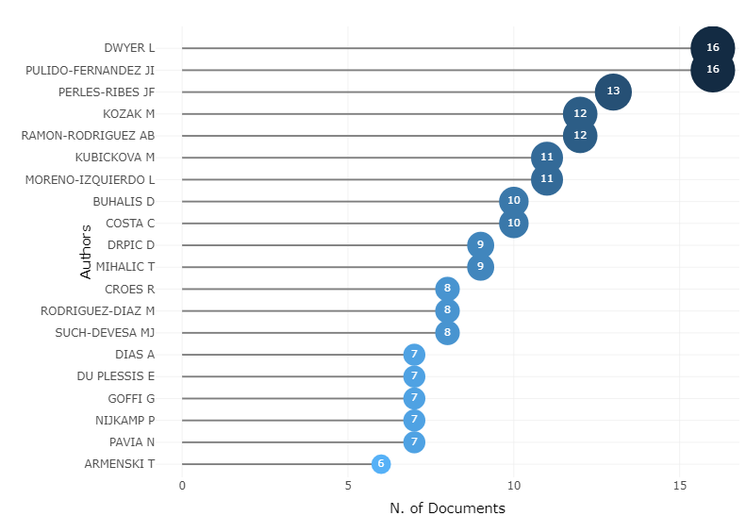

**Figure 4:** Most Relevant Authors

The figure shows that Larry Dwyer and Juan Ignacio Pulido-Fernández are the top authors among 4221 authors, with 16 published papers each. Figure 5 shows that Dwyer has been publishing papers consistently from 2000 to 2022. Dimitrios Buhalis and Tanja Mihalič have also been consistent publishers for a long time. All other documents were published by the authors after 2008.

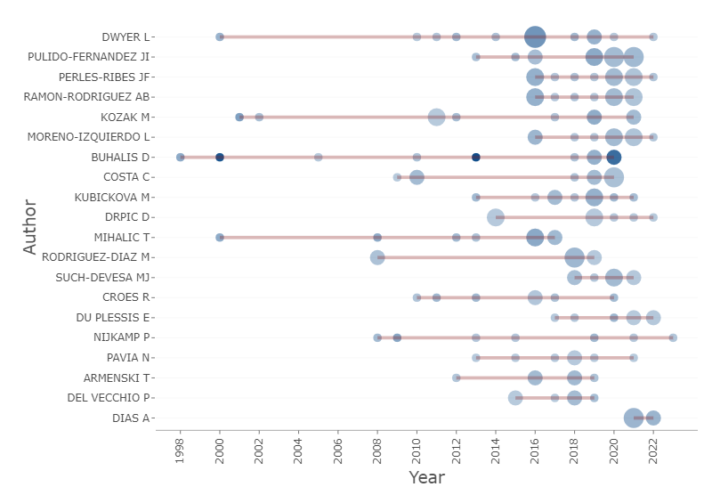

## Figure 5: Authors' Production over Time

Dimitrios Buhalis has the highest local impact among authors, with a total of 2874 citations (Figure 6). Muzaffer Uysal (1830 citations) and Yooshik Yoon (1662 citations) are the most cited authors.

## 

## Figure 6: Author Local Impact

Figure 7 displays the affiliations of the authors, which include 20 institutions. According to the figure, the University of Alicante produced 46 scholarly papers, making it the most academically productive institution. The University of Las Palmas de Gran Canaria followed closely with 45 papers.

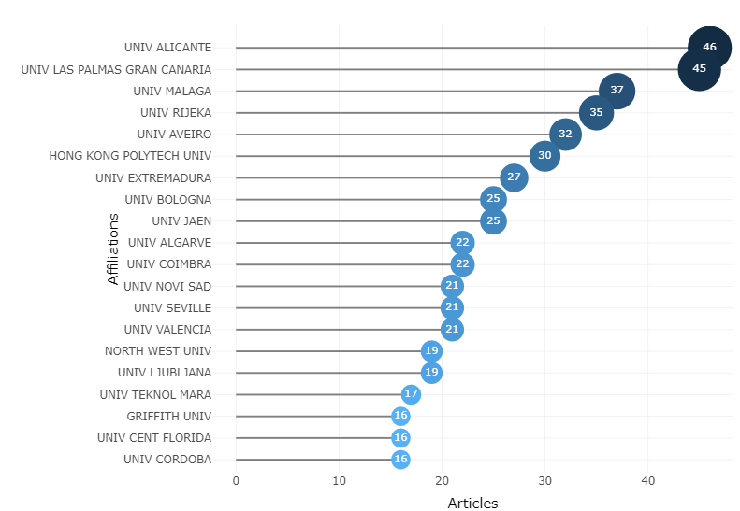

**Figure 7:** Most Relevant Affiliations

Figure 8 shows the top countries of corresponding authors who participated in scientific production.Spain and China are among the top countries in terms of research output, with single-authored papers (SCP) comprising the majority of publications for most countries, followed by multi-authored papers.

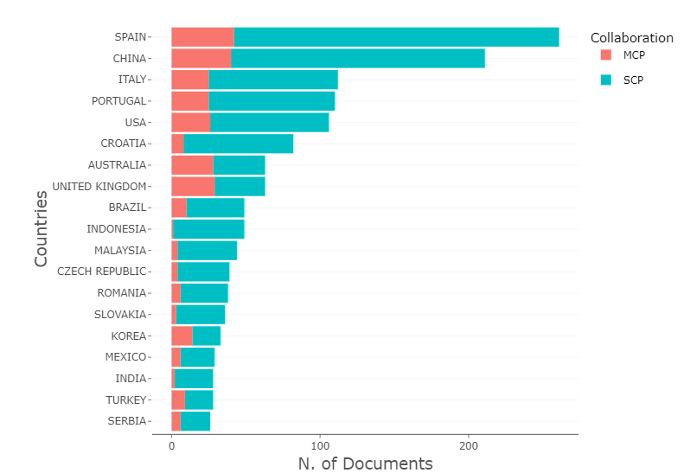

**Figure 8:** Corresponding Author's Country

The impact of top 20 countries is shown in Figures 9. Spain has the highest number of citations (4946), followed by the UK (3426), China (3353), and Australia (3292).

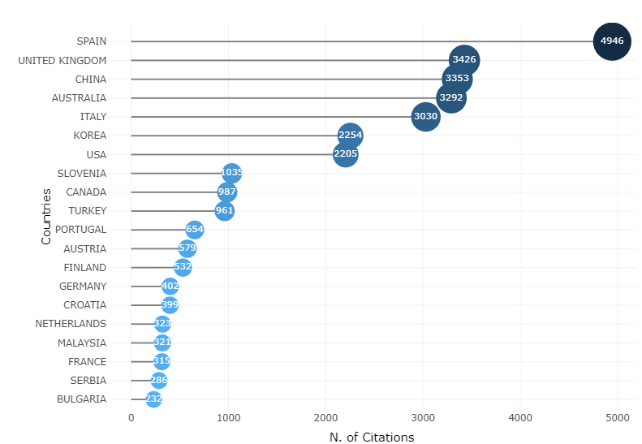

## Figure 9: Most Cited Countries

## 

## Figure 10: Most Frequent Words

The most commonly used author's keywords are shown in Figures 10 and 11. According to the figures, "competitiveness," "tourism," and "destination competitiveness" are the most frequently used keywords in literature on destination competitiveness, appearing 296, 233, and 168 times, respectively.

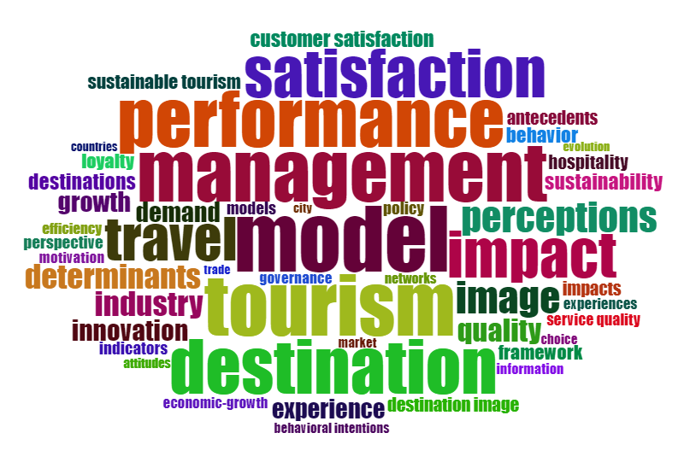

## Figure 11: Most Frequent Words

Figure 12 demonstrates the three-field plot, authors (AU) who are conducting research on this topic, used keywords (DE) and cited papers (CR) by these authors.

## 

## Figure 13: Three-Field Plot

According to the findings, the top 10 authors are Dwyer, Kubickova, Perles-Ribes, Ramon-Rodriguez, Pulido-Fernandez, Moreno-Izquierdo, Kozak, Costa, Buhalis, and Drpic. The most cited documents include Dwyer (2003), Crouch (1999), Hasan (2000), Ritchie (2003), among others. Destination competitiveness, competitiveness, sustainability, tourism, tourism competitiveness, destination management, tourism destination, destination, and sustainable tourism are the most relevant keywords in the studies on this domain.

**4. Conclusion**

In conclusion, this study on destination competitiveness literature has shed light on the current state of research in this field. By analyzing a comprehensive dataset of scholarly articles, this study has identified key trends and patterns in the existing literature.

The findings of this study reveal that destination competitiveness is an emerging and dynamic field that has gained increasing attention from researchers in recent years. The study has identified a growing interest in the topic by various authors, institutions and countries worldwide. Furthermore, this study has identified the most commonly used keywords, journals, and authors in this field, providing insights into the intellectual structure of the literature. The field exhibits an annual growth rate of scientific publications of approximately 12%, and the average age of documents is approximately 6 years. The production of this literature involved 4221 authors and 828 distinct sources. The majority of the documents, accounting for 67%, were articles, while the remaining 33% comprised other types of academic papers.

However, this study also reveals some limitations and gaps in the existing literature. For instance, the contribution of scientific communities from emerging tourism destinations is still very low within the evaluated database. And this is one of the main limitations of this study, which was limited to the Web of Science. Future studies should evaluate the literature based on other international and national databases. However, this bibliometric study provides a comprehensive overview of the destination competitiveness literature, highlighting its state of the art. The findings of this study may contribute to the existing knowledge in this field and provide directions for future research to advance the understanding of destination competitiveness and its implications for destination management and policy.

**References**

Aria, M., & Cuccurullo, C. (2017). Bibliometric: An R-tool for comprehensive science mapping analysis. *Journal of Informetrics*, *11*(4), 959–975. https://doi.org/10.1016/j.joi.2017.08.007.

Armenski, T., Dwyer, L., & Pavluković, V. (2018). Destination competitiveness: Public and private sector tourism management in Serbia. *Journal of travel research*, *57*(3), 384-398.

Bahar, O., & Kozak, M. (2007). Advancing destination competitiveness research: Comparison between tourists and service providers. *Journal of Travel & Tourism Marketing*, *22*(2), 61-71.

Buhalis, D. (2000). Marketing the competitive destination of the future. *Tourism management*, *21*(1), 97-116.

Cronjé, D. F., & du Plessis, E. (2020). A review on tourism destination competitiveness. *Journal of Hospitality and Tourism Management*, *45*, 256-265.

Crouch, G. I., & Ritchie, J. R. B. (1999). Tourism, competitiveness, and societal prosperity. *Journal of Business Research*, 44 (3), 137–52.

Cucculelli, M., & Goffi, G. (2016). Does sustainability enhance tourism destination competitiveness? Evidence from Italian Destinations of Excellence. *Journal of Cleaner Production,* 111*,* 370–382*.*

Donthu, N., Kumar, S., Mukherjee, D., Pandey, N., & Lim, W. M. (2021). How to conduct a bibliometric analysis: An overview and guidelines. *Journal of Business Research*, *133*, 285–296. https://doi.org/10.1016/j.jbusres.2021.04.070

Dwyer, L., Forsyth, P., & Rao, P. (2002). Destination price competitiveness: Exchange rate changes versus domestic inflation. *Journal of Travel Research*, 40(3), 328–36.

Dwyer, L., & Kim, C. (2003). Destination competitiveness: Determinants and indicators. *Current Issues in Tourism*, 6(5), 369–414.

Dwyer, L., Mellor, R., Livaic, Z., Edwards, D., & Kim, C. (2004). Attributes of destination competitiveness: A factor analysis. *Tourism Analysis*, 9, 91–101.

Enright, M. J., & Newton, J. (2004). Tourism destination competitiveness: A quantitative approach. *Tourism Management*, 25, 777–88.

Estevão, C., Costa, C., & Fernandes, C. (2019). Competitiveness in the tourism sector: A bibliometric analysis. *Journal of Spatial and Organizational Dynamics*, 7(1), 4-21.

Goffi, G. (2013). A Model of Tourism Destination Competitiveness: The Case of the Italian Destinations of Excellence (Un Modelo De Destino Turístico Competitivo: El Caso De Los Destinos Italianos De Excelencia). *Anuario turismo y sociedad*, 14.

Happ, E. (2021). Tourism destination competitiveness with a particular focus on sport: the current state and a glance into the future – a systematic literature analysis. *Journal of Sport & Tourism*, 25(1), 66-82, https://doi.org/ 10.1080/14775085.2021.1888775.

Hassan, S. S. (2000). Determinants of market competitiveness in an environmentally sustainable tourism industry. *Journal of travel research*, 38(3), 239-245.

Heath, E. (2002). Towards a model to enhance Africa's sustainable tourism competitiveness.

*Journal of Public Administration, 37*(Special issue 1), 327–353.

Heath, E. (2003). Towards a model to enhance destination competitiveness: A southern

African perspective. *Journal of Hospitality and Tourism Management,* 10(2), 124–141.

Mendola, D., & Volo, S. (2017). Building composite indicators in tourism studies: Measurements and applications in tourism destination competitiveness. *Tourism Management*, 59, 541-553.

Mihalič, T. (2000). Environmental management of a tourist destination: A factor of tourism competitiveness. *Tourism management*, 21(1), 65-78.

Mihalic, T. (2016). Sustainable-responsible tourism discourse–Towards ‘responsustable’tourism. *Journal of cleaner production*, 111, 461-470.

Mirhashemi, A., Amirifar, S., Tavakoli Kashani, A., & Zou, X. (2022). Macro-level literature analysis on pedestrian safety: Bibliometric overview, conceptual frames, and trends. *Accident Analysis & Prevention*, *174*, 106720. https://doi.org/10.1016/j.aap.2022.106720

Ritchie, J. B., & Crouch, G. I. (2003). *The competitive destination: A sustainable tourism perspective*. Cabi Publishing.

Seguí-Amortegui, L., Clemente-Almendros, J. A., Medina, R., & Grueso Gala, M. (2019). Sustainability and competitiveness in the tourism industry and tourist destinations: A bibliometric study. *Sustainability*, 11(22), 6351.

Teixeira, S.J., & Ferreira, J.J.M. (2018). A bibliometric study of regional competitiveness and tourism innovation. *International Journal of Tourism Policy,* 8 (2018),https://doi.org/10.1504/IJTP.2018.094483.

World Economic Forum (2019). *The Global Competitiveness Report*. Available at: <https://www.weforum.org/reports?year=2019#filter>. Retrieved on 16.04.2023.

1. Assistant Professor, Faculty of Economics & Administrative Sciences, Kyrgyz-Turkish Manas University, Bishkek, Kyrgyz Republic, [azamat.maksudunov@manas.edu.kg](mailto:azamat.maksudunov@manas.edu.kg), [ORCID](http://orcid.org/0000-0001-5612-3999): 0000-0002-5010-513X
2. PhD Candidate, Graduate School of Social Sciences, Kyrgyz-Turkish Manas University, Bishkek, Kyrgyz Republic, [kiyalbek.diykanov@manas.edu.kg](mailto:kiyalbek.diykanov@manas.edu.kg), ORCID: 0000-0002-8563-6088