**Computerization of the clocking of agents at the Lualaba revenue department by RFID electronic badge**

**Elam KYUNGU LUKOMBA**

**ABSTRACT**

Currently, the clocking of agents in public companies in the DRC and in particular in the province of Lualaba remains one of the areas that require a lot of attention from managers because the manual clocking that is done to date in Lualaba revenue department, does not allow to maximize the productivity of the company given that the agents who constitute the main workforce, come to the service always in delays sometimes exaggerated for lack of a mechanism of control of the time of arrival of the agents at the service following a clocking in which is done on a sheet where all the agents personally complete the time of arrival at the service and the time of departure, sometimes by filling in the wrong information. Then, exits from the company's facilities are not controlled, an agent can leave the workplace as many times without a valid reason and for an unacceptable period, which causes several agents to abandon their posts during working hours. because the existing system cannot accurately determine when an agent comes into the office and when an agent leaves the office. The existing system does not know how to manage the cases of absence of agents either, because certain agents can sign the presence on behalf of the other absent agents, which leads the company to pay even the absent ones, which causes a problem of payroll management which takes into account the number of days worked, handicapping the productivity of the organization given that human resources constitute the basic workforce of this department. The use of RFID electronic badge clocking nevertheless remains an effective solution for solving the problems of agent clocking management.

Keywords: Clocking, attendance, payroll management, delay, absence

1. Introduction

Most public companies in the Democratic Republic of Congo are faced with several difficulties in personnel management, given the high number of agents and the management system which is still manual.

Indeed, in any company or organization, managers always seek to achieve the objectives they have set themselves. To do this, they use different means to overcome the difficulties deemed harmful to the smooth running of activities in the company. Among the means that managers can use, we can mention computers. This shields any business or organization from the difficulties associated with performing repetitive and tedious tasks.

The use of technology by which the DRLU can effectively manage the presence of agents in the workplace by determining the exact time of arrival and departure, which will allow managers to apply positive sanctions and negative to each agent, would be an effective way to increase the latter's productivity.

The purpose of this study is to present electronic clocking by RFID badge, as a reliable tool for personnel management, capable of solving the problems of clocking in agents, the preparation of individual and collective reports of the presence of agents from manual documents which is a headache for the personnel department who must check the manual documents so many times, thus causing a loss of time.

This is why our problem revolves around the following questions: **"How *to reorganize the clocking management?" What resources should be made available to the Lualaba revenue department in order to resolve the problems mentioned above? »***

In view of the concerns raised, we believe that the use of electronic clocking by RFID badge is an effective way to solve the problems related to personnel management.

In the lines that follow, we will look at the presentation of the Lualaba revenue department, the electronic clocking system by RFID badge, the means of implementing such a system as well as the contribution of the latter in personnel management.

1. METHODOLOGY

The adoption of a methodological approach is fundamental. Inductive and analytical methods are at the center of our thinking. This allows the methodical orientation of research through data collection, analysis and presentation of results.

1. PRESENTATION OF THE LUALABA REVENUE DIRECTORATE (DRLU)

The Lualaba Revenue Department was created by Provincial Decree No. 20/15002/CS/LBA of December 04, 2015, creating the Lualaba Revenue Department DRLU in acronym, with the mission and prerogative of maximizing revenue for the benefit of the province.

Currently the services of the Lualaba Revenue Department use a manual pointing system for all the agents of its administration using a manual directory listing the names of employees according to whether they are in the management, in the urban division or at branches. As a result, each agent on arrival must sign next to his name, specifying the time of his arrival at the service, the time of the resumption after and the time of his exit from the service.

This manual attendance system has many weaknesses since some agents sign attendance for other absent or late agents by falsifying their signatures, some others falsify the arrival time, which causes several cases of unjustified absences , delays, job abandonment, resulting in the lack of productivity of agents in their departments.

It should be noted that the score is an important step in a company because the latter makes it possible to calculate the salary of the agents at the end of each month, while providing decision-makers with the possibility of applying positive or negative sanctions according to the individual report. of each agent.

1. ELECTRONIC SCORING SYSTEM

The purpose of the electronic clocking system is to increase the productivity of agents by providing the precision and accuracy of clocking-related information in real time, in order to reduce the rate of falsification and inconsistency of clocking-related information. punctuality of agents.

* 1. RFID TECHNOLOGY AND RFID BADGE

The abbreviation RFID stands for “Radio Frequency Identification”, in French, “Identification par Radiofrequency”. This technology makes it possible to identify an object, to follow its routing and to know its position in an internal environment in real time thanks to a tag emitting radio waves, attached or incorporated into the object (RFID tag). RFID technology allows tags to be read even without a direct line of sight and can pass through thin layers of material (paint, packaging, snow, etc.).

RFID is a relatively modern identification technology that has been developed recently. However, the first RFID application was used during the Second World War when Watson and Watt developed a military application to verify the "friend" or "enemy" membership of aircraft arriving in British airspace and that in 1935. This system called IFF (Identify: Friend or Foe) remains the basic principle used today for air traffic control.

RFID technology is used to track, identify and locate an object using a medium such as an RFID badge, which consists of a chip and an antenna. The RFID badge uses radio-identification technology compatible with harsh environments. The main application of RFID badges is to implement access controls for professional use.

Today's RFID readers consist of smart antenna systems, dedicated digital signal processing units, and embedded systems alongside middleware and network components. These components allow easy integration of RFID readers into data networks that comply with standardized data transfer protocols.

RFID readers are devices that interrogate RFID tags. In an RFID system, the reader detects the tag using signal processing, demodulation techniques to extract data from the tag signal. A passive RFID tag cannot generate a signal without the reader first sending an interrogation signal to the tag. Therefore, the reader and the tags are in a master-slave relationship in which the reader acts as a master while the tags operate as slaves. However, the RFID readers themselves are also in a slave position with the software which manages the application called middleware and which processes the data from the RFID.

* 1. OPERATION OF THE RFID SYSTEM

In addition, RFID technology makes it possible to identify an object or a person and to know its characteristics remotely according to the capacity of the micro antenna integrated in the tag emitting radio waves. The system components are:

**4.2.1. The label (tag):**

It is a receiving device, which is placed on elements (metal object, plastic, etc.). They are equipped with a chip containing the information and an antenna to allow the exchange of information. The figure below shows a radio frequency tag which consists of a chip and an antenna.

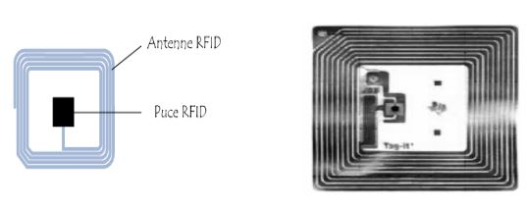

**Figure 1 – Radio Frequency Tag**

**4.2.2. The reader :**

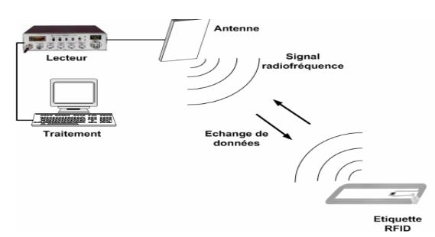The reader/writer consists of a circuit that emits electromagnetic energy through an antenna, which receives and decodes the information sent by the tag and sends it to the data collection device. The RFID reader is the element responsible for reading the radio frequency tags and transmitting the information they contain.



**Figure 2 – RFID Operating Principle**

It should be noted that the communication between the reader and the tag takes place via the antennas which equip one and the other, these elements being responsible for the radio frequency radiation. This is why the choice of characteristics of the reader/tag (type of frequency, type of tag, type of coupling) must absolutely be compatible with each other and also with the choice of use in order to have a good result.

The design of the antennas requires first of all to determine the properties of the antenna of the Tag according to the intended application. The family of RFID systems includes LF, HF and UHF systems. Our interest relating to HF, we know that their transponders use magnetic antennas, they are made up of an inductive coil (of inductance L) which plays the role of antenna, of an electronic chip carrying out the operations of communication and a capacitor C to cause the LC circuit to resonate at the working frequency.

1. IMPLEMENTATION OF THE ELECTRONIC SCORING SYSTEM

Our system will work as follows:

When the agent goes to the entrance of the workplace, he points his entrance with his RFID card via the RFID reader , the latter checks in the system if the agent really exists. If so, the system saves the information found on the card, specifying the "Entry" movement and the time at which the agent showed up at the place of work; otherwise, the system asks the agent to contact the administrator to be added to the database in order to register his presence. At the end of the day, the agent must punch his exit and the system will take care of specifying the "Exit" movement and the time at which the agent punched his exit. At the end of the day, the system automatically updates the agents' clockings.

At the end of each month, the system displays the individual clocking report for each agent in order to allow the personnel department and the finance department to establish the payment list of the agents, in accordance with the monthly performance report. The system is also able to produce the list of all the agents available in the database and to display the overall monthly score report in order to avoid omissions of names on the payroll list and in order to allow decision makers to apply certain positive or negative sanctions on the punctuality of agents.

* 1. IDENTIFICATION OF SYSTEM ACTORS

An actor represents the abstraction of a role played by an external entity (users, hardware device or other system) which interacts directly with the studied system.

The same concrete external entity can successively play different roles in relation to the system studied, and therefore be modeled by several actors. Conversely, the same role can be played simultaneously by several concrete external entities, which will then be modeled by the same actor.

The actors that interact with the system are:

* Agent: This is a person who clocks in and out using their RFID card
* RFID reader: It is a device that allows to read data from an RFID card
* Admin: This is the person responsible for assigning a badge to an agent, adding an agent in the system, modifying agent information and deleting the agent from the system
  1. USE CASE DIAGRAM

Use cases are a means of collecting and describing the needs of system actors. They can also be used later as a means of organizing the development of the software, in particular for the structuring and the running of the software tests.

A use case describes the interaction between the actors (users of the case) and the system. The description of the interaction is made from the user's point of view.

The representation of a use case involves three concepts: the actor, the use case and the interaction between the actor and the use case.

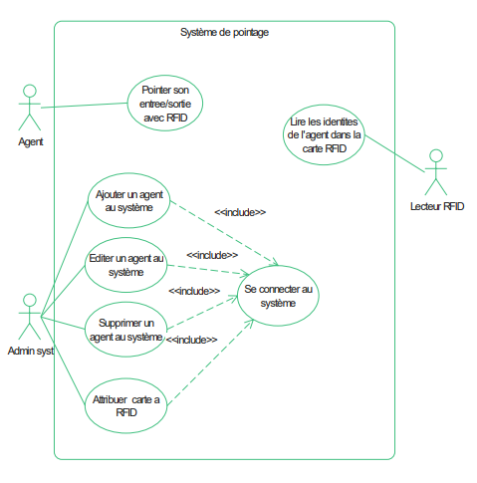

**Figure 3 – Use case diagram**

* 1. SYSTEM OPERATION

This electronic clocking system operates autonomously once the agent's badge is placed in front of the RFID reader, the latter detects the unique ID of the agent, it transmits it directly to the database and the system. records the movement (Entry or Exit) as well as the time of the movement, then automatically takes the presence of the agent and the system automatically updates the information in the database.

This agent management system is developed according to the client-server architecture. The client being the terminal that accesses the system via a computer, a tablet, a smartphone and the server represents the central computer on which the system is housed. Thus, to access the agent management system, the user connects using a web browser installed on his terminal.

To achieve our agent management system, we used the tools below except the RFID technology developed above with the RFID reader which will allow the reading of RFID cards.

For the implementation of the application, we opted for PHP for the server-side development and HTML, CSS and JavaScript for the client-side development. PHP, for Hypertext Preprocessor, designates a computer language, or a scripting language, used mainly for the design of dynamic websites. It is a programming language under a free license which can therefore be used by any programmer completely free of charge.

Created in the early 1990s by Canadian Rasmus Lerdorf, the PHP language is often associated with the MySQL database server and the Apache server. With the Linux or Windows operating system, it is an integral part of the free software suite LAMP and WAMP...

WAMP is an acronym standing for "Windows", "Apache", "MySQL" and "PHP". In order to be able to execute PHP scripts locally, we use the WAMP Server Software.

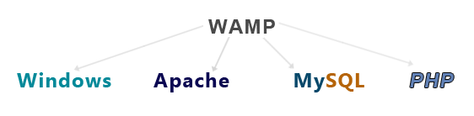

**Figure 4 – Type of systems in a company**

As far as data management is concerned, we have opted for MySQL, which is a Database Management System (SGBD) operating under Linux and Windows. Database Management Systems such as MySQL make it easy and flexible to handle a very large volume of data. However, as robust as MySQL is, it may be interesting to recover all the data contained in our database, to make a backup (backup) or quite simply to switch to another database (export). MySQL offers a number of tools for exporting its databases to other DBMSs or importing them.

The purpose of the use of the DBMS is to offer the user an interaction with the database in the form of a dialogue in order to search and select the data, this interaction is carried out thanks to the manipulation language (LMD).

In terms of data integrity, the greater the mass of information recorded in a database, the greater the risk that the recorded data is erroneous compared to reality. To reduce this risk, the DBMS must offer the user the possibility of defining rules which make it possible to maintain the integrity of the database.

These rules are called Integrity Constraints. They correspond to properties that must always be verified in the database regardless of the values recorded. Regarding data security, if a database is shared between several users, only the really authorized people will have access to it. For this, the DBMS must offer mechanisms to verify the access rights of users. There are different levels of description of these data depending on whether one is interested in the perception of the database by the user on the physical media. This tool allowing the description of data is called the data description language (LDD).

We made the choice of MySQL seen, its speed and its easy integration with the PHP language by its many functions and procedures are relevant qualities, it derives directly from SQL (Structured Query Language) which is a language of structured queries towards the bases data using the relational model. It uses its syntax but does not retain all its power since certain SQL functionalities do not appear in MySQL.

**Client** :

Terminal pointage

& Navigateur web

**Serveur web**

BDD

**Figure 5 – Client Server Model Data Flow**

* 1. PRESENTATION OF THE APPLICATION AND DISCUSSIONS

**Main clocking screen**

This interface makes it possible to clock in the agents when the RFID reader is connected to the application in order to read the card and compare the information contained on the latter with that of the database; unlike the old system which used paper support to collect the presence of agents, by not guaranteeing the security of the data because the paper support can easily get wet, torn or lost.

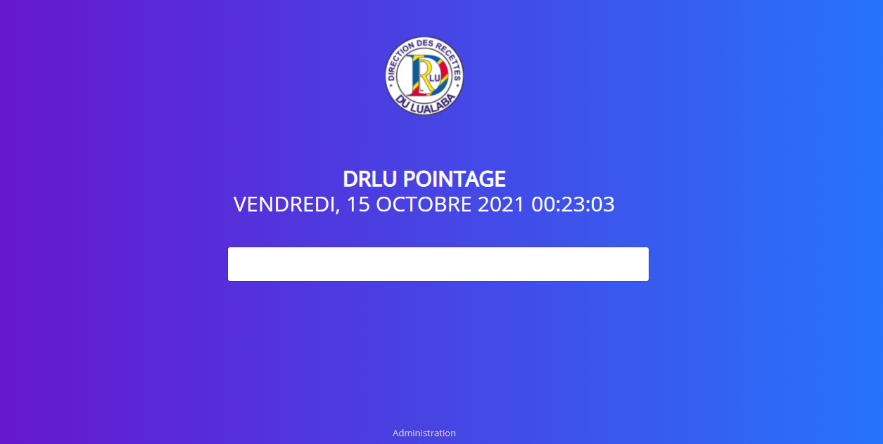

**Figure 6 – Main pointing interface**

**Entry movement clocking screen**

When the agent arrives at the place of service, before accessing his workstation, he points his card to the RFID reader, the latter checks if the agent is registered in the database then, the system records the movement of entry and specifies the date and time at which the agent clocked in.

At this level, any access by agents to the company is automatically recorded in the database, specifying the time of arrival at the service without the possibility of falsifying this information; however, in the old system, it was the agent himself who filled in the arrival time with the possibility of making errors or giving false information with falsification.

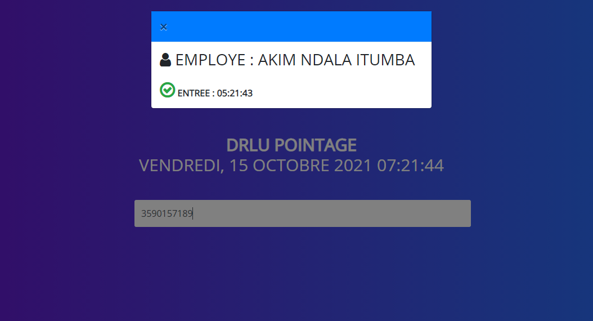

**Figure 7 – Entry motion clocking interface**

**Exit movement clocking screen**

At the end of the day, the agent must mark his exit, in this case the system records the time of the agent exit in the database and automatically updates the individual agent report.

This makes it possible to solve the problem of job abandonment because any exit is signaled in the system; which was not the case with the old system where an agent could go out when he wants and how he wants because the exits were not controlled.

Similarly , some agents could leave before the set time, but fill in the wrong information on the form. As for this new system, the time is recorded automatically as soon as the agent punches his exit without the possibility of modifying or falsifying this information.

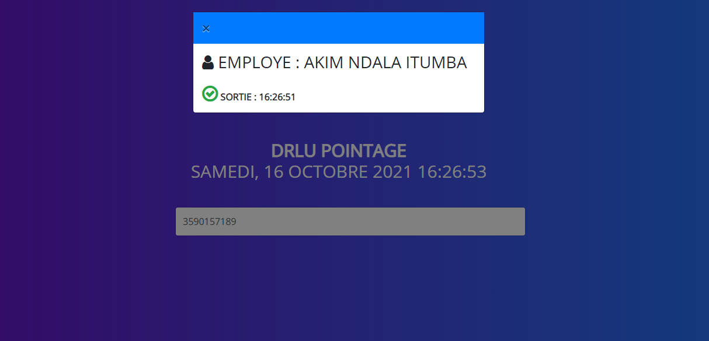

**Figure 8 – Exit movement clocking interface**

**Individual score report screen**

This interface is used to display the individual clocking report of each agent, specifying the date, the movement (Entry/Exit) and the time of each movement.

This makes it possible to have in real time the individual clocking status of the agents and will allow the payroll service to have the exact number of days worked by the agent; unlike the old system where all the lists had to be collected to verify the clocking status of each agent at the end of the month, which created material errors with the possibility of falsifying certain information related to the clocking of a agent.

This system also makes it possible to clearly see the punctuality of each agent after a determined period in order to apply a positive or negative sanction according to the regularity of the latter.

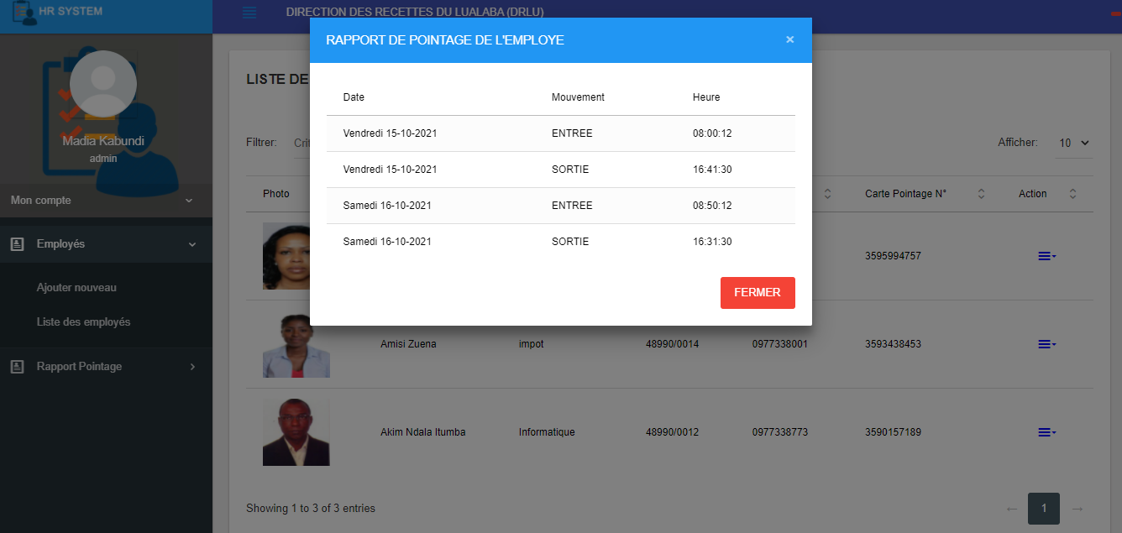

**Figure 9 – Individual time report interface**

**Global Employee Directory Screen**

This interface displays the detailed information of all the agents available in the database with the possibility of exporting this file in Excel or PDF to apply certain specific treatments.

This new system will allow the company to have an updated database of all agents in real time and will make it easy to find specific information by sorting or filtering operations; which was impossible to achieve with the old system.

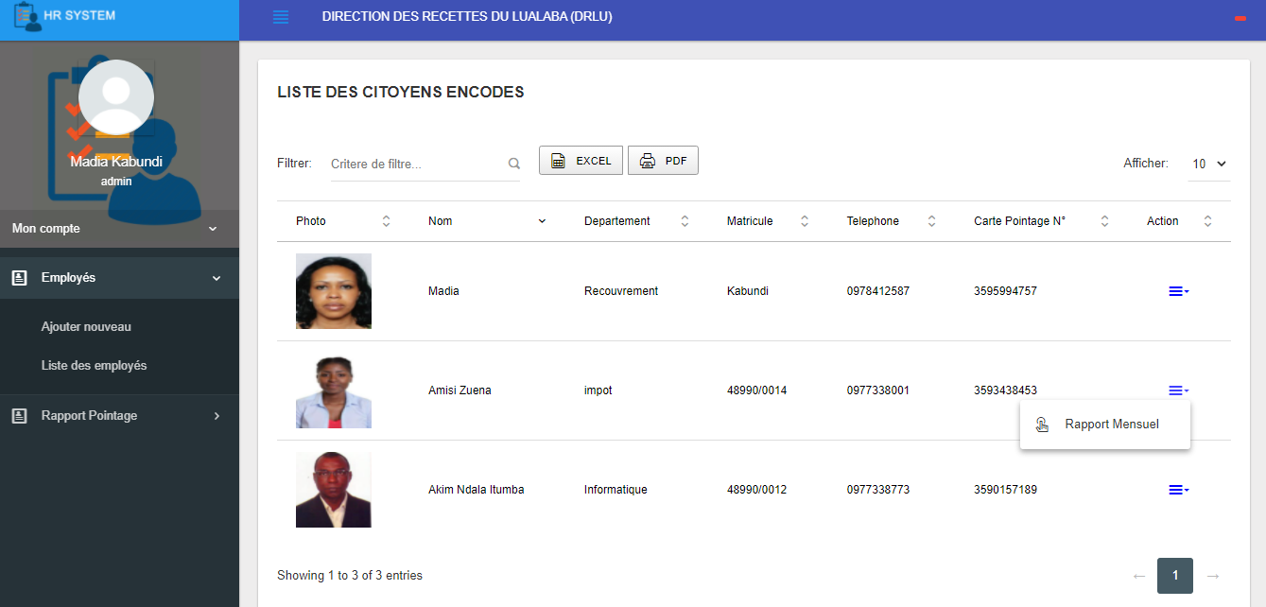

**Figure 10 – Global employee directory interface**

**Screen for adding an employee and assigning the RFID card**

If an agent is not registered in the new system, he will not have an RFID card either, because the latter is only granted after registration. Thus, these interfaces will allow us to swap a card in order to grant it to a new agent who will be registered in the system. The addition of an agent in the new system is the responsibility of the personnel department, which must provide all the necessary information included in an agent's file.

This new system will make it possible to carry out a physical control of the agents insofar as obtaining an electronic badge will be done face-to-face; which will allow to detect the fictitious agents. This system will also provide us with an updated database of all agents in the company.

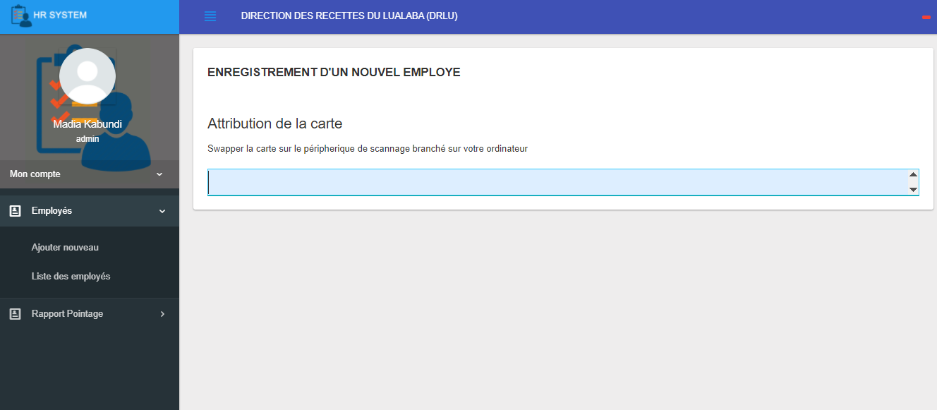

**Figure 11 – RFID card allocation interface**

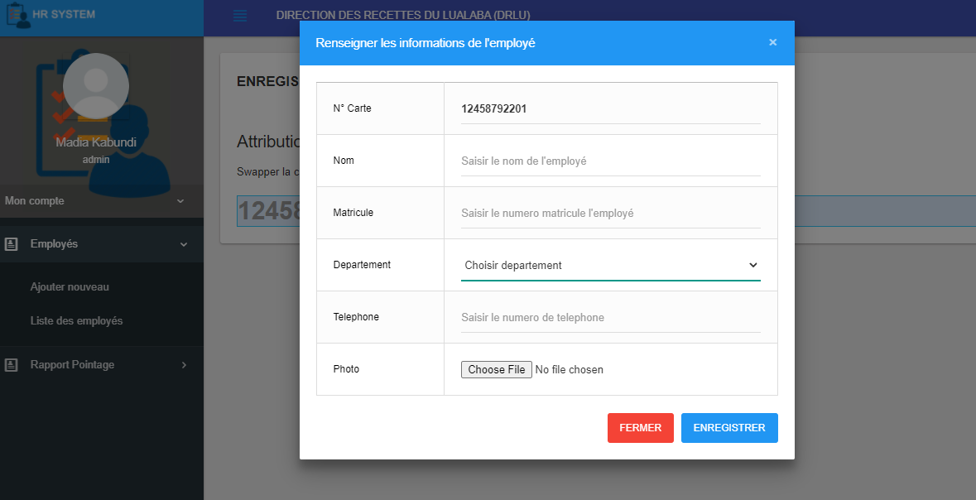

**Figure 12 – Add employee interface**

**Screen showing the overall monthly tally report**

This interface displays the overall monthly tally report for all agents, specifying the date, movement and time of each movement.

The old system was not able to produce the monthly tally report for all agents in real time; which made it difficult for the agents to manage their time.

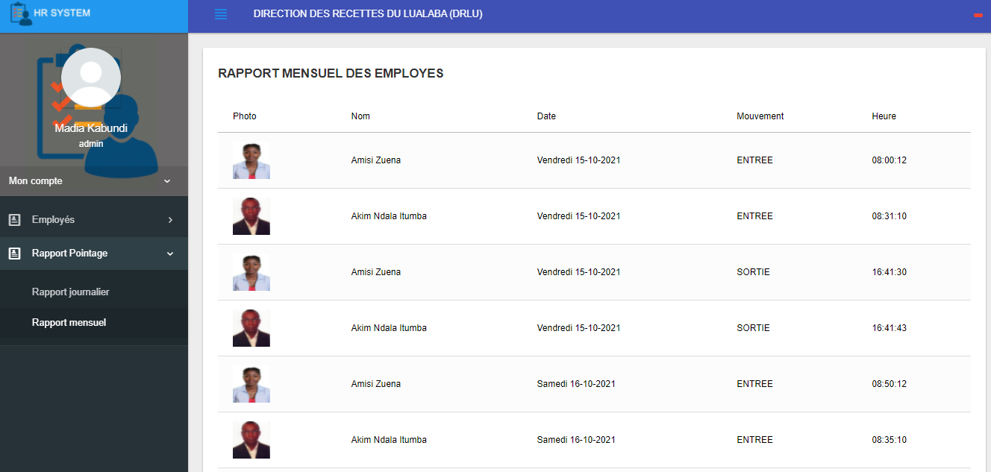

**Figure 13 – Global monthly score report interface**

1. CONCLUSION

At the end of this study, which focused on the electronic clocking of agents of the Lualaba revenue department using RFID technology, as a reliable tool for personnel management, capable of solving the clocking problems of agents, from the development of individual and collective reports of the presence of agents, we can now say that we have found answers to all our research questions raised above.

Starting from the observation that new information and communication technologies are growing rapidly and that they have considerable impacts in the economic sector of public companies, including in particular the DRLU and many other financial authorities most affected. We were interested in the process of integrating digital technology into the management of human resources at the DRLU, from where our problem revolved around two concerns, one of which was the reorganization of the pointing system at the DRLU and the another on the means to be implemented to reorganize the existing system in order to solve the related problems.

In addition, this research object is relevant because of the constantly changing reality of NICTs: the more public companies do not have digital management systems, the more complex the integration process becomes. These companies therefore want to know how to use them effectively to achieve their objectives: better manage human resources, know the performance of agents and take positive actions relating thereto, increase the province's revenues, among others.

After a rigorous analysis of the existing clocking system, we implemented a new system using RFID technology associated with a web application designed to facilitate the manipulation of the information contained on the RFID cards and to allow the personnel manager to have in real time the daily and monthly information of the score of all the agents in order to make the decision-making optimal, rigorous, concise and fast thanks to the advent of new technologies of information and communication.

Hence, the purpose of this research was to come up with a computer solution, which is the proposed system, in order to solve the problems related to the process of pointing of the agents raised at the direction of the receipts of Lualaba and, to have a system which can be generalized in all the public companies of the province of Lualaba in particular and of all the Democratic Republic of Congo in general, which know the similar problems.

References

1. S. Lahiri, RFID Sourcebook. Pearson PTR, 2011.
2. K. Finkenzeller, Fundamentals and applications in contactless smart cards, radio frequency identification and nearfield communication, 3rd ed. Chichester, West Sussex; Hoboken, N.J.: Wiley, 2010.
3. Nemai Chandra Karmakar, Handbook of Smart Antennas for RFID Systems, John Wiley Sons, 2010.
4. Klaus Finkenzeller, RFID Handbook: Fundamentals and Applications in Contactless Smart Cards, Radio Frequency Identification and Near-Field Communication, John Wiley Sons, 2010.
5. Chrisitian Tavenier, Arduino: Master its programming and interface cards (shields), Dunod, 2014.
6. Pascal Roque, Modeling of complex systems with SysML, ed. Eyrolles, 2013.
7. Pascal Roques , UML 2 in action: From needs analysis to design, ed. Eyrolles, 2007.
8. Laurent Debrauwer, Fien Van der Heyde, UML 2.5: initiation, example and corrected exercises, ed. Eyrolles, 2020.
9. Joseph Gabay and David Gabay, UML 2: Analysis and Design, ed. Dunod, Paris, 2008.
10. Harvey Lehpamer, RFID Design Principles, Artech House Publishers, 2012.