**Study of Thin-Layer Pepino Drying with Infrared and Microwave Methods and Color Analysis**

***Zehra Ozden OZYALCIN 1[C:\Users\Abdullah\AppData\Local\Microsoft\Windows\INetCache\Content.Word\ORCID-iD_icon-16x16.gif](https://orcid.org/0000-0002-6662-5885), Azmi Seyhun KIPCAK2,\*[C:\Users\Abdullah\AppData\Local\Microsoft\Windows\INetCache\Content.Word\ORCID-iD_icon-16x16.gif](https://orcid.org/0000-0003-2068-6065)***

*1,2Department of Chemical Engineering, Yildiz Technical University, Istanbul, Turkey*

|  |
| --- |
| **Abstract**  Pepino is an exotic fruit that contains high vitamin C and is known to have many beneficial effects on health. In this study, thin layer drying and color changes of Pepino fruit by infrared (IR) and microwave (MW) methods were investigated. Effective moisture diffusions, activation energy, and drying rates were calculated from the drying data. Uniformly sliced ​​Pepino fruit was processed without peeling. While IR drying processes were performed at 60, 70, and 80˚C temperatures in 210, 165, and 120 minutes, respectively, MW drying processes were completed in 25, 16, and 6 minutes at 140, 210, and 350 W energy levels. While the initial average moisture content was 18.5702 kg water/kg dry, the lowest moisture content was determined as 0.3250 at 80˚C in IR and 0.1263 water/kg dry matter×min at 350 W at MW. Effective moisture diffusions (*Deff*) for IR were calculated between 6.69 × 10-10 - 1.23 × 10-9 m2/s, while for MW it was found between 8.75 × 10-9 - 3.75 × 10-8 m2/s. The activation energy (*Ea*) was 29.80 kJ/mol for IR and 33.30 kW/kg for MW. In addition, it was determined that color preservation was better in the IR method, and local burns were observed in the samples in the microwave method. |
| Keywords: Drying Rate, Activation Energy, Effective Moisture Diffusivity, Exotic Fruit, Solanum maricatum |

1. **Introduction**

Pepino (*Solanum maricatum*) is a thin-skinned and juicy tropical, semi-tropical fruit of the nightshades family. Pepino, whose taste is often likened to melon and cucumber, can also be called pepino melon, melon pear, or tree melon. It is produced in South America, Australia, New Zealand, and the USA. Studies have shown that pepino has protective effects against many health problems thanks to its high vitamin C content [1].

Preservation of foodstuffs and especially fruits is generally provided by drying processes. While thermal-based traditional methods have been used for years, numerous drying techniques have been developed as a result of the need for lower costs and higher final product quality. Microwave drying is a technique based on electromagnetic waves, independent of the thermal properties of the product to be dried. The main benefit of choosing it is that it offers instant drying, which saves time and energy [2, 3, 4]. In addition, infrared drying takes place by absorbing the energy provided from the source by the product to be dried without heating the air in the environment and drying the product by turning it into thermal energy. This method, which has a high end product quality, is gaining popularity due to energy savings [4, 5].

As an example of some drying studies on pepino, Uribe et al. (2011) studied the traditional drying of pepino at different temperatures and its mathematical modeling [6]. Di Scala et al. (2011) examined the traditional drying of pepino and the examination of its physicochemical properties [7]. According to Izli et al. (2021), on the other hand, studied pepino drying using a combination of conventional and conventional methods and microwaves at different temperatures and power levels [8].

Although there are studies on drying exotic fruits, there are relatively few studies on pepino, and those that exist are often based on conventional techniques. In this study, the behavior of Pepino fruit in thin layer drying with infrared and microwave processes was investigated and effective moisture diffusion, activation energy and color changes were investigated.

1. **Materials and Methods**

**2.1. Apparatus**

Pepinos purchased from a local grocery chain in Istanbul, Turkey in April 2021 were sliced unpeeled with a thickness of 5 ± 0.01 mm and weight of 10 ± 0.15 grams. Dimensions were measured with manual calipers and weights were measured with a Radwag AS 220.R2 digital balance. The sliced samples were processed in the oven Nüve EV-018 (Nüve, Ankara, Turkey) for 3 hours at 105 ºC to determine the moisture content. In drying processes using unpeeled pepinos with a thickness of 5 ± 0.01 mm and 10 ± 0.15 grams, MA 50.R model infrared moisture analyzer (Radwag Balances and Scales, Radom, Poland) at 60, 70 and 80 °C and Delonghi MW205S microwave dryer (Delonghi, Treviso, Italy) at power levels of 140, 210 and 350 W were used. Color changes of the samples before and after drying were determined with a PCE-CSM 1 model (PCE Instruments UK Ltd., Southampton Hampshire, UK) color analyzer.

**2.2. Drying kinetics calculations**

The moisture content was calculated to be 94.89% on a dry basis and 18.5702 kg water/kg dry matter by moisture determination. During the drying process, weight measurements were made at intervals of 15 minutes for IR and 1 minute for MW, and drying was continued until the moisture content of the samples fell below 10%. After drying, the samples are shown in Figures 1 and 2 for IR and MW, respectively.

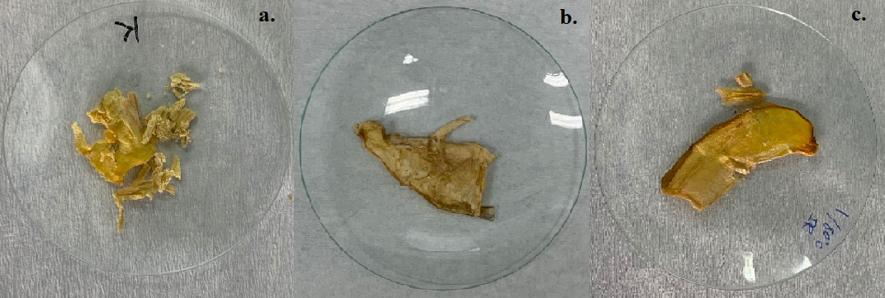

**Figure 1.** IR dried samples at a. 60 ºC, b. 70 ºC and c. 80 ºC

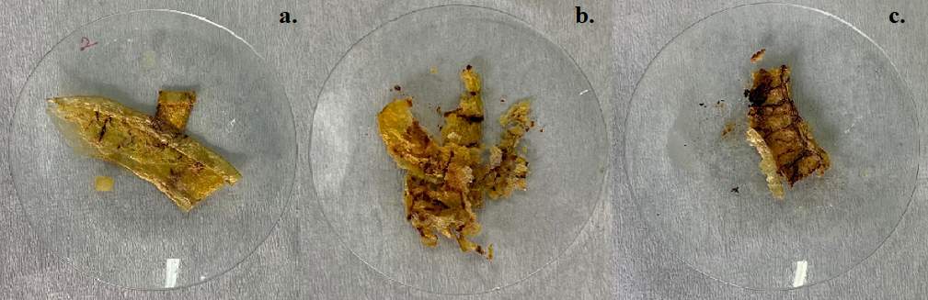

**Figure 2.** MW dried samples at a. 140 W, b. 210 W and c. 350 W

During the falling rate period, in which the drying occurs substantially, moisture is transported from the center to the surface by diffusion. It then evaporates into the surrounding environment of the product, resulting in the mass transfer of moisture. This diffusion mechanism is calculated by Equations (1) and (2) based on Fick's second law of diffusion [9];

$M=\frac{m_{w}}{m_{d}}$ (1)

$MR=\frac{M_{t}-M_{e}}{M_{0}-M_{e}}$ (2)

where *M* is the moisture content (kg water/kg dry matter), mw is the water content (kg) and, md is the dry matter content (kg). *MR* stands for the moisture ratio, *M0*, *Mt*, and *Me* are moisture content at initial, at any time, and at equilibrium in kg water/kg dry matter. Effective moisture diffusivity can be calculated using *MR* value as in Equation (3), by taking its logarithm as in equation (4) to linearize the equation;

$\text{MR=} \frac{\text{8}}{{\text{π}}^{\text{2}}}\text{exp}\left(\text{-}\frac{{\text{π}}^{\text{2}}{\text{D}}_{\text{eff}}\text{ t}}{\text{4}{\text{L}}^{\text{2}}}\right)$ (3)

$\text{ln}\left(\text{MR}\right)\text{=}\text{ln}\left(\frac{\text{8}}{{\text{π}}^{\text{2}}}\right)\text{-}\left(\frac{{\text{π}}^{\text{2}}{\text{D}}_{\text{eff}}}{\text{4}{\text{L}}^{\text{2}}}\text{t}\right)$ (4)

The activation energy was calculated based on the temperature and power provided by the drying devices. Arrhenius-type equations for temperature-based IR and power-based MW operations are given in equations (5) and (6) [10];

$D_{eff}= D_{0}\exp\left(\frac{E_{a}}{RT}\right)$ (5)

$D_{eff}= D_{0}\exp\left(-\frac{E_{a}m}{P}\right)$ (6)

where *Ea* is the activation energy value (kJ/mol), *D0* is the pro-exponential factor of the Arrhenius equation (m2/s), *R* is the universal gas constant (8.314 kJ/mol.K), P is the microwave power (W) and m is the sample weight (kg). When the graph of In(*Deff*) versus 1/*T* for IR and In(*Deff*) versus *m/P* for MW is plotted. For MW the activation energy is the slope of its graph, for IR *Ea* can be calculated as shown in equation (7);

${\text{E}}_{\text{a}}\text{=-}\text{slope}×R$ (7)

To audit the quality standards of the dried products, color analysis was performed on each sample from 5 different regions, before and after the experiment. In the color analysis, the lightness/darkness value L\*, the redness/greenness value a\*, and the yellowness/blueness value b\* were measured and the ΔE (color change) values of the dried samples, which were the difference with the untreated sample, were calculated by equation (8) [9];

$∆E=\sqrt{{\left(L_{0}-L\right)}^{*}+{\left(a_{0}-a\right)}^{*}+{\left(b_{0}-b\right)}^{*}}$ (8)

where, L0\*, a0\*, and b0\* values are the L\*, a\*, and b\* values of the raw colors of the samples, respectively.

1. **Results and Discussion**

The drying curves of the samples whose initial average moisture content was determined as 18.5702 kg water/kg dry matter are given in Figures 3. The final moisture values of the samples dried at IR 60, 70, and 80 ºC for 210, 165, and 120 minutes, respectively, were found as 0.4306, 0.4218, and 0.3250 kg water/kg dry matter. In addition, the final moisture values of the samples dried for 25, 16, and 6 minutes at MW 140 210 and 350 W, respectively, were found to be 0.1322, 0.1286, and 0.1263 kg water/kg dry matter. These results indicate that a decrease in drying times and final moisture contents is brought about by an increase in temperature and power levels. Comparing MW and IR techniques, it can be said that MW offers instant drying.

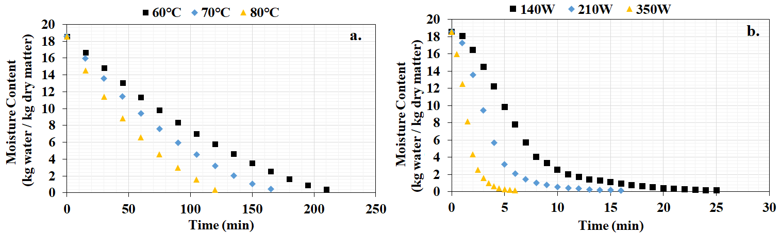

**Figure 3.** Drying curves for a. IR and b. MW dried pepino

Effective moisture diffusion values were calculated using the slope from the logarithmic moisture content-time plot shown in Figures 4. The slope values for IR at 60, 70 and 80 ºC can be read in the graphs as -0.000264, -0.000343 and -0.000486 and as -0.003454, -0.005561 and -0.014812 for MW. The effective moisture diffusion values calculated from here are; 6.69 × 10-10, 8.69 × 10-10 and 1.23 × 10-9 m2/s for IR at 60, 70 and 80 ºC, respectively, 8.75 × 10-9, 1.41 × 10-8, and 3.75 × 10-8 m2/s for MW at 140, 210 and 350 W.

The results show that the effective moisture diffusion increases with increasing temperature levels and energy levels. This situation can be interpreted as the increase in diffusion as a result of the acceleration of the molecules with the increase in the energy taken by the unit cell.

Activation energies calculated using Figures 4 and equations (5) and (6) are 29.80 kJ/mol for IR and 33.30 kW/kg for MW. Using the data from the color analysis, total color change values were calculated and were found as 9.89, 10.67, and 12.43 for IR at 60, 70 and 80 ºC, respectively, and as 11.14, 12.36, and 19.91 for MW at 140, 210 and 350 W, respectively.

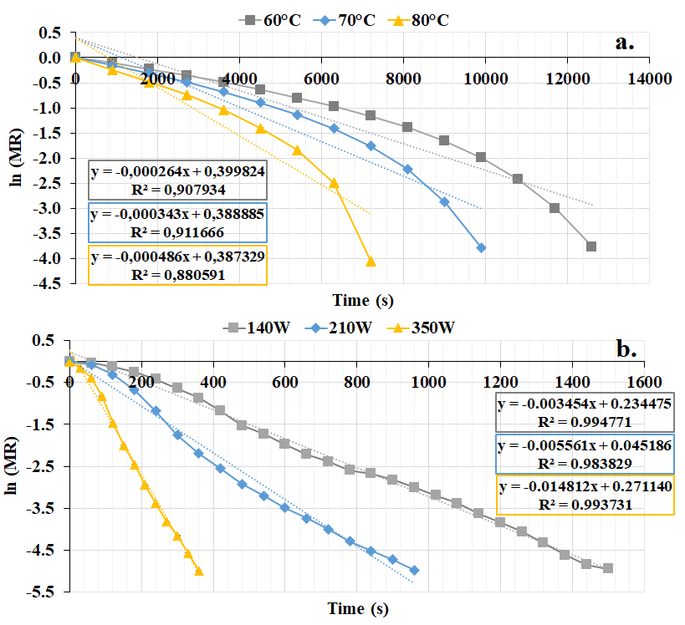

**Figure 4.** ln(MR) vs time graph for a. IR and b. MW

All drying results are summarized in Table 1. As can be seen from Figures 1 and 2 and the color values in the table, local burns have occurred in the MW due to instantaneous high power levels and the quality of the final product has deteriorated considerably. In addition, it was determined that the lowest change was achieved in 80 C products, which have the fastest drying time in IR.

**Table 1.** Thin-layer pepino drying result data.

|  |  |  |  |  |
| --- | --- | --- | --- | --- |
| Drying method | Drying time (min) | Final moisture content  (kg water/kg dry matter) | Effective moisture diffusivity (m2/s) | Color change  (ΔE) |
| IR - 60 ºC | 210 | 0.4306 | 6.69 × 10-10 | 9.89 |
| IR - 70 ºC | 165 | 0.4218 | 8.69 × 10-10 | 10.67 |
| IR - 80 ºC | 120 | 0.3250 | 1.23 × 10-9 | 12.43 |
| MW - 140 W | 25 | 0.1322 | 8.75 × 10-9 | 11.14 |
| MW - 210 W | 16 | 0.1286 | 1.41 × 10-8 | 12.36 |
| MW - 350 W | 6 | 0.1263 | 3.75 × 10-8 | 19.91 |

**Acknowledgment**

The authors received no financial support for the research, authorship, and/or publication of this article.

**References**

1. Mahato, S. K., Gurung, S., Chakravarty, S., Chhetri, B., & Khawas, T. (2016). An introduction to pepino (Solanum muricatum Aiton). *International Journal of Environment, Agriculture and Biotechnology*, *1*(2), 238513.
2. Lenaerts, S., Van Der Borght, M., Callens, A., & Van Campenhout, L. (2018). Suitability of microwave drying for mealworms (Tenebrio molitor) as alternative to freeze drying: Impact on nutritional quality and colour. *Food chemistry*, *254*, 129-136.
3. Radoiu, M. (2020). Microwave drying process scale-up. *Chemical Engineering and Processing-Process Intensification*, *155*, 108088.
4. Ozyalcin, Z. O., & Kipcak, A. S. (2021). The effect of ultrasonic pre-treatment on the temperature controlled infrared drying of loligo vulgaris and comparison with the microwave drying. *Turkish Journal of Fisheries and Aquatic Sciences*, *21*(3), 135-145.
5. Delfiya, D. A., Prashob, K., Murali, S., Alfiya, P. V., Samuel, M. P., & Pandiselvam, R. (2022). Drying kinetics of food materials in infrared radiation drying: A review. *Journal of Food Process Engineering*, *45*(6), e13810.
6. Uribe, E., Vega-Gálvez, A., Di Scala, K., Oyanadel, R., Saavedra Torrico, J., & Miranda, M. (2011). Characteristics of convective drying of pepino fruit (Solanum muricatum Ait.): Application of weibull distribution. *Food and Bioprocess Technology, 4(*8), 1349-1356.
7. Di Scala, K., Vega‐Gálvez, A., Uribe, E., Oyanadel, R., Miranda, M., Vergara, J., ... & Lemus‐Mondaca, R. (2011). Changes of quality characteristics of pepino fruit (Solanum muricatum Ait) during convective drying. *International Journal of Food Science & Technology, 46*(4), 746-753.
8. Izli, G., Taskin, O., & Izli, N. (2021). Convective, microwave and combined microwave-convective drying of pepino. *Erwerbs-Obstbau*, *63*(2), 175-184.
9. Ozyalcin, Z. O., & Kipcak, A. S. (2022). The Ultrasound Effect on the Drying Characteristics of Loligo vulgaris by the Methods of Oven and Vacuum-oven. *Journal of Aquatic Food Product Technology, 31*(2), 187-199.
10. Doymaz I, Kipcak AS, Piskin S. 2015. Microwave drying of green bean (Phaseolus vulgaris) slices: drying kinetics and physical quality. *Czech Journal of Food Sciences. 33*(4) 367-376.