BACTERIAL VAGINOSIS IN GESTANT IN LUBUMBASHI IN DR CONGO: Epidemiological aspect, risk factors and sensitivities to antibiotics.
Ilunga Nkenga JP ¹ , Iteke Fefe R ² , Kasongo Kumelundu K ³ , Mujing Mutomb F ³ , Bitilasi Tema Franck ⁵ , Mukole Bolimaka Bonny ⁵ , Ilunga Kasamba Eric ³ , Mwamba Kalfando Jimmy ¹ , Novel Mbahingana Joseph ⁶ , Tshilondi Malu C ⁷ , Tshizubu Mulungu L ⁷ , Tamubango Kitoko Herman ¹ , Kasonga Kasonga M ¹ , Kawaya Ntonto C ¹ , Tshikala Nday ¹ , Kankolongo Beya G ⁴ , Kabwe Bakajika ¹ , Kujirabwinja Garagomba J, Kasongo Kitungwa ¹ , Kinenkinda Uncle X ¹ , Kakoma The browser Zambeze JB ¹ .
¹ Department of Gynecology-Obstetrics, Faculty of Medicine, University of Lubumbashi
² Department of Anesthesia-Resuscitation, Faculty of Medicine, University of Lubumbashi
^{3.} Department of Nutrition, Clinical Biology, Faculty of Medicine, University of Lubumbashi
⁴ Clinical Biology Department, Diamant Medical Center/Lubumbashi/DR Congo
⁵ Doctor at the Provincial Health Division/Haut-Katanga/DR Congo.
⁶ Ruashi Military Center
⁷ Polyclinic Francis Medical Center.
corresponding e -mail: jeanpaulnkenga@gmail.com

ABSTRACT
Introduction: Bacterial vaginosis and bacterial vaginitis are lower genital infections in women revealing an alteration of the vaginal ecosystem resulting in the replacement of the normal flora composed mainly of lactobacilli and other endogenous bacterial species such as Gardnerella vaginalis, Mobiluncus and Mycoplasma hominis or exogenous like candida and trichomonas vaginalis. Our study aims to establish the prevalence of bacterial vaginosis in pregnant women in Lubumbashi and what were the risk factors in our environment?
Methodology: This is a descriptive cross-sectional study with an analytical component over a period of 4 months, from June 1 to December 31, 2021, having included pregnant women who came for prenatal consultation in the 4 structures mentioned above during the study period and whose informed consent was given. The sociodemographic, clinical, bacteriological and therapeutic data based on the antibiogram of pregnant women included in the study are the independent variables of the study. The Nugent score and the Amsel criteria are used to describe the prevalence of vaginosis. Culture media for isolation are mainly: MacConkey , blood agar, Muller-Hinton, Cled , Sabouraud, as well as antibiogram and antifungigram discs.
Results: During the study period we took 152 samples and analyzed 104 for culture, antibiogram and antifungigram. The prevalence of vaginosis was 23% according to the Nugent score and 39.5% according to the Amsel criteria . Direct examination showed the absence of trichomonas vaginalis in the samples. Enterococci represented 47.6%, Escherichia coli 17.5% and Neisseria gonorrhoeae 9.5%. Of the 54 Candida cases, Candida Albicans accounted for 48.1%. Escherichia coli is 100% sensitive to fosfomycin, while E coli is 40% resistant to imipenem. Candida albicans is sensitive to Amphotericine B at 40% on the other hand it is resistant to Fluconazole at 90%.
Conclusion: Vaginoses are frequent and still constitute a major public health problem, especially the evolution that can lead to complications involving the upper genital tract. Several resistance factors specific to our environment are identified with an antibiogram coming out of our usual probabilistic antibiotic prescriptions. Mass awareness, bacteriological equipment as well as continuous staff training could reduce its extent in our environment.
Keywords: Vaginosis, Obstetrics, DR Congo
ABSTRACT
Introduction: Bacterial vaginosis and bacterial vaginitis are lower genital infections in women revealing an alteration of the vaginal ecosystem resulting in the replacement of the normal flora composed mainly of lactobacilli and other endogenous bacterial species such as Gardnerella vaginalis, Mobiluncus and Mycoplasma hominis or exogenous like candida and trichomonas vaginalis. Our study aims to establish the prevalence of bacterial vaginosis in pregnant women in Lubumbashi and what were the risk factors in our environment?
Methodology: This is a descriptive cross-sectional study with an analytical component over a period of 4 months, from June 1 to December 31, 2021, having included pregnant women who came for prenatal consultation in the 4 structures mentioned above during the study period and whose informed consent was given. The sociodemographic, clinical, bacteriological and therapeutic data based on the antibiogram of pregnant women included in the study are the independent variables of the study. The Nugent score and the Amsel criteria are used to describe the prevalence of vaginosis. Culture media for isolation are mainly: MacConkey, blood agar, Muller-Hinton, Cled, Sabouraud, as well as antibiogram and antifungigram discs.
Results: During the study period we took 152 samples and analyzed 104 for culture, antibiogram and antifungigram. The prevalence of vaginosis was 23% according to the Nugent score and 39.5% according to the Amsel criteria. Direct examination showed the absence of trichomonas vaginalis in the samples. Enterococci represented 47.6%, Escherichia coli 17.5% and Neisseria gonorrhoeae 9.5%. Of the 54 Candida cases, Candida Albicans accounted for 48.1%. Escherichia coli is 100% sensitive to fosfomycin while E coli is 40% resistant to imipenem. Candida albicans is sensitive to Amphotericine B at 40%, on the other hand it is resistant to Fluconazole at 90%.
Conclusion: Vaginoses are frequent and still constitute a major public health problem, especially the evolution that can lead to complications involving the upper genital tract. Several resistance factors specific to our environment are identified with an antibiogram coming out of our usual probabilistic antibiotic prescriptions. Mass awareness, bacteriological equipment and continuous staff training could help reduce its extent in our environment.
Keywords: Vaginoses, Obstetrics, DR.Congo.

Introduction
The vaginal cavity is particularly exposed to infections because of the structure which is closed, homeothermal and moist. Protection is ensured by the predominant, but not exclusive, presence of the Döderlein bacillus which digests the desquamated vaginal cells, transforms their lactic acid glycogen, which makes it possible to maintain the vaginal pH between 3.8 and 4.2 (1) . In addition to the Döderlein bacillus, the normal vaginal flora contains an ecosystem whose balance is subject to physiological variations. Bacterial vaginosis (BV) results from the modification of the vaginal flora with the replacement of lactobacillus sp . By an association of Gardnerella vaginalis of various anaerobic species (Bacteroides sp , Prevotella sp , Porphyromonas sp , Veillonella sp , Perptostreptoclus sp , Mobiluncus sp , Cubacteria sp , Fusobacterium sp ) and Mycoplasma hominis. The causes of the abnormal multiplication of these microorganisms of the endogenous flora are not all known. There are likely host-related factors, including hormonal, but also bacterial. BV, otherwise known as "non-specific" vaginitis, is contrasted with "specific" vaginitis due to Candidas albicans , Trichomonas vaginalis, Neisseria gonorrhoeae and Chlamydia trachomatis.
BV is defined by the WHO as vaginal leucorrhoea characterized by the absence on microscopic examination of yeasts and trichomonads and by the presence of two or more of the following criteria (2) , known as the AMSEL Criteria: Vaginal discharge adherent and homogeneous; Presence of indicator cells or “clues cells ” on microscopic examination; pH of vaginal secretions greater than 4.5; demonstration of a “spoiled fish” amino odor when a drop of VS is mixed with a drop of 10% potassium hydroxide (2) . In the laboratory, great importance is attached to the appearance of the vaginal smear fixed and stained by the Gram method. In practice, a score is assigned to each smear according to the morphotype and the number of bacteria observed (3) . Isolation of germs associated with VS is not routinely recommended. The culture result of gardnerella vaginalis, anaerobes and mycoplasma hominis do not contribute to the diagnosis of these BV (3,4) . The treatment of BV poses two problems: who to treat and how to avoid the recurrences that characterize this condition? Metronidazole is the reference antibiotic. Other antibiotics used are clindamycin, amoxicillin and amoxicillin combined with clavulanic acid. Not all BVs need to be processed; although BV is not, strictly speaking, an STI, the therapeutic management of the partner would, according to some authors, reduce the risk of recurrence (5,6) . BV is the most common lower genital tract disorder in women of childbearing age (pregnant or not) and the most prevalent cause of vaginal discharge and bad odor (7,8) . It has been associated with a significant number of obstetrical and gynecological complications, such as preterm labor and delivery , spontaneous abortion, premature rupture of membranes, chorioamnionitis, postpartum endometritis, infection of the caesarean section wound, post-surgical infections and subclinical pelvic inflammatory syndrome (9,10) . BV is very common, with the exact prevalence varying widely depending on the patient population. In studies of patients in private practice, the prevalence ranged from 4% - 17%, while in patients attending gynecology clinics an increased proportion of women with low incomes and no no insurance, it was 23% in canada (11.12) . Among female college students, the prevalence ranged from 4% to 25%, while it was as high as 61% among women presenting to clinics focusing on sexually transmitted diseases (13–16) . In pregnant women, studies have documented prevalence rates similar to those found in populations of non-pregnant women, 6-32% (9.17–20) . A Canadian study of maternity patients reported an overall prevalence of BV of 14%. This has been associated with race, smoking, sexual activity and douching, young age and low level of education (21) . BV is more common in black women, smokers, sexually active women (compared to virgins) (11) and women who use vaginal douches (22) .
In the United States, it was diagnosed in 33–36% of patients presenting to STI services, 16–20% of pregnant women, and more than 25% of patients presenting to gynecological clinics (23–26) . In Cameroon, a study had shown that out of 93 women consulting at the family planning centre, 39 women or 42% had BV (27) . In Benin, a study carried out in 1994 revealed a prevalence of 20.74% among pregnant women (28) . In Burkina Faso, a study had shown that 21.7% had BV and more recently another study gave a prevalence of 17.3% (29) .
Several other studies had reported the potential role of BV in the occurrence of gynecological complications which include pelvic inflammation, cervicitis, salpingitis, as well as cancer of the cervix. The obstetrical risks associated with BV include premature rupture of membranes, premature labor threats, abortions, chorioamnionitis and postpartum endometritis (26,30–34). Bacterial vaginosis has thus been diagnosed in 20% to 30% of consulting patients in current practice, in France in particular (15,16,18) . In France, it is observed with an even higher frequency in the gynecology and venerology department (18,19) , in pregnant women, the frequency varies from 15% in outpatient clinics to 25–30% in the obstetrics department ( 18) . The VB could be carried in 12% of the cases, at the young girls without sexual experiment (29,30) . In South Africa,
The diagnostic criteria are the same regardless of the presence of pregnancy or not according to Amsel (19). Thus, the clinical diagnosis of bacterial vaginosis is established when three of the following four symptoms are present (19): an adherent and homogeneous vaginal discharge, a vaginal pH greater than 4.5, the detection of rods adhering to epithelial cells (vaginal epithelial cells being so heavily coated with bacteria that their peripheral edges are clogged from a wet saline preparation: 20% of clue cells ), an amine odor following the addition of Potassium hydroxide (positive olfactory test) . The clinical diagnosis in the laboratory will be made by the Nugent score.

The management of infections increasingly takes account of certain principles, in particular the control of microbial ecology, associated factors, and even certain specific areas. The systematic search for these infections is not done in several environments, particularly in Lubumbashi, and yet several studies carried out in more affluent countries than the DR Congo have just shown significant prevalences of vaginosis in general and in pregnant women, immunocompetent or not. especially. This is a worrying situation for the practitioner who does not control the local microbial ecology of his patients. Consequently, it seemed very interesting to us to carry out this study in order not only to fill in the gaps in the literature on this subject, but also and above all to present a panoramic overview of bacterial vaginosis and its sensitivity to antibiotics in pregnant women in our country. environment.
Methodology

Type of study : This was a descriptive cross-sectional study with an analytical component.

Study sites and period : This study was carried out in four health structures in the city of Lubumbashi, namely: the University Clinics of Lubumbashi, the HPGR Sendwe , the Diamond Hospital Center of Lubumbashi and the CHIARA LUBICH Hospital Center over a period of 4 months, i.e. from the ^{1st} June to December 31, 2021.

Study population : It was made up of all the pregnant women who came for consultation in the CPN services of these different structures during the study period.

Sampling : It was of the exhaustive type targeting a minimum size of 125 pregnant women, i.e. 30 per structure.
Sample size : Our minimum sample size was 125, calculated from this formula: n = t² × p × (1-p) / m² ( n = 1.96² × 0.15 × 0.8 / 0.05² = 125) n: Minimum sample size for obtaining significant results for an event and a fixed level of risk , t: Level of confidence (the typical value of the level of confidence of 95% will be 1.96) , p: Estimated proportion of the population that exhibits the characteristic and m: Margin of error (generally set at 5%)
Inclusion criteria : were included, pregnant women who came for prenatal consultation in the 4 structures mentioned above during the study period and whose informed consent will be given.

Exclusion criteria : all pregnant women seen outside the study period, whose consent was not obtained, who had not been on anti-infective treatment for at least 7 days, those who had had an intimate toilet the day before and the morning of the sample, or having had sexual intercourse 24 hours before the sample.

Study variables Independent or explanatory variables : sociodemographic, clinical, bacteriological and therapeutic data based on the antibiogram of pregnant women included in the study.

Dependent variable : Bacterial vaginosis in pregnant women with regard to the above considerations.

Materials : they consisted of materials for vaginal samples, reagents for GRAM staining as well as antibiogram and antifungigram discs with culture media for isolation, in particular: MacConkey , blood agar , Muller-Hinton , the Cled and the Sabouraud

Research techniques : To properly conduct our study, the following research techniques were chosen: interrogation (consultation); general physical examination of the pregnant woman; the complete gyneco-obstetrical examination (speculum); the physico-chemical screening test (pH, potash test); as well as the Sampling of vaginal secretions.

Data collection : it was done on the basis of a sheet drawn up and pre-tested beforehand grouping together socio-demographic, clinical and biological data relating to: the appearance of the VS (color, consistency); the relative abundance of VS (a quantity <2 ml is noted as not very abundant between 2 and 5 ml abundant and greater than 5 ml, very abundant). On the leucorrhoea was carried out the potash test; pH and classic bacteriological examination (sample from the posterior cul-de-sac); the smell of VS; the cells contained in the VS (leukocytes and epithelial cells); identified germs; the sensitivity of germs to antibiotics and antifungals , as well as physico-chemical data (pH of VS, potash test) and cytobacteriological data + Culture, Identification and Antibiogram
The diagnosis of BV was made on the basis of the Nugent score.

Data processing : The initial entry was made on the Excel 2015 software, for further processing using the Epi info version 7.2 software. Student 's t test was performed for comparison of means and Yates' corrected chi ^{2 test} or Fisher's exact test for comparison of proportions. Finally, the calculation of the adjusted odds ratios (adjusted OR) with 95% CIs was done to find the link between the risk factors and the variable to be explained with a significance level of p < 0.05.

Ethical considerations : In compliance with the ethical standards in force, we had obtained the authorizations of the heads of the establishments concerned and the informed consent of the patients; respect for confidentiality; the submission of the protocol to the ethics committee of the University of Lubumbashi in DR Congo.

Results
Workforce: We had to work on 152 samples, each pregnant woman had to benefit from two samples; one for GRAM staining and physico-chemical tests and the other for culture and antibiogram. Of these 152 samples, 104 were analyzed (culture and antibiogram). Socio-demographic characteristics: The average age was 29.03 ± 6.07, of which 88.2% lived as a couple, and only 34.2% had a higher education level. The majority 37.5% came from the commune of Lubumbashi and more than half were housewives. Smoking history: The smoking history showed that 10.5% were active smokers and 17.1% passive smokers.
Genital ulceration and dyspareunia: Genital ulcerations were only found in 2% of cases, of which 1.3% of pregnant women had a notion of dyspareunia. Nature of leucorrhoea: 11.2% of pregnant women had pathological leucorrhoea which was associated with pruritus in 15.8% and low back pain in 0.7% of cases. Appearance of the vulva: The majority of pregnant women (97.4%) had a normal vulva and 2% had warts.
Examination of the cervix: The examination of the cervix noted that 15.8% of the cases the cervix was inflammatory and 5.2% of the cases presented the eggs of Naboth .
Abundance of leucorrhoea: In 33.6% of cases the leucorrhoea was moderately abundant and in 56.6% of cases it was not very abundant.
Parity and gestality : 26.3% of cases pregnant were nulliparous and in 38.8% of cases they were pauciparous and 38.8 of cases they were pauci gestures, 24.3% of cases they were large multi gestures.
History of STIs and condom use: 16.4% of cases with a history of STIs and 15.1% used condoms.
Vaginal hygiene: it appears that: 99.3% had notions of douching, 1.3% used lemon for intimate bathing, 15.1% of cases used borehole water for intimate bathing, 66.4 % of cases for Regideso water for the intimate bath and 2.6% used a vaginal tampon.
Gestational Age and Prenatal Consultations Performed: This figure shows that 46.7% of pregnant women had pregnancies between 14 and 26 weeks old with an average of 24.06 ± 8.1 weeks and 62.5% of pregnant women had already started prenatal consultations
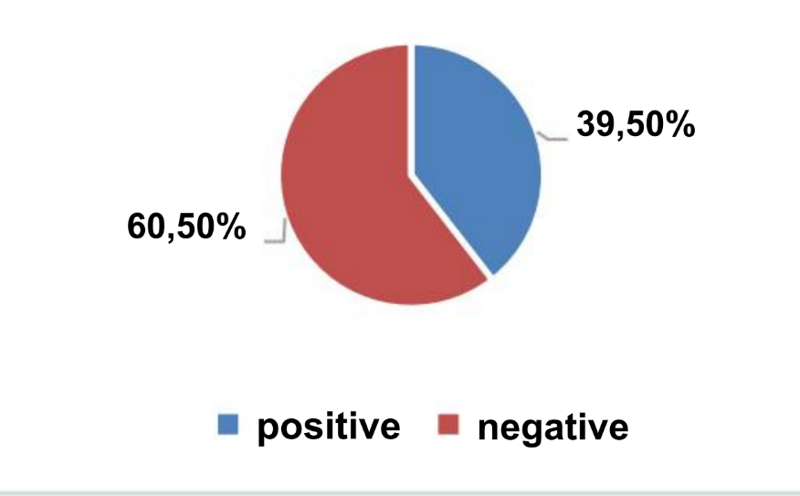

Figure 1: distribution of pregnant women according to the Amsel criteria .
This figure shows that 39.5% of pregnant women had a positive Amsel score.
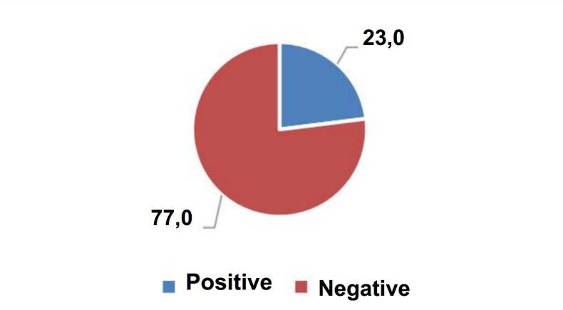

Figure 2: distribution of pregnant women according to the Nugent score
This figure shows that 23.0% of pregnant women had a positive Nugent score.

Medications taken previously: In view of this figure, 10.5% of pregnant women took amoxicillin and 6.6% clotrimazole
Association of Amsel criteria and sociodemographic and clinical parameters: It appears that the presence of leucorrhoea, the presence of odor, the yellowish coloring and the whitish coloring were statistically associated with the Amsel score . Association of Nugent score and socio-demographic and clinical parameters: It appears that the presence of pruritus and the positivity of the Amsel criteria were statistically associated with the positivity of the NUGENT score.

Table I: Determinants of Amsel criteria positivity
Settings | ORa | [95% CI] |  | P
Leucorrhoea ( yes /no) | 4,042 | [ 1,140 | 14,330 ] | 0.031
Odour nauseating ( yes /no) | 7,926 | [ 2,101 | 29.893 ] | 0.002
Whitish ( yes /no) | 2,604 | [ 1,140 | 5.945 ] | 0.023
After adjustment, the presence of foul-smelling and whitish leucorrhoea were the determinants associated with Amsel criteria positivity , increasing the rating by 4, respectively; by 8 and by 2.

Table II: Determinants of the positivity of the NUGENT score
Settings | ORa | [95% CI] |  | P
Vaginal tampon (yes/no) | 0.588 | [ 0.207 | 1.673 ] | 0.320
Pruritus present (yes/no) | 2,888 | [ 1,080 | 7.718 ] | 0.035
Using the vaginal tampon | 0.228 | [ 0.027 | 1,894 ] | 0.171
Yellowish leucorrhoea (yes/no) | 1,269 | [ 0.177 | 9,082 ] | 0.812
Whitish leucorrhoea (yes/no) | 2,430 | [ 0.374 | 15,780 ] | 0.352
After adjustment, the presence of pruritus was the determinant associated with the positivity of the Nugent score , multiplying the odds by 3. In addition, yellowish leucorrhoea and whitish leucorrhoea were associated with the positivity of the Nugent score but the statistical difference does not is not significant.
pH of secretions: 5.868±0.9; Parity: 2(0-5); Gesture : 3(2-5); Gestational age (SA): 24.06±8.13.

Samples and Analysis

Table III: Distribution of Isolated Bacteria in Vaginal Secretions
BACTERIA |  | Frequency | Percentage | Percentage valid | Cumulative percentage
Strongly | EC: Enterobacter Cloacae | 2 | 3,2 | 3,2 | 3,2
Strongly | ECOLI: Escherichia coli | 11 | 17,5 | 17,5 | 20,6
Strongly | EF: Enterococcus Faecalis | 9 | 14,3 | 14,3 | 34,9
Strongly | EFCIM : Enterococcus faecium | 21 | 33,3 | 33,3 | 68,3
Strongly | KP: Klebsiella Pneumonia | 8 | 12,7 | 12,7 | 81.0
Strongly | NG : Neisseria Gonorrhoeae | 6 | 9.5 | 9.5 | 90.5
Strongly | PA : Pseudomonas aeruginosa | 1 | 1,6 | 1,6 | 92.1
Strongly | PM : ̈ Proteus Mirabilis | 3 | 4.8 | 4.8 | 96.8
Strongly | SA : Streptococcus agalactiae | 1 | 1,6 | 1,6 | 98.4
Strongly | SCN: Coagulase Negative Staphylococcus | 1 | 1,6 | 1,6 | 100.0
Strongly | Total | 63 | 100.0 | 100.0
This table shows that 47.6 % were enterococci followed by E.coli with 17.5%.
Out of 104 samples analyzed we have 54 cases of candida which gives us a prevalence of 52%.

ISOLATED CANDIDATES

Table IV: Distribution of Candidas isolated from vaginal secretions
CANDIDATES |  | Frequency | Percentage | valid percentage | Cumulative percentage
Valid | THAT | 26 | 48.1 | 48.1 | 48.1
Valid | CF | 8 | 14.8 | 14.8 | 63.0
Valid | CG | 10 | 18.5 | 18.5 | 81.5
Valid | CK | 10 | 18.5 | 18.5 | 100.0
Valid | Total | 54 | 100.0 | 100.0
It appears from this table that 48.1% were composed of Candidas Albicans, followed by 18.5% made of Candidas Glabrata and Candidas Krusei.
Association Candida and Bacteria: On 24 samples with Co-infected candidiasis; in 41.67% of cases, Candida albicans was noted; in combination with Enterococcus Faecium or Klebsiella Pneumoniae in 12.5% of cases.

ANTIBIOTICS
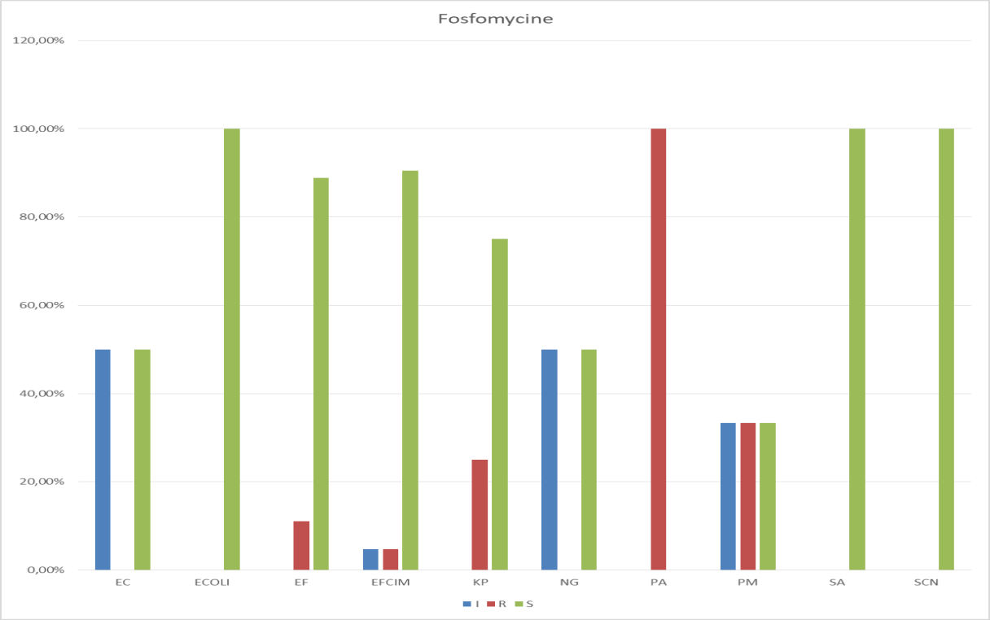

Figure 4.
THE. Coli, SCN and SA are 100% sensitive on the other hand NG is sensitive to fosfomycin at 50%

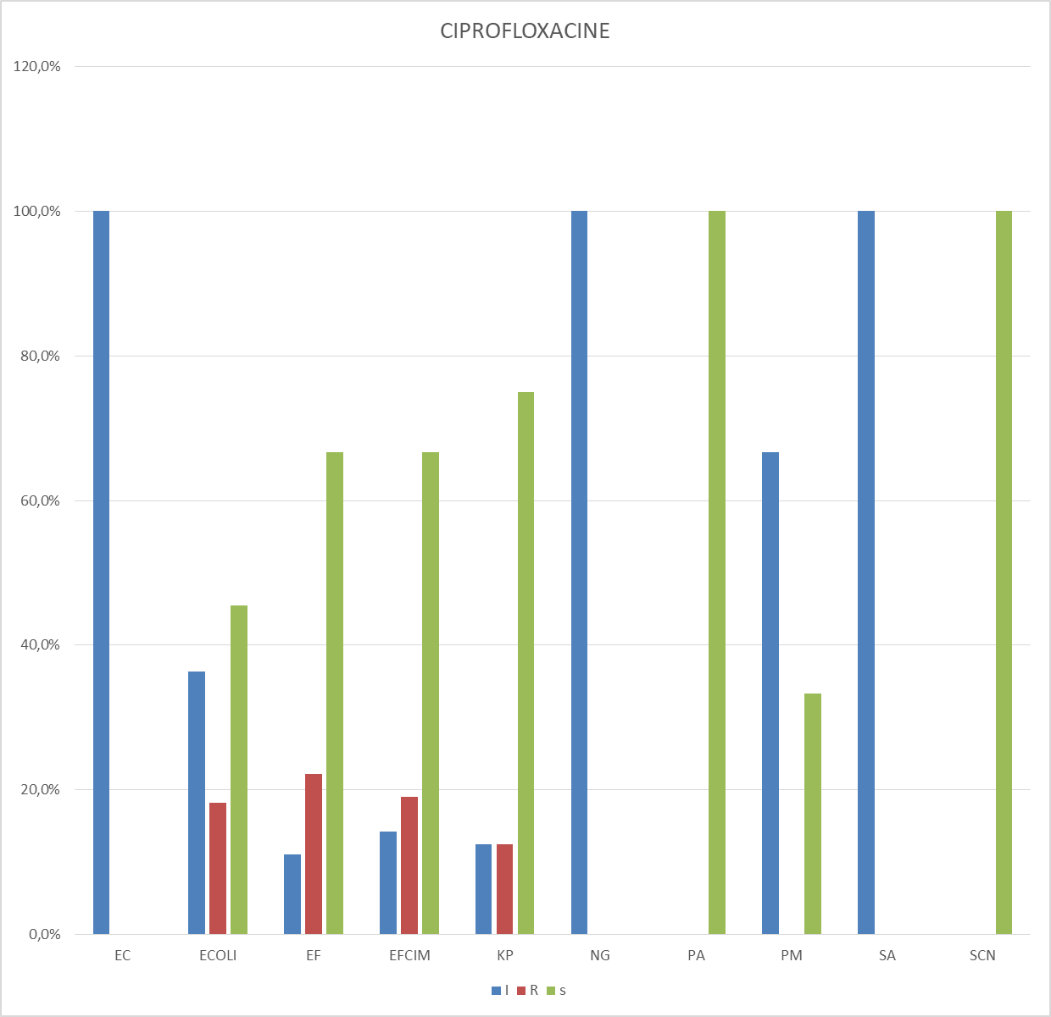

Figure 5.
THE. Coli is 45% sensitive, SCN is 100% sensitive to ciprofloxacin.
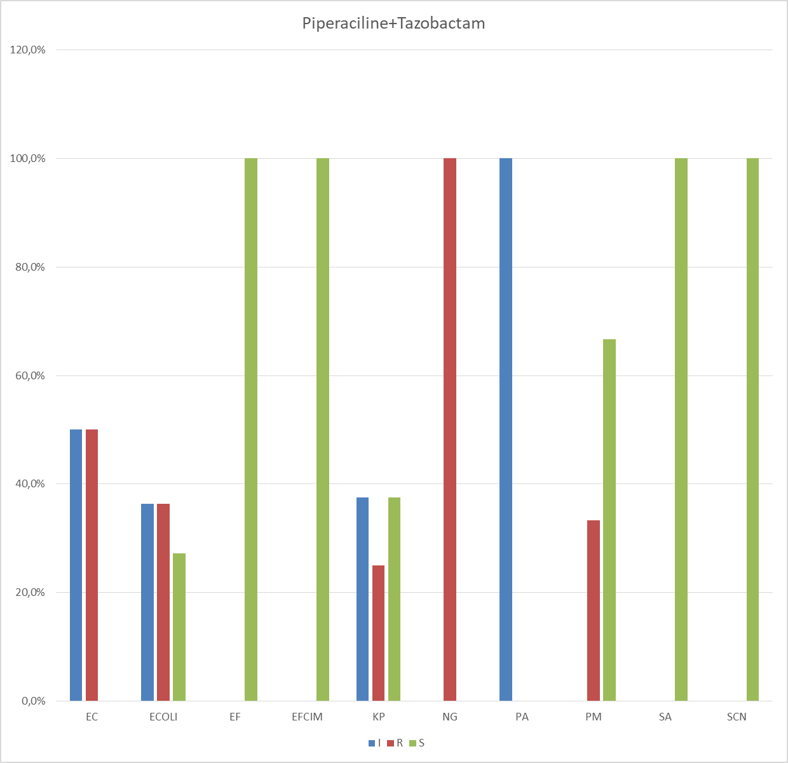

Figure 6.
THE. Coli is 40% resistant, NG is 100% resistant, SA is 100% susceptible, and SCN is 100% susceptible.
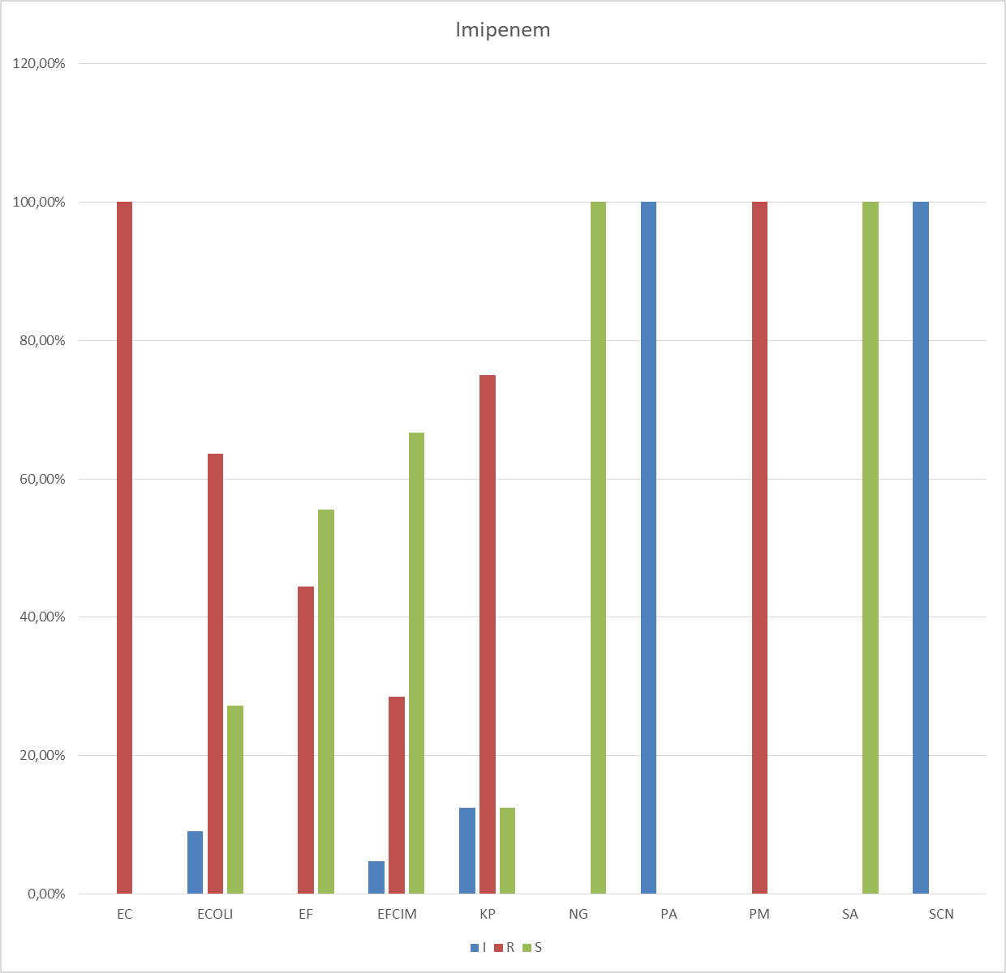

Picture 7.
THE. Coli is 60% resistant , NG and SA are 100 % sensitive .
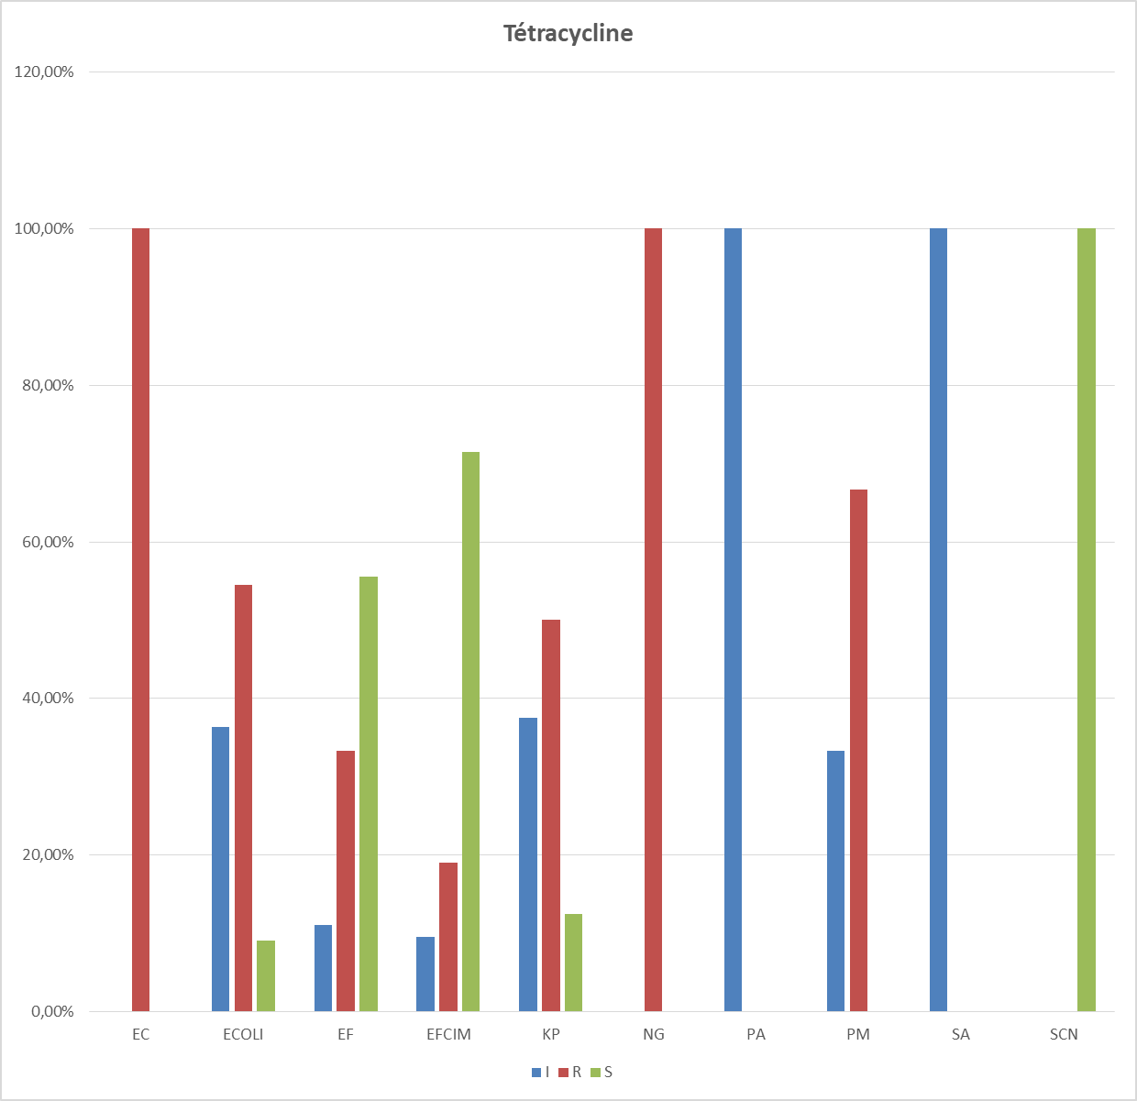

Picture 8.
THE. Coli is 55% resistant , NG is 100% resistant , SCN is 100% susceptible.
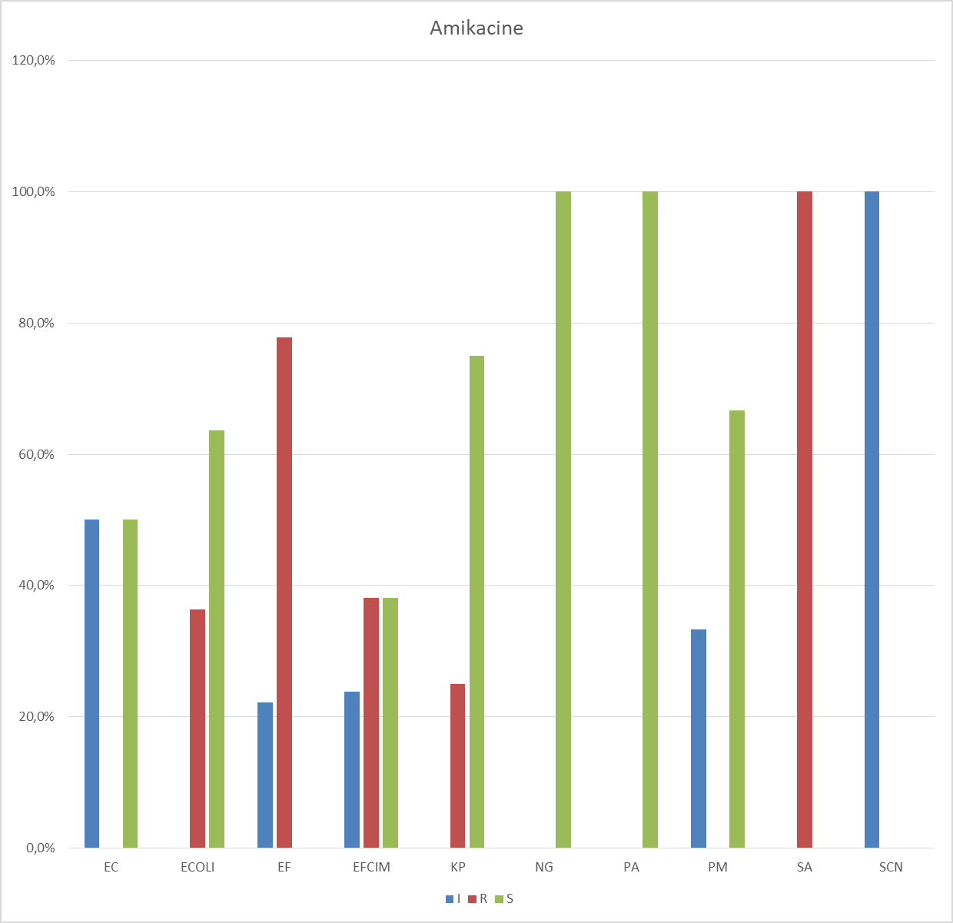

Picture 9.
THE. Coli is 60% susceptible, NG 100% susceptible, SA 100% resistant.
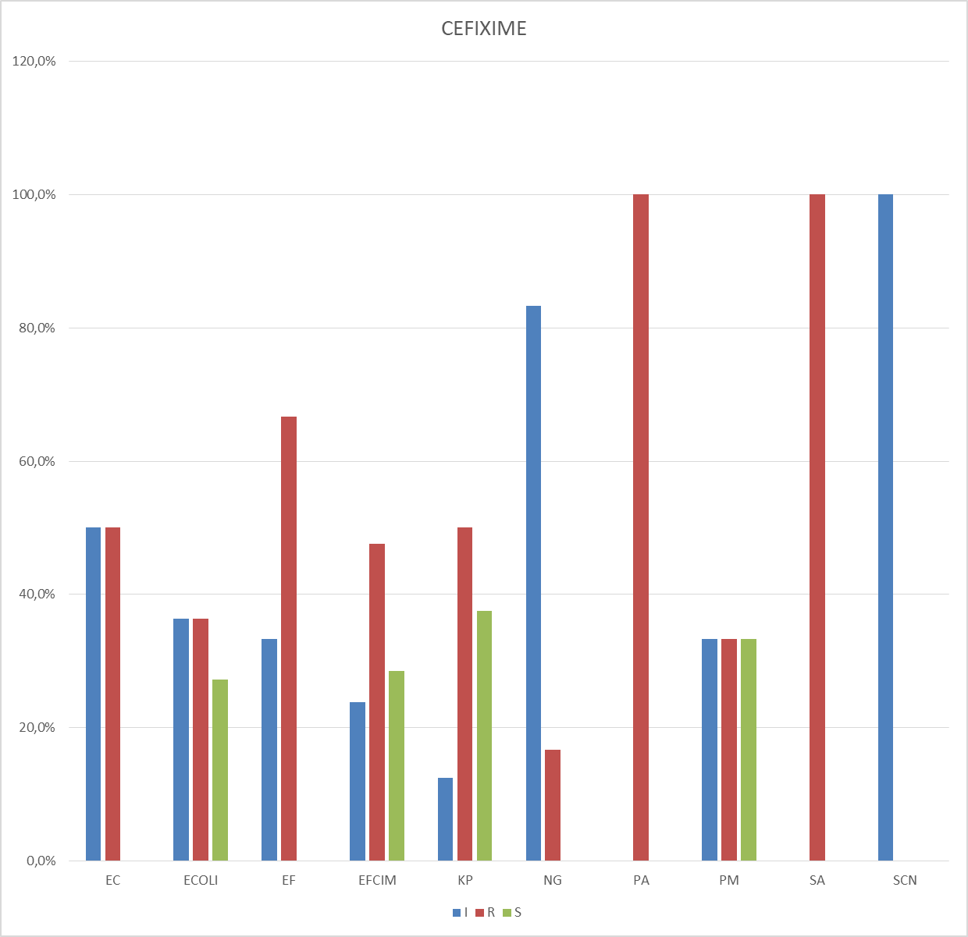

Picture 1 0
THE. Coli is 40% resistant, NG is 20 % resistant, SA is 100% resistant and SCN is 100% intermediate.
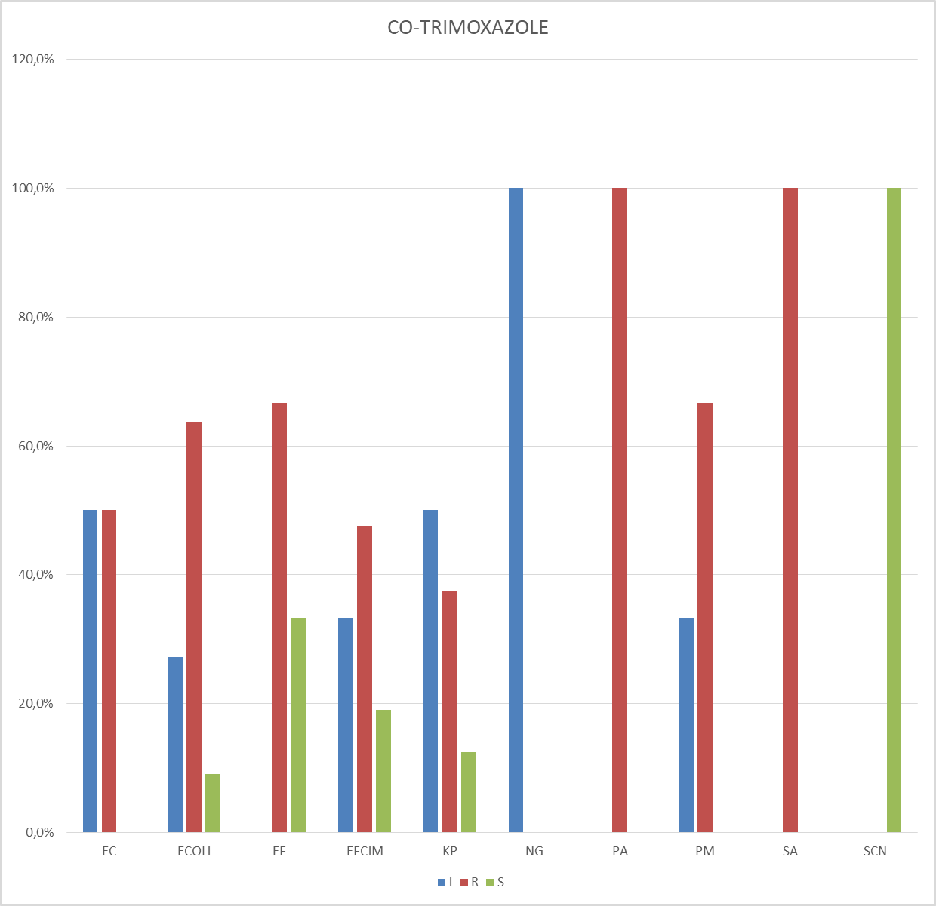

Picture 1 1.
THE. Coli is 60% resistant, NG is 100% intermediate, SA is 100% resistant, and SCN is 100% susceptible.

ANTIFUNGAL
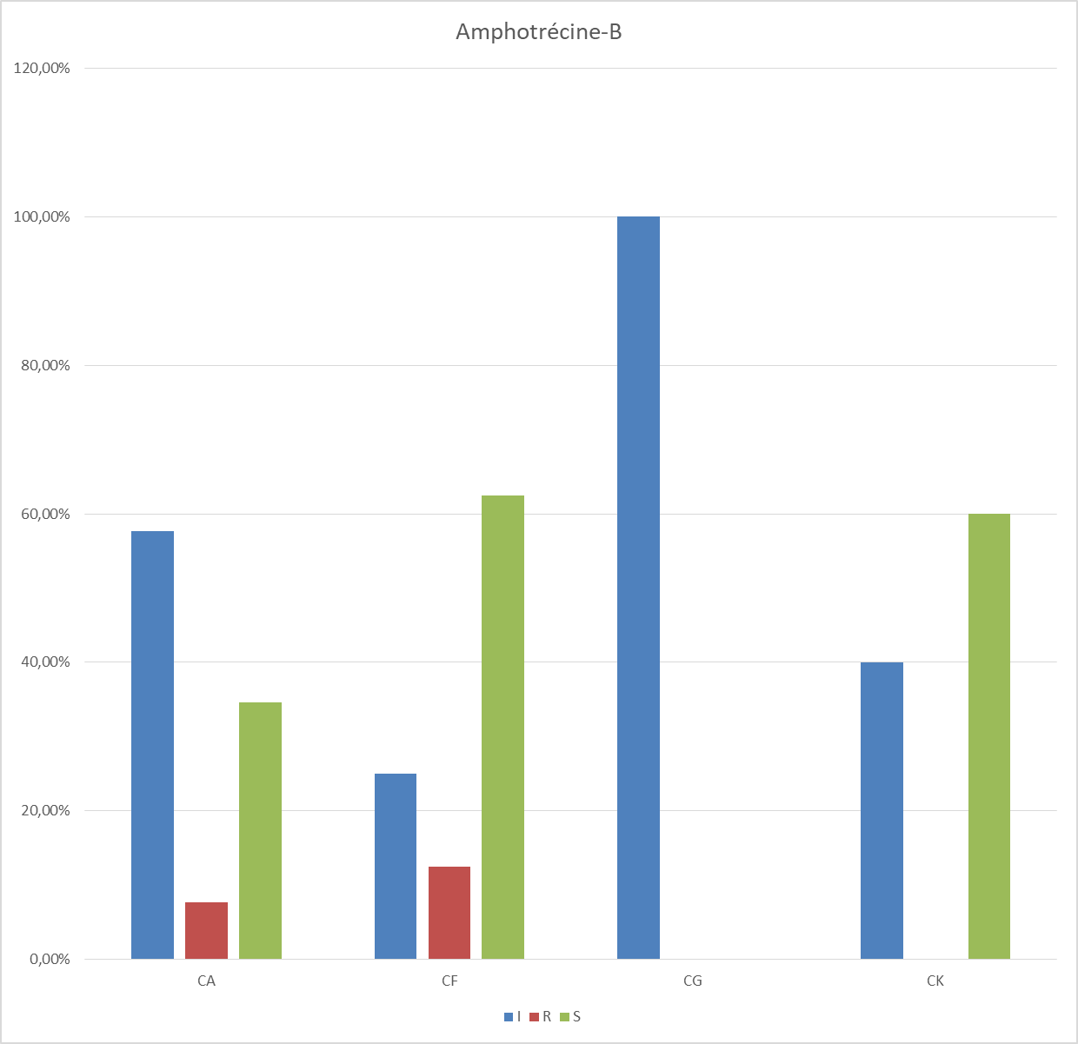

Picture 1 2.
CA is 40% sensitive, CK is 60% sensitive.
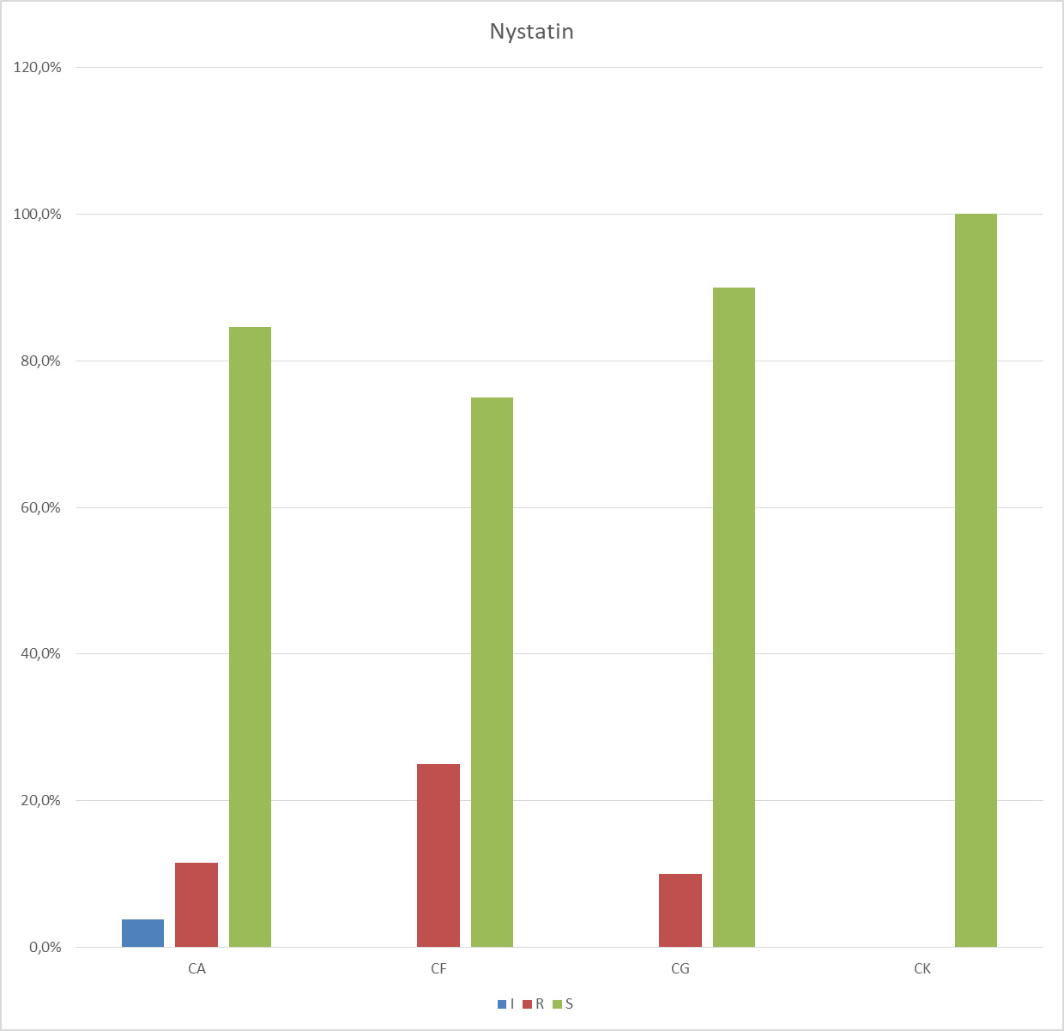

Picture 1 3
CA is 80% sensitive, CK is 100% sensitive.

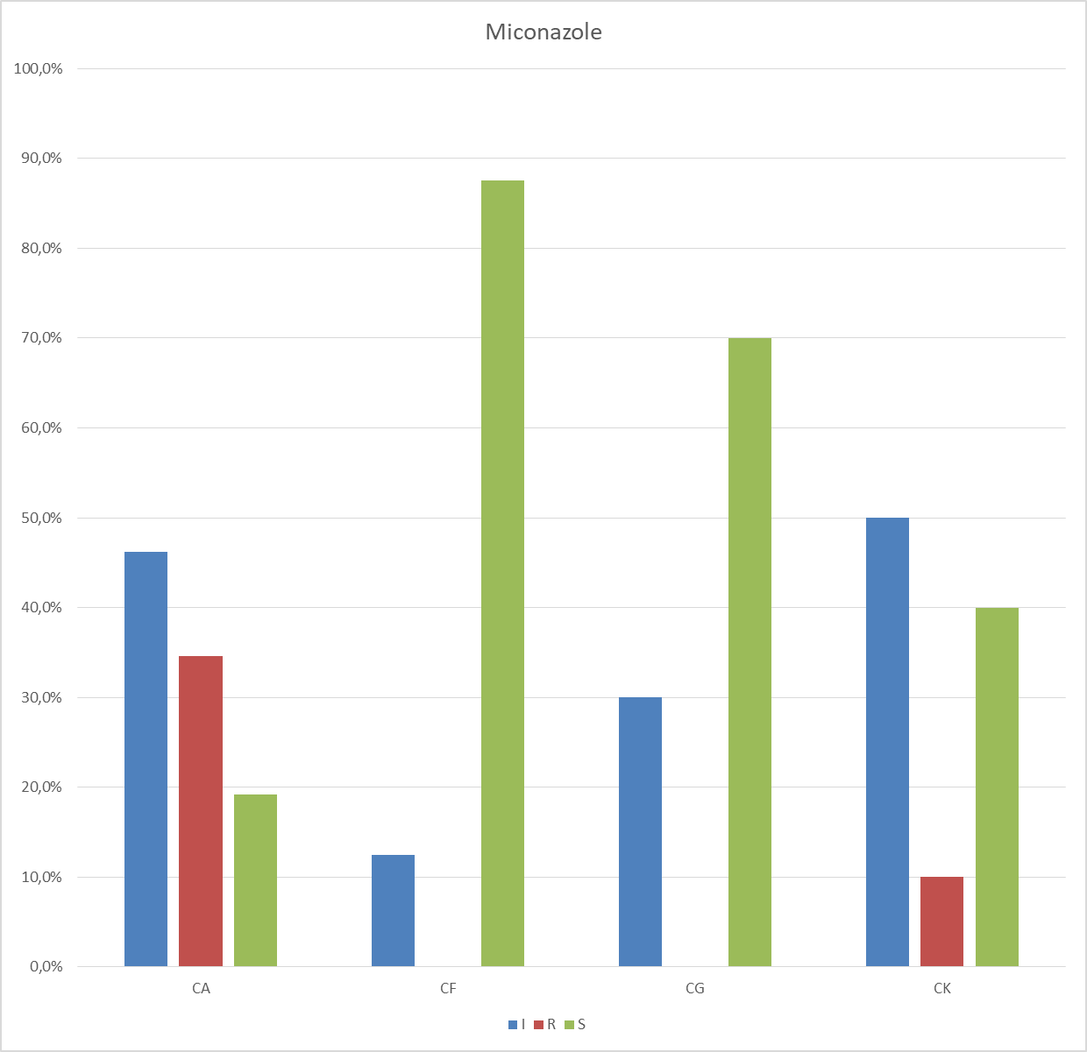

Picture 14
CA is 20% sensitive, CK is 40% sensitive.
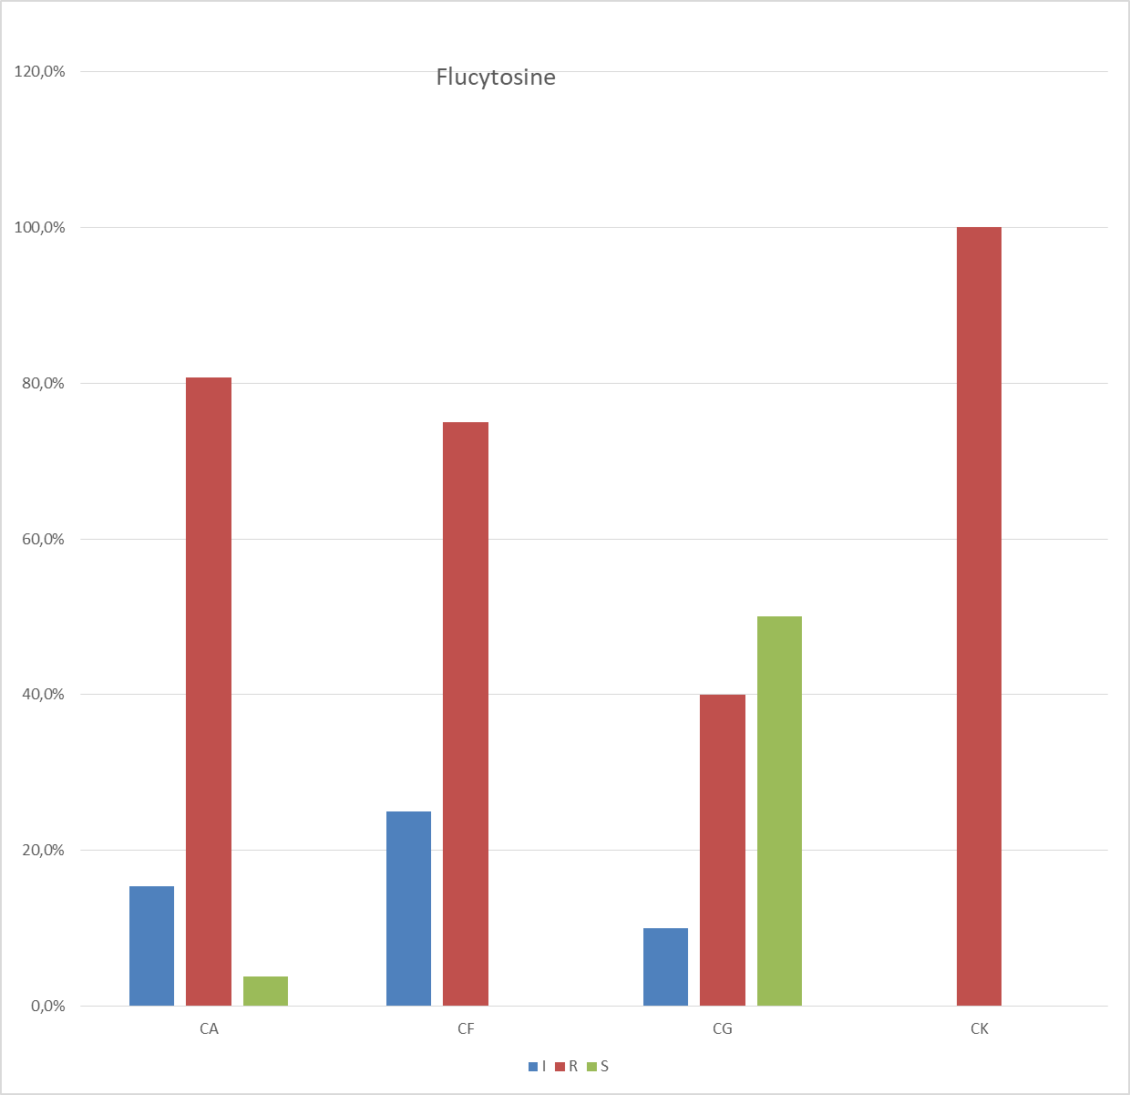

Picture 15
CA is 80% resistant, CK is 100% resistant.
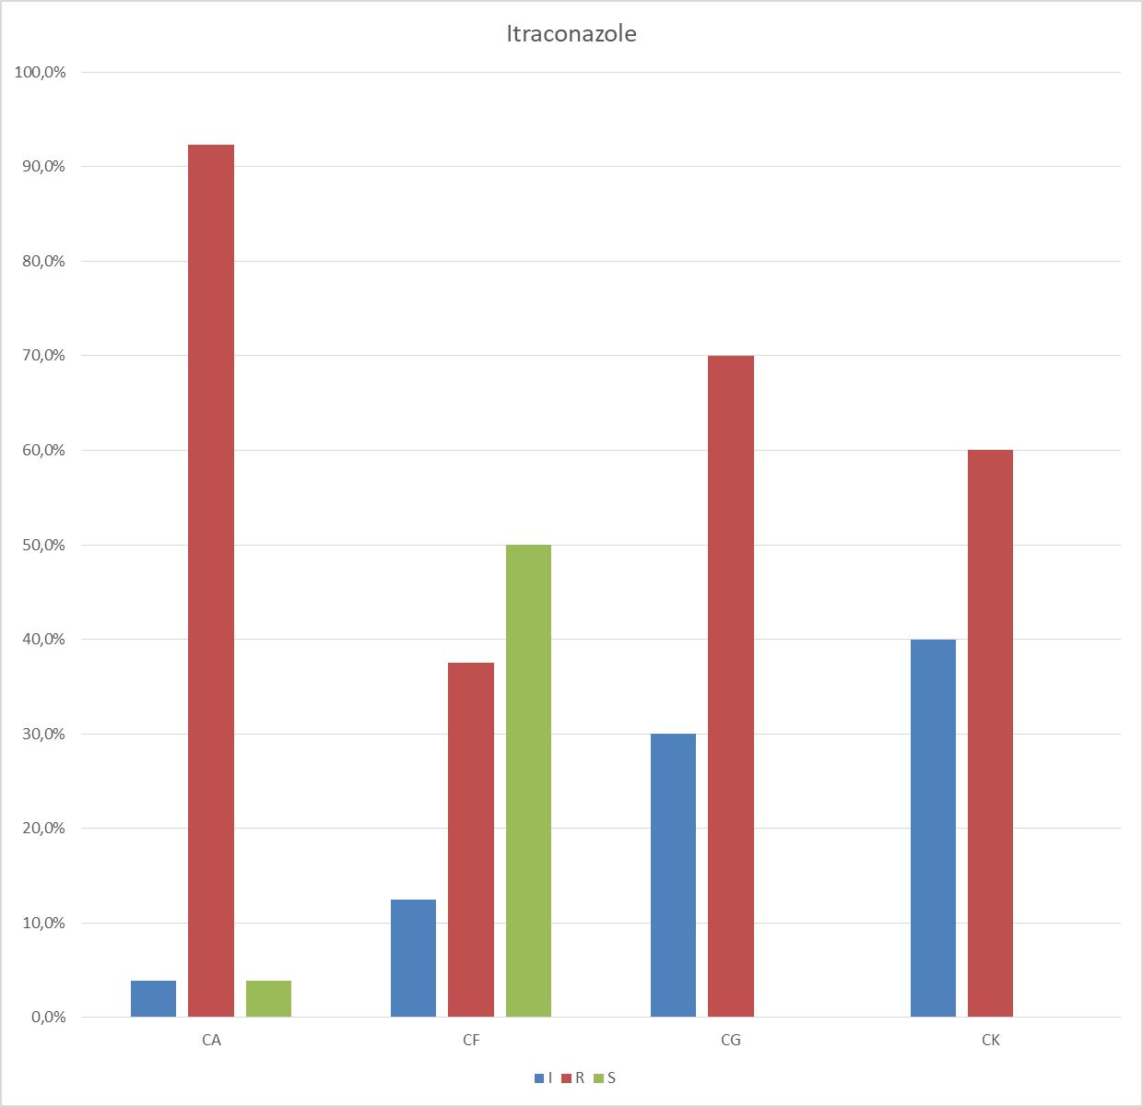

Picture 16
CA is 90 % resistant, CK is 60% resistant .
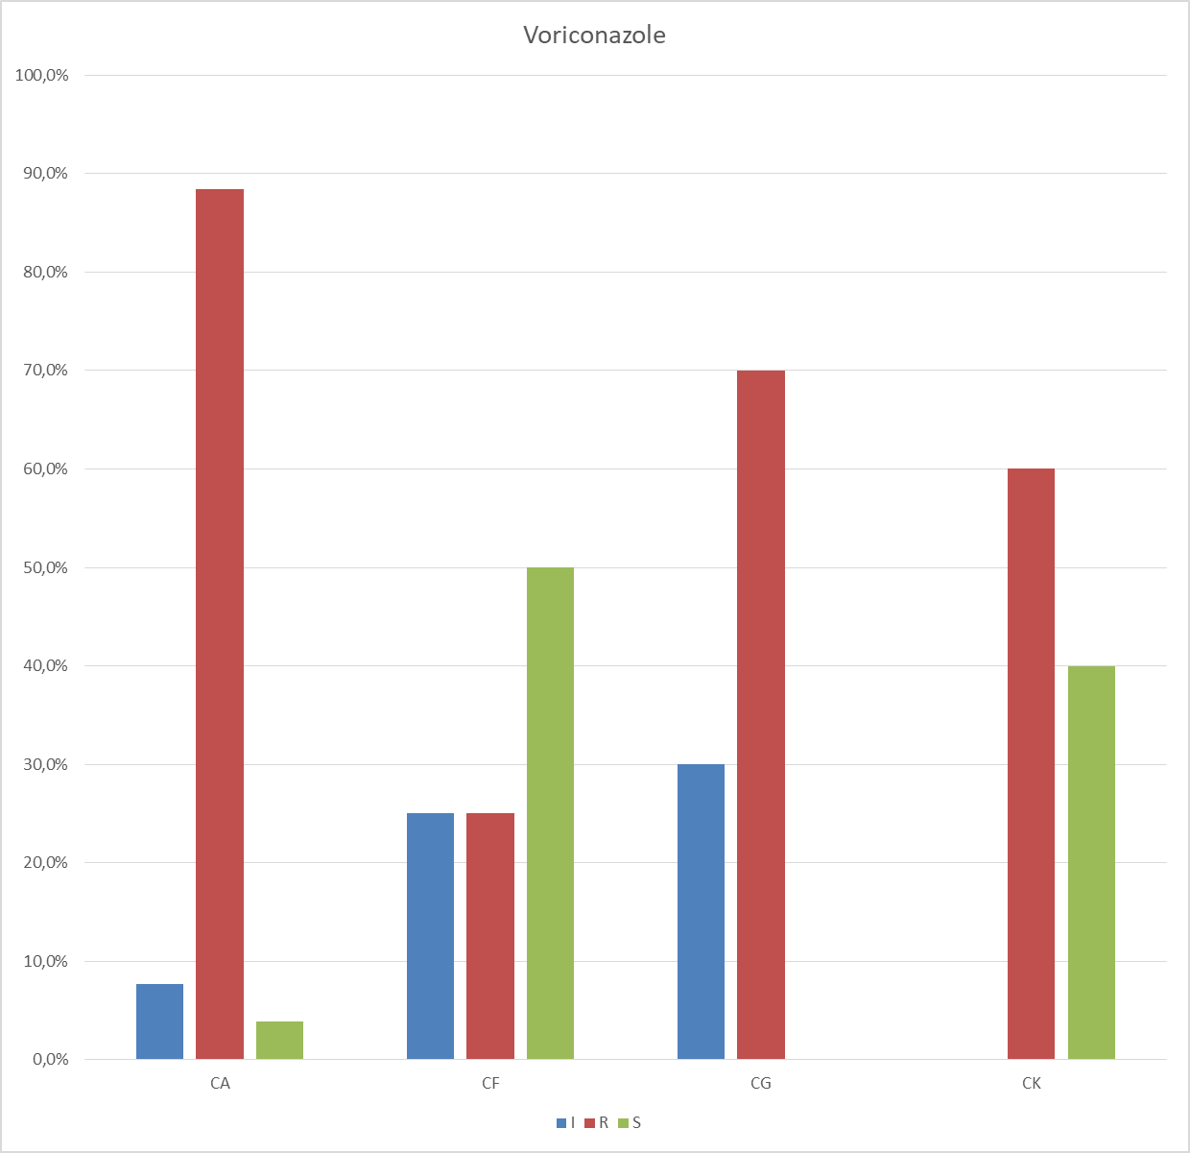

Picture 17.
CA is 90% resistant, CK is 60% resistant.
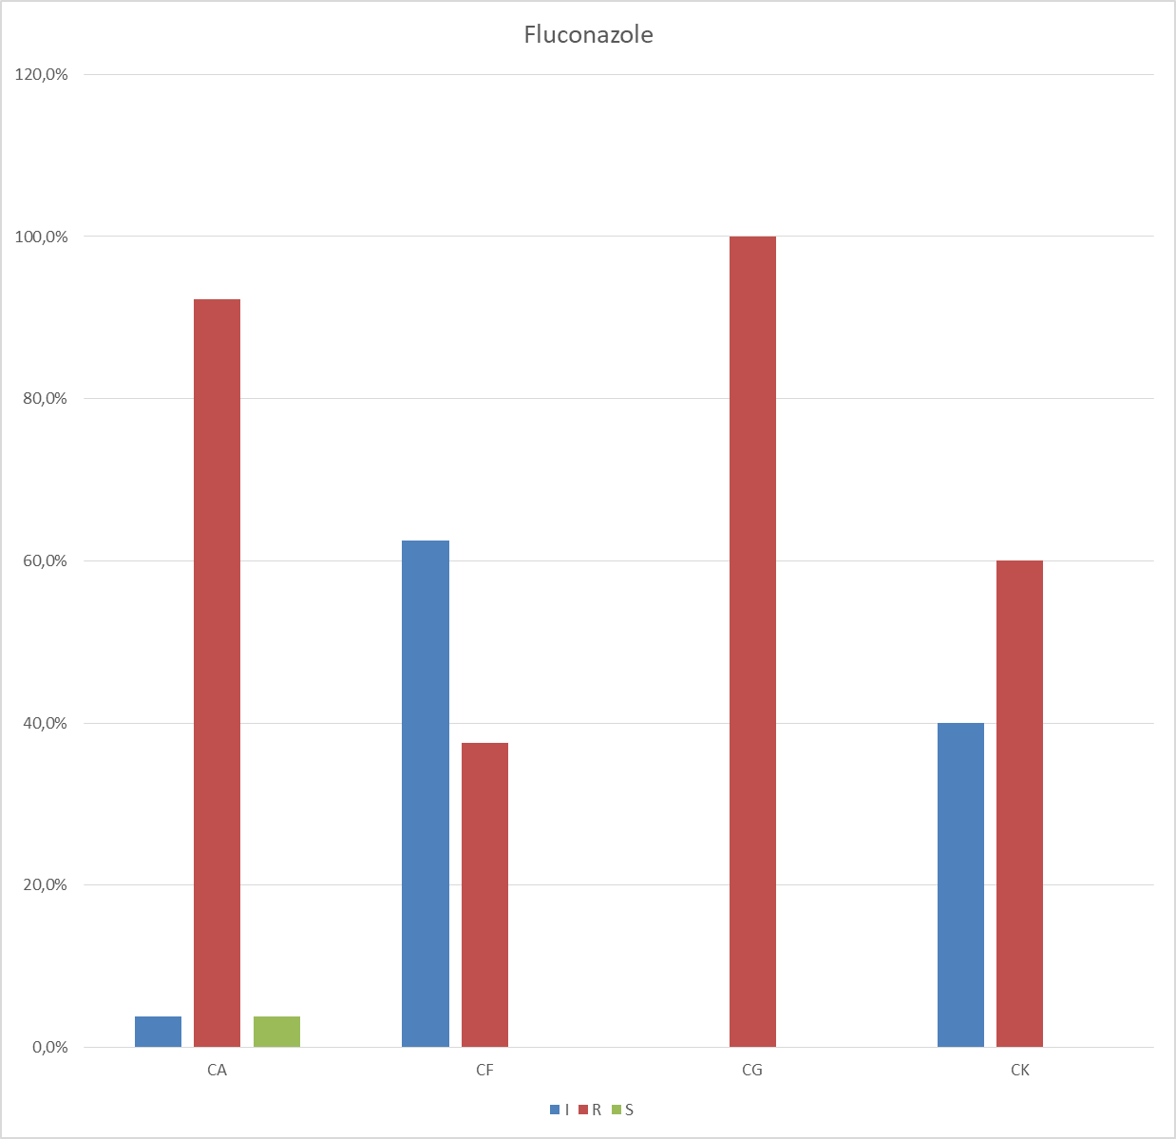

Picture 18.
CA is 90% resistant, and CK is 60% resistant.
DISCUSSION
In our study the prevalence was 23% which is close to that of Balaka . B and all in Togo in 2003 which was 21.5% (64) . Asmaa Sadik in Morocco in 2020 had found a prevalence of 18.4% (65) . In Ethiopia, a prevalence of 19.4% (66) , in Burkina-Faso a prevalence of 17.3% (67) in Denmark a prevalence of 17% (68) were found using the same diagnostic methods (score of NUGEN). The results observed in our study were much lower than the various results of other countries such as Burundi 33.30% (69) , Kenya 37% (70) Botswana 38% (71) Zimbabwe 32.50% (72) . A lower prevalence of bacterial vaginosis was found in India 10% (73) , Sweden 9.30% (74) , France in the Lille region 7.10% (21) .
We say that the prevalence rate of bacterial vaginosis varies among pregnant women from different communities. This may be due to certain factors such as: race, age of the pregnant woman, gestational age, sexual habits, vaginal hygiene, and socio-economic status. An American study reveals that the prevalence of vaginosis is higher among African Americans (23%), and lower among whites (9%) as well as among Asians 6% Hispanics 16% have an intermediate prevalence (75 –79) . This means that the risk of vaginosis seems greater in African women. The black race is one of the most well-known factors of vaginosis . In our study, the age range of pregnant women with bacterial vaginosis ranged from 17 to 45 years. This age group is close to that of Asmaa-Sadik in Morocco in 2020, which was 18 to 45 years old (65) . In the studies in Italy (23) , the United States (80) , Cameroon (81) and Burkina-Faso (82) the age groups were respectively 20 to 45, 17 to 48, 24 to 31 years old and 18 to 41 years old. In 2018 in Burundi, Gasogo had found the age group of 18 to 42 years (69) . Balaka et al in Togo found an age range of 16 to 42 years (64) . We note that BV is found at all ages of a woman's life, however BV is more frequent between 18 and 35 years (81.60%) in our study and these values are close to those of Tchelougou in Togo in 2012 of 20 to 35 years (81.15%) (84) . Similar results were obtained in Benin (73) and Senegal (85) .
Indeed, this age group corresponds to the period of full genital activity of the woman and the age of desire for pregnancy. The antecedents and clinical characteristics of pregnant women in our study paucigestes , primiparous and nulliparous are the most represented with rates of 38.80% and 48.70% respectively, while Gasago in his 2018 study in Burundi had found a rate of 46.67% for pauciparous and rates of 56.67% for nulliparous and primiparous.
Tchelougou in Togo in 2012 also found that nulliparous and primiparous were more represented with a rate of 66.90% (86) .
Faye - Kette et al found the same results in a study on the epidemiological and clinical aspects of bacterial vaginosis in Abidjan (88) this also corroborates with the work of Thakur et al in New Delhi in 1986 (89) .
In all the studies, no scientific explanation is provided to explain the phenomenon. Indeed it is in this category of pregnant women that the desire for pregnancy is more intense with a higher frequency of sexual activity.

Progression stage of pregnancy
Our results reveal that women whose evolutionary stage of pregnancy is in the second trimester are the most numerous / 46.70% / to do the analyzes relating to vaginal sampling ( pv ). While Tchelougou in Togo in 2012 found that women with second trimester pregnancy were 38% more likely to achieve a PV ; this corroborates with our results.
Gasoso in Burundi in 2018 found that the majority of pregnant women 47.78% came for analyzes relating to vaginal sampling between 33 and 36 SA.
Asmaa Sadik in Morocco in 2020 found that the majority of pregnant women 54.55% came for analyzes relating to vaginal sampling between 37 and 41SA.

Bacterial vaginosis and functional signs
In our study we found the presence of leucorrhea of medium abundance 33.60% while Tchelougou found 47.49% of leucorrhea of medium abundance.
Gasogo in his study reported that 50% of patients had no complaints related to leucorrhoea this corroborates with the result of Moutquin . JM in Quebec in 2000 (90) comes close to the results of Abdoulaye Keita in Mali in 2009 for rates of 51% and 49% respectively for the presence and absence of pathological leucorrhoea (89)
Amaa Sadik in Morocco in 2020 associated bacterial vaginosis with the presence of leucorrhea 43.48%. This result is consistent with the study carried out in Ethiopia in 2015 (65) . In the study by Faye- Kette et al, leucorrhea was isolated at a rate of 63.50% while Calzolari et al found a rate of 53.50% of patients with leucorrhoea (23,65,85) . In our series; In 76.5% of cases, the presence of leucorrhoea associated with the positive Amsel score showed a highly significant difference (p=0.001).
In our series; In 85.0% of cases, the presence of the odor associated with the positive Amsel score showed a highly significant difference (p=0.001).
In our series; In 58.3% of cases, the yellowish color of the leucorrhoea associated with the positive Amsel score showed a significant difference (p=0.008).
In our series; In 31.3% of cases, the whitish coloration of the leucorrhoea associated with the positive Amsel score showed a significant difference (p=0.008). While Tchelougou in Togo in 2012 had a frequency of whitish leucorrhea of 89%. This frequency is slightly higher than ours. Tchelougou had also found yellowish leucorrhoea in second position with a frequency of 7.31%. Asmaa Sadik for whitish 67% and yellowish 21% leucorrhoea.

Reason for consultation
In our study, prenatal consultations were the main reason for consultation to carry out a PV with a frequency of 62.50%, while Tchelougou found a frequency of 31.31%. We found a frequency of 15.78% for vulvar pruritus while Tchelougou found a frequency of 10.22%. Asmaa-Sadik in Morocco in 2020 had found a frequency of 53.64% of pregnant women who came only for CPN while vulvar pruritus with a frequency of 8.18%.
- Cultures, Antibiogram And Antifungigram

In our study of the 104 samples of vaginal secretions, 94 had pathological germs and 11 were germ-free and 24 were co-infections From the 1950s to the beginning of the 1960s, the bacteria most often isolated in perinatal infection in the United States and in Europe were S.aureus and E.coli . Today the perinatal bacterial ecology is dominated by the two germs in Africa and Latin America. In industrialized countries, S. agalactiae only emerged as a germ of perinatal infection at the end of the 1960s and still remains the predominant germ there, whereas its rarity is becoming more and more rare in tropical Africa.
The distribution of the germs identified according to the vaginal ecological groups showed in our study, a predominance of the germs of group II and a rarity of the germs of group III corresponding in this to the data of ASMAA SADIK (65) and also to the data of the literature (91) .
- Gram-positive Cocci
In our study, the germs were dominated by enterococcus 47.60%, the ASMAA SADIK result of 25.53% in Morocco (65) and the result reported in the Italian study where enterococcus was isolated in 28, 60% of cases (92–94)
- Gram-negative bacilli
They were represented with 39.8%, enterobacteriaceae represented the majority of Gram-negative bacilli in our study. While ASMAA SADIK in 2020 in Morocco also found that enterobacteriaceae were more represented with a rate of 49.38%.
Escherichia Coli and klebsiella pneumoniae were the most frequently isolated species with a rate of 17.5% and 12.7%; while ASMAA SADIK found a rate of 19.15% for Escherichia Coli and a rate of 6.38% for Klebiella pneumoniae , this result is close to our study. The aforementioned dissimilarities could be linked to the fact that the studies referenced focused on pregnant women from different countries and who have different habits (sexual, behavioral, vaginal hygiene, etc.)
- The other germs
In our Neissera study Gonorhreae was isolated with a rate of 9.5%, this result is double the Moroccan study in 2020 where gonococcus was isolated with a rate of 4.25% (65) , and triple the study Norwegian where gonococcus was isolated in 3% of cases (96) We isolated streptococcus agalactiae only once and ASMAA SADIK also isolated streptococcus B only once, these two results are similar to the study by TCHELOUGOU.D in Togo in 2012 where he isolated no streptococci (95) .
In our series no strain of Trichomonas Vaginalis was isolated, this corroborates with the study of ASMAA SADIK in Morocco in 2020, while TCHELOUGOU.D in Togo in 2012 isolated Trichomonas Vaginalis with a rate of 3.66 % (95) . Our study did not search for Chlamydia Trachomatis as well as Mycoplasmas (Mycoplasma Hominis and Ureaplasma urealyticum ). In our study, E. Coli is 20% resistant to ciprofloxacin while in the TCHELOUGOUD study in Togo in 2012, enterobacteriaceae (E. Coli) resisted ciprofloxacin in 16.67% of cases, this result is close of our study.
In our study the E. Coli is 38% resistant to cephalosporins while TCHELOUGOUD found 8.33% resistance of Enterobacteriaceae (E. Coli) to cephalosporins. In our study, the prevalence of candida albicans in pregnant women was 48.1%; while DJOHAN V, ANGORA KE, et al in Ivory Coast have a prevalence of 43% (100) , ASMAA SADIK in Morocco in 2020 found the rate of 30.49% (65) ; in argentina a rate of 33.3% (97) ; in Italy a rate of 33.8% (93) ; in Turkey a rate of 37.4% (101) ; in Togo a rate of 30.77% (95) ; in benin a rate of 38.9% (102) .
However our result is slightly higher than DJOHAN V 43%. The prevalence of vaginal candidiasis varies from country to country and from region to region within the same country. This could be due to a difference in the risk factors and behaviors of the local population.

CONCLUSION
Vaginoses are frequent and still constitute a major public health problem, especially the evolution that can lead to complications involving the upper genital tract. Several resistance factors specific to our environment are identified with an antibiogram coming out of our usual probabilistic antibiotic prescriptions. Mass awareness, bacteriological equipment as well as continuous staff training could reduce its extent in our environment.
REFERENCES

- Bohbot JM. The cervicovaginal ecosystem. http://www.infogyn.com/detail/fiches/0101020601.asp.
- Dyck EV Mehens AZ, Piot P. Diagnosis in the STD laboratory. WHO, Geneva 2000. (133 pages).
- Askienazy-Elbhar M. Bacteriological diagnosis of bacterial vaginosis in general practice. Rev.Fr.Gynécol.Obstét.1993;88:3 bis:203-6.
- Nicand E., Cavallo JO, Crenn Y. Meyran M. Value of the Gram score in the diagnosis of bacterial vaginosis. PathologyBiology 1994 May;42(5):539-43.
- Berrebi A. Antibiotics and bacterial vaginosis. Rev.Fr.Gynécol.Obstét.1993;88:3 bis:215-7.
- Thomason JL, Gelbart S. M., Scaglione NJ Bacterialvaginosis: Current review with indications for asymptomatic therapy. Am.J. Obstet.Gynecol.1991Oct; 165(1pt2): 1210-16.
- Rein MF, Holmes KK. « Non-specific vaginitis, vulvovaginal candidiasis,and trichomoniasis: clinical features, diagnosis and management », CurrClinTop Infect Dis, vol. 4, 1983, p. 281–315.
- Fleury FJ. « Adult vaginitis »,ClinObstet Gynecol, vol. 24, 1987, p. 407–38.
- Hillier SL, Nugent RP, Eschenbach DA, Krohn MA, Gibbs RS, Martin DHet coll., for the Vaginal Infections and Prematurity Study Group. « Association between bacterial vaginosis and preterm delivery of a low-birth-weight infant », N Engl J Med, vol. 333, 1995, p. 1737–42.
- Wiesenfeld HC, Hillier SL, Krohn MA, Amortegui AA, Heine RP, LandersDV et coll. « Lower genital tract infection and endometritis: Insight in to subclinical pelvic inflammatory disease »,ObstetGynecol, vol. 100, 2002,p. 456–63.
- Bump RC, Zuspan FP, Buesching WJ 3rd, Ayers LW, Stephens TJ. « Theprevalence, six-month persistence, and predictive values of laboratory indicators of bacterial vaginosis (nonspecific vaginitis) in asymptomatic women », Am J ObstetGynecol, vol. 150, 1984, p. 917–24.
- Hill LH, Ruperalia H, Embil JA. « Nonspecific vaginitis and other genitalinfections in three clinic populations », Sex Transm Dis, vol. 10, 1983, p. 114–8.
- Spiegel CA, Amsel R, Eschenbach D, Schoenknecht F, Holmes KK. « Anaerobic bacteria in nonspecific vaginitis », NEngl J Med, vol. 303, 1980, p. 601–7.
- Amsel R, Totten PA, Spiegel CA, Chen KCS, Eschenbach D, Holmes KK. « Nonspecific vaginitis: Diagnostic criteria and microbial and epidemiologic associations », Am J Med, vol. 74, 1983, p. 14–22.
- Eschenbach DA, Hillier S, Critchlow C, Stevens C, DeRouen T, HolmesKK. « Diagnosis and clinical manifestations of bacterial vaginosis », Am J ObstetGynecol, vol. 158, 1988, p. 819–28.
- Embree J, Caliando JJ, McCormack WM. « Nonspecific vaginitis amongwomen attending a sexually transmitted diseases clinic »,SexTransmDis,vol. 11, 1984, p. 81–4.
- Paavonen J, Heinonen PK, Aine R, Laine S, Gronroos P. « Prevalence ofnonspecific vaginitis and other cervicovaginal infections during the third trimester of pregnancy »,Sex Transm Dis, vol. 13, 1986, p. 5–8.
- Kurki T, Sivonen A, Renkonen O-V, Savia E, Ylikorkala O. « Bacterialvaginosis in early pregnancy and pregnancy outcome »,ObstetGynecol, vol. 80, 1992, p. 173–7.
- Platz-Christensen JJ, Pernevi P, Hagmar B, Andersson E, Brandberg A,Wiqvist N. « A longitudinal follow-up of bacterial vaginosis during pregnancy »,ActaObstetGynecolScand, vol. 72, 1993, p. 99–102.
- Meis PJ, Goldenberg RL, Mercer B, Moawad A, Das A, McNellis D et coll.« The preterm prediction study: significance of vaginal infections »,Am JObstetGynecol, vol. 173, 1995, p. 1231–5.
- Dessauve D. et al, Reproduction obstétrique; Gynécol bio, 163, 30-34, 2012.
- Hawes SE, Hillier SL, Benedetti J, Stevens CE, Koutsky LA, Wolner-Hanssen P et coll. « Hydrogen peroxide-producing lactobacilli and acquisition of vaginal infections »,J Infect Dis, vol. 174, 1996, p. 1058–63.
- Calzolari E., Masciangelo R, Milite V. Verteramo R. Bacterial vaginosis and contraceptive methods. Int. J. Gynaecol.Obstet.2000Sep;70(3) : 341-6.
- Holzman C., LeventhalJ.M., Qiu H., Jones NM, Wang J. Factor Linked to bacterialvaginosisin non-pregnantwomen. Am.J. PublicHealth2001Oct; 91 (10): 1664-70.
- Schmid GP The epidemiology of bacterial vaginosis. Int. J. Gynaecol. Obstet.1999; 67:17-20.
- Sweet RL. Gynecologic conditions and bacterial vaginosis: implications for the non-pregnant patient. Infect. Ois.Obstet.Gynecol.2000; 8(3-4):184-90.
- KouekeP. Bacterial gardnerellosis in men and women: treatment with the combination amoxicillin – metronidazole (Ospamox® - Suplin®)- Preliminary study. Med.Afr.Black.1996;43(6):384-7.
- AnagounouS.Y., NdjoumessiG., Makoutode M.etal. Bacterial vaginosis in pregnant women in Cotonou (Benin). Med.Afr.Black1994;41(4):239-42.
- Lefevre JC, Jean M, Averous S et al. Etiology of bacterial vaginosis (nonspecific vaginitis).J Gynecol Obstet Biol Reprot1985; 14:703-8.
- APM / Journal of Infectious Diseases, vol.192. In.
- Kamina Clinical Anatomy, Volume 4,237-240.
- Marie Francois Xavier Bichat. Treatise on Descriptive Anatomy, Volume 5, 274-278.
- Dutta, DC DC Dutta's textbook of gynecology (6th edn. ). London : JP Medical Ltd. (2014).
- Fedele L, Bianchi S, et al. Neovaginal mucosa after Vecchietti's laparoscopic operation for Rokitansky. syndrome: Structural and ultrastructural study. American Journal of Obstetrics and Gynecology, 195, 56–61. (2006).
- O’Hanlon, D. E., Moench, T. R., & Cone, R. A. Vaginal pH and microbicidal lactic acid when lactobacilli dominate the microbiota(2013). PLoS One, 8, e80074.
- Nunn, K. L., & Forney, L. J. Unraveling the dynamics of the human vaginal microbiome(2016). Yale Journal of Biology and Medicine, 89, 331–337.
- Muhleisen, A. L., & Herbst-Kralovetz, M. M. Menopause and the vaginal microbiome.Maturitas (2016), 91, 42–50.
- CNGOF. Ecologie bactérienne vaginale : nature, exploration et prise en charge des déséquilibres 2006. Disponible sur : www.cngof.asso.fr/d_livres/2006_GO_005_quentin.pdf.
- Denis F, Ploy MC, Martin C, Bingen E, Quentin R. BactériologieMédicale. Elsevier Masson, 2007.
- Koumans EH, Sternberg M, Bruce C, et al. The prevalence of bacterial vaginosis in the United States, 2001-2004; associations with symptoms, sexual behaviors, and reproductive health. SexTransmDis. 2007; 34:864-9. O. Pambou1, 2 P. Ntsika-Kaya1, 2 JR
- JC Lefevre. Bacterial vaginosis and its consequences in public health. The letter from the gynecologist. 2002; 268: 36 9. Bohbot JM. The cervicovaginal ecosystem. http://www.infogyn.com/detail/fiches/0101020601.asp consulted on 02/22/18.
- E. Bergogne-Bérézin. Normal vaginal flora, vaginitis and bacterial vaginosis: diagnosis and therapy. Elsevier Masson. 2007; 9:141.
- Fatiha Erraoudy; Bacteriological study of cervico-vaginal samples. Pharmacy thesis in Rabat. 2006; No. 70 p16.
- Mitchell H. Vaginal discharge; causes, diagnosis and treatment. B.M.J. 2001; 328: 1306-8.
- Ashraf-Ganjoei T. Riskfactors for bacterialvaginosis in womenattending a hospital in Kerman, IslamicRepublic of Iran. East MediterrHealth J. 2005; 11:410-5.
- Smart S, Singal A, Mindel A. Social and sexualriskfactors for bacterialvaginosis. SexTransm Infect. 2004; 80:58-62.
- Brotman RM, Klebanoff MA, Nansel TR, Andrews WW, Schwebke JR, Zhang J, et al.A longitudinal study of vaginal douching and bacterialvaginosis--a marginal structural modelinganalysis. Am J Epidemiol. 2008; 168:188-96.
- McClelland RS, Richardson BA, Graham SM, Masese LN, Gitau R, Lavreys L, et al. A prospective study of riskfactors for bacterialvaginosis in HIV-1-seronegative Africanwomen. SexTransmDis. 2008; 35:617-23.
- Bannatyne R, Smith A. Recurrentbacterialvaginosis and metronidazoleresistance in Gardnerellavaginalis, SexTransm Infect. 1998; 74: 455-6 62.
- Hillier S, Holloway M, Rabe L. Antimicrobial agent susceptibility of Lactobacillus crispatus, L. jensenii, L. gasseri, and other Lactobacillus species. In: 39th InterscienceConference on Antimicrobial Agents and Chemotherapy, ASM'sAnnual Meeting on InfectiousDiseases. American Society for Microbiology, Washington. 2000.
- Daméhan TCHELOUGOU: Contribution to the improvement of maternal and neonatal health in Togo: case of vaginal infections in pregnant women who came to consult at the CHR of sokodé.2012https://www.researchgate.net/publication /319471696 .
- Nasioudis D, Linhares IM, Ledger WJ, Witkin SS. Bacterialvaginosis: critical analysis of current knowledge. BJOG. 2016; DOI: 10.1111/1471-0528.14209.
- Turovskiy Y, Noll KS, Chikindas ML. The etiology of bacterial vaginosis. Journal of applied microbiology. 2011; 110(5):1105-1128.
- Lepargneur JP, Rousseau V. Protective role of the Doderleïn flora. Journal of Obstetrics Gynecology and Reproductive Biology. 2002;31(5):485-494.
- Livengood CH. Bacterialvaginosis : an overview for 2009.review in obstetrics and gynecology. 2009;2(1):28-37.
- Neut Christel. Course notes: Normal vaginal flora, bacterial vaginosis, intimate hygiene. Faculty of Pharmaceutical and Biological Sciences of Lille, 2015; 9 p.
- Bautista CT, Wurapa E, Sateren WB, Morris S, Hollingsworth B and Sanchez JL. Bacterialvaginosis: asynthesis of the literature on etiology, prevalence, riskfactors, and relationship with chlamydia and gonorrhea infections. MilitaryMedicalResearch. 2016;3:4.
- D. Affolabi et al. : Comparative study of the Amsel criteria and the Nugent score for the diagnosis of bacterial vaginosis in Cotonou, Benin, 2012, p. 22.
- Machado D, Castro J, Palmeira-de-Oliveira A, Martinez-de-Oliveira J, Cerca N. Bacterialvaginosis biofilms: challenges to currenttherapies and emerging solutions. Front Microbiol. 2015;6:1528.
- Vital Durand D, The young C. Dorosz: Practical guide to medication. 2015.
- Muhleisen AL, Herbst -Kralovetzb MM. Menopause and the vaginal microbiome. Maturitas. 2016;91:42–50.
- Journal of anti-infectives. Probiotics and their place in human medicine. 2014;16:33-43.
- Vidal.2016, [online]http://www.evidal.fr/. In.
- Balaka B. et al: Genital bacterial flora in the last trimester of pregnancy, Journal of Obstetrics Gynecology and Reproductive Biology 2003,32:555-561.
- Asmaa SADIK. Vaginosis and vaginitis in the last trimester of pregnancy. [Casablanca]: Cadi Ayyad University; 2020.
- Zemenu Mengistie, et al. Prevalence of bacterial vaginosis among pregnant women attending antenatal care in Tikur Anbessa University Hospital, Addis Ababa, Ethiopia. BMC Research Notes 2014, 7:822.
- Natama HM Diagnosis of non-specific vaginosis in the CHN-YO biology laboratory. ThesisProfessional Bachelor's Degree in Biomedical Analysis~ Ouagadougou; UFRISDS;200.
- Vogel I, Thorsen P, Young B, et al. Acquisition and elimination of bacterial vaginosis during pregnancy: Danish population-based study. Infect Dis Obstet Gynecol 2006,2006:94646.
- Gasogo Tharcisse. Pathological states of the vaginal flora associated with the threat of premature delivery. University of Burundi; 2018.
- MarxG, John-Stewart G, et al. Diagnosis of sexually transmitted infections and bacterial vaginosis among HIV 1 infected pregnant women in Nairobi. Int J STD AIDS 2010, 21:549–552.
- RomorenM, Velauthapillai M, et al. Trichomoniasis and bacterial vaginosis in pregnancy: inadequately managed with the syndromic approach. Bull World Health Organ 2007, 85:297–304.
- Kurewa NE, Mapingure MP, et al. The burden and risk factors of sexually transmitted infections and reproductive tract infections among pregnant women in Zimbabwe. BMC Infect Dis 2010, 10:127.
- Anagounou S.Y., Ndjoumessi G., Makoutode M. et al. Vaginose bactérienne chez la femme enceinte à Cotonou (Bénin). Méd. Afr. Noire 1994; 41 (4) : 239 -42.
- Larsson PG, Fahraeus L, et al. Predisposing factors for bacterial vaginosis, treatment efficacy and pregnancy outcome among term deliveries; results from a preterm delivery study. BMC Womens Health 2007, 7:20.
- Watts DH, Krohn MA, Hillier SL, Eschenbach DA. « Bacterial vaginosis asa risk factor for postcesareanendometritis »,Obstet Gynecol, vol. 75, 1990, p. 52–8.
- 76. Guise JM, Mahon SM, Aickin M, Helfand M, Peipert JF, Westhoff C.« Screening for bacterial vaginosis in pregnancy »,Am J Prev Med, vol. 20,n° 3 (suppl.), 2001, p. 62–72.
- McDonald H, Brocklehurst P, Parsons J, Vigneswaran R. « Antibiotics fortreating bacterial vaginosis in pregnancy », Cochrane Database Syst Rev,n°2, 2007, CD000262.
- Okun N, Gronau KA, Hannah ME. « Antibiotics for bacterial vaginosis ortrichomonasvaginalis in pregnancy: a systematic review »,Obstet Gynecol, vol. 105, 2005, p. 857–68.
- McGregor JA, French JI, Jones W, Milligan K, McKinney PJ, Patterson Eet coll. « Bacterial vaginosis is associated with prematurity and vaginal fluid mucinase and sialidase: results of a controlled trial of topical clindamycin cream »,Am J ObstetGynecol, vol. 170, 1994, p. 1048–60.
- Harmanli O.H., Cheng G.Y., et al. Urinary tract infections in women with bacterial vaginosis. Obstet. Gynecol. 2000 May; 95 (5 pt1): 710 - 2.
- Koueke P. La Gardnerellose bactérienne chez l’homme et chez la femme: traitement parl’association amoxicilline - métronidazole (Ospamox® - Supplin®) – Étudepréliminaire.Méd. Afr. Noire. 1996; 43 (6) : 384 -7.
- Mary L, et al. Nugent Score Related to Vaginal Culture in Pregnant Women. Obstet Gynecol 2001;98:79–84. 2001 by the American College of Obstetricians and Gynecologists.
- Ngunga MN. Maternal and fetal prognosis in severe pre-eclampsia. Faculty of Medicine, Thesis, Simon Kimbangu University, DRC; 2005.
- Damehan Tchelougou. Contribution to the improvement of maternal and neonatal health in iTogo: case of vaginal infections in pregnant women who came to consult at the University Hospital of Sokode. University of Lome; 2012.
- Faye-Kette AVH, Sylla-Koko OF, Cisse ALF et al. Epidemiological and clinical aspects of bacterial vaginosis in Abidjan. Med. Afr. Black 1992; 39(8/9):607-9.
- Amani BD. Profile of women consulting for contraception at the Kahembe/Goma hospital from January 1 to December 31, 2007. Faculty of Medicine, Memory, University of Goma, DRC; 2007.
- Tsogbale N. Microbiological aspect of vaginal infections: January to December 2008. ESTBA, Memory, University of Lomé, Togo; 2009: 46p.
- Thakur A.: Incidence of Gardenella vaginalis in non specific vaginitis Indian J.Med Res., 1986, 83, 567-574.
- Smart S et al. Social and sexual risk factors for bacterial vaginosis. Sexually transmitted infections.2004;80(1):58-62.
- Moutquin.JM, Maternal genital infection and premature birth Department of Obstetrics and Gynecology, University of Sherbrooke, 3001, 12th avenue North, Sherbrook, Quebec, Canada, ^{Jgynechol} Obstet Biol Reprod, 2000 P 302,.
- B. Balaka,A. Agbèrè , et al . Portage génital bactérien au dernier trimestre de la grossesse et infection néonatale précoce, Archives de pédiatrie 12 (2005) 514–519.
- Cha Han , Huiyang Li , Lulu Han , et al. Aerobic vaginitis in late pregnancy and outcomes of pregnancy,European Journal of Clinical Microbiology & Infectious Diseases, https://doi.org/10.1007/s10096-018-3416-2.
- C. GENOVESE, S. CORSELLO, et al. Alterations of the vaginal microbiota in the third trimester of pregnancy and pPROM, European Review for Medical and Pharmacological Sciences,2016; 20: 3336-3343.
- G. S. Tansarli et al. Abnormal vaginal flora in symptomatic non-pregnant and pregnant women in a Greek hospital: a prospective study .Eur J Clin Microbiol Infect Dis DOI 10.1007/s10096-016-2787-5.
- Tchelougou D, Karou DS, et al. Vaginal infections in pregnant women at the regional hospital center of Sokodé (Togo) between 2010 and 2011, Medicine and Tropical Health 2013; 23: 49-54.
- M Romoren, M Velauthapillai, et al. Trichomoniasis and bacterial vaginosis in pregnancy: inadequately managed with the syndromic approach Bulletin of the World Health Organization 2007;85:297-304.
- Maria J. Mucci, Maria L. Cuestas, et al. A prospective observational study of vulvovagintis in pregnant women in Argentina, with special reference to candidiasis, Blackwell Verlag GmbH Mycoses, 2016, 59, 429–435.
- Zeinab A et al. Vaginal infections amongpregnantwomenat Omdurman MaternityHospital in Khartoum, Sudan.J Infect DevCtries 2014.
- G Marx , et al. Diagnosis of sexually transmitted infections and bacterial vaginosis among HIV-1-infected pregnant women in Nairobi. DOI: 10.1258/ijsa.2010.010005. International Journal of STD & AIDS 2010; 21: 549–552.
- Djohan V, Angora KE, et al. In vitro susceptibility of vaginal Candida albicans to antifungal drugs in Abidjan (Ivory Coast). J Mycol Med 2012;22:129—33. http://dx.doi.org/10.1016/j.myc med.2011.11.005.
- Olowe, O., Makanjuola, O., Olowe, R., et Adekanle, D. Prevalence of vulvovaginal candidiasis, trichomoniasis and bacterial vaginosis among pregnant women receiving antenatal care in Southwestern Nigeria.(2014). European Journal of Microbiology and Immunology, 4(4), 193-197.
- A. Ogouyèmi-Hounto et al. Place of vulvovaginal candidiasis during lower genital infections and associated risk factors in women in Benin, J. Mycol. Med., vol. 24, no. 2, p. 100–105, 2014.
- Mahmoud MOBASHERI, Narges SAEEDI VARNAMKHAST, et al. Prevalence study of genital tract infections in pregnant women referred to health centers in Iran .
- Sangaré , C. Sirima , S. Bamba, A. Zida , et al.Prevalence of vulvovaginal candidiasis in pregnancy at three health centers in Burkina Faso http://dx.doi.org/10.1016/j.mycmed.2017.08.0061156 -5233/ 2017 Elsevier Masson SAS.
- Strengths: Contribution to the knowledge of factors, ecology as well as the sensitivity and resistance of vaginosis in our environment.
- Conflict of interest: The authors declare no conflict of interest to date.
- Contribution of the authors: apart from the main author who contributed from the design to the finalization, the other authors all contributed to the reading as well as to the methodological routing of the work. The last author assumes scientific responsibility.
- Acknowledgements: We would like to thank the University of Lubumbashi in the DRC, the clinical biology laboratory of the university clinics of Lubumbashi as well as that of the Diamond Medical Center for their technical support.

