**The reactive power compensation to improve wind turbine stability**

***Zakaria IDRISS1,***[[1]](#footnote-1)\****[C:\Users\Abdullah\AppData\Local\Microsoft\Windows\INetCache\Content.Word\ORCID-iD_icon-16x16.gif](https://orcid.org/0009-0005-5828-9913), Murat ARI2[C:\Users\Abdullah\AppData\Local\Microsoft\Windows\INetCache\Content.Word\ORCID-iD_icon-16x16.gif](https://orcid.org/0000-0002-2935-8204), Mahmud Esad YİĞİT[C:\Users\Abdullah\AppData\Local\Microsoft\Windows\INetCache\Content.Word\ORCID-iD_icon-16x16.gif](https://orcid.org/0000-0002-0148-1913)***

*1 Department of Electrical and Electronics Engineering, Cankiri Karatekin University, Çankırı, Türkiye*

*2 Department of Electrical and Electronics Engineering, Cankiri Karatekin University, Çankırı, Türkiye*

*2* *Department of Electrical and Electronics Engineering, Cankiri Karatekin University, Çankırı, Türkiye*

|  |
| --- |
| **Abstract**  The efficiency of the power supply network is an important factor in ensuring network reliability. Due to the rapid development of power generation, the requirements for wind system stability have become more important. In this study, the effects of reactive power on wind turbines were examined to see if the wind turbine system is unstable. The studies revealed that there are several factors affecting the stability of the wind turbine system. Wind speed and blade angle are important parameters influencing the energy production of a wind turbine. Wind speed is influenced by air temperature, which modifies air density and thus leads to variations in wind speed. The wind turbine model has been simulated in Matlab/Simulink. Reactive power compensation is a technique that can improve power efficiency by reducing current and voltage distortion. Turbine power characteristics for different pitch angles and the reactive power of wind turbines for different wind speeds are given. Some reactive power compensation techniques for improving wind turbine stability have been examined and a comparison between bibliographic methods is discussed. |
| Keywords: Electric quality, Wind speed, Reactive power compensation, Statcom |

1. **Introduction**

Power efficiency and energy savings are issues that are creating more and more concern among policymakers, economists, and academics who look at them from technological, economic, policy, and human behavior perspectives [1]. As a result, it is necessary to continue to discover and promote power efficiency, dependability, and sustainability technologies, such as the use of synchronous capacitors for reactive power correction in electrical systems [2].

Reactive power describes the power of inductive devices such as motors or capacitive loads. It is frequently calculated in volt-amps reactive (VAR) [3]. To maintain the best possible circumstances for a power system from an engineering and financial standpoint, the electrical power system must always employ the best technology for compensating reactive power [4].

It is critical to comprehend wind qualities to effectively utilize wind energy from a wind turbine system. The wind's velocity varies greatly with space, time, season, and hourly variations [5]. There are certain fluctuations in wind speed on a shorter time scale in addition to seasonal variations [6]. These oscillations, which are known as synoptic variations, peak at approximately four days. Seasonal and synoptic wind speed components are not the only factors causing turbulence. Turbulence is the term used to describe variations in wind speed during short periods, usually less than ten minutes [7].

There are many technologies for compensating power, but some are more adapted than others to electrical networks [8]. This article examines how wind speed and blade orientation affect wind power and reactive power [9].

1. **Win Turbine Modeling**

A wind farm has been simulated using Matlab/Simulink software. Figure 1 shows the simulation model corresponding to the diagram described below.

The simulated system consists of a 2 MW wind turbine connected to a 400 kVA load and a 25 kV grid via a three-phase transformer. The driving and reactive power have been evaluated as a function of wind speed and blade angles. In general, wind power stability depends on the following parameters [10]:

• The relationship between wind speed and wind turbine speed

• Blade angle as a function of wind speed

• Turbine output power

• Speed and blade angle

Electrical power is the amount of energy that flows through a given point in an electrical circuit during a unit of time. Energy storage components like capacitors and inductors in alternating-current (AC) circuits can periodically reverse the direction in which energy is moving [11]. The term active power refers to the portion of the power that is highest on average during an AC waveform is whole cycle. (The suggested of method approach is shown in Figure 1.

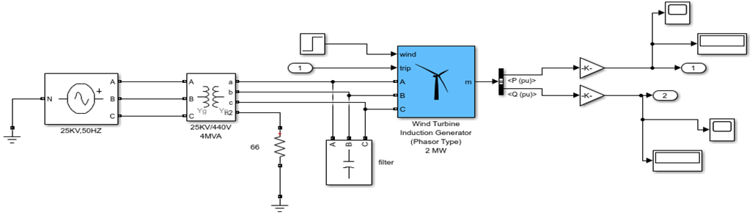

Figure 1. The framework of the suggested method.

In this study, the effect of varying wind speed on the output power of a wind turbine has been examined. The wind turbine under investigation has a maximum output power of 2 MW. This is reached at wind speeds of 12 m/s and above. Below 12 m/s, output power decreases. The output power of the wind turbine rises with increasing wind speed.

Controlling the position of the turbine's pitch angle can be used to raise the power output of the turbine. In changing the pitch angle of the blade, the wind turbine can be rotated at higher speeds as shown in Table 1 [12].

First, the wind turbine speed has been set to 12m/s and the pitch angle will be set to zero to observe the effect of the blade angle. The maximum power is obtained as shown in Figure 2. In Figure 3, the effect of the blade angle is observed more precisely, where the blade angle is changed to 10º while keeping the turbine speed unchanged. It has been noticed that the wind turbine is performance decreased.

**Table 1.** Function of turbine speed on pitch angle

|  |  |
| --- | --- |
| **Pitch angle** | **Wind speed** |
| 0 deg | 12 m/s |
| 10 deg | 12 m/s |
| 0 deg | 10 m/s |
| 0 deg | 12 m/s |
| 0 deg | 14 m/s |

In order to demonstrate the inherent instability of wind turbine systems further, an investigation was conducted to examine the influence of varying wind speeds on deliberate reactive power. This analysis stems from recognition that wind speed is not uniform across the entire length of the turbine blades, leading to power fluctuations. Initially, the wind speed has been set to a constant value of 10 m/s. Examination of the results revealed that during the first and second seconds of operation, the deliberate reactive power was more significant than in subsequent seconds.

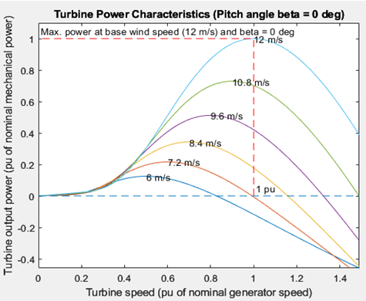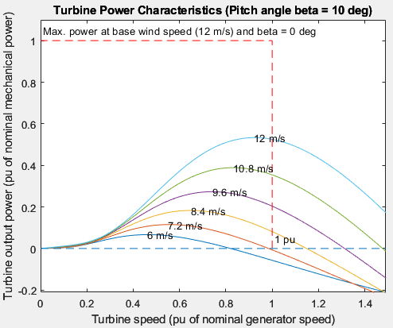**Figure 2**. Turbine power characteristics for a stable pitch angle.

To delve deeper into the analysis, simulations were carried out considering wind speeds of 12m/s and 14m/s, as depicted in Figure 4. These simulations corroborated the crucial role of wind speed in the stability of the wind turbine system.

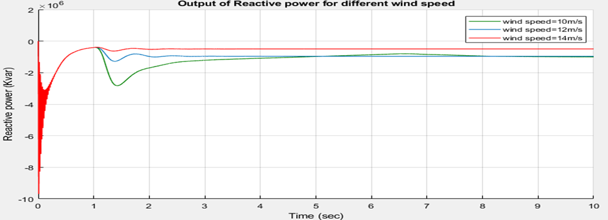

**Figure 4**. Reactive power for different wind speed.

1. **Literature Review**

Some techniques in the literature for reactive power compensation to improve wind turbine stability have been reviewed.

Farees et al. [13] highlight the significance of using devices in the flexible AC transmission system (FACTS) to increase the system is reactive power handling capability to prevent voltage instability. The study suggests the higher performance of STATCOM over traditional Static VAR Compensators (SVC). The authors present a fuzzy logic control technique for SVC and STATCOM, namely a double input, single output (DISO) FLC of the Mamdani type, to successfully reduce oscillations and enhance voltage stability. The fuzzy rule base, fuzzy inference engine, fuzzy fuzzification interface, and defuzzification interface are the four main parts of the FLC [13].

Bisen et. al [14] investigate how well SVC and STATCOM perform in comparison when it comes to improving the power system is multiple machines transient stability, which spans two areas. They highlight the increasing intricacy of power systems and the difficulties in maintaining power system stability, especially when it comes to transient and small-signal stability [14].

Elsady et al. [15] focus on improving the operation of electricity networks with integrated wind farms by a FACTS controller known as the static STATCOM. The authors highlight the capacity of the STATCOM to quickly absorb or inject reactive power into the electrical grid as a means of facilitating efficient voltage management and stability restoration when wind farms are present. They create a dynamic power system model with a wind farm integrated, managed by the suggested STATCOM, and simulate a range of extreme disturbances to verify the model's efficacy. The outcomes show how well the STATCOM controller works to quickly reduce oscillations in the electrical grid and provide reliability [15].

Hosseini et. al [16] investigate the consequences on wind farm stability of using SVC, STACOM, or DBR and the steadiness of induction generator-based wind farms with fixed speeds. They credit the asynchronous functioning of FSIG-based wind farms, which causes FSIG to take in a considerable quantity of reactive power owing to large rotor slip during faults, as the cause of the system is instability. The authors model a wind farm with SVC, STATCOM, or DBR installed, based on fixed-speed induction generators, using MATLAB/SIMULINK. To find out more about the effects of these devices on wind power plant stability under various circumstances and with different variables, they compare the outcomes of system simulations in Figure 5 and Figure 6 [16].

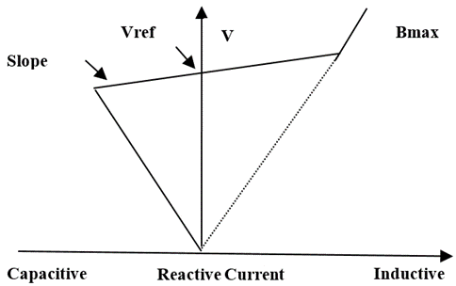

**Figure 5**. V-I characteristics of SVC.

**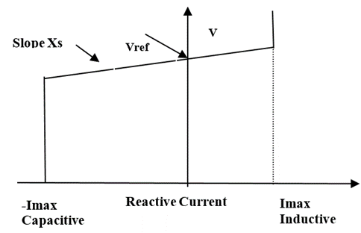**

**Figure 6**. V-I characteristics of STATCOM.

Sedighizadeh et al. [17] studied the impact of STATCOM and SVC power wind farms stability when their fixed-speed induction generators are connected to the power grid. Owing to the asynchronous nature of FSIGs, the excessive consumption of reactive power by FISG following a malfunction is the main source of instability in FSIG-based wind farms. These phenomena result from the increase in reactive power consumption brought on by the FISG is enhanced rotor slide during the failure. A comparison has been made by the authors to show how well wind farms that use SVC and STATCOM can increase stability of wind farms during and following a fault.

Wang et al.[18] studied reactive power management in wind farms to regulate voltage and minimize power loss. They analyzed a real-world wind farm in Hubei, China, considering factors like bus voltage, power factor, transformer taps, and reactive power correction. By comparing different optimization methods, they identified strategies to reduce power loss under varying wind power conditions. Additionally, through simulations, they investigated the impact of various parameters on power loss and optimized transformer taps, capacitor switching, and reactive power output to minimize system losses. Their findings highlight the significant role of transmission line losses and the effectiveness of reactive power optimization, especially at higher wind power levels [18].

Zhou et al. [19] emphasize the importance of maintaining the level of electrical power in a network to guarantee a dependable electrical power infrastructure. They specifically investigate technologies for compensating reactive power as a way to achieve this objective. The paper compares three devices: synchronous condensers, SVCs, and STATCOMs. The authors provide an overview of their technological development, principles, and performance. Additionally, the paper discusses the potential of reactive power compensation technology in the future, highlighting STATCOM is advantages, such as its superior dynamic behavior and ability to control multiple variables. The authors suggest that STATCOM is likely to become more widely used in the future [19].

1. **The comparision Between the Methods of the Literature**

Farees, Sedighizadeh, Bisen, Shrivastava, Elsady, and Hosseini all concluded that STATCOMs are more effective than SVCs in damping oscillations, enhancing voltage stability, and restoring stability after disturbances in wind farm systems. Wang's research highlighted the importance of reactive power management in wind farms, which STATCOMs can effectively address. Zhou predicted a rise in STATCOM usage due to their superior dynamic capabilities and multi-variable control. While SVCs remain viable in specific scenarios, STATCOMs generally offer better performance in power quality and stability enhancement for wind power integration. Table 2 shows the comparison of the different methods.

**Table 2.** Comparison between the methods of the Literature.

|  |  |  |
| --- | --- | --- |
| **Authors** | **Methods** | **Findings** |
| Farees et al. [11] | Fuzzy logic control technique for SVC and STATCOM | Successfully reduces oscillations and enhances voltage stability |
| Bisen et al. [12] | Evaluating SVC versus STATCOM | STATCOM improves transient stability more than SVC |
| Elsady et al. [13] | Dynamic power system model with a wind farm integrated, managed by the suggested STATCOM | STATCOM controller works well to quickly reduce oscillations in the power system and bring stability back |
| Hosseini et al [14] | Comparison of SVC, STATCOM, and DBR | STATCOM is the greatest option for enhancing the stability of network-connected wind farms |
| Sedighizadeh et al. [15] | A comparison between STATCOM and SVC | STATCOM performs better in boosting wind farm stability than SVC |
| Wang et al. [16] | Wind turbines capacity for reactive power management | Power losses in the wind farm system can be efficiently minimized by reactive power optimization |
| Zhou et al. [17] | Comparison of synchronous condensers, SVCs, and static synchronous compensators (STATCOMs) | STATCOM is likely to become more widely used in the future due to its superior dynamic behavior and ability to control multiple variables |

1. **Conclusion**

Wind power for electricity generation has recently attracted much attention in the electricity industry. Used correctly, wind power can contribute to competitively priced electricity generation, improve the capacity factor of renewable energy sources, and extend regeneration capabilities. The power coefficient as a function of air density, wind speed, blade angle and other factors are all considered when producing or installing wind turbines. In this paper, a wind turbine generator was modeled and simulated using MATLAB/SIMULINK. Different levels of wind speed with different angles of inclination were taken into account to show the power characteristics of the wind turbine when integrated into a power system. These characteristics show that the wind energy system is unstable. Different wind levels were used to predict and monitor the system is active and reactive power. It is concluded that the wind energy system needs compensation techniques to reduce energy loss. Literary studies have revealed several reactive power compensation techniques such as STATCOM, SVC, static capacitor, and FLC. The scientific authors have examined the reactive power compensation system and a comparison of these approaches is also given that STATCOM is the best reactive power compensator.

**References**

1. Upadhyai R., & Garg L. An Integration of the SVC and STATCOM Technologies into Wind-Based Power Systems. International Conference on Futuristic Technologies (INCOFT), Belgaum, India, 2022, pp. 1–6.
2. Sumper, A. & Baggini, A. (2012). Electrical Energy Efficiency Technologies and Application. John Wiley and Sons, West Sussex, United Kingdom, ISBN: 9780470975510.
3. Kushwah R. & Gupta M. Modelling & simulation OF SVC and statcom for enhancement of power system transient stability using Matlab*.* International Conference on Electrical, Electronics, and Optimization Techniques (ICEEOT), Chennai, India,2016, pp. 4041–4045.
4. Continental Control Systems, Reactive Power, *Continental Control Systems,* Boulder CO, USA, 2012.
5. Rafiqi I. & Bhat A. Role of STATCOM in improving the power quality issues in hybrid power plant connected to a power grid, 4th International Conference on Recent Developments in Control, Automation & Power Engineering (RDCAPE), Noida, India, 2021, pp. 384–387.
6. 11-IJTPE-Issue57-Vol15-No4-Dec2023-pp72-82.pdf.
7. Ahmad, R., & Abdul-Hussain, M. (2021). Modeling and Simulation of Wind Turbine Generator Using Matlab-Simulink. *J. Al-Rafidain Univ. Coll. Sci.* ISSN 1681-6870 Online ISSN 2790-2293,2(1), pp. 282–300.
8. 9-IJTPE-Issue56-Vol15-No3-Sep2023-pp.68-76.pdf.
9. Demirovic N. Impact of STATCOM and SVC to voltage control in systems with wind farms using induction generators (IG). Mediterranean Conference on Power Generation, Transmission, Distribution and Energy Conversion (MedPower), Belgrade, Serbia, 2016, pp.16-29.
10. Ayaz M., Colak I., & Bayindir R. Matlab/gui based wind turbine generator types on smart grid systems. International Conference on Renewable Energy Research and Applications (ICRERA*),* Birmingham, United Kingdom,2016, pp. 1158–1162.
11. Wei X., Qiu X., Xu J., & Li X. Reactive Power Optimization in Smart Grid With Wind Power Generator. Asia-Pacific Power and Energy Engineering Conference, Chengdu, China,2010, pp. 1–4.
12. Apata, O., & Oyedokun, D. (2018). Novel Reactive Power Compensation Technique for Fixed Speed Wind Turbine Generators. *IEEE PES/IAS PowerAfrica*(pp. 628–633). Cape Town.
13. Farees, S., Gayatri, M., & Umanth, D. (2014). Performance Comparison between SVC and STATCOM for Reactive Power Compensation by Using Fuzzy Logic Controller. ISS N,3(1).
14. Bisen P., & Shrivastava A. Comparison between SVC and STATCOM FACTS Devices for Power System Stability Enhancement. International Journal on Emerging Technologies,2010, pp. 101-109.
15. Elsady G., Mobarak A., & Youssef A. (2010). STATCOM for Improved Dynamic Performance of Wind Farms in Power Grid.International Middle East Power Systems Conference (MEPCON), Cairo University, Egypt, pp.19-21.
16. *International Journal of Engineering and Applied Sciences (IJEAS)* Int. J. Eng. Appl. Sci. IJEAS, 2018, 0(1).
17. Sedighizadeh, M., Rezazadeh, A., & Parayandeh, M. (2010). Comparision of SVC and STATCOM impacts on wind farm stability connected to power system. *International Journal of Engineering and Applied Sciences (IJEAS),*2(2), Issue (2),pp.13-22.
18. Wang, Y. (2019). Reactive Power Optimization of Wind Farm Considering Reactive Power Regulation Capacity of Wind Generators*. Innovative Smart Grid Technologies (ISGT Asia),* Chengdu, China, pp. 4031–4035.
19. Zhou X., Wei K., Ma Y., & Gao Z. A Review of Reactive Power Compensation Devices. *International Conference on Mechatronics and Automation (ICMA),* Changchun, China,2018, pp. 2020–2024.

1. \* Corresponding author. *e-mail address: zakariaidriss223@gmail.com* [↑](#footnote-ref-1)