**Hybridization of Graphene Oxide and Silver Nanoparticles for Cementitious Composites**

***Taha Seham Ismail AL-BAYATI1 [C:\Users\Abdullah\AppData\Local\Microsoft\Windows\INetCache\Content.Word\ORCID-iD_icon-16x16.gif](https://orcid.org/xxxx-xxxx-xxxx-xxxx), Barış ŞİMŞEK1,[[1]](#footnote-1)\* [C:\Users\Abdullah\AppData\Local\Microsoft\Windows\INetCache\Content.Word\ORCID-iD_icon-16x16.gif](https://orcid.org/xxxx-xxxx-xxxx-xxxx), Ömer Faruk DİLMAÇ1 [C:\Users\Abdullah\AppData\Local\Microsoft\Windows\INetCache\Content.Word\ORCID-iD_icon-16x16.gif](https://orcid.org/xxxx-xxxx-xxxx-xxxx),Tayfun UYGUNOĞLU2 [C:\Users\Abdullah\AppData\Local\Microsoft\Windows\INetCache\Content.Word\ORCID-iD_icon-16x16.gif](https://orcid.org/xxxx-xxxx-xxxx-xxxx), Haluk KORUCU1 [C:\Users\Abdullah\AppData\Local\Microsoft\Windows\INetCache\Content.Word\ORCID-iD_icon-16x16.gif](https://orcid.org/xxxx-xxxx-xxxx-xxxx), Mücahit UĞUR1 [C:\Users\Abdullah\AppData\Local\Microsoft\Windows\INetCache\Content.Word\ORCID-iD_icon-16x16.gif](https://orcid.org/xxxx-xxxx-xxxx-xxxx), Özge BİLDİ CERAN1 [C:\Users\Abdullah\AppData\Local\Microsoft\Windows\INetCache\Content.Word\ORCID-iD_icon-16x16.gif](https://orcid.org/xxxx-xxxx-xxxx-xxxx)***

*1 Faculty of Engineering, Chemical Engineering Department, Çankırı Karatekin University, Çankırı, Türkiye*

*2Faculty of Engineering, Civil Engineering Department, Afyon Kocatepe University, Afyon, Türkiye*

|  |
| --- |
| **Abstract**  Graphene oxide (GO) and silver nanoparticles (AgNPs) are attractive nanomaterials due to their unique structure and physico-chemical properties. While the GO has a high surface area, AgNPs have antibacterial, thermal, and electrical properties. Hybridization of these materials' synergistic characteristics has proven beneficial in several applications such as electronics, catalysis, textiles, electrochemical biosensing, drug delivery, and antimicrobial agents. The GO-AgNPs dispersion with low particle size and high stability was important for such dispersion application. This study proposes Hummer’s method- production of graphene oxide and silver nanoparticles dispersion. Four factors such as GO amount, AgNPs amount, and ultrasonic prop. time (UPT), and amount of distilled water (DIW) was determined to be effective on graphene oxide/silver nanoparticles dispersion features. Four quality criteria such as electrical conductivity, thermal conductivity, particle size, and zeta potential were selected. Taguchi method was applied for the first time to achieve the analyzed and optimized features of graphene oxide/silver nanoparticles. It was concluded that the optimum particle size and zeta potential of the GO/AgNPs dispersion are found as 164 ± 17 nm and -44 mV ± 0.4 mV, respectively. The hybridized GO/AgNPs dispersion zeta-potential varied between -30 mV and -60 mV. Furthermore, hybridized GO/AgNPs dispersion mixed cementitious composites were designed. The optimum GO and AgNPs hybrid usage was determined as 5 mg for each nanofiller and the highest compressive strength was determined as 22MPa by usage of 5 mg of GO and 5 mg of AgNPs. It was also concluded that compressive strength and ultrasonic pulse velocity of the GO-AgNPs dispersion mixed cementitious composites decreased with the GO and AgNPs usage of more than 5 mg due to the decrement in dispersion stabilities. |
| Keywords: Cementitious composites, Graphene oxide silver nanocomposites, Hybrid nanoparticles, Synergistic effect |

1. **Introduction**

Graphene is one of the attractive 2D nanomaterials in both industrial and scientific fields is that it has unique mechanical, thermal, electrical, and optical properties [1, 2]. Monolayer graphene with a high thermal conductivity of 6000 W\*m-1\*K-1 [3], electrical conductivity of 5000 S\*cm-1 [4], and Young's modulus of ~1 TPa [5] makes that one of the most unique materials [6, 7]. Physical such as chemical vapor deposition or chemical methods such as oxidation and reduction processes can be mostly preferred in graphene synthesis. Since the production cost is taken into consideration, chemical methods are the most preferred method, especially Hummer’s method. This method consists of the fact that graphite is chemically oxidized to graphene oxide (GO) and reduced with agents to reduced graphene oxide. GO is a kind of material that is very useful with functioning groups to obtain uniform and stable dispersion. Silver nanoparticles (AgNPs), on the other hand, are preferred because of their spherical structure, antibacterial activity, and relatively low-cost production [8]. AgNPS are preferred among all of the metal-based nanoparticles due to their low toxicity, and high electrical conductivity [9]. Moreover, AgNPs could be obtained with biosynthesis and green chemical reduction processes.

While cementitious composites are receiving increasing attention, nanofillers and the design of these composites play an important role. Nanofillers with their high surface area, ability to fill cracks, and superior mechanical properties give important properties to cementitious composites [10]. GO provides valuable properties to cementitious composites due to its relatively low production cost and ease of production [11]. AgNPs due to their antibacterial properties and low-size structure are preferred by the researchers [12]. Dispersion features such as particle size distribution and stability are very important in nanomaterial applications because unstable dispersion has a poor effect in many applications including building materials. Although GO and AgNPs are used to improve cementitious composites, statistical analysis of hybrid GO and AgNPS dispersion and combined application of GO and AgNPs in cementitious composites has not been encountered in the literature.

In the present study, it was aimed to analyze, characterize and optimize the hybridization of GO and AgNPs dispersion and, dipersed hybrid GO and AgNPs mixed cementitious composites (GACEC). For this purpose, the production of graphene oxide by the Hummers method by reacting graphite with potassium permanganate. Moreover, Glucose-reduced dispersed AgNPs were synthesized by a wet-chemical process. Zeta potential, particle size, electrical conductivity, and pH of the solution were preferred as responses. The amount of GO, amount of AgNPs, ultrasonic prop time (UPT), and distilled water amount (DI) as factors were analyzed by the Taguchi method based on main effect plots. Moreover, the dispersion properties of hybrid GO and AgNPs on cementitious composites were evaluated.

1. **Materials and Methods**

The chemicals used in the production of GO are high-purity graphite as a carbon source (< 50 µm, pure of 99%, Merck), sodium nitrate (NaNO3), potassium permanganate (KMnO4) and sulphuric acid (H2SO4) as oxidizers, hydrogen peroxide (H2O2:30 wt. percent) as reaction terminator, and hydrochloric acid as a metal ions removal (HCl). Silver nitrate (AgNO3, > 99.8%) as a precursor, soluble starch as a capable agent, sodium hydroxide pellets as pH adjuster (NaOH,>99%), D (+) glucose anhydrous as a reducer agent was used to obtain AgNPs. A water bath with a circulator (Polyscience 15-R) was used to control the reaction temperature in the experimental systems, and Merck Millipore brand pure water equipment was used to create the pure water. Hummer’s method was used in the synthesis of GO [13, 14]. Hummer’s method consists of strong oxidation of graphite with KMnO4, termination of the reaction with H2O2, and removal of metal ions with HCl. AgNP synthesis consists of dissolving the starch solution and then adding AgNO3 and glucose and pH adjustment (Figure 1).

**Table 1.** Taguchi orthogonal array for preparation of GO and AgNPs hybrid dispersion [15].

|  |  |  |  |  |
| --- | --- | --- | --- | --- |
| Exp. No\* | GO (mg) | AgNPs (mg) | UPT (min.) | DI (mL) |
| GA1 | 5 | 5 | 5 | 300 |
| GA2 | 5 | 10 | 15 | 400 |
| GA3 | 5 | 15 | 30 | 500 |
| GA4 | 10 | 5 | 15 | 500 |
| GA5 | 10 | 10 | 30 | 300 |
| GA6 | 10 | 15 | 5 | 400 |
| GA7 | 15 | 5 | 30 | 400 |
| GA8 | 15 | 10 | 5 | 500 |
| GA9 | 15 | 15 | 15 | 300 |

\* L9 (34) Taguchi design

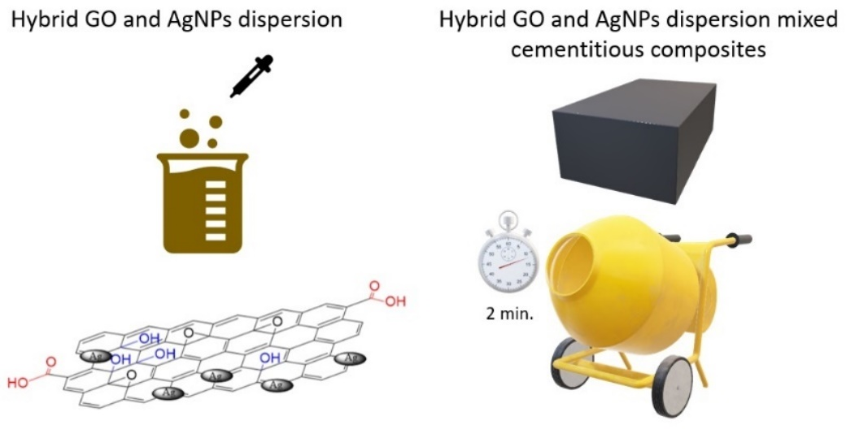

Figure 1. The following Methodology for GACEC production.

Hybrid dispersions were prepared according to the conditions designed according to the L9 Taguchi design [15]. The amount of GO, amount of AgNPs, UPT, and distilled water amount DI with each having four levels was selected as factors. Particle size and zeta potential were determined for each experimental run. After the characterization of dispersed hybrid GO and AgNPs, dispersed nanofillers were mixed with cement pastes (Figure 1). (Cement: water: superplasticizer 1: 0.45: 0.01). Pozzolanic type CEMIV/B (P) 32.5 cement and BASF 608 Masterglenium 608 superplasticizer were used to produce hybrid dispersed-GO and AgNPs mixed cementitious composites.

1. **Results and Discussion** 
   1. **Characterization of hybrid GO and AgNPs dispersion**

The UV-vis spectra obtained for each hybrid dispersed-GO and AgNPs considering the Taguchi design could be seen in Figure 2 [15]. The spectra showed a maximum absorption peak in the 215-275 nm regions and a weak peak in the 280-350 nm regions. The obtained absorption peaks indicate the presence of graphene oxide. The expected AgNPs peaks in the 390-420 nm regions were not found in the samples. However, the apparent shift in the peak around 320 nm show the hybrid GO and AgNPs presence [16].

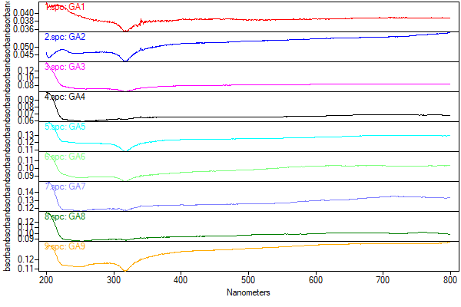

**Figure 2**. UV-Visible spectra for hybrid GO and AgNPs dispersion [15].

The main effect plots for the mean of particles size, zeta-potential and thermal conductivity drown by Minitab software could be seen in Figure 3 [15]. Particle size of hybrid dispersed-GO and AgNPs was decreased with the increasing of UPT and, increased with decreasing DIW amount (Figure 3a) [15]. Zeta-potential of hybrid dispersed-GO was decreased with the increasing of GO amount (Figure 3b) [15]. It has been observed that UPV treatment provides an advantage in dispersing nanofiller and ensuring homogeneous distribution. Thermal conductivity was decreased with the increasing of GO and AgNPs amount (Figure 3c) [15]. This result can be attributed to the oxygenated functional groups of GO.

**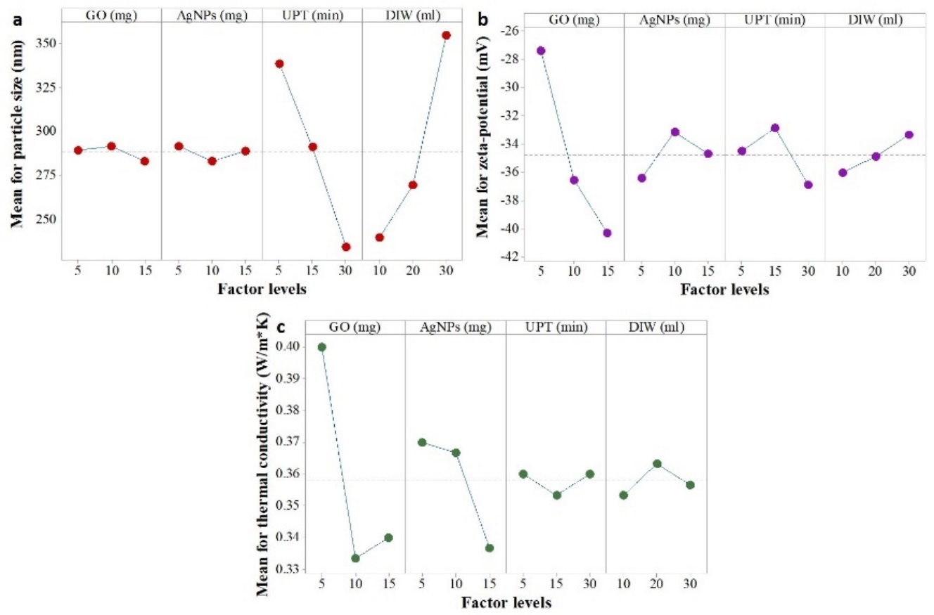**

**Figure 3**. Main effect plots for hybrid GO and AgNPs: a) particle size, b) zeta-potential and c) thermal conductivity [15]

* 1. **Features of hybrid GO and AgNPs dispersion mixed cementitious composites**

All specimens were designed with a size of 5 cm3 and cured at temperature 23ºC in tap water. The first quality criterion was selected as compressive strength at a day of 28 of GACEC, which should be maximized, was determined considering to the ASTM C109. Compressive tests were performed on 5 cm cubes. Second criterion was selected as ultrasonic pulse velocity and this test provide information about integrity of structures. Ultrasonic pulse velocity test, which should be maximized, was performed on 5 cm3 cube specimens according to the ASTM C597-09.

The first point that draws attention is that the highest compressive strength average at 28 days was obtained when GO and AgNPs were used as 5 mg each. An average compressive strength value higher than 22 MPa was obtained in cementitious composites with a 5 mg of GO and 5 mg of AgNPs, which corresponds to C20 class concrete (Figure 4a). It should not be forgotten that obtaining this value without using fine aggregate, which increases the compressive strength of concrete, is remarkable. However, severe loss of strength is observed when using more than 5 mg of GO and AgNPs, which may be a result of the decrease in dispersion stability, in other words, the decrease in zeta potential of hybrid dispersion. Similarly, it is seen that the optimum usage rate for the ultrasonic pulse velocity at 28 days is 5 g for GO and AgNPs, respectively (Figure 4b). When using more than 5 mg for each nanofiller, there is probably a uniformity problem in cemet matrix due to the decrease in zeta potential, the structural integrity is disrupted and the ultrasonic pulse velocity decreases.

When the interaction graphs were analyzed, a very interesting result was encountered (Figure 4c). While the highest values in both compressive strength and ultrasonic pulse velocity were obtained with the use of 5 grams of GO and 5 g of AgNPs, a severe decrease in compressive strength and ultrasonic pulse velocity was observed, especially with the increase of AgNPs to 10 mg (Figure 4c and 4d). In other words, if AgNPs was used more than 10 mg, synergistic effect of hybridization of GO and AgNPs turned into an antagonistic effect on cementitious composite properties (Figure 4d). Especially when two nanomaterials are used at 10 mg, a sudden decrease in compressive strength and ultrasonic pulse velocity begins.

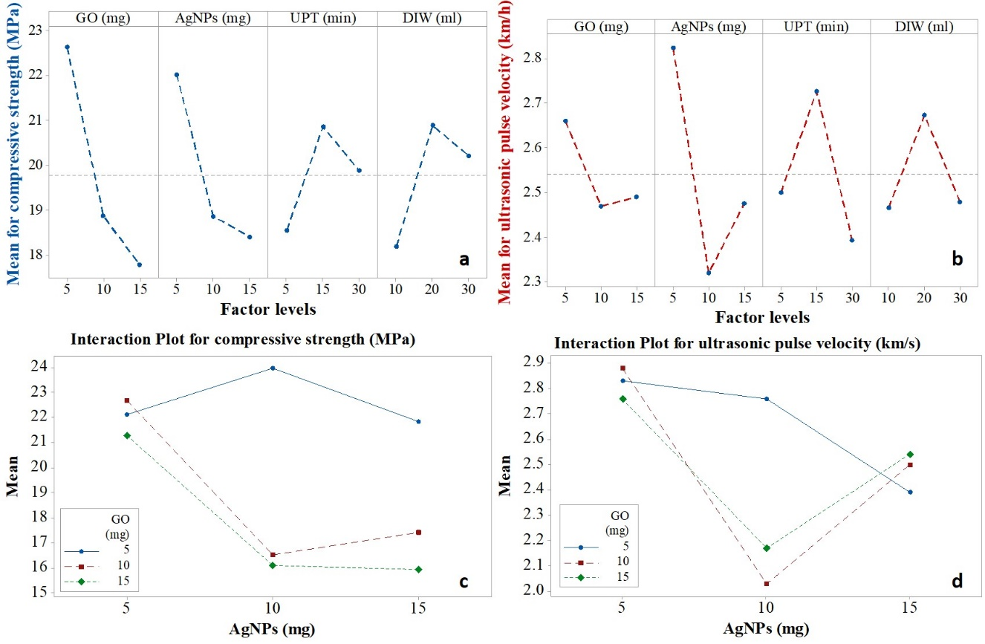

**Figure 4.** Factor effect analysis on GACEC using orthogonal arrays: a) mean plot for compressive strength, b) mean plot for ultrasonic pulse velocity, c) interaction plot for compressive strength, b) interaction plot for ultrasonic pulse velocity.

1. **Conclusion**

In this study, the hybrids dispersed GO and AgNPs was prepared according to the Taguchi design and the dispersion performance was analyzed statistically by the main effect plots systematically. Furthermore, hybrids dispersed GO and AgNPs mixed cementitious composites were designed and compressive strength and ultrasonic pulse velocity were assessed using main and interaction plots. It was concluded that the optimum particle size and zeta potential of the GO/AgNPs dispersion are found as 164.40 ± 17.38 nm and -44 mV ± 0.42 mV, respectively at a dosage of 5 mg of GO and 5 mg of AgNPs. Optimum dosages for preparing cementitious composites are determined as 5 mg each for GO and AgNPs. However, severe loss of strength was observed when using more than 5 mg of GO and AgNPs, which may be a result of the decrease in dispersion stability, in other words, the decrease in zeta potential of hybrid dispersion. Another result is that the synergistic effect that increases compressive strength and ultrasonic pulse velocity disappears more than this dosage levels.

**Acknowledgement**

In this study, the financial support was provided by Çankırı Karatekin University Scientific Research Projects Coordination Unit., Project No. MF210621L02. All experimental works were conducted in Çankırı Karatekin University Research Laboratory. The author would like to thank all supporters due to their precious contributions.

**References**

[1] Geim, A.K., & Novoselov, K.S. (2007). The rise of graphene. *Nature Materials (6)*, 183-191.

[2] Novoselov, K.S., . Geim, A.K, Morozov, S.V., Jiang, D., Zhang, Y., Dubonos, S.V., Grigorieva, I.V., & Firsov, A.A. (2004). Electric field effect in atomically thin carbon films. *Science 306*, 666-669.

[3] Ghosh, S., . Calizo, I., Teweldebrhan, D., Pokatilov, E.P., Nika, D.L., Balandin, A.A., Bao,W., Miao, F., & Lau, C.N. (2008). Extremely high thermal conductivity of graphene: Prospects for thermal management applications in nanoelectronic circuits, *Applied Physics Letters (92)*, 151911.

[4] Du, X., Skachko, I., Barker, A., & Andrei, E.Y. (2008). Approaching ballistic transport in suspended graphene, *Nature nanotechnology (3)*, 491-495.

[5] Zhu, Y., Murali, S., Cai, W., Li, X., Suk, J.W., Potts, J.R., & Ruoff, R.S. (2010). Graphene and graphene oxide: synthesis, properties, and applications. *Advanced materials (22)*, 3906-3924.

[6] Yıldız, B. *Application of graphene on journal bearings*, MSc Thesis, Pamukkale University, Institute of Science, 2006, pp. 97, Pamukkale, Türkiye.

[7] Liu, Z., & Zhou, X. (2014). *Graphene: energy storage and conversion applications*, USA: CRC Press.

[8] Padmavathi, J., Anantharaj, A., Velmurugan, S., Mariappan, G., & Gokulakumar, B. (2023). Synthesis of silver nanoparticles employing Bryophyllum pinnatum leaf extract and it's efficiency towards photocatalytic and antibacterial properties. *Chemical Data Collections (48)*, 101085.

[9] Karhan, Ö., Ceran, Ö.B., Şara, O.N., & Şimşek, B. (2017). Response Surface Methodology Based Desirability Function Approach To Investigate Optimal Mixture Ratio of Silver Nanoparticles Synthesis Process, *Industrial & Engineering Chemistry Research (56)*, 8180-8189.

[10] Joshaghani, A., Balapour, M., Mashhadian, M., & Ozbakkaloglu, T. (2020). Effects of nano-TiO2, nano-Al2O3, and nano-Fe2O3 on rheology, mechanical and durability properties of self-consolidating concrete (SCC): An experimental study. *Construction and Building Materials (245)*, 118444.

[11] Korucu, H. Şimşek, B. Uygunoğlu, T. Güvenç, A.B., & Yartaşı, A. (2019). Statistical approach to carbon based materials reinforced cementitious composites: Mechanical, thermal, electrical and sulfuric acid resistance properties, *Composites Part B: Engineering (171)*, 347-360.

[12] Ceran, Ö.B., Şimşek, B., Doruk, S., Uygunoğlu, T., & Şara, O.N. (2019). Effects of dispersed and powdered silver nanoparticles on the mechanical, thermal, electrical and durability properties of cementitious composites, *Construction and Building Materials (222)*, 152-167.

[13] Hummers Jr, W.S., & Offeman, R.E. (1958). Preparation of graphitic oxide, *Journal of the American Chemical Society* (80), 1339-1339.

[14] Guerrero-Contreras, J., & Caballero-Briones, F. (2015). Graphene oxide powders with different oxidation degree, prepared by synthesis variations of the Hummers method. *Materials Chemistry and Physics (153)*, 209-220.

[15] Al-Bayati, T.S.I. *Synthesis and optimization of graphene oxide/silver nanoparticles nanocomposites*. MSc Thesis, Çankırı Karatekin University, Instute of Science, 2022, pp. 58, Çankırı, Türkiye.

[16] Chook, S.W., Chia, C.H., Zakaria, S., Ayob, M.K., Chee, K.L., Huang,N.M., Neoh, H.M., Lim, H.N., Jamal, R., & Rahman, R. (2012). Antibacterial performance of Ag nanoparticles and AgGO nanocomposites prepared via rapid microwave-assisted synthesis method. *Nanoscale Research Letters (7)*, 541.

1. \* Corresponding author. *e-mail address: barissimsek@karatekin.edu.tr* [↑](#footnote-ref-1)