Flood hits greenhouses in Mediterrain's: Plants response to extreme natural events

Ayşin GÜZEL DEĞER

(*ORCID:https://orcid.org/0000-0001-6336-1872*)

*1 Mersin University, Vocational School of Technical Sciences, Mersin, Turkey.

*Corresponding author e-mail: agozel@mersin.edu.tr

**Abstract**

Global climate change causes the Mediterranean region to receive either more or less precipitation. It seems that precipitation patterns are changing all over the world due to global warming. Especially as a result of extreme weather events between 2018-2022, many greenhouses and agricultural areas were damaged in the floods that occurred in the Mediterranean region in Turkey. Peppers grown in greenhouses in the Mediterranean region, which supplies 70% of the pepper produced in Turkey, were flooded. Waterlogging is an important abiotic stress factor that can affect a large part of the greenhouses. Due to this stress, serious losses occur in agricultural production. In this study, the changes occurring in Capsicum annum exposed to waterlogging stress for mild, moderateand recovery were examined by physiological analyses (Leaf chlorophyll (SPAD), Proline and Lipid peroxidation (MDA) content and also water statuses). Pepper seedlings were grown in greenhouses in pots. MDA and proline contents which are important stress parameters, increased with the severity of stress and decreased significantly during the recovery period. There was a decrease in photosynthetic activity (SPAD) and an improvement occurred during the recovery period. Leaf water potential (LWP) increased with stress and was improve during the recovery period. Results show that, waterlogging significantly suppressed the development of pepper plants. The results revealed that waterlogging significantly decreased the growth of Capsicum annum plants, especially by negatively affecting photosynthetic activity. In this study, effective clues were collected about the waterlogging stress that effect and recovery durations of pepper seedlings in greenhouses, especially as a result of flood disasters.

**Keywords** Waterlogging, Capia pepper, Plant development, Recovery.

**INTRODUCTION**

Flood is a waterlogging event that inundates generally dry land. Floods are considered the second most frequent and among the costliest and deadliest natural disaster in the world after forest fires. Among the natural disasters seen in our country (Turkey), the flood disaster causes the greatest loss of life and property after the earthquake disaster. In addition, as a result of floods, economic losses of billions of liras are experienced. Climate imbalances and extreme weather events have affected the whole world. The Mediterranean area is particularly exposed to flash floods [1,2,3,4]. Due to flash floods, serious losses occur in agricultural production. As it is difficult to predict flooding, it is also difficult to take precautions in this regard. The prediction that the frequency of water puddles will increase with the effect of global warming increases the importance of studies on this subject [5,6,7].

Plants also are affected by natural disasters. Food sources are affected too. As a result of all these, global climate changes are turning into a global food crisis! Pepper is an important type of vegetable widely consumed in different forms in the world and in our country. In our country, an important part of greenhouse pepper production is carried out in the coastal parts of the Mediterranean region (Antalya, Mersin, Adana). Peppers grown in greenhouses in the Mediterranean region, which supplies 70% of the pepper produced in Turkey, were flooded during winter and spring sezon 2018-2022. During waterlogging stress, plant photosynthesis and aerobic respiration are inhibited. Increased anaerobic respiration and hypoxia can result in an excessive accumulation of CO2 and toxic compounds, leading to accelerated leaf senescence and abscission [8]. Waterlogging cause anoxia conditions in the soil, limiting root development, and affecting plant growth and development [9]. With the increase in the duration and height of waterlogging, leaf chlorosis and senescence occurred in pepper seedlings in field conditions and the plant dried out by 90% [10].

In this work, we analyzed of the the changes caused by flood stress in pepper plants by physiological and photosynthetic parameters. The present study, revealed that flood significantly decreased the growth of pepper plants, especially by negatively affecting photosynthetic activity and physiological parameters. It also were emphasized the importance of rapid intervention for the recovery process and that the effect may vary according to the level of stress severity in seedlings grown in a greenhouse conditions. The data obtained from this study may provide effective clues were collected about the waterlogging stress that effect and recovery durations of pepper seedlings in greenhouses, especially as a result of flood disasters.

**MATERIALS AND METHODS**

**Plant Material and Flooding Stress Treatment**

*Capsicum annuum* L. seeds were obtained from Antalya/Turkey. Plants were grown in greenhouse conditions in March 2022, Mersin/Turkey. In this study, the changes occurring in *Capsicum annum* exposed to flooding stress for mild, moderate and recovery were examined by physiological analyses (Leaf chlorophyll, Proline and Lipid peroxidation content and also water statiuses). Pepper seedlings were grown in greenhouses in pots. Flooding took place in greenhouses in real time and plants response to extreme natural events were examined (Figure 1). Control plants were well-irrigated in one times a week under controlled conditions.

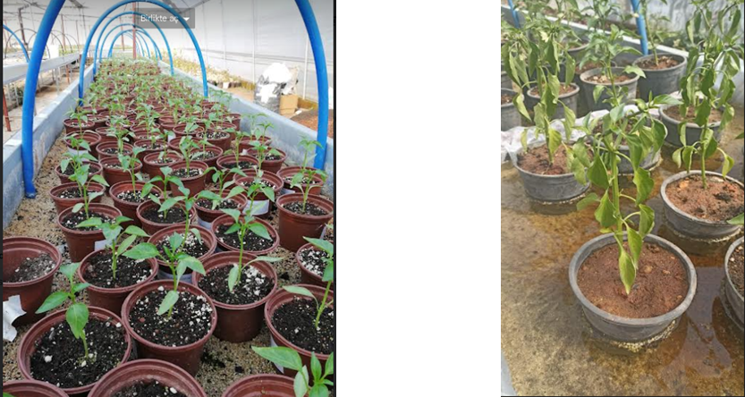

Figure 1. *Capsicum annuum* plants exposed to flood in greenhouse.

**Water Relations**

Leaf water potential and Relative water content were measured for water status analysis (Figure 2).

***Leaf water potential*** (LWP, Ψleaf) was measured by using the PMS Instrument Model 1000 pressure chamber. The leaf relative water content (**RWC**) was deter-mined according to Smart and Bingham (1974).

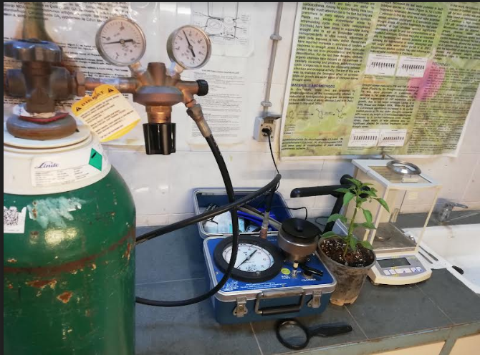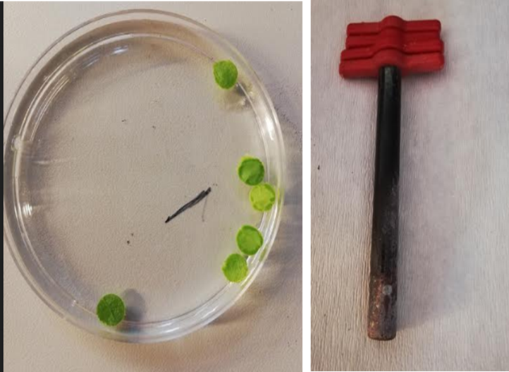

Figure 2. Measurement of leaf water statuses.

***Leaf chlorophyll contents*** were determined with a chlorophyll meter (SPAD 502, Konica–Minolta, Osaka, Japan). Results were given as SPAD units.

**Malondialdehyde (MDA) content measurement**

Lipid peroxidation was determined by measuring the malondialdehyde (MDA) content, according to Ohkawa et al. (1979), with some modification [11]. Fresh leaf tissue (0.2 g) was homogenized in 1 mL (5%) trichloroacetic acid (TCA) solution. The homogenate was centrifuged at room temperature for 15 min at 16,000g. The supernatant was transferred to the tubes by taking equal volumes of 0.5% thiobarbituric acid (TBA) and 20% TCA solutions. The tubes were incubated at 96 °C for 25 min. Then, the tubes were transferred to ice bath and centrifuged at 12,000g for 5 min. The supernatant was measured at 532 and 600 nm. 0.5% TBA in 20% TCA solution was used as blank sample. The MDA content was calculated using the extinction coefficient.

**Proline determination**

The amount of free proline, which is one of the good indicators of oxidative damage due to the severity of drought, was determined according to method of Bates et al. (1973) [12]. 0.5 g fresh leaf sample was homogenized with 3% sulfosalicylic acid (10 ml). After that the homogenate was centrifuged at 3000 rpm for 15 min, then 2 ml supernatant was mixed well with 2 ml acetic acid, 2 ml acid ninhydrin and boiled for 1h. After cooling of the tubes in ice, the products were extracted with 4 ml of toluene by vortex mixing and the toluene phase was decanted into a glass cuvette and its absorbance was measured at 520 nm and was determined by UV-visible spectrophotometer (Jena, Specord 210Plus). The proline concentration was calculated by using a calibration curve and expressed as μmol proline g−1 FW.

**Statistical Analysis**

Stress treatment was carried out in a completely randomized experimental design. Treatments had four replications with five plants each. Data were subjected to ANOVA and the means were separated using the LSD multiple range test at p<0.05. All the statistical analyses were performed using the JMP13 Software package. The reliability of the experiment was determined by calculating the coefficients of variation.

**RESULTS and DISCUSSION**

Flooding negatively affected development and growth in pepper plants (Figure 3). Pepper seedlings are more sensitive to extreme changes (waterlogging, cold, heat, drought...), especially during flowering period (Figure 4). Flash flooding was happened during the flowering period. Flooding decreased plant growth in this study according to the duration and severity of the stress. Some researchers reported that waterlogging creates an anaerobic condition in soil [13, 14].

Anoxia (an absence of oxygen) is the major cause of limited plant growth in waterlogged soils. When soils become waterlogged less gas diffuses to and from the roots through the soil pores; these changes adversely affect growth and development of plants [15]. Despite increasing of element concentration in soil under waterlogging conditions, some researchers also showed low element concentration in roots and leaves [16]. Steffens et al. (2005) showed that even if there were enough minerals in the soil, there must be enough oxygen for these minerals to be absorbed by the root [17]. In the light of these findings, we can say that waterlogging may have reduced the growth of vegetables by preventing mineral uptake to the roots.

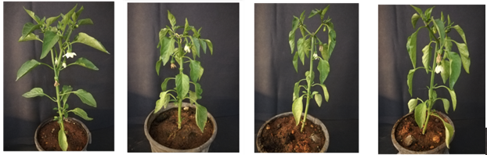



Figures 3. Effect of flooding stress on development of pepper plants.





Figure 4**.** Effect of flooding stress on flowers.

Suh et al. (1987) reported that in field conditions, the survival rate affected by waterlogging (10-20 cm above soil surface) was not significantly reduced within 24 hours, but fruit yield was significantly reduced in the same flooding. They showed that, the 48 hours of waterlogging showed about 90% wilting, death of the hot pepper plant and the whole plant could not withstand the flooding treatment for more than 4 days. In these experiment, leaf yellowing and falling increased linearly with length and height of waterlogging treatment, indicating more than 90% wilt death at 7 days of waterlogging [10].

Flood affected differently physiological parameters measured in this study [Table 1].

Table 1. Effects of flooding on MDA, RWC, LWP, Proline and SPAD in *Capsicum annuum*. The values (mean and standard deviation) followed by different letters are significantly different at least significant difference test (p<0,05). 0 (Control), 1 (Mild), 2(Moderate), R (Recovery)

|  |  |  |  |  |  |
| --- | --- | --- | --- | --- | --- |
| **Flood** | **MDA** | **LWP** | **RWC** | **Proline** | **SPAD** |
| 0 | 0,934±0.01d | -0,633±0.06a | 87±0.8c | 1,488±0.00d | 66,9±0.9a |
| 1 | 1,390±0.07c | -1,267±0.25c | 89±0.7b | 1,552±0.02c | 46,3±6.5b |
| 2 | 2,657±0.08a | -2,100±0.10d | 89±0.8b | 1,718±0.03a | 26,7±5.0c |
| R | 1,755±0.05b | -0,933±0.06b | 91±0.8a | 1,652±0.01b | 51,0±1.0b |
| LSD | 0.109*** | 0.266*** | 1.461*** | 0.032*** | 7.804*** |
| VK | 3.4 | 11.5 | 1 | 1.1 | 8.7 |

***p<0.001

Plant water status was the other parameter that affected by flooding stress in this study. Flooding stress decreased leaf water potential (LWP) compared to control plants. LWP was -0,6 MPa in control, -2,1 MPa in flooding stressed plants (p<0,05). Leaf water potential (LWP) was improve during the recovery period.

Contrasting results have been reported by researchers on leaf water potential under flooding conditions. Some esearchers have found that waterlogging has reduced leaf water potential [18,19], while others have reported, on the contrary, increased [20] or not changed [21]. Our results, supporting the literature, indicate that LWP may vary depending on the duration and severity of flooding stress.

Malondialdehyde (MDA) is the end product of lipid peroxidation and is one of the good indicators of membrane damage due to oxidative stress. In this study, waterlogging stress increased MDA content with the severity of stress and decreased significantly during the recovery period. It has been emphasized in the literature that the main cause of MDA increases is radicals (especially H2O2) [22,23]. Proline provides protection against stress by maintaining cellular osmotic adjustment. MDA and proline contents which are important stress parameters, increased with the severity of stress and decreased significantly during the recovery period. Tatar and Gevrek (2008) reported that proline accumulation increased after lipid peroxidation content became higher and relative water content of leaves became lower. They suggest that, therefore proline appeared to be mainly involved in protection against oxidative stress than osmotic adjustment during initial steps of water stress [24].

In the experiment, it was observed that the leaf chlorophyll index (SPAD value) declined by about 40% during severe flooding stress, significantly lower than that of the non-flooded plant. Our chlorophyll content results are consistent with Nickum 2010 literature results [25]. Similarly, Kozlowski and Pallardy [13] attributed reductions of photosynthesis in flooded plants to be in part due to reduced chlorophyll content of leaves, early leaf senescence, and abscission. Chlorophyll has a vital role in the photosynthesis mechanism [19]. The reduction of chlorophyll content may also cause a decrease in the photosynthetic rate. Reducing photosynthesis activity may also cause inhibition of plant growth.

**CONCLUSION**

This research compares the growth, development, physiological and photosynthetic parameters of pepper (*Capsicum annum*  L.) under flooding stress during flowering period. It is observed that late reproductive period studies are neglected especially in studies on flooding stress. When all measurements were taken into consideration, flooding stress reduced growth and development of capsicum by affecting photosynthesis mechanism and also MDA and proline contents which are important stress parameters. In this study, effective clues were collected about the waterlogging stress that effect and recovery durations of pepper seedlings in greenhouses, especially as a result of flood disasters. It is suggested in our study that food savings can be achieved with rapid intervention and support in greenhouses under flash flood stress.

**ACKNOWLEDGEMENTS**

I thank the Dr. Sara Yasemin, Siirt University, for contributions to statistical analyses.

**REFERENCES**

[1]. <https://en.wikipedia.org/wiki/Flood>

[2]. Munich RE, NatCat Service; Swiss RE, 2015. <https://www.munichre.com/en/solutions/for-industry-clients/natcatservice.html>

[3]. <https://meteoroloji.boun.edu.tr/sel.php>

[4]. Vinet, F.; Bigot, V.; Petrucci, O.; Papagiannaki, K.; Llasat, M.C.; Kotroni, V.; Boissier, L.; Aceto, L.; Grimalt, M.; Llasat-Botija, M.; Pasqua, A.A.; Rossello, J.; Kılıç, Ö.; Kahraman, A.; Tramblay, Y. Mapping Flood-Related Mortality in the Mediterranean Basin. Results from the MEFF v2.0 DB. *Water* 2019, *11*, 2196. <https://doi.org/10.3390/w11102196>

[5] Tarımsal ve Orman Bakanlığı, Su Yönetimi genel müdürlüğü, Taşkın ve kuraklık Yönetimi Daire Başkanlığı, İklim değişikliği ve Uyum, 2020

[6].Sertan ÇEVİK*, Ayşin GÜZEL DEĞER Effects Of Waterlogging On Some Morphological, Physiological And Photosynthetic Parameters In Barley. 271 IV. International Eurasian Agricultureandnatural Sciencescongressonline – 2020

[7]. Bansal, R and Srivastava, J.P. 2015. Effect of waterlogging on photosynthetic and biochemical parameters in pigeonpea. *Russian* *Journal* *of* *Plant Physiology* 62:322-327.

[8]. Ou, L.J., Dai, X.Z., Zhang, Z.Q. *et al.* Responses of pepper to waterlogging stress. *Photosynthetica* 49, 339 (2011). <https://doi.org/10.1007/s11099-011-0043-x>

[9]. Yavaş, İ. and Ünay, A. (2016). Su Taşkınına Maruz Kalan Bitkilerde Kök Gelişimi ve Hormonal Değişiklikler, *Turkish Journal of Agricultural Research*. 3(1): 89-95.

[10]. Suh, H.D. and Cho, K.Y. and Park, S.K. and Lee, K.H. “Effect of flooding on the growth and yield of hot pepper (Capsicum annuum L.)”, RESEARCH REPORTS OF THE RURAL DEVELOPMENT ADMINISTRATION (HORT.), 1987.

[11]. Ohkawa, H., Ohishi, N., & Yagi, K. (1979). Assay for lipid peroxides in animal tissues by thiobarbituric acid reaction. Analytical Biochemistry, 95(2), 351–358. doi:10.1016/0003-2697(79)90738-3 9)

[12]. Bates LS, Waldren RP, Teare ID (1973) Rapid determination of free proline for water stress studies.Plant Soil 39: 205-207

[13]. Kozlowski, T.T. and Pallardy, S.G. 1997. Physiology of woody plants. Academic Press, San Diego, CA.

[14]. Baracaldo, A., Carvajal, R., Romero, A. P., Prieto, A. M., García, J., Fischer, G. and Miranda, D. 2014. Waterlogging affects the growth and biomass production of chonto tomatoes (*Solanum lycopersicum* L.), cultivated under shading. *Revista Colombiana de Ciencias Hortícolas.* 8: 92-102.

[15]. Setter, Tim and Belford, Bob (1990) "Waterlogging : how it reduces plant growth and how plants can overcome its effects," Journal of the Department of Agriculture, Western Australia, Series 4: Vol. 31: No. 2, Article 5.

[16]. Morad, P. and Silvestre J. 1996. Plant injury due to oxygen deficiency in the root environment of soilless culture: A review. *Plant and Soil*. 184: 243-254.

[17]. Steffens D., Hutsch B.W., Eschholz T., Losak T. and Schubert S. 2005. Water logging may inhibit plant growth primarily by nutrient deficiency rather than nutrient toxicity. *Plant, Soil and Environment* 51: 545–552.

[18]. Ashraf, M. and Rehman, H. 1999. Interactive effects of nitrate and long-term waterlogging on growth, water relations, and gaseous exchange properties of maize (*Zea mays* L.). *Plant Science*. 144: 35-43.

[19]. Barickman, T.C., Simpson, C.R. and Sams, C.E. 2019. Waterlogging causes early modification in the physiological performance, carotenoids, chlorophylls, proline, and soluble sugars of cucumber plants. *Plants*. 8: 160.

[20]. Jackson, M.B., Gales, K. and Campbell D.J. 1978. Effect of waterlogged soil conditions on the production of ethylene and on water relationships in tomato plants. *Journal of Experimental Botany*. 29: 183-193.

[21]. Ashraf, M. and Arfan, M. 2005. Gas exchange characteristics and water relations in two cultivars of *Hibiscus esculentus* under waterlogging. *Biologia plantarum*. 49: 459-462.

[22]. Hasanuzzaman, M., Bhuyan, M. H. M., Zulfiqar, F., Raza, A., Mohsin, S. M., Mahmud, J. A., Fujita, M., & Fotopoulos, V. (2020a). Reactive oxygen species and antioxidant defense in plants under abiotic stress: revisiting the crucial role of a universal defense regulator. Antioxidants, 9, 681.

[23]. Ibrahim, M. H., & Jaafar H. Z. E. (2012). Primary, secondary metabolites, H2O2, malondialdehyde and photosynthetic responses of Orthosiphon stamineus Benth. to different irradiance levels. Molecules, 17, 1159-1176.

[24]. Ozgur Tatar and Mithat Nuri Gevrek, 2008. Influence of Water Stress on Proline Accumulation, Lipid Peroxidation and Water Content of Wheat. *Asian Journal of Plant Sciences, 7: 409-412.*

[25]. Nickum, Mark T. et al. “Reponses of mamey sapote (Pouteria sapota) trees to continuous and cyclical flooding in calcareous soil.” Scientia Horticulturae 123 (2010): 402-411.