**LANDSLIDE SUSCEPTIBILITY MAPPING OF BÜYÜK MENDERES BASIN USING GEOGRAPHIC INFORMATION SYSTEMS (GIS)**

**Gulnihal Kurt1*, Cenk Donmez1, Ahmet Cilek1 & Suha Berberoglu1**

*Department of Landscape Architecture, Faculty of Architecture, Cukurova University, Adana, Turkey*

*gulnihalkurtt@gmail.com

# ABSTRACT

Landslide disaster poses a crucial environmental threat in the region where it occurs. It rapidly destroys biological diversity by combining with natural disasters accelerated by human factors such as landslides.

In this study, we evaluated landslide susceptibility in Buyuk Menderes Basin, Turkey using physical entities including slope gradient, distance from roads, drainage lines and faults, lithology, runoff and Normalized Differences Vegetation Index (NDVI) in the Geographical Information Systems (GIS) environment. The determining factors were divided into five groups for evaluation and overlapped with multi-criteria analysis to monitor the susceptibility of landslides in the study region. The study will guide more detailed and high precision studies to be carried out in the future.

**Keywords**: Landslide, Landslide Susceptibility Assessment, Natural Hazards, GIS, MCA

# INTRODUCTION

# Natural disasters can be defined as downward movement of rubble, soil/rock mass (Cruden, 1991) or dangerous and generally large-scale events that occur primarily or entirely outside the control of people and can cause loss of property and life. Indirect effects such as production losses in agricultural and forestry areas, decrease in real estate values, expenditures, and labour losses related to works to prevent landslides cause more damage to the country's economy than direct effects (Schuster and Fleming, 1986). Despite the developing disaster management in the 21st century, it is seen that landslide activities have increased worldwide. This trend is expected to increase in the 21st century. The main reasons for this are explained as follows:

# Increasing urbanization in landslide-prone areas,

# Deforestation in areas susceptible to landslides,

# Fluctuations in precipitation regimes due to climate change (Schuster, 1996).

Along with the developing technology, significant changes have occurred in obtaining landslide susceptibility maps. Geographical Information Systems (GIS) and Remote Sensing (RS) techniques have provided significant advantages in preparing landslide risk maps. Using Remote Sensing techniques, data can be collected and analyzed in a short time. Using GIS techniques, it is possible to store, process and analyze complex data with high data volume in a short time (Dai et al., 2002; Cevik and Topal, 2003; Lee et al., 2004a; Perotto-Baldiviezo et al., 2004).

# Considering the losses caused by natural disasters in Turkey, most of the natural disasters causing loss of life and property from earthquakes is well known that after the mass movements (Ildır, 1995). Due to our country's geological, climatic and geographical characteristics and improper land use, landslides are frequently experienced and often repeated and turn into disasters. In this context, evaluation of landslide and susceptibility maps plays an essential role in disaster risk management. It would be more appropriate to develop sustainable land planning and risk reduction strategies with monitoring and early warning systems (Dai et al., 2002; Corominas et al., 2014).

# In recent years, GIS has been used extensively to assess landslide susceptibility. GIS-based models provide researchers with innovative techniques, allowing large volumes of data in file size and scale. These studies are essential fundamental requirements for proper land planning and risk mitigation methods (Yalcin et al., 2011; Lai et al., 2019).

In this study, the landslide susceptibility of the basin was monitored, considering the physical properties of the basin. With the help of the thematic and topographic maps used, the landslide susceptibility map was produced in the Büyük Menderes Basin, which displays a wide variety of species and habitats. It will provide convenience, especially in field studies for future landslide risk analysis and landslide susceptibility analysis studies.

# MATERIAL AND METHOD

# Study Area

The Büyük Menderes River is located in the South-Western part of Turkey, in Western Anatolia. The basin is surrounded by Samson Mountain, Cevizli Mountain, Elma Mountain and Murat Mountain from the north, Sandıklı Mountains from the east, Madran Mountain, Babadağ and Bozdağları from the south and the Aegean Sea in the west. Büyük Menderes, which was born from the plateaus between Sandıklı and Dinar (Afyon) in Central Western Anatolia, is 584 km long. The narrowest part of the basin is around Sarıkemer, with approximately 34 km width. Büyük Menderes River and its tributaries constitute the mainstream system in the basin. Important streams of the river are Çine, Akçay, Emir, Banaz, Kufi, Dandalaz and Madran. The vegetation of the basin is generally in the form of bush, bush and forest mixture, forest and herbaceous formations. The forest cover of the basin mainly consists of red pine (Pinus brutia) and black pine (Pinus nigra). Plant varieties such as oak (Quercus coccifera) and olives (Olea europaea) can be seen in the scrub areas consisting of bushes. Büyük Menderes Basin hosts different formations such as sea, fresh water and mountains in its geological evolution. The fact that the basin has various climatic conditions brings rich biological diversity value and offers life opportunity to endemic species with limited distribution (Berberoglu et al., 2019).

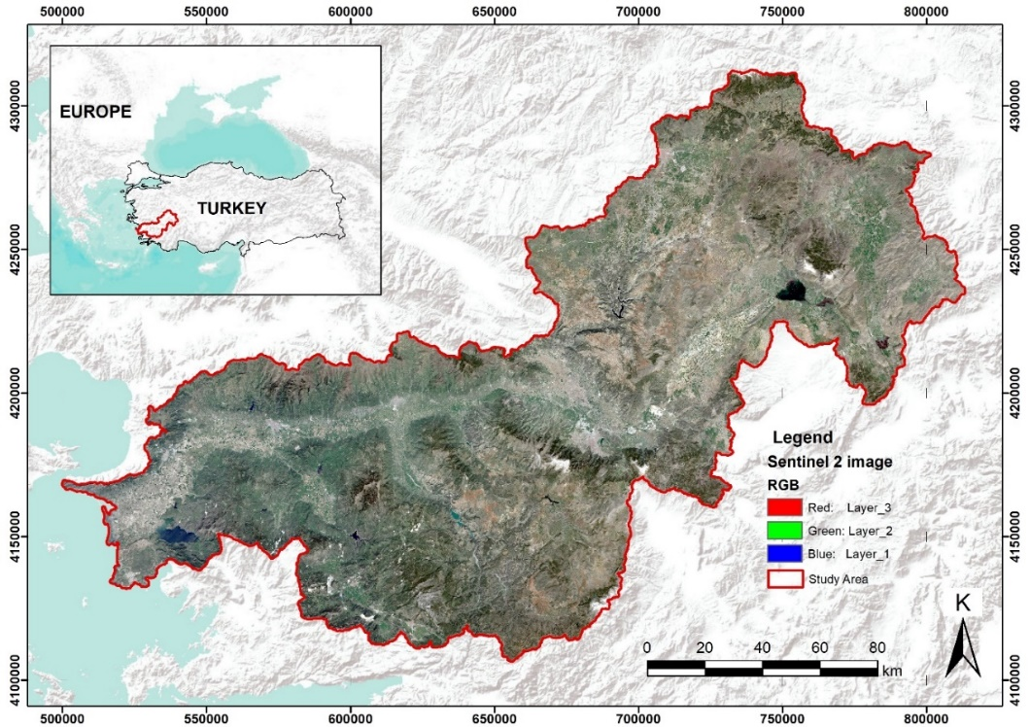

Figure 1. Location of the study area

# METHOD

This study predicts the landslide-prone areas slope gradient, distance from roads, distance from drainage lines, distance from faults, lithology, runoff, and NDVI (Normalized Differences Vegetation Index) were used to evaluate landslide susceptibility. Some factors that affect the landslide susceptibility were determined after the literature review (Table 1.). In the literature review, care has been taken to select the factors clearly stated to increase the sensitivity of landslides.

Table 1. A literature review summary of landslide conditioning factors (Moharrami et al., 2020, modified)

|  |  |  |
| --- | --- | --- |
| **Factors** | **Impact** | **Reference** |
| (1)  Slope Gradient | Slope gradient has a significant effect on landslides. The higher the slope indicates that the area is more susceptible to landslides. | Ghorbanzadeh et al. 2019 |
| (2)  Distance to drainage lines | It has been proven that areas closer to drainage lines have a higher risk of landslides. Besides, wet conditions in these areas affect the underground flow. | Harris et al., 2014  Tsangaratos and Ilia 2015 |
| (3)  Distance from roads | Roads often cut the slope. Therefore, it affects the slope stabilization and changes the morphology of the area. | Yan et al. 2018 |
| (4)  Distance from faults | Active faults are seen as an essential factor in the formation of landslides as they can cause instability in the land. | Chen et al., 2017 |
| (5)  Lithology | Landslides are under the influence of lithological properties since it determines the permeability, strength and susceptibility to degradation. | Yalcin et al. 2007  Segoni et al. 2020 |
| (6)  Runoff | Due to the increase in pressure on the ground surface with surface flow, runoff should be included in the evaluation while evaluating the regional landslide susceptibility. | Chiu et al., 2019 |
| (7) Normalized Difference Vegetation Index (NDVI) | Based on the assumption that landslides generally result in vegetation disturbances, it can be used for monitoring landslide-prone areas | Lu et al., 2019 |

The value of each factor was divided into five groups, and scores between 1 and 5 were given. After obtaining the GIS data, scores based on the factors were overlapped, and Multi-Criteria Analyses (MCA) applied. Multi-criteria decision making (MCDM) is an operational process that explicitly evaluates multiple conflicting criteria in decision making (Triantaphyllou et al., 1998).

* The lithology groups used in the study were grouped under five main groups, considering the similar characteristics such as origin, age and environment (Duman et al., 2009). Based on the study conducted by Duman et al. (2009) in the same region, scores were given by looking at the percentage of landslides.
* Fault distance, drainage line distance and road distance map were derived from the General Directorate of Mineral Research and Exploration. As given in the table, the buffering procedure was made.
* Slope gradient map obtained from Digital Elevation Model from the Aster Satellite.
* The J2000 hydrological model, a modular process-oriented hydrological system for simulating hydrologic processes (Krause 2001), was used to generate runoff data (Donmez and Berberoglu, 2016).
* The Normalized Difference Vegetation Index (NDVI) obtained from Sentinel 2 image using the near-infrared and red wavebands to monitor the surface vegetation coverage.

Table 2. Landslide conditioning factors and classes used in the multi-criteria analysis.

|  |  |  |
| --- | --- | --- |
| **Factors** | **Classes** | **Scores** |
| (1)  Slope Gradient (°) | 10  20  30  40  40 < | 1  2  3  4  5 |
| (2)  Distance to drainage lines (m) | 800-1000  600-800  400-600  200-400  0-200  Other Areas | 1  2  3  4  5  0 |
| (3)  Distance from roads (m) | 450-550  350-450  250-350  150-250  0-150  Other Areas | 1  2  3  4  5  0 |
| (4)  Distance from faults (m) | 2500-3000  2000-2500  1500-2000  1000-1500  0-1000  Other Areas | 1  2  3  4  5  0 |
| (5)  Lithology | Group 1 (Quaternary deposits)  Group 2 (Metamorphic rocks)  Group 3 (Marble, calcschist, recrystallized limestone, etc.)  Group 4 (Ophiolites)  Group 5 (Quaternary-Rhyodacite-basalt-andesite, spilite etc.) | 1  2  3  4  5 |
| (6)  Runoff (mm) | 0,00047 - 65,399716  65,399716 - 130,798963  130,798963 - 196,19821  196,19821 - 261,597457  261,597457 - 326,996704 | 1  2  3  4  5 |
| (7) NDVI | 0,599651 - 0,99928  0,200021 - 0,599651  -0,199609 - 0,200021  -0,599238 - -0,199609  -0,998868 - -0,599238 | 1  2  3  4  5 |

# RESULTS AND DISCUSSION

To determine the landslide susceptibility of the Büyük Menderes Basin, a result map was produced using overlapping seven maps created according to factors and criteria. After the overlapping process, it was determined that the highest score was 29 and the lowest score was 4. The range was divided into five equal intervals, and susceptibility classes were formed (Table 3.).

Table 3. Landslide susceptibility classes

|  |  |
| --- | --- |
| **Landslide Susceptibility Scores** | **Landslide Susceptibility Class** |
| 4 - 9 | Very low susceptibility |
| 9 - 14 | Low susceptibility |
| 14 - 19 | Moderate susceptibility |
| 19 - 24 | High susceptibility |
| 24 - 29 | Very high susceptibility |

The landslide susceptibility map of the study area is given in the output map presented in Figure 2. The settlements in the Büyük Menderes Basin are also provided in the figure. The places shown in red on the map represent areas with very high landslide susceptibility. These areas with the highest landslide susceptibility in the basin are primarily concentrated in high slope degrees.

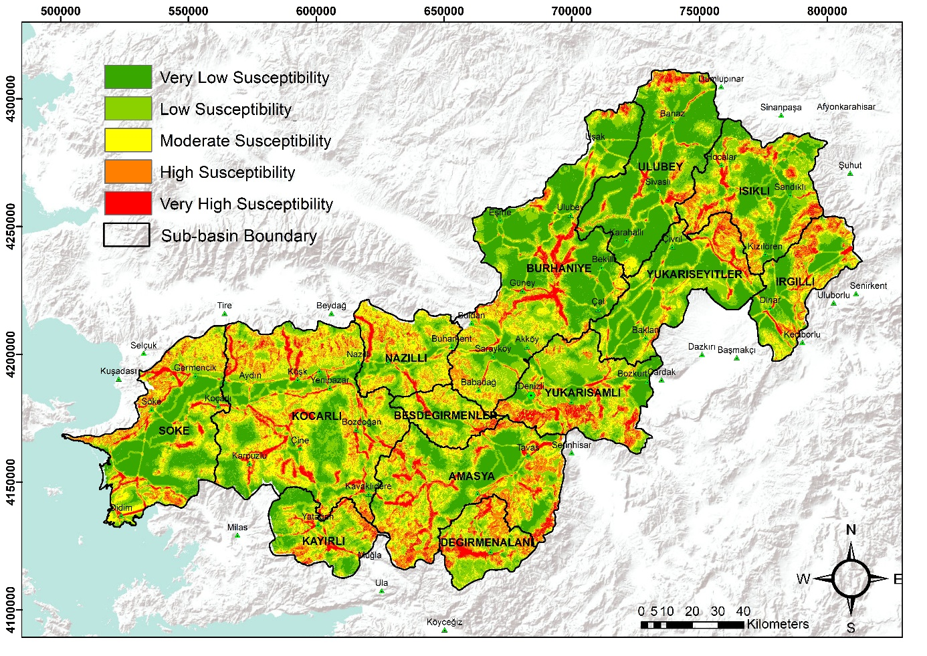

Figure 2. Landslide susceptibility map of the study area.

Some statistics of the obtained landslide susceptibility map in the scale of sub-basins are given in the table. In Nazilli, Kocarlı and Besdegirmenler sub-basins, it is seen that the landslide susceptibility class that occupies the most space is moderate. When the landslide sensitivity scores in the sub-basins are examined, it is seen that the basin with the lowest sensitivity is Ulubey. The lower basin with the highest susceptibility is Besdegirmenler (Table 4.).

Table 4. Landslide susceptibility rates at the scale of sub-basins

|  |  |  |
| --- | --- | --- |
| **Sub-basin** | **The susceptibility class that covers most space in the sub-basin** | **The mean of landslide susceptibility scores** |
| Yukarisamli | Low susceptibility | 13,57 |
| Burhaniye | Very low susceptibility | 13,57 |
| Degirmenalani | Low susceptibility | 11,90 |
| Besdegirmenler | Moderate susceptibility | 14,58 |
| Amasya | Low susceptibility | 12,91 |
| Kayirli | Low susceptibility | 12,58 |
| Nazilli | Moderate susceptibility | 13,18 |
| Kocarli | Moderate susceptibility | 13,64 |
| Irgilli | Very low susceptibility | 13,95 |
| Isikli | Low susceptibility | 12,67 |
| Ulubey | Very low susceptibility | 10,70 |
| Yukariseyitler | Very low susceptibility | 11,85 |
| Soke | Very low susceptibility | 13,42 |

**CONCLUSION**

This study aims to monitor the areas that might be sensitive to landslides in the Büyük Menderes Basin and facilitate taking measures against new landslides. With the regional and local decisions to be taken in this direction, it will be possible to minimize the damage caused by the landslide disaster. Large-scale landslides can trigger severe problems for social, economic and social welfare. It is important to monitor local and regional landslides, which are quite complex and often difficult to define (Schuster et al., 1986; Haque et al., 2016). In the landslide susceptibility analysis of the Büyük Menderes Basin, it is thought that the regions susceptible to landslides will guide the current and future economic development activities. This study will contribute to economic activities (agriculture, industry, transportation and various infrastructure, etc.) to develop the region by presenting multiple data. A more detailed study of the risk and susceptibility of landslides in the basin will be important in protecting the ecological balance and minimizing disaster-related damages and economic development in the region. This study will provide convenience in the detailed and high accuracy monitoring tasks carried out in the area regarding landslides, especially in field studies.

**REFERENCES**

Berberoğlu, S., Yılmaz, K., T., Erdoğan M., A., Çilek, A., 2019. Büyük Menderes Havzası Peyzaj Atlası. T.C. Tarım ve Orman Bakanlığı, Doğa Koruma ve Milli Parklar Genel Müdürlüğü adına Belda Proje Ve Danışmanlık Ticaret Limited Şirketi.

Chen, W., Chen, W., Panahi, M., Kornejady, A., Wang, J., Xie, X., Cao, S., 2017. Spatial prediction of landslide susceptibility using an adaptive neuro-fuzzy inference system combined with frequency ratio, generalized additive model, and support vector machine techniques. Geomorphology, 297, 69–85.

Chiu, Y., Y., Chen, H., E., Yeh, K., C., 2019. Investigation of the influence of rainfall-runoff on shallow landslides in unsaturated soil using a mathematical model. Water, 11(6), 1178.

Corominas, J., Van Westen, C., Frattini, P., Recommendations for the quantitative analysis of landslide risk, 2014. Bull. Eng. Geol. Environ., 73, 209–263.

Cruden, D., M., 1991. A simple definition of a landslide. Bulletin of the International Association of Engineering Geology-Bulletin de l'Association Internationale de Géologie de l'Ingénieur, 43(1), 27-29.

Dai, F.C., Lee, C.F., Ngai, Y.Y., 2002. Landslide risk assessment and management: An overview. Eng Geol., 64, 65–87.

Donmez, C., & Berberoglu, S., 2016. A comparative assessment of catchment runoff generation and forest productivity in a semi-arid environment. International Journal of Digital Earth, 9(10), 942-962.

Ghorbanzadeh, O., Blaschke, T., Gholamnia, K., Meena, S.R., Tiede, D., Aryal, J. Evaluation of different machine learning methods and deep-learning convolutional neural networks for landslide detection, 2019. Remote Sens., 11, 196.

Haque, U., Blum, P., da Silva, P.F., Andersen, P., Pilz, J., Chalov, S.R., Malet, J.P., Aufliˇc, M.J., Andres, N., Poyiadji, E. et al. 2016. Fatal landslides in Europe. Landslides, 13, 1545–1554.

Harris, S., M., Carvalho, L.,V., 2014. Atmospheric River Development and Effects on Southern California; American Geophysical Union: Washington, DC, USA.

Ildır, B., 1995. Turkiyede heyelanların dağılımı ve afetler yasası ile ilgili uygulamalar. 2. Ulusal Heyelan Sempozyumu Bildiriler Kitabı, Sakarya, 1–9.

Lai, J.-S., Tsai, F. Improving GIS-based Landslide Susceptibility Assessments with Multi-temporal Remote Sensing and Machine Learning. Sensors, 2019, 19, 3717.

Lu, P., Qin, Y., Li, Z., Mondini, A. C., & Casagli, N., 2019. Landslide mapping from multi-sensor data through improved change detection-based Markov random field. Remote Sensing of Environment, 231, 111235.

Moharrami, M., Naboureh, A., Gudiyangada Nachappa, T., Ghorbanzadeh, O., Guan, X., & Blaschke, T. (2020). National-scale landslide susceptibility mapping in Austria using fuzzy best-worst multi-criteria decision-making. ISPRS International Journal of Geo-Information, 9(6), 393.

Ohlmacher, G., C., 2007. Plan curvature and landslide probability in regions dominated by earth flows and earth slides. Engineering Geology, 91(2-4), 117-134.

Schuster, R., L., 1996. Socioeconomic significance of landslides. Landslides: Investigation and Mitigation. Washington (DC): National Academy Press. Transportation Research Board Special Report, 247, 12-35.

Schuster, R.L., and Fleming, R.W., 1986, Economic losses and fatalities due to landslides, Bulletin of the Association of Engineering Geologists, 23 (1), 11-28.

Schuster, R.L., Fleming, R.,W., 1986. Economic Losses and Fatalities Due to Landslides. Environ. Eng. Geosci., xxiii, 11–28.

Segoni, S., Pappafico, G., Luti, T., 2020. Catani, F. Landslide susceptibility assessment in complex geological settings: Sensitivity to geological information and insights on its parameterization. Landslides, 1–11.

T., Y., Duman, Ş., Olgun, T., Can, H., A., Nefeslioğlu et. al., 2009. 1/500.000 Ölçekli Türkiye Heyelan Envanteri Haritası, Denizli Paftası. Özel Yayın Serisi-21.

Triantaphyllou, E., Shu, B., Sanchez, S. & Ray, Thomas, 1998. Multi-criteria decision making: An operations research approach.

Tsangaratos, P., Ilia, I., 2016. Comparison of a logistic regression and Naïve Bayes classifier in landslide susceptibility assessments: The influence of models complexity and training dataset size. Catena, 145, 164-179.

Yalcin, A., Bulut, F., 2006. Landslide susceptibility mapping using GIS and digital photogrammetric techniques: A case study from Ardesen (NE-Turkey). Nat. Hazards, 41, 201–226.

Yalcin, A., Reis, S., Aydinoglu, A.C., Yomralioglu, T., 2011. A GIS-based comparative study of frequency ratio, analytical hierarchy process, bivariate statistics and logistics regression methods for landslide susceptibility mapping in Trabzon, NE Turkey. Catena, 85, 274–287.

Yan, G., Liang, S., Gui, X., Xie, Y., Zhao, H., 2018. Optimizing landslide susceptibility mapping in the Kongtong District, NW China: Comparing the subdivision criteria of factors. Geocarto Int., 34, 1408–1426.