**THE CONCEPT OF SUCCESS IN WESTERN AND EASTERN LINGUISTIC CULTURES**

Zharkynbekova Sholpan Kuzarovna 2, Doctor of philology., professor, L. N. Gumilyov Eurasian National University, zharkyn.sh.k@gmail.com, +77011577370, Id 55446258300, ORСID  <https://orcid.org/0000-0002-4160-6215>,

Zadanova Elmira Bekbolatovna,2doctoral student, L. N. Gumilyov Eurasian National University, elmira1587@mail.ru, ORСID https://orcid.org/0000-0001-5548-811X

**ABSTRACT**

The influence of the cultural environment on mental processes remains an important research question, the change in public consciousness has given rise to the ubiquitous idea of spreading success. In this context, our work focuses on the notion of success in Western and Eastern linguistic cultures. The concept of "success" has always played an extremely important role in American culture, and it is firmly embedded in the life of Kazakh society at its present stage of development. It finds its manifestation in various linguistic realities, and the study of these aspects is topical in modern linguistic science.

The **research methods** used were an integrated approach of collection, processing, analysis of linguistic means, descriptive, interpretative and definitional. The definitional method allows us to take a deeper look at the concept of "success", as the analysis of the dictionary entries draws us not only to the etymology of this lexeme, but also to the history of its emergence.

Having carried out the research, we have come to the following **results**: The concept of "success" has universal and national-specific features, which are manifested in conceptual, figurative and value characteristics. The conceptual features overlap in American and Kazakh linguocultures and are reflected in linguistic forms.

The data obtained from the research shows that American and Kazakh culture is focused on success, on achieving results, on career advancement. One model of success prevails and the same strategies and ways of achieving success are proposed. The given analysis seems to be interesting for application of the obtained results in courses on intercultural communication, linguoculturology, cognitive linguistics.

**Key words:** linguoculturology, concept, world picture, cognitive linguistics, intercultural communication.

**INTRODUCTION**

A significant role in the formation of personality, mentality and national character is played by the components of language. The conceptualization of reality in different languages is partly universal and to some extent nationally specific, in this regard representatives of different linguistic and cultural communities may see the world differently [1]. In the comparative aspect, the linguistic representation of national consciousness seems to us to be the most productive research. Comparison of the components of linguistic picture of the world of different linguocultures, allows revealing linguocultural discrepancies. The purpose of the research is to reveal common and some distinctive features of the concept "success" in Eastern (Kazakh) and Western (American) linguocultures. In order to achieve this goal, the following tasks were set:

– Identify the linguistic and cultural characteristics of lexical and phraseological units and utterances in Kazakh and English

– On the basis of the results of comparative analysis, describe the relationship between the cultural and national originality of phraseological units, lexical units, sayings, paremics and aphorisms with the specific features of the worldview of the Kazakh and American peoples.

Thus, the concept of success is one of the most important in the conceptual picture of the world of any linguistic culture. In the Kazakh linguistic culture, this notion is insufficiently studied. Success is becoming a popular manifestation in all spheres of life: famous businessmen publish books about their achievements in business, athletes talk about their victories in interviews, and successful projects run by both men and women are found everywhere. All this proves that the concept of success is fixed in people's minds, so the study of this phenomenon is also relevant in linguistics.

**METHODS**

The material for the study was dictionary definitions, journal articles, fiction and Internet resources. To describe the conceptual component of "success", the dictionary definitions method was taken as the basis. The identification of the signs of success was determined with the help of the contextual method, the interpretative and descriptive analysis of the results was carried out, with the help of which we can make the most complete national picture of the world, compare the value differences of the Eastern (Kazakh) and Western (American) linguocultures.

**RESULTS AND DISCUSSIONS**

Considering success as a concept, we distinguish a core (cognitive and propositional structure of an important concept), a prider zone (other lexical representations of an important concept, its synonyms, etc.) and a periphery (associative-image representations) in it. The study of the conceptual structure of natural language allows obtaining sufficiently reliable information about universal and idio-ethnic features of worldview of any nation [2, P 34-35].

The most important dimensions of a concept are conceptual, figurative and value dimensions. The totality of concepts, considered in the aspect of values, forms a value picture of the world. In this complex mental formation the most essential for the given culture meanings, value dominants are distinguished, the totality of which forms a certain type of culture, supported and preserved in the language [1, P. 5]. As it is known, conceptual meaning is represented by the nuclear zone and the prinuclear zone, and in the peripheral zone figurative and value characteristics are brightly manifested.

In English, the conceptual component of success is presented in the following lexicographical sources:

Oxford advanced learner’s dictionary [3] **1.** **The fact that you have achieved something** that you want and have been trying to do or get; the fact of becoming rich or famous or of getting a high social position: What’s the secret of your **success**? (in doing smth) I didn’t have much **success** in finding a job. They didn’t have much **success** in life. Confidence is the key of **success**. Economic **success**. Their plan will probably meet with little **success.** She was surprised by the book’s **success**. **2.a person or thing that has achieved a good result** and been successful: The party was a big **success**. He’s proud of his daughter **successes**. Thus, in English, the core zone of the concept of success is represented by the lexeme "success".

According to the American Thesaurus [4], the prider zone of the concept "success" is expressed by lexemes: **achievement, benefit, victory, good luck.** The idea of the American dream, which they saw as personal success, was initially religious. The early settlers believed that hard work would contribute to building a successful world [5]. In order to succeed one must be able to take risks, namely to take a leap upwards, when one has achieved good results, one is said to have matured or fully developed and to be financially fortunate. These ideas are reflected in linguistic consciousness, and are represented by lexemes which represent the peripheral zone: **snap, maturation, strike, progress, triumph, eminence, successful person.**

By summarising the dictionary definitions of the various English-language dictionaries, we have established the following meaning of the lexeme "success":

– Success as achievement

– Success as winning something

– Success as receiving material rewards

According to the Kazakh explanatory and synonymic dictionaries, the core meanings of "success" are three lexemes: **Tabys** – 1. *Belgili bir zhymysti atkaru natizhasine tysetin aksha, materialdik igilikter; кіріс, пайда. Money, material benefits from doing some work; income, profit [6,7,8].*  **Zhetistik** - *Kol zhetken tabys, zhenis.* *The success achieved, the victory.* **Zhenis (success, victory).** *Kol zhetken narse, zhenis.* *What has been achieved, victory. Abendi yerte kel, senin* ***zhetistigindi*** *korip, baygys shal kuansyn.* *Come early, let the poor old man rejoice at your* ***success****. Adebiet, madeniet salalarynda buryn bolyp kormegen gazhayip* ***tabystarga*** *kol zhetti.* *He has made unprecedented* ***success*** *in literature and culture. Ulynyn enbek zholyndagy algashky* ***zhenisine*** *maz bolgan ata-anasynyn kyanyshinda shek bolmady.* *Parents rejoice at son's first career* ***win***[9].

The following lexemes constitute the sub-area of the concept of success: **kiris (profit), mal (cattle), olzha (booty, trophy), paida (profit, gain), utys (gain).** Since the economic life of the nomads of the Kazakh Khanate was based on cattle breeding and livestock products formed the basis of trade, the availability of livestock was a valuable or important measure of success. This was also demanded by the interests of creating an independent domestic market. As we can see from historical sources [10], cattle were considered booty, it benefited the khanate, so the Kazakhs see success in owning cattle that may have become booty in any battle.The peripheral zone is represented by lexemes**: onim (output, yield), tusim (production, harvest), zhorgem (yield).**

A reference to the materials of explanatory dictionaries and dictionaries of synonyms of the Kazakh language allows us to identify three dominant themes: "the result of achievement", "monetary gain" and "victory". Thus, at the level of words and phrases, three equally probable types of success are recorded:

* Success as an achievement and the result of effort
* Success as material gain
* Success as winning a competition

Having examined the dictionary definitions, we see differences in English and Kazakh at the level of the core component. In English, the prider zone includes those lexemes, which in Kazakh are represented in the core of the concept, these differences are presented in detail in Figure 1. All three nuclear lexemes in the Kazakh language denote success, but they are used situationally. While the English word "success" can be combined with all lexical units.

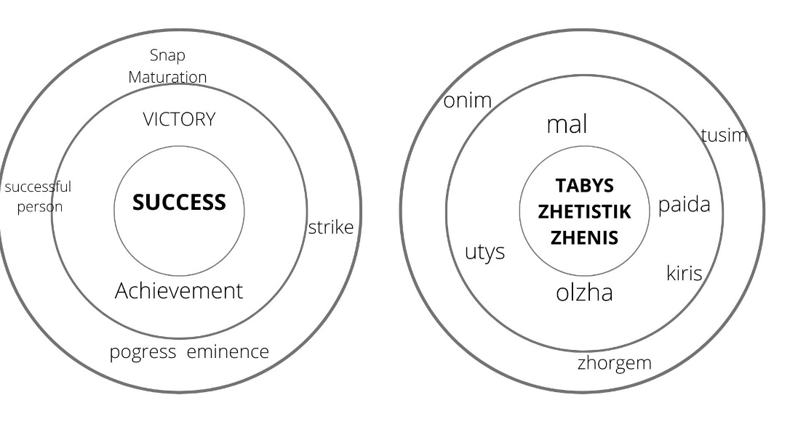

**Figure 1. The core zone of the concept "success" in English and Kazakh**

Success as a value oriented concept is present in many cultures, but it is in the US that it has become a national idea. The historical, economic, and socio-cultural preconditions for the formation of the American nation contributed to the formation of a success-centred society. In which every free man can achieve success on his own. A prime example is the "Yuppies", a trend that emerged in the 1980s in Reagan-era America. Yuppies were very ambitious young people whose goal was to succeed in life, namely in their careers. As for Kazakh culture, the notion of "success" is becoming more popular and contains values characteristic of the whole world culture. According to many scientists (Arutyunova, V.I. Karasik, V.A. Maslova) the value picture of the world is the most important part of the world picture of any nation [2. P.169].

The value component of the concept is modelled through an interpretative analysis of value-labelled statements, phraseological expressions and paremics. For the sake of completeness, we studied texts describing situations of success. Having considered the fragment **(Table 1)** of the analysis of Kazakh and English statements, it can be noted that the value component in both linguocultures is the same.

**Table 1. Values characteristics of success in Kazakh and American linguistic cultures**

|  |  |  |  |
| --- | --- | --- | --- |
|  | **Statements in Kazakh** | **Statements in English** | **Meaning** |
| 1 | Formula arkashan bireu: kiindik bar zharde – dagdy bar. Kiindik bolmasa, dagy bolmaidy. *The formula is always the same: where there is difficulty, there is skill. If there is no difficulty, there is no skill* | If at first you don’t succeed, try, try again | Success comes through hardship |
| 2 | Maksat bolgan kezde gana, siz istep zhatkan enbeginizdin kansha tabys beretinin oilap uaymdamaysiz, siz zhai gana istegen isinizden lyazzat alasiz. Osy kezde gana enbeginizdin zhemisin koresiz.Men mundayda “aksha ozi keledi” deimin. *Only when there is a purpose, you don't have to worry about how much income your labour produces that you do, you just enjoy what you do. Only then will you see the fruits of your labour. In such cases, I say, "the money will come by itself".* | “All who have accomplished great things have had a great aim, have fixed their gaze on a goal which was high, one which sometimes seemed impossible.”  “Our goals can only be reached through a vehicle of a plan, in which we must fervently believe, and upon which we must vigorously act. There is no other route to success.” | Only having a specific goal can lead to success |
| 3 | *Men sattilikke kamil senemin zhane kop zhumys istesem, sonshalykty zholym bolatynyn baikadym. (in this case a literal translation of the word sattilik – luck). I really believe in success and notice that if I work hard, I will be so lucky. Tabys keletin bolsa, ol kesdeysok kelmeitinin korsetu ushin. If success comes, it won't come by chance. Tabyska zhetu ushin köp eenbek etu kerek. You have to work hard to succeed* | There is no secret to success except hard work and getting something indefinable which we call “the breaks.” | You have to work hard to succeed |
| 4 | Keide tabystylyk lotereya biletin eske tusiredi. *Sometimes success resembles a lottery ticket.* | Success is simply a matter of luck. Ask any failure | Success is associated with good luck |
| 5 | Kez kelgen zhetistiktin zhetpis payizi adamnyn ozine degen senimdiligine tikeley baylanysty. Ozine senimsiz adamga ozge adam kalai senui mumkin? *Seventy per cent of any success depends on a person's self-confidence. How can another person trust a person who lacks self-confidence?* | "In order to succeed, we must first believe that we can."  Always bear in mind that your own resolution to success is more important than any other one thing. | To be successful, you need to believe in yourself and your strengths |
| 6 | Ozine unamaityn ispen ainalyssan, tabysty boluy mumkin emes. *You can't succeed if you do things you don't like*. Eger bizdin yelde barlyk maman iesi ozinin suiykti isimen ainalyskan bolsa, biz aldekaida damygan elder katarynda bolar edik. *If all professionals in our country did what they loved, we would be among the most developed countries* | Don't aim for success if you want it; just do what you love and believe in, and it will come naturally. | Success comes from doing what you love |

Definitely, success is the first and foremost about the image of the person: **successful person** – **tabysty adam**, **businessman** – **tabysker, oresi biik adam –**  **a man of great potential.** In English there is a range of lexical units that define a successful person, in Kazakh we do not observe this: self-made person, self-created person, self-made woman, self-made man, heavy hitter (literally a heavy striker - an important/influential person), high achiever (a great achiever/achiever), high-flyer (successful player), social climber, hungry for success, self-starter, achiever. In English, the image of a successful person is most often verbalised by the addition of the lexeme self (self, me), which emphasises the autonomy and individuality of success.

This material analysis indicates that the concept of "success" and "successful person" has a metaphorical meaning in American culture. According to J. Lakoff and M. Johnson our way of thinking is culturally specific and our conceptual system is metaphorical [11].

**SUMMARY**

According to the results of our study, we came to the conclusion that in American and Kazakh linguocultures the concept of success is very similar and widely represented in the languages. Phraseological units have bright evaluative characteristics, which indicates the significance of the concept of "success" in the considered linguocultures. Value dominants are embodied in this concept, they represent a whole set of values, behavioural norms and attitudes. Namely, such values are actualized as:

* self-reliance, a successful person is a person who achieves everything on their own (self-made person\ tabysker);
* hard work, you have to be hard-working and work hard to achieve a goal (hard work\ kop zhumys);
* Wealth, materialism (benefit\ pajda) is the result of work, a measure of success.

In Kazakh culture, success is mainly linked to material rewards: profit, gain, benefit, etc., whereas in American culture, success is linked to triumph, luck, progress.

**CONCLUSIONS**

Co-conceptual features of the concept of success coincide in American and Kazakh linguocultures, as we supposed, during the study some national-specific features were revealed, which found expression in the linguistic units. In contemporary Kazakh culture, the concept of "success" is a value oriented reference point, yet only in American culture has it become a national idea.

**BIBLIOGRAPHY**

1. Karasik V.I. Kul'turnye dominanty v yazyke// Yazykovoj krug: lichnost', koncepty, diskurs. – Volgograd: Peremena, 2000. S. 166-205.
2. Maslova V.A. Kognitivnaya lingvistika. Minsk: Tetra Sistems, 2004.-176 s
3. Oxford Advanced Learner’s dictionary. New 9th edition, 1927 p, 2014.
4. <https://www.thesaurus.com/browse/success>
5. Zenkova T.V. «Uspeshnyj chelovek» kak cennostnaya dominanta amerikanskoj lingvoaksiologicheskoj kartiny mira// Polilingval'nost' i transkul'turnye praktiki. 2019. T. 16 № 2. S. 168-179. DOI 10.22363/2618-897X-2019-16-2-168-179
6. Kazak tilinin tysindirme sozdigi. Almaty 2008, Daik-press. s 301, 771.
7. Kazak tilinin sozdigi. Almaty 1999, Daik press.s 606, 236.
8. Kazak adebi tilinin sozdigi. On bes tomdyk XIII tom S-Т. Almaty 2011. s 598, 600
9. Kazak tilinin sinonimder sozdigi. 16500 soz. Almaty 2005. Arys. s – 261.
10. Istoriya Vostoka: Vostok na rubezhe srednevekov'ya i novogo vremeni. — Moskva, 2000. — T. 3. — S. 567
11. Lakoff Dzh., Dzhonson M. Metafory, kotorymi my zhivem/ per.s angl/ pod red. i s predisl. A.N. Baranova. M.: Editorial URSS, 2004.