**Green and sustainable cellular station based on MPPT for photovoltaic energy**

***Inam Abbas Razooqi AL-SADDAEE1,2,*, Bassam Zayer Salman AZZAWİ1,3, Murat ARI1***

*1Department of Electrical and Electronics Engineering, Graduate School of Natural and Applied Sciences, Çankırı Karatekin Unıversity, Çankırı, Turkey*

*2Department of Electrical Power and Machines Engineering, College of Engineering, University of Diyala, Diyala, Iraq*

*3Electromechanical Engineering Department, University of Technology, Baghdad, Iraq*

|  |
| --- |
| **Abstract**  The increasing prevalence of cellular networks around the world has brought two issues to the fore: the energy cost of operating these networks and the associated environmental impact. The goal of the analysis and simulation in this paper is to develop robust management strategies, and study, and simulate solar energy management systems. We can achieve the backup mode operations of two energy-providing sources since the power sources are hybrid. It is necessary to use a renewable energy source and convert this energy into electrical energy due to the scarcity, inadequacy, and availability of electrical power in some locations so that we can have energy continually with the fewest interruptions and failures. The goal of the project is to design and implement an optimal, effective, and robust control by maximizing the solar modules' maximum power point tracking (MPPT). This will allow us to get the most power out of the solar modules under a variety of load conditions despite variations in turbulence, temperature uncertainty, and other factors. We will make sure that the upgraded MPPT algorithm efficiently transfers the electricity to the solar cell's load. |
| Keywords: PV System, MPPT, Fuzzy, Photocell |

1. **Introduction**

Mobile communication has been one of the most successful technology developments in recent times. These data-oriented services multimedia communications, online gaming as well as HD video streaming over cellular networks have evolved dramatically in the past five years [1]. Mobile network providers have had to extend their base station network to keep up with the ever-increasing volume of data and customers (BSs). Today, there are more than four billion licenses in existence worldwide. Energy consumption has grown exponentially with stations accounting for about 57% of the total energy used by mobile networks; Operational cost (OPEX) of cellular networks, which is largely spent on energy bills, have soared as a result. More than $22 billion of cellular networks' OPEX in 2014 was spent on energy usage (Figure 1) [2]. As a result, cellular service providers are actively expanding their networks to include more rural regions throughout the world, as well as entering new markets and providing services to an additional billion prospective users. Unfortunately, cellular network operators have been forced to employ diesel generators to power their base stations because of the low progress of electricity in rustic areas (Fig. 2), that can be attributed to geographical limitations and economic problems. A feasible alternative for those network organizations looking to expand and serve additional clients is not to run their back-end systems off of distributed generation (DG) [3].

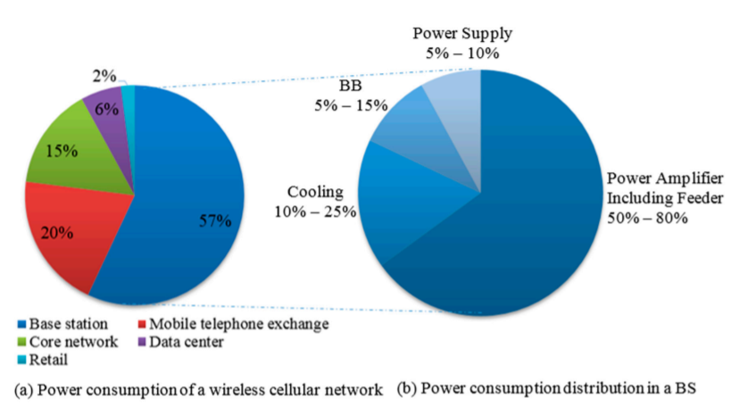

**Figure 1**. Component breakdown and BS in the power consumption of a cellular network [4, 5].

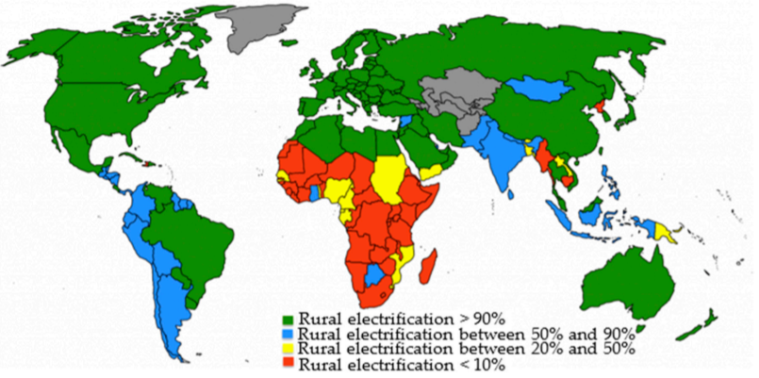

**Figure 2**. Progress in rural electrification across the world [6]

Operators of cellular networks strive to make their networks more energy efficient to keep their businesses profitable while also reducing their impact on the environment. Mobile networks are a major source of greenhouse gas emissions (GHG). The value of (CO2) released from the mobile section reaches 179 million tons of carbon dioxide by the year 2020 and represents 51% of the total carbon emissions of the ICT industry. As a result, cellular network operators are under pressure to fulfill environmental conservation and OPEX reduction requirements [7]. Researchers, vendors, and mobile service providers have a challenge useful in qualifying energy for cellular networks due to the expected economic and environmental impact in the next few years. Because of this, a new field of study called “Green Communication” has just been developed. The primary objective of the Green Communications Project is to raise the efficiency of energy for BS, minimize operating expenses, and clear greenhouse gas emissions. First and foremost, cellular network operators are attempting to implement green practices in two key ways. Energy-saving devices are used in the first strategy to reduce BS energy consumption at the equipment level and provide these plants with low-cost energy sources. Network resources might be wasted if they are not utilized effectively. That's why the second technique promotes network components to be regulated according to traffic load variation [8]. BSs activated by renewable energy sources offer long-range advantages to the cellular sector, according to this study. Besides providing research recommendations, this study examines the relevant literature, the potency of solutions for renewable energy that are used for mobile base stations, geographic potential locations primary for renewable energy stations, the research for using renewable energy in mobile networks, and open cases around solar panel systems, wind turbines, and fuel cells, The current deployment of primary renewable energy plants [9].

1. **Photovoltaic (PV) System**

Photovoltaic (PV) systems are primarily used to convert solar energy into electricity. Around the world, many industries use it. Solar electricity has experienced one of the fastest growth rates among renewable energy sources during the last ten years. PV has several important benefits in terms of cost, environment, and installation. It is suitable for expanding electric utility capacity as well as for urban, suburban, rural, and other areas. Furthermore, it is benign and has little effect on the environment because it depends on sunlight. A PV system is very simple to install because it has no moving parts that could malfunction. Due to these benefits, the PV system is quite useful in many enterprises. The temperature has a substantial impact on the efficiency of the PV cell, and as temperature increases, so does the short circuit current [10].

**2.1. PV output characteristics**

Solar Cell I-V distinguishing Curves, which are a visual exemplification of how a solar cell or module runs, summarize the relationship between the current and voltage at the recent irradiance and temperature conditions. I-V curves give the information desired to configure a solar system to run as close to its ideal peak power point (MPP) as possible. The above diagram shows the current-voltage (I-V) characteristics of a model silicon PV cell running under a typical set of conditions. the amount of power a single solar cell or solar panel can generate lean on its output current and voltage (I*V). In Figure 3, the power curve can be generated by multiplying all voltages, from short circuit to open circuit, point by point, for a given radiation intensity.

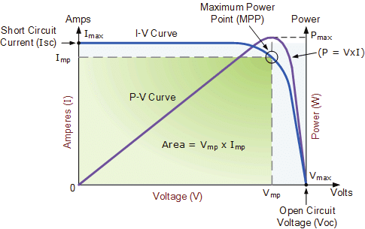

**Figure 3**. AC single diode model representation of solar cell [10].

**2.2. Modeling of a PV system**

The solar cell is the essential component of a PV power system. However, it is rarely used by itself because it cannot supply electrical equipment with significant voltage and power. Several solar cells are connected in parallel or in series to achieve the greatest voltage and power output feasible. Cells connected in series increase the output voltage when those linked in parallel enhance the current (Figure 4). The solar panel or array is composed of several electrically linked modules that operate in series and parallel to generate the required current and voltage, and subsequently the power.

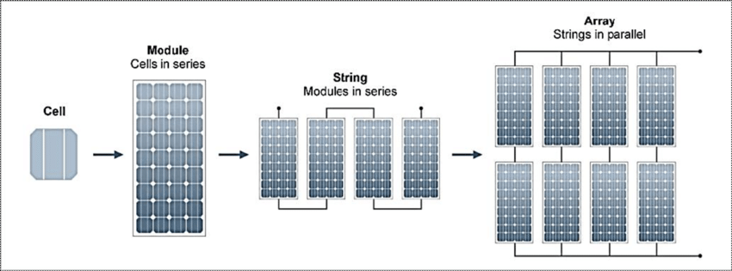

**Figure 4**. Configuration of the cell, module, and array [11]

The photovoltaic system converts sunlight into power without causing any environmental damage. PV arrays are built on PV cells, which are just simple p-n junction devices. In figure 5 the analogous circuit photovoltaic cell is shown. A current origin (photocurrent), the diode in parallel with it, the series resistor represents the internal resistance to the current passage, and a handle resistance to depict a seepage current are similar circuit elements.

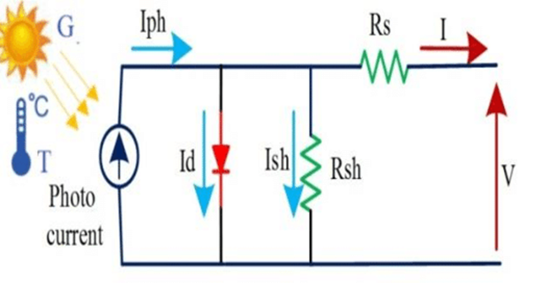

**Figure 5**. The corresponding circuit of a PV cell

As in Equation 1, we can specify the current that is sent to the load. The photocurrent of a PV cell, which is influenced by temperature and radiation, can be written as in Equation 2 [10].

$I=I_{PV}-I_{O}\left[exp\left(\frac{V+IR_{S}}{aV_{T}}\right)-1\right]-\left(\frac{V+IR_{S}}{R_{P}}\right)$ (1)

where *IPV* is photocurrent current, *I0* is the diode’s reverse saturation current, *V* is the voltage across the diode, *an* ideality factor, *VT* is the thermal voltage, *RS* is series resistance and *RP* is Shunt resistance.

$I_{PV}=\left(I_{PV_STC}+K_{i}∆T\right)\frac{G}{G_{STC}}$ (2)

where *Ki* is the temperature of the Cell’s short circuit current coefficient, *G* is solar irradiation in W/m2, *T* is the Cell's temperature, *GSTC* is nominal solar irradiation in W/m2 and *IPV_STC* is the light generated current under standard test conditions.

**2.3. Fuzzy MPPT Technique**

In order to increase the power output from turbines and PV solar modules, you can employ a special technology called Maximum Power Point Tracking, or MPPT. In order to charge the battery as quickly as possible, the MPPT controller may monitor the maximum voltage and current values (the VI) and recognize the voltage produced by solar panels in real-time. Photovoltaic inverters can employ MPPT to coordinate with solar panels, batteries, and workloads.

The ability of fuzzy logic-based intelligent MPPTs to manage system nonlinearity has garnered more interest. Due to inaccuracy in PV module modeling and unpredictability in the performance of PV systems due to varying irradiance and temperature, it is found that the fuzzy MPPT (FMPPT) is more suited for tracking MPP than standard algorithms in PV Systems. FMPPT can deal with uncertainty caused by nonlinearity, unmodeled physical parameters, and erratic variations at the operational point of the PV system. The performance of the photovoltaic system is improved by using this MPPT technology, which improves the choice of the duty cycle's variable step size. This method works by calculating the variable step by the slope value of a solar module's Power-Voltage characteristic. After that, the appropriate duty cycle value is given [12, 13]. In Figure 6, the function of Fuzzy Membership is shown.

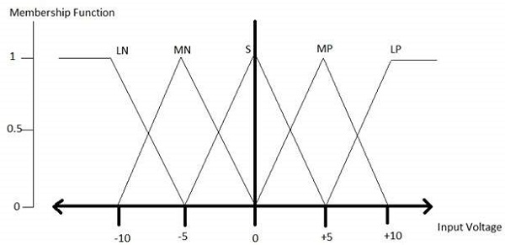

**Figure 6**. The function of Fuzzy Membership for e, ce, and Δd [12].

1. **The Proposed System**

This section will include a presentation of the proposed system's final design as well as all of its findings. The output power in its purest form, with maximum efficiency, maximum power, and pure output free of oscillations and disturbances, has been examined using a 48-Volt battery. The complete system, which uses Fuzzy MPPT technology and solar energy as a load, is shown in Figure 7.

The curve in Figure 8 is used as a benchmark; it represents the PV array model block's characteristic curve and the expected maximum output power.

After the model has run for one second, observe the PV system's outputs and responses, as shown in Figure 7. By simulating the system, we can determine that the PV array's maximum power is approximately 111.4 watts, the module's voltage is almost 23 volts, the current is almost 7 amperes, and these are the characteristics acquired at 50 degrees Celsius and 1000 watts per square meter of solar irradiation (Figure 9). Figure 10 presents the output power of the system.

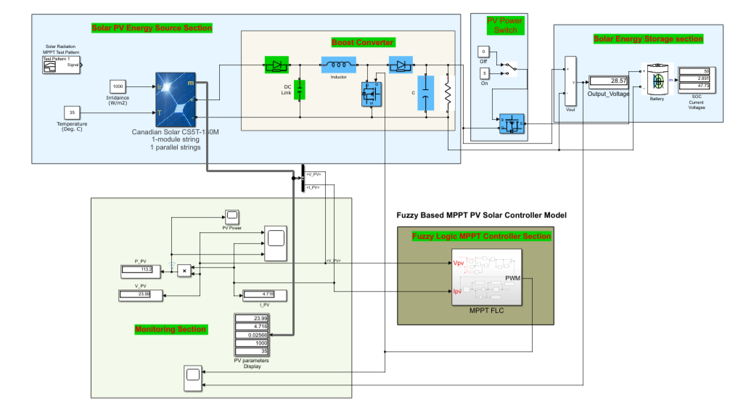

**Figure 7**. The corresponding circuit of a PV cell.

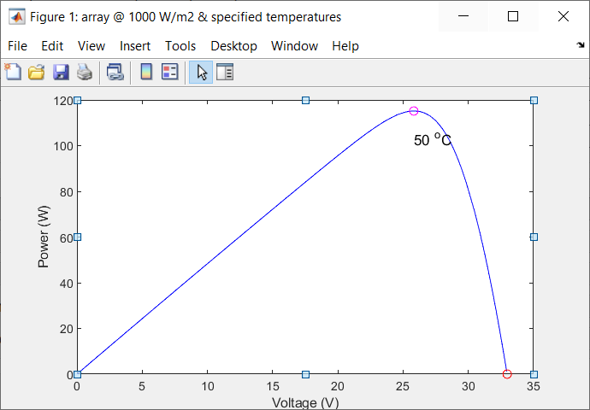

**Figure 8**. The PV characteristic plot**.**

|  |  |
| --- | --- |
|  |  |

**Figure 9**. Simulation results under temperature 50C°.

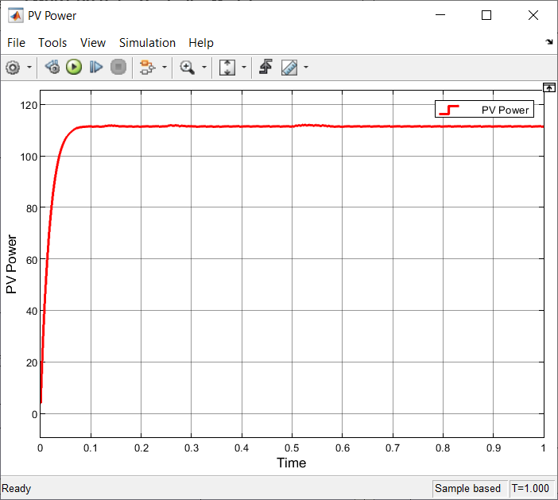

**Figure 10**. The corresponding circuit of a PV cell.

1. **Conclusion**

The effectiveness of several maximum power point tracking approaches was thoroughly investigated. The Incremental Conductance technique surpasses all other methods in both typical and changeable air conditions. The power output obtained from the incremental conductance approach is greater than that obtained from other methods under various air conditions. In a solar system that is connected to the grid, the Maximum Power Point Tracking method has a significant impact. Depending on the complexity, cost of implementation, and required number of sensors, the best MPPT solution is chosen. As a result, the fuzzy logic controller-based MPPT method yields better results for both domestic and commercial applications.

The research-based design and implementation of “Inertia Control by Fuzzy Logic Controler in PV System” led researchers to conclude that the system is robust and performs at its best even when inertia disturbances affect the photovoltaic system. The system is created using a technical and critical design methodology. For the development and implementation of an offshore PV energy system, we need to build an advance-based controller, an intelligent controller, or a fuzzy logic-based controller. To do this, we must thoroughly assess the system and undertake a research-based study of the relevant literature.

**References**

1. Jahid, A., Monju, M.K.H., Hossain, M.E. and Hossain, M.F*., 2018. ‘‘Renewable energy assisted cost aware sustainable off-grid base stations with energy cooperation’’.* IEEE Access, 6, pp.60900-60920.
2. M. J. Farooq, H. Ghazzai, A. Kadri, H. ElSawy, and M. Alouini,2017,*‘‘A hybrid energy sharing framework for green cellular networks,’’* IEEE Trans. Commun., vol. 65, no. 2, pp. 918–934.
3. Jahid, A. B. Shams, and M. F. Hossain*,* 2018, *‘‘Dynamic point selection CoMP enabled hybrid powered green cellular networks,’’* Comput. Electr. Eng., pp. 1–15.
4. *Wu, J.; Zhang, Y.; Zukerman, M.; Yung, E., ‘‘Energy-Efficient Base Stations Sleep Mode Techniques in Green Cellular Networks: A Survey.* IEEE Commun. Surv. Tutor. 2015, 17, 803–826*.*
5. Hasan, Z.; Boostanimehr, H.; Bhargava, V.K. *Green Cellular Networks: A Survey, Some Research Issues, and Challenges.* IEEE Commun. Surv. Tutor. 2011, 13, 524–540.
6. Berkeley Energy & Resources Collaborative (BERC). Available online: *‘‘http://berc.berkeley.edu/energyaccess-across-world/’’*
7. K. Kanwal, G. A. Safdar, M. Ur-Rehman, and X. Yang, *‘‘Energy management in LTE networks,* , 2017,*’’* IEEE Access, vol. 5, pp. 4264–4284.
8. M. Aris and B. Shabani, *‘‘Sustainable power supply solutions for offgrid base stations,* 2015,*’’* Energies, vol. 8, no. 10, pp. 10904–10941*.*
9. M. A. Safwat, *‘‘Framework for multi-operator collaboration for green communication,* 2018,*’’* IEEE Access, vol. 6, pp. 850–865.
10. Jahid, A. S. Ahmad, and M. F. Hossain, *‘‘Energy-efficient BS Cooperation in DPS CoMP based cellular networks with hybrid power supply,’’* in Proc. IEEE Int. Conf. Comput. Inf. Technol. (ICCIT), Dhaka, Bangladesh, Dec. 2016, pp. 93–98.
11. Jahid and M. S. Hossain, *‘‘Feasibility analysis of solar powered base stations for sustainable heterogeneous networks,’’* in Proc. IEEE Region 10 Humanitarian Technol. Conf., Dhaka, Bangladesh, Dec. 2017, pp. 686–690.
12. J. K. Shiau, Y. C. Wei, and B. C. Chen, *“A study on the fuzzy-logic-based solar power MPPT algorithms using different fuzzy input variables,”* Algorithms, vol. 8, no. 2, pp. 100–127, 2015, doi: 10.3390/a8020100.
13. N. Y. Goshwe, G. A. Igwue, and D. T. Kureve, *“Fuzzy Logic Control for harvesting maximum power from PV solar based SEPIC Converter,”* International Journal of Scientific and Research Publications (IJSRP), vol. 8, no. 12, Dec. 2018, doi: 10.29322/ijsrp.8.12.2018.p84108.