**THE INTERCULTURAL COMMUNICATIVE COMPETENCE LEVELS OF EX-ERASMUS STUDENTS: ÇANAKKALE ONSEKIZ MART UNIVERSITY CASE**

**Orçin KARADAĞ[1]**

**ABSTRACT**

This study aims to reveal Intercultural Communicative Competence (ICC) of ex-Erasmus exchange students. ICC is defined as an approach that considers target language-based learning as communicative competence essential for foreign language learners to participate fully in the target language culture. Such competence is seen as crucial to intercultural interaction. Therefore, how we maintain interaction in target language culture is possibly affected by how competent we are in ICC. Thus, the essential role of ICC is believed to be investigated under various inter-cultural contexts such as campus, international conferences or in study abroad exchange programs. In this study, the ex-Erasmus exchange students’ views on their self ICC are aimed to be surveyed through the “ICC scale”. By getting the required permissions and ethical checks, the ICC scale was transferred onto “Google-Forms” and sent to the Erasmus exchange program students online, who are in the database of the Çanakkale Onsekiz Mart University-International Affairs Office. The online-gathered responses were analyzed through statistical software, and descriptive, *t* and *univariate* tests were administered to account for the competency of the responding students. As for findings, no significant difference was found between the overall ICC competency scores and independent variables, but among gender*length of stay*Total ICC scale intercept. It is believed to be due to ethnocultural gender roles in society. Further implications are discussed accordingly.

Keywords: ICC, Intercultural, Communicative competence, Erasmus (+) exchange program

**INTRODUCTION**

In a broader sense, the term culture has been discussed for ages as it is believed to contain every bit of human life since existence. Hence, it has brought several definitions on the defining culture. Kroeber and Kluckhohn (1952) named 162 various definitions till the 50s. In the following time, Spencer-Oatey (2012) also indicated that understanding the concept of culture had evolved even more in the last 50 years. The expanding and continuous nature of culture definition seems to last forever. This evolving nature is believed to due to the culture is continuously evolving with its contemporary agenda. Until the 70s, the notion of culture was assigned with similarities and differences comparatively. This comparison based approach led the scholars to focus on the converging and diverging motives of different nations. Through such nations based comparisons, overgeneralized culture definitions aroused much. By the 70s, subjectivity and context-based emic approaches instead of nation-based and, epic perspectives found more credits in the academy (see Hall, 1972). With the shift in the research perspective, the 80s and 90s mainly focused on micro contexts and more subjective inquiry on the concept of culture. As Spencer-Oatey (2012) refers, the paradigm shift in the definition of culture concept evolved into a more liquid way of understanding. That is to say that the concept of culture is nowadays comprehended as more individualist and context shaped instead of generalizable terms as in the past.

The indicated shift in the concept of culture also brought more context-based approaches to research methodologies as phenomenology, ethnography, discourse analysis and conversation analysis. Due to the new methods, daily/real-time recorded data gained more significance in the understanding of individual cultural investigations. The recorded data, which represent the individual culture, also charmed the attention of several disciplines as sociology, ethnomethodology and several others. Thus, interactional inquiries have been accepted to have a place in the investigation of cultural concepts.

With the interaction-based approaches to culture, communicative facets of culture have been studied under various contexts (Alptekin, 2002; Arasaratnam, 2009; Tuncel & Paker, 2018). To Alptekin (2002), the ICC is defined as an approach that considers target language-based learning as communicative competence essential for foreign language learners to participate fully in the target language culture (p. 58). Such competence is claimed to be crucial to intercultural interaction (Tuncel & Paker, 2018). Therefore, maintaining interaction successfully in the target language culture depends on how competent we are in ICC. Moreover, Peng, Wu and Fan (2015, p. 153) state that the crucial role of ICC is to be investigated under various inter-cultural contexts as “campus, international conferences or in study abroad exchange programs.” The studies conducted mainly focused on the people who have been abroad for some time and tried to come up with the intercultural communicative changes after turning back home. However, not much study focused on the students who have been abroad for educational purposes, particularly in the Turkish context.

Following the indicated research gap, the study focuses on the Erasmus (+) students who have been to several European countries during their learning periods. These ex-Erasmus (+) students, as a regulation of the Erasmus (+) exchange program, these ex-Erasmus (+) students either stay one semester or maximum two semesters in the country they are sent to. So in the study, views of these ex-Erasmus exchange students on their self ICC are aimed to be surveyed through the “ICC scale” developed and statistically tested by Arasaratnam (2009). The online-gathered responses are analyzed through statistical software. *Descriptive*, *t* and *univariate* tests were administered to account for the competency of the respondent students. As for findings and discussion, comparisons and implications on intercultural communication and being abroad are discussed. To sum up, the study aims at revealing the self-reflections of the ex-Erasmus (+) students on their ICC competence. To demonstrate the results, the study tries to compare and contrast the mean scores obtained from the ICC scales with the independent variables as gender, level of grade, and the length of stay as Erasmus (+) students.

In line with the context of the study, the study aims to examine the following questions;

RQ_1:

What are the Intercultural Communication Competence stances of ex-Erasmus (+) Exchange Program students at Çanakkale Onsekiz Mart University?

RQ_2:

A) Do these Erasmus (+) Exchange Students’ gender, level of grade, and the length of stay abroad influence their Intercultural Communication Competence?

B) Do these variables interact with each other as the overall effect is considered?

**METHODOLOGY**

**Research Design**

The study is in the design of a quantitative research method. Field (2009) fundamentally defines these research methods as “inferring evidence for a theory through measurement of variables that produce numeric outcomes” (p. 792). Quantitative research methods have experimental or non-experimental, survey and comparative types of inquiries (Mertens, 2014). Of these research methods, this study utilizes a descriptive/non-experimental research design (Creswell, 2012). Creswell (2014) divides such studies into two sub-dimensions: ‘survey’ and ‘experimental’ research studies. Of these classifications, the study embraces the survey type of the quantitative (non-experimental) research designs. To Nunan and Bailey (2009), survey type of quantitative research design deals with the “numeric descriptions of trends, attitudes, or opinions of a population” through sampling out of that population. Following a descriptive survey of the research designs, this study reveals the intercultural communicative competence of ex-Erasmus (+) students at Çanakkale Onsekiz Mart University.

**Participants**

The study population consists of 500 ex-Erasmus (+) students either currently studying or graduated from Çanakkale Onsekiz Mart University. From these students to whom the links are sent, there received 62 responses which are to be named as the sampling of the study. Table 1 illustrates the fine-tuned distribution of the participants. Briefly, there are 36 graduated participants and 26 under-graduate participants in the study. Thirty of the participants complete their Erasmus (+) experience after one semester; on the other hand, 32 of the participants extend their stay for another semester. There are 13 males and females (nunder_grad_total=26) at the under graduation level, 18 males and females (ngrad_total=36) at the graduated level. The top three most selected countries are Poland (n=18), Czechia (n=15) and Germany (n=6), whereas the least selected countries are Bulgaria, Hungary, Slovakia and UK, with a single participant for each case. To account for the possible reasons for country selection Yılmaz (2016) gives her rationale under several topics: the country's currency, geographical location of the country, dwellers’ attitude towards Erasmus students, and educational leniency[2]. Also, Saykal (2017) also posts similar themes in her blog as well. She lists her suggestions as; the educational system of the country, medium of instruction in the target university, living conditions in the city, geographical conditions and weather conditions of the city. When compared, Saykal (2017) is rather sound to understand the possible reasons of Erasmus students to account for the rationale to choose the country they will be an Erasmus student in.

**Data Collection Instrument and Procedure**

The data for the study is assembled online through a scale developed by Arasaratnam (2009). The scale (see Appendix A) consists of ten items and three factors: cognitive, behavioural, and affective factors. The scale is found to be reliable (*Cronbach’s α = .77, M = 4.79, SD = .88)* by the developer. Regarding the factors, the scale has three items for cognitive factor, four items (1st, 5th and 6th items), for affective factor (4th, 10th and 7th items) and three items for behavioural factor (2nd, 3rd-8th and 9th items). For the sake of reliability concerns of the study, *Cronbach’s Alpha* coefficient of the scale was tested and found to be *α*= .72. To Field (2009), though this is an acceptable level of reliability, it is on the lowest threshold level of being accepted to be reliable.

Following the selection of the scale, the study's population and the sampling are focused initially (Creswell, 2007). The primary focus of the study is on ex-Erasmus (+) students, the related connections with the Foreign Affairs office at Çanakkale Onsekiz Mart University, to ask for the permission of conducting a study on these students and subsequently administering the scale chosen is managed. By getting the survey's approval, the survey is asked to be created online by the Foreign Affairs Office. The Foreign Affairs Office also wanted to send the link for the survey itself due to the privacy regulations of the university on e-mail addresses’ share. Hence, the survey is designed via the “Google-Forms” online platform. The Foreign Affairs Office reported that they sent the survey link to 500 e-mail addresses in their database. It took three weeks to gather responses from ex-Erasmus (+) students. In the meantime, the e-mail containing the link to the survey is resent three more times. Response gathering is disabled after three weeks, and the data is downloaded to the author’s laptop. After that, that data is uploaded to SPSS 21.00 program for statistical testing needs, with the required transformations of the data to run statistical analyses.

**Table 1**

*Descriptive Statistics of the Participants*

|  |  |  |  |  |  |  |  |  |  |  |  |  |  |  |  |  |
| --- | --- | --- | --- | --- | --- | --- | --- | --- | --- | --- | --- | --- | --- | --- | --- | --- |
| Grade | Duration of Stay | Gender | N | | | | | | | | | | | | | |
| Erasmus Country* | | | | | | | | | | | | | |
| Bul. | Cz. | Ger. | Hun. | Ita. | Lat. | Lith. | Pol. | Port. | Rom. | Slov. | Spa. | UK | Total |
| Undergrads. | 1 Semester | Male |  | 3 | 1 |  |  |  |  | 1 |  |  |  |  |  | 5 |
| Female |  | 6 | 1 |  |  |  |  | 1 |  | 1 |  |  |  | 9 |
| 2 Semester | Male |  |  | 2 | 1 |  |  |  | 4 | 1 |  |  |  |  | 8 |
| Female |  | 1 |  |  |  |  | 1 |  | 1 | 1 |  |  |  | 4 |
| Graduated | 1 Semester | Male |  | 1 |  |  | 1 |  |  | 3 |  |  |  |  |  | 5 |
| Female | 1 | 1 | 1 |  | 2 |  |  | 4 |  | 1 |  |  | 1 | 11 |
| 2 Semester | Male |  | 2 | 1 |  | 2 | 1 | 2 | 3 |  |  |  | 2 |  | 13 |
| Female |  | 1 |  |  |  | 1 | 1 | 2 | 1 |  | 1 |  |  | 7 |
|  | Total |  | 1 | 12 | 6 | 1 | 5 | 2 | 4 | 18 | 3 | 3 | 1 | 2 | 1 | 62 |

*\* Bul.: Bulgaria, Cz.: Czechia, Ger.: Germany, Hun.: Hungary, Ita.: Italy, Lat.: Latvia, Lith.: Lithuania, Pol.: Poland, Port.: Portugal, Rom.: Romania, Slov.: Slovakia, Spa.: Spain.*

**Data Analysis**

To analyze the data, SPSS 21.00 program is utilized for statistical analyses. First of all, the outliers are controlled through Histogram diagrams to detect the problematic respondents to protect the data distribution. Conclusion: There were no outliers in data, so the normality tests were run to control the data distribution as recommended by Larsen-Hall (2015). *Skewness (p > .05)* *& Kurtosis (p > .05)* and *Kolmogorov-Smirnov* *(p > .05)* tests revealed that the data is normally distributed which is a sign to administer *Parametric Tests* (Field, 2009). After agreeing upon the no-outliers and normality in distribution, the first research question, *“RQ_1: What are the Intercultural Communication Competence stances of ex-Erasmus (+) Exchange Program students at Çanakkale Onsekiz Mart University?”* is analyzed through *descriptive and frequency* statistics. The mean score and frequencies of each item, each factor and total scale are descriptively examined. After, to answer the second question, the *Independent Samples t-test* was run to account for the influences of independent variables on the total mean score of ICC scale and all three factors in the scale. To control for the intercept among these variables *Univariate test of the General Linear Models* was run. All the tables and figures are given to discuss in the following chapter.

**FINDINGS AND DISCUSSION**

In this chapter, to present the findings and discuss them accordingly, the study follows the order of research questions.

*RQ_1: What are the Intercultural Communication Competence stances of ex-Erasmus (+) Exchange Program students at Çanakkale Onsekiz Mart University?*

**Table 2**

*Descriptive Statistics of the ICC Dimensions (N: 62 for each case)*

|  |  |  |  |  |
| --- | --- | --- | --- | --- |
|  | Min. | Max. | M* | SD |
| Cognitive | 2.33 | 4.67 | 3.16 | .54 |
| Behavioural | 2.00 | 5.00 | 3.90 | .67 |
| Affective | 2.33 | 5.00 | 3.94 | .73 |
| Total SCALE | 2.33 | 4.44 | 3.66 | .47 |

\**1.0–2.4 = low; 2.5–3.4 = medium; 3.5–5.0 = high, see Oxford & Berry-Sock (1995, p. 2)*

Table 2 illustrates the mean scores of the scale's total ICC score and gives the sub-dimensions of the ICC scale as well. When the overall score of the scale is examined *(M= 3.66, SD= .47),* the level of the participants in the study concerning ICC is found to be high (Oxford & Berry-Sock, 1995). However, when the overall mean score is compared to the developer’s findings, this study's overall mean score is too low than the original one by *Arasaratnam (M= 4.79, SD = .88)*. Moreover, the standard deviation is less in this study (*SD= .47)* too.

Furthermore, this study adds to the original scale concerning the statistical comparisons of the factors of the ICC scale. So, Table 2 shows that the highest score among the factors is of *Affective* dimension (*M= 3.94)*. Following this *Affective* dimension *Behavioural* dimension comes second *(M= 3.94).* The mean scores of these two dimensions are very close to each other. On the other hand, the lowest mean score is of the *Cognitive* dimension (*M= 3.16*). This dimension has a medium level of ICC, whereas both of the other dimensions have a high level of ICC. This finding overlaps with Chen (1996) in that Chen also finds limited Cognitive level effect over ICC. However, studies of Arasaratnam and Doerfel (2005) and Sercu (2004) underline the crucial role of the cognitive dimension over ICC. This claim can be better understood by looking at the items for the cognitive dimension in Table 3.

**Table 3**

*Descriptive Statistics of ICC Items for Cognitive Factor (N=62 for each case)*

|  |  |  |  |  |  |  |  |  |  |  |  |  |
| --- | --- | --- | --- | --- | --- | --- | --- | --- | --- | --- | --- | --- |
| **ICC-Cognitive** | **1\*** | | **2\*** | | **3\*** | | **4\*** | | **5\*** | |  |  |
|  | *f* | % | *f* | % | *f* | % | *f* | % | *f* | % | **M\*\*\*** | **SD** |
| 1- I often find it difficult to differentiate between similar cultures (Ex: Asians, Europeans, Africans, etc.) ** | 1 | 1.6 | 1 | 1.6 | 26 | 41.9 | 21 | 33.9 | 13 | 21 | 3.71 | .88 |
| 5- I find it easier to categorize people based on their cultural identity than their personality. | 22 | 35.5 | 21 | 33.9 | 8 | 12.9 | 9 | 14.5 | 2 | 3.2 | 2.16 | 1.16 |
| 6- I often notice similarities in personality between people who belong to completely different cultures. | 0 | 0 | 2 | 3.2 | 29 | 46.8 | 23 | 37.1 | 8 | 12.9 | 3.60 | .76 |

*\*1=Never, 2=Occasionally, 3=Sometimes, 4=Often, 5=Always*

*\*\* Reverse Coding is utilized.*

*\*\*\* 1.0–2.4 = low; 2.5–3.4 = medium; 3.5–5.0 = high, see Oxford & Berry-Sock (1995, p. 2)*

Examining Table 3, it is apparent that the item under the cognitive dimension of the ICC scale mainly focuses on similarities and differences of the cultures. This part is closely related to the idea of Hofstede’s (1984) initial findings on IBM workers over the world. However, the focus in the scale diverges with what Hofstede (1984) claims; instead, this study focuses on how competent the participants are on the realization of the similarities and differences to raise their intercultural awareness on their ICC. To sum it up, the participants in the study bears a medium level of competence in the cognitive realization of the different cultures they come across, even though they have all been abroad for a certain period.

**Table 4**

*Descriptive Statistics of ICC Items for Behavioural Factor (N=62 for each case)*

|  |  |  |  |  |  |  |  |  |  |  |  |  |
| --- | --- | --- | --- | --- | --- | --- | --- | --- | --- | --- | --- | --- |
| **ICC-Behavioural** | **1\*** | | **2\*** | | **3\*** | | **4\*** | | **5\*** | |  |  |
|  | *f* | % | *f* | % | *f* | % | *f* | % | *f* | % | **M\*\*\*** | **SD** |
| 2- I feel that people from other cultures have many valuable things to teach me. | 0 | 0 | 3 | 4.8 | 5 | 8.1 | 22 | 35.5 | 32 | 51.6 | 4.34 | .83 |
| 3(8a) - Most of my friends are from my own culture. ** | 3 | 4.8 | 21 | 33.9 | 12 | 19.4 | 21 | 33.9 | 5 | 8.1 | 3.01 | 1.10 |
| 9- I usually look for opportunities to interact with people from other cultures. | 0 | 0 | 4 | 6.5 | 5 | 8.1 | 23 | 37.1 | 30 | 48.4 | 4.27 | .87 |

*\*1=Never, 2=Occasionally, 3=Sometimes, 4=Often, 5=Always*

*\*\* Reverse Coding is utilized.*

*\*\*\* 1.0–2.4 = low; 2.5–3.4 = medium; 3.5–5.0 = high, see Oxford & Berry-Sock (1995, p. 2)*

The next dimension of the ICC scale is Behavioural factors. Table 4 illustrates that behavioural factors refer to practices in intercultural communications and how willing the participants are. To remind that, this is one of the high levels of dimensions, as stated in Table 2 (*M= 3.90*). Should the items are compared, item 3 has a medium level of ICC, whereas the others have a high level of ICC. Table 4 shows that even though the participants give a medium level of competence regarding possessing friends from their own culture, they employ a high level of interactional approach concerning real-life practice in the behavioural dimension of the ICC. This can be accounted for because of the low possibility of getting a new friend(s) in their context or sustainability of their friendship due to the time constraints of the Erasmus (+) program. These claims coincide with the findings of Rubin and Martin (1994) and Arasaratnam (2009); as they both refer to the impact of behavioural actions on sustaining friendship, so does the ICC.

**Table 5**

*Descriptive Statistics of ICC Items for Affective Factor (N=62 for each case)*

|  |  |  |  |  |  |  |  |  |  |  |  |  |
| --- | --- | --- | --- | --- | --- | --- | --- | --- | --- | --- | --- | --- |
| **ICC-Affective** | **1\*** | | **2\*** | | **3\*** | | **4\*** | | **5\*** | |  |  |
|  | *f* | % | *f* | % | *f* | % | *f* | % | *f* | % | **M\*\*\*** | **SD** |
| 4- I feel more comfortable with people from my own culture than with people from other cultures. ** | 4 | 6.5 | 7 | 11.3 | 11 | 17.7 | 26 | 41.9 | 14 | 22.6 | 3.63 | 1.15 |
| 7- I usually feel closer to people who are from my own culture because I can relate to them better. ** | 2 | 3.2 | 11 | 17.7 | 17 | 27.4 | 21 | 33.9 | 11 | 17.7 | 2.55 | 1.01 |
| 10- I feel more comfortable with people who are open to people from other cultures than people who are not | 0 | 0 | 0 | 0 | 2 | 3.2 | 12 | 19.4 | 48 | 77.4 | 4.74 | 5.10 |

*\*1=Never, 2=Occasionally, 3=Sometimes, 4=Often, 5=Always*

*\*\* Reverse Coding is utilized.*

*\*\*\* 1.0–2.4 = low; 2.5–3.4 = medium; 3.5–5.0 = high, see Oxford & Berry-Sock (1995, p. 2)*

In the following table (Table 5), the Affective dimension of the ICC scale is given. This dimension of the ICC is found to be the highest of all factors (*M= 3.94)*. The *Affective* Dimension of the ICC deals with how the participants feel in the intercultural communicative context and particularly in practice times. For example, item 10 in Table 5 has the highest mean score (*M= 4.74),* and it is related to how open to be during intercultural communication and how the participants fell at those moments. The participants expect their interlocutors to communicate interculturally; however, items 7 and 4 contrast with the idea of being tolerant in the interculturality of item 10. That is to say that, while the results of item 7 have a low level of competence in feeling closer to the people from their own culture as the indicator of being open to the interculturality; in item 4, they show the high value of ICC in feeling comfortable with people from their own culture. In other words, even though the participants seem to feel closer to the intercultural communicative contexts, they do not feel comfortable at these contexts at the same level as the other items.

To sum up, all participants show a medium or higher level of ICC if the dimensions and overall scores of competencies are checked. Also, they show more sensitivity and behavioural approximation in ICC than cognitive dimensions, as in Redmond's (1985, in Arasaratnam, 2009) study. Besides, the overall mean score signal that the ex-Erasmus students possess ICC with a medium level of competence. This finding shows the possible impact of the Erasmus (+) program on the development of ICC.

In the following section of the study, RQ_2 with the sub-questions will focus on inferential statistics of the scale results.

*RQ_2: A) Do these Erasmus (+) Exchange Students’ gender, level of grade, and the length of stay abroad influence their Intercultural Communication Competence?*

To examine the second research question, *Independent Samples t-tests* were run for independent variables (Gender, Duration of Stay and Grade of the Participants). There were no statistically significant results (p > .05, for each case) for all of the listed independent variables. Interestingly, the mean scores range from *3.00 to 4.00*. This situation refers to the medium to the upper-medium level of ICC for participants of the study. However, in the adapted research, it is found to be over *4.5*. This finding proves Arasaratnam (2009) claim and Arasaratnam and Doerfel (2005), which stress that administering the scale under various contexts may end up with various results to convey the discussion on validity and reliability of the study. Matveev (2002) used the same test to control for gender and educational level, yet he also found no significant result in superiority over the other counterparts.

*B) Do these variables interact with each other as the overall effect is considered?*

After finding no significant results of mean comparisons via *Independent Samples t-test*, the intercept among the variable was tested to examine inter-relationships and the directions through the *Univariate tests* of the *General Linear Models.* The *F* ratio of the intercept is found to be significant (*F (1, 61)= 2016.58, p < .001)*. To reveal the between-subjects effects in the intercept model, profile pilots were controlled. It is found that there is an intercept among gender, duration of the participants stay and the total mean score of the ICC scale.

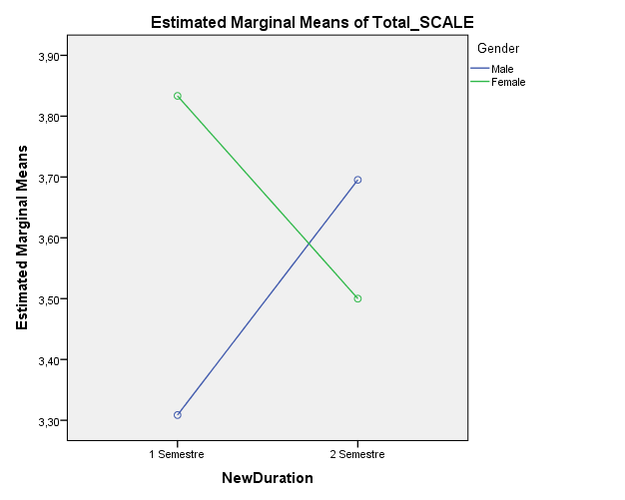

Figure 1: *The intercept among gender, duration of stay and the total mean score of the ICC scale.*

When Figure 1 is analyzed, the mean score of the males, who stayed one semester as Erasmus students, is app. 3.30 and of the females is app. 3.85. However, when the duration of the Erasmus students extends to 2 semesters, it all the around. The mean score of the males increases to approximately 3.70, whereas the mean score of the females decreases to about 3.50. The possible reason for this change in ICC related to the duration can be females’ quick adaptation and getting bored quickly. Another reason can be the family ties each gender has, in that, the females may be more linked to their families, so that they may feel more homesick and closer to communication in time. Dion and Dion (2001, p.519) find some proof regarding the difference in the adaptation of the males and females as immigrants. They conclude it as;

*“Previous research findings documenting greater parental and family scrutiny of daughters’ compared to sons’ lives suggested to us that gender differences in ethnocultural identity might occur...”*

With their conclusion above, Dion and Dion (2001) also suggest that gender roles in the country of stay as an Erasmus might have played an essential role in increasing and decreasing the ICC levels of the ex-Erasmus students.

**CONCLUSION**

In line with the purpose, the study has illustrated the intercultural communicative competence of ex-Erasmus students at Çanakkale Onsekiz Mart University. The data was gathered through the scale online adopted by Arasaratnam (2009). The scale chosen has three sub-dimensions which are taken as the centre of discussion. It is found that the overall score the participants got from the scale is of a high level, according to Oxford and Berry-Sock (1995). In contrast to the adopted study, the study has a lower overall score, even if they both present a high level of competence. The second research question mainly deals with inferential statistics as *Independent Samples t-test, Univariate test of General Linear Model (type III)*. From those inferential statistics, there found no significant difference between scale and any of the independent variables. However, the *Univariate* test gives a significant intercept, which is the intercept among gender, duration of stay, and total ICC score. This finding shows that the gender role (see Byram, 1997; Bryman & Cramer, 1994; Hofstede, 1984; Matveev, 2002) in a society is affected by many cultural variables. Even in the current days, in the second decade of the 21st century, the Anatolian culture might impact gender. Their related decisions, as Dion and Dion (2001) claimed on the ethnocultural differences on gender.

Another point to consider is the country selections before the Erasmus process of the students begin. Even if there is no significant difference, the frequency in the selection of mid-European countries (Poland, Czechia and Germany in order) is an important point to consider since it is believed not to be a coincidence when the high frequency of selection is beheld. As Byram (1997) model claims, “The intercultural speaker knows about perceptions of space in the other country as they do about their own”. From this point, the underlying reasons can be questioned for further understanding of cultural impacts on Erasmus country selection. One of the reasons that lie at the background of country selection may be the limited number of bilateral agreements that Erasmus Offices of the universities have. In accordance, the duration of stay is suggested to be reanalyzed as well.

As for the study's limitations, it has been found via “Regression Analysis” that the study's independent variables can explain only the 6 % of the total variance (*R2 = .06*). Also, the number of participants in the study is too limited to generalize the findings to other contexts. Due to the limited number of participants for sub-categories of the independent variables, some inferential tests could not be administered as *F (ANOVA)* tests for countries, various months of stay and grade of the student. Furthermore, the time of the year when the Erasmus exchange is experienced could have been added for possible climate-based interactional pitfalls. Also, current occupational knowledge and the travels with intercultural communicative possibilities could be added to understand the influencing factors on ICC better.

To sum up, the study concludes that Erasmus experience might impact the ICC of the Erasmus exchange students, as the overall ICC scale score of these Erasmus students was high. Besides, the absence of significant difference implies that no matter where, how long and by whom the Erasmus is experienced, exposure to a different culture via Erasmus boosts the students’ ICC levels positively. Such conclusions verify the impact of Erasmus on the world-citizenship in the long run. Moreover, it is believed to help peace construction among Erasmus countries and the whole world, as these ex-Erasmus students take more responsibilities in their future careers. Hence, more interaction-based paramount solutions will be potential. Beyond these, the study presents limited findings regarding the sources of this high level of ICC scale score. Therefore, the study suggests adding more independent variables by reaching more numbers of students and also a control group to administer more comparative and contrastive inferential studies. Lastly, more qualitative design studies, for in-depth analyses on the unfolding the frame of Erasmus experiences, can help the body of literature to portray a better understanding of Intercultural Communicative Competence.

**REFERENCES**

Alptekin, C. (2002). Towards intercultural communicative competence in ELT. *ELT Journal*, *56*(1), 57-64.

Arasaratnam, L. A. (2005). Sensation seeking and international students’ satisfaction of experiences in the United States. *Journal of Intercultural Communication Research, 34*, 184-194*.*

Arasaratnam, L. A. (2009). The development of a new instrument of intercultural communication competence. *Journal of Intercultural Communication*, (20).

Arasaratnam, L. A. & Doerfel, M. L. (2005). Intercultural communication competence: Identifying key components from multicultural perspectives. *International Journal of Intercultural Relations, 29*, 137-163.

Chen, L. (1996). Cognitive complexity, situational influences, and topic selection in intracultural and intercultural dyadic interactions. *Communication Reports, 9*, 1-12.

Creswell, J. W. (2007). Five qualitative approaches to inquiry. *Qualitative inquiry and research design: Choosing among five approaches*, *2*, 53-80.

Creswell, J. W. (2012). Educational research. *Planning, conducting, and evaluating quantitative and qualitative research*.

Creswell, J. W. (2014). *A concise introduction to mixed methods research*. Sage Publications.

Dion, K. K., & Dion, K. L. (2001). Gender and cultural adaptation in immigrant families. *Journal of Social Issues*, *57*(3), 511-521.

Field, A. (2009). *Discovering statistics using SPSS*. Sage publications.

Larsen-Hall, J. (2010). A guide to doing statistics in second language research. *New York: Rutledge*.

Hofstede, G. (1984). *Culture's consequences: International differences in work-related values* (Vol. 5). SAGE.

Matveev, A. V. (2002). The advantages of employing quantitative and qualitative methods in intercultural research: Practical implications from the study of the perceptions of intercultural communication competence by American and Russian managers. *Theory of communication and applied communication*, *1*(1), 59-67.

Mertens, D. M. (2014). *Research and evaluation in education and psychology: Integrating diversity with quantitative, qualitative, and mixed methods*. Sage publications.

Nunan, D., & Bailey, K. M. (2009). *Exploring second language classroom research: A comprehensive guide*. Boston, MA: Heinle, Cengage Learning.

Oxford, R. L. and J. A. Burry-Stock. 1995. Assessing the use of language learning strategies worldwide with the ESL/EFL version of the strategy inventory for language learning (SILL). *System 23*: 1–23

Peng, R. Z., Wu, W. P., & Fan, W. W. (2015). A comprehensive evaluation of Chinese college students’ intercultural competence. *International Journal of Intercultural Relations*, *47*, 143-157.

Redmond, M. V. (1985). The relationship between perceived communication competence and perceived empathy. *Communication Monographs, 52*, 378-382.

Rubin, R. B., & Martin, M. M. (1994). Development of a measure of interpersonal communication competence. *Communication Research Reports, 11*, 33-44.

Saykal, K. (2017). Erasmusa gitmeyi düşünenlere 5 tavsiye. Retrieved from CEOtudent, 03.01.2019: <https://ceotudent.com/erasmusa-gitmeyi-dusunenlere-5-tavsiye>

Sercu, L. (2004). Assessing intercultural competence: A framework for systemic test development in foreign language education and beyond. *Intercultural Education, 15*, 73-89.

Tuncel, İ. & Paker, T. (2018) Effects of an intercultural communication course in developing intercultural sensitivity. *International Journal of Higher Education, 7*(6), 198-211.

Yılmaz, P. (2016) Polonya’da Erasmus yapmanız için 10 neden. Retrieved from EDUMAG, 03.01.2019: <https://edumag.net/galeri/polonyada-erasmus-yapmaniz-icin-10-neden/>

**APPENDICES**

**Appendix A:**

*The ICC Scale adopted from Arasaratnam, 2009 and administered online as in the format as follows:*

This study aims to reveal Intercultural Communicative Competence (ICC) of pre-Erasmus exchange students. To explain the issue briefly, Alptekin (2002) defines the ICC as an approach that considers target language-based learning as communicative competence to be essential in order for foreign language learners to participate fully in the target language culture (p. 58). Therefore, how we maintain interaction without failure in target language culture depends on how competent we are in ICC. Please read the items (10) carefully and respond honestly.

Thank you so much for your support!

Researcher Orçin KARADAĞ

*Part I:* Background information

1. Gender: ( ) Male ( ) Female
2. Grade: ( ) First-year ( ) Second-year ( ) Third-year ( ) Fourth-year ( ) Graduated
3. In which country were you as an Erasmus(+) student ? ……………..
4. HOW LONG were you there?....................month/year

*Part II:* Intercultural competence

This section is designed to collect your responses of your intercultural communicative competence. Please choose the most appropriate from 1 to 5 about your intercultural communicative competence. We need your honest thoughts. Thank you!

Please read the following items and rate yourself using the scale below:

|  |  |  |  |  |  |
| --- | --- | --- | --- | --- | --- |
| **Intercultural Communicative Competence Items** | **Never** | **Occasionally** | **Sometimes** | **Often** | **Always** |
| 1- I often find it difficult to differentiate between similar cultures (Ex: Asians, Europeans, Africans, etc.) |  |  |  |  |  |
| 2- I feel that people from other cultures have many valuable things to teach me. |  |  |  |  |  |
| 3- Most of my friends are from my own culture. |  |  |  |  |  |
| 4- I feel more comfortable with people from my own culture than with people from other cultures. |  |  |  |  |  |
| 5- I find it easier to categorize people based on their cultural identity than their personality. |  |  |  |  |  |
| 6- I often notice similarities in personality between people who belong to completely different cultures. |  |  |  |  |  |
| 7- I usually feel closer to people who are from my own culture because I can relate to them better. |  |  |  |  |  |
| 8- Most of my friends are from my own culture. |  |  |  |  |  |
| 9- I usually look for opportunities to interact with people from other cultures. |  |  |  |  |  |
| 10- I feel more comfortable with people who are open to people from other cultures than people who are not. |  |  |  |  |  |

**Appendix B**

**Cultural Classification of Europe by 20th Century**

Retrieved from: <https://commons.wikimedia.org/w/index.php?curid=4523224>

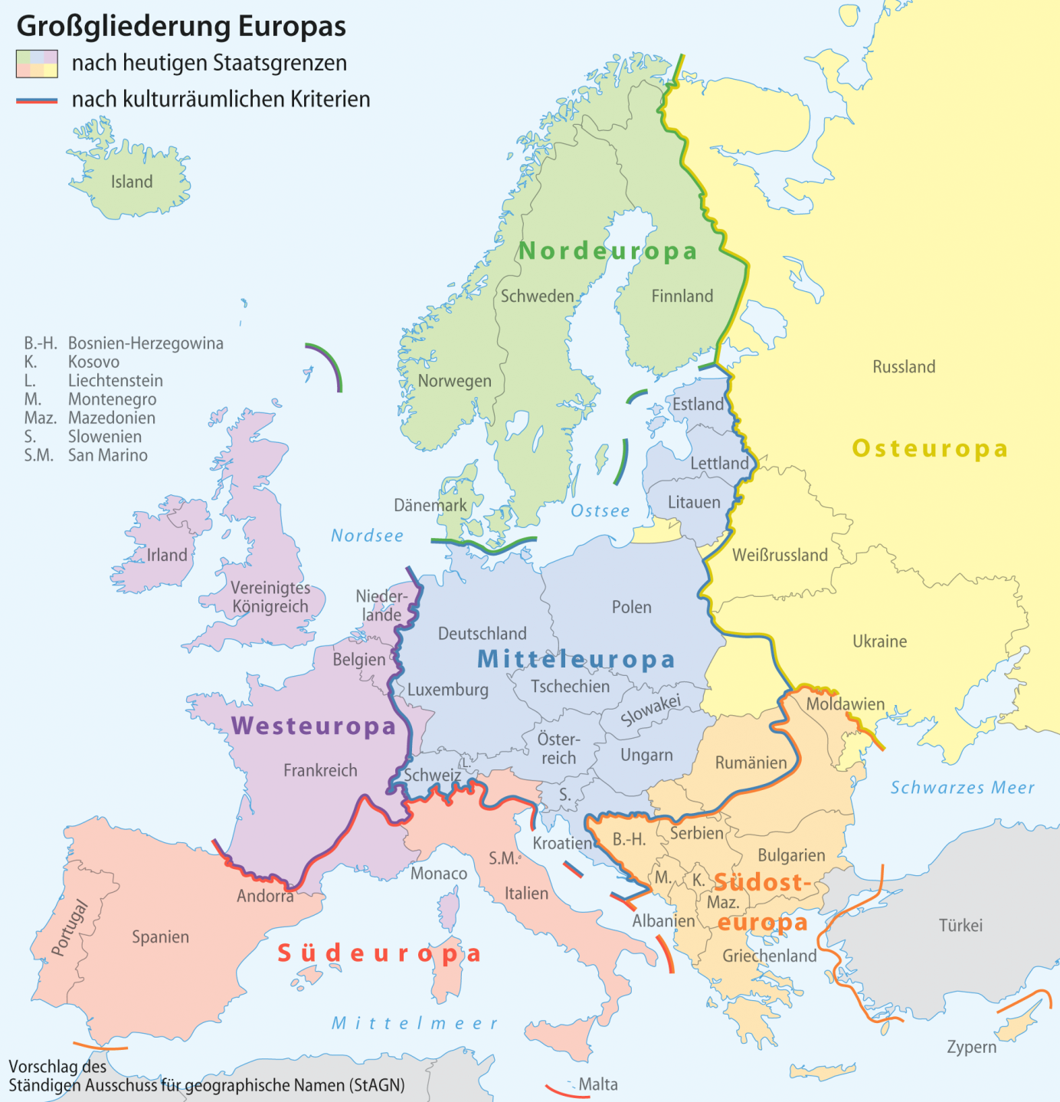

1. PhD Candidate, Çanakkale Onsekiz Mart University, Turkey, [orcinkaradag@gmail.com](mailto:orcinkaradag@gmail.com)
2. Which is unfortunate when the underlying expectations of National Agency is considered, see the list of expectations in the following website of National Agency: <http://www.ua.gov.tr/docs/default-source/di%C4%9Fer/erasmus-program-rehberi.pdf?sfvrsn=0>