**Pathologıcal Fracture of the Mandible due to Actinomycosis**

**Osteomyelitis: Case Report**

**Abstract**

Actinomycosis is a specific and chronic infection caused by gram-positive anaerobic bacteria. While the cervicofacial form has the highest prevelance, it can also be seen in thorax, abdominal and genital region. In this case we reported a pathological fracture caused by actinomyces osteomyelitis. 68 years-old male patients refered to our clinic with pain on left mandibular angulus. Patient is with a diagnose of a fracture due to actinomycosis infection after the clinical, radiologic and microbyologic examinations. Patient is treated with a diagnose of a fracture due to actinomycosis infection after the clinical, radiologic and microbyologic examinations. After the treatment, patient recovered and new bone formation at the fracture line were observed.

## **Introduction**

Actinomycosis of the jaws is a relatively rare infection. The most common cause of cervicofacial actinomycosis infection is Actinomyces israelii. However, Actinomyces naeslundii, Actinomyces viscosus and Actinomyces odontolyticus species are also defined in the oral flora [1]. *Actinomyces* produces chronic, slowly developing infections, particularly when normal mucosal barriers are disrupted by trauma, surgery, or a preceding infection [2].

Because Actinomyces strains resemble both bacteria and fungi, they were generally considered to be transitional between two groups of microorganisms. However, many of the essential characteristics of Actinomyces indicate that they are in fact anaerobic bacteria. In addition, Actinomyces does not contain sterols in its cell walls and is sensitive to antibacterial chemotherapeutic agents[3].

Bacteria that enter the tissue as a result of actinomycosis infection and trauma multiply rapidly in the anaerobic environment due to the disruption of mucosal continuity. Once the infection appears, it is very difficult to completely eradicate it [3].

In general, infected tissues contain areas of severe necrosis and fibrosis. Only soft tissue involvement can occur or they can cause actinomycosis osteomyelitis involving soft tissue and bone. There are few publications in the literature on osteomyelitis caused by actinomycoses. Periostitis occurs when the infection reaches the periosteum from the soft tissue. In slowly progressing infections, the periosteum reacts to form new bone. If the infection progresses rapidly, destruction areas extending into the bone can be observed [4]. Pathological fractures can be observed in these destroyed bone areas due to chronic osteomyelitis [5].

**Case Report**

A 68-year-old male patient complained of pain in his left lower jaw, He applied to Hacettepe University Faculty of Dentistry Department of Maxillofacial Radiology.

In the patient's history, mandibular teeth 36 and 37 were extracted another center. He stated that the region did not heal and that he felt numbness in the left lower lip area with increasing pain over time. The patient received medical treatment for prostate enlargement three years ago, had bypass surgery six years ago, and uses anticoagulants and beta-blockers.

In the clinical examination, exposed bone, submandibular lymphoadenopathy, purulent discharge and painful expansion on palpation in the left corpus region of the mandible were observed in the extraction region (Figure 1-2).

In the Cone Beam Computerized Tomography ( CBCT ) examination, radiolucent lesions in the form of moth bite, sequestered bone and pathological fracture were observed in around the extraction site ( Figure 3-4) . Diagnosed as osteomyelitis caused by actinomycosis has been done. The patient was referred to the surgery clinic for treatment and surgical treatment was applied after long-term antibiotic treatment ( Figure 5 ).

**Discussion**

Actinomycosis is a rare infection that has the potential to spread through weakened host immunity and spread to deep tissues[6]. Although they are frequently observed in the cervicofacial region after traumatic surgical procedures, they can cause osteomyelit infection in any part of the body[7]. In the case we present, the patient's history is similar to the literature, as there are systemic diseases and drug use.

In the literature; It was determined that the vascularization of the relevant region decreased after radiotherapy, and it was stated that it was a predisposing factor in the development of actinomycosis infection[8].

Actinomycosis infections are most common in the perimandibular region of the jaws. Bone involvement is very rare in infections seen in this region[9]. Success has been observed in % 90 of actinomycosis cases after appropriate treatment[8]. In our case In the control examination performed 10 months after the treatment, the patient's complaints were resolved and secondary bone formation was observed at the fracture line in the control CBCT evaluation. The diagnosis of actinomycosis is made with the help of microbiological examinations in addition to the clinical and radiological examination findings. Although anaerobic cultures allow bacteria to be isolated, polymerase chain reaction (PZT) plays an important role in the detection of bacteria today[10]. Actinomycosis infections related to this infection and pathological fractures related to this infection are rarely seen in the cervicofacial region[11]. In the case we presented; diagnosis of pathological fracture due to actinomycosis evaluated.

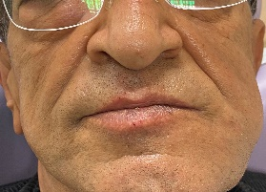

**Figure 1.** Extra oral swelling.

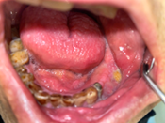

**Figure 2**. İntra oral image exposed bone, purulent discharge.

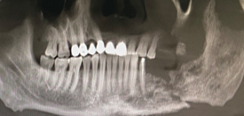

**Figure 3**. CBCT MPR image; radiolucent lesions in the form of moth bite, sequestered bone and pathological fracture

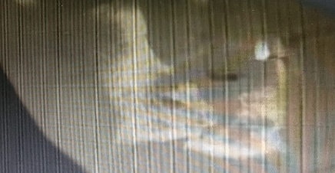

**Figure 4**. CBCT Sagittal image; radiolucent lesions in the form of moth bite, sequestered bone and pathological fracture

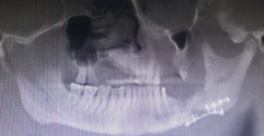

**Figure 5**. CBCT image postop

**References**

1. Herman WW, Whitaker SB, Williams MF, Sangueza OP. Acute actinomycosis presenting as an ulcerated palatal mass . *J Oral Maxillofac Surg 1998;56:1098-101*

2. Murray RP, Kobayashi GS, Pfaller MA, Rosental KS. *Medical Microbiology, 2nd ed. St. Louis, MO: Mosby, 1994.*

3. Schuster GS. *Oral Microbiology and Infectious Disease, 3rd ed. Philadelphia, PA: Decker, 1990.*

4. Chung Ji Liu, Kuo Ming Chang, *Chia Teh Ou. Actinomycosis in a patient treated for maxillary osteoradionecrosis. J Oral Maxillofac Surg 1998;56:251-3.*

5. Kaya GŞ, Yalçın E, Aras MH, Gürsan N. *Kronik osteomyelitin postoperatif komplikasyonu ve tedavisi. J Dent Fac Atatürk 2011;21:39-42.*

6. Russo TA: *Agents of actinomycosis , in Mandell GL, Bennett JE, Dolin R (eds): Principles and Practice of infectious Disease (ed 4). New York, NY, Churchill Livingstone, 1995. p. 2280-2288.*

7. Chung Ji Liu, Kuo Ming Chang, Chia Teh Ou. *Actinomycosis in a patient treated for maxillary osteoradionecrosis. J Oral Maxillofac Surg 1998;56:251-3*.

8. Weese WC, Smith IM. A study of 57 cases actinomycosis over 36-year period: *A diagnostic “failure” with good prognosis after treatment. Arch Intern Med 1975;135:1562-5.*

9. Smith MH, Harms PW, Newton DW, Lebar B, Edwards SP, Aronoff DM. *Mandibular Actinomyces osteomyelitis complicating florid cemento-osseous dysplasia: case report. BMC Oral Health 2011;21: 21.*

10. Hansen T, Wagner W, Kirkpatrick CJ, Kunkel M. *Infected osteoradionecrosis of the mandible: follow-up study suggests deterioration in outcome for patients with Actinomyces-positive bone biopsies. Int J Oral Maxillofac Surg 2006;35: 1001-4.*

11. Sharkawy AA. *Cervicofacial actinomycosis and mandibular osteomyelitis. Infect Dis Clin North Am 2007;25: 543-6.*