**Evaluation of the Performance of Reduced Graphene Oxide Samples Synthesized using Hummers and Chemical Reduction Method using Different Purity Graphite on Cement Mortar**

***Haluk KORUCU [C:\Users\Abdullah\AppData\Local\Microsoft\Windows\INetCache\Content.Word\ORCID-iD_icon-16x16.gif](https://orcid.org/0000-0001-6763-3249)***

***1 Department of Chemical Engineering, Faculty of Engineering, Çankırı Karatekin University, Uluyazı, Çankırı 18100, Turkey***

|  |
| --- |
| **Abstract**  In this study, 85% Nanokar, 99% Nanokar, and 99.9% Merck's different purity of graphite are used with the hummer’s method and chemical reduction method to synthesize reduced graphene oxide. It is aimed to evaluate the performance of synthesized reduced graphene oxide samples by using them in cement mortar. To determine the performance of reduced graphene oxide samples on hardened concrete, 7- and 28-day Thermal Conductivity and Heat Capacity measurements and 28-day electrical resistance and compressive strength measurements are taken. A reference experiment which was reduced graphene oxide not used in this experiment was performed to determine the recovery rates in the measurements. The recovery rates for 7- and 28-day Thermal Conductivity measurements were obtained at 34,63% and 52,63%, respectively by using a reduced graphene oxide sample coded rGO3 synthesized with 99,99% Merck graphite. The recovery rates were found to be 57.10% and 47.59% for 7- and 28-day heat capacity measurements, respectively, and were obtained by using a reduced graphene oxide sample coded rGO3 synthesized with graphite 99.99% Merck. The electrical resistance and compressive strength recovery rates were found to be 15.58% and 35.03%, respectively, and were obtained by using a reduced graphene oxide sample coded rGO1 synthesized with 85% Nanokar graphite. The experimental results showed that the performance of the reduced graphene oxide sample synthesized with low-purity domestic origin graphite, especially on thermal conductivity and heat capacity, was close to the reduced graphene oxide sample synthesized using high-purity foreign origin graphite. When this is evaluated in terms of costs and production on a large scale, getting great importance. |
| Keywords: Thermal Conductivity, Chemical reduction method, Heat Capacity, Redıced Graphene Oxide, Cement mortar |

1. **Introduction**

Chemical additives are materials that are added to the cement mortar during mixing or immediately before mixing. Nowadays, the use of chemical and mineral additives is increasing rapidly to improve the properties of concrete[1]. It improves the properties of concrete during the hardening process and transportation. Along with the use of graphene-doped cement-based composite materials and the use of less cement, a positive effect of their mechanical properties was also observed [2]. The contribution of graphene encourages innovative architecture in structural designs with its lightweight structure. Due to the low porosity, it shows excellent permeability resistance and increases its early strength values. Due to its high thermal conductivity, it increases fire resistance [3]. As can be seen from Fig 1.1, the placement of the nano-material forming a composite with cement in the cement structure has been shown that reduced graphene oxide (rGO) can improve the mechanical properties of hardened cement mortar reported in literature research. The mechanisms proposed so far to explain this strengthening, in general, are that the reduced graphene oxide disperses well in the pores of the portland cement mortar and enlarges the nucleation site as a reinforcing agent during hydration [4].

2 Part

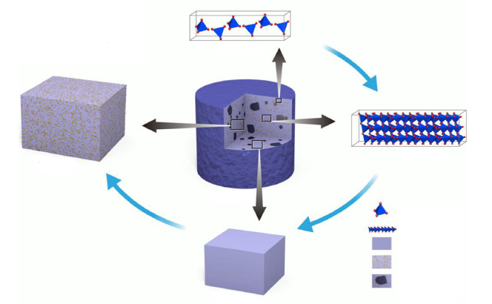

1 Part

3 part

5 part

C-S-H

Çimento Harçı

Mortar

concrete

4 part

SiO4 --4

1.part C-S-H (10-9 m)

2.part C-S-H matris (10-7 m)

3.part Cement Mortar (10-5 m)

4.part Mortar (10-3 m)

5.part concrete (10-1 m)

**Fig 1.1** The relationship between different material scales in cement-based composite [4]

1. **Materials and Methods**

Three different graphene oxide samples were synthesized by the hummers method using different purity of graphite samples (85% Nanokar -99% Nanokar- 99,99% Merck). Three different properties of reduced graphene oxide (rGO) were synthesized by using ascorbic acid with the chemical reduction method of synthesizing the graphene oxide samples. During the synthesis of reduced graphene oxide, 2 grams of graphene oxide samples were taken for each experiment, and sonication was performed in 600 mL of water with an ultrasonic power of 40% for 30 minutes. Then, the mixture was taken to the reactor and 6 grams of ascorbic acid was added to it, and experiments were carried out for 24 hours in a double-walled glass reactor at 80℃. Impurities were removed by pure water, acetone, and ethyl alcohol with a decantation process at the end of the reaction. After this process, the product was dried in a vacuum oven at 60℃. In the experiments of reduced graphene oxide doped concrete mortar (rGO-Concrete), 0.6 grams of rGO was taken for use and subjected to ultrasonication with an ultrasonic probe with 40% power for 30 minutes in 270 ml of pure water. Then these solutions were mixed with 600g portland cement and 1 gram of superplasticizer was added to them. The samples were cast into 50x50x50 mm molds. The samples poured into molds were removed from the molds after 1 day. Thermal conductivity and heat capacity measurements were taken from these samples on days 7-28, and electrical resistance and compressive strength measurements were taken on days 28. The effects of reduced graphene oxide on concrete mortar were analyzed according to the criteria given in Table 2.1. Example reference in concrete mortar concrete, reduced graphene oxide, and reduced graphene oxide samples synthesized using 3 different purity graphite is unused and determined in criteria aimed to determine recovery rates. To determine the properties of rGO-CONCRETE mortar, molds were filled into at least 3 pieces for each experiment. In Fig 2.1, the images taken during the experiment are given.

**Table 2.1** Quality criteria of the reduced graphene oxide-Concrete mortar experiments

|  |  |  |  |  |  |  |
| --- | --- | --- | --- | --- | --- | --- |
| **Quality Criteria** | **Symbol** | | **Explanation** | **İnformation** | **The goal for rGO-Concrete** | |
| **1** | T7 | | **Thermal conductivity (W/(m.K))** | 7 Days | Larger is better | |
| **2** | T28 | | **Thermal conductivity(W/(m.K))** | 28 Days | Larger is better | |
| **3** | CP7 | | **Specific heat capacity (Mj/m3.K)** | 7 Days | Larger is better | |
| **4** | CP28 | | **Specific heat capacity (Mj/m3.K)** | 28 Days | Larger is better | |
| **5** | **E.R** | | **Electrical resistivity (kΩ.m)** | 28 Days | Smaller is better | |
| **6** | CS | | **Compressive strength (N/mm2)** | 28 Days | Larger is better | |
|  | |  |  |  |  |

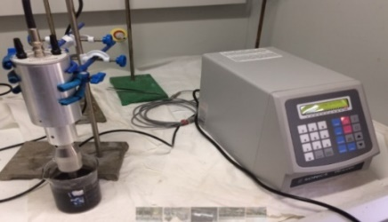 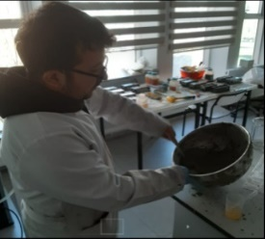 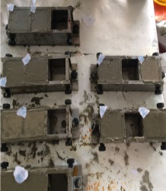 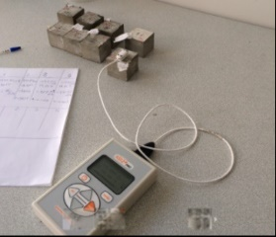

**1 2 3 4**

**Fig 2.1** Images of cement mortar experiments ( 1-Ultrasonication process, 2-Pouring cement mortar into molds 3-Samples removed from molds 4-Making measurements with Kd2 pro)

**3. Results and Discussion**

Using 85% Nanocar, 99% Nanocar and 99% Merck, branded graphite of different purity, graphene oxide of 3 different properties was synthesized by the hummers method and encoded as GO1-GO2-GO3, respectively. The synthesized graphene oxide in 3 different properties was reduced using ascorbic acid by chemical reduction method and synthesized 3 different types of reduced graphene oxide which was encoded as rGO1-rGO2-rGO3. In Figures 3.1, 3.2, and 3.3, FTIR analyses of graphite-graphene oxide and reduced graphene oxide samples are given.

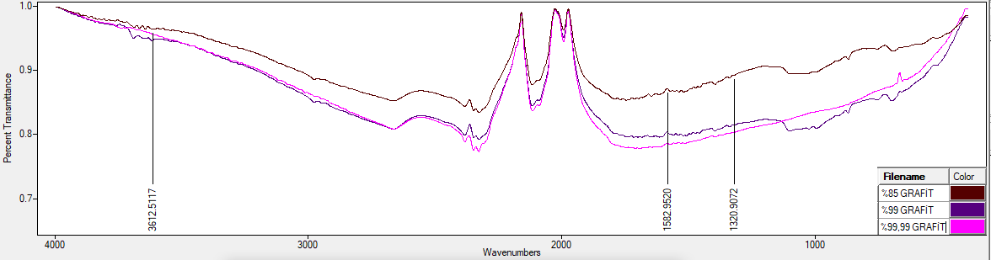

**Fig 3.1.** FTIR images of graphite samples of different purity(85%-99%Nanocar, 99.99% Merck) **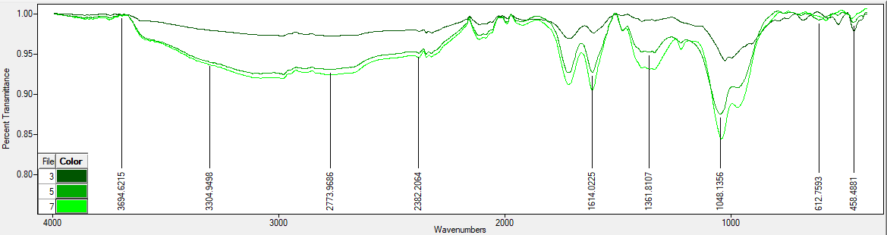**

**GO-1**

**GO-2**

**GO-3**

O-H

C=O

CO2

C-O

C-O-C

C=C

**Fig 3.2.** FTIR images of graphene oxide samples(GO1-GO2-GO3) synthesized by Hummers method using different purity graphite

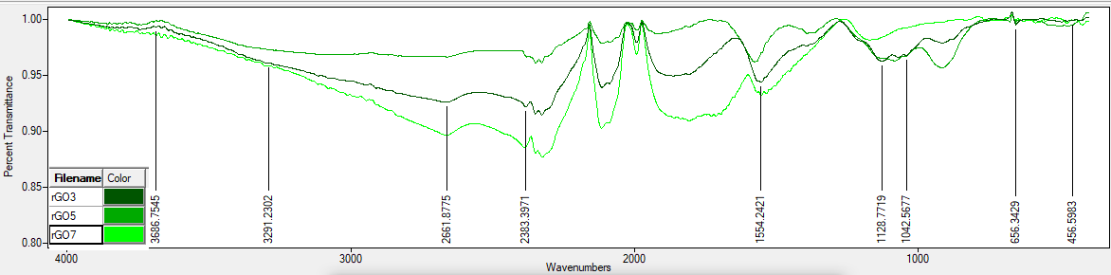

**rGO-1**

**rGO-2**

**rGO-3**

C=C

C=O

C-O-C

C-O

CO2

O-H

**Fig 3.3.** Reduced graphene oxide samples (rGO1-rGO2-rGO3) synthesized using graphene oxide samples of different properties (GO1-GO2-GO3)

In Figure 3.2, the results of the FTIR analysis have shown that the presence of oxygen-containing functional groups indicates that the synthesis of graphene oxide from graphite is successful [5]. In Figure 3.3 graphene oxide and O-H groups and the peaks of the oxygen-containing functional groups (-OH, C-O, and C-O-C) the disappearance of the structure of graphene oxide, and reduced graphene oxide indicate that the synthesis was successful[6-7]. Figures 3.2 and 3.3 indicate that the synthesized graphene oxide and reduced graphene oxide samples were successful. The successfully synthesized reduced graphene oxide samples (rGO1-rGO2-rGO3) were distributed by ultrasonication process and the measurements given in Table 2.1 were performed using cement mortar. The measurement results and recovery rates are given in Table 3.1. When the improvement rates in the results of the rGO-Concrete experiments were evaluated; If the improvement rates in terms of thermal conductivity turned out to be very close to each other, the experiment with the code rGO3-Concrete gave the best value (52,63%). In terms of heat capacity, although the recovery rates are very close to each other, the best value (57.10%) was given by the experiment with the code rGO3-Concrete. The experiment with the rGO1-Concrete code gave the best result (15.58% and 35.03%) in terms of electrical resistance and compressive strength.

**Table 3.1** Recovery ratios reference-concrete between Reduced graphene oxide-concrete

|  |  |  |  |  |  |  |  |  |
| --- | --- | --- | --- | --- | --- | --- | --- | --- |
|  | **Answers** | **Refa**  **Concrete** | **rGO1-**  **Concrete** | **rGO2-**  **Concrete** | **rGO3-**  **Concrete** | **Recovery Rate rGO1-Concrete (%)** | **Recovery Rate rGO2-Concrete (%)** | **Recovery Rate rGO3-Concrete (%)** |
| **Reduced Graphene Oxide – Concrete Experiments Recovery Rates** | T7 (W/(m2.K)) | 0,391 | 0,547 | 0,538 | 0,526 | **39,89b** | 37,59 | 34,53 |
| T28 (W/(m2.K)) | 0,323 | 0,453 | 0,435 | 0,493 | **40,25** | 34,67 | **52,63** |
| Cp7(Mj/(m3.K)) | 1,352 | 2,128 | 2,032 | 2,124 | 57,40 | 50,30 | **57,10** |
| Cp28(Mj/(m3.K)) | 1,202 | 1,737 | 1,701 | 1,774 | 44,51 | 41,51 | **47,59** |
| ED (kΩ.m) | 0,6675 | 0,5635 | 0,7435 | 0,701 | **15,58** | -11,39 | 5,01 |
| B.D.(MPa) | 16,922 | 22,85 | 18,750 | 20,072 | **35,03** | 10,80 | 18,61 |
|  |  |  |  |  |  |  |  |

*Calculation of the % recovery rate of the experiment performed under optimal conditions*

*a The reference experiment is experiment No. 1, which has the lowest levels of the parameter in its design*

*b ((0,547-0,391) / 0,391)\*100 =39,89(plus value means improvement)*

When analyzing the results of quality characteristics in concrete experience, GO1, rGO1and GO2, rGO2 coded domestic-brand low-purity graphite and reduced graphene oxide samples synthesized with graphene oxide and reduced graphene oxide synthesized using high-purity graphite overseas brand of the samples according to your sample, showed higher performance in applications, it is observed that the concrete and mortar. This paves the way for graphene oxide and reduced graphene oxide to be widely used in concrete mortar applications when considering terms of costs and performance

**Acknowledgment**

This research was carried out with the support of the Scientific Research Project (MF210621B08) funded by Çankırı Karatekin University. Author thank to Çankırı Karatekin University, Scientific Research Project Management Unit (ÇAKÜ-BAP).

**References**

1. Korucu H., Investigation of the Physical and Chemical Properties of Carbon-based Material Additive Cement Mortar: An Experimental Design-Based Multi-Response Optimization Application.Phd Thesis.Çankırı Karatekin Universty. İnstitute Of Science.2019
2. Korucu, H., Şimşek B., and Yartaşı A. 2018. Statistical approach to carbon based materials reinforced cementitious composites: Mechanical, thermal, electrical and sulfuric acid. *Composites Part B,*171: 347-360
3. Wang M., Wang R., Yao H., Farhan S., Zheng S.,Du C. 2016, Study on the three dimensional mechanism of graphene oxide nanosheets modifed cement., Construction and Building Materials 126,730-739
4. Yang H., Cui H., Tang W.,Li Z., Han N. and Xing F., 2017. A citical review on research progress of graphene/cement based composites. Composites : Part A 102, 273-296
5. Korucu, H., Şimşek B., and Yartaşı A. 2018. 'A TOPSIS-based Taguchi design to investigate optimum mixture proportions of graphene oxide powder synthesized by hummers method', Arabian Journal for Science and Engineering, 43: 6033-55.
6. Korucu, H,Şimşek B.,Kocakerim, and Karakaş İ.H.. 2019. 'Effective reduction of graphene oxide using sulfur dioxide-containing chemical compounds', International Journal of Environmental Science and Technology: 1-14.
7. Korucu H. 2022. ‘Evaluation of the performance on reduced graphene oxide synthesized using ascorbic acid and sodium borohydride: Experimental designs‐based multi‐response optimization application. Journal of Molecular Structure.1268,133715. <https://doi.org/10.1016/j.molstruc.2022.133715>