**USERS EXPERIENCE FEEDBACK SURVEY on JOB HUNTING ASSISTANT APPLICATION**

**Julie Marlina Hasan [1]& Sharonjit Kaur Walia[2]**

**Abstract**

Hundreds of websites and mobile apps offer a variety of career services in many different sectors. Confused by the abundance of choices, many lecturers and students are put into a dilemma when it comes to the preparation of job applications. Challenges exist in terms of application quality, relevant context, costs and user display. Majority of the apps which are available in the open market do not cater to the Malaysian TVET students' needs, hence it leads to a very discouraging learning process for the students. This app is created in line with the Malaysia TVET context and is relevant to the students’ needs of the Malaysian TVET system. The participants involved in developing this innovation are 30 lecturers and 156 students from nine (9) urban polytechnics. Through the users’ experience feedback analysis, the most helpful section which is popular among the users are the content and information provided (tips/links/sample/video input), followed by the Interface of the application (visual/image), colours used in the application (theme/branding) and most importantly, there are video recording practices available in which users can record and review what they have recorded and improve their performance. This application has made the job search process easier by centralising all relevant documents needed and guiding job seekers through the entire procedure right before sitting for an interview.

**Keywords:** job interview, job hunting application, mobile application, user experience

**Introduction**

As our nation embarks towards Industrial Revolution 4.0 (IR4.0), the increase demand of a new era of automation technology which involves physical, digital and biological worlds have become the main emphasis to all sectors in Malaysia, including the education sector recently (Zulnaidi, 2020). Covid-19 took the entire world by storm. Many organizations including the educational sectors were heavily affected by it. Globally, many were forced to alter their methods and ways in providing education to those in need. Urgent ways and pleas were needed to protect our students, faculty, academic staff, societies and nation as a whole. Having said that, a saviour was needed. In present time, referring to the Malaysian Polytechnic system, lecturers will be considered as saviours to embark in this digital learning technology journey. In which, teaching and learning via online required lecturers to be able to quickly adjust, adapt and always be ready with a contingency action plan at all times when needed (Shafei, Haris & Hamzah, 2018).

This new norm of teaching and learning has forced both students and lecturers to be obliged with challenges and transform difficulties to an opportunity in making sure knowledge and skills are synced together. Preparing students to it is one thing, assisting them to be successful in it will be a challenge.

1. **Problem statement**

Latest Institutional Operating Guidelines instructions were distributed from the Department of Polytechnic Education and Community College Education (JPPKK) in June 2020, where all polytechnic institutions must conduct all teaching and learning via online through 100% asynchronous or 100% synchronous or a combination of both subjected to the course study plan as advised. Institutions’ E-Learning Unit was stormed by a sudden demand of training, guidance and query for online teaching support. Despite of very short time for preparation, classes were then resumed in August. As a result, many online learning alternatives were explored, exploited and the current course outline and assessments were re-framed.

At the first launch of the online teaching, many issues arised. As reported by the International Labour Organization and World Bank 2021, in response to technical and vocational education and training for TVET, online learning could not replace the quality of face-to-face classes, particularly given the exceptional emphasis of TVET on work-based learning and acquisition of practical skills during the initial national lockdown. However, the pandemic has forced lecturers to accelerate existing plans to expand remote learning options through the usage of online teaching platforms, tools, approaches, and applications have increased drastically.

As an initiative, a survey on the teaching and learning of DUE50032 Communicative English 3: Job Hunting Unit was conducted, 30 polytechnic lecturers teaching the subjects responded and about 33% of the lecturers agreed that the most challenging part in teaching the Job-Hunting Unit was the Job Interview. This is followed by 30% of the lecturers agreeing to the resume writing being difficult, 26.7% agreeing that the cover letter writing is also difficult. 6.7% of the lecturers responded that enquiring on job was difficult to teach where else only 3.3% of the lecturers chose job advertisement as the most difficult part to be taught.

The struggle is real. As mentioned by lecturers, it is challenging to assist students in preparing for the MOCK INTERVIEW assessments, especially students with poor English competency. Lecturers need to put in extra effort in helping the low proficiency students to excel, which results in lecturers going through the interview questions with the students one by one thoroughly. If students lost focus or were multi-tasking during class hour, they would usually be left out. It is not easy to assist and coach students via online because of the limited time to meet them due to internet issues specifically. Moreover, lecturers also shared that it is difficult for them to get the most suitable videos for job interviews which caters to the syllabus requirement, a genuine course content. Due to all these, lecturers’ intention to enhance students' confidence level during job interviews becomes more challenging due to their poor language proficiency.

Besides that, marks allocated for the Job – Hunting unit under the continuous assessment is quite a great deal which is 65% (written assignment of cover letter 15%, resume 15% and mock interview 35%) and as we can see the allocated amount of marks for this unit is three quarter total for the overall marks. Due to all these reasons, an initiative to ease the online learning journey for Job Hunting unit is then planned, outlined, designed and tested.

1. **Target group**

The target group for this survey are the Semester 4 Commerce Department students and semester 5 Civil, Electrical and Mechanical Engineering Department students who have registered for the DUE50032 Communicative English course.

1. **Research Objectives**

The objectives of this survey are to: -

* gain insight about users’ preference and views toward the application
* explore users’ good experience and issues faced by the users when they use the application
* improve application performance, based on the feedback gain from the survey

1. **Methodology**

This survey consists of 56, Politeknik Port Dickson students, who enrolled in the DUE 50032, Communicative English 3 course. They were introduced about the Job-Hunting topic and were instructed to install the application from google play link shared. They were then given a chance to explore the application for the first time and were been brief about the development, functions, features and characteristics of the application section by section as described below. This application is created using a PRO version of Thunkable no code mobile app development. Teaching and learning with the application are applicable for android (google play store) and IOS (Apk) users. It is a one-time installation with a tiny storage (45.5Mb) used in installing this application on smartphones or tablet with smooth usability which supports independent and cooperative learning. This Pocket Assistance can be used independently by the users personally or can be used as a teaching and learning tool via online (synchronous/ asynchronous learning) or physical classroom.

This Job-Hunting Assistant Application is a free download and a mobile friendly tool which everyone needs, it will assist users with the job – hunting on the before, during and after job interview procedure. It is a complete step by step guide which consists information on where to start, what to do, how to do it, where to search and which job suits the candidate with detailed input, useful tips and interview practices.

The app consists of: -

1. introduction to job hunting topic, definition, reason why people work, where to start, what to expect and tips on how to find the perfect job.
2. interview preparations tips (what to do BEFORE the interview)
3. interview dos and don’ts in writing a resume, cover letter format and sample, documentation, interview preparations, complete interview questions, answers, tips and a collection of sample mock interviews conducted for references (what to do During the interview)
4. interview wrap up (what to do AFTER the interview)
5. finally, interview practices with recorded functionality for review and built-up confidence activities for the mock interview assessment which in lined with the DUE50032 Communicative English 3 course. It is also applicable for non-polytechnic students who are interested to try it out.

|  |
| --- |
|  |

**Figure 1: Job-Hunting Assistant application interface preview**

|  |
| --- |
|  |

**Figure 2: Job-Hunting Assistant application content preview**

After the briefing, a modified Users’ Experience Questionnaire (UEQ) created by Laugwitz was shared with the students and feedback was gathered. The questionnaire consists of 12 survey questions, which enquire information about which functions, features and characteristics of the application that the students like the most. It also enquires students to rate about their overall experience, application appearance, icons effectiveness and application loading speeds. Feedback about application helpfulness, to be used as reference for their mock interview and future references, as well as whether they will recommend this application with people around them or not and suggestion on how to improve this application were also been enquired.

1. **Findings and discussion**

As mentioned earlier, this survey is conducted based on a modified version of the Users’ Experience Questionnaire (UEQ) created by using Laugwitz to gather participants’ feedback. As referred to in the User Experience Questionnaire (UEQ) main goal is aim to collect immediate and fast feedback to measure users' experience of the interactive products developed by any developer (Laugwitz, Held, & Schrepp, 2008). UEQ has already been established and fully utilized in a variety of research contexts, for instance, it is used for the evaluation of business software (Rauschenberger, Hinderks, & Thomaschewski, 2011), development tools (Wieschnowsky & Heiko Paulheim, 2011), web sites and web services (Hartmann, 2011), even social networks (Hartmann, 2011). Due to these reasons that is why it is been used for this present research.

Participants for this project were semester 5 Diploma students from Mechanical Engineering Department and semester 4 Electrical Engineering Department, taking the DUE 50032 Communicative English 3 course.

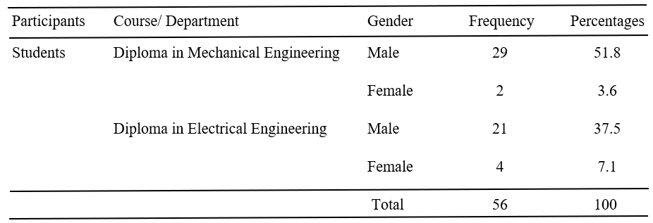

**Table 1: Profile of Participants**

The users' experience feedback survey results are presented in Table 2. It showed the mean and standard deviation of the students’ experience with the application. In general, based on the response results we can see that students’ experience using this application is excellent.

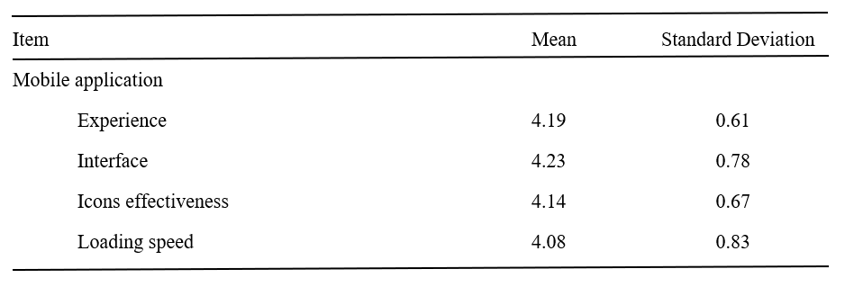

**Table 2. Mean and standard deviation towards Job- Hunting Assistant Application**

While for the application preferences review given by the students is presented in table 3 below.

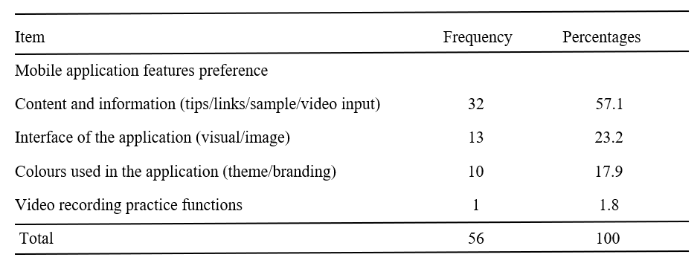

**Table 3. Features preferences towards Job- Hunting Assistant Application**

Based on the survey also 100% of the students agreed that they found that this Job – Hunting Assistant Application will be helpful and useful to be used for their mock interview practice reference and their career future reference and about 98.2% of the students responded that they will recommend this application to their friends and family members.

1. **Impact**

Based on the conducted users' experience feedback about the application, the impact of using this Job-Hunting Assistant application helps to provide systematic and helpful structure along with an approach to maximize users’ ability to land a job which suits their qualification, field of study, experiences and skills. All content gathered came from the latest and updated blogs.

The section of input shared are divided to three most important job-hunting sections of before, during and after job interview. It is an ‘on the go’ and a ‘one stop centre’, just a click away. This application design is fresh, attractive and able to attract any user’s interest, easy to access anywhere and relevant to the CEFR B2 English language. This app is also relatable to the Malaysian TVET context and input which is specifically designed to cater the needs of DUE50032 Communicative English 3 students who are taking this course and are very helpful to be used in preparation for their mock interview assessment and also applicable for their future career reference.

The most helpful section which is popular among users is the job search section because many job searches link directly to websites (private/government) and telegram platforms have been shared. Sufficient inputs and sample of resumes, cover letters, job interview Q&A samples (written/ video) are included in the application. Most importantly, there are video recording practices available in which users can record and review and further improve their performance.

1. **Recommendations**

There were a few recommendations suggested by the students to improve the Job – Hunting Assistant Application which were to make the application available and support the iPhone and published it in the Apple store. They also suggested adding animation for page transition, font and image used in the application. To make the application more interactive, it is suggested to add on/ embed online quizzes based on the information provided. While for video practice sections, reminders and setting instructions on the recording mode for the mobile phone should also be provided to assist users to ensure the recording function works. The UI interface of the application was suggested to be more professional and modernized following the current application trends at the present moment.

**Conclusion**

Based on the user experience survey feedback analysis, the most helpful section which is popular among the users are the content and information provided (tips/links/sample/video input), followed by the Interface of the application (visual/image), colours used in the application (theme/branding) and most importantly, there are video recording practices available in which users can record and review what they have recorded and improve their performance. This application has made the job search process easier by centralising all relevant documents needed and guiding job seekers through the entire procedure right before sitting for an interview.

We can conclude that this application serves not only students but also all job seekers around the world. The guidelines and examples given are sufficient and has an easy-to-use interface. The idea to innovate and create a tool which helps an individual at the very core after graduation is a pointer by its own. Nevertheless, taking into account the suggestions received in the findings, an upgrade of the application is welcomed for future research and references.

**References**

Cate, M.S., Regallis, J.D., Orth, G., Goldstein, T. and Caldwell, D., FLEXHIRE LLC, (2014). Computer based job application via SMS message or mobile email. U.S. Patent 8,682,806.

Hartmann, J. (2011). User experience monitoring: Über die Notwendigkeit geschäftskritische Online-Prozesse permanent zu überwachen. iCom, 10(3), 59–62

Institutional Operating Guidelines Instructions, June 2020, Department of Polytechnic Education and Community College Education (JPPKK)

International Labour Organization and World Bank 2021, Skills development in the time of COVID-19: Taking stock of the initial responses in technical and vocational education and training. <https://www.ilo.org/wcmsp5/groups/public/---ed_emp/---ifp_skills/documents/publication/wcms_766557.pdf>

Laugwitz, B., Held, T., Schrepp, M. (2008). Construction and Evaluation of a User Experience Questionnaire. In: Holzinger, A. (eds) HCI and Usability for Education and Work. USAB 2008. Lecture Notes in Computer Science, vol 5298. Springer, Berlin, Heidelberg. <https://doi.org/10.1007/978-3-540-89350-9_6>

McKenzie, L., (2015). Internet job search: A two-sided search model approach.

Mochol, M., Wache, H. and Nixon, L., (2007). Improving the accuracy of job search with semantic techniques. In International Conference on Business Information Systems(pp. 301-313). Springer, Berlin, Heidelberg. <https://doi.org/10.1007/978-3-540-72035-5_23>

Rauschenberger, Maria & Schrepp, Martin & Cota, Manuel & Olschner, Siegfried & Thomaschewski, Jörg. (2013). Efficient Measurement of the User Experience of Interactive Products. How to use the User Experience Questionnaire (UEQ). Example: Spanish Language Version. International Journal of Interactive Multimedia and Artificial Intelligence. 2. 39-45. 10.9781/ijimai.2013.215.

Shafei, S., Haris, M.H.H., & Hamzah, Z. (2018). The readiness of POLIMAS Lecturers in the Challenges of Industrial Revolution 4.0. Paper presented at the 8th National Conference in Education – Technical & Vocational Education and Training (CiE-TVET) 2018. (577– 582)

Singh, V., Thurman, A. (2019). How many ways can we define online learning? A systematic literature review of definitions of online learning (1988-2018). American Journal of Distance Education, 33(4), 289–306.

Zulnaidi, Hutkemri & Abd Majid, Mohamad Zuber. (2020). Readiness and Understanding of Technical Vocational Education and Training (TVET) Lecturers in the Integration of Industrial Revolution 4.0.

1. [juliemarlina@polipd.edu.my](mailto:juliemarlina@polipd.edu.my), **0000-0002-4505-4294**
2. [sharonjit@polipd.edu.my](mailto:sharonjit@polipd.edu.my), 0000-0002-7910-0922