CASE STUDY OF INVERTER AIR CONDITIONING LOGIC DURING UNDERCHARGE REFRIGERANT

Ts. Syed Amirul Mustaqim Bin Syed Ghazali Jalalulin^{1*}, Ts. Jaslin Bin Rasin²,
Mohd Hazwan Bin Rosdi³

^{1,2,3}Department of Engineering, Politeknik Kuching Sarawak,
Km.22, Jalan Matang 93050 Kuching, Sarawak, Malaysia

Abstract: Preventive maintenance or regularly known as routine or scheduled maintenance of equipment and assets to keep them running and prevent any costly unplanned downtime from unexpected equipment failure. In preventive maintenance of residential air conditioning, the evaporator, condenser, air filter cleanness, running current, and refrigerant charge must be checked and recorded to ensure the design cooling capacity can be delivered. Failure to conduct preventive maintenance will lead to component clogging, high energy consumption, and component malfunction. Lack of refrigerant charge in the air conditioning systems will decrease the cooling capacity and energy efficiency. The main objective of this case study is to study the logic of three parameters which is compressor discharge temperature, expansion valve opening, and operation current for the R32 inverter air conditioner system while running in undercharge state. In achieving the objectives, some methods that need to be done. First, to find the suitable capacity of air conditioning by using the rule of thumb method. Next, the installation of wall-mounted inverter air conditioning is to be done, and observation of three parameters which is compressor discharge temperature, expansion valve opening, and operation current of inverter system that affected if the unit running in undercharge refrigerant capacity. From the result, it seems all three parameters all direct relationships with each other. From the result, undercharging 10% of refrigerant will increase the 6-7oC compressor discharge temperature, increase 0.1 amperes of operation current (A), and 10-40pls the expansion valve opening. In a conclusion, new sets of data and information for inverter split unit air conditioning can be used for teaching and learning reference and can assist the troubleshooting work at the site as well.

Keywords: Undercharge refrigerant; Inverter Air conditioning; Maintenance

INTRODUCTION

An air conditioning is mainly used for treating air in an internal environment to establish and maintain required standard of temperature, humidity, air cleanliness and air motion. Direct expansion system or known as DX system is mainly use for residential as it has a lower price, light weight, quiet operation, ease of installation and maintenance and low energy consumption. (M. A. S. S.A. Nada, Appl. Therm. Eng, 2017) state split type is commonly used as their design simple and flexible. As for today, major electricity consumption among residential, commercial and industries is air conditioner (Mohsen Farzad, 1990). Variety of air conditioner brands and types including inverter and non-inverter unit are available in Malaysia market today, it’s made easier for consumer to make a choice. Previously, non-inverter unit are often used by Malaysia consumer, as the price is much lesser compared to inverter unit. However, the energy consumption is much higher almost 40% due to compressor motor speed cannot be regulate according to room temperature. Meanwhile, Inverter air conditioner has ability to run in partial load and control compressor frequency to maintain a desired room set temperature. As a result, the energy consumption can be reduced between 11% to 38%. Purchasing inverter unit will add more cost compared to non-inverter as this unit comes with multi speed compressor motor and condenser fan motor, add of intelligent sensor and printed circuit board (PCB) at outdoor unit to ensure the maximum thermal comfort can be delivered and maximum efficiency can be achieved. Nevertheless, the extra cost will be absorbed back by electric saving made by inverter unit. The electricity savings of inverter unit can be achieved by ensure the correct design load calculation, correct installation procedure made by installer or contractor, conducting schedule maintenance, usage time and usage method as well. Nowadays, as a quick and easiest way to conduct the refrigerant charging procedure, Malaysian air conditioning technician or contractor will conduct it by using the manifold gauge and ampere meter to measure the capacity of refrigerant in air conditioning system. By using this method, the accurate amount can’t be
measured as the pressure inside the refrigerant system will fluctuate according to ambient temperature and even worse, if no vacuuming procedure conducted after installation or repairing of air conditioner completed. Lack of knowledge and awareness to conduct the refrigerant charging will lead to air conditioner components failure and the system unable to deliver their design cooling capacity. According to (Howard Cheung, James E. Braun, 2010) in their research, improper charge of refrigerant can be defined as contradictory mass of refrigerant with manufacturer standard, and it tends to decrease the capacity and energy efficiency of the system. Besides wrong procedure of refrigerant charging, the leakage of air conditioning components or piping route also can cause the undercharge situation occurred. The 30% reduction of refrigerant in air conditioning system can consume more energy from 17% to 23% (Domanski et al., 2015). (Proctor, 2000) in his study for California, found 4000 unit of residential air conditioner is operating without proper refrigerant charge where 34% of unit is undercharge, 28% overcharge and the balance is operated with sufficient refrigerant charge. According to catalogue and operation manual for some Malaysia air conditioner suppliers, the new split unit air conditioner will have certain amount of pre-charge refrigerant store on condenser unit where its sufficient for certain length of pipe which is from 6 to 10 metre. If the refrigerant piping exceeding the pre-charged length, the additional amount of refrigerant must be added to avoid from decreasing of capacity and efficiency of the system. Therefore, this research will study effect of refrigerant charge for residential inverter air conditioning unit from 60% - 100% refrigerant capacity. The result of compressor discharge temperature, expansion valve opening, and operation current will be presented.
The objective for the study is as follows: -
- To study the logic for compressor discharge temperature, expansion valve opening and operation current for R32 inverter air conditioner system while running in undercharge state.
- To prepare new sets of data and information on inverter air conditioner (split unit) for site troubleshooting and teaching & learning references.

METHODOLOGY

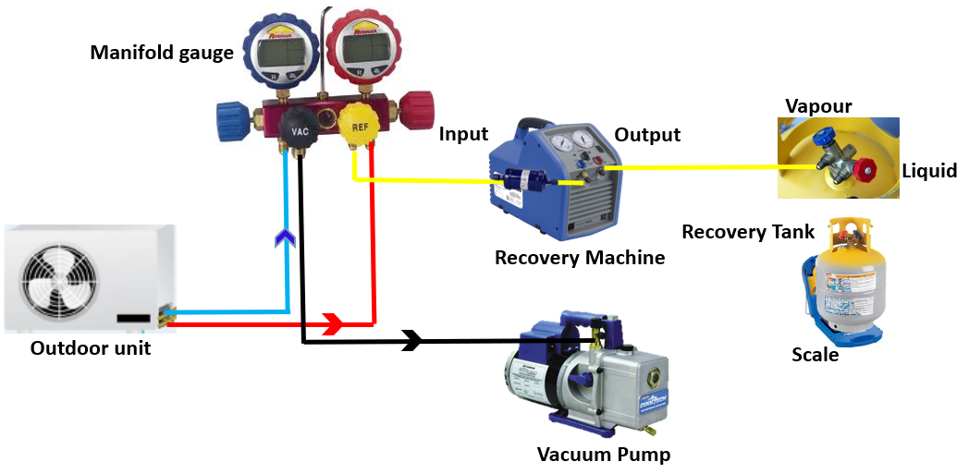 | 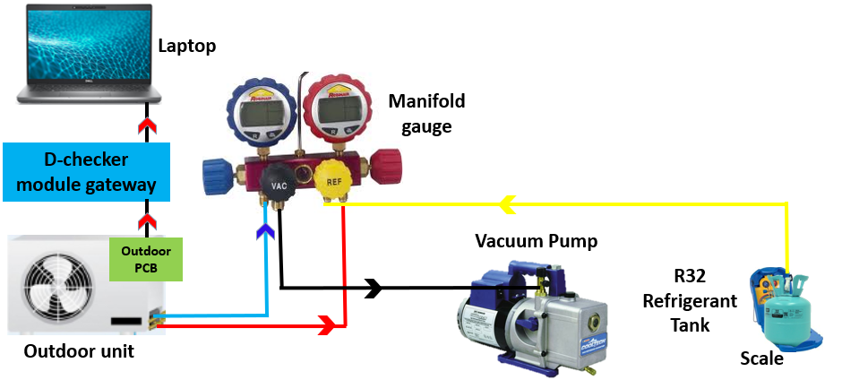
Figure 1 Recovery refrigerant setup | Figure 2 Refrigerant charging setup

The study setup was designed and implemented by using inverter air conditioner unit (split type) with a relevant equipment and accessories. The variable for this experiment work is refrigerant charge and each charge is observed for 15 minutes. The experiment is repeated for all level refrigerant charge from 60% to 100% charge. The findings of this experiment unable to compare with any manufacturer standard and any previous research as it conducted without applied the testing procedure as stated in Air-Conditioning & Refrigeration Institute (ARI) Standard 210/240 due to limitation of equipment and psychrometric room to maintain the fluctuation of outdoor air temperature, A.-C. & R. I. (ARI), Stand. 210/240 (2006). The first procedure before starting the study is to calculate the cooling load require for Lecturer room inside a Metallurgy Lab at Polytechnic Kuching Sarawak by using rule of thumb method as below:

Rule of thumb = Width (W) x Length (L) x Coefficient for laboratories
= 10ft x 12ft x 75btu/hr/ft²
= 9000Btu/hr
After the cooling load was determine, selection and installation of air conditioner unit was made. In this study, the air conditioner unit used is 9,100Btu/hr (2.67kW) inverter wall mounted. The unit used R32 refrigerant as the working refrigerant. D-Checker module is connected to inverter air conditioner PCB to collect the data and the software is used to observe the inverter parameter. The refrigerant charge inside an air conditioner unit will be taken out first to designated R32 recovery cylinder with assistant of recovery machine and continue with vacuuming process to pull down the pressure below the atmospheric value 760mmHg to ensure no remaining refrigerant and moisture trap inside as shown if Figure 1. The new R32 refrigerant cylinder was place on top of weighing scale and connect to manifold gauge and then connected to outdoor unit service valve of inverter air conditioner as shown in Figure 2. In this study, 5 different charges of refrigerant, parameter to be observed and air conditioner mode is shown in Table 1 below:

Table 1 Experiment setup parameter
Refrigerant charge (%) | 60, 70, 80, 90, 100
Observe parameter | - Compressor discharge temperature (ºC)  - Expansion valve opening (pls)  - Operation current (A)
Temperature setting (ºC) | 18
Fan mode | High

RESULT AND DISCUSSION

Figure. 1 Compressor discharge temperature (ºC) data

Discharge pipe temperature (Td) data was recorded 15 minutes for every refrigerant charge percentage. As shown in Fig.1, the highest temperature for compressor discharge recorded was 81.3ºC which is during 60% charge. The temperature of compressor discharge decreases almost 5-10ºC upon 10% of refrigerant was added to the system, and it’s going to decrease until 55.8ºC once reach the optimum charge. During undercharge condition, the amount of refrigerant flow to compressor is lesser and it will cause increasing of superheat value, thus the compressor crankcase will be hotter and will affected the discharge temperature reading. This situation is almost similar with undersize of air conditioner unit, where capacity of air conditioner unable to cater the bigger room size. Hence, the refrigerant will fully be vaporized at the inlet of the evaporator while air conditioner continuously absorbs heat from entire room and it will cause high temperature evaporator outlet to the compressor. According to John Houcek [1] in previous study, state that the undercharged condition will cause decreasing of system capacity and create abnormal high superheat where it will increase the temperature of compressor windings and result to damage if continuous operation. Besides undercharge condition, surrounding fluctuation of outdoor air temperature, cleanliness of condenser fin coil, condenser fan speed and outdoor unit installation clearance will also cause change of discharge pipe temperature. The value of subcooling will rise slightly with increase of outdoor temperature, (Mohsen Farzad, 1999a).

Figure.2 Expansion valve opening (Pls) data

Expansion valve opening (Pls) data was recorded 15 minutes for every refrigerant charge percentage. As shown in Fig. 2, the expansion valve tends to close steadily throughout the increase of refrigerant charge. Increasing of 10% refrigerant charge tends to narrow 33% (10 to 40pls) of expansion valve opening. This trend explained when more refrigerant was added into the system, it will cause more cold refrigerant flow into evaporator and compressor. Thus, once the temperature of evaporator and compressor superheat value is getting lower, the expansion valve opening value will going to decrease. This statement was supported by (Mohsen Farzad, 1999b) in his research mention that the superheat will decrease once the refrigerant amount was added into the system. During the observation, the temperature of compressor discharge data is directly related to the change of expansion valve opening. At the 60% refrigerant charge, the expansion valve opens wider to 466.4 pls to lower the temperature of discharge pipe which is 81.3ºC and its reach the minimum opening 389.3 pls at 100% charge where compressor discharge temperature recorded was 55.8ºC. (Kim, Woohyun and Braun, James E, 2010) state on their research, undercharge of 70% refrigerant will fully open the expansion valve. The situation indicates that wider the opening of valve is to allow more refrigerant flow to evaporator and to reduce the compressor discharge temperature.

Figure.3 Operation current (A) data

Operation current (Amp) data was recorded 15 minutes for every refrigerant charge percentage. As shown in figure 3, it was found that the operation current (A) increase 0.1A during undercharge condition. The operation current was at maximum at 60% refrigerant charge where data recorded was 2.7A. During the observation, found that this trend happens due to increasing of compressor frequency where it tries to pull the evaporator temperature to achieve the desired operation setting temperature. The operation current (A) reduce steadily with increasing of refrigerant charge as the amount of refrigerant flow is sufficient to minimize the valve opening and reduce the discharge pipe temperature. Thus, the compressor tends to slow down its rotation and indirectly it will reduce the operation current. Although the value of current fluctuation is small if compared to others parameter recorded, but the compressor discharge temperature is high. Continuous operation of undercharge operation will shorten the lifespan of the compressor.

CONCLUSION

The present research emphasis on determining the value of 3 parameter of split unit inverter system. Since the experiment not conducted accordance with ARI 210/240 standard, thus the result could not compare directly to the others previous research and manufacturer standard. However, the data can provide some information to air conditioner technician on how air conditioner operated during undercharge refrigerant and could be used as a guidance for troubleshooting work on the inverter system. As a conclusion, all 3 data have relationship among each other’s. Increasing and decreasing of refrigerant charge will give impact on the reading for each component. Besides, the summary for this case study is tabulated in Table 2 below:

Table 2 Case study summary
Refrigerant Charge (%) | Compressor discharge temperature (ºC) | Expansion Valve Opening (pls) | Operation Current (A)
100 | 55 | 380 | 2.5
90 | 62 | 400 | 2.5
80 | 69 | 420 | 2.6
70 | 76 | 440 | 2.7
60 | 82 | 470 | 2.8

ACKNOWLEDGEMENT

The authors would like to acknowledge the support provided by Polytechnic Kuching Sarawak in terms of research facilities and all financial assistances.

REFERENCES

McGraw Hill (1970). Thermal comfort: Analysis and applications in environmental engineering

Wilbert F. Stocker and Jerolo W.Jones (1982). Text book 2nd Edition: Refrigeration & Air Conditioning. ISBN 0-07-066591-5

W.P.Jones. Second edition (1997): Air conditioning application and design. ISBN 0-340-64554-7.

Shank K.W (2000). Handbook of Air Conditioning and Refrigeration (2nd ed.). New York: McGraw-Hill Inc.

Moss, K. J. (2005). Energy Management in Building (2nd ed.). London and New York: Taylor & Francis.

Bill Whitman, Bill Johnson, John Tomczyk & Eugene Silberstein. (2008). Refrigeration and Air Conditioning Technology (6th ed.). New York:Thompson Learning.

Hundy, G.F. Trott, A.R. & Welch, T.C. (2008). Refrigeration and Air Conditioning (4th ed.). United Kingdom: Butterworth-Heinemann.

University of British Columbia (2013). ASHRAE Competition HVAC Design Calculations.

M. F. Sukri and M. K. Jamali Vol. 13, No. 11, June 2018. Economic Analysis of An Inverter and Non-Inverter type split unit Air-Conditioners for Household Application. ISSN 1819-6608

2016 International Electrical Engineering Congress, iEECON2016, 2-4 March 2016, Chiang Mai, Thailand: A Simulation Study of Inverter Air Conditioner Controlled to Supply Reactive Power

Jhon Houcek, Marvin Thedford (1984). Proceedings of the First Symposium on Improving Building Systems in Hot and Humid Climates.

Mohsen Farzad, Dennis L. O’Neal (1989). Energy System Laboratory Research Consortium: An evaluation of improper refrigerant charge on the performance of a split system air conditioner with a thermal expansion valve.

Jeffrey Siegel, Craig wray (2002). Energy Performance of Buildings Group, Lawrence Berkeley National Laboratory, Berkeley California: An Evaluation of Superheat-Based Refrigerant Charge Diagnostics for Residential Cooling Systems. LBNL-47476

Proctor, J. (1998). “Monitored In-Situ Performance of Residential Air-Conditioning Systems”. ASHRAE Transactions, Vol. 104. Part 1. 1833-1840.

Proctor, J. (2000). “AC Performance Associated with AB970”. Presentation to the California Energy Commission.

M. A. S. S.A. Nada, Appl. Therm. Eng. 123, 874 (2017).

