**Study of the association of genes and proteins of resistance to multiple drugs with molecular markers in patients with acute leukaemia**

**Hayder Hatem Abdulwahhab**

**Doctorate PhD , University of Çankırı Karatekin Department of Biology , Molecular biology, [hayderhatam82@gmail.com](mailto:hayderhatam82@gmail.com)**

**Abstract**

The study of thesis the association of genes and proteins of resistance compilations of evidence obtained in this study are patients with AL (n=75) who did not go into remission (n=56/75) after induction chemotherapy had a higher median age than patients who went into remission (n=19/75); the median survival of patients with AML, B-ALL and T-ALL were three months, 25 months and five months, respectively; the median survival of APL patients (n=19) was greater than 60 months; FMS3-DIT (5.8%) and LACTATE DEHYDROGENASE3-D835 (8.4%) mutations were rare; the JAK2V617F mutation was not detected in any patient; only six subjects expressed survivin (9.4%); the expression profile of MDR genes and proteins in AL patients was heterogeneous. In cases of AL, ABCB1 expression and LDH activity were positively correlated, the presence of the CD34 marker was associated with the highest transcription of abcc1, and the highest transcription of *lrp* was associated with the absence of the marker CD56 and with the absence of survivin transcription , In AML carriers (n=28/75), abcc1 transcription and patient age were positively correlated, and the absence of survivin transcription was associated with higher *lrp* transcription and in patients diagnosed with APL (n=19/75), abcc1 and LRP expressions were positively correlated with the percentage of leukemic promyelocytes at diagnosis, and ABCC1 expression was positively correlated with LDH activity and in ALL-B cases (n=19/75), ABCB1 and abcc1 expressions correlated positively with LDH activity, ABCC1 expression was negatively correlated with leukocyte count at diagnosis, and LRP expression was positively correlated with the number of leukocytes at diagnosis and was associated with the presence of TL-2.2.

In T-ALL cases (n=7/75), *abcb1* transcription and leukocyte count were positively correlated; higher LRP expression was associated with the diagnosis of AML , Patients diagnosed with AL and AML who did not go into remission after induction therapy expressed more *abcb1* than those who showed complete remission after induction chemotherapy.

These results suggest that the expression of *abcb1*/ABCB1, abcc1/ABCC1 and *lrp*/LRP is related to prognostic factors, such as age, leukometry at diagnosis, percentage of neoplastic blasts, LDH, presence of CD34 marker and TL-2.2, in cases of AL and that the high expression of *abcb1* and ABCC1 influences the response to induction therapy in patients diagnosed with AML. Furthermore, it could be seen that the analysis of the transcription of chemotherapy resistance genes provides different prognostic information than the analysis of chemotherapy resistance proteins. Therefore, the present study recommends that, at the time of diagnosis of patients with AL, a simultaneous assessment of the transcription of genes (*abcb1*, abcc1 and *lrp*) and proteins (ABCB1, ABCC1 and LRP) of resistance to chemotherapy be performed.

**Kew words :** genes and proteins of resistance, multiple drugs, molecular markers, acute leukaemia.

**Introduction**

All malignant leukaemia’s are defined by the uncontrolled proliferation, survival and aberrant differentiation of hematopoietic cells in the bone marrow (BM) that eventually spread to other organ systems.

There are many stages of tumorigenesis, each of which represents a genetic mutation that impacts a cell. In order for a cell to bypass normal cell growth and homeostasis, each successive genetic mutation provides the cell with a new advantage over regular cells. As a result, a normal cell gradually transforms into a cancerous cell. Scientists believe there are four fundamental changes in cell physiology that reveal themselves in different ways in leukaemia genotypes and together define the disease's uncontrollable growth and spread. Self-sufficiency, insensitivity, apoptosis avoidance and unrestricted replication are all aspects that contribute to a cell's ability to thrive. Reprogramming of energy metabolism and evasion of immune system destruction by T and B lymphocytes, macrophages, and natural killer cells have recently been linked to cancer aetiology (Mjali, 2019).

A somatic mutation in a primordial cell (the stem cell) is the cause of leukemic transformation, which can occur at various stages of lymphoid or myeloid precursor development, making it a diverse disease from a biological and morphological perspective. Acute and chronic lymphoid and myeloid leukemias can be distinguished in this way. ALs are characterized by the accumulation of immature cells (blasts) unable to differentiate due to a maturation block. When this maturational block occurs in the myeloid lineage, it gives rise to acute myeloid leukemias (AMLs) and, when it affects the lymphoid lineage, it causes acute lymphoid leukemias (ALLs). In some rare cases, two populations of blasts from different lineages may coexist, or existing blasts may have specific markers from more than one lineage. Historically, there is a difficulty in how to define this type of acute leukemia of mixed phenotype (ALMP), but, currently, it is accepted the denomination of Bilineal Acute Leukemia for the first case and Acute Biphenotypic Leukemia (ABL) for the second situation.

During the last 20 years, the diagnosis of ALs is no longer based solely on the use of cytomorphological analyses of neoplastic cells to encompass different diagnostic methods and criteria. The diagnosis of ALs is given by the joint assessment of clinical and laboratory characteristics presented by the individual at the time of diagnosis.

The clinical manifestations of ALs are variable and the symptomatology is usually associated with the organs involved and the non-functionality of the leukemic cells. The uncontrolled proliferation of leukemic cells and the infiltration of OM result in the inhibition of the production of normal hematopoietic cells, such as leukocytes, erythrocytes and platelets. As a consequence, individuals with AL often present symptoms such as: fatigue, asthenia and pallor, due to anemia; gingival bleeding and other hemorrhagic manifestations resulting from thrombocytopenia; dyspnoea and muscle pain due to leukocytosis; and fever, due to infectious complications associated with neutropenia or the release of cytokines secreted by leukemic cells. In some cases, generalized lymphadenopathy, splenomegaly and hepatomegaly can also be observed, due to the infiltration of leukemic cells in different tissues of the body (Alyaqubi, et al. 2014).

For the laboratory diagnosis of ALs, an algorithm was established that combines cytomorphological and immunophenotypic analyses with cytogenetic and molecular methods. The laboratory diagnosis of ALs begins with the observation of 20% or more of neoplastic blasts in the morphological examination of peripheral blood and/or. However, differentiation between lymphoblasts and myeloblasts by light microscopy is difficult and inaccurate. Thus, after the cytomorphological evaluation, immunophenotyping and cytogenetic analysis of the leukemic cells are mandatory. In addition, analyses can also be performed using fluorescence in situ hybridization (FISH), PCR or any other method of screening for specific molecular markers of the leukemic clone. All these laboratory analyses are necessary to differentiate and characterize the neoplastic cell found, which allows the correct classification of ALs and allows a better determination of the patient's prognosis and therapeutic approach to be followed.

Leukemia is a blood cancer characterized by a permanent, abnormal and disorderly increase in the number of leukocytes, which leads to an invasion of the bone marrow and in turn prevents the normal development of blood progenitor cells, and consequently lack of red blood cells and platelets. This situation causes the body of the affected person to be exposed to a large number of diseases without the possibility that the body can fight against them due to the lack of defences (Kumar, 2011).

Various types of leukemia can be distinguished, depending on the type of abnormally cloned cells (Rafiq, 2018), such as:

* Acute lymphoblastic leukemia.
* Acute myeloblastic leukemia.
* Chronic myeloid leukemia.
* Chronic lymphatic leukemia.

The development of acute leukemias is expected. In some cases, the bone marrow is replaced by blast cells from a clone that originated from a hematopoietic stem cell that has undergone a malignant transformation. Cell type classification is critical (acute lymphoblastic leukemia "ALL" as opposed to acute non-lymphoblastic leukemia "ANNL") in terms of treatment and prognosis. Other terms are sometimes used for ALL (acute lymphocytic leukemia) and ANL (acute myelocytic, myelogenous, myeloblastic, myelomonoblastic).

ALL is primarily a paediatric disease, with peak incidence between 3-5 years of age. It is the most common malignant disease of childhood, also presenting during adolescence and, less frequently, in adults.

In adults, LNLA is the most prevalent form of acute leukaemia and the kind most commonly linked to irradiation as the causative agent. It is also known as the second malignancy after anticancer chemotherapy (Rafiq, 2018).

**Objective**

Investigate the expression of multiple drug resistance genes and proteins (*abcb1* / ABCB1, abcc1 / ABCC1 and *lrp[1]* / LRP) as molecular markers of differential diagnosis, stratification of prognosis and detection of minimal residual disease in patients with acute leukemia (ALs) assisted by the Oncohematology Service of the Baghdad University, Baghdad, Iraq.

* Establish the laboratory profile of patients with AL treated by the Oncohematology Service at the time of diagnosis, using as parameters leukometry, the percentage of blasts, the presence of CD34 and CD56 markers, the activity of lactate dehydrogenase (LDH) and submicroscopic cytogenetic and genetic abnormalities);
* Investigate, by reverse transcription - semi-quantitative polymerase chain reaction (RT-PCR), the transcription profile of multiple drug resistance genes (*abcb1*, abcc1 and *lrp*) in mononuclear cells of patients diagnosed with AL before the first therapy and during chemotherapy treatment;
* Investigate, by flow cytometry, the expression profile of multiple drug resistance proteins (ABCB1, ABCC1 and LRP) in the leukemic blasts of patients diagnosed with AL before the first therapy and during the chemotherapy treatment;
* Investigate, by polymerase chain reaction (PCR), the frequency of FMS3-DIT, FMS3-D835 and JAK2V617F mutations at the time of diagnosis in patients with AL;
* Investigate the transcription profile of the surviving gene in patients with AL;
* Verify the association between the expression of genes and proteins that are resistant to multiple drugs and the clinical response of patients diagnosed with AL;
* Analyse the expression of multiple drug resistance genes and proteins as an instrument for detecting minimal residual disease in patients diagnosed with AL.

**Materials and Methods**

**Casuistry**

For the study, consecutive samples of peripheral blood or bone marrow with EDTA were collected from patients of both genders, aged over 15 years, with suspected AL and who had been treated at Baghdad Teaching Hospital (BTH), Iraq, in the period from September 2021 to July 2022. Before collecting the samples, the Free and Informed Consent Term (ICF) was signed, according to the Ethics Committee for Research in Human Beings at BTH.

In total, consecutive samples were collected from 92 patients with suspected AL. However, only patients with a final diagnosis of AL were included in the study, without a history of previous treatment of AL and who had their medical records available for consultation. Thus, nine patients who were not diagnosed with AL, three patients with recurrence of AL and five patients who did not have their medical records searched were excluded from the study, as they were not available. Therefore, 75 samples of patients diagnosed with AL were included in the study, of which 37 were from peripheral blood and 38 from bone marrow. The diagnosis of AL was based on the morphological, immunophenotypic, cytogenetic and molecular evaluation of the leukemic cells. Subclassification was performed according to the World Health Organization Classification criteria for Hematopoietic and Lymphoid Tissue Tumors.

To verify the role of the *mdr*/MDR profile as a tool for detecting minimal residual disease, OM samples were collected from the patients included in the present study after the end of the first cycle of induction chemotherapy. Altogether, it was possible to evaluate the expression levels of MDR genes and proteins in 32 samples of bone marrow.

After collection, the samples were divided into three parts (Figure 1). One part was used for RNA extraction, for the synthesis of complementary DNA (cDNA) and for semiquantitative RT-PCR assays. In cases where there was an indication at the time of diagnosis of a specific subtype of AL with cytogenetic alterations, the cDNA synthesized at this stage was also used to perform the search for the following translocations: TL-1, TL-2, TL-3 [t(15;17)(q22;q21)] and TL-4. The second part of the sample was used to perform the protein expression assays by flow cytometry and the third part for DNA extraction and the performance of assays to identify the presence of mutations in the FMS3 gene and in the JAK2 gene.

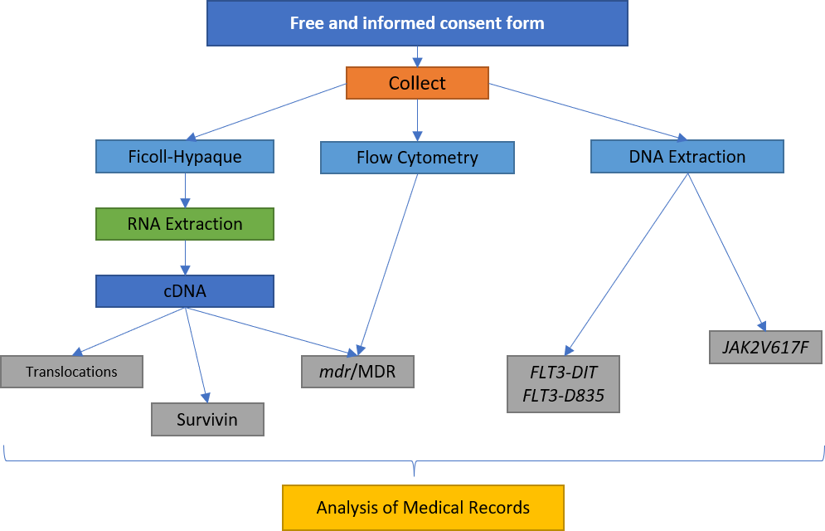

Figure 1 – Processing flowchart of peripheral blood or bone marrow samples.

After collection, part of the sample was used for RNA extraction, complementary DNA (cDNA) synthesis, semiquantitative RT-PCR assays and, when indicated, the investigation of t(8;21)(q22) translocations, TL-2, TL-3 and TL-4. A second part of the sample was used for flow cytometry assays and another part for DNA extraction and the research for the presence of mutations in the FMS3 gene and in the JAK2 gene. TCLE – Free and Informed Consent Term.

In addition to molecular biology and flow cytometry assays, a search was performed on medical records to obtain clinical data and other laboratory data from patients. The following data were collected from the medical records: age, WBC and LDH levels at diagnosis, gender, immunophenotype, karyotype, final diagnosis, occurrence of deaths and presence or absence of MRD after induction therapy. The absence of MRD was considered to be the occurrence of complete hematological remission, that is, the presence of 5% or less of blasts in the OM, reestablishment of normal hematopoiesis (return to normal values ​​of hemoglobin, leukometry, differential leukocyte count and platelet count). and absence of extramedullary disease after induction therapy.

**Reagents**

All reagents for cell culture, molecular biology assays and DNA extraction were purchased from Sigma Aldrich. The RNA extraction kit was purchased from Thermo Fisher and the Ficoll-Hypaque (density 1077 g/m3) from Thermo Fisher. Anti-CD34 and anti-CD45 monoclonal antibodies were purchased from Thermo Fisher Scientific; anti-ABCB1 and anti-ABCC1, from Thermo Fisher Scientific; anti-LRP, from Millipore; and the Alexa Fluor 488, from Thermo Fisher Scientific. The fixation and permeabilization kit were purchased from Thermo Fisher Scientific (USA).

**Controls of Molecular Biology Assays**

Human AL cell lines were cultured and used as positive controls for RT-PCR assays. As a positive control for the expression of *abcb1*/ABCB1, the AML strain of human origin K562-Lucena was used. The Jurkat human ALL lineage was used as a positive control for the expression of abcc1/ABCC1 and *lrp*/LRP. As a control of survivin transcription and the presence of TL-2 the AML strain of human origin K562 was used. For translocations TL-1, TL-3 (TL-3) and TL-4 (TL-4), the AML strain of human origin was used as a positive control. Kasumi1, NB4 and ME-1, respectively.

Cells were maintained in appropriate cell culture bottles containing DMEM (Dulbecco's Modified Eagle's Medium) or RPMI1640 (Roswell Park Memorial Institute 1640 Culture Medium) medium supplemented with 10% fetal bovine serum, 100 U/mL penicillin, 100 μg/mL streptomycin sulfate and 10 mM HEPES buffer (4-(2-hydroxyethyl)1-piperazinyl-ethanesulfonic acid) at pH 7.4. The cells were kept in an oven with a humid atmosphere at 37 ºC containing 5% CO2. To carry out the experiments, the number of viable cells was evaluated by the Trypan Blue dye exclusion method (0.5%) and only samples with viability greater than 80% were used.

In the PCR reactions for the detection of mutations in the FMS3 and JAK2 gene, samples from patients previously identified as carriers of these mutations were used as positive controls.

**RNA Extraction**

Total RNA was extracted from mononuclear cells from patients diagnosed with AL using the QIAamp RNA Blood Mini Kit according to the manufacturer's instructions.

Briefly, mononuclear cells were obtained by density gradient difference from peripheral blood or bone marrow. For this, the samples were diluted in phosphate buffer (PBS) in a proportion of 2:1 (1 mL of sample for 0.5 mL of PBS). After dilution, the sample was placed on 4 mL of Ficoll-Hypaque (density 1077 g/m3) and centrifuged at 300 g for 30 minutes. The interphase with the mononuclear cells was transferred to a conical tube, suspended in 10 ml of PBS buffer and centrifuged at 200 g for 10 minutes. After centrifugation, the supernatant was discarded and the cells were washed again with PBS. At the end of the washes, the cells were suspended in 3 ml of erythrocyte lysis buffer, provided by the kit, and incubated on ice for 15 minutes. After incubation, the cells were subjected to centrifugation at 400 g for 10 minutes at 4 °C. Mononuclear leukocytes were lysed using 600 µL of lysis buffer, provided by the kit, and 0.1% β-mercaptoethanol. The leukocyte lysate was transferred to the QIAshredder column and centrifuged at 10,000 g for 2 minutes. The column was discarded and 600 µL of 70% ethanol was added to the filtrate. The entire lysate was transferred to a QIAamp column and subjected to a new centrifuge at 10,000 g for 15 seconds. The QIAamp column was washed twice with wash buffer provided by the kit. After washing, 50 µL of RNase-free water (provided by the kit) was added to the column and it was subjected to a final centrifugation at 10,000 g for 1 minute. The filtrate containing the total RNA was stored at -80°C to be later used for cDNA synthesis.

**Complementary DNA Synthesis**

RNA quantification was performed by fluorimetry using the Qubit™ Quantitation Platform (Invitrogen) and its quality was assessed by visualizing ribosomal RNA (rRNA) bands in 2% agarose gel electrophoresis. Good quality samples were considered to be those that did not show a trace below the rRNA bands and whose 28S rRNA band had twice the intensity of the 18S rRNA band.

For cDNA synthesis, from 1 μg to 5 μg of total RNA were added in 0.2 mL microtubes. Possible contaminating DNA in the samples was eliminated by DNase digestion. To this end, 1 µL of DNase (1 U/µL), 1 µL of reaction buffer and water treated with diethyl pyrocarbonate (DEPC-water) were added to the total RNA until the volume was 10 µL. After 15 minutes digestion at room temperature, DNase was inactivated by 1 µL of EDTA (25 mM) and incubated for 10 minutes at 65 °C.

After DNase inactivation, the samples were subjected to a 5-minute incubation at 70 ºC, followed by an incubation on ice for 5 minutes. After incubation on ice, 15 µL of mix solution was added to each sample tube containing: 5 µL of 5x first strand buffer (250 mM Tris-HCl, pH 8.3; 375 mM KCl; 15 mM MgCl2), 2 μL of DTT (0.1M), 2 μL of random hexamers (100 ng/μL), 0.4 μL of dNTP mix (100 mM each), 0.5 μL of RNAse (40 U/μL), 0.5 μL of reverse transcriptase (200 U/μL) and water-DPEC q.s.p. to 15 μL. The samples were then taken to the thermocycler (Mastercycler Personal, Eppendorf) and subjected to the following schedule: 25 °C for 5 minutes, 37 °C for 60 minutes and 90 °C for 5 minutes. At the end of programming, the samples were incubated on ice for 5 minutes. The cDNA samples were measured by fluorimetry using the Qubit™ Quantitation Platform (Invitrogen) and stored in a freezer at minus 20 ºC to be later used in assays to detect the transcription of resistance genes and to investigate the presence of chromosomal translocations.

**Detection of Gene Transcription of *abcb1*, abcc1, *lrp* AND survivin BY Semi quantitative RT-PCR**

The evaluation of gene transcription of resistance proteins was performed using the semiquantitative RT-PCR technique. The oligonucleotide primers or primers pairs (Table 1) used to assess the transcription of *abcb1, abcc1, lrp and survivin* were previously described by Tomiyasu, et al. (2012) and glyceraldehyde-3-phosphate dehydrogenase (GAPDH) transcription was used for band normalization.

Table 1 – Sequence of primers for the detection of *abcb1, abcc1, lrp* and survivin.

|  |  |  |
| --- | --- | --- |
| Gene | Sequência | product size |
| *abcb1* | 5’–CCGCAAGTTTACCTGCAGG–3’ | 157bp |
| 5’–GCTCCTAACTTCTGAGGTTCA–3’ |
| *abcc1* | 5’–TGGGGGACTGTCACGAAT–3’ | 260bp |
| 5’–AGGCCGAATATGACTTCCC–3’ |
| *lrp* | 5’–GTCGGGCAGCTCGTCGGTGTTCTG–3’ | 240bp |
| 5’–GCCTGGGTCTGTCTCTTGCCTTGG–3’ |
| *survivin* | 5’–GCATCCTGGACTTCTCAACACC–3’ | 393bp |
| 5’–CCCATGGAGCTGCATCAGCCA–3’ |
| *GAPDH* | 5’–CCCGTCTTCGAGAAACCATGA–3’ | 330bp |
| 5’–TCTGGGATGTATGAGGCAGG–3’ |

All reactions were prepared with a final volume of 50 μL. PCR reactions with primers for *abcb1* and *lrp* were performed. The samples were initially denatured at 94 °C for 5 minutes and then subjected to the ideal reaction conditions for each pair of primers. At the end of the PCR cycles, a final extension was performed at 72°C for 10 minutes. The ideal reaction conditions and the number of cycles used were established in previous tests carried out at the Laboratory of Experimental Oncology and Hemopathies (LOEH) so that the PCR ended in the exponential phase of the amplification. The PCR products were electrophoresed in 2% agarose gel at 100 volts for 30 minutes and stained with ethidium bromide. The bands were visualized in a transilluminator (HOEFER-MacroVue UV-20) under UV light of 320 nm (Figure 2) and photographed with the gel photo-documentation system (DOC-PRINT®, Biosystems). The size of the fragments was estimated by comparison with the 50 bp molecular size marker.

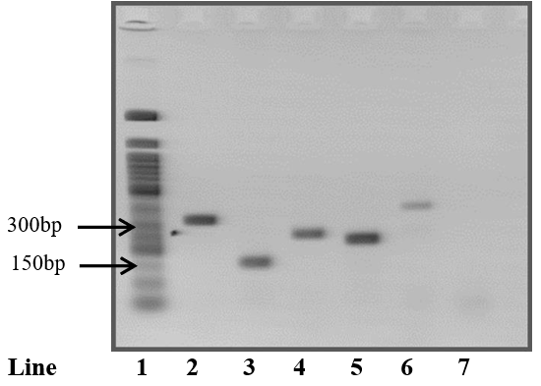

Figure 2 – Representative 2% agarose gel of polymerase chain reaction (PCR) positive controls for detection of *abcb1* (K562-LUCENA), abcc1 (Jurkat), *lrp* (Jurkat) and survivin (K562). [Line 1 – Molecular size marker 50 bp; Line 2 – PCR product with primers for gapdh (330 bp); Line 3 – PCR product with primers for *abcb1* (157 bp); Line 4 – PCR product with primers for abcc1 (260 bp); Line 5 – PCR product with primers for *lrp* (240 bp); Line 6 – PCR product with survivin primers (393 bp); Line 7 – Negative control with water.]

The mean intensity of each band was assessed by the digital analysis program. The intensity of the *abcb1*, abcc1, *lrp* and survivin gene bands was divided by the intensity of the gapdh normalizing gene. Results were reported in the form of relative transcription.

**Research of Translocations TL-1, TL-2, TL-3 & TL-4**

The search for chromosomal translocations was performed using the RT-PCR technique followed by nested PCR. The primers (Table 2) and the PCR conditions used for the investigation of chromosomal translocations were those described by the BIOMED-1 program.

Table 2: Sequence of primers for the investigation of chromosomal translocations.

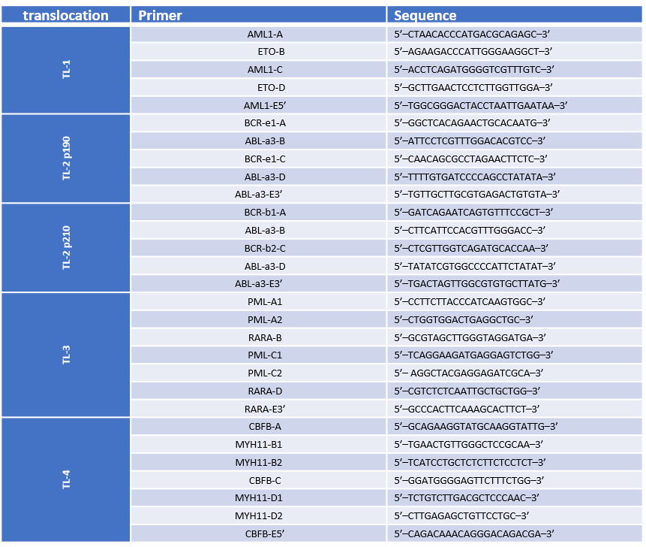

For the first PCRs of all chromosomal translocations, primers coded as A (sense) and B (antisense) were used. To avoid releasing false positive results, in parallel with the first PCR, a confirmatory PCR was performed with primers C (sense) and E3' (antisense), with the exception of TL-1 and inv (16)(p13;q22) in which the confirmatory primers used were those coded as E5' (sense) and D (antisense). Nested PCRs were performed using primers encoded with C (sense) and D (antisense).

Reactions were prepared with a final volume of 50 μL. The PCR stock solution was prepared. The nested PCR reactions were performed under the same conditions, except that, instead of genomic DNA, 1 µL of the amplification product of primers A and B from the first PCR was used as a template. The reaction conditions were: initial denaturation at 95 °C for 30 seconds, followed by 35 cycles of denaturation at 95 °C for 30 seconds, annealing at 65 °C for 1 minute and extension at 72 °C for 1 minute. The PCR product was electrophoresed in 2% agarose gel at 100 volts for 30 minutes and stained with ethidium bromide. The bands were visualized in a transilluminator under UV light of 320 nm. The size of the fragments was estimated by comparison with the 50 bp molecular size marker (Table 3).

Table 3: Expected size of PCR products for the investigation of chromosomal translocations, according to the pair of primers used.

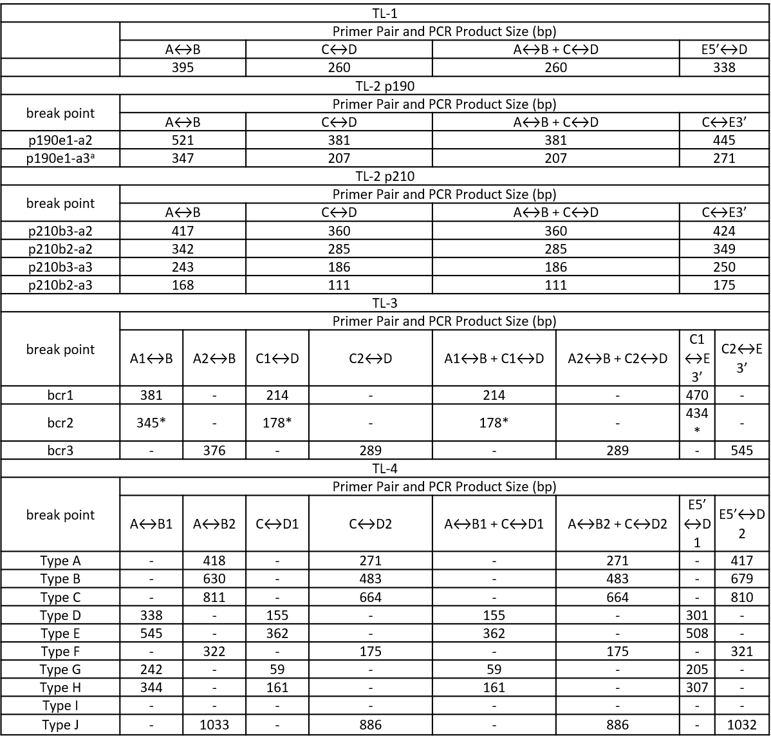

bp – Base pairs;(–): not applicable. *The size of the product is variable due to the variability of exon 6 breakpoints in the PML gene.

**DNA Extraction**

DNA extraction was performed using a 5 M guanidine isothiocyanate solution. For that, 200 μL of peripheral blood or bone marrow were transferred to a microtube containing 1 mL of 5 M guanidine isothiocyanate solution and subjected to vortex homogenization. The sample was then kept under continuous stirring at room temperature for 12 hours overnight. After incubation, 50 μL of acidified silica dioxide solution was added to the microtube and the sample was homogenized by inversion for 5 minutes. Afterwards, the sample was centrifuged at 1000 g for 1 minute at room temperature and the supernatant was discarded. The DNA-containing silica pellet was then washed twice with 500 µL of 5M guanidine isothiocyanate wash solution, twice with 500 µL of 70% ethanol and once with 500 µL of ultra pure acetone. Between each wash, the supernatant was removed after the sample was centrifuged at 1000 g for 1 minute at room temperature. At the end of the last wash, acetone residues were removed by evaporation in a thermoblock (Thermomixer compact, Eppendorf) at 56 °C for 10 minutes. The sample was rehydrated with 25 μL of Tris-EDTA Buffer (10 mM Tris.HCl, pH 6.4; 1 mM EDTA, pH 8.0) and again incubated in thermoblock at 56 °C for 10 minutes under agitation. Afterwards, the sample was centrifuged at 2,600 g for 5 minutes and the supernatant containing the genomic DNA was transferred to a new microtube with a capacity of 0.6 mL and frozen at minus 20 °C for later use in the assays for mutations in genes FMS3 and JAK2.

**Research for Mutation in the FMS3 Gene**

**Detection of the Mutation in the FMS3 Gene of the DIT Type**

For the detection of FMS3-DIT, the amplification of exons 14 and 15 of the FMS3 gene was performed.

Reactions were prepared with a final volume of 50 μL. The PCR mix solution was prepared as follows: 100 ng to 1 µg of genomic DNA, 5 µL of concentrated 10X buffer for Taq DNA polymerase (20 mM Tris-HCl, pH 8.4; 50 mM KCl), 1.5 μL MgCl2 (50 Mm), 0.4 μL dNTP mix (100 mM each), 2 μL primer sense (5'-GCATTTAATATGAAGCAGCCAGG-3') and antisense (5'- CTTGTAACAGCATTTTCCGGCAC-3') (10 µM each), 0.25 µL of Taq DNA polymerase (5 U/μL) and ultra-pure water q.s.p to 50 μL.

The reaction conditions were: A total of 35 cycles of denaturation at 94°C for 30 seconds, annealing for 1 minute at 61°C and 72°C for 2 minutes, followed by a final extension of 72°C for 8 minutes at the end of the process. It was stained with ethidium bromide after electrophoresis in a 12 percent polyacrylamide gel for 90 minutes at 80 volts. Under 320 nm UV transilluminator light, the bands could be seen. In order to estimate the fragment size, we used a molecular size marker (100 bp) as a reference.

In the absence of the FMS3-DIT mutation, just one band with 329 bp was detected, which was consistent with the wild-type gene. The FMS3-DIT homozygous and heterozygous forms of the mutation were associated with the presence of a second, larger band (up to 400 bp) or the absence of the 329 bp band when one or two larger bands were present ( Figure 3).

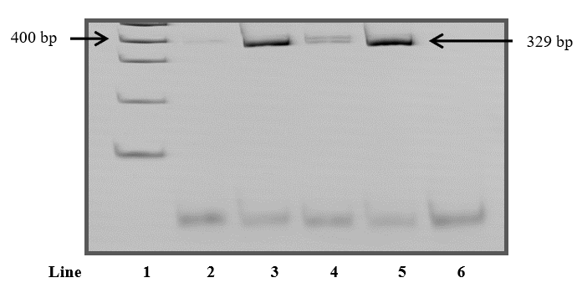

Figure 3 : 12% polyacrylamide gel representative of polymerase chain reaction (PCR) products for the detection of the FMS3-DIT mutation.[ Line 1 – 100 bp molecular size marker; Line 2 – Homozygous patient sample with a band compatible with the FMS3-DIT mutation; Line 3 – Patient sample without a band compatible with the FMS3-DIT mutation; Line 4 – Positive control (Sample from a heterozygous patient known to be positive for the FMS3-DIT mutation); Line 5 – Negative control with DNA (Patient sample known to be negative for the FMS3-DIT mutation); Line 6 – Negative control with water.]

**Detection of the Mutation in the FMS3 Gene of Type D835**

To detect the FMS3-D835 mutation, exon 20 amplification of the FMS3 gene was performed followed by an enzymatic digestion with EcoRV. Reactions were prepared with a final volume of 50 μL. The reaction conditions were: initial denaturation at 94 °C for 3 minutes, followed by 35 cycles of denaturation at 94 °C for 30 seconds, annealing at 66 °C for 1 minute and extension at 72 °C for 2 minutes, with a final extension of 72 °C for 8 minutes. Before enzymatic digestion, the success of amplification was verified by performing electrophoresis in a 2.5% agarose gel at 100 V for 30 minutes. The gel was stained with ethidium bromide and the bands were visualized on a transilluminator under UV light of 320 nm. The size of the fragments was estimated by comparison with the 50 bp molecular size marker. Samples that showed a single band with 114 bp were subjected to digestion with EcoRV.

Enzymatic digestion was prepared with a final volume of 15 μL and was performed. A 20 percent polyacrylamide gel was incubated at 70 V for 90 minutes with the reaction at 37 °C, and the digestion products were seen. In order to see the bands, the gel was stained with ethidium bromide and the UV light of 320 nm was used. The molecular size marker of 50 bp was used to assess the size of the fragments. Samples without the FMS3-D835 mutation were fully digested and showed two bands (68 bp/46 bp). Samples homozygous or heterozygous for the FMS3-D835 mutation were not digested or were partially digested, respectively. Thus, homozygous samples showed a single undigested band (114 bp) and in heterozygotes three bands resulting from partial digestion (114 bp/68 bp/46 bp) were observed (Figure 4).

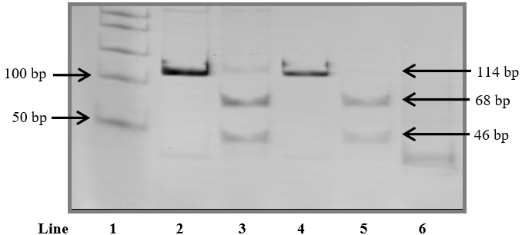

Figure 4: Representative 20% polyacrylamide gel of polymerase chain reaction (PCR) products for FMS3-D835 mutation detection.[Line 1 – 50 bp molecular size marker; Lane 2 – Patient sample with bands compatible with the FMS3-D835 mutation before digestion with EcoRV; Lane 3 – Sample from a heterozygous patient with bands compatible with the FMS3-D835 mutation after digestion with EcoRV; Lane 4 – Patient sample without bands compatible with the FMS3-D835 mutation before digestion with EcoRV; Lane 5 – Patient sample without bands compatible with the FMS3-D835 mutation after digestion with EcoRV; Line 6 – Negative control with water.]

**Statistical Analysis**

The creation of the database and the statistical analysis were performed using SPSS version 17.0® and MedCalc® version 12.3.0.0 software. Demographic data were summarized as absolute numbers and percentages in the case of nominal variables; and median of maximum and minimum values ​​in the case of numeric variables. The expression of multidrug resistance proteins (ABCB1, ABCC1 and LRP) were numerically summarized through median and maximum and minimum values ​​(thresholds). The presence of FMS3-DIT, FMS3-D835 and JAK2V617F mutations, as well as survivin translocations and transcription were summarized dichotomously (present or absent).

To evaluate the distribution of the samples, the Shapiro-Wilk or Kolmogorov-Smirnov tests were used. Independent numerical variables were compared between groups using the Mann-Whitney U test or the Kruskal-Walli’s test. The comparison of two dependent numerical variables between the groups was performed using the Wilcoxon test. The correlation between two numerical variables was performed using Pearson's correlation and the association between two or more nominal variables was verified using the chi-square or Fisher's exact test. The survival curve was constructed using the Kaplan-Meier method. A significance level of 5% (P<0.05) was considered.

**Results**

**Sample Characterization**

In this study, 75 patients diagnosed with AL were evaluated. Of these, 40 (53.3%) were male and 35 (46.7%) were female and the median age was 41 years (15-87 years; Table 1). Regarding the AL subtype, 47 (62.6%) cases of AML, 26 (34.6%) of ALL and two (2.8%) of AL were diagnosed. The distribution of AL subtypes according to WHO criteria was as follows: AML (one case; 1.3%), AML with minimal differentiation (one case; 1.3%), AML without maturation (five cases; 6.7 %), maturing AML (six cases; 8.0%), maturing AML with TL-1 (three cases; 4.0%), acute myelomonocytic leukemia (three cases; 4, 0%), acute monoblastic leukemia (two cases; 2.7%), acute monocytic leukemia (two cases; 2.7%), acute erythroblastic leukemia (one case; 1.3%), acute megakaryoblastic leukemia (one case; 1.3%), acute promyelocytic leukemia with t(15;17)(q22;q12) **(Denoted as TL-5)**(19 cases; 25.4%; APL), AML secondary to PMN (one case; 1.3%), AML secondary to MDS (two cases; 2.7%), pro-B type ALL-B (one case; 1.3%), common type ALL-B (nine cases; 12.0%), B-ALL with **TL2.2** (five cases; 6.7%), pre-B-type ALL-B (four cases; 5.3%), T-ALL (seven cases; 9.3%) and ABL (two cases; 2.8%). As can be seen in Table 1, which presents the clinical and laboratory characteristics at the time of diagnosis of the patients included in the study, the patients who did not go into remission were those who had a significantly higher median age (54 years) than those who went into remission. remission (35 years) (P<0.001). The medians of leukometry, percentage of blasts and LDH at diagnosis were similar between the two groups of patients. In addition, there was also no association between gender and response to treatment.

Table 1 – Clinical and laboratory characteristics of patients diagnosed with acute leukemia at the time of diagnosis, according to response to the first cycle of induction therapy.

|  |  |  |  |  |  |  |
| --- | --- | --- | --- | --- | --- | --- |
|  | Negative MRD (n=56) |  | Positive MRD (n=19) | | Total (n=75) | |
| parameters | No. % | | No. % | | No. % | |
| Age (years) |  | |  | |  | |
| median | 35 | | 54* | | 41 | |
| Limits | 15-76 | | 29-87 | | 15-87 | |
| Leukometry (x103/µL) |  | |  | |  | |
| median | 3.9 | | 10.7 | | 5.7 | |
| Limits | 0.3-177.2 | | 0.6-288.7 | | 0.3-288.7 | |
| Blasts (%) |  | |  | |  | |
| median | 59.1 | | 52 | | 56.1 | |
| Limits | 6.0-98.8 | | 5.4-96.0 | | 5.4-98.8 | |
| Lactate dehydrogenase(U/L) |  | |  | |  | |
| median | 308.5 | | 297 | | 308.5 | |
| Limits | 0.0-3060.0 | | 131.0-3197.0 | | 0.0-3197.0 | |
| LA subtype |  | |  | |  | |
| AML | 20 | 35.4 | 11 | 55.2 | 29 | 39.2 |
| EPS | 19 | 33.5 | 2 | 11 | 20 | 26.6 |
| ALL-B | 16 | 27.6 | 5 | 27.6 | 20 | 26.6 |
| ALL-T | 6 | 11.8 | 1 | 5.6 | 7 | 9.8 |
| ABL | 1 | 2 | 1 | 5.6 | 2 | 2.9 |
| Genre |  |  |  |  |  |  |
| Male | 36 | 63 | 8 | 44.2 | 42 | 56 |
| Female | 26 | 47.3 | 12 | 60.8 | 37 | 49 |
| FMS3-DIT | 0 |  | 0 |  | 0 |  |
| negatives | 43 | 76.8 | 11 | 55.2 | 51 | 68.6 |
| positives | 2 | 4 | 1 | 5.6 | 3 | 4.2 |
| Unrealized | 17 | 29.5 | 8 | 44.2 | 24 | 32.2 |
| FMS3-D835 |  |  |  |  |  |  |
| negatives | 38 | 66.9 | 12 | 60.8 | 47 | 63 |
| positives | 4 | 7.9 | 0 | 0 | 4 | 5.6 |
| Unrealized | 20 | 35.5 | 8 | 44.2 | 27 | 36.4 |
| survivin |  |  |  |  |  |  |
| negatives | 48 | 86.6 | 15 | 77.4 | 61 | 81.2 |
| positives | 5 | 9.8 | 1 | 5.6 | 6 | 8.4 |
| Unrealized | 7 | 13.8 | 4 | 22.1 | 12 | 15.4 |

MRD – Minimal residual disease; AL – Acute Leukemia; AML – Acute Myeloid Leukemia; APL – Acute Promyelocytic Leukemia with TL-5; ALL-B – Acute Lymphoblastic Leukemia type B; T-ALL – T-type Acute Lymphoid Leukemia; ABL – Acute Biphenotypic Leukemia; LDH – Lactate Dehydrogenase. Mann-Whitney U Test, Chi-square Test or Fisher's Exact Test. *Statistical significance when compared with the negative MRD group, P<0.05.

Of the 75 patients included in this study, it was not possible to analyse the presence of the FMS3-DIT mutation in 23 cases and the FMS3-D835 mutation in 26 cases due to the insufficient amount of sample or the absence of amplification of the wild-type gene.

Of the total number of patients analysed (n=75), only three had the FMS3-DIT mutation (Table 1). One was diagnosed as having APL, another as a non-mature AML, and the third as a common-type ALL-B. Patients with APL and AML without maturation achieved remission after treatment. However, the patient diagnosed with common type B-ALL died without going into remission. The four patients who were positive for the FMS3-D835 mutation went into remission after treatment and were alive until the end of the present work. Two of them were diagnosed as AML with maturation with TL-1, one as APL and another as myelomonocytic AML. No association was observed between treatment response and the presence of FMS3 mutations. In addition, no patient had the JAK2V617F mutation. Regarding the research of translocations, three patients presented TL-1, 19 to TL-5 and five to t(9;22)(q34;q11.2**) (denoted as TL-2.2),** receiving the diagnosis of AML with maturation with TL-1, APL with TL-5 and ALL-B with **TL-2.2**, respectively. No patient had TL-4.

In addition to these genetic alterations, the transcription of survivin, an anti-apoptotic protein, in the leukemic cells of these patients was also investigated. Due to the insufficient amount of sample or the absence of amplification of the constitutive gene (gapdh), it was not possible to assess the transcriptional intensity of survivin in 11 cases. As can be seen in Table 1, six patients expressed survivin at the time of diagnosis. Of these, one had mature AML, one had acute monoblastic leukemia, two had common type-ALL-B and two had T-ALL. Patients diagnosed with maturation AML, acute monoblastic leukemia and T-ALL died. There was no association between the presence of MRD and survivin transcription.

Of the total number of patients (n=75), 38 (50.7%) died. Only one death was not related to the underlying hematologic disease or treatment-associated complications. Of the patients who died, 19 (50%) were in remission at the time of death and 19 (50%) died without going into remission. Although APL is a subtype of AML, this leukemia has different pathophysiology, prognosis and treatment from other AMLs. Because of this, for the construction of the survival curve and determination of the median survival of the patients, it was decided to separate the cases of APL from the other cases of AML. As they present different prognoses, patients diagnosed with ALL-B and ALL-T were also divided into two groups.

The median survival of patients with AML was three months, those diagnosed with B-ALL at 25 months and those diagnosed with T-ALL at five months (Figure 5). The median survival of patients with APL could not be calculated, as few patients diagnosed with APL died during the period of this study. Of the patients diagnosed with ABL, one died nine days after diagnosis and another was alive until the end of this study.

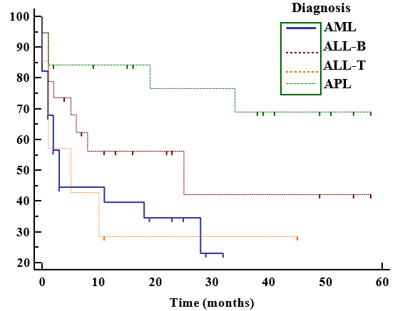

Figure 5: Survival curve of patients diagnosed with acute leukemia.

**Transcription of *mdr* Genes**

Of the 75 patients included in this study, 10 did not present amplification of the constitutive gene (gapdh) and therefore their samples were excluded from the gene transcription detection assays. Therefore, transcription assessment of *abcb1*, abcc1 and *lrp* was performed in 65 patients. For the transcription analysis of the *mdr* genes, the patients were divided into five groups: AML (n=24), APL (n=17), ALL-B (n=17), ALL-T (n=5) and ABL (n=2). Once again, this division into groups was chosen due to differences in prognosis between the AL subtypes.

As can be seen in Table 2, the medians (thresholds) of transcription of *abcb1*, abcc1 and *lrp* in the total of patients were 0.00 (0.00-1.32), 0.78 (0.00-7, 35) and 0.00 (0.00-1.38), respectively. At the time of diagnosis, there was no correlation between the transcription intensity of the different *mdr* genes.

Table 2 – Median transcription of *abcb1*, abcc1 and *lrp* in samples from patients with acute leukemia at diagnosis, according to response to the first cycle of induction therapy and/or differential diagnosis.

|  |  |  |  |  |
| --- | --- | --- | --- | --- |
|  | **Gene** | **Negative MRD (n=49)** | **Positive MRD (n=16)** | **Total (n=65)** |
| **Total of AL (n=65)** | ***abcb1*** |  |  |  |
| median | **0** | **0.00\*** | 0 |
| Limits | 0.00-1.10 | 0.00-1.32 | 0.00-1.32 |
| ***abcc1*** |  |  |  |
| median | 0.79 | 0.74 | 0.78 |
| Limits | 0.00-7.35 | 0.00-1.08 | 0.00-7.35 |
| ***lrp*** |  |  |  |
| median | 0 | 0.68 | 0 |
| Limits | 0.00-1.38 | 0.00-1.01 | 0.00-1.38 |
| AML(n=24) | ***abcb1*** |  |  |  |
| median | **0** | **0.60\*** | 0 |
| Limits | 0.00-0.84 | 0.00-1.32 | 0.00-1.32 |
| ***abcc1*** |  |  |  |
| median | 0.85 | 0.74 | 0.84 |
| Limits | 0.00-7.37 | 0.00-1.08 | 0.00-7.35 |
| ***lrp*** |  |  |  |
| median | 0 | 0 | 0 |
| Limits | 0.00-1.01 | 0.00-1.01 | 0.00-1.01 |
| **APL (n=17)** | ***abcb1*** |  |  |  |
| median | 0 | 0 | 0 |
| Limits | 0.00-1.08 | - | 0.00-1.08 |
| ***abcc1*** |  |  |  |
| median | 0.68 | 0.89 | 0.68 |
| Limits | 0.00-0.95 | - | 0.00-0.95 |
| ***lrp*** |  |  |  |
| median | 0 | 0.76 | 0 |
| Limits | 0.00-1.12 | - | 0.00-1.12 |
| ALL-B (n=17) | ***abcb1*** |  |  |  |
| median | 0 | 0 | 0 |
| Limits | 0.00-1.10 | 0.00-1.09 | 0.00-1.10 |
| ***abcc1*** |  |  |  |
| median | 0.87 | 0.78 | 0.83 |
| Limits | 0.00-1.13 | 0.62-0.92 | 0.00-1.13 |
| ***lrp*** |  |  |  |
| median | 0.69 | 0.86 | 0.74 |
| Limits | 0.00-1.38 | 0.62-0.91 | 0.00-1.38 |
| ALL-T (n=5) | ***abcb1*** |  |  |  |
| median | 0 | 0 | 0 |
| Limits | 0.00-0.57 | - | 0.00-0.57 |
| ***abcc1*** |  |  |  |
| median | 0.39 | 0 | 0 |
| Limits | 0.00-1.01 | - | 0.00-1.01 |
| ***lrp*** |  |  |  |
| median | 0.26 | 0 | 0 |
| Limits | 0.00-0.73 | - | 0.00-0.73 |
| ABL(n=2) | ***abcb1*** |  |  |  |
| median | 0 | 0 | 0 |
| Limits | - | - | 0.00-0.00 |
| ***abcc1*** |  |  |  |
| median | 0 | 0.75 | 0.38 |
| Limits | - | - | 0.00-0.75 |
| ***lrp*** |  |  |  |
| median | 0 | 0.67 | 0.22 |
| Limits | - | - | 0.00-0.67 |

MRD – Minimal residual disease; AML – acute myeloid leukemia; ALL – acute lymphoblastic leukemia; ABL – Acute biphenotypic leukemia; n – number of patients. Mann-Whitney U test. *Statistical significance when compared with the negative MRD group, P<0.05.

In addition, we analysed whether there was an association between the transcription levels of *mdr* genes and the response to treatment (Table 2) and it can be seen that there is an association between the higher transcription of *abcb1* and the presence of MRD, both in the total of patients (P=0.004), and in the group of patients diagnosed with AML (P=0.005). This same association was not found in the other groups of patients. The expressions of abcc1 and *lrp* were not related to the response to treatment in any of the AL subtypes. Subsequently, we evaluated whether there was an association between the intensity of transcription of *mdr* genes and the differential diagnosis of patients (AML, APL, ALL-B, ALL-T or ABL). However, no association was found between gene transcription and differential diagnosis, even when patients were separated according to treatment response (MRD negative and MRD positive).

Another data that was evaluated is whether there was an association between the transcription of *mdr* genes and some prognostic factors such as: age, leukometry and percentage of blasts at diagnosis, Lactate Dehydrogenase, expression of CD34, CD56 and survivin, presence of FMS3-DIT mutations, FMS3-D835 and TL-1 translocation in AML cases and TL-2.2 in B-ALL cases (Table 3, 4 and 5 ). Due to the small number of patients in the ABL group, it was not possible to verify the existence of a relationship between the transcription of *abcb1*, abcc1 and *lrp* and the prognostic factors in this group. As can be seen in Table 3, transcription of *abcb1* was positively correlated with leukocyte count in T-ALL cases (P=0.007; R2=0.967). This correlation was maintained in the group of patients diagnosed with T-ALL and negative MRD (P=0.030; R2=0.970).

Table 3 – Association between *abcb1* transcription and prognostic factors in samples from patients with acute leukemia at diagnosis, according to response to the first cycle of induction therapy and/or differential diagnosis.

|  |  |  |  |  |
| --- | --- | --- | --- | --- |
|  | **Prognostic Factors** | **Negative MRD (n=49)** | **Positive MRD (n=16)** | **Total (n=65)** |
| **TOTAL of AL (n=65)** | Age (years) | 0.13 | 0.73 | 0.54 |
| Leuco (x103/µL) | 0.32 | 0.27 | 0.99 |
| Blasts (%) | 0.65 | 0.39 | 0.71 |
| Lactate dehydrogenase(U/L) | 0.33 | 0.19 | 0.17 |
| CD34 expression | 1.00 | 1.00 | 0.53 |
| CD56 expression | 1.00 | 0.53 | 0.33 |
| survivin | 1.00 | 1.00 | 0.60 |
| *FMS3-DIT* | 1.00 | 1.00 | 1.00 |
| *FMS3-D835* | 0.23 | - | 0.19 |
| TL-1 | 0.20 | - | 0.90 |
| TL-2.2 | 1.00 | 1.00 | 0.57 |
| AML(n=24) | Age years) | 0.10 | 0.76 | 0.94 |
| Leuco (x103/µL) | 0.78 | 0.52 | 0.83 |
| Blasts (%) | 0.08 | 0.97 | 0.30 |
| Lactate dehydrogenase(U/L) | 0.39 | 0.72 | 0.25 |
| CD34 expression | 0.30 | 0.87 | 0.74 |
| CD56 expression | 1.00 | 0.41 | 0.98 |
| survivin | 0.14 | 0.91 | 0.10 |
| *FMS3-DIT* | 1.00 | - | 1.00 |
| *FMS3-D835* | 0.28 | - | 0.20 |
| TL-1 | 0.20 | - | 0.90 |
| TL-2.2 | - | - | - |
| **APL (n=17)** | Age years) | 0.92 | - | 1.00 |
| Leuco (x103/µL) | 0.53 | - | 0.54 |
| Blasts (%) | 0.49 | - | 0.56 |
| Lactate dehydrogenase(U/L) | 0.88 | - | 0.84 |
| CD34 expression | 1.00 | - | 1.00 |
| CD56 expression | 0.28 | - | 0.28 |
| survivin | - | - | - |
| *FMS3-DIT* | 1.00 | - | 1.00 |
| *FMS3-D835* | 1.00 | - | 1.00 |
| TL-1 | - | - | - |
| TL-2.2 | - | - | - |
| ALL-B (n=17) | Age years) | 0.36 | 0.34 | 0.77 |
| Leuco (x103/µL) | 0.51 | 0.47 | 0.66 |
| Blasts (%) | 0.71 | 0.58 | 0.70 |
| Lactate dehydrogenase(U/L) | 0.74 | 0.29 | 0.39 |
| CD34 expression | 1.00 | - | 1.00 |
| CD56 expression | - | - | - |
| survivin | 1.00 | - | 1.00 |
| *FMS3-DIT* | - | 1.00 | 1.00 |
| *FMS3-D835* | - | - | - |
| TL-1 | - | - | - |
| TL-2.2 | 1.00 | 1.00 | 0.57 |
| ABL(n=2) | Age years) | 0.12 | - | 0.09 |
| Leuco (x103/µL) | - | - | - |
| Blasts (%) | 0.50 | - | 0.52 |
| Lactate dehydrogenase(U/L) | 0.77 | - | 0.84 |
| CD34 expression | 0.26 | - | 0.41 |
| CD56 expression | - | - | - |
| survivin | 1.00 | - | 1.00 |
| *FMS3-DIT* | - | - | - |
| *FMS3-D835* | - | - | - |
| TL-1 | - | - | - |
| TL-2.2 | - | - | - |

MRD – Minimal residual disease; AL – Acute Leukemia; AML – Acute myeloid leukemia; APL – Acute promyelocytic leukemia with TL-5; ALL-B – Acute lymphoblastic leukemia type B; T-ALL – T-type acute lymphoid leukemia; LDH – Lactate dehydrogenase; Leuco - Leucometry. Mann-Whitney U test or Pearson correlation. *Statistical significance.

**Discussion**

**Clinical and Laboratory Characteristics of Patients**

ALs constitute a heterogeneous group of malignant neoplasms that affect individuals in all age groups and are slightly more frequent in men. As expected, the group of patients included in the present study showed a predominance of males (n=40; ​​Female=35) and a wide age range (15-87 years; Table 1). In addition, the median age of patients diagnosed with AML was 54 years (18-87 years), while that of those diagnosed with ALL was 30 years (15-60 years).

Worldwide, the median age at diagnosis of adult patients with AML and ALL is 63 to 72 years and 25 to 45 years. years, respectively. At the Iraq, a study carried out in Baghdad with AML patients found a median age at diagnosis of 43 years (n=69). Studies reported median age at diagnosis in AMLs of 34 years (n=109), 67 years (n=97), 35 years (n=17) and 34 years (n =115), respectively. Regarding ALLs, a study in Bahia and another in Rio Grande do Sul reported medians of age at diagnosis of 49 years (n=70) and 26 years (n=42), respectively. As can be seen, with the exception of the Baghdad study, the patients diagnosed with AML evaluated here had a median age slightly higher than that found in other studies (James, 2017), but still lower than that reported in international studies. On the other hand, the median age of patients diagnosed with ALL included in the present study was similar to those reported in national and international studies.

Unlike the other AL subtypes, APLs do not show an age-peak distribution. Its incidence progressively increases during adolescence, reaches a plateau during early adulthood and remains constant until it decreases around the age of 60. Thus, most APL diagnoses occur between 20 and 50 years of age. Therefore, the median age (26 years) and age group (15-87 years) of patients diagnosed with APL included in the present study are in line with expectations for this AML subtype.

Still regarding the age of the patients included in this study, it was found that individuals who did not go into remission after induction therapy had a significantly higher median age (54 years) than patients who went into remission (35 years; P< 0.001; Table 1). As already mentioned, “advanced age” is considered a poor prognostic factor independent of ALs. In addition, older patients generally have a higher occurrence of other poor prognostic factors, such as unfavorable cytogenetic abnormalities, greater susceptibility to the toxic effects of chemotherapy, overexpression of genes associated with MDR, and the presence of contraindications to intensive care, which explains because these patients usually do not respond as well to chemotherapy. Therefore, it was already expected that, in the present study, patients with positive MRD would present a median age higher than those who entered complete remission after induction therapy.

Leukometry at diagnosis was another prognostic factor evaluated in this study. Patients diagnosed with AL may have elevated, normal, or decreased WBC counts at the time of diagnosis and, in general, counts greater than 30,000 WBCs/mm3 are considered to have a poor prognosis. In the present study, the group of patients who went into remission and the group that presented MRD after induction therapy had similar median leukocyte counts of 3,900 leukocytes/mm3 and 10,700 leukocytes/mm3, respectively (P>0.05; Table 1). Iraq study carried out in Abdulsalam, et al. (2010) reported a median number of leukocytes a little higher (12,600 leukocytes/mm3; n=115) than that found in this study. However, a study carried by Liu, (2002) in terms of ethnic and socioeconomic characteristics, reported that 51% of the evaluated patients had leukocyte counts below 10,000 leukocytes/mm3 (n= 39), which is very similar to the leukometries found in the present work. In addition, an interesting fact observed is that both the good prognosis group (negative MRD) and the poor prognostic group (positive MRD) had medians of leukometry considered as having a good prognosis and within the reference values ​​stipulated by the Clinical Analysis Service BTH (3,800 to11,000 leukocytes/mm3). However, it is important to note that of the 19 patients who did not go into remission after induction therapy, seven (36.8%) had a WBC greater than 30,000 leukocytes/mm3, while in the group with negative MRD, only ten patients (17.8%) out of a total of 56 had a leukocyte count above 30,000 leukocytes/mm3. Thus, it is evident that, despite the leukocyte medians of the two groups being within the parameters of a good prognosis, the group with positive MRD presented, as expected, a higher frequency of patients with leukocyte counts greater than 30,000 leukocytes/mm3. Another fact to be highlighted is that, although the median of the leukometry of the patients who went into remission (3,900 leukocytes/mm3; Table 1) was within the reference limits, it is very close to the lower limit of normality adopted for this parameter by the Clinical Analysis Service of BTH(3,800 leukocytes/mm3). Probably, the low leukocyte count is due to the high number of APL cases in the negative MRD group (n=17). This AML subtype usually has a favorable prognosis and is characterized by frequently presenting pancytopenia at diagnosis.

**Relationship of *mdr*/MDR Profile with Prognosis Factors**

**Relationship of *abcb1*/ABCB1 Expression Profile with Prognostic Factors**

Analysis of the association between *abcb1*/ABCB1 expression and prognostic factors showed that patients diagnosed with AL and negative MRD after the induction phase of chemotherapy showed only a moderate correlation between ABCB1 protein expression and LDH activity (P=0.002; R2=0.601; Table 8), while individuals diagnosed with ALL-B with negative MRD showed a strong correlation between these two parameters (P=0.006; R2=0.931; Table 8). This finding allows us to suggest that the correlation found in the group of patients diagnosed with AL and negative MRD is a reflection of the presence of ALL-B cases in this group.

Differently from what was observed in the present study, Carrillo, et al. (2016) found no association between ABCB1 expression and LDH in adult individuals diagnosed with ALL (n=95). A possible explanation for the divergence between the results of Thomas et al. (2003) and those of the present work is that, in their analysis, Jamroziak, et al. (2006) chose to express the results of ABCB1 and LDH dichotomously (positive/negative and low/high, respectively), which implies the use of statistical methods different from those used in this study. Furthermore, Maroofi, et al. (2015) demonstrated that certain *abcb1* gene polymorphisms are associated with higher concentrations of LDH. Thus, another possible explanation for the disagreement between the results by Miladpoor, et al. (2009) and those of the present work would be the difference in the frequency of certain polymorphisms in the two populations studied.

**Relationship of abcc1/ABCC1 Expression Profile with Prognostic Factors**

Analysis of abcc1/ABCC1 expression revealed several associations between their expression and prognostic factors (Tables 4 and 9). In individuals diagnosed with AL, the highest transcription of abcc1 was associated with the presence of the CD34 marker in leukemic blasts (P=0.005). This same association was found for the AL group with negative MRD (P=0.006). When the patients were divided according to the differential diagnosis, no group showed a significant association between the transcription of abcc1 and the presence of the CD34 marker. However, patients diagnosed with APL showed a trend of association between these two parameters (P=0.061). This finding suggests that the significant association found for the AL group is due, in part, to the presence of APL cases in the group. In fact, studies that analysed the transcription of abcc1 in adult patients diagnosed with AML or ALL also found no relationship between the transcription of this gene and the presence of the CD34 marker. Unfortunately, no other studies were found that specifically evaluated the gene transcription of abcc1 in patients diagnosed with APL. Therefore, to confirm whether this trend of association between abcc1 and the presence of the CD34 marker in patients with APL will become significant or not, studies with a larger number of patients are needed.

When evaluating the expression of abcc1/ABCC1 in AML patients, a directly proportional correlation was found between gene transcription and age in the group that did not go into remission after induction therapy (P=0.031; R2=0.721; Table 4). As already mentioned, elderly patients commonly overexpress resistance genes and proteins. However, studies that specifically evaluated the transcription of abcc1 could not find a relationship between its transcription and the age of the patients, which suggests that the transcription of abcc1 would not influence the worse response to induction chemotherapy in elderly patients. In fact, as will be discussed later, the present study also found no relationship between abcc1 transcription and the response to induction therapy in AML patients (Table 2). However, it is important to emphasize that elderly patients are more susceptible to the toxic effects of chemotherapy, which often makes it impossible for clinicians to indicate intensive doses of chemotherapy, which, consequently, increases the risk of resistance to treatment due to the induction of overexpression. of resistance genes. Thus, the results found in the present study suggest that older patients are more susceptible to developing chemotherapy-induced resistance, since, from the moment of diagnosis, they already express more abcc1.

**Conclusion**

The compilations of evidence obtained in this study are:

1. Patients with AL (n=75) who did not go into remission (n=56/75) after induction chemotherapy had a higher median age than patients who went into remission (n=19/75);
2. The median survival of patients with AML, B-ALL and T-ALL were three months, 25 months and five months, respectively;
3. The median survival of APL patients (n=19) was greater than 60 months;
4. FMS3-DIT (5.8%) and LACTATE DEHYDROGENASE3-D835 (8.4%) mutations were rare;
5. The JAK2V617F mutation was not detected in any patient;
6. Only six subjects expressed survivin (9.4%);
7. The expression profile of MDR genes and proteins in AL patients was heterogeneous;
8. In cases of AL, ABCB1 expression and LDH activity were positively correlated, the presence of the CD34 marker was associated with the highest transcription of abcc1, and the highest transcription of *lrp* was associated with the absence of the marker CD56 and with the absence of survivin transcription;
9. In AML carriers (n=28/75), abcc1 transcription and patient age were positively correlated, and the absence of survivin transcription was associated with higher *lrp* transcription;
10. In patients diagnosed with APL (n=19/75), abcc1 and LRP expressions were positively correlated with the percentage of leukemic promyelocytes at diagnosis, and ABCC1 expression was positively correlated with LDH activity;
11. In ALL-B cases (n=19/75), ABCB1 and abcc1 expressions correlated positively with LDH activity, ABCC1 expression was negatively correlated with leukocyte count at diagnosis, and LRP expression was positively correlated with the number of leukocytes at diagnosis and was associated with the presence of TL-2.2;
12. In T-ALL cases (n=7/75), *abcb1* transcription and leukocyte count were positively correlated;
13. Higher LRP expression was associated with the diagnosis of AML;
14. Patients diagnosed with AL and AML who did not go into remission after induction therapy expressed more *abcb1* than those who showed complete remission after induction chemotherapy;
15. AML patients who did not respond to induction therapy expressed more ABCC1 than those who experienced complete remission after induction therapy;
16. There was no association between the expression of *abcb1*/ABCB1, abcc1/ABCC1 and *lrp*/LRP and the occurrence of deaths;
17. Patients diagnosed with AML expressed less abcc1 after induction therapy;
18. APL carriers expressed more LRP after induction chemotherapy.

These results suggest that the expression of *abcb1*/ABCB1, abcc1/ABCC1 and *lrp*/LRP is related to prognostic factors, such as age, leukometry at diagnosis, percentage of neoplastic blasts, LDH, presence of CD34 marker and TL-2.2, in cases of AL and that the high expression of *abcb1* and ABCC1 influences the response to induction therapy in patients diagnosed with AML. Furthermore, it could be seen that the analysis of the transcription of chemotherapy resistance genes provides different prognostic information than the analysis of chemotherapy resistance proteins. Therefore, the present study recommends that, at the time of diagnosis of patients with AL, a simultaneous assessment of the transcription of genes (*abcb1*, abcc1 and *lrp*) and proteins (ABCB1, ABCC1 and LRP) of resistance to chemotherapy be performed.

**References**

1. Abdulsalam, Abbas. (2010). Laboratory diagnosis of acute leukemia in Iraq, the available options. Turkish Journal of Hematology. 27. 10.5152/tjh.2010.59.
2. Alyaqubi, Kifah & AL-Faisal, A. & Almothaffar, Ali & Tobal, Khalid. (2014). Assessment of Multidrug Resistance Gene (MDR1) Expression in Acute Myeloid Leukemia.. IJAR.. 2. 375-383.
3. Biteau B, Hochmuth CE, Jasper H. Maintaining tissue homeostasis: dynamic control of somatic stem cell activity. Cell Stem Cell. 2011 Nov 4;9(5):402-11. doi: 10.1016/j.stem.2011.10.004. PMID: 22056138; PMCID: PMC3212030.
4. Carrillo, Olarte & Ramos-Peñafiel, Christian & Peralta, E & Fuller, E & Ipiña, J & Centeno, Federico & Garrido, Efraín & Jaloma, J & Vargas, K & Martínez Tovar, Adolfo. (2016). Clinical significance of the ABCB1 and ABCG2 gene expression levels in acute lymphoblastic leukemia. Hematology (Amsterdam, Netherlands). 22. 1-6. 10.1080/10245332.2016.1265780.
5. Ferlay J, Ervik M, Lam F, Colombet M, Mery L, Piñeros M, et al. Global Cancer Observatory: Cancer Today. Lyon: International Agency for Research on Cancer; 2020 (https://gco.iarc.fr/today, accessed February 2021.
6. James, William & Grech, Victor. (2017). A review of the established and suspected causes of variations in human sex ratio at birth. Early Human Development. 109. 10.1016/j.earlhumdev.2017.03.002.
7. Kumar CC. Genetic abnormalities and challenges in the treatment of acute myeloid leukemia. Genes Cancer. 2011 Feb;2(2):95-107. doi: 10.1177/1947601911408076. PMID: 21779483; PMCID: PMC3111245.
8. Liu, TC & Lin, Hsiu-Fen & Chen, TP & Chang, JG. (2002). Polymorphism analysis of CYP3A5 in myeloid leukemia. Oncology Reports. 9. 327-329.
9. Maroofi, Farzad & Amini, Sabrieh & Roshani, Daem & Ghaderi, Bayazid & Abdi, Mohammad. (2015). Different frequencies and effects of ABCB1 T3435C polymorphism on clinical and laboratory features of B cell chronic lymphocytic leukemia in Kurdish patients. Tumor Biology. 10.1007/s13277-014-2914-9.
10. Miladpoor, Behnoosh & Shokouhi, Amireh & Shirdel, Abbas & entezari heravi, Reza & Banihashem, Abdollah & Esmaily, Habibollah & Khedri, Azam & Behravan, Javad. (2009). Association of Acute Lymphoblastic Leukemia and MDR1 Gene Polymorphism in an Ethnic Iranian Population. Iranian journal of blood and cancer. SIDIRANIAN JOURNAL OF BLOOD AND CANCER | Volume 1,Number 2 ,63-66
11. Mjali, Ahmed & Hasan Jaleel Al-Shammari, Haider & Abbas, Nareen & Azeez, Zahraa & Abbas, Saja. (2019). Leukemia Epidemiology in Karbala province of Iraq. Asian Pacific Journal of Cancer Care. 4. 135-139. 10.31557/apjcc.2019.4.4.135-139.
12. Rafiq, Sabika & Raza, Muhammad & Younas, Mehwish & Naeem, Fariha & Adeeb, Romisha & Iqbal, Javed & Anwar, Pervez & Sajid, Umara & Manzoor, Hafiza. (2018). Molecular Targets of Curcumin and Future Therapeutic Role in Leukemia. Journal of Biosciences and Medicines. 06. 33-50. 10.4236/jbm.2018.64003.
13. Thomas X, Le Q. H. Prognostic factors in adult acute lymphoblastic leukemia. Hematology; 2003; 8: 233-42.
14. Tomiyasu, Hirotaka & Watanabe, Manabu & Goto-Koshino, Yuko & Fujino, Yasuhito & Ohno, Koichi & Sugano, Sumio & Tsujimoto, Hajime. (2012). Regulation of the expression of ABCB1 and LRP genes by MAPK/ERK pathway and its role in the generation of side population cells in canine lymphoma cell lines.. Leukemia & lymphoma. 54. 10.3109/10428194.2012.751529.

1. Pulmonary resistance-associated protein/Main vault group protein/MVP