**The Effect of Thickness on the Morphological and Optical Properties of**

**ZnSe Thin Films**

***Irmak KARADUMAN ER1,\*[C:\Users\Abdullah\AppData\Local\Microsoft\Windows\INetCache\Content.Word\ORCID-iD_icon-16x16.gif](https://orcid.org/0000-xxxx-xxxx-xxxx), Aytunç ATEŞ3[C:\Users\Abdullah\AppData\Local\Microsoft\Windows\INetCache\Content.Word\ORCID-iD_icon-16x16.gif](https://orcid.org/0000-xxxx-xxxx-xxxx) , Selim ACAR 4[C:\Users\Abdullah\AppData\Local\Microsoft\Windows\INetCache\Content.Word\ORCID-iD_icon-16x16.gif](https://orcid.org/0000-xxxx-xxxx-xxxx)***

*\*1 Çankırı Karatekin University , Department of Medical Services and Techniques, Eldivan Medical Services Vocational School, , Çankırı, Turkey*

*2 Ankara Yıldırım Beyazıt University, Department of Metallurgy and Materials Engineering, Faculty of Engineering and Natural Sciences, Ankara, Turkey*

*3 Gazi University, Department of Physics, Faculty of Science, Ankara, Turkey*

|  |
| --- |
| **Abstract**  With the expansion of electronics and digital industries and their penetration into all areas of our lives, the production and development of high-precision, reliable, integrated, low-noise and low-power electrical components has become a very important consideration. However, when the relationships between the structure, properties and processing of materials are fully understood and assimilated, we can make the raw materials that nature gives us more available, and as scientists develop them, we can transform them into superior technologies. Today, the rapid change that occurs with the acceleration of research and studies in thin film materials creates new opportunities for the development of new processes, materials, and technologies. Therefore, many experiments and model systems have been developed to improve the previously known properties of basic physical and chemical properties related to thin film performance and structure in various applications and to increase progress in this field. A prerequisite for the development of new thin-film systems is the combined results of experimental and theoretical investigations and shaping their structure and performance. In this sense, the characteristics of thin-film materials and their control and optimization are of great importance. One of the most important features affecting these features is the producing method. There are chemical solution-based methods such as sol-gel method, chemical bathing technique, hydrothermal method, SILAR method and spraying method. In this study, Cadmium Selenide (ZnSe) thin films were grown on glass substrate using succession ionic layer adsorption and reaction (SILAR) method. Morphological and optical properties of ZnSe thin films grown at different thicknesses (40 and 50 cycle) are given comparatively. |
| Keywords: SILAR method, thin films, Zinc Selenide |

1. **Introduction**

The science of thin films plays a significant role in the development of solid materials especially for energy-efficient display devices such as diodes, transistors, display screens, photodetectors, photovoltaics, and solar cells. Thin films show distinctive behavior comparing with their bulk structure. A thin film is recognized as thin unless the properties of its surface are unlike its bulk behavior. The thin films have a higher volume surface ratio, such the thin film characteristics are determined by the surface and near-surface properties. The thickness of thin films is in a range of a few nanometers to 1 micrometer, the design of the substrate on which the films are grown, as well as the deposition research methods of deposition used in the production of thin films. Thin-film processing is generally done by depositing the required material over the appropriate substrate in the atomic deposition (atom by atom), which may lead to either a single crystalline, polycrystalline or amorphous form based on the deposition conditions. The thickness of the thin film, amount of doping, or constitute element can be changed as requested for the used substrate and deposition method. These advantages of thin films have benefits for developing advanced products and commercialization [1].

Zinc selenide (ZnSe) is II–VI, n-type semiconductor material, which has many applications like high-efficiency thin film transistors, solar cells, photoconductors, and gas sensors [2]. In order to improve the performance of the devices, key attention has been given in recent years to study the physical properties of ZnSe thin films. A variety of methods have been used to prepare ZnSe thin films, including physical vapor deposition [3], sputtering [4], spray pyrolysis [5], SILAR [6] and chemical deposition [7]. The SILAR method, cheaper and more economical than these methods, can produce at room temperature, does not require complex materials, and is suitable for making high-quality thin films. Compared to the physical vapor deposition methods used in vacuum systems, it is quite economical and the production steps are comfortable [8,9]. It is seen that there are changes in the properties of the films produced by changing the producing parameters of the SILAR method. The aim is to produce the best films with the optimal production parameters. It is reported in the literature that there are changes in the properties of the films produced by doping with different elements, changing the hot water parameter, producing cycle, cationic solution, and pH in the growth process [10]. In this study, we produced ZnSe thin films with different cycles and investigated their morphological and optical characterization.

1. **Materials and Methods**

The SILAR method was used to grow the ZnSe thin film, and appropriate solutions were created as described; At room temperature and atmospheric pressure, ZnSe thin films were formed on glass substrates using the SILAR process. The cationic and anionic precursor solutions utilized to deposit ZnSe thin films were 0.1 M ZnCl2 solution at pH 5.5 and 0.13 M Na2SeSO3 solution at pH 10.5. The durations for adsorption, reaction, and rinsing were chosen empirically to ensure layer wise deposition and a homogeneous thin film structure. The glass substrate was immersed in the ZnCl2 solution for 40 seconds to allow cadmium (Zn+2) and small amounts of chlorine (Cl-) ions to settle on the surface in order to grow the ZnSe thin film using the SILAR process. The glass substrate was then placed in deionized water for 50 seconds after being removed from the ZnCl2 solution, allowing weakly bound Zn+2 and Cl- ions to dissociate from the surface. As a result, the connected Zn+2 ions interacted with selenium ions (Se-2). Finally, the weakly attached sodium (Na+) ions and non-reacting selenium (Se-2) ions are removed from the surface supplied by immersing the sample holder in deionized water for 50 seconds. This procedure was continued until the necessary thickness of uniform film was achieved. Finally, the glass substrate was submerged for 40 seconds in a Na2SeSO3 solution and held.

**3. Results and Discussion**

Figure 1 shows the SEM analysis of ZnSe thin films with 40 cycle(a) and 50 cycle(b). Although the ZnSe thin films have a compact, flat, and homogeneous surface, there are some pinholes, cracks, and other defects. All of the films have the same granular structure, with round-shaped grains tightly packed in larger irregular-shaped particles. Aggregates dispersed on the film surface have been observed, which is common in the chemical deposition of some semiconductor films. Figure 2 shows the EDAX analysis of ZnSe thin films with 40 cycle (a), 50 cycle (b). ZnSe thin films were produced on glass substrates with the different SILAR cycles under the same ambient conditions. The change of Zn and Se on the EDAX spectrum was associated with the producing cycle. The presence of Mg, Na, Si, O and Ca elements in the spectra may have originated from the glass substrates. And also, some pinholes, cracks, or other defects were observed from the surface, therefore, the higher oxygen value can be found from the EDAX analysis.

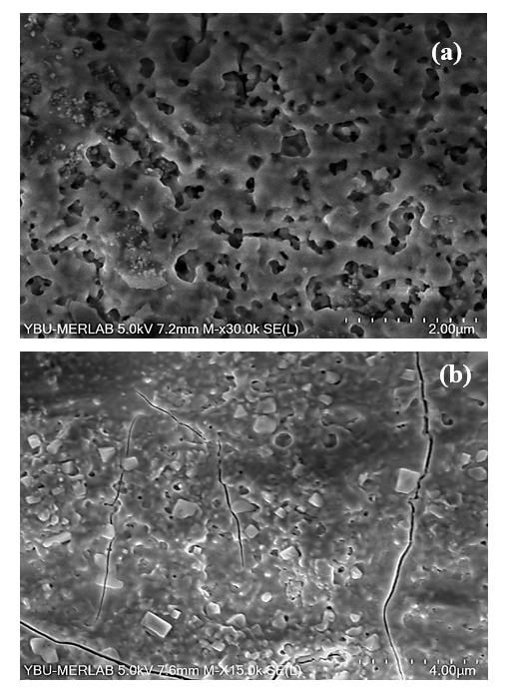

**Figure 1.** SEM analysis of 40ZnSe (a) and 50ZnSe (b) thin films

**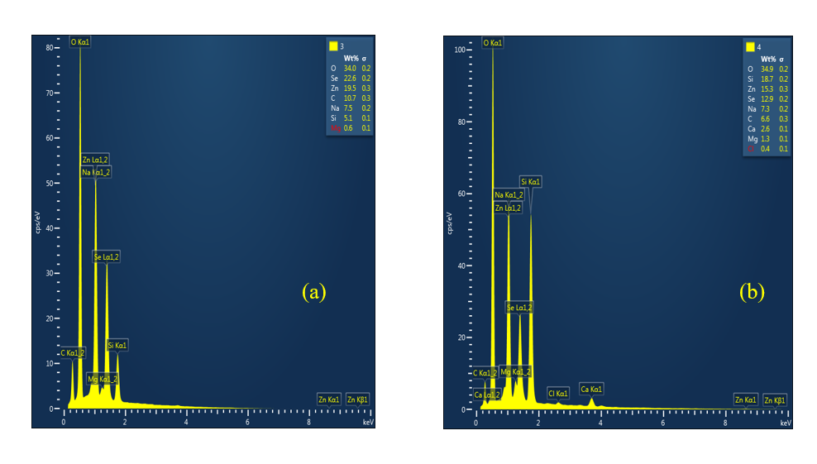**

**Figure 2.** EDAX analysis of 40ZnSe (a) and 50ZnSe (b) thin films

Fig. 3 shows the absorbance spectra of the ZnSe thin films. The absorbance spectra increase with the increasing of film thickness. It is found that the absorption spectra for Zn–Se system are blue shifted due to increase in the optical band gap for these materials. An opposite behavior was observed for transmittance spectra, as shown in Figure 4. Figure 5 shows the plot of (*αhν*)2 against *hν*. The optical band gap was determined by using the below Tauc plot [11];

$α=\frac{A({hϑ-E_{g})}^{n}}{hϑ}$

where A is a constant and n is an index for allowed direct and non-direct transitions are 1/2 and 2, respectively. When the slope of the graph is taken, the value where it intersects the x point gives the optical band gap value. Extrapolating the straight portion of the plot (*αhν*)2 against *hν* to energy axis, optical band gap energy values of 2.42 eV and 2.33 eV were estimated for 40ZnSe and 50ZnSe, respectively. The values were decreased with increasing film thickness because of the bulk material does not have discrete energy states. But as the particle becomes smaller, the energy levels become discrete. According to the particle in a box concept, the energy gap between different energy states is inversely proportional to the square of the length of the box, for a quantum dot, the length of the box is actually its size. So with a decrease in size, the energy gap increases. This is the primary reason behind dependence of bandgap energy of nanocrystalline thin films [3].

**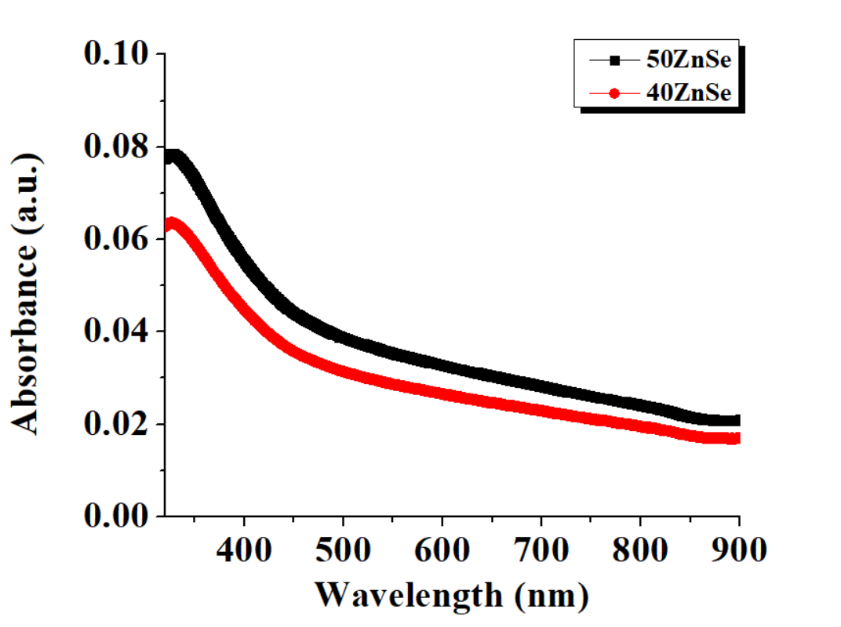**

**Figure 3.** Absorbance measurements of 40ZnSe and 50ZnSe thin films

**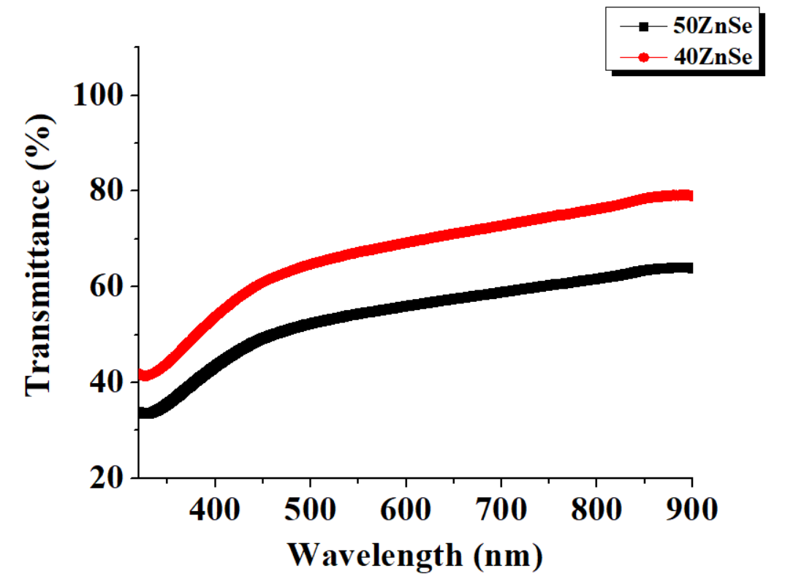**

**Figure 4.** Transmittance measurements of 40ZnSe and 50ZnSe thin films

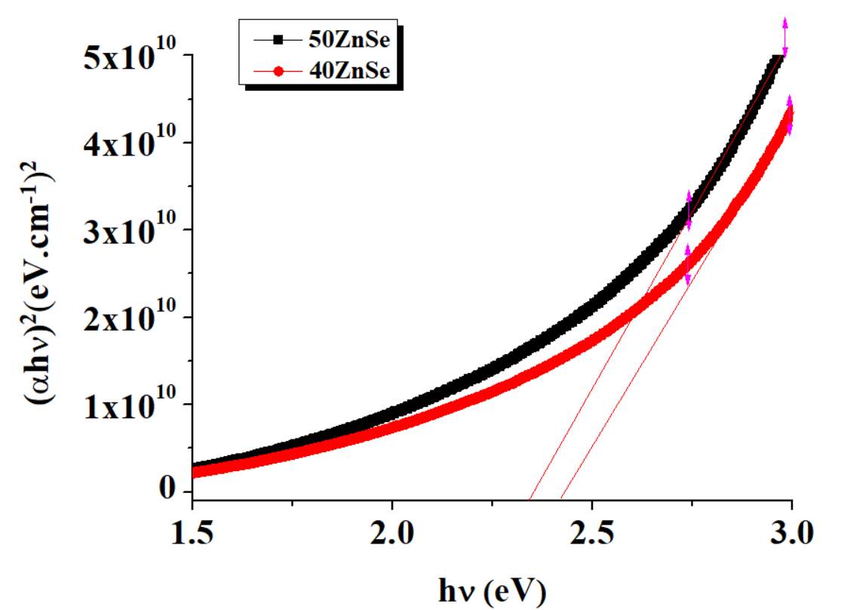

**Figure 5**. The plot of (*αhν*)2 against *hν* for 40ZnSe and 50ZnSe

Figure 6 shows the Raman spectra of ZnSe thin films. We interpret the series of up to 4 peaks (at ≈ 250, 500, 850 cm−1 ) as being due to the so-called longitudinal optical LO-phonon replicas in ZnSe, well known in polar semiconductors. As the 1LO band is the most intensive in the Raman spectrum excited by the 457.9 nm line, the energy of this line should be close to the optical band gap. The peaks at 251 cm−1 which shifted from the ZnSe peaks at (253 cm−1). Another peak observed at 550 cm−1 was closer to the peak for ZnS (546 cm−1).

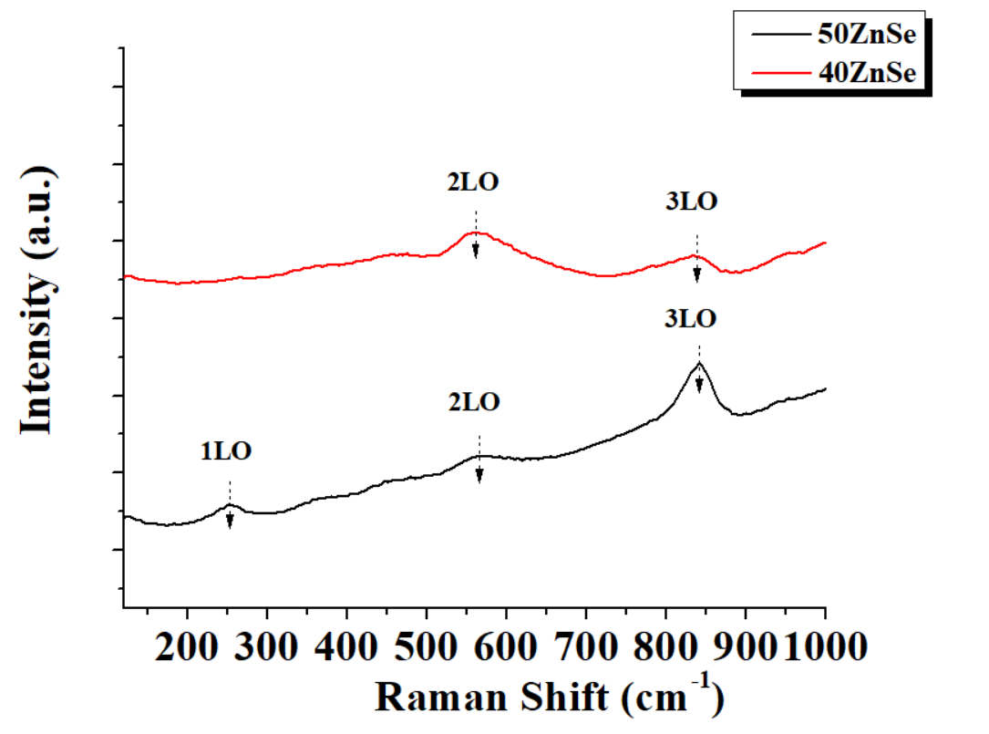

**Figure 6.** Raman spectra of 40ZnSe and 50ZnSe thin films

**4.Conclusion**

SEM research shows that ZnSe thin films have a compact, flat, and homogenous surface, yet there are some pinholes, cracks, and other flaws. Round-shaped grains are closely packed in larger irregular-shaped particles in all of the films. Aggregates scattered on the film surface have been found, which is frequent in the chemical deposition of some semiconductor films. According to the EDAX analysis, the atomic ratios of Cd and Se changed as the cycle changed. Mg, Na, Si, and Ca elements were found in the spectra, which could have come from the glass substrates. Because of the increase in the optical band gap for these materials, the absorption spectra for the Zn–Se system are blue shifted. From Raman analysis, the series of up to 4 peaks (at ≈ 250, 500, 850 cm−1 ) as being due to the so-called longitudinal optical LO-phonon replicas in ZnSe, well known in polar semiconductors.

**References**

[1] Abebe G.H., Hone, F.G., (2019). “The influence of malonic acid on the structural, morphological and optical properties of CdSe thin films prepared by chemical bath deposition method”, F Inorganic Chemistry Communications, 103, 107–112

[2] Amalraj A.S. & Senguttuvan, G., (2014). “Effect of multiple dipping of SILAR deposited ZnO thin films by physico-chemical process”, Journal of Materials Science: Materials in Electronics, 25, 2035–2040

[3] Chaudhari, K.B., Gosavi, N.M., Deshpande, N.G., Gosavi, S.R., (2016). “Chemical synthesis and characterization of CdSe thin films deposited by SILAR technique for optoelectronic applications”, Journal of Science: Advanced Materials and Devices, 1, 476-481

[4] Devadasona, S. & Muhamad, M.R., (2007). “Structural and optical properties of vapor deposited multi-layer CdSe thin films”, Physica B: Condensed Matter, 393, 125-132

[5] Karaduman Er, I., (2021). “Effect of Synthesis Parameters on the Structural, Optical and Electrical Properties of Successive Ionic Layer Adsorption and Reaction (SILAR)-Deposited CuO Thin Films”, Russ J Appl Chem 94, 1334–1343

[6] Karaduman Er, I., Yıldırım, M.A., Örkçü, H.H., Ateş, A., and Acar, S., (2021). “Structural, morphological and gas sensing properties of Zn1−xSnxO thin films by SILAR method”, Appl. Phys. A, 127, 230, 1–14

[7] Pathan, H.M., Sankapal, B.R., Desai, J.D., Lokhande C.D., (2002). “Preparation and characterization of nanocrystalline CdSe thin films deposited by SILAR method”, Materials Chemistry and Physics, 78, 11–14

[8] Rosly, H.N., Rahman, K.S., Harif, M.N., Doroody, C., Isah, M., Misran, H., Amin, N., (2020). “Annealing temperature assisted microstructural and optoelectrical properties of CdSe thin film grown by RF magnetron sputtering”, Superlattices and Microstructures, 106716

[9] Sharma, K., Saini, G.S.S., Tripathi, S.K., Siwatch, P., (2018). “A comparative study of transport properties of copper doped cadmium selenide thin films at two dopant concentrations”, J. Mater. Sci. Mater. Electron, 29, 9596–9604

[10] Yadav, A.A., Barote, M.A., Masumdar, E.U., (2010). “Studies on cadmium selenide (CdSe) thin films deposited by spray pyrolysis”, 121, 53-57

[11] Zgair, I.A., Omran Alkhayatt, A.H., Muhmood, A.A., and Hussain, S. K., (2019). “Investigation of structure, optical and photoluminescence characteristics of Li doped CuO nanostructure thin films synthesized by SILAR method”, Optik, 191, 48–54