**VISIBILITY OF ARTIFICIAL INTELLIGENCE APPLICATIONS IN DIGITAL MARKETING ON WOS**

Esma Ebru ŞENTÜRK[1]

Cihat KARTAL[2]

Rabia Vildan İŞCAN[3]

**ABSTRACT**

Until recently, it was a matter of preference for businesses to benefit from digital marketing strategies while maintaining marketing practices. Due to factors such as pandemics, wars, and economic crises experienced in the past decade, coupled with technological developments that are progressing by leaps and bounds, it has become mandatory for businesses to use digital marketing strategies today. For this reason, many businesses small-to-big have understood the necessity of existing both physically and digitally. Digital marketing facilitates the process for businesses to interact and communicate with customer more intimately and faster. In addition, the ability of consumers to access unlimited information about products and services in the digital environment; the ability to compare products, prices, brands, and consumer experiences within seconds also provides various advantages for the consumer. However, situations that are an advantage for customers are sometimes disadvantageous from the point of view of businesses. This situation has made it difficult to retain the consumer. This difficulty is being overcome through artificial intelligence applications from the point of view of many businesses. Artificial intelligence assistants, which can quickly learn consumer preferences and evaluate these preferences, provide a great advantage in directing customer preferences to match customer preferences by analyzing their past experiences and profiles. While the industry is trying to take advantage of the advantages of artificial intelligence, researchers are also conducting research and experiments in many areas, including marketing related to artificial intelligence, all over the world. While academic studies are being carried out by researchers, artificial intelligence is also developing every day and it is difficult to keep up with the pace of development. For this reason, determining the axis on which academic studies related to artificial intelligence are conducted and what the main theme is important for researchers to identify shortcomings and direct their studies. In this direction, the published studies related to artificial intelligence in the December 2022 – 2023 date range were scanned on the Web of Science, where scientific studies in the academic field are included and their visibility is ensured on the world. The ones of these studies that have artificial intelligence, AI, ChatGPT, and marketing keywords have been quantitatively examined in various fields such as publication year, publication type, origin, and author keywords. As a result of the examination, it was observed that although artificial intelligence is a very current topic for all fields, there are very few publications on artificial intelligence and digital marketing in the field of marketing.

**Keywords:** Artificial Intelligence /AI, Marketing, Digital Marketing, WOS.

**INTRODUCTION**

Today, customer data obtained from channels such as the Internet and social media is very valuable for marketing professionals. But finding and managing your way in very large datasets is quite complicated. This data, which is quite difficult to collect and process manually, can be collected very quickly and analytically by artificial intelligence. Artificial intelligence (AI) can analyze customer behavior and unlock the best within larger datasets. Through AI and machine learning, business owners and marketers can be aware of the latest trends and changes in customer behavior. This helps to create smarter and more effective marketing strategies. For example, AI technology can use algorithms to detect customer preferences and even customer feelings and can help send more personalized marketing messages to the customer. This also increases customer loyalty and customer satisfaction by creating customer value.

AI also plays a major role in customer service. Thanks to AI technologies, ChatGPT, chatbots, or other virtual assistants can receive basic customer requests and respond quickly. The execution of the most basic tasks by AI relieves customer service departments and becomes a tool to deliver a better customer experience. AI can also be used to increase advertising efficiency. Through detailed data analysis, the most appropriate target audience for advertising campaigns can be identified and advertisements can be made more effective.

As a result, AI technology offers a great opportunity for marketing professionals. With AI, it can create more effective marketing strategies, make customer service departments more efficient, and ensure advertising campaigns are more successful. Therefore, using AI as an effective tool for marketing can bring great benefits to. The innovations brought by the Internet and information technologies and the increasing number of online customers have made digital marketing mandatory as it is known. Digital channel is a very dynamic measure and brands should develop an interactive and effective communication process with consumers. Consumers are sensitive beings. They want to be appreciated, taken seriously, and answer every question of them. AI can communicate with consumers faster and more analytically today. This has even made AI an inevitable game-builder in digital marketing strategies.

Even though not all have adapted to AI applications today, industry leaders and innovative leaders have already begun to use artificial intelligence in their digital marketing strategies. Whether it’s the industry’s major acceptance or not, its academic work has also led to work to identify the theoretical foundations and shortcomings of the relationship between artificial intelligence and digital marketing. To this end, this research is intended to be defined by studying the worldwide visibility of the scientific research carried out by marketing researchers in the field of digital marketing and artificial intelligence within the academic framework. WOS is prestigious in this regard and its scope is an acknowledged database worldwide. This is why the Web of Science (WOS) database has been reviewed.

**1. Conceptual Framework**

**1.1. Digital Marketing**

The rapid adoption of advanced technologies over the last decade has made consumers who want to get everything instantly, effortlessly, and at the lowest cost quite impatient. As a driving result, almost every business has had to go through the digitization phase to be more productive, automated and evol,ve (Joshi, 2021). This new phase has unveiled the concept of digital marketing that we face every moment today but first began to be used in literature in the 90s. According to Birzu (2023), digital marketing is a model of advertising delivered through e-mail, blogs, websites, search engines, etc. digital channels. The American Marketing Association (AMA) defines digital marketing as a dynamic and two-way process that requires interactive communication with the consumer as opposed to traditional methods. In short, digital marketing is any type of online marketing effort carried out by companies through electronic devices that can connect to the Internet to their marketing goals.

With the explosion of digital technology, including the widespread use of computers and smartphones, along with the increase in the number of Internet users, have begun to try out new marketing tactics, which are the origin of digital marketing (AMA, n.d.). As a result of the introduction of Google in 1988, consumers were able to find information about the products and services they were interested in in the digital environment, resulting in a change in their purchasing behavior (Bîrzu, 2023:75). While consumers can search for products and services from their websites, businesses have begun to track and understand their visitors’ behavior using both general traditional methods and online methods using Google AdSense. The use of digital marketing strategies along with traditional marketing strategies has brought the concept of multi-dimensional (interactive) marketing to the fore.

Since its first introduction in the 1990s, digital marketing has become today with the accumulation of various innovations and processes. As shown in Table 1, after the first use of the concept of digital marketing in the 1990s, the first search engine Archie was launched. In 1994, the first online advertising banners were created and the first e-commerce process took place. Between 1994-1998, Amazon, Yahoo, Microsoft, and Google emerged, which we all know today. In 1997, the social media site Sixdegrees.com, leaving its place today to young competitors such as Instagram, Facebook, and TikTok, opened. Universal music, Linked In, Word Press, Gmail, Facebook, Youtube, and Twitter were released between 2000 and 2010. The I-phone, which has created high-price competition with the value of the brand it has created today, has also been launched in the years (Bose, 2020; Goel, 2022).

**Table 1: The Brief History Of Digital Marketing**

|  |  |  |  |  |  |
| --- | --- | --- | --- | --- | --- |
| **Date** | **Event** | **Date** | **Event** | **Date** | **Event** |
| 1990 | The term digital marketing was used for the first time. | 2001 | Universal Music mobile marketing | 2010 | Instagram is on the market. |
| 1990 | Archie; the first search engine launched | 2003 | Linked-In and Word Press released | 2011 | Internet usage has surpassed television usage among young people |
| 1994 | First clickable web ad banner | 2004 | Gmail has started | 2011 | Snapchat introduced to the market |
| 1994 | The first e-commerce event has taken place | 2004 | Facebook is in the market | 2013 | Social media advertising budgets increase |
| 1994 | Amazon is on the market | 2005 | YouTube is launched | 2013 | Amazon is the leader in e-commerce |
| 1995 | Yahoo launched | 2006 | Twitter is launched | 2014 | Facebook Messenger introduced |
| 1997 | The first social media site opened | 2007 | iPhone launched on the market | 2014 | Mobile traffic exceeds desktop traffic |
| 1998 | Meeting with Google | 2009 | Google's real-time search engine results launched | 2015 | Marketing has gained importance |
| 1998 | Microsoft launches its search engine | 2009 | WhatsApp is launched | 2019 | 91% of Facebook advertising revenue comes from mobile advertising |

**Source:** Merged from Bose (2020) and Goel (2022).

While have preferred to use digital marketing strategies over the past decade, the covid-19 pandemic, which has affected and restricted the entire world, followed by wars and physical communication with consumer disruption, has made it compulsory for to be a digital marketplace and use Digital Marketing strategies. Even small entrepreneurs who are unable to withstand economic pressures have left physical stores and traditional marketing strategies and have only started to exist in the digital marketplace. As can be seen in Figure 1, there are many different digital marketing strategies and tools that can be used at the end of digital marketing. (Shah, 2020).

**Figure 1: Series of Digital Solutions**

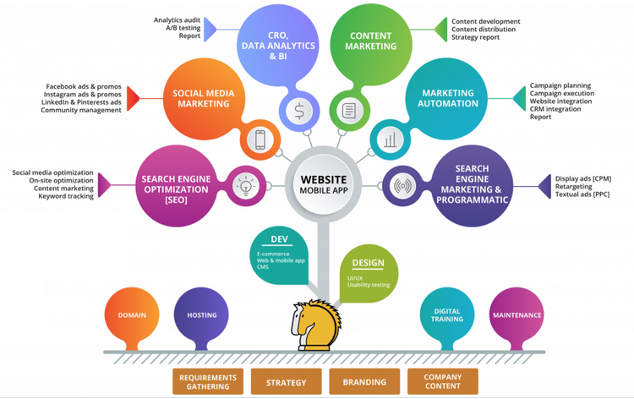

Source: <https://2stallions.com/blog/introduction-to-digitalmarketing/>

Today, when digital marketing is inevitable, technology has created a new helper for AI. While discussions on the use of AI in marketing are ongoing, it is predicted that digital intelligence-based marketing will continue to exist as long as the online population increases (Ryan & Jones, 2014:2).

**1.2. AI and Marketing**

Traditional digital marketing is time-consuming and expensive as it involves a significant amount of resources (money and human) based on manual processes, pre-defined performance criteria, and can beined. This is where AI is used (Yaiprasert & Hidayanto, 2023:4). AI can search the web in milliseconds, and access user profiles and preferences. It can analyze the data it obtains without the need for another assistant and can respond to the customer's request much faster than manual applications. Therefore, AI has been used in digital marketing applications. AI-based digital marketing is an automated process that uses algorithms to create targeted ads, tailor campaigns to demographic variables, and track process errors. The fact that these practices can be done by separating fewer people and financial resources helps marketers save time and money while facilitating and enhancing their communication and interaction with their target audiences (Yaiprasert & Hidayanto, 2023:4).

Big businesses, such as Red Balloon and Harley Davidson, can be given as an example that uses AI in digital marketing. These businesses with high brand awareness use AI to automate advertising campaigns as part of their digital marketing strategies. But since the process of using AI in digital marketing has only just begun, it is a fact that conceptualizing, theorizing, and exploring its details is still at the very beginning of the process (Esch & Black, 2021:1). These shortcomings, combined with the lack of knowledge in the field from the point of view of marketers, can be said to have to struggle a lot to take advantage of the opportunities offered by the marketing of AI technology (Broardhurst, 2022:122).

The most well-known examples of AI applications used in marketing are chatbots. Chatbots help to automate the various stages of the marketing process in terms of responding to FAQs, recording customer contact information, and solving key problems that you may often encounter. In addition, chatbots can interact with customers without any source support. They can present the brand they represent at a good level and ensure that consumers communicate with the business or the brand. This makes it easier for the marketing team to focus more on critical and strategic issues. In addition, chatbots that quickly return to the consumer can also increase the volume of their marketing conversations thanks to this feature. (Nail & Gupta, 2020:324).

ChatGPT, which can be defined as an AI chatbot, is an advanced state of chatbots. (www.mynet.com, 2022). Launched as a prototype on November 30, 2022, ChatGPT showed everyone how much space and ease AI can be used, not just for marketers. ChatGPT, which uses deep learning, has even reached its best in a period of 4-5 months from the day it was launched. ChatGPT is versatile in terms of marketing, such as text writing, video creation from text, content creation for blogs, and time-space operations that can be done on their own in a short time. In March 2023, the Kit Kat brand launched advertising films that are fully supported by AI (Uyan, 2023). However, the prevailing sentiment was that these advertisements were far from human intelligence and aesthetic point of view.

AI, which is capable of learning itself, has now evolved to a level where it can almost understand human emotions as well. Therefore, taking advantage of chatbots that can understand customer emotions can raise the perceived customer experience to a significant level and increase the awareness and attractiveness of the business/brand (Joshi, 2021). As a result, the use of AI-based digital marketing strategies (Strauss, 2023):

* For marketing experts; This means saving a lot of time they would have to spend on manual data analysis and developing targeted campaigns.
* For consumers; increases the likelihood of encountering content they will enjoy. This can either excite them or, on the contrary, frighten them.

**1.3. Web of Science (WOS)**

The Web of Science Core Collection database is the oldest citation index for sciences, which has survived from the early 1900s to the present day (Birkle at al., 2020:363), covering many subject areas, including natural sciences, social sciences, arts and humanities, and health sciences (Dölek, 2015). Science Citation Index Expanded, Social Sciences Citation Index, Arts & Humanities Citation Index, Conference Proceedings Citation Index-Science, Conference Proceedings Citation Index-Social Science & Humanities, Book Citation Index–Science, Book Citation Index-Science (Dölek, 2015), in the database in which approximately 34,000 journals are scanned around the world – more than 75 million scientific records (Birkle at al., 2020) (editorial notes, articles, books, book chapter, conference paper, etc.).

In addition to cataloging academic publications, WOS is a structured, balanced (Birkle at al., 2020:364), expert, objective (Clarivate Analytics, 2016), and quite prestigious database with reference links between publications and advanced metadata that support a wide range of information purposes (Birkle at al., 2020:364). Thanks to this feature, researchers can access all related records using the work, references, and subject relationships of expert researchers who produce publications worldwide in the field they work with (Clarivate, n.d.). In summary, The WOS database is a wide platform where researchers can follow developments in their fields, publish their innovative ideas, and ensure their visibility in the world academic community.

**1.4. Development of Marketing Studies in WOS**

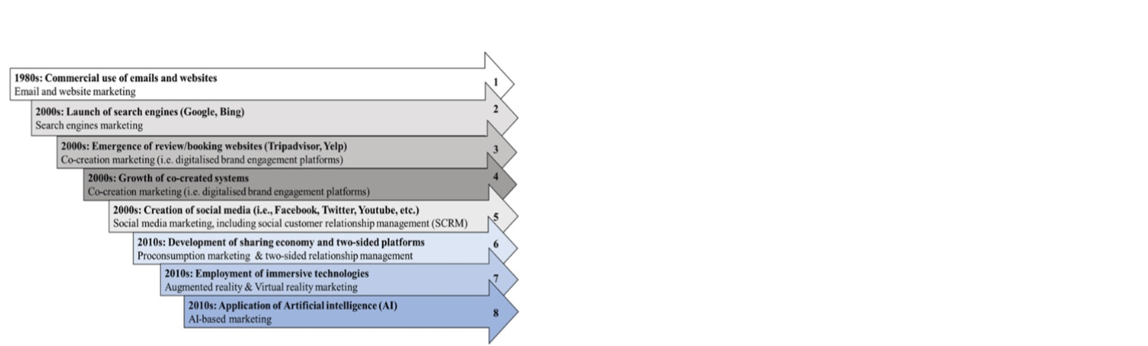With the development of computer use and the internet, digital marketing applications have developed exponentially and the existence of deficiencies and unknowns in the application have also directed the direction of academic studies to consumer behavior in the digital environment. Figure 2 shows the development of academic studies on digital marketing.

**Figure 2: Major Research Flows in Digital Marketing Over Time**

**Source:** Le, 2021:3

The 1980s was the era of email marketing when web pages began to flourish commercially. In this period, researchers such as Attaran (1999), Howes and Mailloux (1999), Oikle (1997), and Scarbrough (1996); Studies such as what are the ethical rules to be considered in e-mail marketing, how to market using e-mail, how to increase the customer population stand out. The 2000s were the years in which, search engines, electronic word of mouth, user content, shared value creation, and social media academic studies were on the subject in many studies such as Deighton and Kornfeld (2009), Dou and Chou (2002), Maltz and Chiappetta (2002) and Rowley (2008). The 2010s were the period also when, search engines, electronic word of mouth, user content, shared value creation, and social media academic studies were in force in many studies such as Damirkhanpour and Vrontis (2017), Sokolova and Titova (2019), Musova and Poliacikova (2018), Ryu (2015), Tchelidze (2019) ve Wirth (2018).

**2. Research Study**

**2.1. Methodology**

A general screening model was used in this study. The purpose of this research is to describe the scientific research carried out by marketing researchers in the fields of digital marketing and artificial intelligence by examining the visibility of the world in the academic community. For this purpose, the studies in the WOS database were examined. The research was limited to the digital marketing studies, published between 01.01.2020-31.03.2023, identified with artificial intelligence, AI, ChatGPT, and marketing author keywords and categorized in the Business category of WOS.

**2.2. Research Steps and Findings**

**2.2.1. Initial Search**

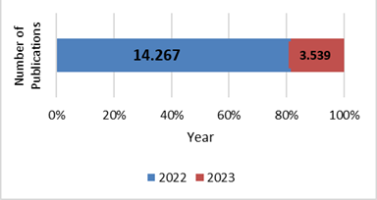First, all the articles published between January 1, 2022, and March 31, 2023, containing the keywords “artificial intelligence” or “AI” were scanned. There are 17,806 results from the Web of Science Core Collection. These studies are classified according to the year of publication, type of document, the field of research, and country in which they were published (not the origin of the works, but the source of their publication).

**Figure 3: Documents Refine By Years**

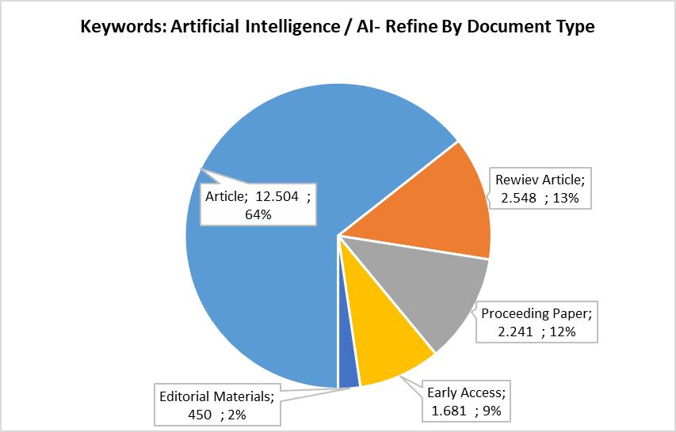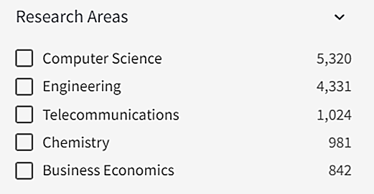There are 14,267 studies in 2022, and 3,539 studies defined by AI author keywords at the end of the first quarter of 2023 (Figure 4). When viewed proportionally, the number of studies published in the first quarter of 2023 is in parallel with the number of publications in the quarter of 2022. It can be said that there has not been an increase in the number of publications as expected.

**Figure 5: Documents Refine By Research Areas**

**Figure 4: Documents Refine By Type**

Studies of related keywords are grouped under five document types (Figure 5): article, review article, proceeding paper, early access, and editorial materials. It is seen that 70% of the results are articles. It is seen that studies with artificial intelligence keywords are mostly published in the field of computer science (29.88%), then in the field of engineering (24.32%), followed by Telecommunications (5.75%) and Chemistry (5.51%). On the other hand, business economics ranks fifth with a rate of 4.73%. Considering the research areas, it can be said that application-oriented researches are still intense, but there are few sufficient studies on how to find a place for itself in business practices.

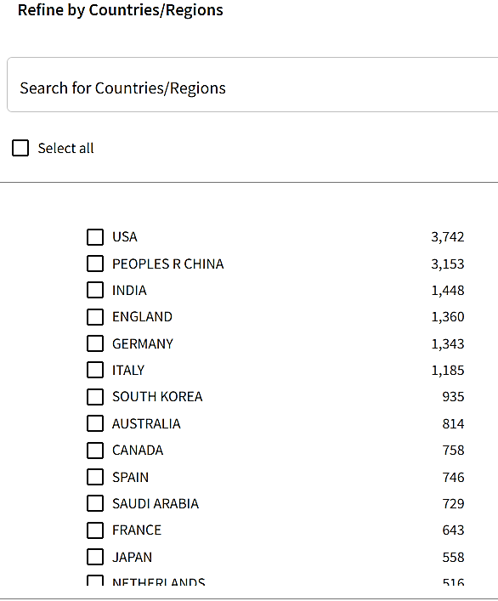**Figure 6: Documents Refine By Countries**

WOS refines studies based on their published origin. As a result of the query, It is seen that 21% of the studies were from the USA, 17.8% from Peoples R China, and 8% of them from India. The first three are followed by publications originating from England (7.64%) and Germany (7.54%). Publications originating in Türkiye, on the other hand, correspond to the 1.61% slice and are in the 23rd place in the country ranking.

**2.2.2. Second Search**

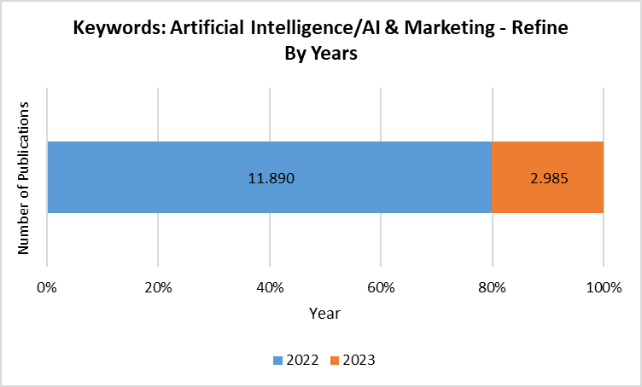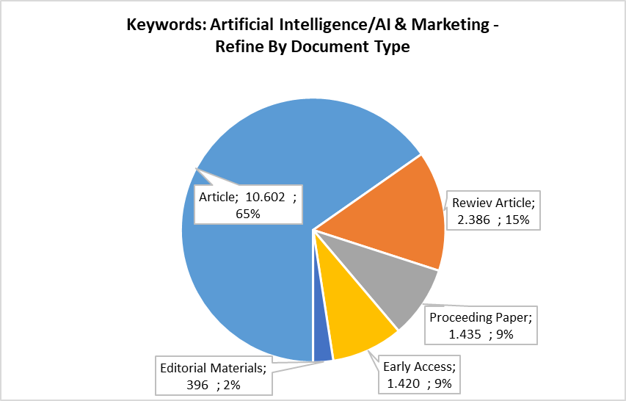In the second stage, the search was limited to publications using artificial intelligence/AI and marketing author keywords together. 14,875 results scanned in the Web of Science database were obtained. Again, these studies were refined on the basis of publication year, document type, research area, and country of publication.

**Figure 7: Documents Refine By Type**

**Figure 8: Documents Refine By Years**

There are 11,890 studies in 2022 and 2,985 studies at the end of the first quarter of 2023, defined by the keywords of artificial intelligence and marketing author (Figure 8). When viewed proportionally, the number of studies published in the first quarter of 2023, similar to the studies published with the AI keyword, is parallel to the number of publications made in the quarter of 2022. It is seen that 71% of these published studies are articles (Figure 7).

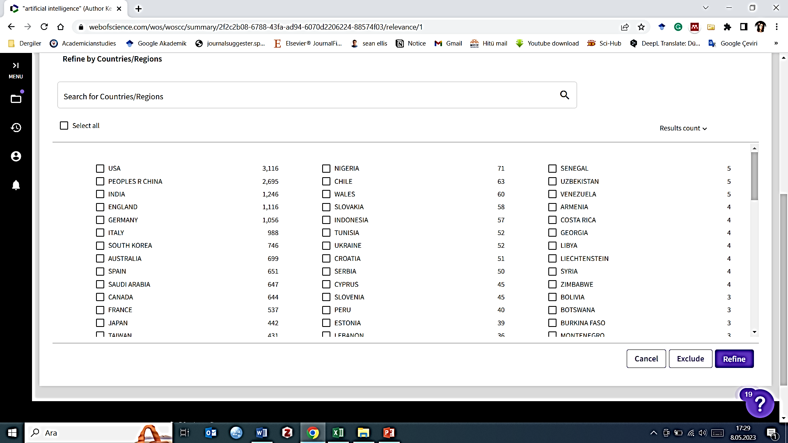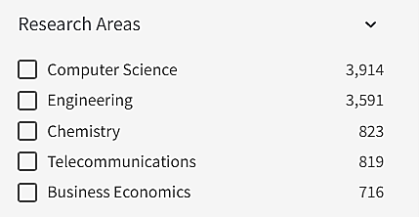Similarly, studies with AI and marketing keywords (Figure 10) are mostly in computer science (26.31%), followed by engineering (24.14%), Chemistry (5.53%) and Telecommunications (5%, 51) have been published in the fields. On the other hand, business economics ranks fifth with a rate of 4.81%. The first two places seem preserved in AI and marketing-oriented studies, but chemistry takes the third place from communication. Although business economics has increased the percentile, it still does not appear in sufficient numbers in studies. As a result of the query made on a country basis, it is seen that the studies are ranked as USA, China, India, England, and Germany, respectively. Publications originating in Türkiye, on the other hand, correspond to the 1.75% slice and continue to rank 23rd in the country ranking (Figure 9).

**Figure 9: Documents Refine By Country**

**Figure 10: Documents Refine By Research Areas**

**2.2.3. Third Search**

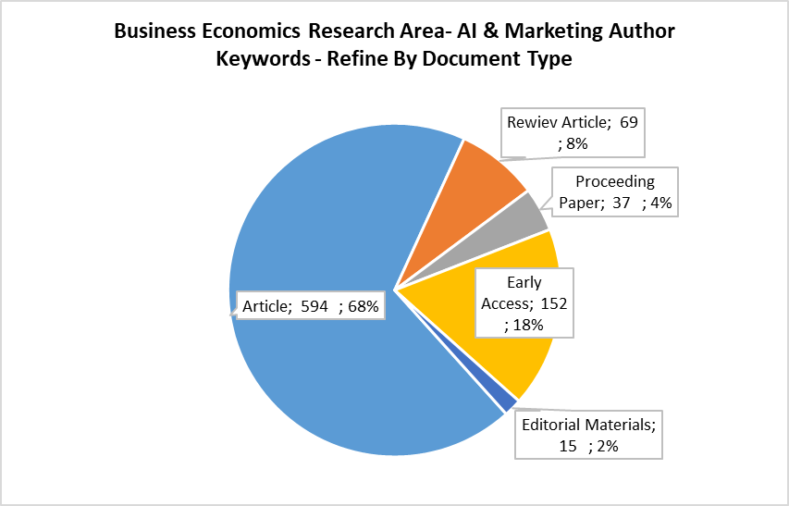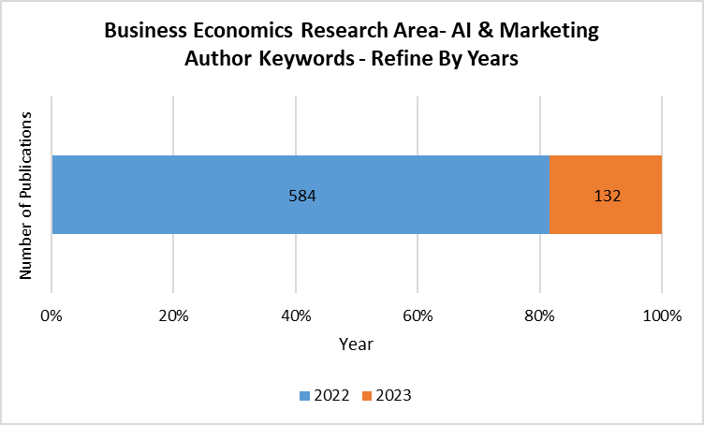In the third stage, publications using AI and marketing author keywords are limited to those published in the research area of business economics of WOS. It was concluded that only 716 of the 14,875 publications scanned under the Web of Science Core Collection were scanned in this study area. Again, these studies are refined by publication year, document type, research area, and country of publication.

**Figure 12: Documents Refine By Type**

**Figure 11: Documents Refine By Years**

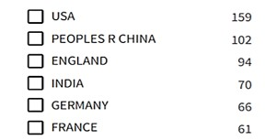There are 584 studies in 2022 and 132 at the end of the first quarter of 2023, published under the business research area defined by AI and marketing author keywords (Figure 11). It is seen that 82% of these published studies are articles. When viewed proportionally, the number of studies published in the first quarter of 2023, like the previous surveys, is approximately parallel to the number of publications made in the quarter of 2022. However, it was expected that the studies on the theoretical and conceptual parts of artificial intelligence, which found a great place in practice, would increase with rising momentum. In addition, unlike previous scans, it is striking that the number of early access has increased proportionally. This means that the number of publications in 2023 is even less than in previous surveys (Figure 12).

**Figure 13: Documents Refine By Country**

As a result of the country-based query, it is seen that most publications in the field of business economics are from the USA (22.21%) and Peoples R China (14.25%). England (13.13%) ranks third, while India (9.78%) and Germany (9.22) rank fourth and fifth. Publications originating in Türkiye, on the other hand, correspond to the 2% slice and rise to 19th place in the country ranking (Figure 13).

**2.2.4. Forth Search**

In the fourth stage, studies that were limited to the business economics research area were also limited to those in the WOS business category. A total of 322 results were achieved, 257 of which were published in 2022 and 65 of which were published in 2023. Again, 81% of these results consist of articles (Figure 15). When the distribution of publications based on countries is examined, it is seen that the first three do not change at all. Turkey, on the other hand, has only 2 publications (0.62%) in the WOS business category and ranks 51st among the countries publishing in the field.

**Figure 14: Documents Refine By Type**

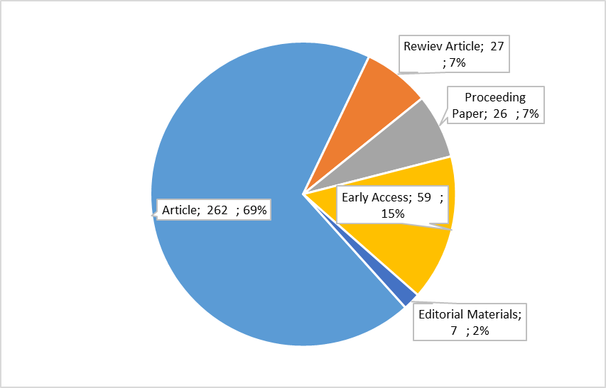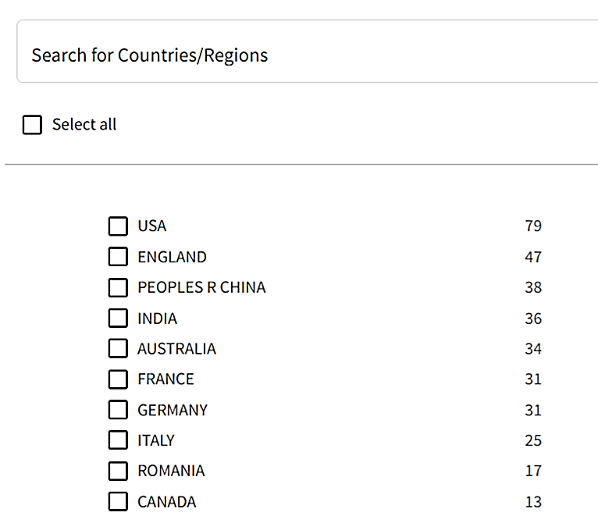**Figure 15:** **Documents - Refine By Country**

**2.2.5. Fifth Search**

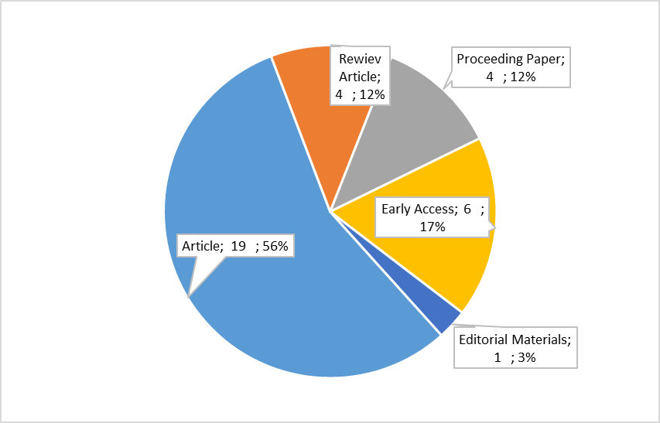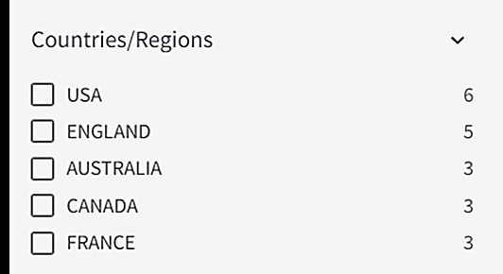The studies in which the words "digital marketing" were used in any field were scanned in the publications that were defined with AI and marketing keywords, in the business economics research arae category and in the WOS business category. As a result of the limitations, a total of 28 studies, 23 of which were published in 2022 and 5 of which were published in the first quarter of 2023, could be reached.

**Figure 17: Digital Marketing Refine By Country**

**Figure 16: Digital Marketing Refine By Doc. Type**

**2.2.6. Sixth Search**

Finally, publications containing the ChatGPT author keyword were scanned. Only one study was found in the field of marketing. Thus, a total of 29 digital marketing studies containing AI and marketing keywords were obtained. These studies were classified in terms of author keywords used by their authors to describe the study.

**Table 2: First 50 Author Keywords**

It has been determined that 141 different keywords are used in 29 different studies. Among these keywords, the most repeated (24 times) artificial intelligence/AI words. As can be seen in Table 2, while AI creates the common definition, other keywords show that it focuses on specific topics such as anthropomorphism, social media marketing, customer, digital customer, digital marketing, data, competition, and digital technologies. In the relationship between artificial intelligence and digital marketing, researchers work multi-dimensionally, but the inadequacy of the number of studies is one of the inferences that can be made from keywords.

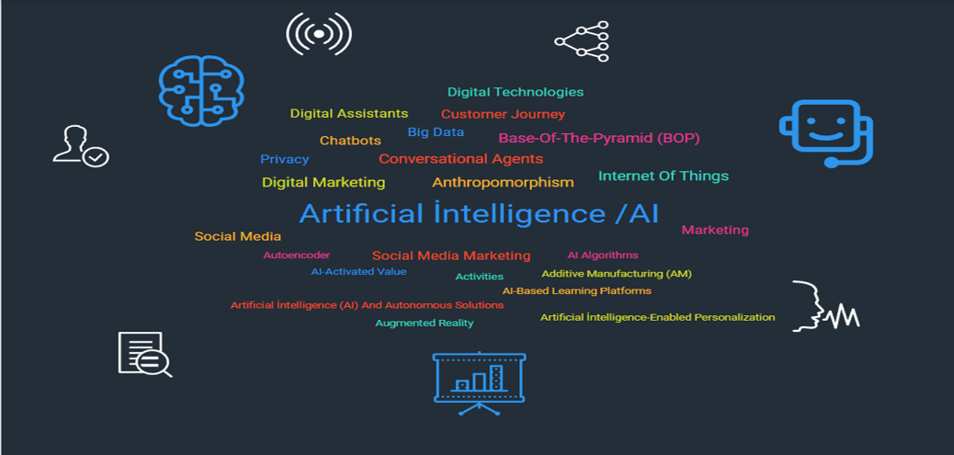**Figure 18: AI & Marketing Author Keywords Top 25**

**CONCLUSION**

As a result of efforts towards digitalization, businesses have evolved their marketing activities from traditional to virtual. Literature studies in the field have focused on researching the effects of digital activities on businesses, from e-mail marketing to artificial intelligence applications, to overcome digital marketing in this context. The common deduction of a significant portion of the current research reveals that businesses that adopt digital marketing can perform much better. In the studies carried out to date; consumer awareness of digital marketing, consumer expectations, and satisfaction depending on various factors, digital consumption experience and re-purchase relationship, cooperation systems, types of digitalization and its effects on digital marketing activities and digital strategies, digital change and accordingly legal/political/social Issues such as its effects have been examined on quite different platforms, especially on technical infrastructure.

Between January 2022 and March 2023, 17,806 studies were found in the academic search on WOS on digital marketing and artificial intelligence in the business category. In 2022, it was seen that academic studies on the relationship with many concepts in the field of artificial intelligence were carried out, but contrary to expectations, it continued in the same parallelism in 2023 proportionally. Approximately 95% of these studies are related to technical application areas such as computers, engineering, and communication. The fact that there is not enough work in the field of social sciences shows that the social effects of artificial intelligence need to be investigated. In the country of origin ranking, Türkiye took 23rd place with the studies carried out in the field of social sciences. In the second search made with artificial intelligence and marketing keywords, 14,875 works, mostly articles, were reached. Although the general distribution of the studies is in parallel with the first survey, it has been determined that the number of studies in the field of chemistry has increased. In the third search, only 716 studies in the field of business economics were identified, but due to the increasing importance in 2023, much more publications were expected, and results were obtained in parallel with 2022. However, the proportional increase in the number of early access in this period draws attention. Türkiye was ranked 19th in origin publications. In the fourth survey, the field of the business economy was limited to the business category, and a total of 322 studies were reached. Türkiye has two publications in this category. In the fifth scan, "Digital Marketing" was used as a keyword in any field and a total of 28 studies were reached. In the sixth and final search, only one work was found in the marketing field containing the ChatGPT keyword.

29 different studies using 141 keywords show that academics work multi-dimensionally in terms of digital marketing and AI, although it is seen that they focus on specific studies in certain fields, these fields are far from meeting the requirements of the free market yet. In particular, the experiences on the free market reveal the expectations for the development of models for consumer personalized and localized decision-making, the establishment of the relationship between AI and robotics/automation technologies, and the development of virtual experience and the execution of routine activities by AI. For this reason, it is thought that future studies on AI and digital marketing will gain momentum toward the development of the social dimension rather than the technical dimension.

**KAYNAKÇA**

American Marketing Association. (n.d.). What is digital marketing?. Retrieved May 16, 2023 From <https://www.ama.org/what-is-digital-marketing/>.

Bîrzu, S. (2023). Tracing The Evolution Of Digital Marketing From The 1980s, Review of Management and Economic Engineering, 22(1), 73-77.

Bose, C. (2020, January 24). Brief history of digital marketing (1990-2020). Retrieved May 18, 2023, From <https://webcentral.au/blog/brief-history-of-digital-marketing-1990-2020/>.

Broardhurst, M. (2022). How Businesses of Any Size Can Use AI in a Digital Marketing Strategy, Applied Marketing Analytics, 8(2), 122 – 132. <https://d74ec2d6f7db4603480eca467de32d3f06478210.vetisonline.com/record/display.uri?eid=2-s2.0-85143616387&origin=inward&txGid=991b16a67fcd73ba6b44749eab80860d>.

Clarivate. (n.d.). Streamline your research. [www.clarivate.com](http://www.clarivate.com). Retrieved May 19, 2023, From: <https://clarivate.com/products/scientific-and-academic-research/research-discovery-and-workflow-solutions/webofscience-platform/>.

Clarivate Analytics. (2016, January 3). Acquisition of the Thomson Reuters Intellectual Property and Science Business by Onex and Baring Asia Completed. Retrieved May 19, 2023,Ffrom: <https://www.prnewswire.com/news-releases/acquisition-of-the-thomson-reuters-intellectual-property-and-science-business-by-onex-and-baring-asia-completed-300337402.html>.

Deighton, J., & Kornfeld, L. (2009). Interactivity's unanticipated consequences for marketers and marketing. Journal of Interactive marketing, 23(1), 4-10.

Dou, W., & Chou, D. C. (2002). A structural analysis of business-to-business digital markets. Industrial marketing management, 31(2), 165-176.

Dölek, A.N. (2015, October 09). Web of Science nedir? Retrieved May 18, 2023, From: <https://portal.dpu.edu.tr/aysenur.dolek/makale_oku/72/web-of-science-nedir>.

Esch, P. V. & Black, J. S. (2021). Artificial Intelligence (AI): Revolutionizing Digital Marketing, Australasian Marketing Journal, 29(3), <https://doi.org/10.1177/18393349211037684>.

Goel, N. (2022). A Brief Overview of Digital Marketing, International Journal of Recent Advancesin Multidisciplinary Topics, 3(7), 10-12, <https://journal.ijramt.com/index.php/ijramt/article/view/2247/2184>.

Howes, C., & Mailloux, M. (1999). Using e-mail web based technology to survey your current student population. In American Marketing Association. LA: Symposium for the Marketing of Higher Education. New Orleans.

Joshi, N. (2021). 3 Technologies Every Digital Marketer Should Use. Retrieved May 18, 2023 From <https://www.bbntimes.com/technology/3-technologies-every-digital-marketer-should-use>,

Le, D., Nguyen, T. M., Quach, S., Thaichon, P. & Ratten, V. (2021). The Development and Current Trends of Digital Marketing and Relationship Marketing Research (Chapter-1), 1-18, Developing Digital Marketing: Relationship Perspectives, Ed. By: Thaichon and Ratten, Emerald Publishing, 1.st ed., U.K.

Maltz, E. And Chiappetta, V. (2002). Maximazing value in the digital world. MIT Sloan Management Review, 43(3), 77.

Musova, Z., & Poliacikova, E. (2018). Consumers Perception of Digital Marketing Tools. In Proceedings of the 15th Annual International Scientific Conference on Marketing Identity-Digital Mirrors .

Nair, K. & Gupta, R. (2020). Application of AI Technology in Modern Digital Marketing Environment, *World* Journal of Entrepreneurship, Management and Sustainable Development, 17(3), 318-328. <https://doi.org/10.1108/WJEMSD-08-2020-0099>.

Oikle, J. (1997). The power of e-mail marketing. Intrepid Net Marketing.

Rowley, J. (2008). Understanding digital content marketing. *Journal of marketing management*, *24*(5-6), 517-540.

Ryan D. & Jones C. (2014). The Best Digital Marketing Campaigns in The World II, 2.ed.,USA, Kogan Page Ltd.

Ryu, J. S. (2015, July). Digital Marketing of Cotton to Generation Y College Students. In *KODISA ICBE, International Conference on Business and Economics*.

Shah, R. (2020). Introduction to Digital Marketing: Understanding & Mastering the Digital Marketing Basics. Retrieved May 17, 2023 From <https://2stallions.com/blog/introduction-to-digitalmarketing/>.

Sokolova, N. G., & Titova, O. V. (2019, May). Digital marketing as a type: concept, tools and effects. In 1st International Scientific Conference" Modern Management Trends and the Digital Economy: from Regional Development to Global Economic Growth".

Strauss, L. (2023). What is AI marketing—and how can you leverage it? Retrieved May 17, 2023 From <https://zapier.com/blog/ai-marketing/>.

Tchelidze, L. (2019). Potential and skill requirements of artificial intelligence in digital marketing. *Calitatea*, *20*(S3), 73-78.

Uyan, G. (April 17, 2023). KitKat'tan Yapay Zekâ Modelleriyle Dalga Geçen Reklam Kampanyası [Video]. Retrieved May 19, 2023 From: <https://www.webtekno.com/kitkat-yapay-zeka-reklam-video-h133843.html>.

Wirth, N. (2018). Hello marketing, what can artificial intelligence help you with?. *International Journal of Market Research*, *60*(5), 435-438.

[www.mynet.com](http://www.mynet.com). (2022, December 12). ChatGPT kimin, OpenAI'yi kim kurdu? OpenAI ChatGPT yapay zekâ botu kim tarafından geliştirildi, sahibi kim? Retrieved May 19, 2023 From https:// <https://www.mynet.com/chatgpt-kimin-openai-chatgpt-yapay-zeka-botu-kim-tarafindan-gelistirildi-sahibi-kim-110107078684>.

Yaiprasert, C. & Hidayanto, A. N. (2023). AI-Driven Ensemble Three Machine Learning to Enhance Digital Marketing Strategies in the Food Delivery Business, Intelligent Systems with Applications, <https://doi.org/10.1016/j.iswa.2023.200235>.

1. Lecturer, Dr., Hitit University, ebrucesurr@gmail.com, 0000-0002-4528-1518
2. Assoc. Prof., Kırıkkale University, [dr_cihat_kartal@yahoo.com](mailto:dr_cihat_kartal@yahoo.com), 0000-0003-2390-8268
3. Lecturer, Kırıkkale University, [vildanakdemirr@gmail.com](mailto:vildanakdemirr@gmail.com), 0000-0003-0011-6479