**THE INFLUENCE OF PRESSURE ON THE STRUCTURAL AND ELASTIC PROPERTIES OF THE CuY INTERMETALLIC COMPOUND**

***İlknur KARS DURUKAN1,[[1]](#footnote-1)\*[C:\Users\Abdullah\AppData\Local\Microsoft\Windows\INetCache\Content.Word\ORCID-iD_icon-16x16.gif](https://orcid.org/0000-0001-5697-0530), Yasemin ÖZTEKİN ÇİFTÇİ1[C:\Users\Abdullah\AppData\Local\Microsoft\Windows\INetCache\Content.Word\ORCID-iD_icon-16x16.gif](https://orcid.org/0000-0003-1796-0270)***

*1Science Faculty, Physics Department, Gazi University, Ankara, Turkey*

|  |
| --- |
| **Abstract**  Intermetallic compounds incorporating rare earth elements exhibit compelling physical and mechanical characteristics that typically surpass those of conventional metals. These properties encompass heightened strength and hardness, reduced specific gravity, enhanced corrosion resistance, and superior hot strength. Our investigation delved into the theoretical analysis of the intermetallic compound CuY. This study is purely theoretical, devoid of any reliance on experimental parameters. The compound adopts a cubic CsCl structure. We examined the impact of pressure on both the structural and electronic properties of the compound, employing the first principles method within the framework of Density Functional Theory (DFT). Given its significance as a crucial parameter, investigating materials under pressure holds merit. Exploring the deformation behavior of compounds subjected to compression is valuable, as it provides insights into alterations in their physical and chemical properties. Such research is indispensable for a comprehensive understanding of the nature of solids. The CuY compound satisfied the Born criteria, demonstrating structurally stable properties. By utilizing elastic constants, we scrutinized the impact of increasing pressure on its mechanical properties. Furthermore, upon confirming its electronic metallic properties, we delved into the examination of the compound's response to pressure |
| Keywords: DFT, Elastic properties, Electronic properties |

1. **Introduction**

Intermetallic compounds are typically alloys formed by the combination of different metal elements in specific proportions[1]. These compounds amalgamate the characteristic properties of metal-metal bonds with traditional metallic features. These bonds involve the sharing of an electron sea among metal atoms, resulting in generally high electrical and thermal conductivity.

Moreover, intermetallic compounds often generate intricate crystal structures. These structures are pivotal factors determining the mechanical and thermal properties of materials. Additionally, with attributes such as high temperature resistance, hardness, strength, and chemical resilience, intermetallic compounds find diverse applications, particularly in industries such as aviation, energy production, and automotive[2], [3].

The distinctive properties of these compounds attract researchers and industry professionals in the fields of material engineering and material science. The exploration of intermetallic compounds establishes a crucial foundation for developing novel material designs and enhancements. Furthermore, the properties of these compounds inspire material engineers to create more effective and durable materials in various applications.

Our investigation delved into exploring the impact of pressure on the physical properties of the CuY intermetallic compound. Given the pivotal role that pressure plays, research conducted under these conditions holds significant value in unraveling the deformation behaviors exhibited by compounds. The essential alterations in the physical and chemical properties under pressure are indispensable for gaining insights into the fundamental nature of solids. Conducting studies under pressure is instrumental in providing a deeper understanding of how compounds deform and proves particularly valuable for discerning the modifications in their physical and chemical characteristics.

1. **Materials and Methods**

The investigation of CuY's physicochemical attributes has been conducted through the implementation of the plane-wave pseudo-potential Density Functional Theory (DFT) method, as documented in references [4], [5] utilizing the VASP software. In order to address the computational requirements, the Generalized Gradient Approximation (GGA) was employed for the exchange-correlation functional. The optimization process for lattice parameters and atomic positions involved the utilization of a 14x14x14 Monkhorst and Pack grid of k-points for integration within the irreducible Brillouin zone. A kinetic energy cutoff of 600 eV was set for the plane-wave basis set. Elastic properties were determined through the stress-strain method [6]

1. **Results and Discussion** 
   1. **Structural Properties**

CuY represents an intermetallic compound characterized by its crystallization in the CsCl structure, specifically adopting the B2 structure, with the space group 221 (pm3m). The CsCl structure itself is composed of two intricately interlocked sub-lattices housing anions and cations. Positioned at the center of a cube within the system, an ion finds itself surrounded by eight ions. Consequently, within the unit cell, Cu and Y atoms find their designated locations at Wyckoff 1a (0,0,0) and 1b (0.5, 0.5, 0.5) respectively, as illustrated in Figure 1. Preceding any calculations, a geometric optimization was meticulously conducted to ascertain the most stable configuration of the CsCl crystal structure. The lattice constant of the compound was determined, compared with previous studies and experimental data, and presented in Table 1.

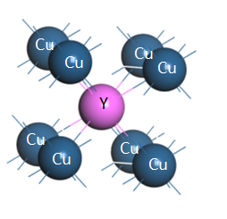

**Figure 1**. The unitcell of CuY.

**Table 1.** The calculated lattice constant, previous study, experiment

|  |  |  |  |
| --- | --- | --- | --- |
| CuY, a(Å) | Present Study | Previous calculation | Experiment |
| [7] | 3.580 | 3.511,3.477,3.472 | 3.477 |
|  |  |  |  |

* 1. **Elastic Properties**

The elastic constants inherent in crystals play a pivotal role in determining the stability crucial for unraveling the macroscopic mechanical characteristics of materials, making them a paramount parameter in material processing. The application of the strain-stress method facilitates the calculation of elastic constants, denoted as Cij. In the case of the cubic crystal structure of CuY, three essential elastic constants (C11, C12, and C44) define its mechanical behavior. Specifically, C11 elucidates elasticity in length, while C44 and C12 delineate elasticity in shape. The evaluation of mechanical stability in the cubic crystal structure involves the application of Born elastic stability conditions [8]. Examination of Table 2 reveals that the CuY compound, with its specified Cij values, satisfies the criteria for mechanical stability.

The bulk modulus serves as a measure of a material's resistance to volume change. The shear modulus, on the other hand, quantifies a material's resistance to deformation within atomic planes. The Young's modulus, meanwhile, can be employed as an indicator of a material's resistance to elastic strain. Lower values of these moduli signify a softer character in the material. As pressure increases, the hardness of the material intensifies.

Hv is a hardness parameter, and if this value is below 10, it is known that the material is soft. As pressure increases, the hardness of the material also increases. Within the realm of materials science, plasticity refers to the phenomenon wherein a material, typically in a solid state, experiences irreversible alterations in shape when subjected to applied force. The quantification of plasticity can be achieved through the ratio B/C44. The specific plasticity values for the CuY compound have been detailed in Table 2.

**Table 2.** Elastic constants Cij (GPa), Bulk modulus B (GPa), shear modulus G (GPa), Young Modulus E (GPa), Hardness (GPa), Plasticity measurement B/C44 of CuY compound.

|  |  |  |  |  |  |  |  |  |
| --- | --- | --- | --- | --- | --- | --- | --- | --- |
| Pressure | C11 | C12 | C44 | B | G | E | Hv | B/C44 |
| 0 | 115.2 | 46.1 | 36.6 | 69.1 | 35.1 | 91.3 | 3.9 | 1.887 |
| 5 | 131.7 | 59.9 | 44.4 | 83.8 | 40.7 | 105.0 | 4.5 | 1.887 |
| 10 | 145.8 | 73.3 | 51.5 | 97.4 | 44.7 | 116.3 | 4.9 | 1.891 |
| 15 | 158.4 | 86.4 | 58.0 | 110.4 | 47.9 | 125.5 | 5.3 | 1.903 |
| 20 | 169.8 | 99.3 | 64.2 | 122.8 | 50.4 | 133.0 | 5.6 | 1.912 |
| 25 | 180.3 | 112.1 | 70.1 | 134.8 | 52.4 | 139.1 | 5.8 | 1.922 |
| 30 | 189.7 | 124.6 | 75.4 | 146.3 | 53.7 | 143.5 | 5.9 | 1.940 |
| 35 | 198.2 | 137.1 | 80.2 | 157.4 | 54.4 | 146.3 | 6.0 | 1.962 |
| 40 | 206.1 | 149.5 | 84.8 | 168.3 | 54.6 | 147.8 | 6.0 | 1.984 |
| 45 | 213.7 | 162.0 | 89.1 | 179.2 | 54.4 | 148.2 | 6.0 | 2.011 |
| 50 | 220.7 | 174.3 | 93.3 | 189.7 | 53.7 | 147.2 | 5.9 | 2.033 |

The ductile or brittle nature of a material can be assessed by employing the Pugh ratio [9]. A material is characterized as ductile or brittle based on whether the Pugh ratio (G/B) is smaller or larger than 0.57, respectively. In the case of the CuY compound, the calculated Pugh ratio falls below 0.57, indicating its ductile nature, a characteristic that remains consistent even under increased pressure.

Poisson's ratio (ν) is a defining factor for the bonding forces within solids. When atomic forces in a material are centrally aligned, the ν value typically falls between 0.25 and 0.50 [10]. The obtained ν value indicates the centralization of interatomic forces in the material.

Another approach involves the use of Cauchy pressure, where the nature of the compound's structure is contingent upon whether C12-C44 is positive or negative. A positive Cauchy pressure signifies a metallic character [11]. Given that the C12-C44 values obtained are positive, it can be concluded that this compound exhibits metallic characteristics.

The Elastic Anisotropy Parameter A holds significant importance in engineering sciences. A solid is considered entirely isotropic when A equals 1. As pressure increases, anisotropy values persist in their anisotropic behavior.

The Debye temperature (ΘD) holds significant relevance in elucidating various physical properties of solids, such as specific heat and melting temperature[12]. At low temperatures, vibrational excitations primarily consist of acoustic vibrations. The estimation of the Debye temperature involves the utilization of the average sound velocity (vm), derived from elastic constant data. The calculated sound velocities and Debye temperatures are also provided in Table 3. Notably, for materials categorized as hard, the Debye temperature tends to be higher, while for softer materials, it is lower. As observed in Table 3, the low Debye temperature values of CuY indicate its classification as a soft material.

**Table 2.** G /B ratio, C11-C44 Cauchy pressure (GPa), Poisson’s ratio (υ) and Zener Anisotropy factor (A), debye temperature (K) and sound velocities(m/s) of CuY compound

|  |  |  |  |  |  |  |  |  |
| --- | --- | --- | --- | --- | --- | --- | --- | --- |
| Pressure | G/B | C12-C44 | v | A | ΘD | Vl | Vt | Vm |
| 0 | 0.516 | 9.5 | 0.279 | 1.059 | 293.2 | 4429 | 2449 | 2729 |
| 5 | 0.485 | 15.5 | 0.290 | 1.237 | 310.1 | 4666 | 2533 | 2826 |
| 10 | 0.458 | 21.8 | 0.300 | 1.421 | 322.7 | 4851 | 2588 | 2891 |
| 15 | 0.433 | 28.4 | 0.310 | 1.611 | 332.2 | 5003 | 2623 | 2934 |
| 20 | 0.410 | 35.1 | 0.319 | 1.821 | 338.9 | 5128 | 2641 | 2957 |
| 25 | 0.388 | 42.0 | 0.327 | 2.056 | 344.1 | 5236 | 2649 | 2970 |
| 30 | 0.367 | 49.2 | 0.336 | 2.316 | 347.0 | 5323 | 2642 | 2965 |
| 35 | 0.345 | 56.9 | 0.345 | 2.625 | 348.1 | 5345 | 2624 | 2948 |
| 40 | 0.324 | 64.7 | 0.353 | 2.996 | 347.7 | 5456 | 2596 | 2920 |
| 45 | 0.303 | 72.9 | 0.362 | 3.447 | 346.1 | 5510 | 2561 | 2884 |
| 50 | 0.283 | 81.0 | 0.370 | 4.021 | 343.0 | 5552 | 2516 | 2837 |

* 1. **Electronic Properties**

The electronic properties of materials play a pivotal role in influencing electrical conductivity, band structure, chemical bonds, and overall material quality. Fig. 2 presents the energy band structure alongside the total electronic state density, offering insights into the electronic structure and phase stability of CuY. The Fermi level is consistently set at 0eV. The absence of a band gap near the Fermi level indicates a metallic structure for CuY, suggesting its inherent metallic properties, a characteristic that remains evident even under elevated pressure conditions.

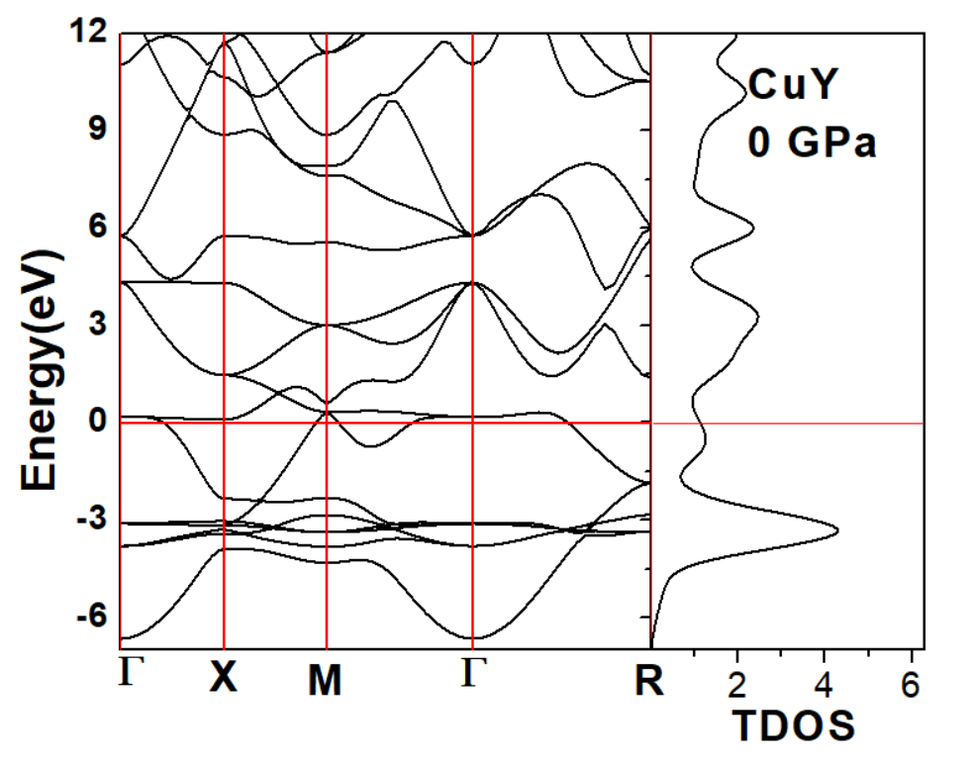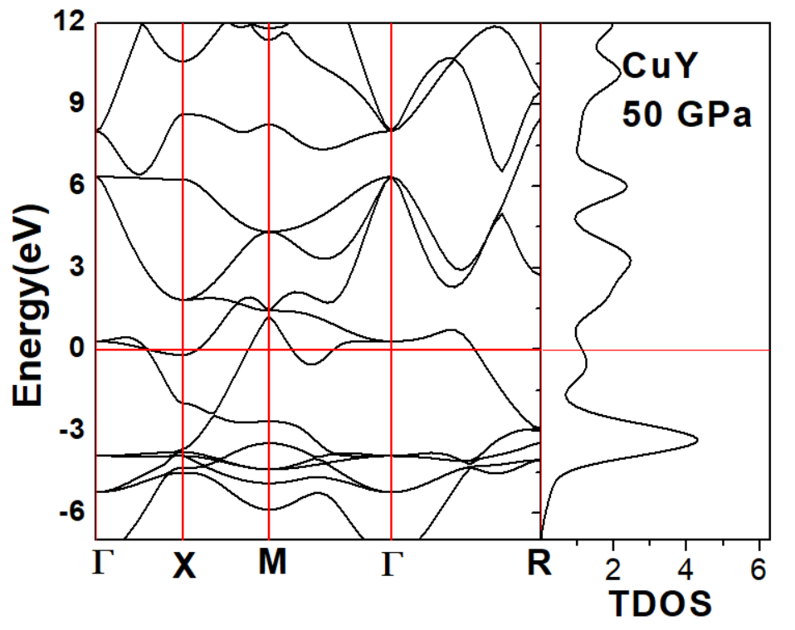

**Figure 2**. Electronic band structure and total density of CuY at 0, 50 GPa.

The changes in the partial DOS graphs of the CuY compound with the effect of pressure are shown in Figure 3. We can evaluate our graph as Fermi level, valence band and conduction band. The biggest contribution to the Fermi level at zero comes from the Y-d states. The largest contribution to the valence band comes from Cu-d states, while the largest contribution to the conduction band comes from Y-d states.

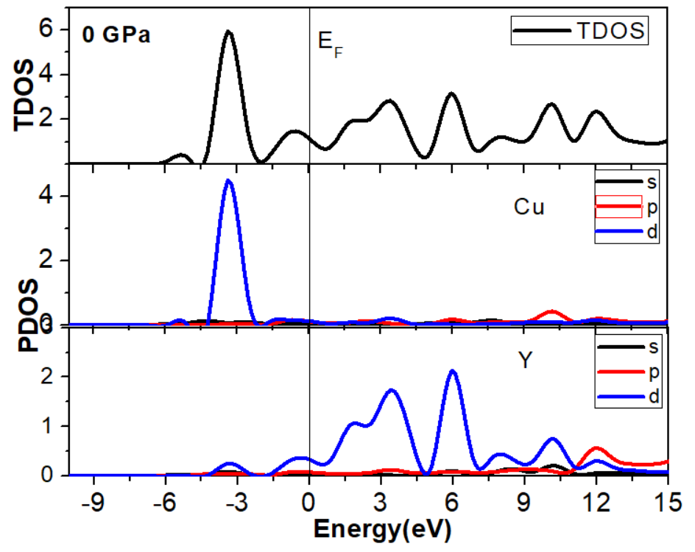 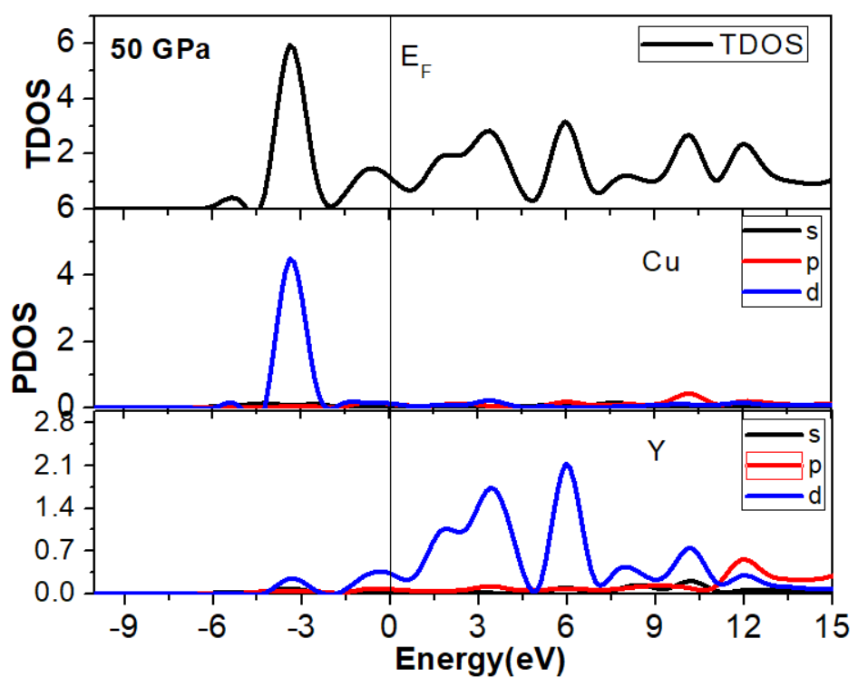

**Figure 3**. Electronic band structure and total density of CuY at 0, 50 GPa.

1. **Conclusion**

In our purely theoretical exploration, we delved into the impact of pressure on the mechanical, elastic, and electronic attributes of the CuY compound. Our findings indicate that CuY possesses characteristics of being both ductile and soft. CuY exhibiting metallic properties, also displays compressibility. Notably, the plasticity value for CuY stands at 1.887 under zero pressure. Additionally, the calculated Debye temperature, derived from elastic constants, is determined to be 293 K. Our investigation extended to examining acoustic wave velocities in various directions, revealing a highly anisotropic elasticity for CuY. The outcomes presented in this study offer detailed insights and serve as a valuable reference for future experimental inquiries.

**References**

[1] Mouhat, F., & Coudert, F. X. (2014). Necessary and sufficient elastic stability conditions in various crystal systems, *Physical Review B - Condensed Matter and Materials Physics*, *90*, 4–7.

[2] Fatima, B., & Sanyal, S. P. (2018). Ab initio study of electronic structure, elasticity, bonding features and mechanical behaviour of zinc intermetallics, *Computational Condensed Matter*, *14*, 144–152.

[3] Liu, L., Chen, C., Chen, L., & Wen, Y. (2021). The elastic and thermodynamic properties of TbAl and DyAl under high pressure, *High Temperatures - High Pressures*. *50*, 133–147.

[4] Kresse, G., & Hafner, J. (1993). Ab initio molecular dynamics for liquid metals, *Physical Review B*, *47*, 558–561.

[5] Mehmood, N., Ahmad, R., & Murtaza, G. (2017). Ab Initio Investigations of Structural, Elastic, Mechanical, Electronic, Magnetic, and Optical Properties of Half-Heusler Compounds RhCrZ (Z = Si, Ge), *Journal of Superconductivity and Novel Magnetism*, *30*, 2481–2488,

[6] Ciftci, Y. O., and Evecen, M. (2018). First principle study of structural, electronic, mechanical, dynamic and optical properties of half-Heusler compound LiScSi under pressure, *Phase Transitions*, *91*, 1206–1222.

[7] Liu, L., Chen, C., Xu, G., Jiang, Y., Wen, Y., & Zeng, X. (2021). Elastic constants and thermodynamic properties of AgY and CuY compounds under pressure and temperature effects, *High Temperatures - High Pressures*, *50*, 185–195.

[8] Benmakhlouf, A., Benmakhlouf, A., Allaoui, O., & Daoud, S. (2018). Theoretical study of elastic and thermodynamic properties of CuSc intermetallic compound under high pressure, *Chinese Journal of Physics*, *57*, 179–188..

[9] Joubert, D. (1999). From ultrasoft pseudopotentials to the projector augmented-wave method, *Physical Review B - Condensed Matter and Materials Physics*, *59*, 1758–1775.

[10] Zeng, X., Peng, R., Yu, Y., Hu, Z., Wen, Y., & Song, L. (2018). Pressure effect on elastic constants and related properties of Ti3Al intermetallic compound: A first-principles study, *Materials*, *11*,114-116.

[11] Ganeshan, S., Shang, S. L., Zhang, H., Wang, Y., Mantina, M., & Liu, Z. K. (2009). Elastic constants of binary Mg compounds from first-principles calculations, *Intermetallics*, *17*, 313–318.

[12] Blanco, M. A., Francisco, E., & Luaña, V. (2004). GIBBS: Isothermal-isobaric thermodynamics of solids from energy curves using a quasi-harmonic Debye model, *Computer Physics Communications*, *158*, 57–72.

1. \* Corresponding author. *e-mail address: ilknurdurukan.@gazi.edu.tr* [↑](#footnote-ref-1)