**the use of the dmaic model in identifying potential defects in MANUFACTURING INDUSTRY**

**Masniza Yusof, Yap Teck Hongand Mohd Fadhli Ahmad**

Department of Mechanical Engineering, Politeknik Tuanku Syed Sirajuddin, Pauh Putra,

02600 Arau, Perlis, Malaysia.

Corresponding Author Email: ariqarissa99266@gmail.com

**ABSTRACT:** The DMAIC approach of Lean Six Sigma is being used in this project to optimize the hand lay-up process for composite material manufacturing to find probable Foreign Object Debris (FOD). Individual prepreg layers are laid up on a tool using the hand lay-up technique, and they are subsequently cured. The manual process of hand lay-up yields a variety of quality flaws, including voids, delamination, voids, warpage, and Foreign Object Debris (FOD). The FOD quality flaw is the sole focus of this study. The DMAIC model approach (Define, Measure, Analyze, Improve, Control) is used in this study to help companies identify and reduce the number of FOD quality defects on composite panels, ensuring that high-quality composite panels can be produced that ultimately fit the aircraft. The major cause of the issue has been located because of this study, and a few solutions have been put up. Kaizen, SMED, and standard operating procedures were some of these answers. Composite material production businesses can decrease the amount of FOD flaws and enhance the overall effectiveness of the hand-laying process by utilizing the DMAIC model, Lean Six Sigma, and other quality techniques.

**KEYWORDS:** *Lean Six Sigma; DMAIC; Foreign Object Debris (FOD)*

# Introduction

Manufacturing firms confront a variety of issues nowadays, such as unstable production methods, poor product quality, monetary losses, delayed product delivery, etc., but frequently these issues are not understood by the companies themselves (Desai, T.N., & Shrivastava, R.L., 2008). Therefore, this deterioration may result in a failure to meet customer expectations and, as a result, a decline in market share. Because of this, businesses must constantly be able to satisfy their clients to thrive in the competitive market. To do this, they must continually enhance their production processes and track these advancements using the right Key Performance Indicators.

Due to the study's emphasis on the aerospace manufacturing sector and the corporate personnel involved in the various stages of developing, testing, promoting, and shipping the aircraft component. Hand lay-up is the primary manufacturing method used by the company. The fundamental method of processing composite material, which is a key component of aircraft construction, is hand lay-up. The hand lay-up method is susceptible to many kinds of errors. The most major flaw in monolithic structures is porosity, which is brought on by improper manufacturing and impact damage when the structure is in use. Foreign object debris (FOD) defects are yet another potential flaw that may impact the mechanical characteristics of the aircraft construction. One potential flaw that could lower an aircraft's quality is FOD. Therefore, the specifics of FOD will be explored.

The company Aerospace Composites Malaysia Sdn. Bhd. (ACM) is recording a bigger FOD defect. The information was afterwards gathered from the target company by visiting and observing the state of a production line. In 2014, there were 58 pieces of FOD defect on the product. In 2015, there were just 28 pieces of defect on the product. However, there were 23 pieces of FOD defects in 2017 (up until September), and it is predicted that this number would remain the same or even decline in the coming year. As a result, the research problem statement has been established, which aims to increase product quality by lowering the FOD fault.

Defective foreign objects always FOD is a possible threat to aviation safety, according to Kedir, Faucett, Sanchez, and Choi (2016). Damage from FOD results in annual costs of millions of dollars. According to Taneja, M. & A. Manchanda (2013), the type of FOD may be split into two main categories: FOD on the physical aspects of aircraft and FOD on the structure of aircraft. As a composite material defect that is challenging to detect and manage, FOD on the structure of aircraft is the subject of this study because it affects the mechanical properties of the aircraft. During the production process or other labour processes in the industry, FOD might unintentionally be created or engaged in composite materials (Kim, S.Y., 2014). To decrease the number of FOD defects, the research suggested using Lean and Six sigma approaches in the production process.

# 2.0 LITERATURE REVIEW

2.1 Composite Materials

To create a new material with improved and enhanced qualities, two or more distinct materials are combined to create a composite material. In addition to improving the material's qualities, a good material combination makes fabrication easier, improves the material's physical and chemical characteristics, and improves the processing-related characteristics. It involves a thorough analysis of material properties before choosing the material to be used to produce the product and designing composite components. Glass fibre reinforced composites with epoxy resin matrix reinforcement were chosen as the research's chosen materials (Barbero, 1998).

Since most materials are substantially stronger in fibre form than in their bulk form, their research indicates that fibre reinforcement is recommended. Weight reduction, corrosion resistance, part count, and resistance to abrasion are the primary factors in the use of composite materials. Electromagnetic transparency, wear resistance, prolonged fatigue life, thermal insulation, low thermal expansion, and low or high thermal conductivity are additional benefits that drive some applications. Additionally, studies on the simulation of composite material moulding for the automotive industry show that composite materials can be used in the construction of cars because they have modern composite material properties like lowering vehicle weight, requiring less strength, and having vibration-dampening qualities (Grabowski, L., 2016). Metal makes up most of a car's composition. Composite materials are frequently associated with the aerospace industry because of their high strength to weight and stiffness to weight ratios, which are far higher than those of steel or aluminium.

2.2 Foreign Object Debris (FOD)

Debris, chemicals, or items/systems are included in FOD. FOD is thus defined as line operations that are not appropriate for that location. FOD can affect persons or equipment and comes in different sizes. The damage to aeroplanes, helicopters, launch vehicles, engines, or other aviation equipment that results from a foreign object smashing the engine, flight controls, airframe, or other operating systems is another definition of FOD.

Foreign object debris (FOD) is a broad term for a type of material, debris, or foreign systems or vehicles that may cause harm, particularly in aeronautical situations. The fact that FOD was discovered at the airport's air operations area (AOA) poses a serious risk to the security of air travel. FOD may cause damage to the aircraft during a crucial stage of flight, which could result in a tragic loss of life and damage to the fuselage as well as raising the cost of maintenance and operation. Foreign object debris (FOD) can also damage airports, airlines, and airports, costing a total of millions of dollars annually. According to Kedir, D. Faucett, L. Sanchez, and S. R. Choi (2016), FOD is anything that shouldn't be in or around aeroplanes and, as a result, has the potential to harm airport or airline staff as well as damage aircraft.

2.3 Six Sigma DMAIC

Six-sigma is a methodical, data-driven approach to removing flaws from any process. A process must produce no more than 3.4 failures per million opportunities to achieve six sigma qualities. The core tenet of six sigma is that process improvement concepts, statistical techniques, customer focus, process attention, management systems centred on high-return improvement initiatives, and statistical approaches all lead to continuous improvement and substantial financial gains.

Six sigma is an enterprise management method that was first used by MOTOROLA and is now widely used in a variety of industrial sectors. It tries to locate and get rid of flaws as well as the source of errors in the production, business, and/or service delivery processes. It employs a variety of management techniques, including statistical techniques, and builds a specialized infrastructure of experts in each technique within the organization.

The Design for Six Sigma (DFSS) and the Design, Measure, Analyze, Improve, Control (DMAIC) techniques were emphasized as the two most popular ways to deploy Six Sigma in the research (Tjahjono, B., 2010). DMAIC is a continuous improvement technique that aims to identify and get rid of the root causes of errors, defects, and process delays in company operations.

# 3.0 Methodology

The DMAIC framework from Six Sigma, which consists of five stages (Define, Measure, Analyze, Improve, and Control), served as the foundation for the organization of the current study. The Six Sigma methodology was utilized to lessen variation in output and product quality (Stephens, J.S., and McDonald Jr., C.L., 2007). Lean Manufacturing tools and procedures are another approach that has been used in this research. To increase item quality, Lean Manufacturing methods and procedures were utilized to eliminate defects (Thomas, A., R. Barton, & C. Chuke Okafor, 2009).

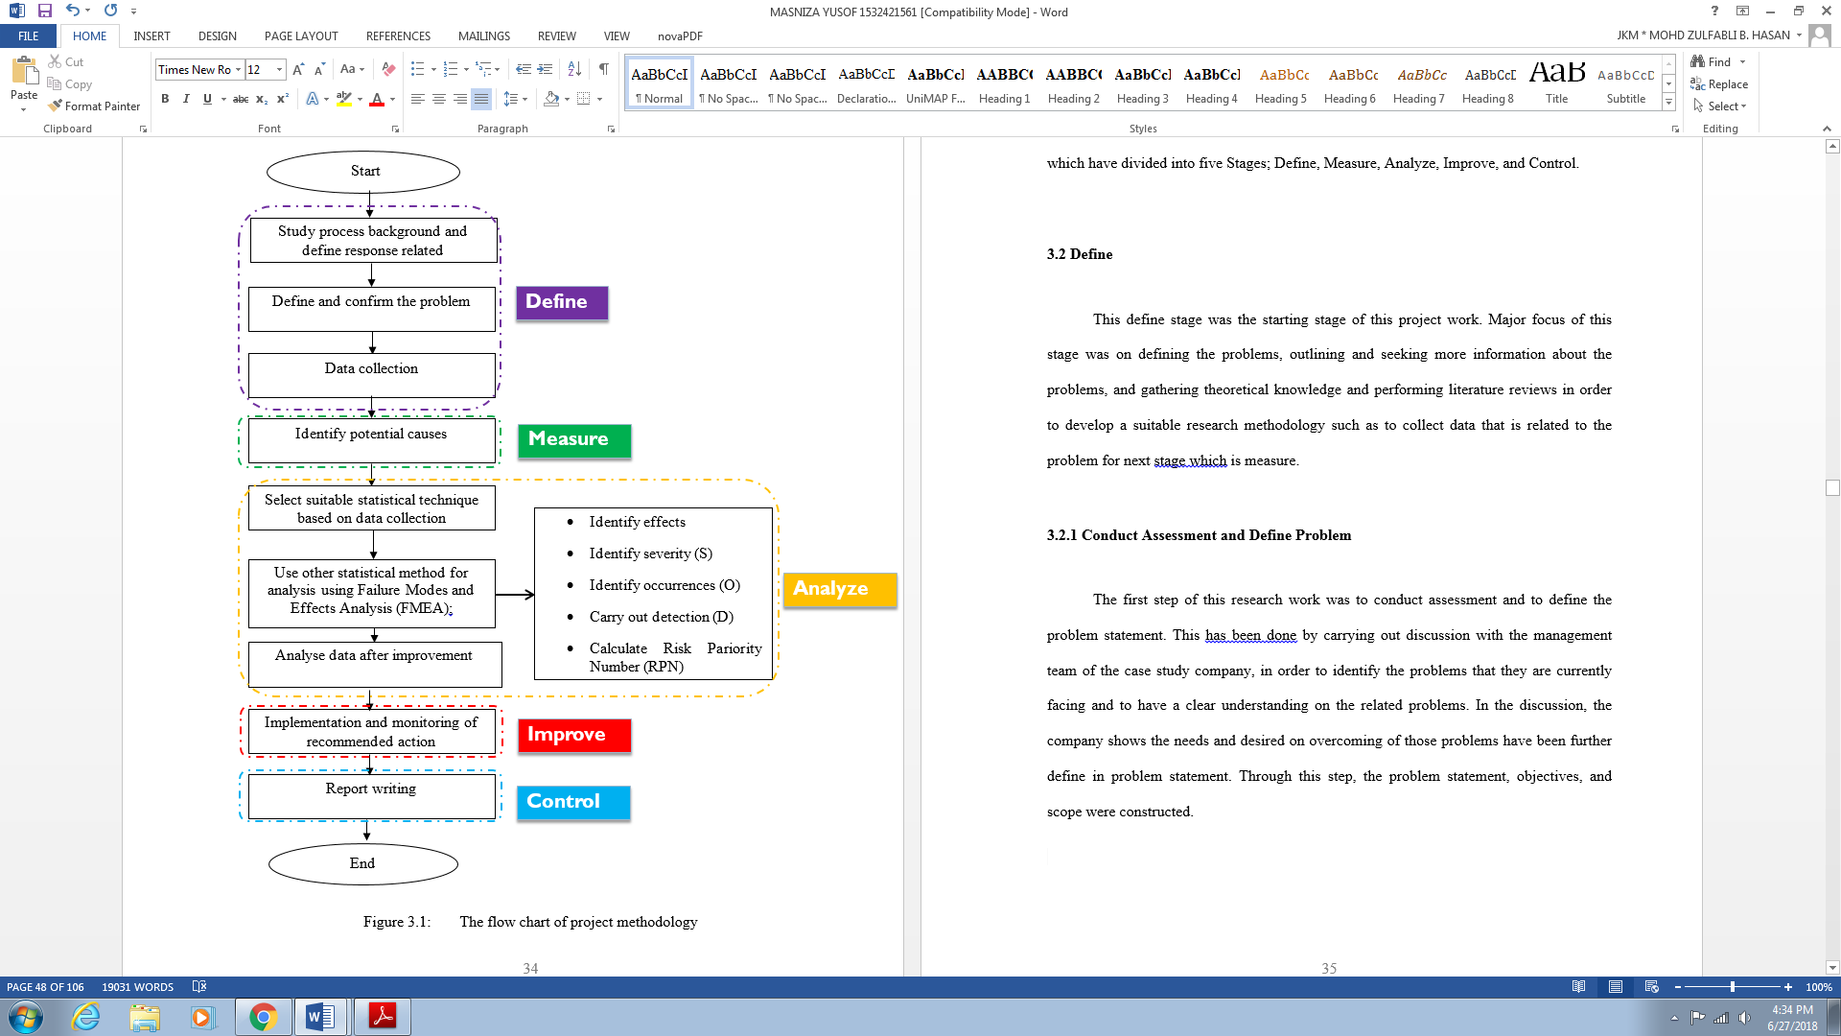

**FIGURE 1.** Methodology flowchart.

The Six Sigma DMAIC framework, which is broken into five Stages—Define, Measure, Analyze, Improve, and Control—was used to structure this project, according to the flowchart.

3.1 Define

The project work started at this stage of definition. This stage's primary focus was on defining the problems, outlining them, and obtaining more information about them. It also included gathering theoretical knowledge and conducting literature reviews in order to develop an appropriate research methodology, such as gathering data relevant to the problem in preparation for the next stage, which involves measurement.

3.2 Measure

The project work's measure stage came following the define stage. This stage's primary focus was on gathering information relating to the issues. Measurement is a crucial stage that typically requires a lot of work and time to assure data accuracy because it determines the project's outcomes. The DMAIC's foundation is accurate data since without it, it is impossible to accomplish the project's goals. A suitable data collection plan was developed together with the management team by brainstorming technique. This is because the management team of the target company have more experience and they know the best way to carry out the data collection plan. Then the collection plan was executed, and with the data collected sort out the relationship between them. The data collected will be used to compare with the data collected in the improved stage to determine whether significant improvement has been made to the project.

3.3 Analyze

The data gathered in the previous stage is analyzed in the following stage to determine the true cause of the product or process issue. The Pareto chart is first used to identify the Program or Panel with the highest incidence of defects. Second, the causes of the defect are divided into personal, technological, managerial, methodological, environmental, and other variables. The Pareto chart will next be applied to these criteria to identify which is most crucial. Additionally, a fish-bone diagram, sometimes referred to as a cause-and-effect diagram, is used to sort out root causes that have a significant impact. Finally, FMEA is employed to confirm the main cause even further.

3.4 Improve

Errors and waste are eliminated or reduced at this step-in order to improve the process. Based on the root issues that were identified in the previous stage, a set of remedies are presented at this step. The appropriate Lean and Six Sigma plan must be determined by considering all the factors that contribute to the fault, which may be done by using tools like the 5 Why method and brainstorming. The team will discuss the best course of action and recommend it to the target organization after it has been chosen.

3.5 Control

The recommended solutions, as well as the advantages and disadvantages they have for the system, are now recognized because of the earlier processes. The essential employees are allocated implementation duties during the last stage of the DMAIC process. It is also advised to use measuring methods to track these implementations. Persuading the relevant parties that the implementation is better than the current practice is a crucial component of having improvements accepted. The production manager and the process development manager, who oversee many of the affected departments in the facility, are additional linked individuals. This group of individuals has the power to lead the change and the expertise to guarantee that the change is technically feasible to implement.

3.6 Problem Encountered

The fact that the entire research's information came from a literature review, a questionnaire, and a personal interview suggests that it is qualitative. As a result, analyzing a qualitative work solely depends on the researchers' understanding of the subject matter and capacity to interpret the responses they get. The researchers now have the tools they need to get over this anxiety thanks to their careful analysis of the literature and the knowledge they have acquired during their academic and professional careers.

# 4.0 Results and Discussions

From January 2017 through September 2017, 23 cases of FOD problems were reported, according to the information provided. The company's team unanimously agreed that the number of FOD defects is expected to rise through the end of the year. Most cases are brought about by human problems, next by methods, then by visuals, and finally by management. Most of the issues required rework, which meant that the business would have to pay the operators more. In rare circumstances, businesses must discard the parts due to FOD flaws. The indirect expenses are more difficult to calculate. When rework is required frequently, schedules frequently leave room for it, which soon turns into a self-fulfilling prophecy. However, the effect on customer pleasure looms over these costs. Losing revenue because of late deliveries and subpar quality can far outweigh direct and indirect expenditure.

There are many kinds of defects in composite materials, but the Foreign Object Debris (FOD) defect is one of the more difficult ones to manage. Due to the heavy demands placed on human labor during the Hand lay-up process, the majority of FOD defect instances occurred during this phase.

# 5.0 Conclusions

Since the DMAIC Model Six Sigma was used to research and analyze probable FOD faults on composite materials, the primary goal of this project had been accomplished. As a result, the operator's personal behavior was identified as the primary contributing factor to the FOD flaws, which related to the study's second goal. The Lean Six Sigma strategy was also suggested in this study to cut down on FOD faults. Understanding the whole range of advantages is crucial when evaluating a project's success.

# Acknowledgments

The authors acknowledge the Aerospace Composites Malaysia Sdn. Bhd. (ACM) teams for the teamwork and data given. Special thanks to those who contributed to this project directly or indirectly.

# 6.0 References

*Barbero, E. J. (1998). Introduction to Composite material design*. New York: Anchor

*Desai, T.N & Shrivastava, R.L. (2008). Six sigma- a new direction to quality and productivity management.* Proceedings of World Congress on Engineering and computer science. Mahwah, NJ: Erlbaum.

*Grabowski, L., A.Baier, M.Majzner & M.Sobek. (2016). Composite materials molding simulation for the purpose of automotive industry*. International Journal of Industrial Automotive, 34(5), 220-230.

*Kedir, N., D.Faucett, L.Sanchez & S.R.Choi. (2016). Foreign object damage in an oxide/oxide ceramic matrix composite under prescribed tensile loading.* Journal Engineering Gas Turbines Power, 139(2), 213-221.

*Kim, S.Y., C.Sik Shim, C.Sturtevant, D.Kim & H. Cheol Song. (2014). Mechanical properties and production quality of hand-layup and vacuum infusion processed hybrid composite materials for GFRP marine structures.* International Journal Navy Architecture Ocean Engineering, 6(4), 2092-6782.

*Stephens,J.S & McDonald Jr,C.L. (2007). Lean six sigma*. The Journal of Organizational Leadership and Business, 14(6), 552-572.

*Taneja, M. & A.Manchanda. (2013). Six sigma an approach to improve*. International Journal Industrial Engineering, 60(4),281-286.3.

*Thomas, A., R.Barton, & C.Chuke Okafor. (2009). Applying lean six sigma in a small engineering company-a model for change*. Manufacturing Technology Management, 14(2), 113-129.

*Tjahjono, B. (2010). Six sigma: a literature review*. International Journal Lean Six Sigma, 7(2), 216-233.

*Worley, J. & Dolen, T. (2006). The role of communication and management support in lean manufacturing implementation*. Management Decision, 44(2), 228-245.