**THE EFFECT OF FAT AND FATTY ACİDS ADDED TO THE FEED OF RUMİNANTS ON GREENHOUSE GAS**

Meryem Badayman1, Ekin Dinçel Kasapoğlu2

1,2istanbul Aydın University Anadolu Bıl Vocational School of Higher Education, Food Technology Program, 34290 Küçükçekmece/İstanbul

Corresponding Author: mbadayman@aydin.edu.tr

**ABSTRACT**

*Greenhouse gases, which have an important place in climatic changes, are increasing rapidly with the increase of gases given to the atmosphere by humans. In relation to this, with the increase in the world population, the demand for animal products such as meat, milk and eggs increases, which is known to increase greenhouse gas emissions with animal production and cause environmental problems.*

*Worldwide, livestock is responsible for 14.5 percent of anthropogenic greenhouse gas emissions and therefore a significant portion of current climate change. The greatest effect on the formation of greenhouse gases is related to the release of methane gas by enteric fermentation as a result of ruminants breaking down cellulose in feed.About 10% of methane production in livestock is produced from anaerobic manure storage. One of the most effective of these strategies is known to reduce enteric methane emissions by adding oil (rapeseed, sunflower seeds and linseed, sunflower oil, coconut oil, corn oil, etc.) to the diet of ruminants. The effect of medium chain fatty acids on methane production, digestibility and rumen fermentation in ruminant animals has been observed. Methane production of dietary fats; The effect on feed digestibility and rumen fermentation is known to differ between studies, which may be related to the type and concentrations of fat, diet composition, and animal species. The aim of this study; scientific data on the use of fatty acids as feed additives in ruminant rations to reduce enteric methane production have been collected and studies on reducing the emission of greenhouse gases that affect climate change have been included.*

**1.INTRODUCTION**

One of the biggest environmental problems of today is global climate change. Especially the change in temperatures, the main greenhouse gases carbon dioxide, methane, etc. This can be explained by the high level of production that includes emissions (Albergel et al., 2010). Properties such as temperature, precipitation amount, air humidity and soil are constantly changing with climate change. It is known that the main reason for this is human activities (Alirezaei et al., 2017; Bayer, 2015; Moumen et al., 2019; Chehabeddine and Tvaronavičienė, 2020).

The greenhouse effect is an increase in the temperature of the earth's surface due to the heating of the lower layers of the atmosphere by the accumulation of greenhouse gases. As a result, the air temperature is greater than it should be, and this leads to such irreversible consequences as climate change and global warming (Huang et al., 2016). Methane (CH4), Carbon Dioxide (CO2), Nitrous oxide/Diazotyl oxide (N2O),Hydrofluorocarbons (HFCs), Perfluorocarbons (PFCs) and Sulfur hexafluoride (SF6) are 6 main compounds greenhouse gas emissions (IPCC, 2007; IPCC, 2013; Singh ve Singh, 2012; Solomon ve ark., 2007). These compounds the most important ones are CH4, CO2 and N2O (Haque, 2018). Especially; the rapid increase in the amount of CO2 and CH4 causes climate change that can threaten marine life and human survival. CO2 leads to the growth of the carbon footprint, also known as it is known, and causes many negative effects on the environment (Hristov et al., 2018). In addition to environmental pollution, the problem of depletion of fossil fuels has also increased. With the studies on climate change issues, awareness of the rise and fall in fossil fuel prices and the sustainability of energy security has also increased. (Edenhofer et al., 2011; Lu et al., 2015).

The aim of this study; scientific data on the use of fatty acids as feed additives in ruminant rations to reduce enteric methane production have been collected and studies on reducing the emission of greenhouse gases that affect climate change have been included.

**2.** **RUMINANTS AND THE RELATIONSHIP OF RUMINANTS WITH GREENHOUSE GAS**

Ruminants; They are quite different from monogastric animals in terms of the anatomical and physiological characteristics of their digestive systems (Janssen, 2010). Ruminants, which have four compartments and a highly developed stomach structure, are able to ferment the nutrients they have taken with feed into animal foods such as meat and milk, thanks to the enzymes secreted by the microorganisms (bacteria, archaea, protozoa and yeast fungi) in their reticulo rumen Jafari et al., 2019). Carbohydrate sources taken with feed are fermented in the rumen and converted into volatile fatty acids (VFA), H2 and CO2. The main volatile fatty acids formed as a result of fermentation are acetic, propionic and butyric acids, which are used to meet the energy needs of animals (Zhao et al., 2020). Rumen methane reaction is showed at Figure 1.

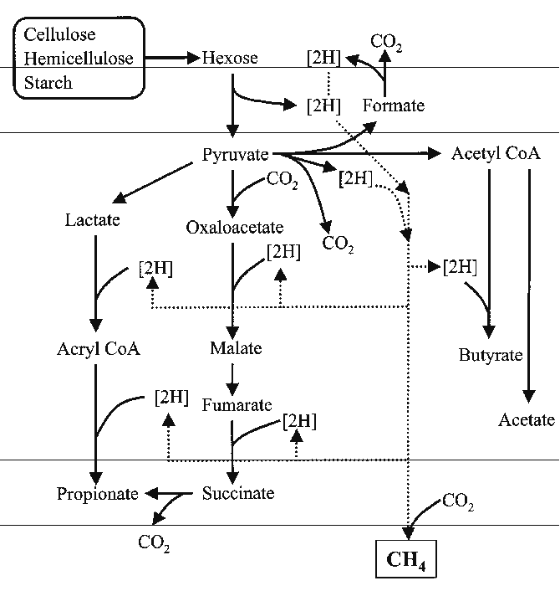

Figure 1. Rumen methane reaction (Görgülü et al., 2009)

H2 and CO2 released as a result of rumen fermentation are produced by methanogenic microorganisms (bacteria, archaea, protozoa); CO2 + 4H2 → CH4+2H2O is directed to methane gas formation (methanogenesis) by reduction reaction (Görgülü et al., 2009). The figure 2 showed methane production processes in ruminant animals.

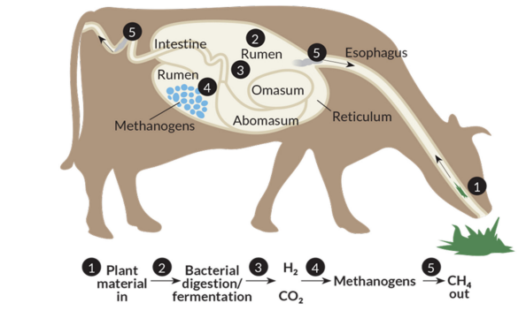

Figure 2. Processes of methane production in ruminants (Zhao et al., 2020)

**2.1. Strategies to reduce methane emissions**

Ruminant animals contribute to anthropogenic methane (CH4) in greenhouse gas formation. Therefore estimating gas emissions from these livestock and developing new technology related to it has become an important issue (Haque, 2018).

Feed management decisions are essential to the ruminant animal system as enteric microbial fermentation affects digestion, nutritional value and ruminant fecal composition. Among the main causes of greenhouse gas emissions from livestock farming are methane (CH4) emissions from enteric fermentation and stored manure, and nitrous oxide (N2O) from animal excreta. As a result, animal nutrition and feeding management have become an important issue in order to reduce greenhouse gas emissions. Reducing the amount of dietary crude protein in animal feeds, forage quality, increasing feed digestibility, reducing the amount of crude protein by increasing grain levels etc. are among the promising options to control gas emissions (de Souza Congio et al., 2021) (Figure 3). Many technologies and methods for reducing greenhouse gasses are implemented in many countries, including the United States.

Emissions, which are the main cause of ruminant livestock, are the result of enteric fermentation and manure management and account for 40% of total emissions (FAOSTAT, 2008). In greenhouse gas emissions, nitrous dioxide emissions directly from the rumen occur with enteric fermentation. The excretion of faeces and urine, both in the field and in the stable, causes emissions of methane, nitrous oxide and ammonia, due to fermentation, nitrification, denitrification and ammonia volatilisation, respectively (Mekuriaw ve ark., 2020). In addition, direct carbon dioxide and nitrogen oxide emissions occur with silage feeding made with the use of fuel-powered machinery. In addition, methane nitrogen oxide and ammonia emissions occur in stored fertilizers depending on the storage system. Emissions during barn and storage are known to be higher than pasture emissions (Schils, 2005).

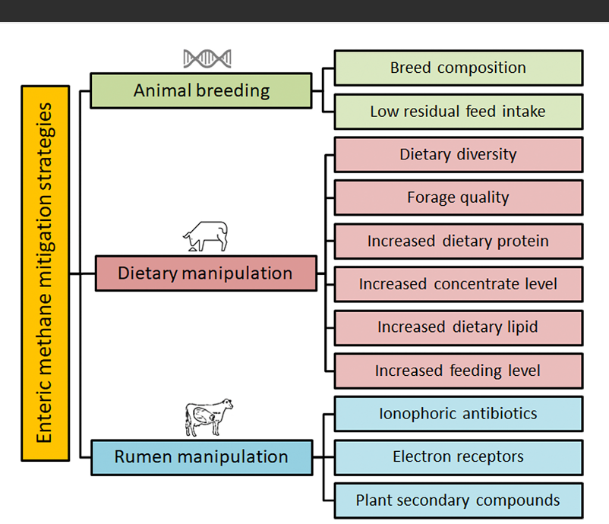Figure 3**.** Many technologies and methods lists for reducing greenhouse gasses (de Souza Congio et al. 2021).

**2.1.1. Adding fat to the ration**

Fat, which is one of the energy sources used in the ration, is known to significantly reduce methane production. Although the addition of oil to the ration varies according to the amount, form and composition of the feed, it has been reported that methane production decreases by 5.6% for each 1% of added oil (Beauchemin et al., 2006).The main reason for this is that methane production decreases with the change of microbial flora and energy use efficiency in the rumen (McGinn et al., 2004; Beauchemin and McGinn, 2006). In studies conducted in dairy cows, it was stated that the addition of 5% myristic acid, 5.7% flaxseed, extruded flaxseed and flax oil to the ration reduced methane release. It was determined that the decrease was caused by the suppression of the activities of methanogens in the rumen by myristic acid (Reverdin et al., 2003; Odongo et al., 2007). In a study carried out by adding coconut oil at different feed rates in beef cattle; It was determined that methane release decreased in all oil added groups (Lovett 2003). Likewise, Martin et al. (2008) concluded that the addition of raw flaxseed, extracted flaxseed, and flaxseed oil to dairy cattle diets significantly reduced methane production, and that the addition of oil to the ration inhibited cellulatic bacteria and protozoa, resulting in decreased feed fermentation. In another study, it was observed that methane release was reduced by 34, 21 and 20 %, respectively, in feeds depleted in stearic acid, enriched in oleic acid, canola oil, palm kernel oil and coconut oil (Blanco et al., 2012).

On the other hand, in another study conducted in dairy cows, it was reported that the addition of a mixture of cottonseed oil: canola oil in equal proportions (50:50) to the ration of 2.3%, 4.0 and 5.6 did not change the methane release (Johnson et al., 2002).

In another study on the inclusion of sunflower oil and proteolytic enzyme in feeds, it was stated that the addition of sunflower oil to the ration significantly reduced methane gas production, but the addition of enzyme did not cause any change in methane gas production ( McGinn et al., 2014).

On the other hand, methane production, which decreased by 37% with the addition of flaxseed to barley silage, did not change when flaxseed was added to meadow grass (Chung et al., 2011).

In a study investigating the effects of thyme, mint and orange oils on rumen fermentation, it was reported that there was a significant decrease in CH4 and CO2 gas production with increasing levels of essential oils added to the ration (Canbolat et al., 2011).

Patra et al. (2006) found that fennel, clove, garlic, onion and ginger essential oil inhibited methane production in vitro.

**3.CONCLUSİON**

When the mentioned studies on reducing methane release by adding fat to the rations are evaluated, it is seen that the addition of fat sources rich in unsaturated fatty acids to the rations reduces methane release. The main reason for this is the digestion of structural carbohydrates with the addition of fat, the acetate: propionate ratio decreases or the number of methanogenic microorganisms decreases or both situations occur together and methane production decreases. Also, in case of adding fat sources rich in unsaturated fatty acids to the ration, some of the H2 in the rumen is converted to unsaturated fatty acids by rumen microorganisms. The hydrogen in the environment is reduced by using in the saturation (biohydrogenization) and methane production decreases depending on this decrease.

Born on 10.12.1990 in Şişli, Istanbul, Lecturer. Msc Food Engineer Meryem BADAYMAN graduated from Istanbul Aydın University, Department of Food Engineering in 2013. Between 2013 and 2016, she worked as a responsible engineer in various food companies and also worked as a lecturer at Adnan Menderes University for one term in 2016. She completed her master's degree in Adnan Menderes University, Faculty of Veterinary Medicine, Department of Food Hygiene in 2018. Since 2016, she has been teaching at Istanbul Aydın University Food Technology Department as a lecturer.

Born on 28.08.1990 in Diyarbakir, Lecturer. Ekin DİNÇEL KASAPOĞLU, MSc Food Engineer, graduated from Mustafa Kemal University, Department of Food Engineering in 2012. She completed her master's degree in Food Engineering at Istanbul Aydın University in 2015. Since 2013, she has been teaching at Istanbul Aydın University Food Technology Department as a lecturer.

**REFERENCES**

Albergel, C., Calvet, J. C., Gibelin, A. L., Lafont, S., Roujean, J. L., Berne, C. (2010). Observed and modelled ecosystem respiration and gross primary production of a grassland in southwestern France. Biogeosciences7(5),1657-1668. www.biogeosciences.net/7/1657/2010/<https://doi.org/10.5194/bg-7-1657-2010>.

Alirezaei, M., Onat, N., Tatari, O., Abdel-Aty, M. (2017). The climate change-road safety-economy nexus: A system dynamics approach to understanding complex interdependencies. *Systems* 5(1), 1-24. <https://doi.org/10.3390/systems5010006>.

Bayer, A. D., Pugh, T. A. M., Krause, A., Arneth, A. (2015). Historical and future quantification of terrestrial carbon sequestration from a greenhouse-gas-value perspective. *Global Environmental Change*. 32, 153-164. <https://doi.org/10.1016/j.gloenvcha.2015.03.004>.

Beauchemin, K.A., McGinn, S.M. (2006). Methane emissions from beef cattle: effects of fumaric acid, essential oil and canola oil. *Journal of Animal Science.* 84, 1489-1496.

Blanco C., Bodas R., Prieto N., Moran L., Andres S., Lopez S., Giraldez FJ. (2012). Vegetable oil soapstocks reduce methane production and modify ruminal fermentation. *Animal Feed Science and Technology.* 176, 40-46.

Canbolat, Ö., Kalkan, H., Karaman, Ş., Filya, İ. (2011). Esansiyel Yağların Sindirim, Rumen Fermantasyonu Ve Mikrobiyal Protein Üretimi Üzerine Etkileri. *Kafkas Üniversitesi Veteriner Fakültesi Dergisi.* 17(1), 557-565.

Chehabeddine, M., Tvaronavičienė, M. (2020). Securing regional development. *Insights into Regional Development*. 2(1), 430-442. <http://doi.org/10.9770/IRD.2020.2.1(3)>.

Chung, Y. H., Walker, N. D., McGinn, S. M., & Beauchemin, K. A. (2011). Differing Effects Of 2 Active Dried Yeast (Saccharomyces Cerevisiae) Strains On Ruminal Acidosis And Methane Production İn Nonlactating Dairy Cows. *Journal Of Dairy Science*. *94*(5), 2431-2439.

De Souza Congio, G. F., Bannink, A., Mogollón, O. L. M., Jaurena, G., Gonda, H., Gere, J. I& Hristov, A. N. (2021). Enteric Methane Mitigation Strategies For Ruminant Livestock Systems İn The Latin America And Caribbean Region: A Meta-Analysis. *Journal Of Cleaner Production*. *312*, 127693.

Edenhofer, O., Pichs-Madruga, R., Sokona, Y., Seyboth, K., Matschoss, P., Kadner, S., von Stechow, C. (2011). Renewable Energy Sources and Climate Change Mitigation. Cambridge: Cambridge University Press. <http://dx.doi.org/10.1017/CBO9781139151153>.

FAOSTAT(2008).http://faostat.fao.org/DesktopDefault.aspx?PageID=291&lang=en

Giger-Reverdin S., Morand-Fehr P., Tan G. (2003). Literature Survey Of The İnfluence Of Dietary Fat Composition On Methane Production İn Dairy Cattle. *Livestock Production Science.* 82, 73-79.

Görgülü, M., Kolumnan Darcan, N., Göncü, S. (2009). Hayvancılık Ve Küresel Isınma, V. Ulusal Hayvan Besleme Kongresi. 30 Eylül-3 Ekim, Çorlu.

Haque, M.N. (2018). Dietary Manipulation: A Sustainable Way To Mitigate Methane Emissions From Ruminants. *Journal Of Animal Science And Technology,* 60(1), 15.

Hristov, A.N., Kebreab, E., Niu, M., Oh, J., Bannink, A., Bayat, A.R., Boland, T.M., Brito, A.F., Casper, D.P., Crompton, L.A., Dijkstra, J., Eugène, M., Garnsworthy, P.C., Haque, N., Hellwing, A.L.F., Huhtanen, P., Kreuzer, M., Kuhla, B., Lund, P., Madsen, J., Martin, C., Moate, P.J., Muetzel, S., Muñoz, C., Peiren, N., Powell, J.M., Reynolds, C.K., Schwarm, A., Shingfield, K.J., Storlien, T.M.,Weisbjerg, M.R., Yáñez-Ruiz, D.R., Yu, Z. (2018). Symposium Review: Uncertainties İn Enteric Methane İnventories, Measurement Techniques, And Prediction Models. *Journal of Dairy Science*. 101, 6655–6674.

Huang, S. K., Kuo, L., Chou, K. L. (2016). The Applicability Of Marginal Abatement Cost Approach: A Comprehensive Review. *Journal Of Cleaner Production* 127. 59-71. <https://doi.org/10.1016/j.jclepro.2016.04.013>.

Jafari S, Ebrahimi M, Goh YM, Rajion MA, Jahromi MF, Al-Jumaili WS., (2019). Manipulation Of Rumen Fermentation And Methane Gas Production By Plant Secondary Metabolites (Saponin, Tannin And Essential Oil) -A Review Of Ten-Year Studies*. Annals Of Animal Science,* 19(1). 3-29.

Janssen PH., (2010). Influence Of Hydrogen On Rumen Methane Formation And Fermentation Balances Through Microbial Growth Kinetics And Fermentation Thermodynamics. *Animal Feed Science And Technology*, 160(1–2): 1-22.

Johnson, L. M., Harrison, J. H., Davidson, D., Swift, M., Mahanna, W. C., & Shinners, K. (2002). Corn Silage Management III: Effects Of Hybrid, Maturity, And Processing On Nitrogen Metabolism And Ruminal Fermentation. *Journal Of Dairy Science*. *85*(11), 2928-2947.

Lovett, D., Lovell, S., Stack, L., Callan, J., Finlay, M., Conolly, J., & O'Mara, F. P. (2003). Effect Of Forage/Concentrate Ratio And Dietary Coconut Oil Level On Methane Output And Performance Of Finishing Beef Heifers. *Livestock Production Science*. *84*(2), 135-146.

Lu, Y., Nakicenovic, N., Visbeck, M., & Stevance, A.-S. (2015). Policy: Five Priorities For The UN Sustainable Development Goals. Nature, 520, 432–433. [Http://Dx.Doi.Org/10.1038/520432a](http://dx.doi.org/10.1038/520432a).

Martin, C., Rouel, J., Jouany, J. P., Doreau, M., Chilliard, Y. (2008). Methane output and diet digestibility in response to feeding dairy cows crude linseed, extruded linseed, or linseed oil. *Journal of Animal Science*. 86, 2642-2650.

McGinn, S.M., Beauchemin, K.A., Coates, T., Colombatto, D. (2004). Methane Emissions From Beef Cattle: Effects Of Monensin, Sunflower Oil, Enzymes, Yeast, And Fumaric Acid. *Journal of Animal Science.* 823346-3356.

Mekuriaw S, Tsunekawa A, Ichinohe T, Tegegne F, Haregeweyn N, Kobayashi N, Tassew A, Mekuriaw Y, Walie M, Tsubo M, Okuro T, Meshesha DT, Meseret M, Sam L, Fievez V. (2020). Effect Of Feeding Improved Grass Hays And Eragrostis Tef Straw Silage On Milk Yield, Nitrogen Utilization, And Methane Emission Of Lactating Fogera Dairy Cows İn Ethiopia. Animals. 10(6), 1021.

DOI: https://doi.org/10.3390/ ani10061021.

Moumen, Z., El Idrissi, N.E.A., Tvaronavičienė, M., Lahrach, A. (2019). Water Security And Sustainable Development. *Insights İnto Regional Development.*1(4),301-317. <https://doi.org/10.9770/ird.2019.1.4(2)>.

Odongo, N.E., Or-Rashid, M.M., Kebreab, E., France, J., McBride, B.W., (2007). Effect Of Supplementing Myristic Acid İn Dairy Cow Rations On Ruminal Methanogenesis And Fatty Acid Profile İn Milk. *Journal of Dairy Science.* 90(4),1851-1858.

Parry, M., Parry, M.L., Canziani, O., Palutikof, J., Van Der Linden, P., Hanson, C. (2007). Climate Change 2007-İmpacts, Adaptation And Vulnerability: Working Group II Contribution To The Fourth Assessment Report Of The IPCC (Vol. 4). Cambridge University Press.

Patra, A. K., Kamra, D. N., & Agarwal, N. (2006, July). Effect Of Spices On Rumen Fermentation, Methanogenesis And Protozoa Counts İn İn Vitro Gas Production Test. In *International Congress Series* Elsevier*,* 1293, 176-179.

Schils, R. L. M., Verhagen, A., Aarts, H. F. M., & Šebek, L. B. J. (2005). A Farm Level Approach To Define Successful Mitigation Strategies For GHG Emissions From Ruminant Livestock Systems. *Nutrient Cycling İn Agroecosystems*. *71*(2), 163-175.

Singh, B.R., Singh, O. (2012). Study Of İmpacts Of Global Warming On Climate Change: Rise İn Sea Level And Disaster Frequency. Global Warming-İmpacts And Future Perspective.

Zhao, Y., Nan, X., Yang, L., Zheng, S., Jiang, L., & Xiong, B. (2020). A Review Of Enteric Methane Emission Measurement Techniques İn Ruminants. *Animals*. *10*(6), 1004.