**Spatial Variability of Fertilizer Recommendation of Rainfed Wheat-Cultivated Semiarid Sloping Soils**

***Al-Mabrouk Hamid Hasan WARDAMI1[C:\Users\Abdullah\AppData\Local\Microsoft\Windows\INetCache\Content.Word\ORCID-iD_icon-16x16.gif](https://orcid.org/0000-xxxx-xxxx-xxxx)Sabit ERŞAHİN2[C:\Users\Abdullah\AppData\Local\Microsoft\Windows\INetCache\Content.Word\ORCID-iD_icon-16x16.gif](https://orcid.org/0000-xxxx-xxxx-xxxx)Gülay KARAHAN3\*[C:\Users\Abdullah\AppData\Local\Microsoft\Windows\INetCache\Content.Word\ORCID-iD_icon-16x16.gif](https://orcid.org/0000-xxxx-xxxx-xxxx)***

*1 Institute of Natural and Applied Science, Çankırı Karatekin University, Çankırı, Turkey*

*2 Soil Science and Plant Nutrition Department, Faculty of Agriculture, Iğdır University, Iğdır, Turkey*

*3Landscape Architecture Department, Faculty of Forestry, Çankırı Karatekin University, Çankırı, Turkey*

|  |
| --- |
| **Abstract**  Uniform application of phosphourus (P) fertilizers to spatially varible soils often results in under-fertilization of low P-localities and over-fertilization of high P-localities. This study aimed at evalauting variable appleceability of P fertilizers on a 300-ha sloping landscape under rainfed winter wheat cıltivation for over 70 years. The soils in the study area were sampled intesively and plant avalilable soil P content (PASPC) was measured in each soil sample. Spatial variability of PASPC was evaluated by geositatistical technique and the area was divided into three uniform fertilizer P application zones (low, medium and high applicaton zones) based on spatial pattern of PASPC. PASPC was moderately variable; its mean was 11.74 kg P ha-1 with sdandard deviation of 3.30 kg P ha-1. Fertilizer recommended by Ministry of Agriculture and Foresty (FRMAF) was calculated for five sub-regions in the study area. The results showed that P fertilizer rates calculated for all five sub-regions were identical (24 kg P ha-1), suggesting that the FRMAF was insensitive to spatial variability of PASPC in the study area. Surface maps of soil properties indicated a strong spatial association between PASPC and each of clay content, sand content, wilting point (WP), and CaCO3 content. A further more comprehensive study is needed for evaluating efficiency and cost: benefit economis of variable P application in study soils. |
| Keywords: Geositatistics, Management zone, Phosphorous fertilizers, Site-specific management, Variable P application |

1. **Introduction**

It has long been recognized that soil properties which vary spatially and temporally over a landscape should be considered for a proper fertilizer application [1]. The application of commercial N, P, and K fertilizers has contributed to crop growth to a large extent, resulting in a tremendous increase in yields of agricultural crops. A uniform rate-fertilizer application on spatially variable soils induces some areas to be over-fertilized, whereas others are under-fertilized. Fertilizer use efficiency is reduced and a problem with water and soil pollution by unused fertilizer in the over-fertilized areas may arise [2]. Excessive use of those fertilizers has induced pollution on the surface and groundwater worldwide [3] and across Turkey. Because of the substantially high spatial variability of N, P, and K status within a particular agricultural field, application rates of those fertilizers should be adjusted site-specifically to optimize the nutrient supply to crops across the field [4]. Researchers often establish replicated research trials on a small scale and extrapolate their results to larger areas. However, the actual treatment effects are sometimes masked by trends in soil fertility in replicated field trials, and fertilizer recommendations thus cannot be formulated correctly and economically [2]. Site-specific crop management (SSCM) is a soil and crop management system that assesses variability in soil and crop parameters depending on field data to optimize inputs such as fertilizers and pesticides [5]. Conventional soil testing methods used in determining localities where insufficient or excess nutrient levels exist are costly and time-consuming. Without an adequate knowledge of spatial variability of soil nutrient content and fertilizer needs for crops, it is impossible to apply soil nutrients site-specifically for the purpose of increasing fertilizer use efficiency [6]. In addition, the time and cost required for intensive sampling in the SSCM may make it impossible to implement a variable-rate fertilizer system. Using the mean soil test values to formulate a fertilizer recommendation may result in over-fertilization and under-fertilization of large areas, decreased efficiency in fertilizer resources, and increased potential for contamination of surface and ground water. Therefore, there is a great need for detailed studies for determination of viability of variable fertilizer applications. Geostatistics is a useful mean to understand the spatial variability of soils [1]. The aim of this study was to formulate a variable rate P application for rainfed winter wheat on a landscape showing variation in slope steepness, slope aspect, slope position, and soil color. Three uniform P application zones were defined based on spatial variation of soil P test-values, and zone-specific rates for P application rates were determined.

1. **Materials and Methods**

**2.1. Materials**

The study was carried out on a sloping farmland approximately 300 hectares and 20 km to the center of Çankırı on the Çankırı-Ankara highway (Figure 1). The study area comprises hillslopes with different aspect, steepness, and shape. The area has been under rain-fed wheat production for more than 70 years. The differences in slope properties and parent material distribution are principal factors affecting yield variability. The prominent differences in soil color indicate a high soil spatial variability that would lead to the variability in crop yield across the study area.

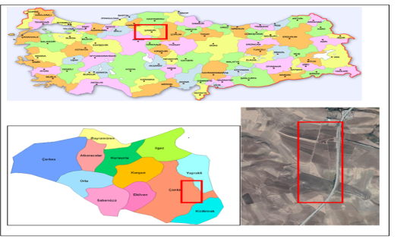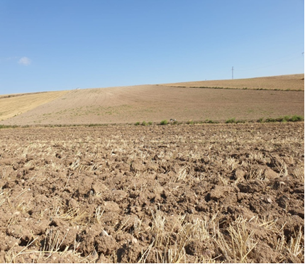

**Figure 1.** Location and view of the study area. The lighter colors indicate low fertility localities.

**2.2. Methods**

In the study area, 155 soil samples were taken randomly from the plow depth (approximately 0-20 cm). The coordinates of each sampling points were recorded using a global positioning system (GPS). Soil samples were transferred to a laboratory, dried at room conditions, passed through a 2-mm sieve and stored for analysis. The soil variables analyzed and the methods used in their analysis are given in the Table 1.

**Table 1.** Soil variables and the methods used in their analysis

|  |  |  |
| --- | --- | --- |
| Soil property | Methods/device | Reference |
| Soil texture | Mechanical analysis | Gee and Bouder (1986) |
| Available potassium and sodium content | Using a flame photometer | Kacar (1994) |
| Field capacity and wilting point | Pressure chambers | Cassel and Nielsen (1986) |
| Plant available water content | Difference between field capacity and wilting point | Cassel and Nielsen (1986) |
| Electrical conductivity | With an EC electrode in 1/2.5 soil-water suspension | Rhoades et al. (1999) |
| Soil reaction (pH) | With a pH electrode in 1/2.5 soil-water suspension | Rhoades et al. (1999) |
| Organic matter content | Walkley-Black method | Nelson and Sommers (1982) |
| CaCO3 content | Scheibler calcimeter | McLean (1982) |
| Available P content | Olsen method | Olsen et al. (1954) |
| Aggregate stability index | Wet sieving | Kemper and Rosenau (1986) |

The study area was divided into five sub-regions and P recommendation-values were calculated on mean of data for each of the sub-regions using fertilizer recommendation calculator of Ministry of Agriculture and Forestry of Turkey. Since P recommendations for all five sub-regions were identical, a single FRMAF (Fertilizer recommended by Ministry of Agriculture and Forestry)-value was applied to entire of the study area. Standard deviation for plant available P contents of 155 soil sampling points was calculated and used in delineation of uniform P application zones. Three uniform application zones were set by Equations (1-3).

If Pi ≤ Mp – SD then FPi = FRMAF + SD (1)

If Pi ≥ Mp – SD then FPi = FRMAF - SD (2)

If Pi > Mp – SD and Pi < Mp + SD then FPi = ERMAF (3)

Where, SD is the standard deviation of 155 plant available soil P contents (PASPC), Mp is the mean of 155 PASPCs, FRMAF is the fertilizer recommended for the study area by Ministry of Agriculture and Forestry, and Pi is the PASPC on the sampling site i.

A typical geostatistical analysis is conducted at three stages: an exploratory data analysis, a semivariogram analysis, and a spatial interpolation of the variable of subject [7]. Exploratory data analysis was conducted, and the distributions of the data, including PASPC, were described by calculating the mean, standard deviation, coefficient of variation, skewness, and kurtosis [8]. One of experimental, Gaussian, linear, and spherical models was fitted to the data for experimental semivariograms. Some extreme data points were discarded from dataset to improve fit of theoretical semivariograms to the experimental data. The geostatistical software GS+ (Gamma Design, St. Plainwell, MI) was used to model the spatial structure and to conduct ordinary kriging (OK) interpolations. The most proper semivariogram model was selected based on the highest R2- and lowest SSE-value for semivariogram fitting. Also, r (correlation coefficient) was considered to judge if the theoretical semivariogram could adequately represent the experimental semivariogram for variable. Variable lag-distances were used to detect the most proper semivariograms. Ordinary point kriging (OK) interpolations were conducted using the parameters (nugget, A, and sill) from the corresponding theoretical semivariograms. A minimum of 10 and a maximum of 13 neighbors within the geostatistical range were used in the OK predictions. The data were interpolated by normal distance interpolation in the case r was insignificant.

**3. Results and Discussion**

**3.1. Descriptive statistics of soil properties**

Soil textural components of sand, silt and clay contents are moderately variable according to [9]. There is a marked difference between variability of clay and other two variables of sand and silt content. Silt content is moderately and sand and clay contents are slightly right-skewed according to [10]. The values of CaCO3 content are moderately variable and slightly right-skewed. The mean value for CaCO3 suggests that majority of the study soils are highly calcareous. The values of OM content are moderately variable and strongly left-skewed, indicating that some extremely low OM-valued localities are present. Soil pH is slightly variable, while it was strongly right-skewed, suggesting presence of some high pH-valued localities (Table 2). Spatial variability of soil pH is important as it has a strong control on the soil P availability to plants [11].

**Table 2.** Descriptive statistics for properties of study soils

|  |  |  |  |  |  |  |  |  |
| --- | --- | --- | --- | --- | --- | --- | --- | --- |
| Soil property | n | Min | Max | Mean | SD | Skewness | Kurtosis | CV |
| pH (1:2.5) | 155 | 6.80 | 7.69 | 7.15 | 0.23 | 1.70 | 1.49 | 3.21 |
| EC (μS/mm) | 144 | 2.49 | 2630.0 | 472.1 | 521.3 | 3.16 | 9.31 | 110.4 |
| Sand (%) | 144 | 11.20 | 43.70 | 25.70 | 7.52 | 0.200 | -0.680 | 29.28 |
| Clay (%) | 144 | 40.50 | 69.70 | 54.59 | 6.13 | 0.130 | -0.250 | 11.23 |
| Silt (%) | 155 | 5.45 | 47.05 | 20.18 | 5.61 | 0.960 | 3.00 | 27.80 |
| CaCO3 (%) | 150 | 4.65 | 32.76 | 17.12 | 6.22 | 0.380 | -0.34 | 36.32 |
| OM (%) | 155 | 0.620 | 2.95 | 2.19 | 0.540 | -1.10 | 0.64 | 24.65 |
| Na (mg/kg) | 155 | 5.90 | 37.69 | 15.78 | 15.78 | 0.700 | 2.57 | 75.91 |
| K (mg/kg) | 144 | 13.51 | 65.10 | 38.94 | 12.98 | - 0.008 | -0.920 | 33.33 |
| P (mg/kg) | 155 | 6.84 | 23.53 | 11.74 | 3.30 | 1.70 | 2.68 | 28.13 |
| FC (%) | 125 | 19.54 | 42.06 | 30.56 | 4.53 | 0.210 | -0.126 | 14.85 |
| WP (%) | 93 | 5.56 | 20.59 | 15.43 | 2.36 | -1.02 | 2.75 | 15.34 |
| ASI (%) | 155 | 0.327 | 0.611 | 0.492 | 0.055 | -0.211 | 0.204 | 11.16 |

n: Number of soil samples, EC: Electrical Conductivity, OM: Organic Matter, Na: Sodium, K: Potassium, P: Available Phosphorus, FC: Field capacity, WP: Wilting point, ASI: Aggregate stability index, Min: Minimum, Max: Maximum, SD: Standard deviation, S: Skewness, K: Kurtosis, CV (%): Coefficient of variation.

**3.2. Uniform P application zones as related to spatial variability of PASPC**

Figure 2a and 2b show the spatial pattern of plant available P content of soils across the study area. Most of low P-content sites are located in the southern and nothern parts of the study area. Please notice that the “north” in the surface maps is different from the absolute north on the Google Earth Map for the study area. Corresponding semivariogram indicates very high short-range varibility of soil PASPC values in the study area, suggesting that determination of uniform P application zones may be difficult in this area. High nugget effect due to short-range variablity (Table 3) made OK and inverse distance intepolations of PASPC-values impossbile. Therefore, a normal distance interpolation was applied to produce surface map for PASPC. Figure 2c shows uniform P fertilizer application zones determined based on spatial distribution of PASPC-values across the study area. High P application localities are located in low PASPC localities in the Figure 2c. The FRMAF is 24 kg P ha-1 for the uniform application in the study area. The Figure 2c shows that application of 24 kg P ha-1 in the entire study area would be resulting in approximately half of the study area to be under-fertilized. On the other hand, the area of management zone 1 is almost negligible, therefore, the study area was divided into two management zones: a medium and a high application zone.

 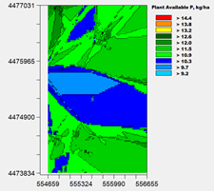 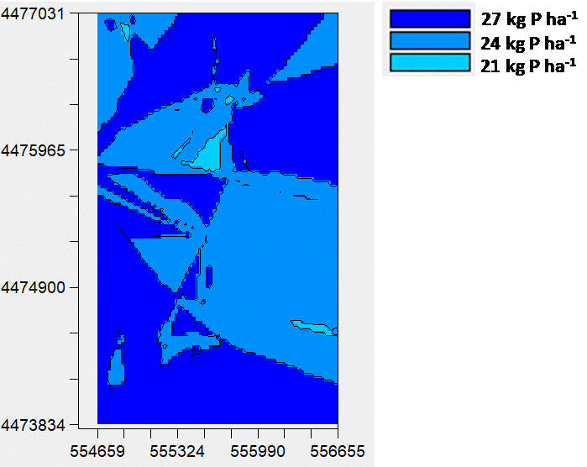

(c)

(b)

(a)

**Figure 2.** (a) Semivariogram and (b) spatial distribution pattern for plant available P content in study soils, (c) delineated uniform P application zones and corresponding fertilizer P requirements for each of the zones

The uniform P application would result approximately 450 kg P to be saved, while the amount of grain yield lost due to under-fertilization is unknown. A more comprehensive study is needed for evaluating cost: benefit economics of variable P application in the study area. Figure 3.1c shows that a significant portion of the field has a recommended P fertilizer rate of 28 kg ha-1, greater than the uniform application rate of 24 kg N ha-1, indicating that plants in this portion would be suffering P deficiency due to inadequate P fertilizer application rate, which may result in significant amount of yield loss. Phosphorous is predominantly used for photosynthesis, protein synthesis, seed germination, and flowering [12]. The study area is located on a sloping landscape with exposed subsoil or shallow topsoil on the eroded hilltops and ridges. Field observations indicated that soils at the eroded positions were generally lighter in color than soils at non-eroded positions and that low PASPC-values are generally coincided with those localities. Variability in soil fertility across landscapes affects crop yield [13]. In Nebraska, greater corn (Zea mays C.) yields were the case on the upper and lower interfluve and foot slope positions, and decreased yields were found on the upper and lower linear slopes [13]. Also, winter wheat yields and P levels were strongly correlated with landscape positions in northeast Colorado. Greater crop yields were obtained in foot slope positions than backslope and side-slope positions in western Iowa. Greater yields at foot slope positions were associated to greater soil organic matter content, nutrient concentrations, and plant available water content [13].

The results of geostatistical analysis were useful to evaluate spatial structure and spatial pattern of PASPC, providing valuable information on variable P application in the study area. [2] compared different criteria for dividing a field into homogenous management zones and determining fertilizer rates for each zone. Geostatistical analysis showed that PASPC-values had considerably high short-range variability with short geostatistical range (A) (Table 3). [14] showed that P and K variability ceased to have any effect beyond a range of about 140 meters in Israel, suggesting that samples should be collected within 140 m. On the other hand, no strong autocorrelation exists for the available levels of P in many fields, needing far greater number of samples for developing of an accurate map. Such extensive soil sampling is too costly in most of the cases. The variable fertilizer application results in benefit in majority of the cases. [2] conducted cost: benefit economics of variable fertilizer use for the three management zones based on the results of the uniformity trial, they found that the net profit for the zones 1, 2, and 3 was $321, $392, and $416 ha-1, respectively, with a cost: benefit ratio of 4.33, 5.28, and 5.62, respectively. Hybrid selection and hybrid specific fertilizer management are also important in management of nitrogen fertilizers.

**3.3. Spatial variability of soil properties as related to PASPC pattern in the study area**

Table 3 shows results of semivariogram analysis and Figure 3 shows the spatial pattern of the soil properties.

**Table 3.** Geostatistical analysis of spatial variability of study soils

|  |  |  |  |  |  |  |  |  |  |
| --- | --- | --- | --- | --- | --- | --- | --- | --- | --- |
| SV | M | Co | C | Co/C | A | RSSE | R2 | r | n |
| Sand (%) | E | 33.3 | 66.6 | 0.34 | 276.0 | 349.0 | 0.86 | 0.54 | 151 |
| Clay (%) | E | 16.8 | 58.0 | 0.29 | 690.0 | 149.0 | 0.94 | 0.62 | 152 |
| Silt (%) | E | 8.37 | 30.0 | 0.29 | 51.0 | 71.4 | 0.74 | 0.29 | 153 |
| OM content (%) | G | 0.047 | 0.102 | 0.46 | 69.4 | 6.74 x 10-4 | 0.85 | 0.03 | 155 |
| pH | E | 0.025 | 0.055 | 0.47 | 36.0 | 1.64 x 10-4 | 0.60 | 0.03 | 155 |
| EC (ms/cm) | S | 9.9 x 103 | 9.9 x 103 | 0.25 | 53.0 | 7.6 x 1010 | 0.47 | 0.65 | 155 |
| CaCO3 content (%) | S | 6.24 | 33.8 | 18.0 | 25.0 | 430.0 | 0.38 | 0.56 | 155 |
| FC (%) | E | 98.6 | 231.1 | 0.43 | 15.0 | 1001.0 | 0.51 | 0.05 | 152 |
| WP (%) | E | 49.4 | 104.1 | 0.47 | 15.0 | 2702.0 | 0.04 | 0.03 | 150 |
| PAWC (%) | S | 71.9 | 146.5 | 0.49 | 29.0 | 536.0 | 0.80 | 0.10 | 152 |
| ASI | S | 6.3 x 10-3 | 2.8 x 10-2 | 0.23 | 20.0 | 6.0 x 10-7 | 0.62 | 0.26 | 150 |
| P (mg/kg) | S | 2.42 | 7.93 | 30.5 | 20.0 | 4.88 | 0.61 | 0.07 | 149 |

SV: Soil variable, M: type of model used in the fitting the experimental semivariogram (E exponential, S: spherical, G: Gaussian), Co: Nugget variance, C: sill, A: geostatistical range, RSSE: Residual sum of squares, R2: Coefficient of determination for semivariogram fit, r: Correlation coefficient between cross validation-predicted and actual values. n: number of data points (out of 155 data points) included in the geostatistical analysis, EC: Electrical conductivity, OM: Organic matter, P: Available Phosphorus, FC: Field capacity, WP: Wilting point, ASI: Aggregate stability index.

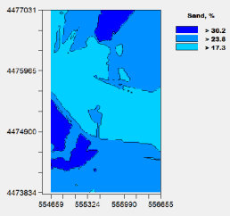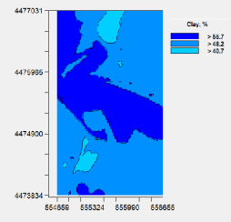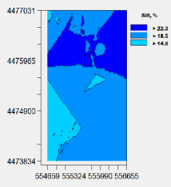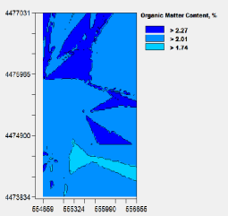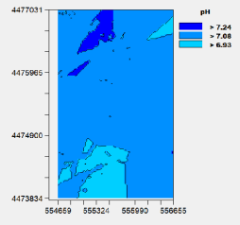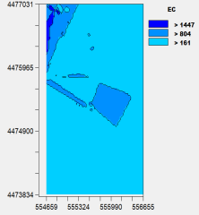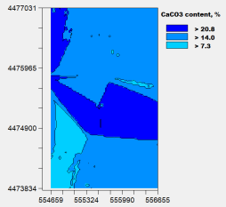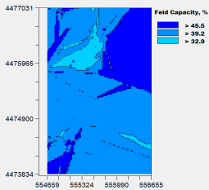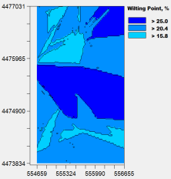 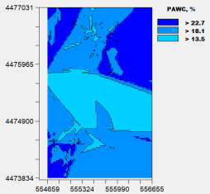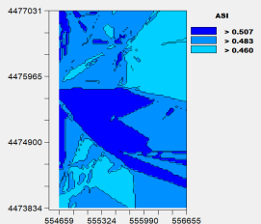

**Figure 3.** Semivariograms and corresponding surface maps of soil variables

According to [15] a soil variable with a nugget ratio <0.25 is strongly spatially dependent, between 0.25 and 0.75 moderately spatially dependent and >0.75 is weakly spatially dependent. Based on this classification, majority of the soil properties are moderately spatially dependent. Geostatistical range (A) defines the distance within which the separated values of a variable of subjet are spatially dependent. The greatest value for A occurred for soil clay content, while the lowest one occurred for WP and FC. Values for r indicate that many of the studied soil variables could not be adequately represented by their theoretical semivariograms. Denser soil samplings with a different sampling design would yield better results for those variables. Figure 3 shows spatial distribution pattern of soil variables across the study area. Greater values of sand content and lower values of clay content are generally located on medium P application zone. Spatial pattern for OM content showed no evident spatial association to the spatial pattern of PASPC in the study area, while those for CaCO3 content and wilting point showed that their greater values tended to be located in medium application zone. Similarly, a spatial relationship between ASI and P application zones is evident, while soil pH and EC showed no spatial relationship with PASPC. Results showed that significant portion (approximately 50%) of the study area would be under-fertilized when variable P application strategy was not applied. Therefore, a uniform P application on the entire study area may result in significant yield losses on the under-fertilized sub-regions. Surface maps showed that soil properties clay content, CaCO3 content, sand content, and WP had a close spatial association to PASPC, while no clear spatial relationship was evident between PASPC and OM content of the study soils. The fertilizer recommendation calculator of Ministry of Agriculture and Forestry was insensitive to variability in soil P test values. Therefore, a variable fertilizer application program should be based on soil P test values and yield variability of the wheat in the study area. A comprehensive study is needed for evaluating efficiency and cost: benefit economics of variable P application on the region.

**References**

[1] Raddy, G. Lalitha, B., & Jayadeva, H. (2021). Spatial fertilizer recommendation mapping based on soil test crop response equations for important crops using GIS and GPS. Commun. *Soil Sci. Plant Anal*., *52*, 58-75.

[2] Bhatti, A. Hussain, F. Ullah, F., & Khan, M. (1998). Use of spatial patterns of soil properties and wheat yield in geostatistics for determination of fertilizer rates. *Commun. Soil Sci. Plant Anal,* *29*, 509-522.

[3] Vadas, P.A. Kleinman, P.J.A., & Sharpley, A.N. (2004). A simple method to predict dissolved phosphorus in runoff from surface‐applied manures. *J. Environ. Qual.*, *33*, 749–756.

[4] Ruffo, M.L. Bollero, G.A. Hoeft, R.G., & Bullock, D.G. (2005). Spatial variability of the Illinois soil nitrogen test: Implications for soil sampling. *Agron. J.,* *97*, 1485-1492.

[5] Sudduth, K.A. Hummel, J.W., & Birrell, S.J. (1997). Sensors for site‐specific management. *Site Specif. Manag. Agric.,* *18*,183-210.

[6] Sawyer, J.E. (1994). Concepts of variable rate technology with considerations for fertilizer application. *J. Prod. Agric.*, *7*, 195-201.

[7] Isaaks, H., & Srivastava, E. (1989). *An introduction to applied geostatistics.* Oxford University Press, 553 page, NY.

[8] Erşahin, S. Aşkın, T. Tarakçıoğlu, C. Özenç, D.B. Korkmaz, K. Kutlu, T. Sünal, S., & Bilgili, B.C. (2017). Spatial variation in the solute transport attributes of adjacent Typic Haplusteps, Mollic Ustifluvents, and Lithic Ustipsamments. *Geoderma,* *289*, 107–116.

[9] Mulla, D.J., & McBratney, A.B. (2002). Soil spatial variability, in: *Soil Physics*, Warrick, A.W. (ed), 343–373, Boca Raton.

[10] Webster, R. (2001). Statistics to support soil research and their presentation. *Eur. J. Soil Sci*. *52*, 330-340.

[11] Tisdale, S. Nelson, W. Beaton, J., & Havlin, J. (1993). *Soil fertility and fertilisers*, 5th ed., 850 p., NY.

[12] Liu, W. Khan, Z.I. Mehmood, N. Fardous, A. Gondal, S. Ahmad, K., & Noorka, I.R. (2021). Mineral availability in soil and fodders affecting blood profiles in Nili-Ravi dairy buffaloes. *Trop. Anim. Health Prod.*, *53*,52-98.

[13] Fleming, K. Westfall, D. Wiens, D., & Brodahl, M. (2001). Evaluating farmer defined management zone maps for variable rate fertilizer application. *Precis. Agric.*, *2*, 201–215.

[14] Bonfil, D., Pimstein, A., Mey-tal, S., & Karnieli, A. (2006). Integrated nutrient management through precision agriculture and remote sensing, In: Bembi, D., Brar, M., Bansal, S. (eds), *International Symposium on Balanced Ertilization. International Potash Institute*, pp. 115–134, Horgen.

[15] Cambardella, C.A., Moorman, T.B., Parkin, T.B., Karlen, D.L., Novak, J.M., Turco, R.F., & Konopka, A.E. (1994). Field-Scale variability of soil properties in Central Iowa soils. *Soil Sci. Soc. Am. J*., *58* (5), 1501-1511.