**Computational Investigation on the Complexes between Aza-Cryptands and Transition Metals**

***Abdurrahman Atalay1,[[1]](#footnote-1)\*[C:\Users\Abdullah\AppData\Local\Microsoft\Windows\INetCache\Content.Word\ORCID-iD_icon-16x16.gif](https://orcid.org/0000-0002-9018-7264), Emel Ekinci2[C:\Users\Abdullah\AppData\Local\Microsoft\Windows\INetCache\Content.Word\ORCID-iD_icon-16x16.gif](https://orcid.org/0000-0003-2323-2747), Harun Çiftçi3,4 [C:\Users\Abdullah\AppData\Local\Microsoft\Windows\INetCache\Content.Word\ORCID-iD_icon-16x16.gif](https://orcid.org/0000-0002-3210-5566)***

*1 Avrasya University, Department Of Nutrition And Dietetics, Trabzon, Turkey*

*2 Çankırı Karatekin University, Department of Chemistry, Çankırı, Turkey*

*3 Kırşehir Ahi Evran University, Department of Medical Biochemistry, Kırşehir, Turkey*

*4 Çankırı Karatekin University, Institute of Science, Department of Chemistry, Çankırı, Turkey*

|  |
| --- |
| **Abstract**  Cryptands are useful in a variety of fields such as organic chemistry, biochemistry, and material science because of their ability to selectively interact with metal ions. In this study, we have performed a computational study to elucidate the structures and energetics of the complexes formed by transition metals, such as Cr2+, Mn2+, Fe2+, Co2+, Ni2+, Cu2+ and Zn2+, with aza-cryptand 36adamanzane using DFT method. At their optimized geometries of complexes studied, all complexes possess the S4 symmetry except the 36adz−Cr2+ and 36adz−Cu2+ complex (C1 symmetry). The computed interaction energies of all 36adz−M2+ complexes studied were given with and without relativistic energy corrections at the CAM-B3LYP/6-311++G(d,p) level. The 36adz−Ni2+ complex possesses a highest IE value (−438.6 kcal mol-1) including relativistic energy corrections than the other complexes. |
| Keywords: Cryptands, Transition Metal Complexes, DFT, Noncovalent Interactions |

1. **Introduction**

The three-dimensional counterparts of crown ethers, known as cryptands, were first synthesized in 1987 by Lehn and coworkers (Dietrich, Lehn, ve Sauvage 1969). They are helpful in several fields, including organic chemistry, biology, and material science, because of their ability to modify the size of the metal ion cavity and interact with metal ions selectively (Beer vd. 2003; Buschmann, Cleve, ve Schollmeyer 1997; Sarkar, Mukhopadhyay, ve Bharadwaj 2003; Sesta ve D’Aprano 1998). Furthermore, cryptands have the unique ability to combine with alkali metals to create stable complexes (Beer vd. 2003; Buschmann vd. 1997; Sarkar vd. 2003; Sesta ve D’Aprano 1998). A cryptant and a metal ion interact electrostatically in a host-guest type interaction. A great deal of research has been done on the complexes of cryptands with heavy metals and alkali cations (Beer vd. 2003; Buschmann vd. 1997; Sarkar vd. 2003; Sesta ve D’Aprano 1998; Sun vd. 2022). Among these cryptand-metal complexes, especially those with transition metals are quite interesting (Beer vd. 2003; Buschmann vd. 1997; Sun vd. 2022). Dehghani and coworkers reported the structures and energetics of complexes formed by Cryptand[2.2.2] and Mn2+, Fe2+, Co2+, Ni2+, Cu2+, and Zn2+ cations utilizing DFT methods and and stated that those formed by respective cryptand with Cu2+ and Co2+ were the most and the least stable systems, respectively (Dehghani vd. 2019). Behjatmanesh–Ardakani et al. reported the binding energies of complexes formed by benzocryptand [222B] with alkali metals, Li+, Na+, K+, and alkaline earth metal Ca2+ using DFT methods (Behjatmanesh-Ardakani vd. 2016).

A crucial class of chemical molecules is amine-containing cryptands, aza-cryptands (Bharadwaj 2017; Gupta vd. 2019; Taschner vd. 2020). These compounds can also form complexes with different transition and main-group metal ions (Bharadwaj 2017; Gupta vd. 2019; Taschner vd. 2020). Based on the aforementioned properties of the cryptands, the structure and energetics of the complexes formed by the 36adamanzane (36adz) aza-cryptand (Figure 1) with transition metal (M) cations (M: Cr2+, Mn2+, Fe2+, Co2+, Ni2+, Cu2+, and Zn2+) were computationally investigated using DFT methods.

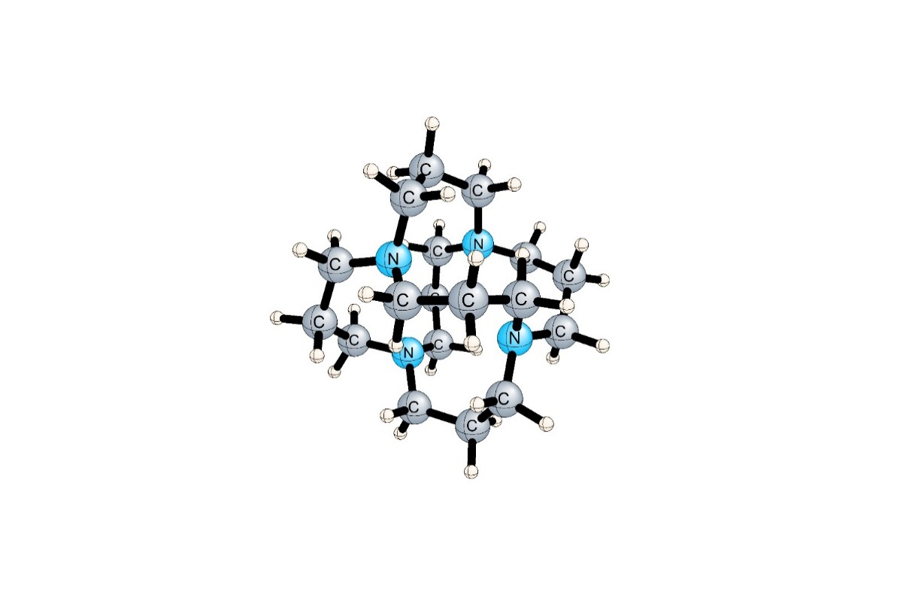

**Figure 1**. Optimized Structure of 36adz Aza-Cryptand at the CAM-B3LYP/6-31+G(d, p) level.

1. **Materials and Methods**

Geometry optimization and harmonic vibrational frequency computations were performed by employing the density functional theory (DFT) and the CAM-B3LYP functional (Tawada vd. 2004; Yanai, Tew, ve Handy 2004) for the complexes formed by 36adz with M cations such as Cr2+, Mn2+, Fe2+, Co2+, Ni2+, Cu2+, and Zn2+. In this regard, the 6-31+G(d,p) basis set (Ditchfield, Hehre, ve Pople 2003; Hehre, Ditchfield, ve Pople 2003) was utilized for all complexes. To determine the structures with the lowest energy for 36adz−M2+ complexes, doublet, quartet, and sextet spin states of 36adz−Co2+, 36adz−Cu2+, and 36adz−Mn2+ complexes, and singlet, triplet, quintet, and septet spin states of 36adz−Cr2+, 36adz−Fe2+, 36adz−Ni2+, and36adz−Zn2+ complexes were optimized at the CAM-B3LYP/6-31+G(d,p) level. All interaction energies for all complexes studied were computed with the counterpoise procedure (Boys ve Bernardi 1970) at the CAM-B3LYP/6-311++G(d,p) level. In addition, the Douglas-Kroll-Hess (DKH) approximation was used to account for scalar relativistic effects on the complexes considered.

1. **Results and Discussion**

The optimized geometries of all complexes studied at the CAM-B3LYP/6-31+G(d, p) level is illustrated in Figure 2. The structures with the lowest energy are quintet for 36adz−Cr2+ and 36adz−Fe2+, sextet for 36adz−Mn2+, quartet for 36adz−Co2+, triplet for 36adz−Ni2+, doublet 36adz−Cu2+, and singlet state 36adz−Zn2+ complexes at the CAM-B3LYP/6-31+G(d,p) level. The 36adz is an S4-symmetric structure containing the four lone pairs of the N atom oriented toward the center of the cage. The M2+−N1 and M2+−N2 distances are 2.049−2.059, 2.057−2.057, 2.022−2.022, 1.993−1.993, 1.985−1.985, 1.982−1.992, and 1.994−1.994 Å for the 36adz−M2+ (M: Cr2+, Mn2+, Fe2+, Co2+, Ni2+, Cu2+, and Zn2+) complexes at their optimized geometries, respectively. This clearly shows that in the 36adz−Mn2+, Fe2+, Co2+, Ni2+, and Zn2+ complexes studied the metal cations were symmetrically placed to the center of the 36adz to which they are attached, while in the 36adz−Cr2+ and Cu2+ complexes metal cations were not symmetrically placed to it. The critical structural parameters for all 36adz−M2+ complexes are shown in **Table 1**. As seen in **Figure 2**, the 36adz−Mn2+, Fe2+, Co2+, Ni2+, and Zn2+ complexes maintain the S4 symmetry of 36adz, whereas the 36adz−Cr2+ and Cu2+ complexes is lowered to C1.

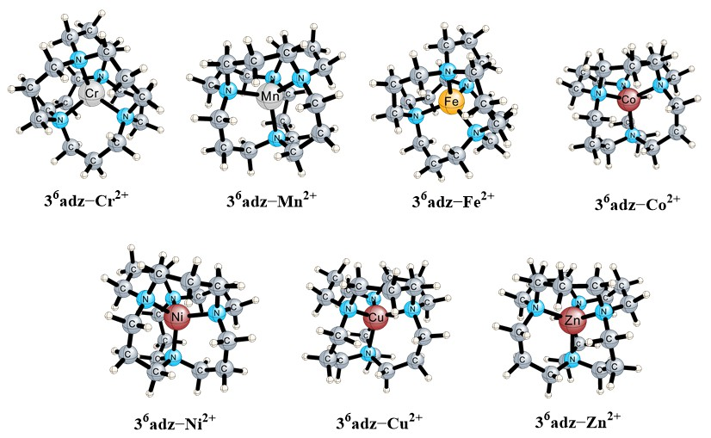

**Figure 2**. The optimized geometries of the 36adz−M2+ (M: Cr, Mn, Fe, Co, Ni, Cu and Zn) complexes at the CAM-B3LYP/6-31+G(d,p) level.

**Table 1**. M2+ꞏꞏꞏN1/N2 Distances (in Å) at the CAM-B3LYP/6-31+G(d, p) Level, Nonrelativistic Interaction Energies and Interaction Energies Including Relativistic Corrections (in kcal mol−1) at the CAM-B3LYP/6-311++G(d,p) Level for the 36adz−M2+ (M: Cr, Mn, Fe, Co, Ni, Cu and Zn) Complexes Considered.

|  |  |  |  |  |
| --- | --- | --- | --- | --- |
| Complexes | MꞏꞏꞏN1  Distance | MꞏꞏꞏN2  Distance | Non-relativistic IEs | IEs Including Relativistic Corrections |
| 36adz−Cr2+ | 2.049 | 2.059 | −339.7 | −342.8 |
| 36adz−Mn2+ | 2.057 | 2.057 | −330.9 | −334.9 |
| 36adz−Fe2+ | 2.022 | 2.022 | −363.1 | −367.8 |
| 36adz−Co2+ | 1.993 | 1.993 | −400.0 | −405.2 |
| 36adz−Ni2+ | 1.985 | 1.985 | −432.7 | −438.6 |
| 36adz−Cu2+ | 1.982 | 1.992 | −420.7 | −427.0 |
| 36adz−Zn2+ | 1.994 | 1.994 | −404.1 | −413.1 |

Table 1 shows the computed nonrelativistic interaction energies (IE) for the 36adz−M2+ complexes considered at the CAM-B3LYP/6-311++G(d,p) level. The computed nonrelativistic IE values for the 36adz−M2+ complexes are −339.7 for 36adz−Cr2+, −330.9 for 36adz−Mn2+, −363.1 for 36adz−Fe2+, −400.0 for 36adz−Co2+, −432.7 for 36adz−Ni2+, −420.7 for 36adz−Cu2+ and −404.1 kcal mol-1 for 36adz−Zn2+ at the CAM-B3LYP/6-311++G(d,p) level.

The computed IE values with relativistic corrections for the 36adz−M2+ complexes at the CAM-B3LYP/6-311++G(d,p) level are reported in Table 1. The computed relativistic energy correction for interaction energy is −3.1 for 36adz−Cr2+, −4.0 for 36adz−Mn2+, −4.6 for 36adz−Fe2+, −5.3 for 36adz−Co2+, −5.9 for 36adz−Ni2+, −6.3 for 36adz−Cu2+ and −9.0 kcal mol-1 for 36adz−Zn2+complex at the CAM-B3LYP/6-311++G(d,p) level, indicating that these energy correction values are not negligible for an accurate description of interaction energies of the corresponding 36adz−M2+ complexes.

The computed IE values including relativistic energy correction for the 36adz−M2+ complexes are −342.8 for 36adz−Cr2+, −334.9 for 36adz−Mn2+, −367.8 for 36adz−Fe2+, −405.2 for 36adz−Co2+, −438.6 for 36adz−Ni2+, −427.0 for 36adz−Cu2+ and −413.1 kcal mol-1 for 36adz−Zn2+at the CAM-B3LYP/6-311++G(d,p) level. The highest negative value for the 36adz−Ni2+ complex indicates that it is more stable than the other complexes because it fits into the cage cavity more easily.

1. **Conclusion**

In recent study, we have performed an computational study to elucidate the structures and interaction energies of the complexes formed by transition metals, such as Cr2+, Mn2+, Fe2+, Co2+, Ni2+, Cu2+ and Zn2+, with 36adamanzane using DFT method and CAM-B3LYP functional. At their optimized geometries of complexes studied, the 36adz−Mn2+, Fe2+, Co2+, Ni2+, and Zn2+ complexes maintain the S4 symmetry of 36adz, whereas the 36adz−Cr2+ and Cu2+ complexes is lowered to C1. The computed relativistic energy correction for interaction energy is −3.1, −4.0, −4.6, −5.3, −5.9, −6.3, and −9.0 kcal mol-1 for 36adz−Cr2+, Mn2+, Fe2+, Co2+, Ni2+, Cu2+ and Zn2+ complexes, respectively, at the CAM-B3LYP/6-311++G(d,p) level, indicating that these energy correction values are not negligible for allcomplexes. The computed IE values including relativistic energy correction for the 36adz−M2+ complexes are −342.8 for 36adz−Cr2+, −334.9 for 36adz−Mn2+, −367.8 for 36adz−Fe2+, −405.2 for 36adz−Co2+, −438.6 for 36adz−Ni2+, −427.0 for 36adz−Cu2+ and −413.1 kcal mol-1 for 36adz−Zn2+ at the CAM-B3LYP/6-311++G(d,p) level.

**References**

Beer, Paul D., Andrew R. Cowley, John C. Jeffery, Rowena L. Paul, ve Wallace W. H. Wong. 2003. “Self-assembled xanthate-transition metal polyether macrocycles and cryptands”. *Polyhedron* 22(5):795-801. doi: 10.1016/S0277-5387(02)01412-2.

Behjatmanesh-Ardakani, Reza, Motahare Arab, Zahrabatoul Mosapour Kotena, ve Saharuddin Bin Mohamad. 2016. “NBO- NEDA and AIM studies on the interactions between benzocryptand [222B] and Li+, Na+, K+ and Ca2+”. *Int J Pharml Sci Rev Res* 39:45-53.

Bharadwaj, Parimal K. 2017. “Metal Ion Binding by Laterally Non-Symmetric Macrobicyclic Oxa–Aza Cryptands”. *Dalton Transactions* 46(18):5742-75. doi: 10.1039/C7DT00722A.

Boys, S. F., ve F. Bernardi. 1970. “The calculation of small molecular interactions by the differences of separate total energies. Some procedures with reduced errors”. *Molecular Physics* 19(4):553-66. doi: 10.1080/00268977000101561.

Buschmann, H. J., E. Cleve, ve E. Schollmeyer. 1997. “Complex Formation Between Heavy Metal Cations and Diaza Crown Ethers and Cryptands in Aqueous Solution”. *Journal of Coordination Chemistry* 42(1-2):127-30. doi: 10.1080/00958979708045285.

Dehghani, Nasibeh, Bahram Ghalami-Choobar, Masoud Arabieh, ve Hamid Dezhampanah. 2019. “Theoretical Insight to the Complexation of Some Transition Metals with Cryptand”. *Structural Chemistry* 30(4):1437-50. doi: 10.1007/s11224-018-1268-0.

Dietrich, B., J. M. Lehn, ve J. P. Sauvage. 1969. “Diaza-polyoxa-macrocycles et macrobicycles”. *Tetrahedron Letters* 10(34):2885-88. doi: 10.1016/S0040-4039(01)88299-X.

Ditchfield, R., W. J. Hehre, ve J. A. Pople. 2003. “Self‐Consistent Molecular‐Orbital Methods. IX. An Extended Gaussian‐Type Basis for Molecular‐Orbital Studies of Organic Molecules”. *The Journal of Chemical Physics* 54(2):724-28. doi: 10.1063/1.1674902.

Douglas, Marvin, ve Norman M. Kroll. 1974. “Quantum Electrodynamical Corrections to the Fine Structure of Helium”. *Annals of Physics* 82(1):89-155. doi: 10.1016/0003-4916(74)90333-9.

Gupta, Mayank, Kapil Tomar, Sarvesh K. Pandey, ve Parimal K. Bharadwaj. 2019. “Weak and Reversible Binding of Alkali Metal Ions (Na+/K+) by an Aza-Oxa Cryptand”. *ChemistrySelect* 4(5):1785-88. doi: 10.1002/slct.201803353.

Hehre, W. J., R. Ditchfield, ve J. A. Pople. 2003. “Self—Consistent Molecular Orbital Methods. XII. Further Extensions of Gaussian—Type Basis Sets for Use in Molecular Orbital Studies of Organic Molecules”. *The Journal of Chemical Physics* 56(5):2257-61. doi: 10.1063/1.1677527.

Jansen, Georg, ve Bernd A. Hess. 1989. “Revision of the Douglas-Kroll transformation”. *Physical Review A* 39(11):6016-17. doi: 10.1103/PhysRevA.39.6016.

Sarkar, Bijay, Pritam Mukhopadhyay, ve Parimal K. Bharadwaj. 2003. “Laterally non-symmetric aza-cryptands: synthesis, catalysis and derivatization to new receptors”. *Coordination Chemistry Reviews* 236(1):1-13. doi: 10.1016/S0010-8545(02)00058-9.

Sesta, Blanca, ve Alessandro D’Aprano. 1998. “Ionic transport across lipid bilayers activated by cryptands and alkyl-cryptands”. *Colloids and Surfaces A: Physicochemical and Engineering Aspects* 140(1):119-26. doi: 10.1016/S0927-7757(98)00231-3.

Sun, Wei-Ming, Xin Cheng, Wen-Lu Wang, ve Xiang-Hui Li. 2022. “Designing Magnetic Superalkalis with Extremely Large Nonlinear Optical Responses”. *Organometallics* 41(17):2406-14. doi: 10.1021/acs.organomet.2c00193.

Taschner, Ian S., Tia L. Walker, Sharath Chandra M, Briana R. Schrage, Christopher J. Ziegler, Xinfeng Gao, ve Steven E. Wheeler. 2020. “Topomeric Aza/Thia Cryptands: Synthesis and Theoretical Aspects of in/out Isomerism Using n-Alkyl Bridging”. *Organic Chemistry Frontiers* 7(9):1164-76. doi: 10.1039/D0QO00123F.

Tawada, Yoshihiro, Takao Tsuneda, Susumu Yanagisawa, Takeshi Yanai, ve Kimihiko Hirao. 2004. “A long-range-corrected time-dependent density functional theory”. *The Journal of Chemical Physics* 120(18):8425-33. doi: 10.1063/1.1688752.

Yanai, Takeshi, David P. Tew, ve Nicholas C. Handy. 2004. “A new hybrid exchange–correlation functional using the Coulomb-attenuating method (CAM-B3LYP)”. *Chemical Physics Letters* 393(1):51-57. doi: 10.1016/j.cplett.2004.06.011.

1. \* Corresponding author. *e-mail address:* [*atalay.abdurrahman@yahoo.com*](mailto:atalay.abdurrahman@yahoo.com) [↑](#footnote-ref-1)