**Investigation in terms of soil characteristics of Inandik (Cankiri, Turkiye) sinkholes due to gypsum karstification\***

***Mehmet Salih YILDIZ1[C:\Users\Abdullah\AppData\Local\Microsoft\Windows\INetCache\Content.Word\ORCID-iD_icon-16x16.gif](https://orcid.org/0000-0002-6580-7978), Ender SARIFAKIOĞLU2[C:\Users\Abdullah\AppData\Local\Microsoft\Windows\INetCache\Content.Word\ORCID-iD_icon-16x16.gif](https://orcid.org/0000-0001-6930-000X)***

*1 Vocational School of Social Sciences, Cankiri Karatekin University, Cankiri, Türkiye*

*2 Faculty of Engineering, Department of Civil Engineering, Cankiri Karatekin University, Cankiri, Türkiye*

|  |
| --- |
| **Abstract**  Sinkholes are karstic landforms that are formed as a result of the collapse of the ceilings of underground cavities, which are formed as a result of the interaction of groundwater with soluble rocks. The sudden occurrence of collapse makes these formations dangerous. Many buildings can be damaged due to sinkhole formations, and they can become unusable on lands that are a source of livelihood for the local people.  In this study, we investigated the sinkhole formations around Inandik village of Çankırı. When these sinkhole formations are considered in terms of the geology of the area, it is understood that they occurred as a gypsum karst. Since gypsum dissolves faster in water than carbonate rocks, it poses a greater risk. The structural damages in the region were observed with the field investigations. In addition, discontinuous gypsum units were observed in field studies and classified as extremely wide and void structures according to ISRM. When the boreholes drilled in the study area were examined, it was understood that there were molten gypsum layers underground . Point loading test was carried out with the samples taken by opening research pits in the gypsum units and it was observed that the rock had very low resistance. As a result, it was determined that the sinkholes formed around Inandik village were caused by the deformation and dissolution of the gypsum units. |
| Keywords: Sinkhole, Gypsum karst, Soil characteristic, Cankiri |

**1. Introduction**

Karstifications developed on evaporitic rocks (gypsum, rock salt) on the earth cover relatively less area than karstifications developed on carbonate rocks (limestone, marble, dolomite). This is also the case in Turkey (Figure 1). However, the evaporitic rocks in contact with water dissolve faster than carbonate rocks [3]. This means that both karstification and deformation are faster in evaporitic rocks.

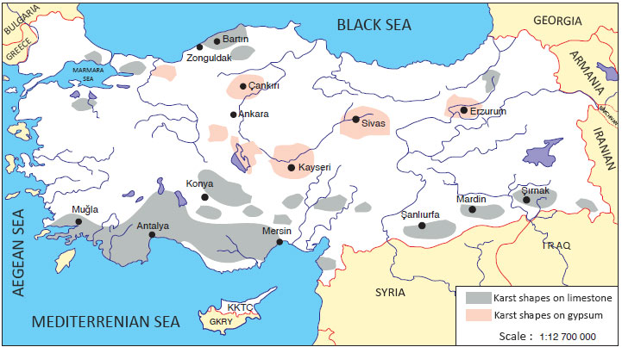

**Figure 1.** Karst regions of Turkey [9].

The study area is the village of İnandik, located at the 40th km of the Ankara road, in the south of the province of Çankırı, where karstic shapes on gypsum are commonly seen. The İnandik village is 803 meters above the sea level. The administrative area of the village is 26.53 km². In the İnandik village, the sinkhole formations occur due to the gypsum karstification. The map containing the location information of the study area is shown in the figure below (Figure 2).

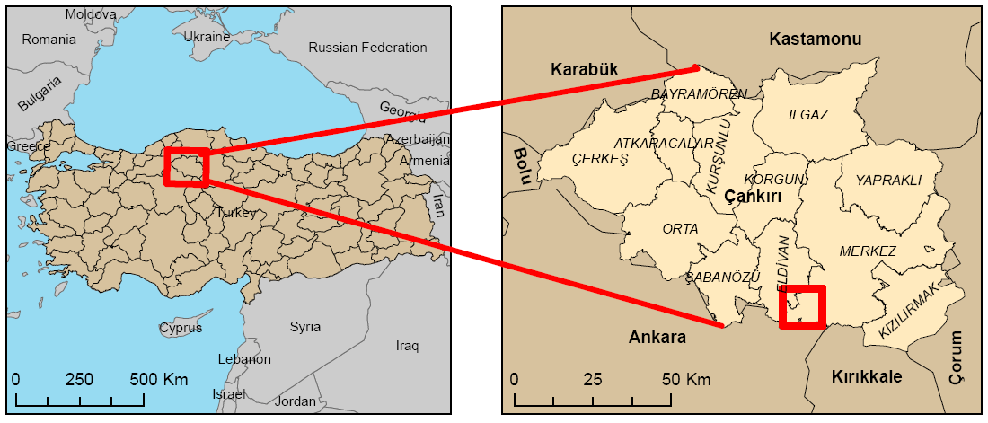  
**Figure 2.** Location of the study area [11].

Sinkhole formations, one of the macro forms in karstic lands, are the product of rapid dissolution. "Sinkhole" literally means pit, hollow, depression. Sinkholes are generally defined as karstic landforms that occur as a result of the collapse of underground cavities, which are formed as a result of the interaction of underground waters with soluble rocks, over time, unable to carry the load on them. Another definition of sinkhole is that it is the name given to deep pits similar to chimneys or wells that are formed as a result of the collapse of underground rivers or active cave ceilings in stratified limestone [8]. The depths of sinkholes can vary from a few meters to several hundred meters. Sinkholes, which take a regular circular shape especially on flat lands, may form oval on sloping lands. While it is seen that there is water at the bottom of some sinkholes, some of them appear dry.

In this study, some studies were carried out to obtain information about the soil characteristics of the region by examining the sinkhole formations in İnandik village and its surroundings. The aim of the study is to investigate the causes and consequences of the sinkholes formed close to the village settlement area and the gradual settlements that cause structural damage.

Studies on sinkhole formations in Turkey until today generally belong to the Konya region. Again, the studies on gypsum formations are mostly concentrated around Sivas. The studies in this regard for Çankırı and its surroundings are very limited. This study will be an important data source for other studies by partially filling the gap in the literature regarding both sinkhole formations and gypsum karst for Çankırı and its surroundings.

1. **Materials and Methods**

**2.1. On-site observation of sinkholes**

The sinkholes were observed in terms of both their size and type of soil they occurred in the place, and it was investigated whether there were other ground deformations in the vicinity. In addition, the sinkholes in the region were classified according to Walltham and Fokes (2005) and their characteristics such as the year of formation, altitude, diameter, depth and rock type were determined [10].

**2.2. Detection of structural damage on buildings located in the residential area**

The fact that the sinkholes were formed close to the settlement and the gradual settlement of the ground in the settlement caused structural damage to the buildings there [11]. The structural damages were determined as a result of the examinations made in the region.

**2.3. Boreholes**

In the study area, three boreholes were drilled by the Çankırı Provincial Directorate of Disaster and Emergency [6]. By examining the drilling logs obtained from these boreholes, information about the soil properties of the study area was obtained.

**2.4. Sampling from research pits and point load test**

Since the study area consists of gypsum-bearing units and the gypsum is extremely fragile and soluble, two research pits were opened in the region to collect samples with minimum damage. The strength values were obtained by applying the point load test on the samples obtained. The point load index is used to classify the rocks according to their strengths [11].

**2.5. Measurement of discontinuities observed in gypsum-bearing units**

As a result of on-site investigations in the study area, some discontinuities were observed in gypsum units. The discontinuities measured with the help of a tape measure have occurred as a result of the surface waters dissolving and deforming the gypsum layers. The dimensions of the measured discontinuities were classified according to ISRM (2007) [5].

**2.6. Geological Properties**

Lithological, tectonic and volcanic characteristics of the ground, as well as the groundwater and flow direction, have a great impact on the formation of sinkholes. Here, the effect of lithology is relatively greater. The limestone, gypsum, dolomite and rock salt, which are soluble rocks, are the lithological elements where the karstification is most common.

The region in which the study area is located contains gypsum series belonging to the Bozkır formation [1]. Determining that the dominant rock type in the region is gypsum will be useful in determining the causes of environmental problems in the formation of sinkholes and gradual ground settlements etc. There are also occasional landslides caused by the dissolutions in the gypsum series in the Bozkır formation [7].

1. **Results and Discussion**

**3.1. Evaluation of sinkhole observations in the study area**

Until today, total of 8 sinkholes have occurred in the study area. The years in which these sinkholes were formed were examined before 1953 and after 1953 [4]. The oldest sinkhole has occurred before 1953 and the most recent sinkhole occurred in 2012 (Figure 3). The height of the sinkholes from sea level varies between 832 - 927 m. The diameters of the sinkholes vary between 1 - 44 m, and their depths vary between 1 - 22.5 m. Three types of sinkholes were observed in the study area. These are; collapse sinkhole, dropout sinkhole, and buried sinkhole [11].

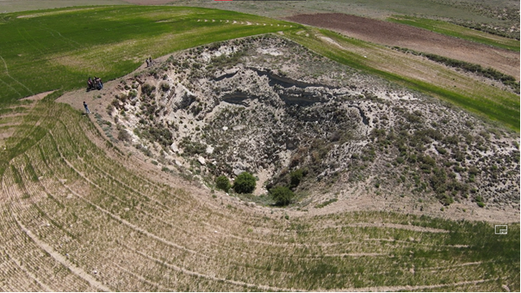  
**Figure 3.** The oldest and biggest sinkhole in study area.

The sinkhole formations in the study area, the year of formation, altitude information, diameter, depth and type of sinkhole are given in Table 1.

**Table 1.** Characteristics of the sinkholes in the study area [4].

|  |  |  |  |  |  |
| --- | --- | --- | --- | --- | --- |
| Sinkhole No | Year  of formation | Altitude (m) | Diameter(m) | Depth(m) | Sinkhole Type |
| 1 | Before 1953 | 877 | - | - | Buried Sinkhole |
| 2 | Before 1953 | 882 | 44 | 22.5 | Collapse Sinkhole |
| 3 | Before 1953 | 881 | 5 | - | Buried Sinkhole |
| 4 | Before 1953 | 886 | 12 | - | Buried Sinkhole |
| 5 | Before 1953 | 916 | 7 | - | Buried Sinkhole |
| 6 | 1953-1971 | 927 | 13.5 | - | Buried Sinkhole |
| 7 | 1990-2008 | 832 | 1 | 1 | Dropout Sinkhole |
| 8 | 2012 | 898 | 13 | 10 | Dropout Sinkhole |

**3.2. Evaluation of structural damages**

Within the scope of field studies, the damages of the buildings in the settlement were examined on site [11]. According to the information received from both the local people and the official institutions of the province, the most recent sinkhole formation occurred in 2012 [4-6-11]. Especially after the formation of the last sinkhole, the damage observed in the structures and the anxiety of the local people have increased (Figure 4).

**Figure 4.** Images of damaged buildings from the study area [11].

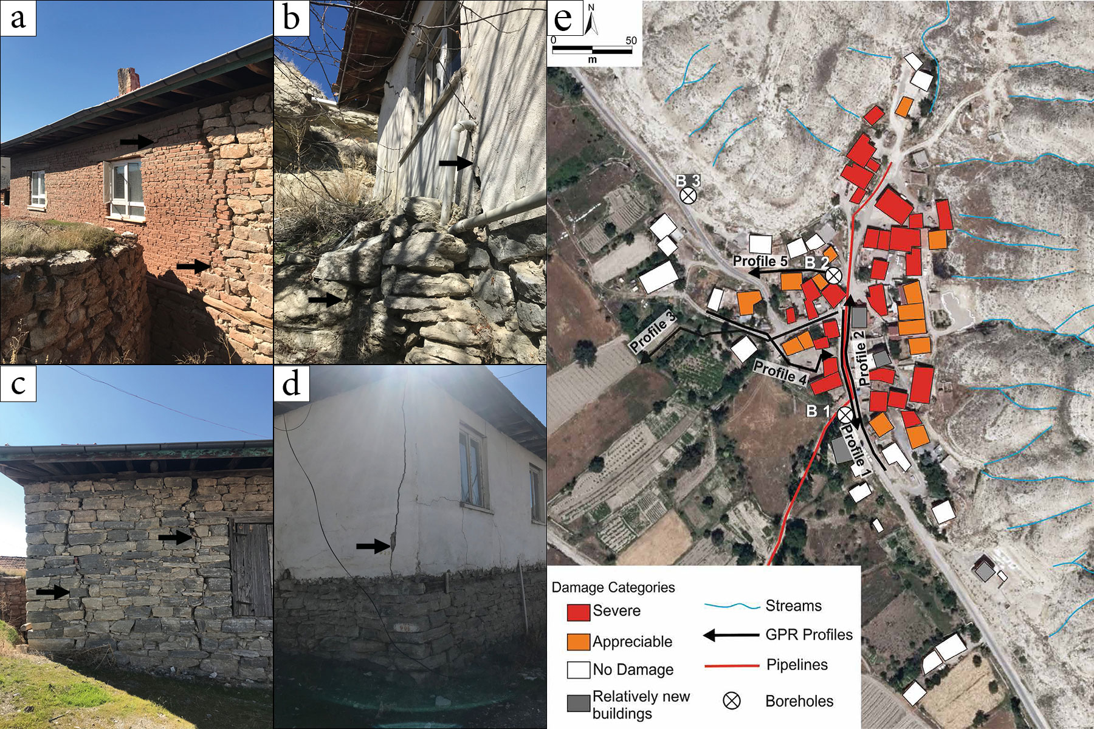

A damage assessment study was carried out in the study area [6]. The buildings within the area were evaluated in 4 categories (Figure 4). These 4 categories are that; the buildings shown in red color represent heavily damaged buildings, the buildings in orange color represent slightly damaged buildings, the buildings shown in white color are undamaged and the buildings in gray color represent relatively new residences. The dominant color scale is red and orange, indicating that most buildings are damaged.

**3.3. Evaluation of data from boreholes**

Three boreholes were drilled in and around the settlement area [6]. From three boreholes as SK-1, SK-2 and SK-3, the "molten gypsum" units in places were observed in SK-1 and SK-2. These dissolved gypsums encountered near the surface indicate that the ground is affected by surface waters. The drilling SK-3 was made in a relatively safe area and was observed that there was no gap. The findings obtained from the studies indicate that dissolved gypsum layers can be found in other parts of the ground and explain the reason for the gradual soil settlements.

**3.4 Evaluation of the samples taken from the research pits and the results of the point load test performed**

Two research pits were dug to take samples from the study area [11]. The point load strength index was calculated on the samples taken from this research pit.

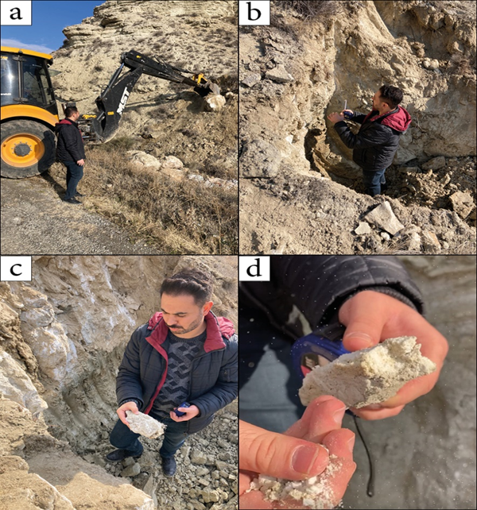  
**Figure 5**. (a) A view from the exploration pit opening. (b) A view from Research Pit-1. (c) A view from Research Pit-2. (d) An image of the altered gypsum sample, which disperses even in hand [11].

**Table 2.** Point load test samples and parameters [11].

|  |  |  |  |  |  |  |
| --- | --- | --- | --- | --- | --- | --- |
| SampleName | D(cm) | W(cm) | A=W\*D(cm²) | De²=4A/ $π$ (cm²) | F=(De/50)^0,45 | P (kgf) |
| 1 | 4.11 | 5.38 | 22.1 | 28.17 | 1.03 | 65 |
| 2 | 4.28 | 6.11 | 26.2 | 33.31 | 1.07 | 75 |
| 3 | 3.11 | 5.98 | 18.6 | 23.69 | 0.99 | 86 |
| 4 | 3.55 | 6.24 | 22.2 | 28.22 | 1.03 | 105 |
| 5 | 4.17 | 6.36 | 26.5 | 33.78 | 1.07 | 115.5 |
| 6 | 3.91 | 5.22 | 20.4 | 26.00 | 1.01 | 72.5 |
| 7 | 4.03 | 6.19 | 24.9 | 31.78 | 1.06 | 82.5 |
| 8 | 5.28 | 7.33 | 38.7 | 49.30 | 1.17 | 69.5 |
| 9 | 5.11 | 6.80 | 34.7 | 44.26 | 1.14 | 76.8 |
| 10 | 3.99 | 6.11 | 24.4 | 31.06 | 1.05 | 81.5 |

In the point load test, firstly, the uncorrected point load strength value (Is) is found by Equation (1) using the force (P) with which the specimen is defeated, the diameter of the specimen (D) and the axial length (W) of the specimen. However, in order to obtain a standard point load strength value, the correction is made according to the equivalent core diameter determined as 50 mm. It is expressed as the corrected point load strength value (Is50) and found with the help of the Equation (2).

*Is=P/De²* (1)

*Is50=F\*Is* (2)

In this test performed on 10 samples, the highest and lowest two strength values were ignored and the average of the remaining 6 strength values was taken (Table 3).

**Table 3.** Point load test results [11].

|  |  |  |
| --- | --- | --- |
| Pit name | Sample name | Is50 (kPa) |
| A.Ç-1 | 1 | 232.45 |
| A.Ç-1 | 2 | 235.51 |
| A.Ç-1 | 3 | 351.70 |
| A.Ç-1 | 4 | 374.97 |
| A.Ç-2 | 5 | 358.76 |
| A.Ç-2 | 6 | 275.87 |
| A.Ç-2 | 7 | 268.71 |
| A.Ç-2 | 8 | 161.06 |
| A.Ç-2 | 9 | 193.48 |
| A.Ç-2 | 10 | 270.23 |
| Average | | 272.41 |

Since the average Is50 value found is less than 1 MPa, the rock class was determined as "very low strength" when a classification was made according to Table 4.

**Table 4.** Classification of rocks according to point load strength [2].

|  |  |
| --- | --- |
| Rock Class | Point Load Strength (Is50) (MPa) |
| Very Low Strength | <1 |
| Low Strength | 1-2 |
| Medium Strength | 2-4 |
| High Strength | 4-8 |
| Very High Strength | >8 |

**3.5. Evaluation of discontinuities observed in gypsum units**

During the examinations made in the study area, some discontinuities were observed in gypsum units (Figure 6) [11]. While these discontinuities are sometimes in large sizes, they can sometimes be observed in small fractures. In all probability, the discontinuities observed are indicative of weathering in the rock and at the same time it is the harbinger of the decrease in the strength of rock. These discontinuities can sometimes take the form of a cavity, sometimes horizontally and sometimes vertically. The aperture values of the discontinuities are classified as defined in ISRM (2007) (Table 5).

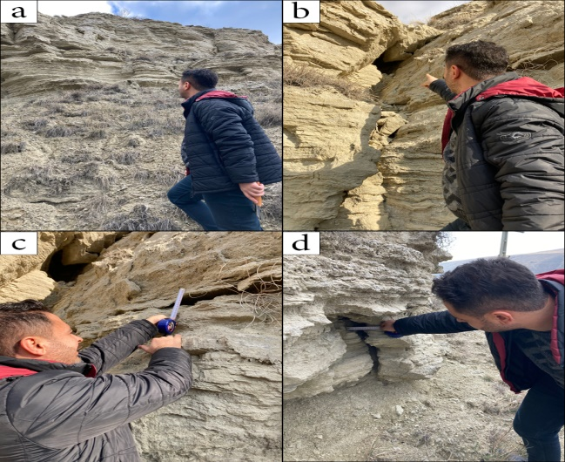  
**Figure 6.** (a) A view of the gypsum units in the study area. (b) An image of cavity resulting from dissolution in the gypsum unit. (c) A view of the horizontal discontinuities occurring in the gypsum unit. (d) A view of the vertical discontinuities occurring in the gypsum unit [11].

**Table 5.** Aperture definition criteria for discontinuities [5].

|  |  |  |
| --- | --- | --- |
| Aperture (mm) | Definition | |
| <0,1 | Very Tight | Close Structures |
| 0,1 – 0,25 | Tight |
| 0,25 – 0,5 | Partly apertured |
| 0,5 – 2,5 | Apertured | Apertured Structures |
| 2,5-10 | Medium Wide |
| >10 | Wide |
| 1-10 | Very Wide | Open Structures |
| 10-100 | Extremely Wide |
| >100 | Open |

Classification of discontinuities occurring in gypsum in the region varies as "apertured structures" and "open structures" according to Table 5. Since the discontinuity in Figure 6(b) is considerably more than 100 mm, it is possible to define it as "open". Since the horizontal discontinuity observed in Figure 6(c) is around 50 mm and the vertical discontinuity observed in Figure 6(d) is around 80 mm, it is possible to define it as “extremely wide” [11].

**References**

1. Ateş, Ş., Özata, A., Gülmez, F. K., Osmançelebioğlu, R., Mutlu, G., Özerk, O. C., Yeleser, L. ve Üstün, A. B. (2008). Geoscience data of Çankırı Province and urban areas (province-district centers). Ankara, 220 p.
2. Bieniawski, Z. T. (1975). The point load test in geotechnical practice. *Engineering Geology*, *9*, 1-11.
3. Doğan, U. (2002). Subsidence Dolines Formed by Gypsum Karstification at The East of Çankırı. *G.U. Journal of Gazi Educational Faculty*, *22*(1), 67-82.
4. Gökkaya, E. and Tunçel, E. (2019). Natural and human-induced subsidence due to gypsum dissolution: a case study from Inandik, Central Anatolia, Turkey. *Journal of Cave and Karst Studies*, *81*(4), 221-232.
5. ISRM. (2007). The complete ISRM Suggested Metodts for Rock Characterization, Testting and Monitoring: 1974-2006. *Suggested Methots Prepared by the Commission on Testing Metohods, ISRM,* R. Ulusay and J.A. Hudson (eds.), Compilations Arranged by the ISRM Turkısh National Group Ankara, Kozan ofset; 628 p., Turkey.
6. Özçelik, A., Yiğit, A. E., Işık, B., Arıtürk, M. A., Özen, Ö. and Büyükurvayli, B. (2016). Determination of karstic cavities and sinkholes by geophysical methods: Inandık Village Application, in Keskin, İ., and Göloğlu, C., eds., *Proceedings of International Symposium on Natural Hazards and Hazard Management,* 543-549.
7. Sarıfakıoğlu, E., Erin, B., Tırın, M., and Sezgin, İ.İ. (2021). Landslides caused by gypsum levels in Çankırı. *4. International Uni-DOKAP Symposium. Book of proceedings*, 98-113.
8. Şen, M. (2018). Use of unmanned aerial vehicle images for disaster management and Karapınar colapsed. Master thesis, Necmettin Erbakan University. 56 p., Konya.
9. URL. https://www.cografyaci.gen.tr/turkiyede-karstik-sekiller/ Date of access: 20.07.2022.
10. Waltham A. C. and Fookes P. G. (2005). Engineering classification of karst ground conditions, *Speleogenesis and Evolution of Karst Aquifers*, 3, 1-20.
11. Yıldız, M. S. (2022). Investigation of Cankiri Inandık village sinkhole disasters in terms of soil characteristics. Master thesis. Cankiri Karatekin University. 71p., Çankırı.