**Optimization based energy management approach for prosumers located in**

**small-scale microgrids**

***Enes BEKTAŞ1,\* [C:\Users\Abdullah\AppData\Local\Microsoft\Windows\INetCache\Content.Word\ORCID-iD_icon-16x16.gif](https://orcid.org/0000-0002-8380-4519), Mohammad Ruhul Amin BHUIYAN2  [C:\Users\Abdullah\AppData\Local\Microsoft\Windows\INetCache\Content.Word\ORCID-iD_icon-16x16.gif](https://orcid.org/0000-0001-7335-4158)***

*1Engineering Faculty, Electrical and Electronics Engineering Department, Çankırı Karatekin University, Çankırı, Türkiye*

*2Faculty of Engineering and Technology, Electrical and Electronic Engineering Department, Islamic University, Dhaka, Bangladesh*

|  |
| --- |
| **Abstract**  Benefits of integrating renewable energy resources (RESs) into the electrical grid include increased efficiency and less strain on transmission lines and the need for significant infrastructure investments. Therefore, presents new difficulties, though, like over-voltage and stability issues, which could endanger the dependability and safety of the power supply. Energy management system (EMS) can increase efficient use of produced renewable energies. Thus, EMS contributes positively to solving the mentioned problems in networks. This paper proposes and presents an optimization-based energy management system for prosumers with PV panel and battery equipment located in small scale microgrids. The objective function is determined as to prosumer bill minimization ensuring maximum power injection to the grid. |
| Keywords: Energy management system, Microgrid, Optimization, Prosumer |

1. Introduction

The global demand for clean and sustainable energy has intensified research into advanced materials capable of driving efficient energy conversion technologies. Thin-film materials form the foundation of both photovoltaic (PV) and thermoelectric (TE) technologies [1-3], facilitating the development of efficient and sustainable energy conversion devices. Their integration offers significant potential for advancing next-generation energy systems.

Over the past ten years, a lot of residential clients have expressed a strong desire to install PV plants on their property, although on a small scale on the roofs of their homes. The LV distribution network is where these PV installations are situated. The distribution system's typical operating behaviour is impacted as a result of the quick increase in PV penetration.

The grid is supported by energy storage devices in terms of voltage. An association with battery energy storage systems (BESS) is also offered as an alternative for the issues driven on by the widespread installation of PV systems. The goal is to temporarily store extra active power for usage at night or during times of high demand [4, 5]. In this situation, creating an efficient solution requires careful design of numerous important elements. These factors include storage capacity, infrequent charging, protection against deep discharge or overcharging, and compatibility with the current infrastructure (load characteristics, load types, etc.).

[6] examines prosumer-based energy management systems (PEMS) in smart grid systems and their effects on energy sustainability and power system dependability in detail PEMS has tremendous promise for peak load balancing, energy conservation, and cost reduction. EMS for energy sharing between neighbours in residential micro grids is presented in [7]. Depending on whether solar photovoltaic (PV) and battery energy storage systems are installed, homes in residential micro grids are divided into three categories: traditional, proactive, and enthusiastic. [8] describes an energy management system to help prosumers coordinate their operations. It has been found that working cooperatively with other prosumers in a local setting result in greater performance. Both PV and ESS are part of the system. The objective function is to maximize the usage of available generation and reduce each household's load disconnection.

[9] investigations into grid-connected AC-coupled PV and BESS configurations. The goal of this study is to solve the over-voltage problems generated on by PV penetration by using customer-owned BESS devices. The BESS unit's active power set points are determined using an optimization-based scheduling technique. It has been shown that over-voltage problems can be resolved with residential BESS units without materially altering the main requirements of BES owners.

[10] seeks to maximize PV use, increase load supply, and reduce cost from the use of generating units. The system consists of PV, ESS, and wind. There are two stages in the best planning strategy. The first step involves fixing the voltage fluctuations brought on by P. Investments in equipment and line losses are employed to optimize ESS operation.

By taking into account both physical limitations and prerequisites for a practical deployment in the real network, [11] maximizes income for selling energy produced by photovoltaic arrays while minimizing the cost of electricity received from the main grid.

In order to reduce the operational and maintenance costs of PV and ESS, [12] works on the basic microgrid topology, emphasizing that PV maintenance costs should be disregarded. The forecasting module is in charge of temperature, load demand, and solar irradiance. The best day-ahead scheduling is carried out by the optimization module. The only constraint applied is power balance [12]. Reliable intra-day forecasting methods are necessary to optimize the EMS's benefits. In order to generate the prediction, the applied tools mostly rely on modelling the PV or using previous data [13]. So as to maintain the day-ahead energy forecasts and give the system operator relevant data, it is necessary to have a self-adjusting forecasting tool.

This research offers an optimization-based energy management system for prosumers equipped with photovoltaic panels and battery systems inside small-scale microgrids. The objective function is established to minimize the prosumer's bill while maximizing power injection to the grid. The total of the bill is determined as a value, indicating that the prosumer can earn by selling generated solar electricity to the grid. The profit derived by augmenting battery capacity and photovoltaic output capacity could be further enhanced.

1. Defining of Basis Formulation for EMS

A simple structure of prosumer at low voltage grid and connection to medium voltage can be expressed as in Figure 1. As shown in Figure 1, DC or AC microgrid system term is not included. Because this paper focuses on not microgrid type but control of AC or DC microgrid with EMS.

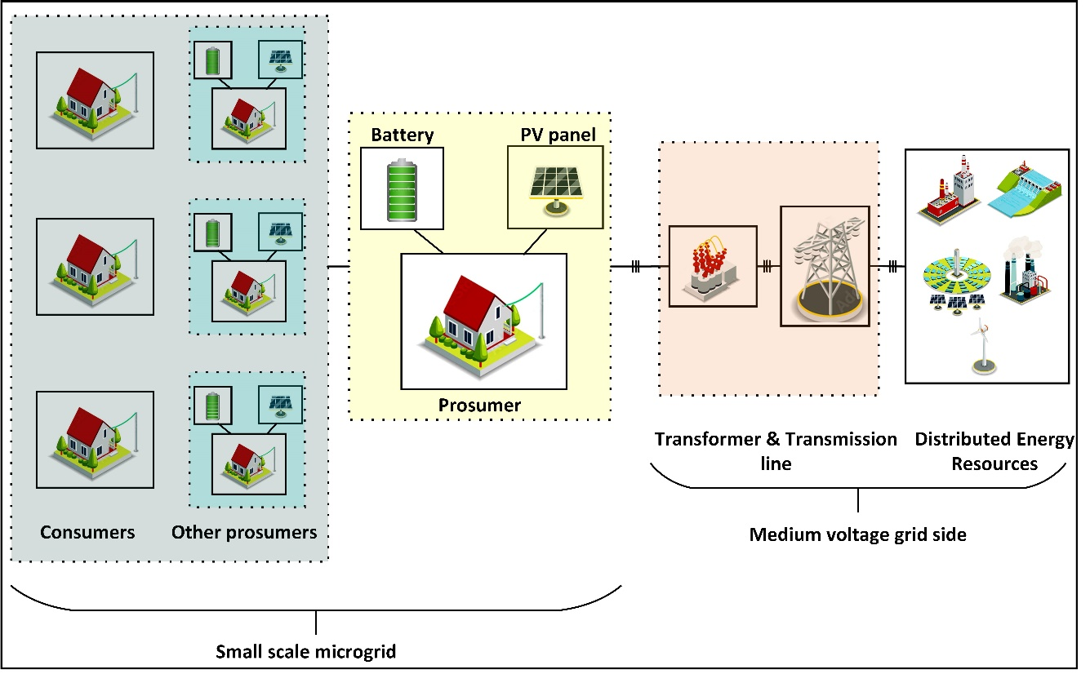

**Figure 1**. General diagram of low voltage microgrid and connections medium voltage

Proposed EMS concentres on one prosumer energy management system and minimizing of bill of the prosumer. Energy management formulations can be derived by using parameters given in Table 1.

Table 1. Basic parameters of EMS formulations

|  |  |  |
| --- | --- | --- |
| **Variable** | **Description** | **Unit** |
| $$t$$ | Time of 24 hour | [Hour] |
| $$P_{t}^{Panel}$$ | Solar power generation of PV panel (average) | [kW] |
| $$P_{t}^{Prosumer}$$ | Load demand of prosumer (average) | [kW] |
| $$P_{t}^{Charge}$$ | Battery charge | [kW] |
| $$P_{t}^{Discharge}$$ $${SOC}_{max}$$ $${SOC}_{min}$$ $${SOC}_{t}$$ | Battery discharge  Battery maximum capacity  Battery minimum capacity  Battery capacity | [kW]  [kWh]  [kWh]  [kWh] |
|  |  |  |

Objective function, to be minimized in optimization process, includes prosumer bill formulations. Bill formulation can be derived by using parameters given in Table 2. Prosumer’s bill can be formulized as in Equation (1).

Table 2. Parameters of bill in EMS formulations

|  |  |  |
| --- | --- | --- |
| **Variable** | **Description** | **Unit** |
| $$P_{t}^{Inj}$$ | Injected power from prosumer to grid (average) | [kW] |
| $$P_{t}^{Abs}$$ | Absorbed power from grid to prosumer (average) | [kW] |
| $$p_{t}^{Inj}$$ | Price of average injected power | [TL]/[kWh] |
| $$p_{t}^{Abs}$$ | Price of average absorbed power | [TL]/[kWh] |
| $$B$$ | Calculated bill of prosumer | [TL] |
|  |  |  |

$B=\sum_{t=1}^{24}{({p_{t}}^{Abs}.{P_{t}}^{Abs}-{p_{t}}^{Inj}.{P_{t}}^{Inj})}$ (1)

It can be understood from Equation (1) that if bill is lower than zero, prosumer can make profit from the EMS. Therefore, the further the bill value is from 0, the more profit the producing prosumer makes.

The power balance, an equality constraint for the EMS optimization problem, must be formulated and presented in Equation (2). The total of the PV power, battery charge and discharge power, power absorbed from the grid, and electricity supplied to the grid must equal zero for every hourly interval. The values for battery charging and discharging, as well as absorbed and injected grid power—which are opposing values—can simultaneously be zero, or only one of them must equal zero. The optimization configuration must adhere to this guideline. The principle can be highlighted in solver-based optimization techniques. Nonetheless, particularly optimization strategies based on soft computing do not permit this. In soft computing-based optimization methods, the difference between the two values must be computed, and the charge/discharge or received/given value should be assessed based on whether the difference is positive or negative, necessitating a corresponding modification of the objective function. The identified issue can be regarded as the most challenging aspect in the implementation of soft computing-based energy management techniques.

${P_{t}}^{Panel}+{P_{t}}^{Discharge}+{P_{t}}^{Abs}-{P_{t}}^{Inj}-{P_{t}}^{Charge}-{P_{t}}^{Prosumer}=0$ (2)

Other constraints are defined for Battery. Battery charge and discharge power cannot be lower than zero and greater than battery power. And, state of charge (SOC) at ant t time, time interval of (t-1) hour and t hour, affects next time period and is affected by previous time period. The SOC equation is given in equation (3). Thus, the battery inequalities can be defined as in Equations (4)-(6)

${SOC}_{t+1}={SOC}_{t}+\left(η_{chg}*{P_{t}}^{Charge}-\frac{{P_{t}}^{Discharge}}{η_{dcg}}\right)$ (3)

where ${SOC}_{t+1}$ is the battery state of charge value for next time interval, $η_{chg}$ is the battery charge efficiency and $η_{dcg}$ is the battery discharge efficiency. And, $P_{max}$ is defined as battery power. Generally, in the literature, the initial energy value of the battery, ${SOC}_{0}$, is taken as between 90% and 70% of its energy capacity. For this reason, in this paper optimization is run with 70% SOC value. Battery power is determined as 50kW and energy capacity is 85kWh.

${P_{t}}^{Charge}≤P_{max}$ (4)

${P_{t}}^{Discharge}≤P_{max}$ (5)

${SOC}_{min}≤{P_{t}}^{Discharge}≤{SOC}_{max}$ (6)

In this paper, GLPK solver/Python is used for optimization tool. The GLPK (GNU Linear Programming Kit) software is designed for addressing large-scale linear programming (LP), mixed integer programming (MIP), and associated difficulties. It comprises a collection of routines authored in ANSI C and structured as a callable library [14]. Finally, optimization-based EMS input and outputs is illustrated in Figure 2.

|  |
| --- |
|  |

**Figure 2**. Interaction of Python based GLPK Solver and input/output data for EMS

1. **Results**

By running the optimization tool battery charge and discharge power are scheduled. In Figure 3, obtained results are given.

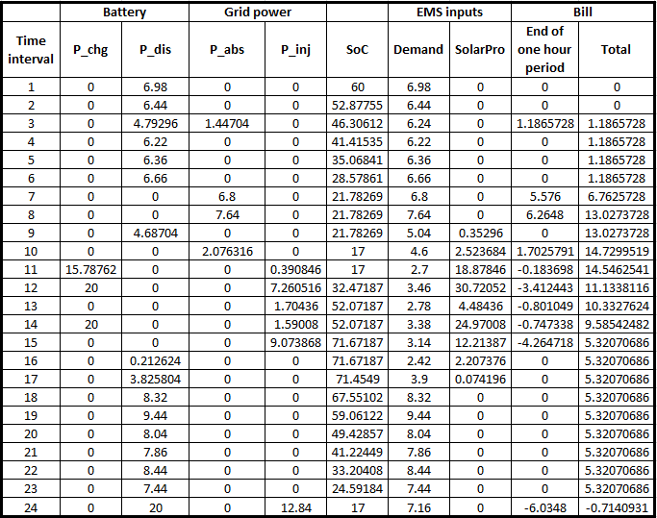

**Figure 3.** Results of Python based GLPK Solver based EMS

As seen in Figure 3, the battery is discharged between 0 and 01:00 hour (for t=0) and quantity of discharged is 6.98 kW. And power balance equation is satisfied and can be verified using Equation (2) as; $0+6980+0-6980-0-0=0$**.** At the end of first-time interval, final SOC is calculated as 52.83 kWh with Equation (3). Calculated SOC is the initial SOC parameter for second time interval. For each time interval, calculated hourly bill is illustrated too. The total bill is calculated as – value, means that prosumer can make profit by selling generated solar power to the grid side. The profit obtained by increasing the battery capacity and PV production capacity can be further increased. For this purpose, it is recommended to conduct more detailed studies considering the system installation cost. In Figure 4, optimization outputs are given visually for the system operation, load profile and PV profile to be more easily interpreted together. Power balance is equal to zero as desired for optimization output. As stated in Section 2, Battery charging and discharging values, absorbed grid power and injected grid power which are opposite values. In EMS, power quality equality constraints are satisfied successfully by proposed method.

****

**Figure 4.** Demand, PV production, SOC, hourly charge and discharge, Pabs, Pinj for 24-hour

1. **Conclusion**

Within the scope of this investigation, an optimization-based method to energy management is provided and meticulously discussed. Both the load profile and the PV profile of the prosumer have been chosen at random in accordance with certain generic characteristics. For prosumer, the constraints are described in extensively. For the purpose of making it easier to grasp the results of optimization simultaneously, the system operation, load profile, and PV profile are all displayed graphically. It is necessary for there to be no power imbalance in order to achieve maximum production. It has been demonstrated that the proposed method is capable of successfully satisfying the power quality equality restrictions with minimized prosumer bill.

**References**

1. Bhuiyan, M. R. A., Alam, M. M., & Momin, M. A. (2010). Effect of substrate temperature on the optical properties of thermally evaporated ZnS thin films. TURKISH JOURNAL OF PHYSICS. <https://doi.org/10.3906/fiz-0902-9>
2. Bhuiyan, M. R. A. (2022). Overcome the future environmental challenges through sustainable and renewable energy resources. Micro & Nano Letters, 17(14), 402–416. <https://doi.org/10.1049/mna2.12148>
3. Bhuiyan, M. R. A., Mamur, H., & Dilmaç, Ö. F. (2020). Review on Performance Evaluation of Bi2Te3-based and some other Thermoelectric Nanostructured Materials. Current Nanoscience, 17(3), 423–446. <https://doi.org/10.2174/1573413716999200820144753>.
4. Alam, M. J. E., Muttaqi, K. M., & Sutanto, D. (2013). Mitigation of Rooftop Solar PV Impacts and Evening Peak Support by Managing Available Capacity of Distributed Energy Storage Systems. *IEEE Transactions on Power Systems*, *28*(4), 3874–3884. <https://doi.org/10.1109/tpwrs.2013.2259269>
5. Liu, X., Aichhorn, A., Liu, L., & Li, H. (2012). Coordinated Control of Distributed Energy Storage System With Tap Changer Transformers for Voltage Rise Mitigation Under High Photovoltaic Penetration. *IEEE Transactions on Smart Grid*, *3*(2), 897–906. <https://doi.org/10.1109/tsg.2011.2177501>
6. Rehman, Z., Mahmood, A., Razzaq, S., Ali, W., Naeem, U., EE, (2017, July). Prosumer based energy management and sharing in smart grid (journal-article). Renewable and Sustainable Energy Reviews. Retrieved from <http://dx.doi.org/10.1016/j.rser.2017.07.018>
7. Akter, M., Mahmud, M., & Oo, A. (2017). A Hierarchical Transactive Energy Management System for Energy Sharing in Residential Microgrids. *Energies*, *10*(12), 2098. <https://doi.org/10.3390/en10122098>
8. Luna, A. C., Díaz, N. L., Graells, M., Vásquez, J. C., & Guerrero, J. M. (2016, September). Cooperative Energy Management for a Cluster of Households Prosumers. *Department of Energy Technology*.
9. Ranaweera, I., Midtgård, O., & Korpås, M. (2017). Distributed control scheme for residential battery energy storage units coupled with PV systems. *Renewable Energy*, *113*, 1099–1110. <https://doi.org/10.1016/j.renene.2017.06.084>
10. Xu, T., Meng, H., Zhu, J., Wei, W., Zhao, H., Yang, H., Ren, Y. (2018). Considering the Life-Cycle Cost of Distributed Energy-Storage Planning in Distribution Grids. *Applied Sciences*, *8*(12), 2615. <https://doi.org/10.3390/app812261>
11. Luna, A., Diaz, N., Savaghebi, M., Vasquez, J. C., Guerrero, J. M., Sun, L. (2016). Optimal Power Scheduling for a Grid-Connected Hybrid PV-Wind-Battery Microgrid System (journal-article). *IEEE* (p. 1227). <https://ieeexplore.ieee.org/document/7472016>
12. Tayab, U. B., B., Yang, F., El-Hendawi, M., & Lu, J. (2018). Energy Management System for a Grid-Connected Microgrid with Photovoltaic and Battery Energy Storage System. (Swinburne University of Technology), *2018 Australian & New Zealand Control Conference (ANZCC)* (p. 141). IEEE. <https://doi.org/10.1109/ANZCC.2018.8602017>
13. International Energy Agency. (2013). World Energy Outlook 2013. *World Energy Outlook*. <https://iea.blob.core.windows.net/assets/a22dedb8-c2c3-448c-b104-051236618b38/WEO2013.pdf>
14. <https://anaconda.org/conda-forge/glpk>