**A THESIS SUBMITTED TO**

**THE GRADUATE SCHOOL OF NATURAL AND APPLIED SCIENCES**

**OF ÇANKIRI KARATEKİN UNIVERSITY**

**BODY COMPOSITION ANALYSIS, BLOOD PRESSURE, VIT D3, FERRITIN, IRON, TSH AND CBC IN SERA OF PATIENTS WITH HAIR LOSS**

**IN PARTIAL FULFILLMENT OF THE REQUIREMENTS**

**FOR**

**THE DEGREE OF MASTER OF SCIENCE**

**IN**

**CHEMISTRY**

**BY**

**RAAD HAFEDH MAHMOOD ALKARAWI**

**ÇANKIRI**

**2022**

BODY COMPOSITION ANALYSIS, BLOOD PRESSURE, VIT D3, FERRITIN, IRON, TSH AND CBC IN SERA OF PATIENTS WITH HAIR LOSS

By Raad Hafedh Mahmood ALKARAWI

May 2022

We certify that we have read this thesis and that in our opinion it is fully adequate, in scope and in quality, as a thesis for the degree of Master of Science

**Advisor :** Assoc. Prof. Dr. Şevki ADEM

**Co-Advisor :** Prof. Dr. Nasser M. F. AL-RUBAIE

**Examining Committee Members:**

**Chairman :** Prof. Dr. Volkan EYÜPOĞLU

Chemistry

Çankırı Karatekin University

**Member :** Asst. Prof. Dr. Ümit YIRTICI

Medical Laboratory

Kırıkkale University

**Member :** Assoc. Prof. Dr. Şevki ADEM

Chemistry

Çankırı Karatekin University

**Approved for the Graduate School of Natural and Applied Sciences**

**Prof. Dr. İbrahim ÇİFTÇİ**

**Director of Graduate School**

**I hereby declare that all information in this document has been obtained and presented in accordance with academic rules and ethical conduct. I also declare that, as required by these rules and conduct, I have fully cited and referenced all material and results that are not original to this work****.**

**Raad Hafedh Mahmood ALKARAWI**

# ABSTRACT

BODY COMPOSITION ANALYSIS, BLOOD PRESSURE, VIT D3, FERRITIN, IRON, TSH AND CBC IN SERA OF PATIENTS WITH HAIR LOSS

Raad Hafedh Mahmood ALKARAWI

Master of Science in Chemistry

Advisor: Assoc. Prof. Dr. Şevki ADEM

Co-Advisor: Prof. Dr. Nasser M. F. AL-RUBAIE

May 2022

This study was carried out to investigate some biochemical aspects in Iraq patients with hair loss compared to non-hair loss individuals. Recent studies on hair loss are one of the pathological and therapeutic challenges in the world. In the past 10 years, the chemical parameters of vitamin D3, ferritin and blood viscosity in hair loss have played a large role in new research, including in dermatology and especially hair loss. Vitamin D3, serum ferritin, TSH, and blood viscosity in hair loss. A prospective case study includes 50 male patients with hair loss and 50 male person with non-hair loss individuals causes. aged from 20-40 years old in Iraq / Baghdad. The results showed that the levels of hair loss patients significantly decreased when compared with non-hair loss individuals (P < 0.05). in each of the following parameters. Vitamin D3, serum ferritin, and basal metabolic rate. The blood pressure of the hair loss patients also decreased according to the chi-square test, while the levels below increased significantly when compared with those of the non-hair loss individuals (p < 0.05). body fat mass and the HCT level in plasma. While HB level in plasma, TSH and serum iron level non significant change occurred when compared with non-hair loss individuals (P < 0.05).

**2022, 46 pages**

**Keywords:** Hair loss, Vit D3 with hair loss, Iron defetionsy, Diffused hair loss.

# ÖZET

SAÇ DÖKÜLMESİ OLAN HASTALARIN SERALARINDA VÜCUT KOMPOZİSYON ANALİZİ, KAN BASINCI, VİT D3, FERRİTİN, DEMİR, TSH VE CBC

Raad Hafedh Mahmood ALKARAWI

Kimya, Yüksek Lisans

Tez Danışmanı: Doç. Dr. Şevki ADEM

Eş Danışman: Prof. Dr. Nasser M. F. AL-RUBAIE

Mayis 2022

Bu çalışma, saç dökülmesi olan Iraklı hastalarda, saç dökülmesi olmayan bireylere göre bazı biyokimyasal yönleri araştırmak amacıyla yapılmıştır. Saç dökülmesi ile ilgili son çalışmalar, dünyadaki patolojik ve terapötik zorluklardan biridir. Son 10 yılda saç dökülmesinde D3 vitamini, ferritin ve kan viskozitesinin kimyasal parametreleri dermatoloji ve özellikle saç dökülmesi dahil olmak üzere yeni araştırmalarda büyük rol oynamıştır. Saç dökülmesinde D3 vitamini, serum ferritin, TSH ve kan viskozitesi. Prospektif bir vaka çalışması, saç dökülmesine neden olan 50 erkek hastayı ve saç dökülmesine neden olmayan 50 erkek kişiyi içerir. Irak / Bağdat'ta 20-40 yaş arası. Sonuçlar, saç dökülmesi olan hastaların düzeylerinin, saç dökülmesi olmayan bireylerle karşılaştırıldığında önemli ölçüde azaldığını gösterdi (P < 0.05). aşağıdaki parametrelerin her birinde. D3 vitamini, serum ferritin ve bazal metabolizma hızı. Saç dökülmesi olan hastaların kan basıncı da ki-kare testine göre düşerken, altındaki düzeyler saç dökülmesi olmayan bireylere göre anlamlı olarak arttı (p < 0.05). vücut yağ kütlesi ve plazmadaki HCT seviyesi. Saç dökülmesi olmayan bireylerle karşılaştırıldığında plazmada HB, TSH ve serum demir düzeylerinde anlamlı olmayan değişiklik meydana geldi (P < 0.05).

**2022, 46 sayfa**

**Anahtar Kelimeler:** Saç dökülmesi, D3 vitamini ile saç dökülmesi, Demir eksikliği.

# PREFACE AND ACKNOWLEDGEMENTS

I would like to thank my thesis advisor, Assoc. Prof. Dr. Şevki ADEM and Prof. Dr. Nasser M. F. AL-RUBAIE, for his patience, guidance and understanding.

**Raad Hafedh Mahmood ALKARAWI**

**Çankırı-2022**

# CONTENTS

ABSTRACT i

ÖZET ii

PREFACE AND ACKNOWLEDGEMENTS iii

CONTENTS iv

LIST OF SYMBOLS vii

LIST OF ABBREVIATIONS viii

LIST OF FIGURES ix

LIST OF TABLES x

1. INTRODUCTION 1

1.1 Aim of the Thesis 2

2. LITERATURE REVIEW 3

2.1 General Knowledge 3

2.2 Human Hair Growth 3

2.3 Hair Anatomy 4

2.3.1 Dermal papillae 5

2.3.2 Matrix of hair 5

2.3.3 The root sheath's outer sheath 5

2.3.4 Sheath of the inner root 6

2.3.5 Hair shaft 6

2.4 Hair Loss Types 7

2.4.1 Telogen effluvium 7

2.4.2 Androgenic Alopecia 8

2.4.3 Alopecia Areata 8

2.4.4 The occurrence of alopecia areata 8

2.4.5 Androgenetic Alopecia (Pattern Hair Loss) 9

2.5 The Hair Cycle 10

2.5.1 Anagen-the period of growth 10

2.5.2 Catagen-the regressive phas 11

2.5.3 Telogen-the phase of rest 11

2.6 The Role of Vitamins in Hair Loss 12

2.6.1 Vitamin D and hair loss 12

2.6.2 Biotin and hair loss 13

2.6.3 Polyphenols and hair loss 13

2.7 Supplement and Minerals that promote hair growth are Fe, Zn, Cu, and Se 14

2.7.1 Supplementation 14

2.7.2 Iron and hair loss 14

2.7.3 Ferritin and hair loss 15

2.7.4 Zinc and Copper and hair loss 15

2.7.5 Selenium and hair loss 16

2.8 Hemoglobin and Hematocrit 16

2.9 Body Composition Analysis 17

3. MATERIALS AND METHODS 20

3.1 Materials 20

3.1.1 Equipment 20

3.2 Methods 21

3.2.1 Body composition analysis (In body 270) 21

3.2.2 Blood pressure measurements 22

3.2.3 Determination of Serum vitamin D3 22

3.2.4 Determination of serum ferritin 23

3.2.5 Determination of serum tsh 23

3.2.6 Assay procedure for CBC 24

3.3 Statistical Analysis 24

4. RESULTS AND DISCUSSION 25

4.1 Results 25

4.1.1 Blood pressure measurements 25

4.1.2 Body fat mass levels 25

4.1.3 Basal metabolic rate 27

4.1.4 Serum vitamin D3 28

4.1.5 Serum ferritin 30

4.1.6 Serum iron 32

4.1.7 Thyroid stimulating hormone serum 34

4.1.8 Hematocrit HCT level 35

4.1.9 Hemoglobin Hb level 37

5 CONCLUSIONS AND RECOMMENDATION 39

5.1 Conclusions 39

5.2 The Orginal Think in This Study 39

5.3 Recommendations (Suggestions) 40

REFERENCES 41

CURRICULUM VITAE 46

# LIST OF SYMBOLS

% Percent

± Plus-minus

°C Degrees Celsius

µL Microliter

dL Deciliter

g Gram

L Liter

m2 Square-meters

mg Milligram

mL Milliliters

ng Nanogram

Ulu Unusual incidents unit

# LIST OF ABBREVIATIONS

AA Alopecia areata

AGA Androgenetic alopecia

AI Adequate intake

BIA Bioelectric impedance analysis

DHT Di-hydro-testosterone

FPHL Female patron hair loss

Hb Hemoglobin

HCT Hematocrit

MPB Male pattern baldness

MPHL Man patron hair loss

RBC Red blood cell

TE Telogen effluvium

TSH Thyroid stimulating hormone

# LIST OF FIGURES

Figure ‎2.1 Human hair growth 4

Figure ‎2.2 Hair anatomy 5

Figure ‎2.3 Hair shaft 6

Figure ‎2.4 Male patient with alopecia areata 9

Figure ‎2.5 The hair cycle 12

Figure ‎2.6 Body composition analysis test 18

Figure ‎2.7 Studied sample for male pattern hair loss 19

Figure ‎3.1 Body composition analysis (In body 270) 21

Figure ‎4.1 Fat mass levels in body of non-hair loss individuals cases and hair loss patients (Mean ± SD) 26

Figure ‎4.2 Distribution of fat levels of non-hair loss individuals and hair loss patient 27

Figure ‎4.3 Basal metabolic rate levels in body of non-hair loss indivituals cases, and hair loss patients (Mean ± SD) 28

Figure ‎4.4 Serum vit D3 levels in sera of non-hair loss individuals cases, and hair loss' patients (Mean ± SD) 30

Figure ‎4.5 Distribution of vitamin D3 levels of non-hair loss individuals and hair loss patients 30

Figure ‎4.6 Serum ferritin levels in sera of non-hair loss indivituals cases, and hair loss patients (Mean ± SD) 32

Figure ‎4.7 Distribution of ferritin levels of non-hair loss individuals and hair loss patient 32

Figure ‎4.8 Serum iron levels in serum of non-hair loss indivituals cases and hair loss patients (Mean ± SD) 34

Figure ‎4.9 TSH levels in sera of non-hair loss indivituals cases and hair loss patients (Mean ± SD) 35

Figure ‎4.10 HCT levels in whole blood of non-hair loss indivituals cases, and hair loss patients (Mean ± SD) 37

Figure ‎4.11 Distribution of HCT levels of non-hair loss individuals and hair loss patient 37

Figure ‎4.12 HB levels in whole blood of non-hair loss indivituals cases and hair loss patients (Mean ± SD) 38

# LIST OF TABLES

Table ‎2.1 Hair loss types 7

Table ‎3.1 Apparatus used in the study 20

Table ‎4.1 Bio statistical calculation and student t-test for body fat mass levels in body of non-hair loss individuals cases and hair loss patients 26

Table ‎4.2 Bio statistical calculation and student t-test for body Basal Metabolic rate levels in body of non-hair loss individuals cases, and hair loss patients 27

Table ‎4.3 Bio statistical calculation and student t-test for vit D3 levels in sera of non-hair loss individuals cases, and hair loss patients 29

Table ‎4.4 Bio statistical calculation and student t-test for ferritin levels in sera of normal healthy controls, and hair loss patients 31

Table ‎4.5 Bio statistical calculation and student t-test for Iron levels in serum of normal healthy controls, and hair loss patients 33

Table ‎4.6 Bio statistical calculation and student t-test for TSH levels in sera of non hair loss indivituals cases and hair loss patients 34

Table ‎4.7 Bio statistical calculation and student t-test for HCT levels in plasma of normal healthy controls, and hair loss patients 36

Table ‎4.8 Bio statistical calculation and student t-test for HB levels in whole blood of normal healthy controls, and hair loss patients 38

# INTRODUCTION

Most males under 50 lose hair from this condition. Androgenetic alopecia in men is normally ignored although for others it causes distress. Male Androgentic Alopecia Damages Hair Follicles anagen hair shrinks and telogen hair grows during an androgenetic alopecia patient's cycle. Anagen phase too short to reach the surface results in an empty follicular pore. 5-alpha reductase converts testosterone to DHT, which targets hair follicles. It's 2.5 times stronger and twice as effective as testosterone. DHT harms hair follicles (Choi et al. 2022). This causes hair loss. Protein, minerals, essential fatty acids, and vitamins are among the macro- and micronutrients that promote hair growth. Iron is necessary for metabolism and can cause hair loss. Iron deficiency is linked to a variety of clinical illnesses due to its many functions. Hair loss has been connected to non-anemia iron shortage. Most alopecia patients are given iron supplements because doctors believe low iron storage causes hair loss. But there's no evidence to back this up (Tahlawy et al. 2021). Vitamin D is also vital for hair development and health. This vitamin may help prevent hair loss. Vitamin D is an inactive precursor that requiring two hydroxylation steps: once in the liver and once in the kidney before it can be transformed to 1,25-dihydroxyvitamin D3 (calcitriol), the active hormone. (Najm et al. 2021).

Consumption of dietary lipids influences hair retention in skin integument (through cholesterol). Saturated fatty acids may also cause this condition. Lipid complexes combine free fatty acids, ceramides, and sterols to protect the skin and its products. Lack of these substances in the body may induce hair loss due to dehydration. Lactic, linolic, and linolenic acid deficiencies induce hair loss. These polyunsaturated plant oils contain omega-6 polyunsaturated fatty acids, which are essential for a healthy diet. (Goluch-Koniuszy 2016). Keratin is a sulfur amino acid .can cause brittle thin or balding hair Follicles. Keratin is the main component of hair shafts and hair shields. Flexibility is provided by keratin fibres. Hair without keratin (the hair barrier) splits easily. Carbs and hair a diet high in simple sugar has been associated to balding. Simple carbs boost sebum production. Sebum improves hair in moderation, but too much feeds skin bacteria. Simple carbs can create glycaemic and insulin abnormalities. Insulin elevates DHT levels. In addition to hypoxia, it causes hair loss.therefore, A diet high in complex carbohydrates. (Goluch-Koniuszy 2016). The significance of this study is in determining the true cause of hair loss and the appropriate therapy for this condition, as this disease may create many issues for people, particularly those aged 20 to 40, and hair transplantation does not cure the problem. Because the primary cause of hair loss is unknown at this time, this study attempts to identify the primary cause of hair loss. This study was conducted to investigate the possible clinical influence of the following parameters on the progression of hair loss: vitamin D3; ferritin, iron, TSH, CBC, in sera, body composition analysis, and blood pressure. An attempt has been made to ascertain the impact of these variables on hair loss.

## Aim of the Thesis

The purpose of this study includes for the following:

1. This study aims to discover the primary cause of hair loss, which is currently unknown.
2. These indicators (vitamin D3, ferritin, iron, TSH, CBC, and in sera as well as body composition analysis and blood pressure) were examined in this study to see if they could have a clinical influence on hair loss.
3. There has been some investigation on the relationship between these variables and hair thinning.

# LITERATURE REVIEW

## General Knowledge

Hair grows from follicles in the dermis. Most people's confidence depends on their hair. The human hair shaft has three different microstructures. A cuticle protects the intermediate cortex in the medulla, a disorganised and open area in the fiber's core. The hair cuticle is made up of dead flat cells. Protection of the inner cortex is the cuticle's principal job. Keratin filaments help cuticle cells stay firm. All across the human body are hair follicles (e.g., non-hairy palms). The condition of one's hair can reveal one's health (Guryanov *et al.* 2022)

## Human Hair Growth

People's hair is unique because of the wide range of variations in hair follicles and, as a result, hair shafts that may be found in the human body. In addition, a single hair follicle can produce a wide variety of hair types. Pregnancy, childhood, and adulthood all create the same type of hair from the same follicles. Genetically, the quantity and location of hair follicles remain consistent throughout one's entire life (Anastassakis 2022). On the soles of the feet, the inside of the mouth and lips, the backs of ears, palms of hands, some external genital sites, the navel and scar tissue there is no hair growth. Multi-layered flat cells make up the multi-stranded filamentous epithelium that is hair (Figure 2.1).

Keratin, the protein that makes up hair, encourages hair growth. Anagen, catagen, and telogen are the three distinct stages of hair growth. Vellus hair and androgenic hair are just two examples of the many types of hair that exist on the human body, each with its own distinct cellular structure. The hair's varied structure gives it a wide range of characteristics (Trost *et al.* 2006). 90% of scalp hair follicles are in the anagen stage, whereas 5-15% are in the telogen stage. In the catagen stage, only a few follicles remain An average of 50–150 hairs fall out each day. It might take months to years for a person's hair to grow to its full potential. Scalp hair has a longer anagen phase than body hair. The following are the main points: (1.1) (Kanwar and Narang 2013).

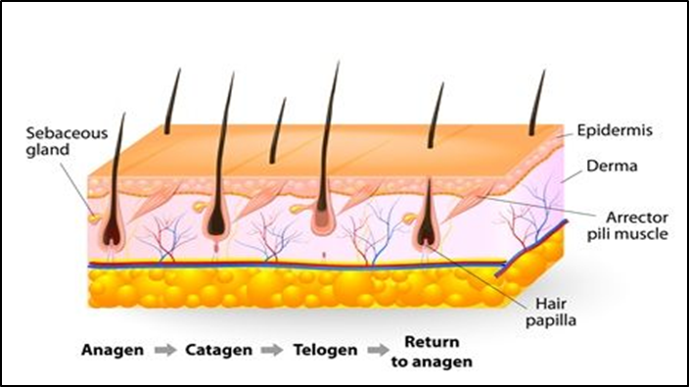

Figure ‎2.1 Human hair growth

## Hair Anatomy

Hair follicles develop in the scalp's fatty layer. "Follicular units," as they're known in the medical community, are clusters of one to four hairs that form from a single follicle. Hair follicle formation occurs at the base of each follicle in the hair bulb. It is through these blood vessels that hair follicles obtain their nourishment from the dermis. Cells divide and develop to make the hair follicle. When hair is still forming beneath the skin, it is particularly vulnerable. When it breaks through the epidermis, the outer layer of hardens into keratin (Anastassakis 2022). Human hair is made up of between 65 and 95 percent proteins, depending on the individual. The human hair cuticle contains a number of different amino acids, including cysteic acid, proline, threonine, isoleucine, methionine, leucine, tyrosine, and phenylalanine (Figure 2.2). Lipids and pigment, as well as trace elements attached to proteins or fatty acids, make up the remaining ingredients (Faruk *et al.* 2018).

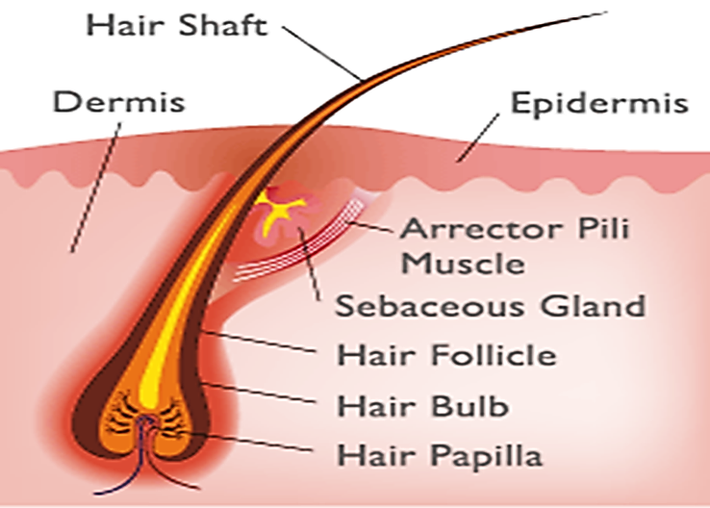

Figure ‎2.2 Hair anatomy

### Dermal papillae

Atopic Dermatitis The androgen receptors in the dermal papilla are activated by the hormone dihydrotestosterone (DHT) (1.2) (Guryanov *et al.* 2022)

### Matrix of hair

The outer and inner root sheaths, as well as the hair shafts, are all produced in the matrix, which contains all of the active cells essential for hair growth and development. The matrix surrounds the dermal papillae. Matrix and dermal papillae, which are both in the dermis, form the hair bulb.

### The root sheath's outer sheath

Hair's trichelemma is the outermost root sheath that has been keratinized. Through an epidermal pore and the dermal hair follicles it covers, it emerges from the dermal layer and reaches the outer skin (Guryanov *et al.* 2022).

### Sheath of the inner root

The Henley, Huxley, and cuticle layers make form the inner root sheath when broken down into its constituent parts. The Henley and Huxley's layers are made up of capsular layers that connect to one another in order to maintain the hair in place. Protecting the hair shaft from the elements is done by the cuticle, which is made up of dead, rigid cells. Combined with the Henley and Huxley layers' capsular layers, this holds the hair in place and encourages it to grow longer (Tan *et al.* 2019).

### Hair shaft

As the hair shaft emerges from the skin, it is the only part of the follicle that is visible. A hair strand is made up of three parts: the medulla, cortex, and cuticle. The medulla is an irregular structure found at the base of the hair follicle, but it is not always present. The cortex, in contrast to the medulla, is exceptionally well-organized. The cortex, which is composed of keratin, is responsible for hair's strength, durability, and water absorption. Hair colour is determined by the amount, distribution, and type of melanin granules in the cortex. The cuticle, the hair's outermost layer of defence, is internally connected to the root sheath (Figure 2.3). A single lipid molecule layer in the hair's complex structure aids in its water-repellent properties (Table 2.1) (Rudnicka *et al.* 2018).

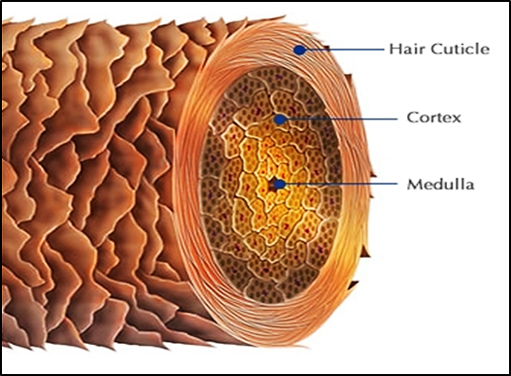

Figure ‎2.3 Hair shaft

Table ‎2.1 Hair loss types

|  |  |
| --- | --- |
| Alopecia | A condition characterized by abnormal hair loss. |
| Alopecia areata | Is characterized by patchy hair loss produced by an autoimmune inflammatory reaction to the follicle. |
| Alopecia totalis | Is Total autoimmune hair loss on the scalp is referred to as alopecia totalis. |
| Alopecia universalis | Is characterized by complete autoimmune hair loss on the scalp and body. |
| Anagen effluvium | A halt in the regular hair growth cycle, most usually caused by chemotherapeutic drugs. |
| Androgenetic alopecia (Pattern Hair Loss) | Is a genetically defined loss of hair in either a male (frontal recession and vertex thinning) or female pattern (loss of hair over the crown with sparing of the frontal hairline). |
| Hair bulb | The lowest region of the hair follicle that contains rapidly growing cells. |
| Telogen effluvium | Is the losing of hair caused by a disruption in the hair cycle, resulting in an increased proportion of hair follicles entering the telogen phase. |
| Traction / Scarring Alopecia | Is a kind of hair loss caused by societal, cultural, and aesthetic practices. |
| Trichotillomania | Is a psychological compulsive illness characterized by excessive hair plucking (Patel *et al.* 2013). |

## Hair Loss Types

Some or most of the most common hair loss cases include folliculitis, alopecia areata, telogen effluvium, anagen fluid, lichen planus, traction/scarring alopecia, and androgenetic alopecia (typical hair loss).

### Telogen effluvium

Non-pattern increase in terminal hair shedding occurs over the entire scalp, with an apparent thinning of hair that ranges from mild to severe. Resting or Telogen effluvium. Exudation from the telogen phase Acute and chronic forms of this illness are possible. The follicle's transition from the resting stage known as catagen to a more active resting stage known as telogen can lead to premature anagen. Researchers (Najm 2021). Diffuse, non-scarring hair loss can be caused by telogen effluvium, which is a common condition (TE). With a precise diagnosis in the acute stage, the patient's anxiety can be relieved. Hair loss that is chronic may go untreated for a lengthy amount of time, though (Grover and Khurana 2013).

### Androgenic Alopecia

Dihydrotestosterone is the most common cause of androgenic alopecia. This disorder is the most common cause of hair loss in humans. The androgen sensitivity of hair follicles plays a major part in this non-regenerative hair loss, which is controlled and altered by androgens (di-hydro-testosterone, DHT). On the scalp, both sexes are impacted by a decrease in terminal hair density, as well as an increase in the number of telogen hairs (Khatu *et al.* 2014).

### Alopecia Areata

Autoimmune skin disease that is unpredictable Scalp hair loss and hair loss on other regions of the body are caused by Alopecia Areata. Hair follicle autoimmunity may be to blame for AA's symptoms, although the exact aetiology is still unknown. Auto-reactive T-cell lymphocytes and a range of cytokines, all of which have a negative impact on hair growth, are involved in hair follicular degeneration. Nearly one in seven people worldwide, including more than 4.7 million people in the United States, are impacted by this common yet challenging and unpredictable disorder. It can have a huge impact on one's life and functional level because many people are still unfamiliar with the disease, which can have a significant impact on one's life and functional status.

### The occurrence of alopecia areata

There is a blockage in hair growth in alopecia areata because white blood cells misdirect their attention. In most cases, the first signs of alopecia areata are one or more small, round, smooth bald patches on the scalp, although it can progress to complete hair loss on the scalp or the entire body (alopecia universalis). Men and women of all ages and races are affected by alopecia areata, although it is most common in youngsters, where it can have a significant impact on their mental well-being. It's not life-threatening, but alopecia areata can have a severe psychological impact on those who suffer from its unpredictable onset and recurrence (Figure 2.4) (Chanprapaph *et al.* 2022).

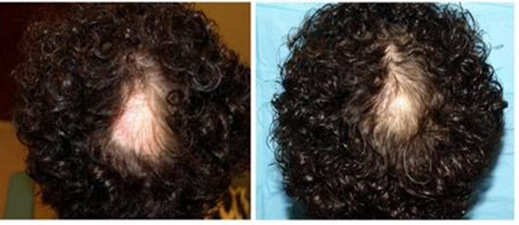

Figure ‎2.4 Male patient with alopecia areata

### Androgenetic Alopecia (Pattern Hair Loss)

Pathophysiology: Male pattern baldness affects the front-vertical scalp. Affected hairs become finer and less pigmented, resembling vellus hairs (Whiting 1998). Beyond physical protection, hair loss or damage can affect mental health and possibly cause major social problems. AGA is the most common type of hair loss in both men and women. AGA hair loss is caused by follicle shrinking, resulting in symmetric baldness. AGA is connected to two types of hair loss. MPHL is characterised by a receding frontal hairline and balding of the vertex area. Hair loss occurs in the centre of the scalp, but not at the frontal hairline. Hair loss is still mislabeled as masculine or female. As a result, most researchers regard MPHL and FPHL as different entities with distinct clinical and therapeutic manifestations. FPHL has no susceptibility locus/gene, and its aetiology looks separate from MPHL (Chen *et al.* 2021).

Hair loss can occur for numerous reasons, including: Pregnancy/postpartum hair loss, hormonal imbalance, nutritional inadequacies.

## The Hair Cycle

Research into the dynamic system that controls hair growth is ongoing. During this process, hair follicles are formed, elongated, and shed. Human hair has anagen, catagen, and telogen follicles (Tiwari *et al.* 2021). Growth, involution, and rest are the only three states that ever exist in a hair follicle (telogen) To find the chemical cues that control hair follicle development, hair researchers face many challenges. Hair follicle cycle has been studied in mice, and some molecular pathways have been identified.

Many growth factors and growth factor receptors are required to correctly cycle hair follicles, but no one growth factor appears to have complete control (Alonso *et al.* 2006). Human hair growth occurs in three-phase cycles, with hair follicles showing intermittent activity. Two to seven years is the anagen (growth phase). During the anagen phase, epidermal cells multiply and grow at a rate only rivalled by that of hemopoietic tissue. Keratinization is a constant process in hair. Anagen phase length, which varies with age and hair type, determines hair length (Anastassakis 2022). Three unique stages of hair growth are involved in this dynamic process. The length and appearance of hair in different parts of the body can be affected by the length and duration of these stages. In the basal matrix of the hair follicle, mitotic division is extremely high, resulting in the growth of hair. The hair grows continually on the scalp throughout this period (Schneider *et al.* 2009).

### Anagen-the period of growth

The genesis of a new lower hair follicle is reenacted by the proliferation of secondary germ cells in the bulge during the anagen stage. The same proteins and signalling processes are not known to cause womb foliculogenesis and adult anagen. Both procedures require dermal papilla-follicular epithelium interactions. IGF-1 and FGF-1 are released chemicals that regulate hair follicle development and cycling. Its receptors are present in the matrix cells that cover it. It promotes and maintains folicle development in vitro. When the fibroblast growth factor receptor is disturbed, the formation of healthy hair follicles is significantly hampered. It is determined by the location of the hair follicles. For example, while scalp hair follicles can remain anagen for two to eight years, eyebrow follicles only remain anagen for two to three months. To notify the follicle to stop releasing anagen, it must first create fibroblast growth factor. (Randall and Botchkareva 2009).

### Catagen-the regressive phas

The majority of follicular keratinocytes undergo apoptotic cell death (apoptosis) when hair follicles reach the catagen state. Follicular melanogenesis halts and some follicular melanocytes die at this point. The dermal papilla condenses and rises above the hair follicle bulge, allowing it to rest beneath it. If the dermal papilla fails to reach the bulge during the catagen stage, the hair follicle stops cycling and falls out. For people who have a balding gene, the dermal papilla does not rise and interacts with the bulge stem cells, leading to permanent thinning of hair. Some mouse hair follicles are destroyed unexpectedly during the catagen stage by an inflammatory cell infiltration. In some cases of persistent alopecia, it's possible that organ loss is the cause (Randall and Botchkareva 2009).

### Telogen-the phase of rest

During the telogen stage, the hair shaft turns into a club hair, which falls out of the follicle while brushing or washing. During the anagen stage, when new hair grows in, it's unclear if shedding is managed, active, or passive. Every day, 50-150 hairs fall from the scalp. The cycle of anagen and telogen hair phases is repeated every two to three months. The percentage of telogen hair follicles varies greatly depending on body geography (e.g., 5 to 15 percent of scalp follicles are in the telogen stage at any one time, as compared with 40 to 50 percent of follicles on the trunk). Over-shedding happens when telogen phase increases. Thus, drugs that protect or reduce the percentage of follicles in this stage could help treat hair loss (Alotaibi 2018). Circumstances might disrupt the hair formation cycle, causing temporary hair loss. So, here they are: Depression is a common symptom of thyroid illness and radiation/chemotherapy. Hormonal and nutritional imbalances, as well as skin diseases (Figure 2.5).

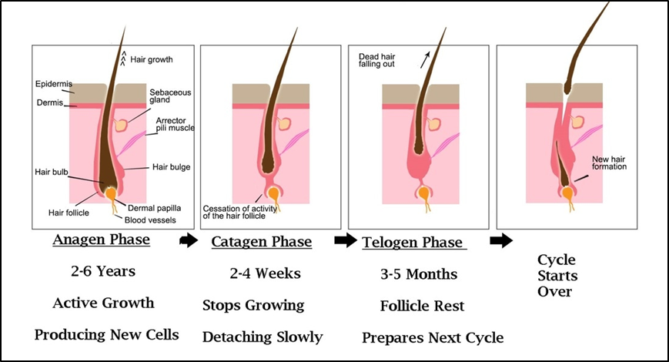

Figure ‎2.5 The hair cycle

## The Role of Vitamins in Hair Loss

Hair loss is one of the most common dermatological diseases that vitamin and mineral supplementation and nutrition are asked to help treat or prevent. Trying to answer these issues might be a challenge because of the sheer volume and variety of data. 100 thousand hair follicles cover the human head. For healthy hair to develop, the majority of them are anagen, which necessitates the addition of proteins, vitamins, and minerals to the diet. The incidence of hair loss and the significant impact it has on a patient's quality of life make alopecia care an essential part of clinical dermatology. It is possible to have an androgenetic alopecia, an effluvium of the hair, or an alopecia areata, all of which are non-scarring conditions. Non-scarring alopecia may be linked to micronutrient deficiencies for a variety of causes. The follicular bulb's rapidly dividing matrix cells are a source of micronutrient-dependent cellular turnover. Diet and nutrition have a wide range of effects on hair loss (Rasheed *et al.* 2013).

### Vitamin D and hair loss

Dermal keratinocytes produce fat-soluble vitamin D. The anti-inflammatory and immunomodulatory characteristics of vitamin D, a vitamin and hormone, are critical in dermatology and dermatotherapeutics. The hair cycle is also affected by it (Saini and Mysore 2021). An enzyme must be used to activate vitamin D obtained from diet or skin synthesis. When 7-dehydrocholesterol is metabolised by the skin, it becomes cholecalciferol, which is hydroxylated in the liver and kidney to 1,25(OH)2D. Vitamin D deficiency has been linked to hair loss. Hair follicles depend on vitamin D for growth. An alopecia areata patient's lack of it has been related to the condition. It has been found that those with alopecia areata lack vitamin D significantly more than those who do not suffer from the condition. A population of keratinocyte stem cells residing in the bulge of hair follicles depends on the function of their vitamin D3 receptors. The loss of hair follicles is caused by vitamin D insufficiency, which affects stem cell function (Saini and Mysore 2021). Vitamin D3 and its role in a wide range of disorders, including hair loss, have become more prominent in Iraq and around the world in recent years (Najm *et al.* 2021).

### Biotin and hair loss

Carboxylase enzymes require water-soluble biotin (vit B7 or vitamin H) as a cofactor in various metabolic processes. Because of its low price and wide availability in beauty products, biotin has become the new must-have for those seeking longer, healthier hair and nails. According to current recommendations from the Institute of Medicine, an adult's daily adequate intake (AI) for biotin is 30 grammes. Supplementing their meals with up to 1,000 g of biotin a day is not necessary for the vast majority of healthy persons. In spite of a paucity of studies examining the true benefits of biotin for hair and nail growth, it has not been found to be hazardous in high doses (Patel *et al.* 2017).

### Polyphenols and hair loss

Most polyphenols in human diets are antioxidants like flavonoids, which are well-studied. Flavones, anthocyanins, flavanones, and flavanoles interact structurally in a variety of ways. All of these interactions result in plant hormones, growth regulators, and enzyme inhibitors. Flavonides, which are anti-oxidant and anti-radical in their purest form, are found in the stratum corneum of the skin. Protect the skin's deeper layers from the harmful effects of UV radiation via altering enzyme activity Skin microcirculation is stimulated, and blood vessels in the corium are changed, supplying nutrients for hair. Flavonoids, which also safeguard vitamin C's activities, help increase absorption of vitamin C from the gastrointestinal system. The flavonoids in green tea increase the length of time that hair follicles spend in the anagen phase (Guo and Katta 2017).

## Supplement and Minerals that promote hair growth are Fe, Zn, Cu, and Se

### Supplementation

The Protein Chain and Amino Acids Lack of protein can cause hair thinning and loss. There was a study that looked at the important amino acid L-lysine and found that it may help with iron and zinc absorption. If iron treatment alone did not work for some women with chronic TE, the addition of L-lysine boosted mean serum ferritin concentrations considerably (Guo and Katta 2017). To make up for nutritional shortfalls, many people may benefit from taking nutritional supplements in addition to their regular diets. Zn, Cu, and Fe (particularly for vegetarians) are among the most commonly prescribed dietary supplements by dermatologists in the treatment of skin and hair abnormalities. Among the B-complex based examples are pantothenic acid and p-amino benzoic acid (Rasheed *et al.* 2013).

### Iron and hair loss

A lack of iron, the most common nutritional deficiency, has been related to a host of developmental problems, behavioural problems, intellectual problems, and even an increased susceptibility to infection in young children. Iron deficiency anaemia can be caused by a variety of factors, the most prevalent of which are gastrointestinal bleeding and malabsorption. Haemoglobin concentration can be used to screen for iron deficiency and serum ferritin concentration can be used to confirm the presence of iron shortage. Serum ferritin levels may rise in patients with a variety of diseases. Although iron deficiency has been associated to diffuse hair loss and telogen effluvium, this has not been demonstrated decisively. All patients with hair loss should be examined for iron inadequacy, but there is currently insufficient evidence to do so. In patients with hair loss and iron deficient anaemia, iron supplementation therapy should not be recommended because data does not support this suggestion. The decision-making process should be guided by clinical judgement. Hair loss, both cicatricle and noncicatricle, is caused by an iron shortage. Despite the lack of scientific backing, we believe treating iron deficiency, whether or not it is linked to anaemia, improves the efficiency of hair loss treatment. It is important to treat anaemia caused by iron deficiency. Anemia-free treatment for iron deficiency is a hot-button topic. The combination of a healthy diet and oral iron supplements helps alleviate anaemia brought on by a shortage of iron in one's diet. Overdosing on iron supplements, especially in people with hereditary hemochromatosis, can lead to iron overload. Patients who do not react to iron replacement medication should undergo additional testing to uncover any other underlying causes of iron deficient anaemia (Trost *et al.* 2006).

### Ferritin and hair loss

Nonerythroid cells need ferritin to bind iron. Also in iron storage. SER makes ferritin inside cells. The Golgi apparatus glycolyzes serum ferritin. Intracellular ferritin links serum ferritin to total body iron reserves. Because low serum ferritin levels solely indicate iron insufficiency, they are very selective (Rajput 2018). Iron storage is measured by serum ferritin, which is employed in hair loss research. Ferritin levels can rise in inflammatory, viral, neoplastic, and hepatic diseases. Balding ladies frequently lack iron. A long-standing controversy surrounds hair loss with low serum ferritin. (Almohanna) a shortage of iron-containing molecules and decreased oxygen transport to tissues. Henna matrix cells have lower ferritin and free iron levels than other cells. In addition to rib nucleotide reductase, iron may have a function in hair production. Hypoferremia can affect this enzyme's function, slowing cell development (Moeinvaziri *et al.* 2009).

### Zinc and Copper and hair loss

Trace elements are essential cofactors for many enzymes and play a role in hair follicle function. Zinc and copper are important micronutrients for metalloenzyme activity. Thirosinase and Lysyl Oxase are involved in melanin production and collagen cross linking (Jen *et al.* 2008). Anti-regression and anti-inflammatory properties of zinc. Acrodermatitis enteropathica hair loss due to zinc deficiency (Cheshire *et al.* 2009). Zinc and copper are essential trace metals for hair growth. Zn is an essential trace element. Zn is required for hair follicle health. It protects the sebum secreting glands and prevents hair dryness. A Zn2+ deficiency impairs hair follicle protein structure. Weakening follicles shed. Hair follicle cell division and hair growth are inhibited by zinc deficiency.

A copper shortage can cause cellular and Copper enlarges and thickens hair follicles. Cu inhibits 5-Alpha Reductase, the enzyme that transforms testosterone to DHT (DHT). In Cu deficiency, DHT accumulates. DHT causes male pattern baldness. Trace elements act at the atomic level. Anemia can induce alopecia(Rahman and Akhter 2019).

### Selenium and hair loss

As a key component of selenium protein, selenium has a role in a variety of functions including antioxidant defence, thyroid hormone production, DNA synthesis, fertility and reproduction. During keratinization, hair can absorb selenium, which is largely found in the blood, into its matrix. At least 35 proteins in the body contain selenium, many of which are enzymes, and both pseudo-albinism and hair loss are linked to selenium insufficiency. Excessive intake of selenium, which can cause hair loss in some but is far less prevalent than selenium shortage, can lead to this condition. Beef liver, cod, tinned tuna (and eggs), milk and dairy products are all sources of selenium (Chen *et al.* 2021).

## Hemoglobin and Hematocrit

Only haemoglobin is required for the binding of oxygen to red blood cells.

Red blood cells contain iron-containing haemoglobin, which can be measured. The hematocrit measures how much blood is made up of red blood cells. Because of the low cost and vast variety of standard supplies that they offer. Haemoglobin and hematocrit levels in blood can be used to identify iron insufficiency. Hematocrit and haemoglobin concentration are not affected by iron deficiency, although they are in severe IDA. Anaemia can have a variety of causes, and a drop in haemoglobin concentration or hematocrit does not always indicate this. Decreased haemoglobin concentration and hematocrit can be caused by deficiencies in folic acid and vitamin B12, thalassemia, sickle cell disease, chronic anaemia, renal failure.

## Body Composition Analysis

Obesity and muscle loss are connected to cardiovascular and metabolic illnesses. Skeletal muscle mass is a measure of general health and is required for movement, metabolism, and the influence of other organs. Muscle mass and strength decline in cardiometabolic disorders. Obesity in adolescents has been linked to cardiovascular disease, metabolic syndrome, and other health issues. Monitoring and analysing changes in body composition over time is critical for evaluating important health outcomes like muscle building and fat reduction, as well as functional status and health. This supplement promises to prevent hair loss, illness, and disease. There are currently numerous methods available to determine one's body composition. Bioelectrical impedance analysis (BIA) is touted to be a safe, noninvasive, quick, and low-cost procedure. The BIA approach is affected by hydration since it relies on tissue conductivity (extracellular water) People were first tested for their body fat percentage by lying on a table and being hooked up to an analysis gadget. A barefoot BIA gadget would let users to stand on a scale for a few seconds (Figure 2.6). Because of their low cost and ease of use, BIA scales have become popular for measuring body composition in large groups, such as field research. Due to their short testing period and rapid body composition data, BIA scales are gaining popularity in the fitness sector and clinical setting. It was used to assess body fat, basal metabolic rate, and BMI, as well as hair loss (Figure 2.7) (Larsen *et al.* 2021).

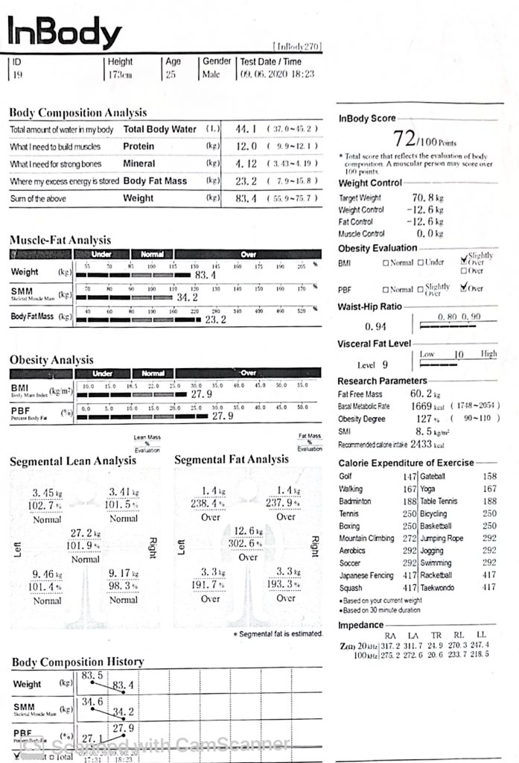

Figure ‎2.6 Body composition analysis test

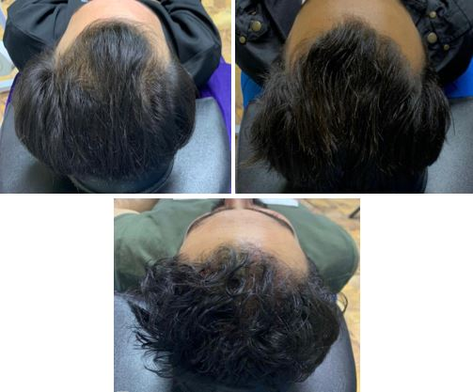

Figure ‎2.7 Studied sample for male pattern hair loss

# MATERIALS AND METHODS

3mL sera of 50 patients with hair loss only (group I) and 50 person without hair loss (group2) as control. Both group are 20-40 ages.

Biochemical tests include parameters (vit D3, Ferritin, Iron, TSH in sera, CBC in whole blood, and body Composition analysis, and blood pressure with hair loss) were determined in both groups.

A student t-test was used to see if the mean biochemical test values in the hair loss patient's group were different from those in the control group by a significant amount. P value <0.05 were considered significant.

## Materials

### Equipment

Table 3.1 all equipment used in this study is listed.

Table ‎3.1 Apparatus used in the study

|  |  |
| --- | --- |
| **NO** | **APPARATUS** |
| 1 | I Chroma II to measure vit D3 (Lot) VDRHC02 |
| 2 | I-Chamber solt. |
| 3 | UV-VIS Spectrophotometer |
| 4 | Centrifuge |
| 5 | Incubator |
| 6 | Afias-6 (boditech) To measure ferritin, (Lot) FRREA53F and Tsh (Lot) TSRCA75Q |
| 7 | Roller mixer |
| 8 | Mind ray bs-30s (complete blood count cbc) |
| 9 | Biochemistry bs-240 to measure Iron |
| 10 | In body 270 to measuer Body Composition analysis |
| 11 | Automatic micropipettes, to deliver 100 to 1000 µl, and pipette tips |
| 12 | Omron otomattic blood pressure model HEM-8712 TO mersure blood pressure |
| 13 | Automatic micropipettes, to deliver 10 to 100 µl, and pipette tips |

## Methods

### Body composition analysis (In body 270)

You can use it to see how much fat and water you're burning off. For each body type, the chart displays the weight that is desirable. for all ages, as well as nutrition plans Moreover, each patient with a long-term medical condition has a unique diet. Weight, water, fat mass, muscle mass, internal burning rate and percentage of body fat are all taken into account by the In Body 270. Multiple frequencies are used to calculate water content in and out of cells, and so the In Body gadget delivers more accurate findings for cell nutrition. Five distinct body regions each with their own distribution of fat and muscle (arms - legs - torso). As a result, it uses eight electrodes, two in each hand and two in each leg, which improves accuracy. Rather than relying on statistical tables, Bioelectric Impedance Analysis BIA is used in Body 270 to provide an accurate measurement of the subject's body (Figure 3.1).

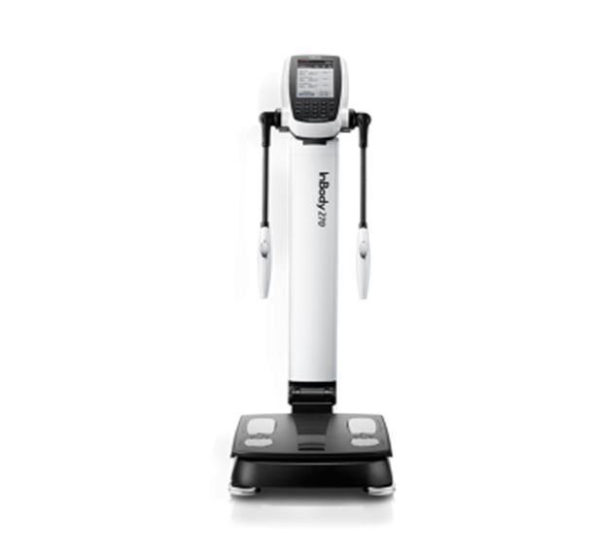

Figure ‎3.1 Body composition analysis (In body 270)

### Blood pressure measurements

Blood pressure was measured in hair loss sufferers and non-hair loss individuals. With an automatic blood pressure measuring device, model HEM-8712 from Omron Company. Chi segure was used to determine the significant of blood pressure in hair loss patient compared to non hair loss individuals. The results were compared according to the Chi square test.

### Determination of Serum vitamin D3

A completely automated equipment was used to estimate serum vitamin D3 levels.

Principle: It is possible to establish an antigen-antibody complex when antibodies in buffer attach to antigens contained in the sample and travel onto the nitrocellulose matrix to be captured by the other immobilized-antibody on the test strip There are more antigens present in a sample if the fluorescence signal from the detector antibodies is brighter, which is subsequently processed by the device for ichroma testing to evaluate vitamin D content.

Assay Procedure for vit D3 kit

* + 1. Place the test cartridge in the i-Chamber and close it.
    2. Transfer 50L of releasing buffer to a sample mixing tube using a transfer pipette.
    3. Transfer 50 mL of sample (Human serum/plasma/control) to the sample mixing tube using a transfer pipette while releasing buffer and mixing thoroughly by pipetting 10 times.
    4. Place the sample mixing tube in the inserting tube block and set the temperature to 35 degrees Celsius for 5 minutes.
    5. Transfer 100 mL of detection buffer to the sample mixing tube containing the releasing buffer and sample combination using a transfer pipette with a fresh tip.
    6. Combine 10 times with a pipette, then re-insert into the inserting tube block at 35°C for 15 minutes.
    7. Remove half of the test cartridge from the i-Chamber and pipette 75L of incubated mixer into the test cartridge's sample well. The test cartrigde should then be fully inserted into the i-Chamber.
    8. Leave the sample-loaded test cartrige in the i-Chamber for 8 minutes. You'll obtain an erroneous test result if you don't scan the sample-loaded cartridge as soon as the incubation period is up.
    9. To scan the sample-loaded cartridge, place it in the cartrigde holder of the ichromaTM testing instrument. Make sure the cartridge is in the correct position before placing it all the way into the cartridge holder. For this reason, a special arrow has been painted on the cartrigde.
    10. Press the Select button on the instrument to perform ichroma TM tests. to initiate the scanning process.
    11. The ichroma TM testing instrument will immediately begin scanning the sample-loaded cartrigde.
    12. Read the test result on the instrument's display screen for ichromaTM testing.

### Determination of serum ferritin

A completely automated equipment was used to estimate serum ferritin levels.

Principle: As part of the sandwich immunodetection approach, the detector antibodies in buffer are bound to antigens and migrate onto nitrocellulose matrix, where the other immobilised antibody on the test strip is used to collect the antigen-antibody combination. Samples containing more antigen will yield higher fluorescence signals from detector antibodies, which are used in AFIAS assays to measure ferritin concentration in a sample.

### Determination of serum tsh

Automated devices were used to estimate TSH levels in the bloodstream.

Principle: The other immobilised antibody in the buffer catches the antigen-antibody complex as it migrates onto the test strip. This is an immunodetection sandwich strategy. An AFIAS test uses a fluorescence signal from detector antibodies to assess the sample's TSH concentration. The fluorescence signal is subsequently analysed by the equipment.

### Assay procedure for CBC

* + 1. draw a whole blood sample 3mL Putting the whole blood sample in a EDTA tube 2.
    2. The purple tube EDTA is used in analyzes that require whole blood without a clot, for example (CBC/ESR/ HBA1C) that contains a substance (Ethylene Diamine Tetraaacetic Acid). It works to prevent blood clotting by binding to calcium ions that are necessary for the clotting process.
    3. Shake the tube slowly to mix well with the anticoagulant. We put the sample on the Roller mixer for 2 min. So that the blood mixes well with the anticoagulant substance and that no clotting occurs.
    4. We make the pipette of the device reach the end of the tube so that it absorbs the blood properly with pressing the big button behind the pipette until we hear the sound of the device telling us that the blood collection process in the pipette is completed, we get the tube out quickly.
    5. The device continues to count blood components for about half a minute, we wait for the reading and printing to complete.

## Statistical Analysis

The non-hair loss individual and the hair loss patients were compared using the Student t.test to see if the mean value for biochemical tests was substantially different. P<0.05 was regarded as statistically significant. While the chi-segure test was performed to evaluate if there was a significant difference in blood pressure between the non-hair loss persons and the hair loss patients. P<0.05 was considered signifigant.

# **RESULTS AND DISCUSSION**

## Results

50 male patients with hair loss between (2021-2022) were enrolled. The samples was taken from Ibn Al-Nafis Hospital. Under the supervision of Dr. Abdel Latif Kamouna the results obtained for the studied biochemical parameters were as follows.

### Blood pressure measurements

Blood pressure was measured in hair loss sufferers and non-hair loss individuals. In comparison to non-hair loss individuals, 80 percent of hair loss patients have low blood pressure. The existence of blood pressure in hair loss patients was decreased significant for a test at the 0.05 level when compared to non-hair loss individuals, according to the Chi square test. There is no recent studies concern the relationship between hair loss and blood pressure so our study considered original study about the subject.

### Body fat mass levels

Table 4.1 and Figure 4.1 show the mean ± SD of fat level expressed as kg in body of non-hair loss individuals cases and Hair loss patient. Also Table 4.1. show the body fat mass calculation and student t-test for body fat mass levels in body of all groups studied. (Calculation were carried by taking the mean ± SD of non-hair loss individuals cases). Figure 4.2 illustrates the distribution of body fat mass levels in body of non-hair loss individuals and hair loss patients. Among patient group, 16.6% had of body fat mass level in body lies within the range of non hair loss individuals and 83.3% their of body fat mass levels shows increased level. In this study, The results presented The body fat mass levels in hair loss patients were significantly increased when compared to non-hair loss individuals cases (p<0.05). The reasons for the increased body fat mass levels in patients with hair loss. Body fat mass are important determinants of metabolic health at the population level. Adipose tissue failure affects the distribution of body fat and insulin resistance, which in turn affects the transfer of oxygen to several cell types, including hair cells. It is possible to suffer from hair loss as a side effect of obesity. This is what Goossens say: (Goossens 2017). Because no one had previously looked at the link between hair loss and body fat mass, so our study considered original study about the subject.

Table ‎4.1 Bio statistical calculation and student t-test for body fat mass levels in body of non-hair loss individuals cases and hair loss patients

|  |  |  |
| --- | --- | --- |
| **FAT (kg)** | **NON-HAIR LOSS INDIVITUALS CASES** | **HAIR LOSS PATIENT** |
| Sample size n1 | 50 | 50 |
| Mean ± SD | 15.11 ± 4.66 | 23.55 ± 8.70 |
| Standard error of the mean SX1 | 1.47 | 1.58 |
| Confidence interval of mean | 12.16 _ 18.05 | 20.37 – 26.72 |
| t-test | - | 3.035 |
| Probability (p value) | - | <0.05 |

* + Calculation based on unpaired observation of fatt level (kg).
  + T-test and probability for hair loss patients as compared to non hair loss individual's cases and hair loss patients.

Figure ‎4.1 Fat mass levels in body of non-hair loss individuals cases and hair loss patients (Mean ± SD)

Figure ‎4.2 Distribution of fat levels of non-hair loss individuals and hair loss patient

### Basal metabolic rate

Table 4.2 and Figure 4.3 show the mean ± SD of Basal Metabolic rate level expressed as Kcal in body of non-hair loss individuals cases and hair loss patients also Table 4.2 show the Basal Metabolic rate calculation and student t-test for Basal Metabolic rate levels in body of all groups studied. (Calculation were carried by taking the mean ± SD of non-hair loss individuals cases). The Basal Metabolic rate levels in Hair loss patients was non significant when compared to non-hair loss individuals cases (p<0.05). There is no recent studies concern the relationship between hair loss and Basal Metabolic rate levels so our study considered original study about the subject.

Table ‎4.2 Bio statistical calculation and student t-test for body Basal Metabolic rate levels in body of non-hair loss individuals cases, and hair loss patients

|  |  |  |
| --- | --- | --- |
| **BASAL METABOLIC RATE (Kcal)** | **NON-HAIR LOSS INDIVIDUALS CASES** | **HAIR LOSS PATIENT** |
| Sample size n1 | 50 | 50 |
| Mean ± SD | 1647.8 ± 407.10 | 1644.33 ± 210.04 |
| Standard error of the mean SX1 | 128.741 | 38.398 |
| Confidence interval of mean | 1389.31 _ 1904.28 | 1567.2 – 1721.12 |
| t-test | - | 0.1583 |
| Probability (p value) | - | NS* |

NS* - Non significant.

* Calculation based on unpaired observation of Basal Metabolic rate (Kcal) For normal healthy controls, and hair loss patients.
* T-test and probability for hair loss patients as compared to non-hair loss individual's cases.

Figure ‎4.3 Basal metabolic rate levels in body of non-hair loss indivituals cases, and hair loss patients (Mean ± SD)

### Serum vitamin D3

The mean ng/mL of vitamin D3 in the sera of people with and without hair loss is shown in the Table 4.3 and Figure 4.4. To compare the vitamin D3 levels in the sera of all groups examined, we used a student t-test (Table 4.3). The mean standard deviation (SD) of non-hair loss cases can be calculated (calculations were carried out). Figure 4.5 shows various levels of vitamin D3 in those who aren't experiencing hair loss and in people who are. Serum vitamin D3 levels were normal in 56.6% of patients, while in 43.3% of patients, they were below the normal range for persons without hair loss. According to the results of this investigation, vitamin D3 levels in patients with hair loss were significantly lower than in non-hair loss cases (p <0.05). The reasons for the decreased serum vitamin D3 concentrations. because vitamin D3 concentrations must be preserved at their ideal levels to slow down the ageing process, which includes hair loss. The anagen phase of the hair follicle cycle is dependent on the activation of the vitamin D receptor, according to animal research. Hair follicle development may be influenced by the vitamin D receptor, either directly or indirectly (Saini and Mysore 2021). There were significant variations in serum 25(OH) D levels in patients with various types of non-scarring alopecia, which were consistent with earlier studies (Gerkowicz *et al.* 2017). Most investigations reported reduced mean serum levels of 25(OH) D when compared to non-hair loss people, which could indicate a causative role in hair loss aetiology. The study results also agree with (Tahlawy *et al.* 2021). Vitamin D levels were substantially lower in patients with male pattern hair loss than in those without hair loss. Furthermore, the study's findings are in line with. According to (Naser *et al.* 2021), those with hair loss had lower levels of vitamin D than those without hair loss, indicating that vitamin D is an important factor in hair loss. While (Iyanda 2012). It's not clear if patients with hair loss and vitamin D3 insufficiency are linked.

Table ‎4.3 Bio statistical calculation and student t-test for vit D3 levels in sera of non-hair loss individuals cases, and hair loss patients

|  |  |  |
| --- | --- | --- |
| **SERUM VIT D3 (ng/mL)** | **NON-HAIR LOSS INDIVITUALS CASES** | **HAIR LOSS PATIENT** |
| Sample size n1 | 50 | 50 |
| Mean ± SD | 30.37 ± 14.74 | 17.55 ± 6.93 |
| Standard error of the mean SX1 | 4.66 | 1.26 |
| Confidence interval of mean | 21.049 _ 39.697 | 15.026 – 20.082 |
| t-test | - | 5.698 |
| Probability (p value) | - | <0.05 |

* Calculation based on unpaired observation of Serum vit D3 (ng/mL) for non hair loss individual's cases and hair loss patients.
* T-test and probability for hair loss patients as compared to non-hair loss individual's cases.

Figure ‎4.4 Serum vit D3 levels in sera of non-hair loss individuals cases, and hair loss' patients (Mean ± SD)

Figure ‎4.5 Distribution of vitamin D3 levels of non-hair loss individuals and hair loss patients

### Serum ferritin

The mean standard deviation of serum ferritin levels expressed as (ng/mL) in non-hair loss individual and hair loss patients is showns in Table 4.4 and Figure 4.6. Also includes the ferritin levels in sera from all groups studied, a student t-test, and the computations needed to arrive at those levels. Finding the mean SD of non-hair loss cases (calculations were carried out). Figure 4.7 shows the distribution of ferritin levels in non-hair loss individual and hair loss patients' sera. Serum ferritin levels were normal in 40% of patients, but fell in 60% of those without hair loss. In this study, hair loss patients' serum ferritin levels were lower than non-hair loss patients (p<0.05). Low blood ferritin levels in people with hair loss have detrimental effects on oxygen transport to tissues and iron-containing molecules. Lower ferritin levels and higher free iron levels in hair follicle matrix cells, which replicate the fastest, appear to be linked. Iron's significance in hair formation is also explained by its role in the DNA synthesis enzyme ribonucleotide reductase. A lack of iron may limit proliferation by inhibiting this enzyme's normal action (Tahlawy *et al.* 2021). Our findings fit with earlier research (Moeinvaziri *et al.* 2009). When ferritin levels were utilised as a proxy for the body's iron store, our study demonstrated an association between iron insufficiency and hair loss. Male pattern hair loss patients had lower serum ferritin levels than female pattern hair loss patients, according to a previous study (Park *et al.* 2013). Moreover, the research findings support (Tahlawy *et al.* 2021). Less serum ferritin in male pattern baldness sufferers compared to non-balding men. Despite the study's conclusions (Bregy and Trüeb 2008). The blood ferritin levels of 181 non-hair loss individuals did not correlate with hair loss patients or those with telogen effluvium, the researchers found. Moreover, our findings contradict (Sinclair 2002). The researchers found that people with and without hair loss had the same ferritin levels.

Table ‎4.4 Bio statistical calculation and student t-test for ferritin levels in sera of normal healthy controls, and hair loss patients

|  |  |  |
| --- | --- | --- |
| **SERUM FERRITIN (ng/mL)** | **NON-HAIR LOSS INDIVITUALS CASES** | **HAIR LOSS PATIENT** |
| Sample size n1 | 50 | 50 |
| Mean ± SD | 123.88 ± 61.94 | 68.01 ± 64.87 |
| Standard error of the mean SX1 | 19.589 | 11.845 |
| Confidence interval of mean | 84.709 _ 163.067 | 44.322 – 91.705 |
| t-test | - | 2.6862 |
| Probability (p value) | - | <0.05 |

* Calculation based on unpaired observation of Serum ferritin (ng/mL) for non hair loss individuals cases and hair loss patients.
* T-test and probability for hair loss patients as compared to non hair loss individuals cases and hair loss patients.

Figure ‎4.6 Serum ferritin levels in sera of non-hair loss indivituals cases, and hair loss patients (Mean ± SD)

Figure ‎4.7 Distribution of ferritin levels of non-hair loss individuals and hair loss patient

### Serum iron

Table (4.5) and figure (4.8) show the mean ± SD of serum iron level expressed as mg / dL in sera of non-hair loss individuals cases and Hair loss patient also table (4.5) show the serum iron levels calculation and student t-test for iron levels in sera of all groups studied. (Calculation were carried by taking the mean ± SD of non hair loss individuals cases). The serum iron levels in hair loss patients was non significant when compared to non hair loss individuals cases (p<0.05). the role of iron deficiency in hair loss has not yet been shown. According to (Tahlawy and colleagues 2021), The results of the current investigation back up (Sinclair 2003). Hair loss and non-hair loss patients had the same iron levels. Consistent with previous research (Amornpinyo *et al.* 2022). There was no association between serum iron levels and hair loss activity, according to the research. study found that men with male pattern hair loss had significantly lower serum iron levels than non-hair loss individuals. Male androgenetic alopecia patients have lower serum iron levels than non-hair loss patients, according to (Rasheed *et al.* 2013).

Table ‎4.5 Bio statistical calculation and student t-test for Iron levels in serum of normal healthy controls, and hair loss patients

|  |  |  |
| --- | --- | --- |
| **SERUM IRON (mg/dL)** | **NON-HAIR LOSS INDIVITUALS CASES** | **HAIR LOSS PATIENT** |
| Sample size n1 | 50 | 50 |
| Mean ± SD | 95.7 ± 31.4 | 105.2 ± 26.2 |
| Standard error of the mean SX1 | 9.952 | 4.79 |
| Confidence interval of mean | 75.796 _ 115.604 | 95.636 – 114.796 |
| t-test | - | 1.1288 |
| Probability (p value) | - | NS |

* Calculation based on unpaired observation of Serum Iron (mg / dL) for non hair loss individuals cases, and hair loss patients.
* T-test and probability for hair loss patients as compared to non hair loss individual's cases and hair loss patients.

Figure ‎4.8 Serum iron levels in serum of non-hair loss indivituals cases and hair loss patients (Mean ± SD)

### Thyroid stimulating hormone serum

TSH levels represented as ULu/mL are shown in Table 4.6 and Figure 4.9 for non-hair loss persons and Hair loss patients, respectively. Serum TSH levels and student t-tests for all groups tested are shown in Table 4.6. By calculating the mean SD of non-hair loss people cases, (calculations were carried out). When compared to non-hair loss cases (P>0.05), the serum TSH levels of hair loss patients were not significant. Hair loss may be linked to low serum thyroid dysfunction, which can be utilised as a diagnostic biomarker (Mohammed *et al.* 2021). However, thyroid patients were not included in our research. Only the TSH test is available. Our findings are in line with those of (Fatani *et al.* 2021) who found that hair loss was not associated with an elevated thyroid function.

Table ‎4.6 Bio statistical calculation and student t-test for TSH levels in sera of non hair loss indivituals cases and hair loss patients

|  |  |  |
| --- | --- | --- |
| **TSH (ULu\mL)** | **NON-HAIR LOSS INDIVITUALS CASES** | **HAIR LOSS PATIENT** |
| Sample size n1 | 50 | 50 |
| Mean ± SD | 1.63 ± 0.63 | 2.65 ± 1.08 |
| Standard error of the mean SX1 | 0.201 | 0.484 |
| Confidence interval of mean | 1.226 _ 2.033 | 1.112 – 3.048 |
| t-test | - | 0.531 |
| Probability (p value) | - | NS |

* Calculation based on unpaired observation of TSH (ULu\mL) for non-hair loss individuals cases and hair loss patients.
* T-test and probability for hair loss patients as compared to non-hair loss individuals cases and hair loss patients

Figure ‎4.9 TSH levels in sera of non-hair loss indivituals cases and hair loss patients (Mean ± SD)

### Hematocrit HCT level

Table 4.7 and figure 4.10 show the mean ± SD of HCT level in whole blood expressed as percentage % in whole blood of non-hair loss individuals cases and Hair loss patients. Also, table 4.7 show the HCT levels calculation and student t-test for HCT levels in whole blood of all groups studied. (Calculation were carried by taking the mean ± SD of non-hair loss individuals cases). Figure 4.11 illustrates the distribution of HCT levels in whole blood of non-hair loss individuals and hair loss patients. Among patient group, 16.6 % had of HCT levels in whole blood lies within the range of non hair loss individuals and 83.3 % their of HCT levels in whole blood shows increased level. In this study, The results presented shows, The HCT levels from Hair loss patients were significantly increased when compared to non-hair loss individuals cases (p<0.05). In this investigation. When the body is overloaded with iron, free radical species are formed. These radicals can damage various lipids and protein molecules to induce an increase in blood viscosity. This causes normal tissue damage and fibrosis. Absorption alterations in the gastrointestinal tract are what help maintain iron balance (Trost *et al.* 2006). In the current study, it was found that the results are consistent with. (Sloop *et al.* 2020). Blood viscosity decreases tissue perfusion. Blood is a non-Newtonian fluid and increased viscosity will lead to deadly polycythemia: increased blood viscosity will decrease renal perfusion, which will increase erythropoietin production, increasing viscosity and reducing perfusion, and leading to fatal polycythemia. Then, hair loss occurs as a result. While there is no recent study inconsistent with our results.

Table ‎4.7 Bio statistical calculation and student t-test for HCT levels in plasma of normal healthy controls, and hair loss patients

|  |  |  |
| --- | --- | --- |
| **HCT (%)** | **NON HAIR LOSS INDIVITUALS CASES** | **HAIR LOSS PATIENT** |
| Sample size n1 | 50 | 50 |
| Mean ± SD | 43.23 ± 2.29 | 46.15 ± 3.53 |
| Standard error of the mean SX1 | 1.671 | 0.644 |
| Confidence interval of mean | 39..88 _ 46.57 | 44.86 – 47.43 |
| t-test | - | 2.588 |
| Probability (p value) | - | <0.05 |

* Calculation based on unpaired observation of HCT (percentage) % non hair loss individuals cases and hair loss patients.
* T-test and probability for hair loss patients as compared to non hair loss individuals cases and hair loss patients.

Figure ‎4.10 HCT levels in whole blood of non-hair loss indivituals cases, and hair loss patients (Mean ± SD)

Figure ‎4.11 Distribution of HCT levels of non-hair loss individuals and hair loss patient

### Hemoglobin Hb level

Table 4.8 and Figures 4.12 show the mean of whole blood Hb level represented as g/dL, as well as the calculation and student t-test for HB levels in whole blood for all groups examined.. Calculating the mean and standard deviation for those who haven't lost their hair (calculations were carried out). If patients with hair loss were compared to those without, there was no statistically significant difference in Hb levels (p>0.05). Haemoglobin levels may be normal if an iron deficiency status exists without anaemia. An iron deficiency without anaemia affects about two-thirds of people in the country. Anaemia and iron deficiency are more common in women than in men. as stated by (Jasim and Aledan 2021). The study results agree with. (Naser et al. 2021) Advising that should not depend on hemoglobin values alone in the evaluation of hair loss, as its not significantly different among patients have hair loss patient and non-hair loss individuals. While there is no recent study inconsistent with our results.

**Table ‎4.8** Bio statistical calculation and student t-test for HB levels in whole blood of normal healthy controls, and hair loss patients

|  |  |  |
| --- | --- | --- |
| **Hb (g/dL)** | **NON HAIR LOSS INDIVITUALS CASES** | **HAIR LOSS PATİENT** |
| Sample size n1 | 50 | 50 |
| Mean ± SD | 14.39 ± 2.43 | 14.96 ± 3.97 |
| Standard error of the mean SX1 | 0.768 | 0.725 |
| Confidence interval of mean | 12.87 _ 15.91 | 13.51 – 16.41 |
| t-test | - | 0.452 |
| Probability (p value) | - | NS |

* Calculation based on unpaired observation of Hb (g/dL) for non hair loss individuals cases and hair loss patients.
* T-test and probability for hair loss patients as compared to non hair loss individuals cases.

Figure ‎4.12 HB levels in whole blood of non-hair loss indivituals cases and hair loss patients (Mean ± SD)

# **CONCLUSIONS AND RECOMMENDATION**

## Conclusions

In general, it could be concluded from this study the following

* + - 1. Body fat mass level in hair loss patients presented significant increase compare with non hair loss indivituals persons.
      2. Basal Metabolic rate level in hair loss patients presented non significant increase compare with non hair loss indivituals persons.
      3. Serum vitamin D3 level in hair loss patients presented significant decrease compare with non hair loss indivituals persons.
      4. Serum ferritin level in hair loss patients presented significant decrease compare with non hair loss indivituals persons.
      5. Serum iron level in hair loss patients presented non significant decrease compare with non hair loss indivituals persons.
      6. Serum TSH level in hair loss patients presented non significant increase compare with non hair loss indivituals persons.
      7. Hematocrit HCT level in hair loss patients presented significant increase compare with non hair loss indivituals persons.
      8. Hemoglobin Hb level in hair loss patients presented non significant increase compare with non hair loss indivituals persons.

## The Orginal Think in This Study

The orginal in this study are the followings:

1. Blood pressure: There is no extensive recent study of blood pressure in hair loss disease then the study of blood pressure is considered orginal think.
2. Body fat mass: There is no extensive recent study of body fat mass in hair loss disease then the study of body fat mass is considered orginal think.
3. Basal Metabolic rate: There is no extensive recent study of Basal Metabolic rate in hair loss disease then the study of Basal Metabolic rate is considered orginal think.
4. Hematocrit HCT level (blood viscosity):- There is no extensive recent study of Hematocrit HCT level (blood viscosity) in hair loss disease then the study of Hematocrit HCT level is considered orginal think.

## Recommendations (Suggestions)

Suggestions for future work according to the results presented in this study the following:

* + - 1. More comprehensive cohort and interventional studies, particularly in males, are needed to evaluate the role of ferritin in diffuse hair loss.
      2. The pattern of hair development in the afflicted group after ferritin and vitamin D treatment should also be investigated.
      3. Potentially significant criteria must be established in order to delve deeper into the role of thyroid dysfunction in hair loss.

# REFERENCES

‏Almohanna, H. M., Ahmed, A. A., Tsatalis, J. P. and Tosti, A. 2019. The role of vitamins and minerals in hair loss: a review. Dermatology and therapy., 9: 51-70.

Alonso, L. and Fuchs, E. 2006. The hair cycle. Journal of cell science., 119: 391-393.‏

Alotaibi, M. 2018. Telogen Effluvium. Journal of the Turkish Academy of Dermatology., 12.‏

Amornpinyo, W., Thuangtong, R., Wongdama, S. and Triwongwaranat, D. 2022. Clinical Characteristics of Female Patterned Hair Loss in Patients Attending Hair Clinic in Thailand. Siriraj Medical Journal., 74:, 19-26.‏

Anastassakis, K. 2022. The Morphology and Structure of the Hair Shaft. In Androgenetic Alopecia From A to Z. Springer., Cham. 59-76.

Anastassakis, K. 2022. Types of Hair Follicles in Humans. In Androgenetic Alopecia From A to Z. Springer, Cham. 77-81.

Bregy, A. and Trüeb, R. M. 2008. No association between serum ferritin levels> 10 microg/l and hair loss activity in women. Dermatology., 217: 1-6.‏

Chanprapaph, K., Pomsoong, C., Kositkuljorn, C. and Suchonwanit, P. 2022. Intramuscular corticosteroid therapy in the treatment of alopecia areata: a time-to-event analysis. Drug design, development and therapy., 16: 107.‏

Chen, N., Zhao, C. and Zhang, T. 2021. Selenium transformation and selenium-rich foods. Food Bioscience., 40: 100875.‏

Chen, X., Li, X., Chen, B., Yin, Y., Zhang, J. and Zhou, C. 2021. Female Pattern Hair Loss in Female and Male: A Quantitative Trichoscopic Analysis in Chinese Han Patients. Frontiers in Medicine., 8: 314

Cheshire, H., Stather, P. and Vorster, J. 2009. Acquired acrodermatitis enteropathica due to zinc deficiency in a patient with pre-existing Darier's disease. Journal of Dermatological Case Reports., 3: 41.

Choi, H., Lee, Y., Shin, S. H., Nam, J., Park, W. S., Park, B. C. and Kim, B. J. 2022. Induction of hair growth in hair follicle cells and organ cultures upon treatment with 30 kHz frequency inaudible sound via cell proliferation and antiapoptotic effects. Biomedical Reports., 16: 1-9.‏

Faruk, S. R., Chowdhury, M. K. and Kamal, B. 2018. Hair Loss Management. Clinical Research in dermatology., 1: 1-3.‏

Gerkowicz, A., Chyl-Surdacka, K., Krasowska, D. and Chodorowska, G. 2017. The role of vitamin D in non-scarring alopecia. International journal of molecular sciences., 18: 2653.‏

Goluch-Koniuszy, Z. S. 2016. Nutrition of women with hair loss problem during the period of menopause. Przeglad menopauzalny= Menopause review., 15: 56.‏

Goossens, G. H. 2017. The metabolic phenotype in obesity: fat mass, body fat distribution, and adipose tissue function. Obesity facts., 10: 207-215.‏

Grover, C. and Khurana, A. 2013. Telogen effluvium. Indian journal of dermatology, venereology and leprology., 79: 591.‏

Guo, E. L. and Katta, R. 2017. Diet and hair loss: effects of nutrient deficiency and supplement use. Dermatology practical and conceptual., 7: 1.‏

Guryanov, I., Naumenko, E. and Fakhrullin, R. 2022. Hair surface engineering: Combining nanoarchitectonics with hair topical and beauty formulations. Applied Surface Science Advances., 7: 100188.

Heitman, N., Sennett, R., Mok, K. W., Saxena, N., Srivastava, D., Martino, P., ... and Rendl, M. 2020. Dermal sheath contraction powers stem cell niche relocation during hair cycle regression. Science., 367: 161-166.

Iyanda, A. A. 2012. Serum elements status of androgenetic alopecia subjects exposed to cigarette smoke or alcohol. Journal of Emerging Trends in Engineering and Applied Sciences., 3: 702-707.‏

Jasim, Z. and Aledan, H. 2021. Reticulocyte Hemoglobin Content as a Best Indicator of Iron Deficiency in Female Patients with Diffuse Non-Scarring Hair Loss. Biomedical and Pharmacology Journal., 14: 1359-1362.‏

Jen, M., Shah, K. N. and Yan, A. C. 2008. Cutaneous changes in nutritional disease. Fitzpatrick’s Dermatology in General Medicine. 7th ed. USA: McGraw Hill., 1209-11.

Kanwar, A. and Narang, T. 2013. Anagen effluvium. Indian journal of dermatology, venereology and leprology., 79: 604.‏

Khatu, S. S., More, Y. E., Gokhale, N. R., Chavhan, D. C. and Bendsure, N. 2014. Platelet-rich plasma in androgenic alopecia: myth or an effective tool. Journal of cutaneous and aesthetic surgery., 7: 107

Kil, M. S., Kim, C. W. and Kim, S. S. 2013. Analysis of serum zinc and copper concentrations in hair loss. Annals of Dermatology., 25: 405-409.

Larsen, M. N., Krustrup, P., Araújo Póvoas, S. C. and Castagna, C. 2021. Accuracy and reliability of the InBody 270 multi-frequency body composition analyser in 10-12-year-old children. Plos one., 16: e0247362.‏

Moeinvaziri, M., Mansoori, P., Holakooee, K., Safaee Naraghi, Z. and Abbasi, A. 2009. Iron status in diffuse telogen hair loss among women. Acta Dermatovenerologica Croatica., 17: 0-0.‏

Mohammed, S. S., Fatani, M. I. and Khan, A. S. 2021. Role of ferritin, vitamin D, and thyroid dysfunction in telogen effluvium among the hospital population in Western Saudi Arabia: a case–control study. Al-Azhar Assiut Medical Journal., 19: 452.

‏Najm, M. S., Farhan, N. M., Dawood, N. M. and Najm, W. S. 2021. Serum Vitamin D3 Level in Association with Chronic Telogen Effluvium in Adult Females. Journal of Medical and Surgical Practice (JMSP)., 7.

Naser, R. T., Fadheel, Q. J. and Hafedh, A. H. 2021. The Significance of Serum Ferritin and vitamin D Levels in Females Patients with Chronic Telogen Effluvium. Indian Journal of Forensic Medicine and Toxicology., 15: 3993.‏

Park, S. Y., Na, S. Y. and Kim, J. H. 2013. Iron plays a certain role in patterned hair loss. Journal of Korean medical science., 28: 934–938.

Patel, D. P., Swink, S. M. and Castelo-Soccio, L. 2017. A review of the use of biotin for hair loss. Skin appendage disorders., 3: 166-169

Patel, K. V., Farrant, P., Sanderson, J. D. and Irving, P. M. 2013. Hair loss in patients with inflammatory bowel disease. Inflammatory Bowel Diseases., 19: 1753-1763.‏

Plonka, P. M., Handjiski, B., Popik, M., Michalczyk, D. and Paus, R. 2005. Zinc as an ambivalent but potent modulator of murine hair growth in vivo–preliminary observations. Experimental dermatology., 14: 844-853.

Rahman, F. and Akhter, Q. S. 2019. Serum zinc and copper levels in alopecia. Journal of Bangladesh Society of Physiologist., 14: 21-25.

Rajput, R. J. 2018. Controversy on the role of iron and a clinical trial with intermittent iron and nutritional supplements in hair loss management.‏

‏Randall, V. A. and Botchkareva, N. V. 2009. The biology of hair growth. Cosmetics Applications of Laser and Light-Based Systems., 3-35.‏

Rasheed, H., Mahgoub, D., Hegazy, R., El-Komy, M., Hay, R. A., Hamid, M. A. and Hamdy, E. 2013. Serum ferritin and vitamin d in female hair loss: do they play a role?. Skin pharmacology and physiology., 26: 101-107.‏

Rudnicka, L., Olszewska, M., Waśkiel, A. and Rakowska, A. 2018. Trichoscopy in hair shaft disorders. Dermatologic Clinics., 36: 421-430.‏

Saini, K. and Mysore, V. 2021. Role of vitamin D in hair loss: A short review. Journal of Cosmetic Dermatology., 20: 3407-3414.‏

Schneider, M. R., Schmidt-Ullrich, R. and Paus, R. 2009. The hair follicle as a dynamic miniorgan. Current Biology., 19: R132-R142.‏

Sinclair, R. 2002. There is no clear association between low serum ferritin and chronic diffuse telogen hair loss. British Journal of Dermatology., 147: 982-984.

Sinclair, R. 2003. There is no clear association between low serum ferritin and chronic diffuse telogen hair loss: reply from authors. British Journal of Dermatology., 148: 1284-1284.‏

Sloop, G. D., De Mast, Q., Pop, G., Weidman, J. J. and Cyr, J. A. S. 2020. The role of blood viscosity in infectious diseases. Cureus., 12.‏

Tahlawy, S. M., Alkhayat, M. A., Ali, H. S. and Samhoud, E. A. 2021. Serum Vitamin D And Serum Ferritin Levels In Male Pattern Hair Loss: Is There A role?. Fayoum University Medical Journal., 8: 1-8.‏

‏Tan, T., Guitart, J., Gerami, P. and Yazdan, P. 2019. Premature desquamation of the inner root sheath in noninflamed hair follicles as a specific marker for central centrifugal cicatricial alopecia. The American Journal of Dermatopathology., 41: 350-354.‏

Tiwari, R., Tiwari, G., Yadav, A. and Ramachandran, V. 2021. Development and Evaluation of Herbal Hair Serum: A traditional way to Improve Hair Quality. The Open Dermatology Journal., 15.‏

Trost, L. B., Bergfeld, W. F. and Calogeras, E. 2006. The diagnosis and treatment of iron deficiency and its potential relationship to hair loss. Journal of the American Academy of Dermatology., 54: 824-844.‏

Whiting, D. A. 1998. Male pattern hair loss: current understanding. International journal of dermatology., 37: 561-566

# CURRICULUM VITAE

**Personal Information**

Name and Surname : Raad Hafedh Mahmood ALKARAWI

**Education**

MSc Çankırı Karatekin University

Graduate School of Natural and Applied Sciences 2020-2022

Department of Chemistry

Undergraduate Baghdad University

College of Science 2005-2011

Department of Chemistry