**SELF RISING FLAG MACHINE**

Jane Daniela anak Mugan1*, Mohd Fazrullah Bin Zakaria2,  
Alexandria anak George Empam3

1,2,3Department of Engineering, Politeknik Kuching Sarawak,

Km.22, Jalan Matang 93050 Kuching, Sarawak, Malaysia

**Abstract**

This paper presents a motorized flag-raising and lowering device that can be used in different settings such as public spaces, governmental buildings, and private residences. The device has a hollow flagpole with a storage compartment and a side exit port, a pulley at the top, and a drive wheel at the bottom. The flag is connected to the motorized assembly by a continuous halyard that runs through the pulley and the drive wheel. A reversible motor is housed in the assembly, which can be activated to lower the flag into the storage compartment and raise it for display. The device offers easy flag maintenance, adjustable speed rate, and reduced twisting of the flag strap. The research aims to solve the problems encountered during official flag assemblies in Malaysian schools, including the absence of students on duty, the flag not reaching the top of the flagpole, and twisting of the flag rope. To address this complex problem, a self-rising flag machine was created using a combination of simple machines such as polycarbonate, PVC, and remote-controlled car motors. The machine is portable, user-friendly, and can be easily controlled by a remote controller, reducing the time taken to prepare the flag during the assembly.

Although the self-rising flag machine was initially designed for use in schools, it has the potential to be used in various settings, enhancing aesthetics, and providing convenience and safety features for flag maintenance. However, the machine has a limitation that it cannot be controlled at more than 20 meters from the machine, and the tension of the flag rope should be neither too tight nor too loose. Overall, this research offers a practical solution to the challenges faced during flag-raising ceremonies in different settings.

**Keywords**: self-rising, motorized flag-raising

**JEL Classification: 0009-0002-5073-0100, 0009-0001-8265-1514, 0009-0006-1466-2605**

1. **Introduction**

The traditional method of raising and lowering flags on flagpoles is to do it manually. This requires someone to go under the flagpole, hold onto it, and then pull it down to raise or lower the flag. This can be a difficult and time-consuming task, especially if the flagpole is tall or located in a difficult-to-access area. In Malaysia, schools are required to hold a daily assembly for 30 minutes. During the assembly, students sing the state anthem, school anthem, and national anthem. An invigilator is responsible for raising the flag manually. Researchers have found that there are several problems with the current method of raising the flag. An automatic flag raising and lowering device. In this device, the flag moves inside a tube that is located outside the flagpole. The flag is attached to a sleeve-like part that is lowered into a space between the tube at the bottom of the pole and the pole. This equipment is also not suitable for use with old flagpoles. Another disadvantage of this construction is that the tube that is attached around the flagpole is only supported at its lower end. This type of support is not very durable. Sometimes, the student on duty is absent or sick. Other times, the flag does not reach the top of the flagpole before the song is finished. In addition, the flag can sometimes become twisted when it is raised. This requires the invigilator to tie the flag to the flagpole after the assembly is over. These problems can disrupt the assembly and make it difficult to show respect for the flag. To address these problems, researchers have developed a new flagpole that uses a combination of simple machines to raise and lower the flag automatically. A new method called the self-rising flag method makes it easier and faster to raise and lower flags. This method uses a motorized system that automatically raises and lowers the flag at a set time. This system is easy to use and can be operated by anyone, regardless of age or strength. The self-rising flag method has several advantages over the traditional method. It is faster, easier, and requires less manpower. It is also more weatherproof, as the flag is not exposed to the elements when it is being raised or lowered. This can help to prolong the life of the flag. The self-rising flag method is a great way to make raising and lowering flags easier and more efficient. It is a valuable tool for schools, businesses, and government organizations that want to show their patriotism and respect for their country.

Here are some additional benefits of using the self-rising flag method:

* It can help to improve safety by reducing the risk of falls from ladders or other elevated surfaces.
* It can help to protect the flag from damage by the elements.
* It can help to save time and money by eliminating the need to hire someone to raise and lower the flag manually.

This invention relates to flagpoles, and more specifically to a flagpole with a motorized, remote-controlled system for raising and lowering the flag. The system includes a motorized pulley at the bottom of the flagpole that is operated by a remote control. The pulley is connected to a cable that runs up the inside of the flagpole and exits through a closable hatch at the top. The flag is attached to the cable and is raised and lowered by the pulley. When the flag is lowered, the cycle is reversed, and the flag is pulled into the flagpole through the closable hatch. The flagpole can also be equipped with sensors that detect inclement weather. When the sensors detect inclement weather, the flag is automatically lowered. There are other flagpoles that can be raised and lowered automatically, but they are not as suitable for the purposes of this invention. Currently, there are a few inventions available in the market that allow for the automatic raising and lowering of flags on flagpoles. The inventive disclosures described herein provide an electrically operated apparatus that can be used to raise a flag on a flagpole for display and then lower it into a storage box for safekeeping (United State of America Patent No. US 2008/0121167 Al, 2008). The disclosed apparatus allows these steps to be performed using electrically operated mechanisms. The apparatus can be operated remotely, such as from inside a home or office, which makes raising and lowering the flag much easier.

Here are some of the benefits of using an electrically operated apparatus for raising and lowering flags:

* It can save time and effort, as you no longer must manually raise and lower the flag.
* It can help to protect the flag from damage, as it is not exposed to the elements when it is being raised or lowered.
* It can help to improve safety, as there is no risk of falling from a ladder or other elevated surface when raising or lowering the flag.
* It can help to improve visibility, as the flag can be raised and lowered at the touch of a button.

For example, other flagpoles may not be as reliable or as easy to use. Additionally, other flagpoles may not be as safe for the flag. The flagpole of this invention is reliable, easy to use, and safe for the flag. It is a valuable tool for schools, businesses, and government organizations that want to show respect for their country's flag. The new flagpole uses a pulley system to lift the flag. The pulley system is powered by a small electric motor. The motor is controlled by a timer, which ensures that the flag is raised and lowered at the correct times. The new flagpole has several advantages over the old method of raising the flag. It is more reliable, as it does not rely on a student to be present. It is also more efficient, as it takes less time to raise and lower the flag. Finally, it is more respectful of the flag, as it does not require the flag to be tied to the flagpole after the assembly is over. The new flagpole is a valuable tool for schools that want to show respect for their country's flag. It is a reliable, efficient, and respectful way to raise and lower the flag. This study aims to design and fabricate a self-rising flag machine.

1. **Methodology**

|  |  |
| --- | --- |
|  |  |

The main goal of this study is to design and build a machine that can raise a flag using a remote control to minimize flag rope twisting while raising the flag. The twisting of the flag rope is a common problem that occurs when raising a flag manually. This can be caused by several factors, including the wind, the weight of the flag, and the way the flag is being raised. The twisting of the flag rope can damage the flag and make it difficult to lower the flag. The machine that will be designed and built in this study will use a remote control to raise the flag. This will allow the user to raise the flag slowly and carefully, which will help to prevent the flag rope from twisting. This will prevent the user from over-extending the flag rope, which can also cause it to twist. The machine that will be designed and built in this study will help to reduce the twisting of the flag rope and protect the flag from damage. This will make it easier and safer to raise and lower the flag. The method of producing the machine is divided into designing of the machine, fabrication of the body and pulley, and the remote-control car was modified to create the motor for a self-rising flag.

* 1. **Designing**

The first step in creating a self-rising flag machine is to design the body and the look of the machine using Autodesk Inventor 2021 software. Several sketches are developed, and the final design is finalized as shown in the figure below. Once the 3D model is complete, it can be analysed to ensure that it is structurally sound. This can be done using the FEA (finite element analysis) tools in Autodesk Inventor 2021.



**Figure 1 Design of the body using Autodesk Inventor 2021**



**Figure 2 Assembly view of the final design**

* 1. **Fabrication**

Acrylic sheets with a thickness of 2mm are measured before being cut to form a housing for the flag machine. The housing has four sides: two sides that are 200mm long and 300mm high, and two sides that are 160mm long and 300mm high. The following are the measurements for each side of the housing:

* Left side: 200mm x 300mm
* Right side: 200mm x 300mm
* Front side: 160mm x 300mm
* Back side: 160mm x 300mm

The acrylic sheets are placed on the laser cutting machine. The measurements for the housing are set using a computer and transferred to the laser cutting machine using a pen drive. The laser cutting machine then cuts the acrylic sheets to size. The laser cutting machine uses a high-powered laser to cut through the acrylic sheets. The laser beam is guided by a computer, which ensures that the cuts are made accurately. Once the acrylic sheets are cut to size, they can be assembled to form the housing for the flag machine. The housing will protect the flag machine from the elements and keep it safe from damage.

 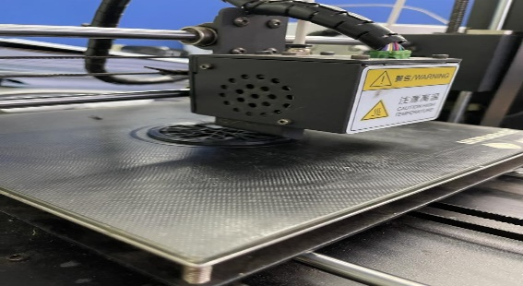**Figure 3 Processof cutting acrylic** **Figure 4 Process of printing the pulley**

**sheet using laser. using 3D printer**



**Figure 5 Pulley printed by 3D Printer.**

The pulley is an important part of the flag machine. It is a simple machine that is used to raise and lower the flag. The pulley is made of PLA filament and is 3cm in size. The pulley will be combined with the body part and other components to create a fully functioning flag machine. Then, the remote-control car was modified to create the motor for a self-rising flag. The remote-control car was originally used to power a small car. The modified remote-control was then used to power a flagpole.

1. **Result and Discussion**

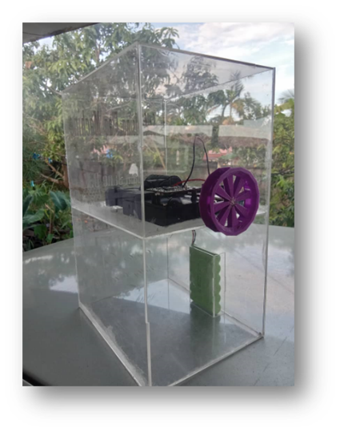

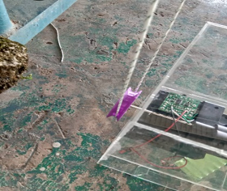

**Figure 5 The assembled pulley**

**Figure 4 Final product**

Figure 4 shows the final design of the self-rising flag machine. The machine is made of acrylic and has a simple, modern design. The machine is easy to use and can be raised and lowered with the remote control. The flagpole is now able to raise and lower the flag automatically. The modification of the control car engine to create the motor for a self-rising flag is a significant improvement over the traditional method of raising and lowering flags. The traditional method of raising and lowering flags requires someone to manually pull on a rope or chain. This can be difficult and time-consuming, especially if the flagpole is tall. The self-rising flag system is much easier to use. The self-rising flag system is a valuable tool for schools, businesses, and government organizations. It is a reliable, efficient, and respectful way to raise and lower flags.

During testing, the project objectives were successfully achieved. Firstly, the fabrication of the project can be deemed a success as the machine functions as expected. Secondly, during testing, the rope remained untangled due to the effective operation of the pulley system, which ensured its straight alignment. One strength test was conducted on this machine by excluding the use of the flag rope. During the test, certain deficiencies was identified in the machine and subsequently altered the machine's circuit design. The revised concept involves dividing the machine's circuit into two parts: placing the battery below and the motor above. This arrangement allows for the inclusion of a pulley system to raise the flag.



**Figure 6 Stress simulation using FEA**

Based on the stress simulation conducted, it was determined that the pulley can withstand a maximum stress of 2.297 MPa before experiencing deformation. In the context of the project, this pulley can be utilized since the load exerted by the flag is only 0.2 Pa. Therefore, whether it can withstand the load will depend on the circuit design.

The inclusion of cost management is crucial for the project, as it allows for the comparison of progress and actual expenses with the allocated budget. Table 1 displays the actual cost of the self-rising flag machine. The affordability of this machine is evident through the percentage of the cost incurred, highlighting its low-cost nature.

**Table 1 Actual Cost**

|  |  |  |  |
| --- | --- | --- | --- |
| **ITEM** | **QUANTITY** | **PRICE PER UNIT**  **(RM)** | **AMOUNT**  **(RM)** |
| Acrylic hinges  (45 mm) | 2 pcs | 4.50 | 9 |
| Acrylic lock pad (A) | 2 pcs | 6.00 | 12 |
| Acrylic sheet (Clear) (2.0mmX4’X6’) | 1 sheet | 100 | 100 |
| Remote control car | 1 pc | 95 | 95 |
| Filament (PLA) | 1 pc (1kg) | 65 | 65 |
| Super glue | 4 pcs | 1.50 | 6 |
| Multi-purpose silicon sealant | 1 pc | 9 | 9 |
| Flag strap  (10m) | 1pc | 12 | 12 |
| **TOTAL** | | **RM 308** | |

1. **Conclusion**

The self-rising flag machine offers convenient flag-raising and lowering capabilities, adjustable speed options, user comfort, and labour-saving advantages. Researchers have utilized simple materials like polycarbonate, PVC, and remote-control car motors to develop innovative applications that leverage knowledge of both simple and complex machines. The school highly recommends the use of self-rising flag machines for teachers and students. These machines incorporate a flag timer mechanism operated via remote control, supported by a battery-powered control car motor. They are designed to be portable, moderately sized, and user-friendly.

One significant benefit of the self-rising flag machine is its ability to minimize twisting of the flag strap. Additionally, it assists in reducing the time required for flag preparation during assembly. It is important to ensure that the rope is neither too tight nor too loose on the pulley. An excessively tight rope may cause the motor to automatically shut off due to the heavy load, resulting in overheating and potential circuit damage. On the other hand, a loose rope may not provide sufficient grip.

# **References**

Bart A. Randall, R. R. (2008). *United State of America Patent No. US 2008/0121167 Al.*

Heva, R. J. (2015). *United States of America Patent No. US9093001B1.*

KOTILAINEN, O. K. (1997). *Finnish Patent No. WO1997009500A1.*

Quintero, J. (2016, Jan 10). *Flag Raising Device.* Retrieved from CWU: https://digitalcommons.cwu.edu/undergradproj/21