**English Title (Identification of potent COVID-19 ...) (times new roman 14 bold)**

***Name SURNAME1,\*[C:\Users\Abdullah\AppData\Local\Microsoft\Windows\INetCache\Content.Word\ORCID-iD_icon-16x16.gif](https://orcid.org/0000-xxxx-xxxx-xxxx), Name SURNAME2[C:\Users\Abdullah\AppData\Local\Microsoft\Windows\INetCache\Content.Word\ORCID-iD_icon-16x16.gif](https://orcid.org/0000-xxxx-xxxx-xxxx), Name SURNAME3[C:\Users\Abdullah\AppData\Local\Microsoft\Windows\INetCache\Content.Word\ORCID-iD_icon-16x16.gif](https://orcid.org/0000-xxxx-xxxx-xxxx)*(*times new roman 11 bold-italic)***

*1Institute, Faculty, Department, University, City, Country* ***(times new roman 9 italic)***

*2Institute, Faculty, Department, University, City, Country* ***(times new roman 9 italic)***

*3Institute, Faculty, Department, University, City, Country* ***(times new roman 9 italic)***

|  |
| --- |
| **Abstract**  In this study, the relationship between transport performance of Cr(VI) through PVDF-co-HFP based ionic polymer inclusion membranes (IPIM), alkyl chain length of symmetric imidazolium bromide based room temperature ionic liquids (RTILs), and morphological changes of these IPIMs has been comprehensively described. Butyl, hexyl, octyl, and decyl substituted RTILs containing IPIMs were prepared in different compositions and their effectiveness on Cr(VI) transport was experimentally optimized. In optimum conditions, the initial mass transfer coefficient (Jo) value of Cr(VI) was found as 5.0x10-6 mols-1m-2, and also, we found that the optimized process is significantly selective for chromium in existence the other heavy metal ions. Morphological and structural characterizations of IPIMs have been performed before and after Cr(VI) transport to illuminate the morphological and structural changes. Also, the additional plasticizing effect of RTILs as an unusual morphological phenomenon has come forward. In today’s industrialised world, the demand for environmentally friendly processes for removal or recycle of toxic substances by simpler and cheaper ways have been increasing day by day. As a result, our developed and optimised membrane-based process seems to be overcome some Cr(VI) dependent environmental and industrial difficulties. **(times new roman 10) (75-300 words)** |
| Keywords(max.5): Keyword1, Keyword2, Keyword3, Keyword4, Keyword5 (times new roman 10) |

Total page number should be max four (4) pages.

1. **Introduction (times new roman 12 bold)**

In the world, each pollution types, existing in different environmental sources, affects a significant amount of the organisms who live in there [[1-3](#_ENREF_1)]. The discharge limits of heavy metals at the end of the industrial activities should be held in the acceptable concentration limits according to the boundaries of World Health Organization (WHO) and EPA [[4](#_ENREF_4), [5](#_ENREF_5)]. The high-level intake or exposure to the chromium can create bad results on survival conditions of humans, animals and plants depending on the chromium species [[6](#_ENREF_6), [7](#_ENREF_7)]. Cr(III) in lower concentrations has less toxic than Cr(VI) on natural life. Cr(III) especially shows its toxic effects on the viscera of mammal organisms like liver and kidney [[8-10](#_ENREF_8)]. (times new roman 11) References should be given in order.

$E=mc^{2}$ (times new roman 11) (1)

In the present study, we aimed to illuminate Cr(VI) transport through PVDF-co-HFP based IPIMs by using RTILs involving different lengths of alkyl chains. For this purpose, butyl, hexyl, octyl, and decyl substituted RTILs were synthesised and characterised using spectral and physicochemical characterization techniques like NMR, viscosity measurement, electrical conductivity, density, refractometry, etc.

1. **Materials and Methods(times new roman 12 bold)**

**2.1. Apparatus (times new roman 11 bold)**

The reagents, 1H-imidazole, 1-bromo propane, 1-bromo hexane, 1-bromo octane and 1-bromo decane, employed in the synthesis of RTILs and were purchased from VWR (Seelze, Germany) and used directly in the RTIL synthesis without further purification. Dichloromethane, toluene, diethyl ether, hexane, N,N-dimethyl formamide, NH4OH, Na2CO3, KOH, HCl, HNO3, NaOH, and H2SO4 were purchased from Sigma-Aldrich (Sleaze, Germany) and used directly without any purification.

**3. Results and Discussion(times new roman 12 bold)**

**3.1. Selection of working wavelength (times new roman 11 bold)**

We have illuminated the usage of imidazolium-based RTILs having different lengths of alkyl chains in symmetric positions as carrier in PVDF-co-HFP based PIMs as a carrier.



**Figure 1**. Absorbance spectra obtained in selected chemical conditions.(times new roman 10)

**3.2. Effect of pH**

Electrostatic interactions between chemical species vary depending on the pH of the aqueous solution. In the extraction experiments, the interaction between the analyte and the selected chemical medium should be high.

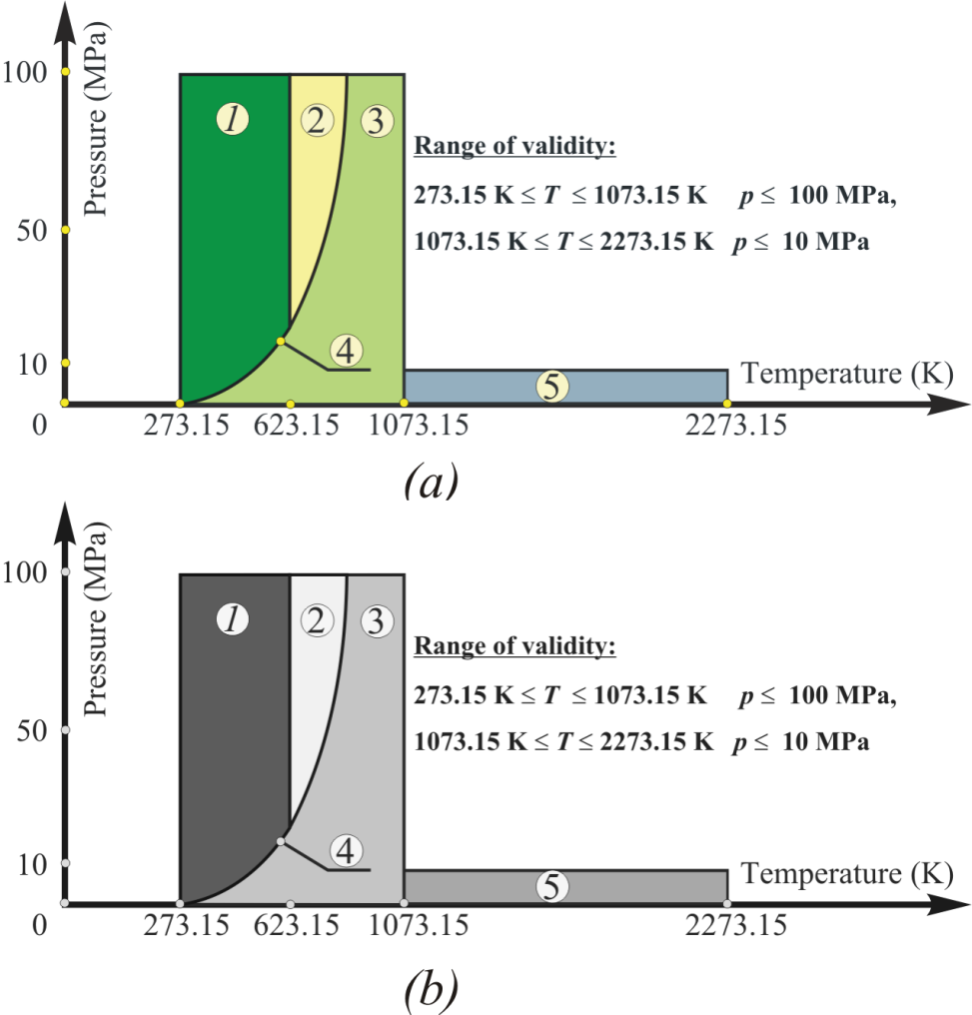

**Figure 2.** Use of appropriately contrasting colours for black and white printing: a) colour figure, b) greyscale figure.

**Table 1.** Table format in IKSTC: Template for manuscripts. **(times new roman 10)**

|  |  |  |  |
| --- | --- | --- | --- |
| Interfering species | Tolerance limits | Recovery (%) | RSD (%) |
| Sn2+ | 1000 | 94.7 | 2.1 |
| Cd2+ | 1000 | 96.4 | 2.4 |
| K+ | 1000 | 98.1 | 2.2 |
| Co2+ | 1000 | 95.3 | 2.1 |
| Mg2+ | 1000 | 96.2 | 2.0 |
| Ca2+ | 750 | 96.8 | 2.8 |
| Tartaric acid | 750 | 97.5 | 2.5 |
| Ponceau 4R | 750 | 96.5 | 2.6 |
| Fe3+ | 750 | 98.2 | 1.8 |
| SO42- | 500 | 94.4 | 2.7 |
| Allura red AC | 500 | 95.9 | 2.5 |
| Ascorbic acid | 500 | 97.1 | 2.6 |
| Al3+ | 500 | 96.3 | 2.9 |
| Brilliant Blue | 250 | 96.5 | 2.5 |
| Sunset yellow | 250 | 93.4 | 2.4 |
| Erythrosine | 250 | 93.1 | 2.1 |
| Carmoisine | 100 | 92.4 | 2.8 |
| Amaranth | 100 | 92.5 | 2.5 |

\*\*footnote and abbreviation times new roman 9 punto

**Acknowledgment**

In this study, the financial support was provided by The Scientific and Technological Research Council of Turkey (TUBITAK), Project No. 112T806. All experimental works were conducted in Çankırı Karatekin University Research Laboratory. The author would like to thanks to all supporters due to their precious contributions.

**References (Max.40) (times new roman 12 bold)** *Journal name should be written in italics (journals)*(times new roman 11)

1. Nosrati, S., Jayakumar, N. S., Hashim, M. A., & Mukhopadhyay, S. (2013). Performance evaluation of vanadium (IV) transport through supported ionic liquid membrane. *Journal of the Taiwan Institute of Chemical Engineers*, *44*(3), 337-342.
2. Soylak, M., & Yilmaz, E. (2011). Ionic liquid dispersive liquid–liquid microextraction of lead as pyrrolidinedithiocarbamate chelate prior to its flame atomic absorption spectrometric determination. *Desalination*, *275*(1-3), 297-301.

*(for book chapters)*(times new roman 11)

1. Murdock, T. A., Veras, E. F., Kurman, R. J., & Mazur, M. T. (2018). *Diagnosis of endometrial biopsies and curettings: A practical approach*. 2nd ed. Berlin: Springer, 100-120.

*(for book)*

1. García-Río, E., & Kupeli, D. N. (2013). *Semi-Riemannian maps and their applications* (Vol. 475). Springer Science & Business Media.

*(for websites)*

1. National Cancer Institute, Surveillance Epidemiology and End Results. Cancer of the Corpus and Uterus, NOS. Available    at:    http://seer.cancer.gov/statfacts/html/corp.html?statfacts\_page=corp. Retrieved March 2, 2008.

*(thesis)*

1. Surname N., Title of thesis, PD or master thesis, Name of university, name of institue, year.

*(Abstratcs in conferences are not accepted as a valid reference except full text)*

1. Surname N., Title of fulltext conference paper, name of conference, city, year, pages.