Effective Maintenance Engineering and Management in Manufacturing Industry

J Sam Hamidon1*, Mazrul Hisyam Mat Ali2, Mohd Zairunizam Umar3

1 Department of Electrical Engineering, Politeknik Seberang Perai,

Jalan Permatang Pauh, 13500 Permatang Pauh, Pulau Pinang, Malaysia

2 Department of Student Affairs, Politeknik Tuanku Syed Sirajuddin,

Pauh Putra, 02600 Arau, Perlis, Malaysia

3 Department of Mechanical Engineering, Politeknik Tuanku Syed Sirajuddin,

Pauh Putra, 02600 Arau, Perlis, Malaysia

*Corresponding e-mail: jsam@psp.edu.my

**ABSTRACT:**

This paper's investigation of the machine maintenance requirements for the industrial sector aims to provide recommendations for reducing breakdown times and averting significant losses. As a result, the article discusses maintenance organization, strategy, system approach, planning, and scheduling, as well as the computerized maintenance management system appropriate for the industrial sector. To effectively replicate a corporation and plan maintenance, the organization must be taken into account first. The process is then moved on to the following stage, which involves picking the best strategy to apply inside the business. Along with the strategy, the system approach to maintenance is introduced, which will require organized/secure planning and scheduling. When everything is organized and secure on a computer system, a business can be better maintained because everything is better organized.

**KEYWORDS**: Maintenance, approach, manufacturing industry

1. INTRODUCTION

Maintenance is an important part of quality control and, in some cases, has an impact on a business' long-term existence. Unstable resources can stop production if they have not been maintained appropriately. For most firms, dealing with a machine malfunction or complete breakdown can be expensive. When a breakdown happens, the price of labor per unit rises gradually until the equipment is working again. In this situation, fixing the problems will result in unexpected costs, such as extra costs for repair facilities, technicians or repair team, preventative maintenance inspections, and spare parts. These are just a few problems that a company, even one that uses brand-new machines in its production operations, may run into overtime if a reliable maintenance management solution is not put in place.

The goal of maintenance is to guarantee the highest levels of productivity and availability of production tools, utilities, and related facilities at the most affordable prices possible while maintaining acceptable levels of quality, safety, and environmental protection. Long ago, maintenance was viewed as a secondary task that always resulted in financial waste. There was a propensity to group it with troubleshooting and maintaining worn-out or obsolete equipment. Yet, businesses nowadays are realizing that maintenance is a crucial component of production, not just a "partner" in it. Its connection to equipment performance is a high management level integrated strategy issue. As a result, management is now in charge of the maintenance function. The objective is to control expenses, schedule work effectively and efficiently, and guarantee that the business complies with all rules and regulations while preventing failures and reducing breakdowns through extensive studies and accurate reports.

The Facility Manager (FM) function in Figure 1 is becoming more and more well-known for the significant contribution it can make to cost savings and workplace effectiveness. Managing support services to meet the needs of the organization, its core functions, and employees is FM's main responsibility. It focuses on the management of physical asset maintenance and includes the controlling services required for a successful business [1].

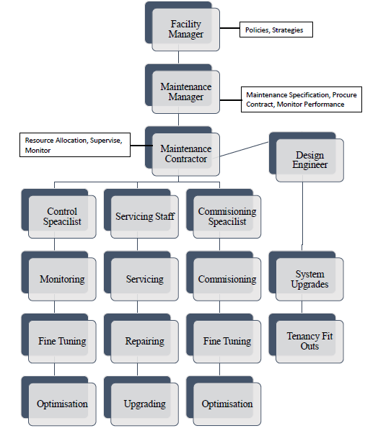

**Figure 1**: A maintenance management structure proposed for Manufacturing Industry

A simple input/output system can be used to describe a maintenance system. Manpower, damaged equipment, materials and spare parts, tools, information, policies and procedures, and spares constitute the system's inputs. Equipment that is operational, dependable, and properly designed to carry out the planned function of the plant is the output. The system is functional thanks to a number of actions. Planning, scheduling, execution, and control are among the tasks. According to the maintenance system's goals, the control is accomplished. Equipment availability, affordability, and quality are among the objectives, which are typically in line with those of the company. An essential component of this system that can be used to enhance performance is feedback and control.

1. METHODOLOGY:

MAINTENANCE STRATEGY USED IN MANUFACTURING INDUSTRY

By performing routine inspections, replacing worn out parts, and cleaning equipment, a strong preventative maintenance program foresees and avoids equipment problems. Robotic systems, for instance, require a targeted, regular preventive maintenance program to ensure optimal operation and offer the longest possible in-service lifespan. An efficient program includes regular, systematic performance testing and analysis, software updates, and component replacement, adjustment, lubrication, and replacement.

In order to extend the life of industrial equipment, Total Productive Maintenance (TPM) can be implemented to improve productivity and reduce the operating costs [2]. TPM enables a company to:-

1. Reduce waste and product defects;
2. Empowering workers to set-up and take care of their equipment;
3. Reduce operating costs;
4. Minimize safety issues;
5. Increase productivity rates (less equipment breakdown); and
6. Ensuring all systems and processes are production of high-quality products.
7. RESULTS:

IMPLEMENTATION OF SYSTEM APPROACH TO MAINTENANCE IN MANUFACTURING INDUSTRY

The goal of the maintenance management control system is to improve profitability while reducing losses and waste while boosting productivity and efficiency. The goal of maintenance is to achieve the best level of personal safety and operational reliability while spending the least amount of money. Design modifications, better lubricants, an improved suspension system, calibration, alignment, etc. can be used to facilitate maintenance, for example:

1. *Chips sorting machine maintenance*

It is crucial to establish a scheduled preventive maintenance program to get the most efficiency out of the chipper and prevent unneeded downtime. The daily, weekly, and monthly maintenance checks must be planned out, and operators must adhere to them strictly. The operator’s manual will provide specific guidelines for the equipment. On a daily basis, check the chipper to make sure it is operating correctly.

1. *Soldering machine maintenance*

Cleaning the sensors and maintenance after 200 hours. Clean all the sensors on the conveyor with a cloth and some detergent. Other than that, do a maintenance heating zone (bottom and top). The cleaning plates should have some maintenance after 200 hours. Clean hole plates with reflow oven cleaner and cloth.

1. *Terminal hot press machine maintenance*

It is typically strongly advised to use a Terminal Hot Press Maintenance checklist to help with memory and mark activities off as they are completed. Create check-sheets that are organized with each itemized task connected to a specific interval. It could be on a daily, monthly, or seasonal basis. It also may be according to machine time where particular hourly milestones demand specific attention. You can schedule upcoming activities by recording the maintenance of your machinery. This includes scheduling maintenance that needs to be outsourced to a dealer if shop time is necessary or a dealer site visit is desired, as well as being reminded to order new parts, fluids, and filters.

1. FINDINGS:

EFFECTIVE MAINTENANCE PLANNING AND SCHEDULING SYSTEM

While maintenance planning is exactly what it sounds like: the planning process, maintenance scheduling is the process of shifting responsibilities in a production or manufacturing process. Maintenance scheduling is used to plan human resources, industrial processes, allocate machinery and equipment resources, and acquire materials [3]. Planning and scheduling are two of the simplest and most economical actions a business can take to boost output and availability. The dependability and efficiency of an asset are improved by good scheduling. Pool scheduling increases costs and complicates the process. Electronic component manufacturers need to embrace current technology more than ever to reduce the risk and expenses associated with maintaining their products because of globalization, fierce rivalry, and pressure to cut operational costs. Maintenance planning and scheduling should provide considerable benefits such as:

(i) Monitoring expenses related to maintenance can assist in budgeting;

(ii) Decreased equipment outages;

(iii) A decrease in replacement components;

(iv) Increased efficiency; and

(v) Heightened effectiveness through less resource mobility between locations.

1. CMMS SOFTWARE IN MANUFACTURING INDUSTRY

A Computerized Maintenance Management System (CMMS) is a piece of software created specially to make the work of maintenance teams more effective. The software's purpose is to distribute maintenance jobs more effectively among employees of a corporation. Software such as Fiix CMMS can be used in manufacturing industry to:

1. Control expenses;
2. Gather and utilize data;
3. Boost safety and health;
4. Script work request; and
5. Make scheduling and do preventive maintenance.
6. CONCLUSION

In order to acquire sound maintenance management skills in the manufacturing sector, this study provided knowledge related keeping facilities and machine/equipment activities in good operating order.

REFERENCES

[1] A. De Marco, G. Mangano. (2012). A Review of the Role of Maintenance and Facility Management in Logistics. *Proceedings of the World Congress on Engineering 2012, Vol III, WCE 2012, July 4 - 6, 2012, London, U.K*.

[2] [I.P.S. Ahuja](http://www.emeraldinsight.com/author/Ahuja%2C+IPS), [J.S. Khamba](http://www.emeraldinsight.com/author/Khamba%2C+JS). (2008). Total productive maintenance: Literature review and directions. *International Journal of Quality & Reliability Management, Vol. 25 Issue: 7, pp.709-756*.

[3] Golub, D. (2021). What is Maintenance Scheduling? Hippo CMMS. Available online: *https://hippocmms.iofficecorp.com/blog/what-is-maintenance-scheduling*